# Fluorescence enhancement of a single nanodiamond with SiV centers using a plasmonic nanoantenna

# N. Rahbany1, S. Lindner2, C. Pauly2, D. Legrand1, M. Atature?, R. Bachelot1, C. Becher2 and C. Couteau1,3,4

# 1 Laboratory of Nanotechnology, Instrumentation and Optics, ICD CNRS UMR 6281, University of Technology of Troyes, 10000, Troyes, France 2 Fachrichtung Physik, Universität des Saarlandes, Campus E2.6, D-66123 Saarbrücken, Germany 3 CINTRA CNRS-Thales-NTU, UMI 3288, Research Techno Plaza, 50 Nanyang Drive, Singapore 4 Centre for Disruptive Photonics Technologies (CDPT), Nanyang Technological University, Singapore

1. **Introduction**

Color centers in diamond are being widely used as efficient single photon sources due to their indistinguishability and photostability at room temperature. This allows them to play an important role in the fields of quantum information processing1,2, super-resolution microscopy3,4, and biological imaging5. Silicon vacancy (SiV) centers in diamond have shown to have several advantages over other types of defects due to their strong narrow fluorescence spectrum at room temperature (full width at half maximum (*FWHM) < 5 nm* at *737 nm*) with low phonon coupling, a short lifetime (*1.8 ns*), and an almost fully linearly polarized zero phonon line fluorescence6,7.

However, the reported values of the photoluminescence (PL) and radiative quantum efficiency of SiV centers so far remain low. Consequently, experiments involving coupling SiV centers to optical cavities have led to an improvement in their radiative quantum efficiency and Purcell factor, as well as a reduction in lifetime8. Plasmonic coupling which in general allows for large local electrical fields was also studied to enhance the emission of SiV centers in microdisk cavities9, in the vicinity of gold nanoparticles10, and in hybrid metal-diamond structures11.

In this work, we present the integration of SiV centers in nanodiamonds with double bowtie nanoantenna structures, which is shown to cause an enhancement in their photoluminescence (PL) emission. A single nanodiamond is pre-characterized and transferred to the gap of a gold nanoantenna by the “pick and place” technique with the help of a nanomanipulator with a tungsten tip. We show that the PL spectrum of the nanodiamond is modified depending on the geometry of the nanoantenna as well as the position of the emitter in the gap. This provides us with flexibility in designing the nanoantennas to accurately predict and shape the emitters’ PL spectrum as desired.

1. **Nanodiamond Characterization – Photoluminescence Spectroscopy**

A solution of *100 nm* nanodiamonds was spin-coated on a clean iridium substrate To ensure that a pre-characterized nanodiamond exhibiting preferred optical properties (eg. narrow linewidth, high count rate) will later be found again, the iridium substrate was engraved with reference cross markers produced by a focused ion beam prior to the spin-coating process. The nanodiamonds were produced by milling a diamond film grown by chemical vapour deposition. After spin-coating, the sample was placed in an oven for 3 hours at *450 oC* to oxidize the surface and remove any residual graphite and amorphous carbon.

In a first step, we identified nanodiamonds which lie isolated enough to be picked up and transferred to the antenna structure later on. For that purpose, we recorded high resolution pictures of the sample surface via a commercial confocal laser scanning microscope (Fig.1a)

Next, the samples were tested using a home-built confocal microscopy setup to identify nanodiamonds hosting SiV centers with the preferred optical properties. In this setup, the sample is either illuminated with diffuse white light to investigate the sample surface, or with a red diode laser (Schaefter-Kirchhoff , *λex = 660 nm*) that is focused on the studied sample through a *100X*, *NA = 0.8* microscope objective to study the fluorescence of SiV centers in diamond. The same objective serves to collect light stemming from the sample. The collected light can be guided to a CCD camera, avalanche photo diodes (APDs), or a spectrometer.

To identify the nanodiamonds on the sample surface, the sample is illuminated with diffuse white light and the collected light is guided to a CCD camera. The optical image in Fig. 1b shows a picture of the sample surface under white light illumination. White spots correspond to nanodiamonds that might contain SiV centers. They appear as bright spots due to the scattering caused by the white light illumination. The two bright lines correspond to two cross markers that were previously engraved on the surface of the sample.

In order to test the presence of SiV centers in the nanodiamonds and to pre-select nanodiamonds hosting SiV centers with desired optical properties, such as narrow linewidth and high countrates, the sample is excited with the red laser and photoluminescence (PL) scans and spectra are recorded. A long pass filter (*λ = 720 nm*) is placed in the detection path to suppress any signal stemming from the laser.. During the PL scan, the laser spot scans the surface and the emitted PL is recorded by the APD. In front of the APD a 730-750nm bandpass filter is installed. The center wavelength of the zero-phonon line of an SiV center is located at around *738 nm.* Therefore, if a nanodiamond contains an SiV center, its emission will results in a bright spot in the PL scan. Fig. 1c shows an example of a PL scan where bright spots (highlighted by the red circles) correspond to nanodiamonds with PL in the SiV center spectral range. To further verify the presence of SiV centers, PL spectra at room temperature are recorded. Fig. 2 shows a representative spectrum where the intense narrow peak (*λ = 738.55 ±0.01nm, Δλ = 5.09±0.03 nm* corresponds well to the zero phonon line (ZPL) of unstrained SiV centers and therefore allows us to deduce that the studied nanodiamond contains at least one SiV center.

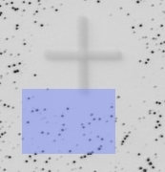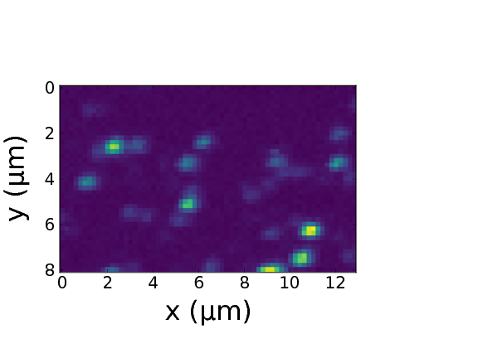

a)

b)

c)

Fig. 1 a) Picture recorded with a commercial high resolution laser scanning microscope. The area shaded in blue represents the PL scan in image 1c. b) Images of the sample surface of 100 nm CVD-grown nanodiamonds spin-coated on an Iridium substrate illuminated with diffuse white light. The white bars are the horizontal bars of the cross markers which serve as a coarse orientation on the sample surface, the white dots are nanodiamonds, the big black spot is an artifact. b) Photoluminescence scan of a  *8x13 μm* area on the sample. Bright dots correspond to nanodiamonds that might contain SiV centers.

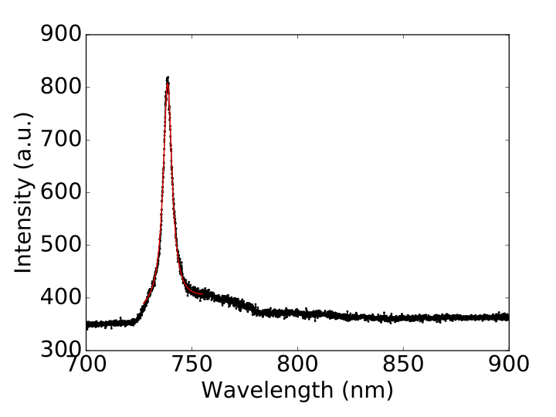

Fig. 2 PL spectrum of a nanodiamond at room temperature. Black: experimental results; red: fit to experimental data, which yields the following values: ZPL center wavelength *λ = 738.55 ±0.01nm,* linewidth *Δλ = 5.09±0.03 nm.*

1. **Double Bowtie Nanoantennas - FDTD Numerical Simulations and Fabrication**

FDTD numerical simulations were performed using Lumerical software to characterize gold double bowtie nanoantennas on a gold substrate. The nanoantennas have a gap of *g = 150 nm* (taking into account the diameter of the nanodiamonds of around *100 nm*), side length of *L = 2 µm*, and a thickness of *t = 60 nm* (see Fig.3a). Upon excitation with incident light, an intense electromagnetic hotspot is formed in the nanoantenna gap12, which is expected to excite a nanodiamond containing SIV centers aiming to enhance its fluorescence emission.

Unlike a single bowtie that is sensitive only to the polarization along its principle axis (C2 rotational symmetry), a double bowtie features a C4 rotational symmetry and therefore focuses both parallel and perpendicular polarizations. For that, a circularly polarized light with a wavelength range of *λ = 400 - 1500 nm* is chosen to illuminate a gold double bowtie nanoantenna on a gold substrate, which efficiently excites both the horizontal and vertical components of the structure. The index of refraction of gold is taken from Palik13, and that of the nanodiamond is chosen to be *n = 2.4* at *λ = 660 nm*. The electric field intensity in the nanoantenna gap is then measured as a function of wavelength to identify the antenna resonance. The spectrum is given in Fig.3b where we observe that the resonance shows two peaks; an intense peak coinciding with the SiV emission wavelength (*λ = 739 nm*), and an additional mode at a lower wavelength (*λ = 710 nm*). The resonance spectrum of the antenna alone shows only one peak at 739 nm. Thus, the additional peak is attributed to the presence of the nanodiamond that is slightly shifted from the center of the gap, corresponding to our experimental conditions.

Fig.3. a) Schematic of a double bowtie nanoantenna with side length *L*, thickness *t* and gap *g*, b) Electric field intensity as a function of wavelength measured in the gap of a double bowtie nanoantenna containing a nanodiamond

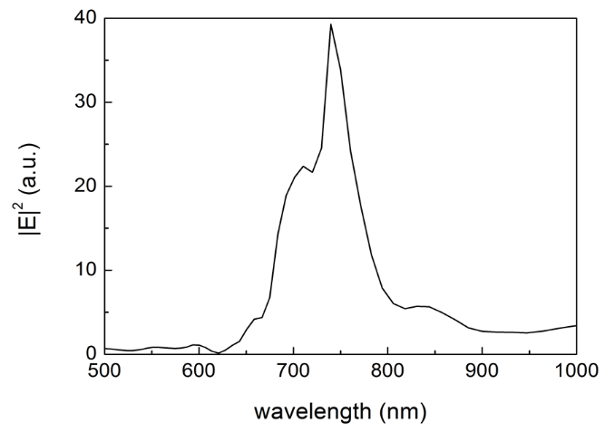

710 nm

739 nm

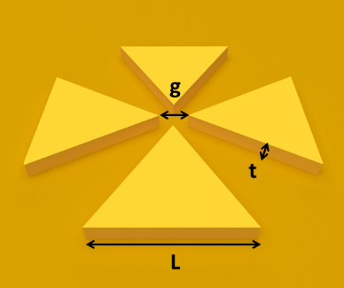

a)

b)

The structures were fabricated by electron beam lithography (EBL). A 200 nm layer of polymethyl methyl acrylate (PMMA) is first deposited on a clean silicon substrate. This is followed by e-beam exposure to engrave the desired design on the substrate, after which a 60 nm layer of gold is evaporated to cover both the antennas and the substrate underneath. An SEM image of the fabricated gold double bowtie nanoantennas is shown in Fig.4.

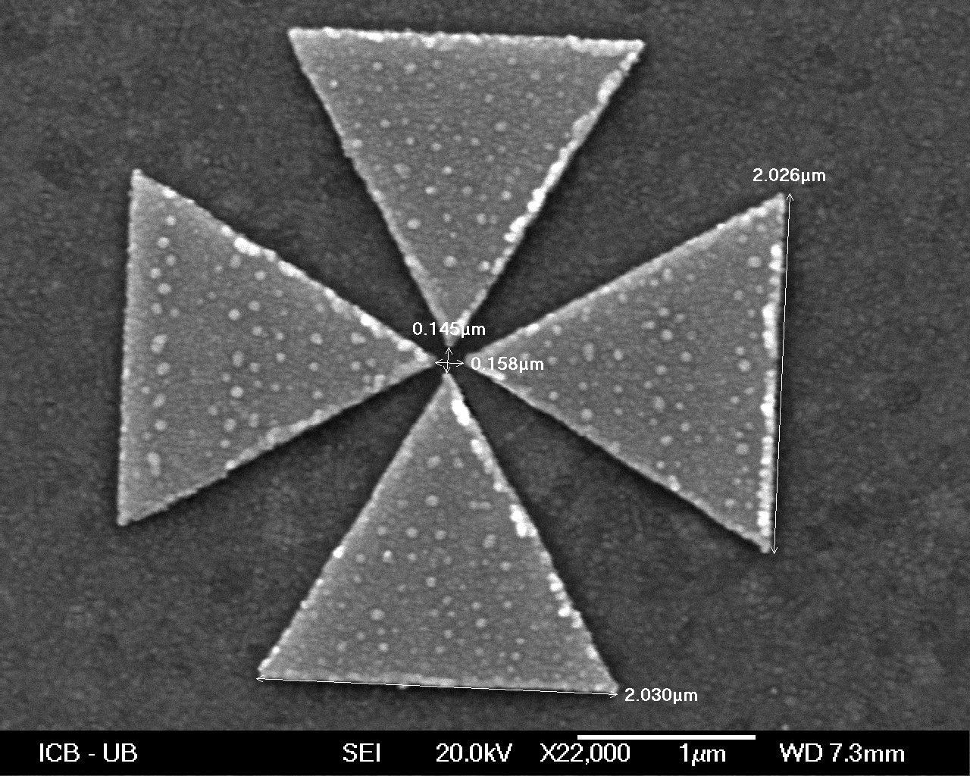  
Fig.4. SEM image of a gold double bowtie nanoantenna on a gold substrate with gap size g=150 nm and side length L=2µm

1. **Nanodiamond Manipulation – Pick and Place technique**

After the a nanodiamond was pre-selected according to the procedure outlined in Sec. II, we used the “pick and place” technique to transfer nanodiamonds, with the help of a nanomanipulator .to the sample containing the nanoantenna structures (schematic in Fig. 5). A nanomanipulator with a tungsten tip (radius of curvature = *100 nm,* sharpened by a focused ion beam) is incorporated inside an SEM, which allows us to visualize and manipulate the nanodiamonds at the same time. The two samples, i.e. nanodiamonds on the substrate and the gold nanoantenna samples, are placed inside the SEM. The tip is approached to the surface and gets in contact with the desired pre-characterized nanodiamond registered to the markers on the substrate. This procedure was performed for the nanodiamond characterized in section 2 (with PL spectrum as given in Fig.2). Due to Van der Waals forces between the tip and the nanodiamond, the latter successfully sticks to the tip, as seen in Fig. 6a. The tip is then moved to the second sample and carefully approached to the gap of the target nanoantenna. When the nanodiamond touches the surface, and also due to the existing Van der Waals forces, it gets off the tip and lies precisely in the gap, as demonstrated in Fig. 6b (the nanodiamond is the black dot in the gap).

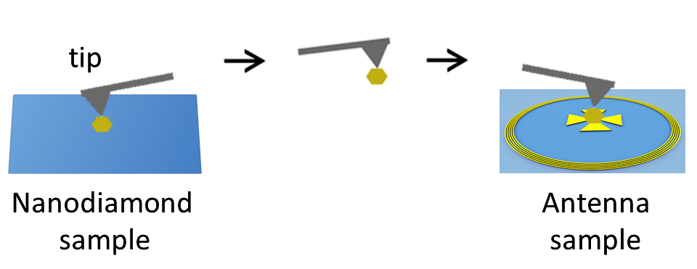

Fig.5. Schematic of the pick and place technique.

Fig.6. Pick and Place technique for nanodiamond manipulation, nanodiamond colored blue in the image; a) nanodiamond stuck to the tip and was lifted off the substrate b) nanodiamond layed off in the nanoantenna gap.

a)

b)

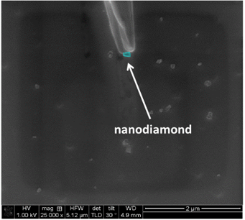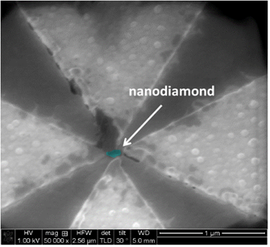

After this deterministic placement we measure the PL spectrum of the nanodiamond to identify the effect of the nanoantenna on its emission. The result is displayed in Fig. 7a where an increase in the PL intensity is observed by more than a factor 10 indicating that the nanoantennas indeed contribute to the enhancement of the SiV centers emission. A *λ = 710 nm* long pass filter is used to eliminate any signal from the laser. The additional peak at a lower wavelength is attributed to the antenna resonance mode. To verify this, we convolute the experimental PL spectrum of the nanodiamond measured before placing it in the nanoantenna (Fig. 2) with the intensity spectrum of the nanoantenna obtained by simulations (Fig. 3b). The resulting spectrum is given in Fig. 7b, and is in good agreement with the measured spectrum in Fig. 7a, confirming that indeed the extra peak is due to the antenna resonance.

Fig.7. a) Experimental PL spectrum of the nanodiamond after placing it in the nanoantenna, b) Convoluted spectrum of the experimental PL spectrum of the nanodiamond (see Fig. 2) with the simulated resonance spectrum of the nanoantenna (see Fig. 3b)

739 nm

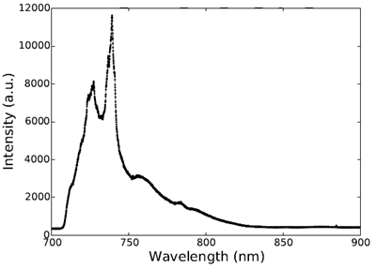

726 nm

a)

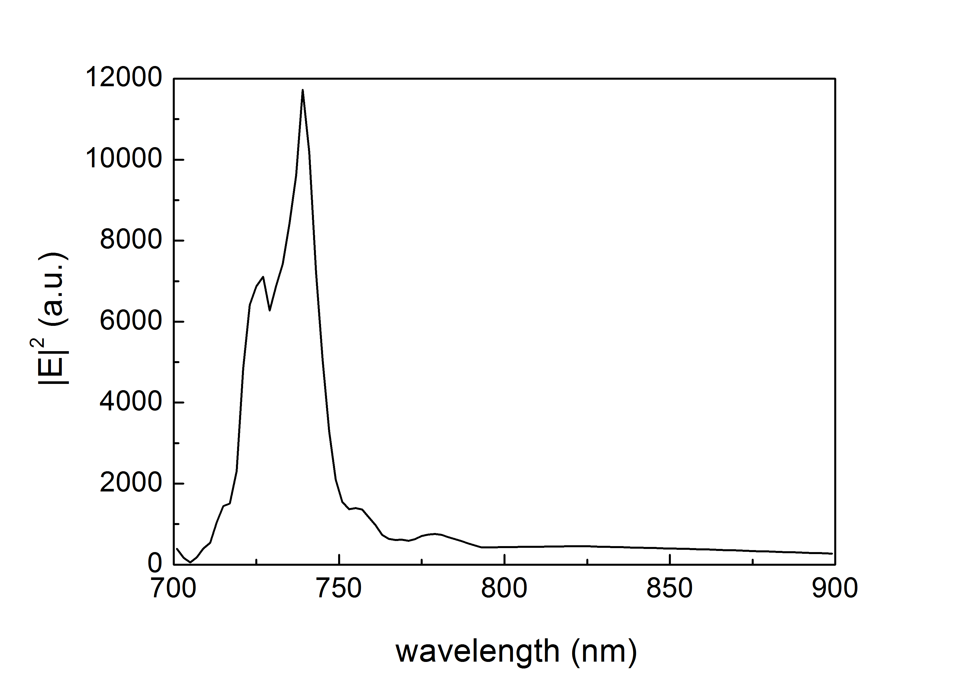

727 nm

739 nm

b)

1. **Conclusion**

In this work we presented the successful integration of SiV centers in nanodiamonds to plasmonic nanoantenna structures. This was achieved by the “pick and place” technique allowing to transfer a single nanodiamond with SiV centers to the gap of a double bowtie nanoantenna. Optical characterization, sample fabrication, as well as numerical FDTD simulations were performed to study our plasmonic structures. Photoluminescence measurements showed a significant increase in the emission intensity of the nanodiamond after placing it in the nanoantenna gap. We conclude that careful optimization of various parameters such as the geometry of the antenna, the materials used, and the position of the emitter in the gap, provides flexibility in defining the resulting PL spectrum of the nanodiamond, which can be adjusted according to the desired application.

Further work including lifetime measurements is necessary to give an accurate description of the emission enhancement of the nanodiamond. In addition, the success of our manipulation technique encourages us to go further with this experiment and apply it to nanodiamonds containing only one single SiV center. This includes saturation and second order correlation measurements to probe single SiV centers, and consequently quantify the exact Purcell enhancement imposed by the nanoantenna on a single photon emitter.

**References**

1. Rittweger, E., Han, K. Y., Irvine, S. E., Eggeling, C. & Hell, S. W. STED microscopy reveals crystal colour centres with nanometric resolution. *Nat. Photonics* **3,** 144–147 (2009).

2. Maurer, P. C. *et al.* Far-field optical imaging and manipulation of individual spins with nanoscale resolution. *Nat. Phys.* **6,** 912–918 (2010).

3. Togan, E. *et al.* Quantum entanglement between an optical photon and a solid-state spin qubit. *Nature* **466,** 730–734 (2010).

4. Dutt, M. V. G. *et al.* Quantum Register Based on Individual Electronic and Nuclear Spin Qubits in Diamond. *Science* **316,** 1312–1316 (2007).

5. Aharonovich, I. *et al.* Diamond-based single-photon emitters. *Rep. Prog. Phys.* **74,** 76501 (2011).

6. Siyushev, P. *et al.* Low-temperature optical characterization of a near-infrared single-photon emitter in nanodiamonds. *New J. Phys.* **11,** 113029 (2009).

7. Muller, T. *et al.* Optical signatures of silicon-vacancy spins in diamond. *Nat. Commun.* **5,** (2014).

8. Riedrich-Moller, J. *et al.* Deterministic Coupling of a Single Silicon-Vacancy Color Center to a Photonic Crystal Cavity in Diamond. *Nano Lett.* **14,** 5281–5287 (2014).

9. Lee, J. C., Aharonovich, I., Magyar, A. P., Rol, F. & Hu, E. L. Coupling of silicon-vacancy centers to a single crystal diamond cavity. *Opt. Express* **20,** 8891 (2012).

10. Orlanducci, S., Cianchetta, I., Tamburri, E., Guglielmotti, V. & Terranova, M. L. Effects of Au nanoparticles on photoluminescence emission from Si-vacancy in diamond. *Chem. Phys. Lett.* **549,** 51–57 (2012).

11. Song, J. *et al.* Plasmon-enhanced photoluminescence of Si-V centers in diamond from a nanoassembled metal-diamond hybrid structure. *CrystEngComm* **16,** 8356 (2014).

12. Rahbany, N. *et al.* Integrated plasmonic double bowtie / ring grating structure for enhanced electric field confinement. *Nanospectroscopy* **1,** (2015).

13. Palik, E. D. *Handbook of optical constants of solids*. **3,** (Academic press, 1998).