Boot loader update manual
Index
● Update CLI firmware & CLI boot loader 2
● Update Web firmware & Web boot loader 3
● Solution of power failure when update boot loader 5

- Update CLI firmware & CLI boot loader
  - Update CLI firmware from web:

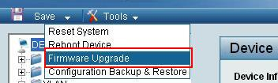

Select CLI binary file, click Upgrade button and wait until update process end.

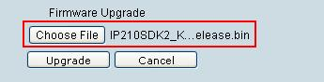
  - Update CLI boot loader by tftp:

Telnet to switch and login, enter command “bootloaderupdate”,then enter the password.

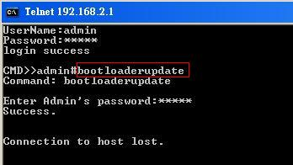

Use tftp put the CLI binary file to switch.(the file is the same in step 1)

You can see the update progress by telnet to switch.

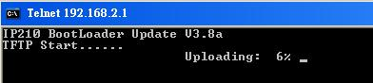

Wait for update process and finish boot loader update.

- Update Web firmware & Web boot loader
  - Update Web boot loader from CLI:

Telnet to switch and login, enter command “bootloaderupdate”,then enter the password.

Use tftp put Web binary file to switch.

You can also see the update progress by telnet to switch, and wait the process done.
  - Update Web firmware from CLI:

Telnet to switch and login, enter command “firmwareupdate”,then enter the password.

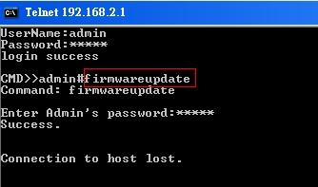

Connect to the switch web page, select Web binary file, click Upgrade button. (the file is the same in step 1)

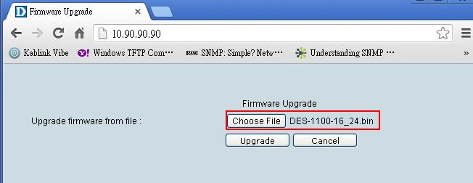

After update process done, the Web firmware and boot loader are successfully update to switch.

- Solution of power failure when update boot loader

When power down or some connection problem occur during the update process, telnet to switch when the system is stable.
  - If you see the login request in the screen, enter the username, password, and redo the boot loader update process.

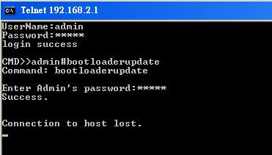
  - If you see the screen as below, directly use tftp to put the binary file to switch.

