VISVESVARAYA TECHNOLOGICAL UNIVERSITY
Belagavi, Karnataka – 590018

MINI PROJECT REPORT
on
STUDENT RESULT MANAGEMENT SYSTEM

Submitted in partial fulfillment of the requirements for
Bachelor of Engineering in Computer Science & Engineering

Subject: Database Management System
Subject Code: BCS403
Scheme: 2022 | Semester: III / IV

Submitted by
Rakesh M Badiger
USN: 1SV24CX021

Under the Guidance of
Prof. Vijayalakshmi
Department of Computer Science & Engineering

Department of Computer Science & Engineering
Shridevi institute of engineering and technology
Academic Year: 2024 – 25

Table of Contents
1 Abstract ···························································· 3
2 Introduction ···························································· 3
3 System Requirements ···························································· 4
4 Entity-Relationship (ER) Diagram ···························································· 4
5 Schema Design ···························································· 5
6 Normalization ···························································· 7
7 SQL Queries – DDL ···························································· 8
8 SQL Queries – DML & SELECT ···························································· 9
9 Sample Output ···························································· 11
10 Advantages & Limitations ···························································· 12
11 Conclusion ···························································· 12
12 References ···························································· 13

1. Abstract
The Student Result Management System is a relational database application designed to efficiently store, manage, and retrieve the academic records of students in an engineering college. The system automates the process of recording student details, subject information, semester-wise marks, and grade computation.
The project is built using MySQL and follows the principles of the Relational Database Model. Five normalized tables — DEPARTMENT, STUDENT, SUBJECT, RESULT, and SEMESTER — are designed following First, Second, and Third Normal Forms to eliminate data redundancy and maintain data integrity.
SQL features such as DDL (CREATE), DML (INSERT, UPDATE, DELETE), SELECT with JOINs, aggregate functions, subqueries, and VIEWs are demonstrated. The system can display student result sheets, calculate subject-wise averages, identify toppers, and detect students with backlogs.

2. Introduction
In any educational institution, managing student results manually is time-consuming, error-prone, and difficult to scale. A Database Management System (DBMS) provides a structured and efficient way to store and retrieve large volumes of academic data.
The Student Result Management System addresses this problem by providing a centralized relational database that stores information about students, subjects, marks, and grades. The system ensures:
• Data consistency through the use of primary and foreign key constraints
• Elimination of data redundancy through normalization up to 3NF
• Fast and accurate data retrieval using optimized SQL queries
• Easy generation of result reports, grade sheets, and toppers list

2.1 Scope of the Project
This project covers the academic result management for one department across one semester. It can be extended to support multiple departments, multiple semesters, CGPA calculation, and backlog tracking in future enhancements.

3. System Requirements
3.1 Hardware Requirements
Component | Minimum Requirement
Processor | Intel Core i3 or above
RAM | 4 GB or above
Storage | 50 GB Hard Disk
Display | 1024 × 768 resolution

3.2 Software Requirements
Software | Version / Details
Operating System | Windows 10 / Ubuntu 20.04
Database | MySQL 8.0
Query Tool | MySQL Workbench / DB Fiddle
Documentation | MS Word 2019 / Google Docs

4. Entity-Relationship (ER) Diagram
4.1 Entities and Their Attributes
Entity | Primary Key | Attributes
DEPARTMENT | Dept_ID | Dept_ID, Dept_Name, HOD
STUDENT | USN | USN, Name, DOB, Gender, Phone, Dept_ID
SUBJECT | Sub_Code | Sub_Code, Sub_Name, Credits, Dept_ID, Semester
RESULT | Result_ID | Result_ID, USN, Sub_Code, Internal, External, Total, Grade
SEMESTER | Sem_ID | Sem_ID, USN, Sem_No, SGPA, Status

4.2 Relationships and Cardinality
Relationship | Entity 1 | Entity 2 | Cardinality | Foreign Key
Studies in | STUDENT | DEPARTMENT | Many : One (N:1) | Dept_ID in STUDENT
Has result | STUDENT | RESULT | One : Many (1:N) | USN in RESULT
Belongs to | RESULT | SUBJECT | Many : One (N:1) | Sub_Code in RESULT
Enrolled in | STUDENT | SEMESTER | One : Many (1:N) | USN in SEMESTER
Offers | DEPARTMENT | SUBJECT | One : Many (1:N) | Dept_ID in SUBJECT

4.3 ER Diagram
The following ER diagram shows all entities, attributes, and relationships for the Student Result Management System:

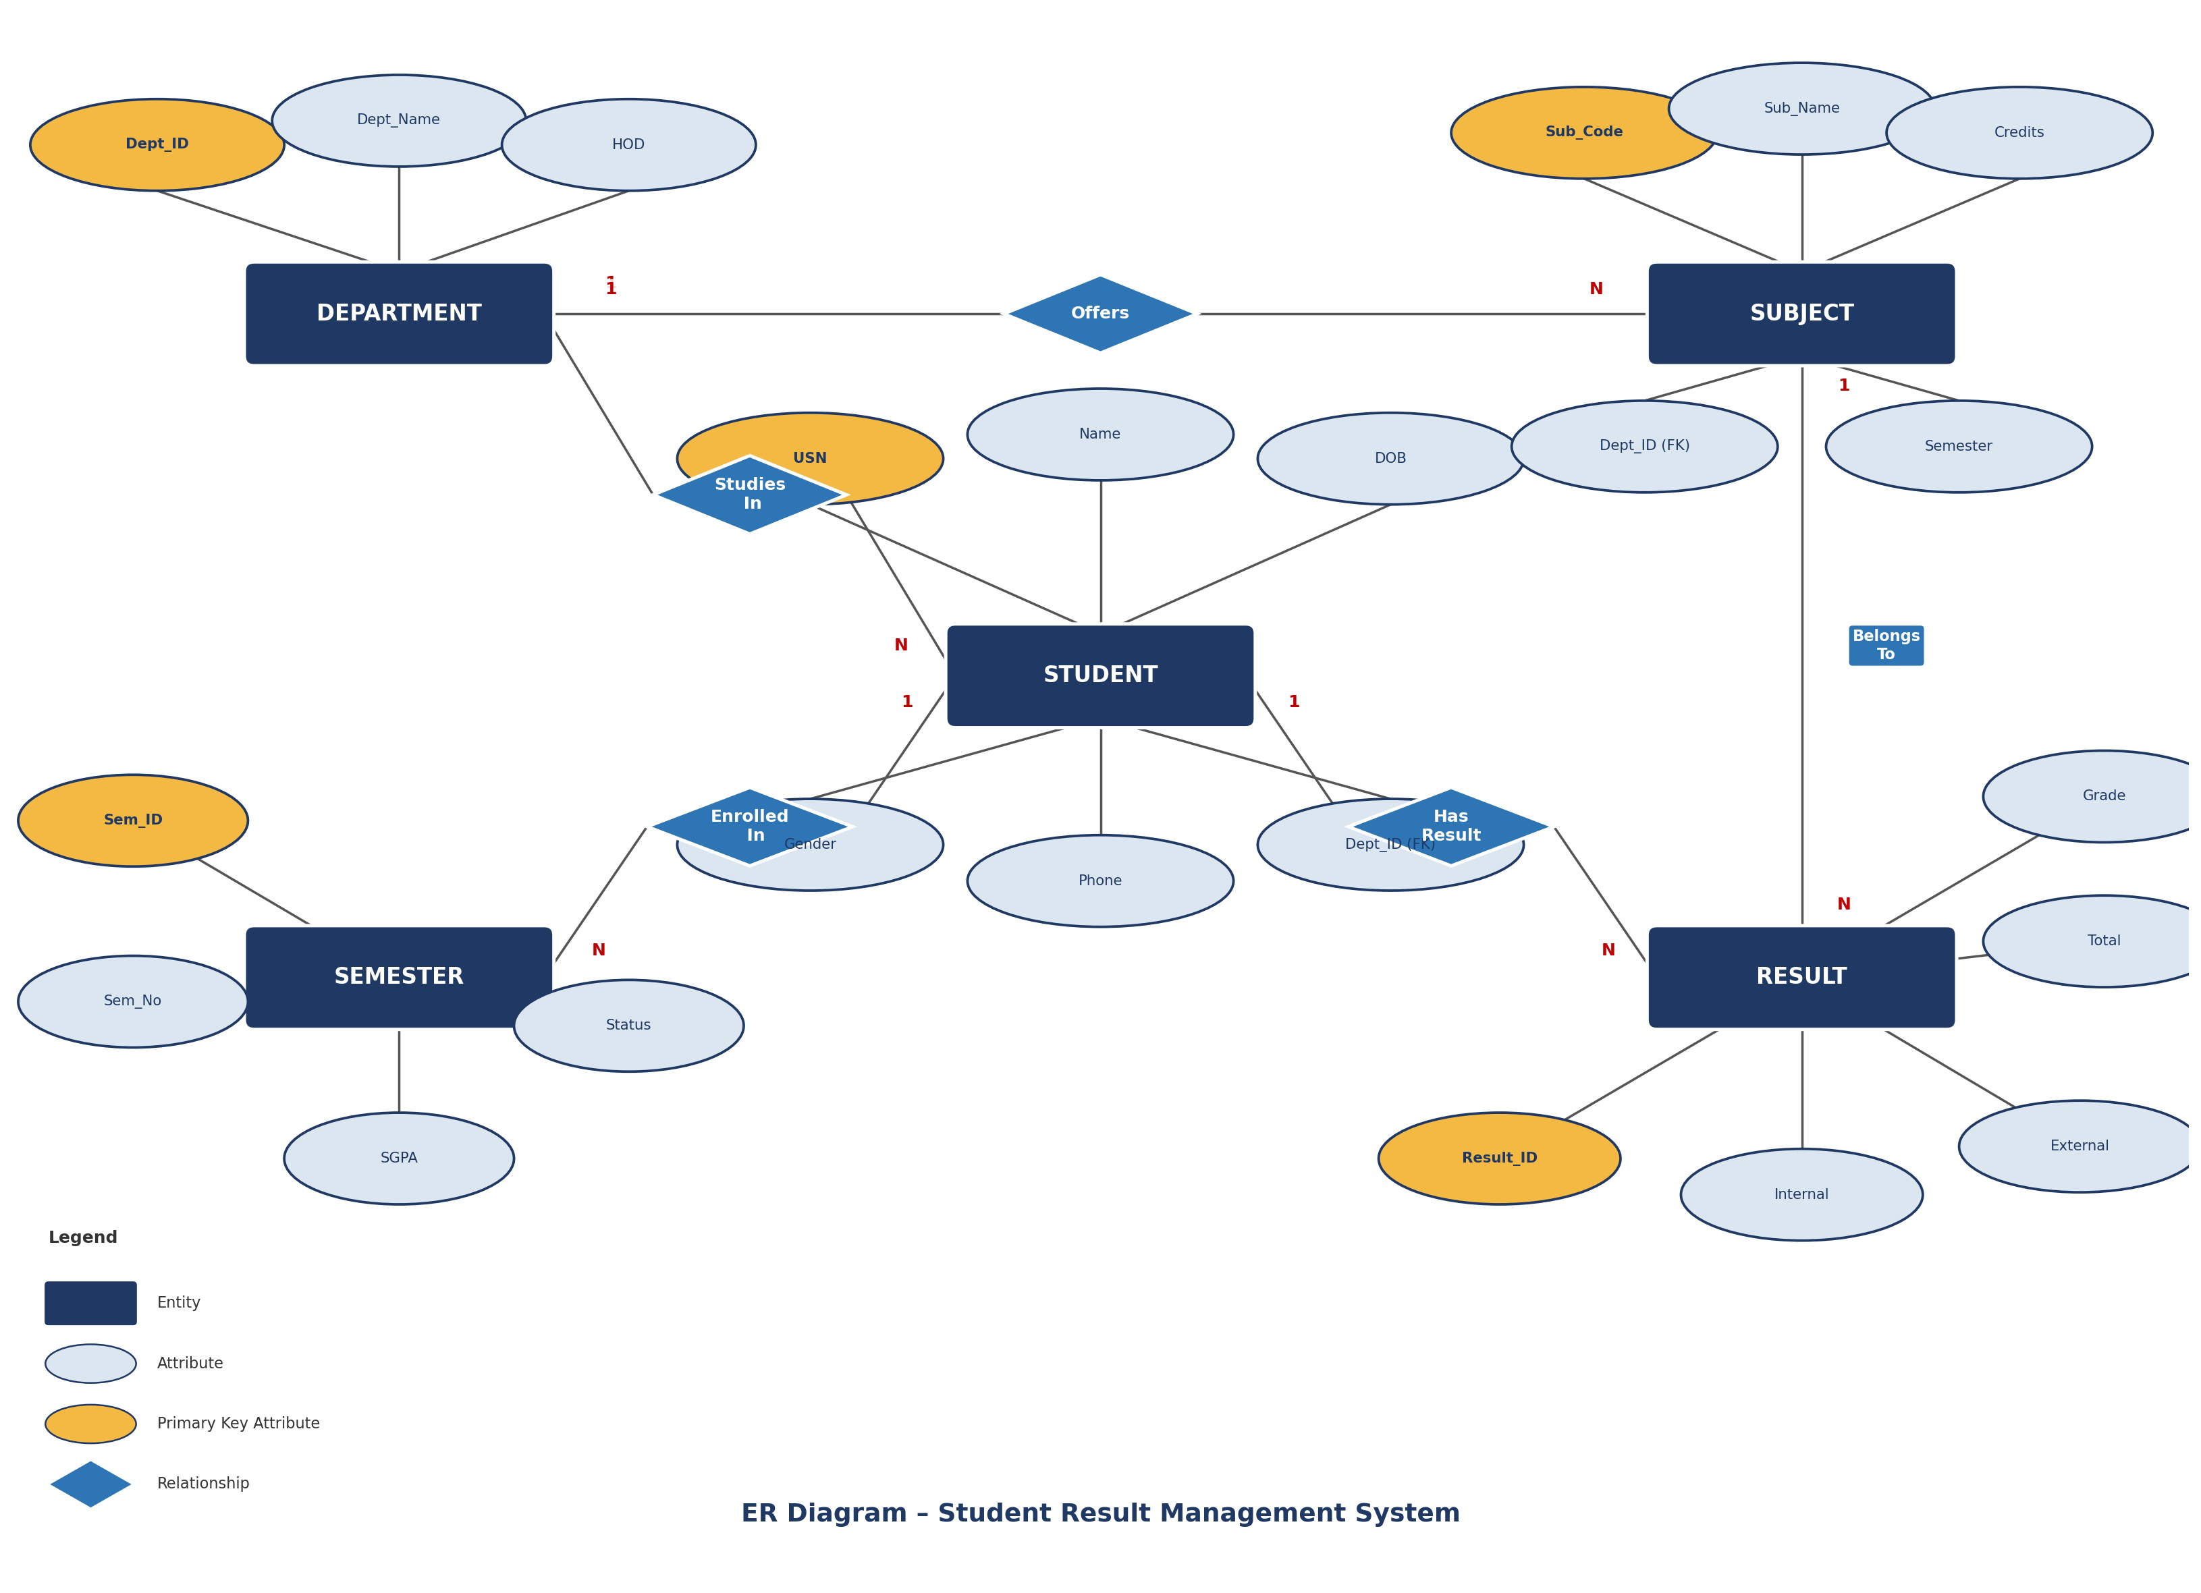

Figure 1: ER Diagram – Student Result Management System

5. Schema Design
5.1 DEPARTMENT Table
Attribute | Data Type | Constraint | Description
Dept_ID | VARCHAR(5) | PRIMARY KEY | Unique department code e.g. CS, EC
Dept_Name | VARCHAR(50) | NOT NULL | Full name of the department
HOD | VARCHAR(40) | NOT NULL | Name of Head of Department

5.2 STUDENT Table
Attribute | Data Type | Constraint | Description
USN | VARCHAR(10) | PRIMARY KEY | University Seat Number
Name | VARCHAR(50) | NOT NULL | Full name of student
DOB | DATE | NOT NULL | Date of birth
Gender | CHAR(1) | CHECK (M or F) | Gender of student
Phone | VARCHAR(10) | UNIQUE, NOT NULL | Mobile number
Dept_ID | VARCHAR(5) | FOREIGN KEY | References DEPARTMENT(Dept_ID)

5.3 SUBJECT Table
Attribute | Data Type | Constraint | Description
Sub_Code | VARCHAR(8) | PRIMARY KEY | Subject code e.g. BCS303
Sub_Name | VARCHAR(60) | NOT NULL | Full name of subject
Credits | INT | NOT NULL | Credit points assigned (1–4)
Dept_ID | VARCHAR(5) | FOREIGN KEY | References DEPARTMENT(Dept_ID)
Semester | INT | NOT NULL | Semester number (1–8)

5.4 RESULT Table
Attribute | Data Type | Constraint | Description
Result_ID | INT | PRIMARY KEY, AUTO_INCREMENT | Auto-generated unique ID
USN | VARCHAR(10) | FOREIGN KEY | References STUDENT(USN)
Sub_Code | VARCHAR(8) | FOREIGN KEY | References SUBJECT(Sub_Code)
Internal | INT | CHECK 0–50 | Internal assessment marks
External | INT | CHECK 0–100 | Semester end exam marks
Total | INT | — | Internal + External
Grade | VARCHAR(2) | NOT NULL | O / A+ / A / B+ / B / C / F

5.5 SEMESTER Table
Attribute | Data Type | Constraint | Description
Sem_ID | INT | PRIMARY KEY, AUTO_INCREMENT | Auto-generated ID
USN | VARCHAR(10) | FOREIGN KEY | References STUDENT(USN)
Sem_No | INT | NOT NULL | Semester number (1–8)
SGPA | DECIMAL(4,2) | NOT NULL | Semester Grade Point Average
Status | VARCHAR(10) | NOT NULL | PASS or FAIL

6. Normalization
Normalization is the process of organizing a relational database to reduce data redundancy and improve data integrity by dividing large tables into smaller related tables and defining relationships between them.

6.1 First Normal Form (1NF)
Rule: All column values must be atomic (indivisible). No repeating groups or arrays allowed.
Unnormalized Table (UNF):
USN | Name | Subjects & Marks
1VT22CS001 | Rakesh | DBMS:85, OOPs:90, CN:78
1VT22CS002 | Suresh | DBMS:70, OOPs:65

Problem: 'Subjects & Marks' column contains multiple values — not atomic.
After 1NF:
USN | Name | Subject | Marks
1VT22CS001 | Rakesh | DBMS | 85
1VT22CS001 | Rakesh | OOPs | 90
1VT22CS002 | Suresh | DBMS | 70

6.2 Second Normal Form (2NF)
Rule: Must be in 1NF. Every non-key attribute must be fully functionally dependent on the entire primary key (no partial dependencies).
Problem: In the 1NF table, composite key is (USN + Subject). 'Name' depends only on USN — this is a partial dependency.
After 2NF — Split into two tables:
Table | Primary Key | Attributes
STUDENT | USN | USN, Name, DOB, Gender, Phone, Dept_ID
RESULT | Result_ID | Result_ID, USN(FK), Sub_Code(FK), Marks, Grade

6.3 Third Normal Form (3NF)
Rule: Must be in 2NF. No transitive dependencies (non-key attribute must not depend on another non-key attribute).
Problem: If STUDENT contained Dept_Name and HOD, then USN → Dept_ID → Dept_Name → HOD. Here HOD transitively depends on USN through Dept_Name.
After 3NF — Extract DEPARTMENT table:
Table | Transitive Dep. Removed | Result
STUDENT | Dept_Name, HOD removed | Only Dept_ID (FK) kept in STUDENT
DEPARTMENT | New table created | Dept_ID → Dept_Name, HOD stored here

7. SQL Queries – DDL (Data Definition Language)
DDL commands are used to define and create the structure of the database tables.

7.1 CREATE TABLE Statements
-- Table 1: DEPARTMENT
CREATE TABLE DEPARTMENT (
Dept_ID VARCHAR(5) PRIMARY KEY,
Dept_Name VARCHAR(50) NOT NULL,
HOD VARCHAR(40) NOT NULL
);

-- Table 2: STUDENT
CREATE TABLE STUDENT (
USN VARCHAR(10) PRIMARY KEY,
Name VARCHAR(50) NOT NULL,
DOB DATE NOT NULL,
Gender CHAR(1) CHECK(Gender IN ('M','F')),
Phone VARCHAR(10) UNIQUE NOT NULL,
Dept_ID VARCHAR(5),
FOREIGN KEY (Dept_ID) REFERENCES DEPARTMENT(Dept_ID)
);

-- Table 3: SUBJECT
CREATE TABLE SUBJECT (
Sub_Code VARCHAR(8) PRIMARY KEY,
Sub_Name VARCHAR(60) NOT NULL,
Credits INT NOT NULL,
Dept_ID VARCHAR(5),
Semester INT NOT NULL,
FOREIGN KEY (Dept_ID) REFERENCES DEPARTMENT(Dept_ID)
);

-- Table 4: RESULT
CREATE TABLE RESULT (
Result_ID INT PRIMARY KEY AUTO_INCREMENT,
USN VARCHAR(10),
Sub_Code VARCHAR(8),
Internal INT CHECK(Internal BETWEEN 0 AND 50),
External INT CHECK(External BETWEEN 0 AND 100),
Total INT,
Grade VARCHAR(2) NOT NULL,
FOREIGN KEY (USN) REFERENCES STUDENT(USN),
FOREIGN KEY (Sub_Code) REFERENCES SUBJECT(Sub_Code)
);

-- Table 5: SEMESTER
CREATE TABLE SEMESTER (
Sem_ID INT PRIMARY KEY AUTO_INCREMENT,
USN VARCHAR(10),
Sem_No INT NOT NULL,
SGPA DECIMAL(4,2) NOT NULL,
Status VARCHAR(10) NOT NULL,
FOREIGN KEY (USN) REFERENCES STUDENT(USN)
);

8. SQL Queries – DML and SELECT
8.1 INSERT Statements
INSERT INTO DEPARTMENT VALUES
('CS','Computer Science','Dr. Sharma'),
('EC','Electronics','Dr. Rao'),
('ME','Mechanical Engg','Dr. Patil');

INSERT INTO STUDENT VALUES
('1VT22CS001','Rakesh Kumar','2004-05-10','M','9876543210','CS'),
('1VT22CS002','Suresh Patil','2004-08-22','M','9876543211','CS'),
('1VT22CS003','Anita Reddy', '2003-11-15','F','9876543212','CS'),
('1VT22EC001','Meena Singh', '2004-03-30','F','9876543213','EC');

INSERT INTO SUBJECT VALUES
('BCS301','Mathematics-3', 4,'CS',3),
('BCS302','Analog & Digital Elec',4,'CS',3),
('BCS303','DBMS', 4,'CS',3),
('BCS304','OOPs with C++', 4,'CS',3);

INSERT INTO RESULT(USN,Sub_Code,Internal,External,Total,Grade) VALUES
('1VT22CS001','BCS301',40,68,108,'A'),
('1VT22CS001','BCS302',38,72,110,'A+'),
('1VT22CS001','BCS303',45,80,125,'O'),
('1VT22CS001','BCS304',42,75,117,'O'),
('1VT22CS002','BCS301',30,55, 85,'B'),
('1VT22CS002','BCS302',28,40, 68,'C'),
('1VT22CS003','BCS301',48,90,138,'O'),
('1VT22CS003','BCS303',45,88,133,'O');

INSERT INTO SEMESTER(USN,Sem_No,SGPA,Status) VALUES
('1VT22CS001',3,8.75,'PASS'),
('1VT22CS002',3,6.20,'PASS'),
('1VT22CS003',3,9.50,'PASS');

8.2 SELECT Queries
Query 1 – All students with department name (INNER JOIN)
SELECT S.USN, S.Name, S.Gender, D.Dept_Name, S.Phone
FROM STUDENT S
JOIN DEPARTMENT D ON S.Dept_ID = D.Dept_ID;

Query 2 – Complete result of a specific student
SELECT S.Name, R.Sub_Code, SB.Sub_Name,
R.Internal, R.External, R.Total, R.Grade
FROM RESULT R
JOIN STUDENT S ON R.USN = S.USN
JOIN SUBJECT SB ON R.Sub_Code = SB.Sub_Code
WHERE R.USN = '1VT22CS001';

Query 3 – Count students per department (GROUP BY)
SELECT D.Dept_Name, COUNT(S.USN) AS Total_Students
FROM STUDENT S
JOIN DEPARTMENT D ON S.Dept_ID = D.Dept_ID
GROUP BY D.Dept_Name;

Query 4 – Subject-wise average marks (Aggregate Function)
SELECT SB.Sub_Name,
ROUND(AVG(R.Internal),2) AS Avg_Internal,
ROUND(AVG(R.External),2) AS Avg_External,
ROUND(AVG(R.Total),2) AS Avg_Total
FROM RESULT R
JOIN SUBJECT SB ON R.Sub_Code = SB.Sub_Code
GROUP BY SB.Sub_Name;

Query 5 – Students with SGPA above 8.0 (ORDER BY)
SELECT S.USN, S.Name, SE.Sem_No, SE.SGPA, SE.Status
FROM SEMESTER SE
JOIN STUDENT S ON SE.USN = S.USN
WHERE SE.SGPA > 8.0
ORDER BY SE.SGPA DESC;

Query 6 – Students who failed in any subject (Subquery)
SELECT USN, Name FROM STUDENT
WHERE USN IN (
SELECT USN FROM RESULT WHERE Grade = 'F'
);

Query 7 – Highest marks per subject (MAX + GROUP BY)
SELECT SB.Sub_Name, MAX(R.Total) AS Highest_Total
FROM RESULT R
JOIN SUBJECT SB ON R.Sub_Code = SB.Sub_Code
GROUP BY SB.Sub_Name;

Query 8 – CREATE VIEW for result summary
CREATE VIEW Result_Summary AS
SELECT S.USN, S.Name, D.Dept_Name,
R.Sub_Code, SB.Sub_Name,
R.Internal, R.External, R.Total, R.Grade
FROM STUDENT S
JOIN DEPARTMENT D ON S.Dept_ID = D.Dept_ID
JOIN RESULT R ON S.USN = R.USN
JOIN SUBJECT SB ON R.Sub_Code = SB.Sub_Code;

-- Use the view
SELECT * FROM Result_Summary WHERE USN = '1VT22CS001';

Query 9 – UPDATE and DELETE
-- Update phone number
UPDATE STUDENT SET Phone = '9999988888'
WHERE USN = '1VT22CS001';

-- Update marks after revaluation
UPDATE RESULT SET External = 60, Total = 88, Grade = 'A'
WHERE USN = '1VT22CS002' AND Sub_Code = 'BCS302';

-- Delete a result record
DELETE FROM RESULT
WHERE USN = '1VT22CS002' AND Sub_Code = 'BCS302';

9. Sample Output
9.1 Output – Query 1: All Students with Department
USN | Name | Gender | Dept_Name | Phone
1VT22CS001 | Rakesh Kumar | M | Computer Science | 9876543210
1VT22CS002 | Suresh Patil | M | Computer Science | 9876543211
1VT22CS003 | Anita Reddy | F | Computer Science | 9876543212
1VT22EC001 | Meena Singh | F | Electronics | 9876543213

9.2 Output – Query 2: Result of Student 1VT22CS001
Name | Sub_Code | Sub_Name | Internal | External | Total | Grade
Rakesh Kumar | BCS301 | Mathematics-3 | 40 | 68 | 108 | A
Rakesh Kumar | BCS302 | Analog & Digital | 38 | 72 | 110 | A+
Rakesh Kumar | BCS303 | DBMS | 45 | 80 | 125 | O
Rakesh Kumar | BCS304 | OOPs with C++ | 42 | 75 | 117 | O

9.3 Output – Query 4: Subject-wise Average Marks
Sub_Name | Avg Internal | Avg External | Avg Total
Mathematics-3 | 39.33 | 71.00 | 110.33
Analog & Digital | 33.00 | 56.00 | 89.00
DBMS | 45.00 | 84.00 | 129.00
OOPs with C++ | 42.00 | 75.00 | 117.00

9.4 Output – Query 5: Students with SGPA > 8.0
USN | Name | Sem_No | SGPA | Status
1VT22CS003 | Anita Reddy | 3 | 9.50 | PASS
1VT22CS001 | Rakesh Kumar | 3 | 8.75 | PASS

10. Advantages and Limitations
10.1 Advantages
• Eliminates manual paper-based record keeping and reduces errors
• Normalized design (3NF) ensures no data redundancy
• Foreign key constraints maintain referential integrity automatically
• SQL queries provide fast and accurate data retrieval
• VIEWs simplify complex queries for report generation
• Easy to update marks, grades, and student details
• Scalable — new departments, subjects, and semesters can be added easily

10.2 Limitations
• No graphical user interface (GUI) — currently command-line based
• CGPA calculation across multiple semesters not implemented
• No user authentication or role-based access control
• Backlog subject tracking not included in current version
• No automated grade calculation — grades must be entered manually

10.3 Future Enhancements
• Develop a web-based front-end using PHP or Python (Django/Flask)
• Add CGPA calculation using all semester SGPA values
• Implement login system for admin, faculty, and students
• Generate automated PDF result sheets
• Add backlog and arrear subject management module

11. Conclusion
The Student Result Management System successfully demonstrates the application of core Database Management System concepts in a practical, real-world scenario. The project covers all key aspects of DBMS including ER modeling, relational schema design, normalization up to Third Normal Form, and a comprehensive set of SQL queries.
Through this project, the following DBMS concepts were applied and understood:
• Entity-Relationship modeling with entities, attributes, and relationships
• Relational schema design with proper primary keys and foreign keys
• Data integrity enforcement through CHECK, UNIQUE, and NOT NULL constraints
• Normalization from UNF through 1NF, 2NF, and 3NF
• DDL commands — CREATE TABLE with all constraints
• DML commands — INSERT, UPDATE, DELETE for data manipulation
• SELECT queries with INNER JOIN, GROUP BY, HAVING, ORDER BY
• Aggregate functions — COUNT, AVG, MAX
• Subqueries and nested SELECT statements
• VIEW creation for simplified data access
This project provides a strong foundation for building larger academic management systems. With the addition of a front-end interface and additional modules, this can be deployed as a full college result management portal.

12. References
[1] Abraham Silberschatz, Henry F. Korth, S. Sudarshan, "Database System Concepts", 7th Edition, McGraw Hill, 2019.
[2] Ramez Elmasri, Shamkant B. Navathe, "Fundamentals of Database Systems", 7th Edition, Pearson Education, 2016.
[3] C.J. Date, "An Introduction to Database Systems", 8th Edition, Addison-Wesley, 2004.
[4] VTU Course Material – Database Management System (BCS403), Scheme 2022.
[5] MySQL 8.0 Reference Manual, Oracle Corporation. Available at: https://dev.mysql.com/doc/
[6] W3Schools SQL Tutorial. Available at: https://www.w3schools.com/sql/

— End of Report —

