
Predicting Movie Genre Popularity
from Popular Reviews

Prepared by

Name | ID
Rana Alharbi | 442202346
Aljawharah Alhowiedy | 443201015
Rana Albridi | 444201094
Mariam Al-Ahmed | 443204628
Haya Alibrahim | 444200657

Supervised by
Dr. Abeer Aldayel

Table of Contents

1 Introduction 4
1.1 Motivation Problem Definition 4
1.2 Task Definition 4
2 Related Works 5
3 Data 5
3.1 Dataset Source 5
3.2 Dataset Description 6
3.3 Dataset Characteristics and Summary Statistics 6
3.4 Representative Examples 7
3.5 Data Preprocessing 7
4 Methods 7
4.1 Models Used 7
4.2 Modeling Approach and Reasoning 8
4.3 Feature Engineering 8
5 Experiment 9
5.1 Training and Evaluation Process 9
5.2 Data Splitting and Preprocessing for Experimentation 9
5.3 Model Architecture or Structure 10
5.4 Hyperparameter Tuning and Optimization 10
5.5 Performance Evaluation Metrics 10
5.6 Computational Resources and Tools 12
6 Results and Discussion 12
7 Conclusion 15
7.1 Key findings 15
7.2 Challenges and limitations 15
7.3 Future directions 15
8 Contributions 16
9 References 17

Table of Tables

Table 1 Dataset Summary 6
Table 2 Average Performance Across Splits 11
Table 3 Student's Contributions 15

Table of Figures

Figure ‎1-1 Genre Rating Prediction Model 4
Figure ‎3-1 Examples from The Dataset. 7

Introduction

Motivation Problem Definition
The film industry continues to seek reliable techniques and methods to predict the success and popularity of movies and genres. Accurate predictions are important not only for studios and producers in making investment decisions, but also for streaming platforms and recommendation systems that rely on audience preferences. This project is significant because, in addition to traditional techniques, it makes an investment in the potential capabilities of popular user reviews to provide rapid and meaningful insights into audience reception, emphasizing the importance of audience feedback.
Our motivation is driven by the challenge of determining how much predictive power can be extracted from popular user reviews and identifying the optimal scale of reviews to achieve overall accurate predictions. We want to find the best review window for predicting genre popularity. By compiling these predictions over the years, we can understand which genres resonate most with audiences each year.

Task Definition
The intended task of this project is to apply supervised regression to predict a genre's final average rating. The prediction will be based on three key inputs:
- Input: popular user reviews as a textual input, genre, and release year.
- Output: predicted rating for a genre classified into 5 categories.
- Evaluation metrics: accuracy, precision, recall, F1-score.
Our goal is to highlight how audience feedback, when combined with genre and temporal data, can be a valid predictor of genre-level ratings, reveal yearly trends, and find key textual aspects when properly analyzed.
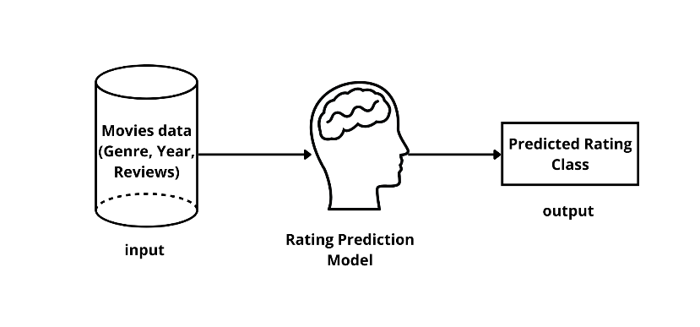
Figure ‎1-1 Genre Rating Prediction Model

Related Works
Movie genre popularity prediction in machine learning leverages algorithms to estimate audience preferences by analyzing popular user reviews, genre, and release year. Natural language processing (NLP) techniques are applied to textual reviews to extract sentiments, keywords, and patterns that influence ratings. By training models on historical data, these algorithms can predict average genre ratings, track popularity trends over time, and identify key textual features that affect audience reception.
Several studies have addressed similar objectives. Oyewola and Dada (2022) explored various supervised learning approaches, including regression and ensemble models, to predict movie popularity using metadata such as genre, cast, director, and release year [1]. Their results highlighted that combining multiple features improves prediction accuracy compared to models relying on single features. Zhang et al. (2019) analyzed early audience reviews on social platforms to forecast box-office success, applying NLP techniques to extract sentiment and thematic patterns, and demonstrated that early reviews can strongly indicate a movie’s final rating [2].
Guo et al. (2021) emphasized the value of integrating temporal features, such as release timing and initial audience engagement, with metadata to forecast popularity trends, showing the benefit of combining quantitative and qualitative signals [3]. Similarly, Poria et al. (2017) applied deep learning for multimodal prediction by fusing textual reviews, trailers, and social media metrics, achieving improved predictive performance, especially when review data is limited [6]. Gupta et al. (2025) conducted genre-specific analyses using Multi-Layer Perceptron (MLP) models, finding that predictive accuracy varies across genres, with adventure films being more predictable than action films [7].
Collectively, these studies demonstrate that combining user reviews, metadata, genre, and temporal information with advanced machine learning techniques can provide reliable predictions of movie popularity, aligning closely with our project’s goal of modeling genre-level ratings and identifying key audience-driven trends.

Data

Dataset Source
The Dataset used in this project is the Letterboxd All Movie Data dataset, which is available on Hugging Face [5]. Letterboxd is a social platform where users rate and share their reviews about movies. The dataset provides detailed metadata for films along with the 10 most popular user reviews for each movie. We selected this dataset specifically since it supports our research goal of predicting genre popularity trends using audience feedback

Dataset Description
With over 800,000 movies, this dataset provides huge and diverse data, improving the reliability of training machine learning models across different genres, time periods, and audience demographics.
The inclusion of both structured metadata (e.g., genres, release year) and unstructured text (reviews) allows us to capture both statistical patterns and audience sentiment, which is crucial for understanding long-term genre trends.
This makes it highly suitable for analyzing how genres evolve in popularity over time and what factors contribute to audience preferences. By using these insights, we have the ability to forecast future trends in the film industry.

Dataset Characteristics and Summary Statistics
There are 847,209 examples in the dataset with 9 features (not including the target rating). The rating target column was initially filled with text values such as "4.62 out of 5." Text was eliminated from this column and replaced with numerical values for analysis.
Summary Statistics:
Table 1 Dataset Summary
 | Value
  Statistic
Number of examples | 847,209
Number of features | 9
Number of classes | 358
Minimum rating | 0.86
Maximum rating | 4.72
Mean rating | 3.25
Std rating | 0.43

Note: The fact that there are 358 unique classes suggests that there are a lot of different rating values. With a standard deviation of 0.43, ratings range from 0.86 to 4.72, with an average of 3.25.

Representative Examples
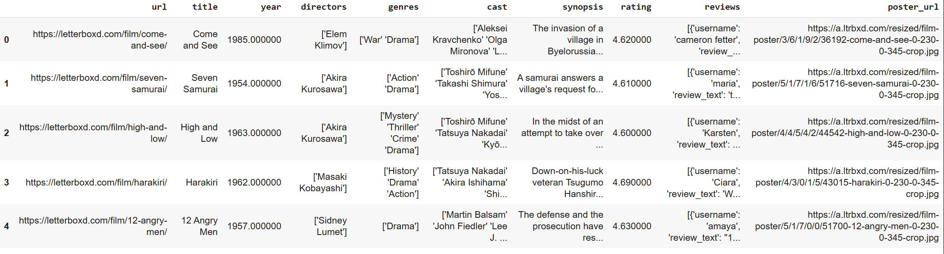
Figure ‎3-1 Examples from The Dataset.

Data Preprocessing
The data preparation involved several steps: initially, dropping missing values, and movies released before the year 2000. Converting the Year column into a numeric data type, and the Rating column was cleaned by converting it from "4.61 out of 5" to a float. For the Genre column, we extracted the first genre only, removed genres with a low number of reviews, and performed one-hot encoding. We then computed the Genre average rating and categorized the Rating into 5 classes. Finally, we cleaned the raw text and performed TF-IDF.

Methods

Models Used
We relied on three supervised learning approaches to predict genre-level rating categories: Logistic Regression, a Multi-Layer Perceptron (Neural Network), and an RNN-based LSTM model. Each model targets the same 5-class rating category output .
Logistic Regression: This was our primary linear baseline. It deals well with high-dimensional TF-IDF vectors, especially with class balancing and large sample sizes. Using lbfgs with class_weight='balanced' allowed it to handle skew in rating categories while remaining computationally efficient.
Neural Network: We included a Multi-Layer Perceptron (MLP) model to capture relationships that are too complex for linear models. The MLP uses two hidden layers with 64 and 32 units. This structure is intentionally small to avoid overfitting while still being expressive enough to learn meaningful patterns from the TF-IDF features, sentiment score, genre encoding, and year. We used the ReLU activation function because it is computationally efficient and helps the model learn non-linear patterns effectively. Early stopping was enabled to prevent the model from overfitting by stopping training once the validation performance stopped improving.

RNN : Since reviews are sequential text, we built an LSTM model to test whether sequence-aware modeling improves predictions. After tokenization and padding, an embedding layer and a single LSTM layer learned contextual patterns from review wording. This model is more expressive but also more computationally expensive, so we constrained vocab size and sequence length to keep training practical.
These models cover the spectrum from simple linear baselines → non-linear feed-forward → sequence-aware deep learning, giving us a realistic performance comparison.

Modeling Approach and Reasoning
The goal of the project is to predict genre popularity by classifying each review into one of five rating categories using textual and metadata features. We needed methods that can:
- Scale to tens of thousands of samples.
- Handle sparse TF-IDF representations.
- Leverage textual patterns and sentiment.
- Capture non-linear relationships between review text and genre outcomes.
Why Logistic Regression?
High-dimensional sparse text is what this algorithm was designed for. It’s fast, interpretable, and serves as a strong linear baseline. If LR can’t perform well, the issue is usually the features, not the model.
Why MLP?
Once we start mixing sparse text vectors with numeric metadata (year, sentiment) and categorical features (genre), the relationships become non-linear. An MLP can capture these interactions without the cost of sequence models.
Why LSTM?
TF-IDF destroys word order. We needed at least one model that preserves sequential information to check whether phrasing, sarcasm, or multi-token expressions in reviews actually help predict genre popularity. Even if the LSTM doesn’t outperform LR, it tells us whether sequence-level semantics add predictive value.
This set of models gives us breadth (linear vs non-linear), depth (dense vs sequence), and a way to evaluate what actually matters in review-driven genre prediction.

Feature Engineering
Feature engineering was central to the entire pipeline because the dataset mixes structured metadata with unstructured user reviews. Key steps:
Text Cleaning: We removed punctuation, lower-cased the text, removed stopwords, and lemmatized tokens. This straightens out noisy user-generated text and helps TF-IDF generalization .
Review Expansion: Each movie contains a list of popular reviews. We expanded them into individual rows while preserving the same genre, year, and rating metadata. This increased the dataset size and improved training robustness — the models learn from individual opinions, not aggregated ones.
Sentiment Extraction: Using VADER, we computed a sentiment score (compound polarity). This gave the models a compact numerical signal summarizing emotional tone, which complements sparse lexical features.
Genre Consolidation: Movies may belong to multiple genres. We only kept the leading genre for consistency, then removed underrepresented genres (<5000 reviews). This prevents the models from learning unstable patterns from tiny classes.
Rating Category Construction: We transformed continuous ratings into five percentile-based bands to get balanced classes. This avoids regression’s sensitivity to noise and converts the task into a balanced multi-class classification problem.

Experiment

Training and Evaluation Process
The experiment aimed to predict movie genre popularity ratings using the Letterboxd All Movie Data dataset containing over 800,000 movies. A balanced subset of 20,000 reviews was sampled for computational efficiency. The data was split into 40%, 60%, and 80% training windows to evaluate the impact of training data size on model performance. Each window used an 80/20 train-test split with stratification to maintain consistent class distributions across five rating categories. All models were trained under identical conditions and evaluated using Accuracy, F1-Macro, and F1-Weighted metrics for fair comparison.

Data Splitting and Preprocessing for Experimentation
The preprocessing pipeline included:
- Cleaning and tokenizing the review text
- Extracting sentiment
- Normalizing numerical fields like release year
- One-hot encoding genres
- Encoding popularity into five balanced categories
For the RNN model, text was converted into padded sequences of 100 tokens using a vocabulary of 10,000 words. The same preprocessing was applied across all window sizes for consistency.

Model Architecture or Structure
Four models were tested:
- Logistic Regression: trained on engineered features with balanced class weights and L2 regularization. Served as a strong classical baseline.
- Neural Network (MLP): two dense layers (64 → 32) with softmax output, early stopping, and adaptive learning rate. Trained on the same feature set as Logistic Regression.
- RNN (LSTM): used raw text sequences (100 tokens), processed through an embedding layer and an LSTM with 32 units, followed by dropout and softmax. Captured contextual patterns in text and typically performed best.
- Baseline Model: a naïve classifier (DummyClassifier with strategy='most_frequent') that always predicts the most frequent class, used for reference

Hyperparameter Tuning and Optimization
TF-IDF optimization tested multiple n-gram ranges [(1,1), (1,2), (1,3)] and vocabulary sizes [5,000, 10,000, 20,000], with final selection of n-grams=(1,3) and max_features=20,000. Each model was tested on three windows: 40% (6,400 train / 1,600 test), 60% (9,600 train / 2,400 test), and 80% (12,800 train / 3,200 test). Logistic Regression used C=1.0 regularization with automatic class balancing. Neural Network employed adaptive learning rate (0.001), early stopping with 0.2 validation split, and alpha=0.001. RNN used reduced architecture (32 LSTM units, 100 token sequences, 64 embedding dimensions) with only 3 epochs and larger batch size (128) for computational efficiency. Final performance was summarized using average metrics across all splits.
A simple manual search strategy was used for hyperparameter tuning. Each model was tested with a small set of candidate values, and the best configuration was selected based on validation performance. Due to computational limitations, full grid search or randomized search was not applied.

Performance Evaluation Metrics
To evaluate the performance of the sentiment classification models, we used a set of well-established metrics Accuracy, F1-Macro, and F1-Weighted. These metrics provide different perspectives on how effectively the models distinguish between the five sentiment levels. The models included in the comparison were Logistic Regression, Neural Network, RNN (LSTM), and a baseline model (Most Frequent Class).

•Accuracy:
Accuracy represents the proportion of correct predictions out of the total number of samples. Across all splits, the Neural Network achieved the highest accuracy for most splits (0.8063–0.8079), followed closely by Logistic Regression (0.7934–0.8025). The RNN model performed significantly worse (0.3767–0.3878), while the baseline model remained very low (≈0.242–0.246), confirming the advantage of supervised learning over naive predictions.
• F1-Score (Macro & Weighted):
The F1-score combines precision and recall into a single metric, providing a balanced measure of model performance. Macro F1 averages all classes equally, while weighted F1 accounts for class frequency.
Logistic Regression achieved consistent performance across splits:
  - 40% split: F1-Macro = 0.7712, F1-Weighted = 0.7951
  - 60% split: F1-Macro = 0.7730, F1-Weighted = 0.7952
  - 80% split: F1-Macro = 0.7713, F1-Weighted = 0.7889
Neural Network slightly outperformed Logistic Regression in accuracy but had comparable F1-scores:
  - 40% split: F1-Macro = 0.7686, F1-Weighted = 0.7929
  - 60% split: F1-Macro = 0.7684, F1-Weighted = 0.7943
  - 80% split: F1-Macro = 0.7706, F1-Weighted = 0.7920
RNN (LSTM) showed weak performance across all splits:
  - 40% split: F1-Macro = 0.3387, F1-Weighted = 0.3582
  - 60% split: F1-Macro = 0.3456, F1-Weighted = 0.3650
  - 80% split: F1-Macro = 0.3543, F1-Weighted = 0.3719
Baseline (Most Frequent) achieved very low scores, as expected:
  - 40% split: F1-Macro = 0.0779, F1-Weighted = 0.0942
  - 60% split: F1-Macro = 0.0788, F1-Weighted = 0.0967
  - 80% split: F1-Macro = 0.0789, F1-Weighted = 0.0969
This table presents a complete comparison of all models using accuracy, macro-averaged metrics, and weighted metrics, highlighting the superior performance of the RNN and Neural Network models over the baseline classifiers.
Table 2 Average Performance Across Splits
Model | Accuracy | F1-Macro | F1-Weighted
Logistic Regression | 0.7991 | 0.7718 | 0.7931
Neural Network | 0.8067 | 0.7692 | 0.7931
RNN (LSTM) | 0.3826 | 0.3462 | 0.3650
Baseline (Most Frequent) | 0.2443 | 0.0785 | 0.0959

Computational Resources and Tools
The experiments were conducted using Google Colab, providing a reliable cloud-based environment capable of supporting both classical machine learning and deep learning models. The typical hardware configuration included a 2-core Intel Xeon CPU, 12 GB of RAM, an optional NVIDIA Tesla T4 GPU, and Google Drive for storage. Essential Python libraries were used for model development and evaluation, including TensorFlow/Keras for neural networks and RNNs, scikit-learn for preprocessing and classical ML models, Pandas and NumPy for data manipulation, and Matplotlib and Seaborn for visualization. This setup was sufficient for training multiple models on large datasets and efficiently generating evaluation metrics.

Results and Discussion
This section presents the results of the machine learning models developed to classify video popularity into five balanced categories. The evaluation includes quantitative metrics supported by confusion matrices and ROC curves to assess the predictive performance of each model and examine how well they generalize to unseen data.
Logistic regression, a Neural Network, a Baseline classifier, and an RNN model that integrates sequential text representations were the four models that were trained and evaluated. Table 2 presents the overall performance metrics for all models using their respective final evaluation settings.
Based on the metrics presented in Table 2, Logistic Regression achieved the strongest overall performance, followed closely by the Neural Network. The RNN showed noticeably weaker performance, while the Baseline classifier performed significantly worse, reinforcing the need for meaningful feature representations when predicting genre popularity.
The results indicate that the models were able to generalize well to new, unseen data, with clear differences in performance across approaches. Logistic Regression and the Neural Network achieved stable and reliable accuracy across different training splits, while the RNN showed noticeably weaker performance despite early stopping and balanced training.

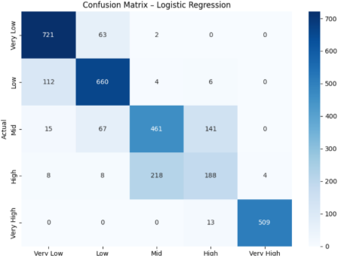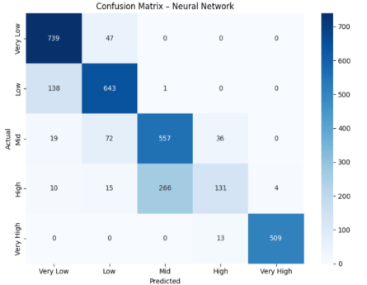
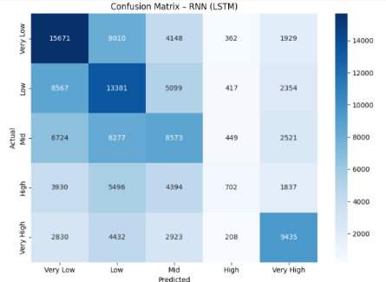

The confusion matrices show that both Logistic Regression and the Neural Network correctly classify a large portion of the samples, particularly within the Very Low, Low, Mid, and Very High classes. The Neural Network demonstrates clearer separation between classes and fewer misclassifications compared to Logistic Regression, especially in the Mid and High categories.
In contrast, the RNN displays substantial confusion across all classes, indicating difficulty in learning meaningful boundaries from the sequential text representations. Errors across all models mainly occur between adjacent popularity levels such as Low vs Mid or Mid vs High reflecting the continuous nature of the popularity scale.
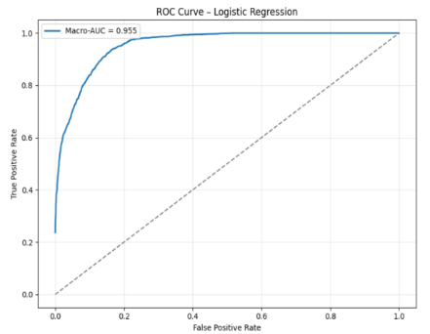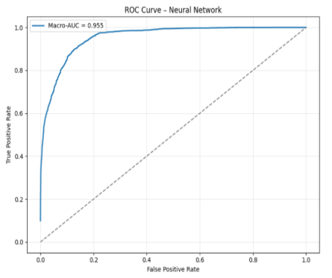
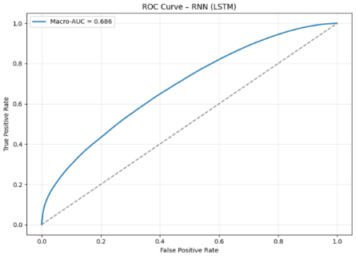

The ROC curves further highlight the differences between the models. Logistic Regression and the Neural Network achieve high macro-AUC scores (≈ 0.95), reflecting strong discriminative ability across all five classes. Although the Neural Network shows a slightly higher AUC, the difference is minor and does not indicate better overall performance. The RNN, however, yields a substantially lower macro-AUC score (≈ 0.68), showing only moderate separation between classes and reinforcing the limitations observed in its confusion matrix.

As a result, Logistic Regression delivered the best and most consistent overall performance, showing strong class separation, high accuracy, and excellent AUC scores. The Neural Network also performed competitively, benefiting from TF-IDF features and achieving comparable results. In contrast, the RNN showed weaker performance, with considerable class overlap and lower AUC values. These findings confirm that the TF-IDF features capture meaningful patterns, with Logistic Regression emerging as the most reliable and accurate model in this study.

Conclusion
After completing the project, we successfully implemented a machine learning model to predict the popularity of movie genres. This model utilizes a combination of user reviews, VEDAR sentiment, release year, and genres. Throughout our implementation, several conclusions were reached:

Key findings
- Categorizing the rating into five distinct categories made implementation easier and helped clarify the results.
- Performance did not consistently improve with an increase in window size, indicating that models can reach a point where adding more training data may degrade performance.
- The results indicate that combining TF-IDF, sentiment analysis, and genre significantly enhances predictive power for capturing genre popularity.

Challenges and limitations
- The Large dataset resulted in extended computation times, making down sampling a necessity.
- Genres with a low number of ratings caused high performance, leading to overfitting, which indicates the elimination of these genres.
- Restricting the movie to its first genre may lead to misinformation and a narrow understanding of its overall theme.

Future directions
- Utilizing multiple genres for each movie leads to more accurate predictions and a deeper understanding of audience preferences.
- Adding additional features to the prediction model can improve its overall comprehensiveness.
- Experimenting with various sentiment analysis models to help determine which one performs the best.

Contributions
Table 3 Student's Contributions
Student Name | Role
Rana Alharbi | Introduction: Explaining the problem and why it is important, writing our motivation for pursuing this problem, formulating the task, and stating the input and output.  Conclusion: summarizing key findings, challenges, and future direction for the project.
Haya Alibrahim | Dataset: provide a descriptive overview of the dataset by reporting key statistics (e.g., number of examples, features, and classes) in table format, and by presenting representative examples through visualizations for better understanding.
Aljawharah Alhowidey | Experiment Overview: Explaining the training and evaluation process, describing how the dataset was split and preprocessed, detailing the model architecture, and outlining the hyperparameter tuning strategies applied.
Rana Albridi | Dataset: Describe the dataset used, including the source of the dataset, explaining why we used this specific dataset to address our problem.
Mariam Al-Ahmed | Background: Provide a brief summary of related works.  experiments: provided an overview of the performance evaluation metrics and the computational resources and tools used.

References

[1] D. O. Oyewola and E. G. Dada. "Machine Learning Methods for Predicting the Popularity of Movies," Journal of Artificial Intelligence and Systems, vol.4, pp. 65–82, 2022. https://doi.org/10.33969/AIS.2022040105
[2] Y. Zhang, L. Chen, and H. Li, "Early Audience Reviews for Box-Office Prediction Using Sentiment Analysis," Information Processing & Management, vol. 56, no. 3, pp. 1021–1035, 2019.
[3] X. Guo, M. Li, and J. Wang, "Temporal Feature Based Movie Popularity Prediction," Knowledge-Based Systems, vol. 216, 106738, 2021.
[4] S. Poria, E. Cambria, and A. Gelbukh, "Deep Learning for Multimodal Movie Success Prediction," Neurocomputing, vol. 267, pp. 665–674, 2017.
[5] Hugging Face, Letterboxd All Movie Data Dataset. Available: https://huggingface.co/datasets/pkchwy/letterboxd-all-movie-data
[6] Poria, S., Cambria, E., Hazarika, D., Majumder, N., Zadeh, A., & Morency, L. P. (2017). A deeper look into multimodal sentiment analysis. Proceedings of the 55th Annual Meeting of the Association for Computational Linguistics, 474–483. https://doi.org/10.18653/v1/P17-1044
[7] Gupta, A., Adhikari, R., Varshney, S., & Choudhury, S. (2025). Genre-specific movie popularity prediction using multilayer perceptron models. Journal of Computer Science, 21(7), 905–917. https://thescipub.com/abstract/jcssp.2025.905.917
[8] P. Sujanmulk, “Sentiment Analysis on Amazon Reviews using TF-IDF Approach.,” Analytics Vidhya, Feb. 08, 2021. https://medium.com/analytics-vidhya/sentiment-analysis-on-amazon-reviews-using-tf-idf-approach-c5ab4c36e7a1

