Configure and Launch a simple Linux EC2 instance

Select ec2 service: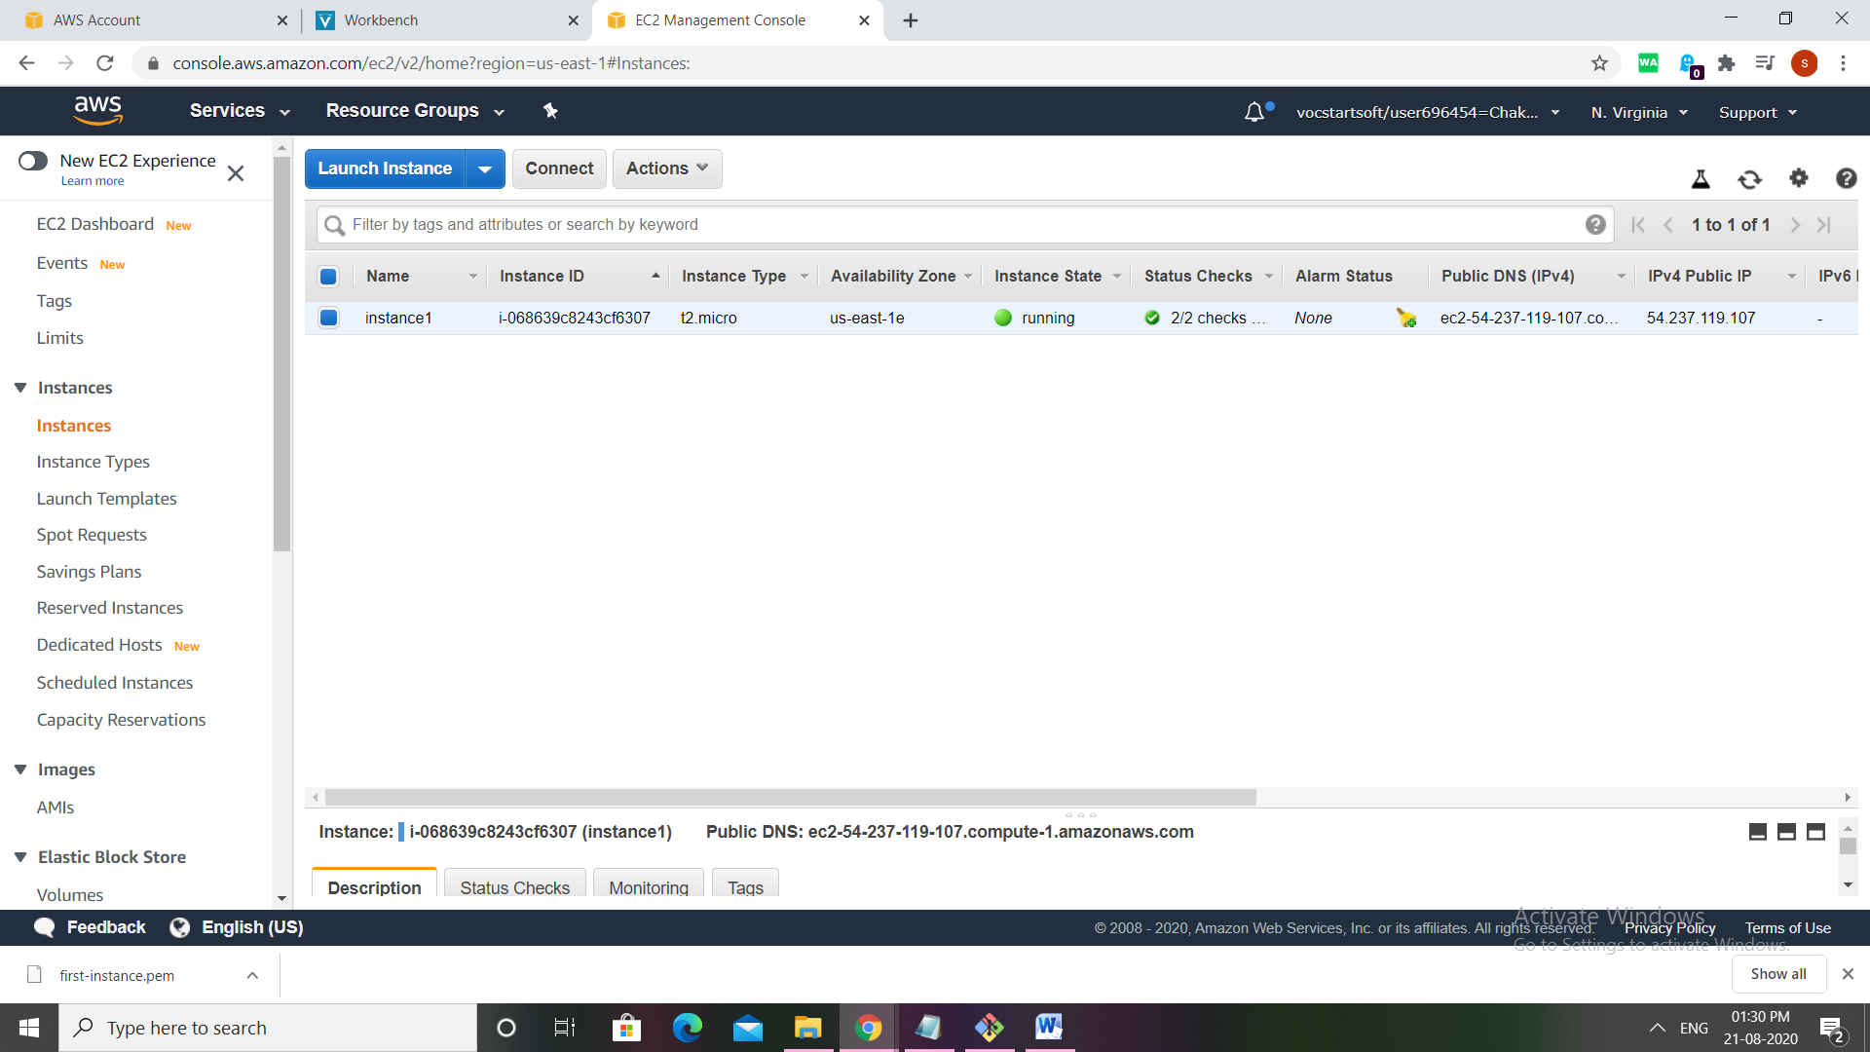

Click on launch instance, 7 steps to create instance

Choose Amazon Linux AMI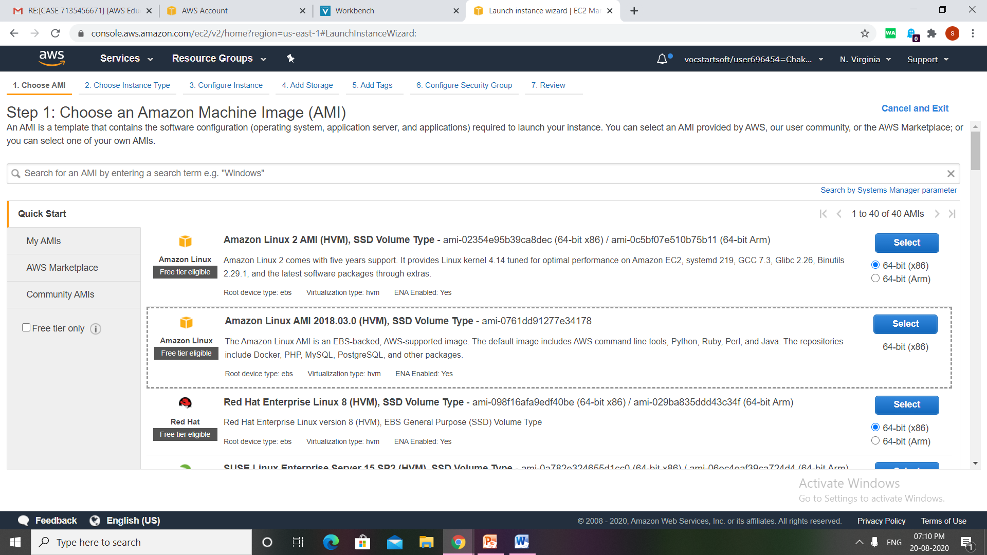

Choose instance type as

. general purpose t2.micro

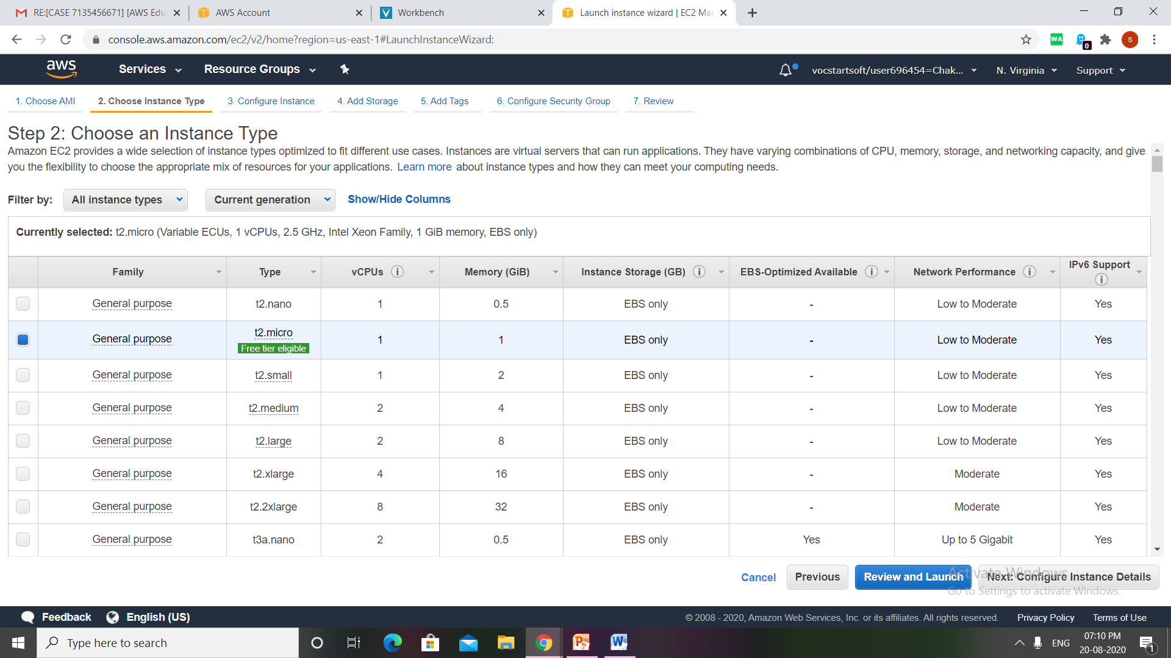

Configure instance details keep it as same (default)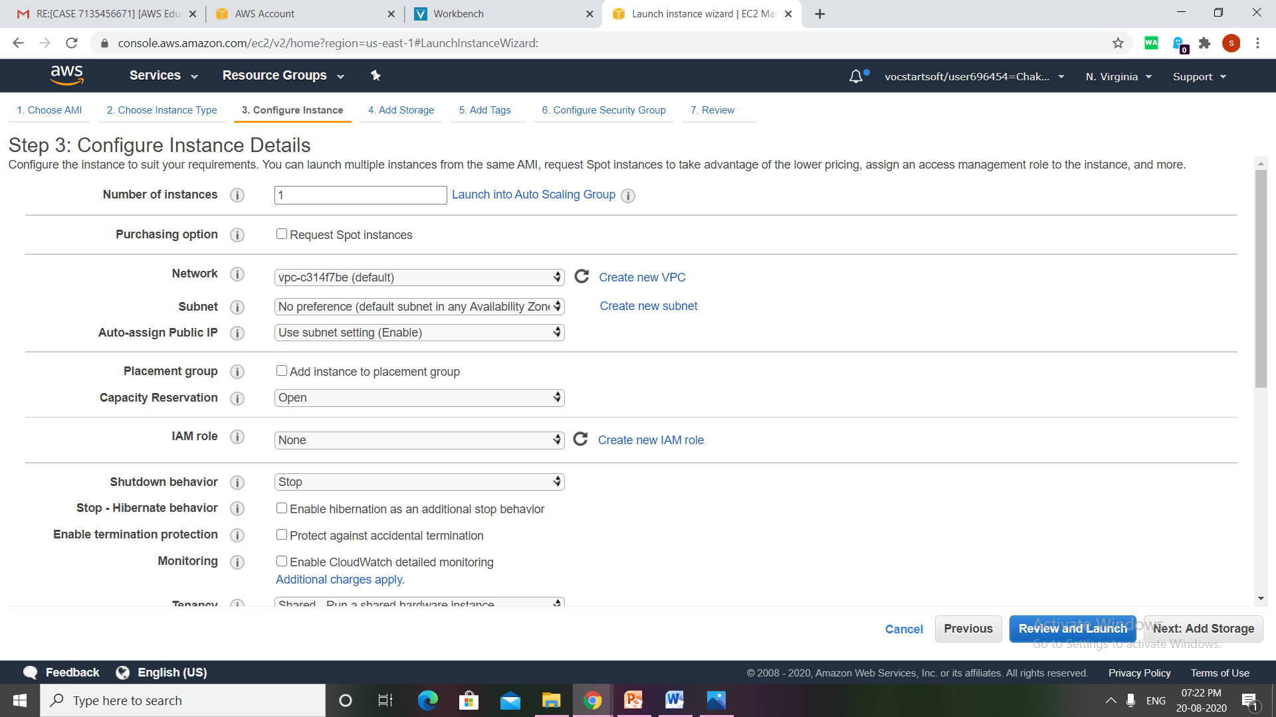

Add storage keep it as default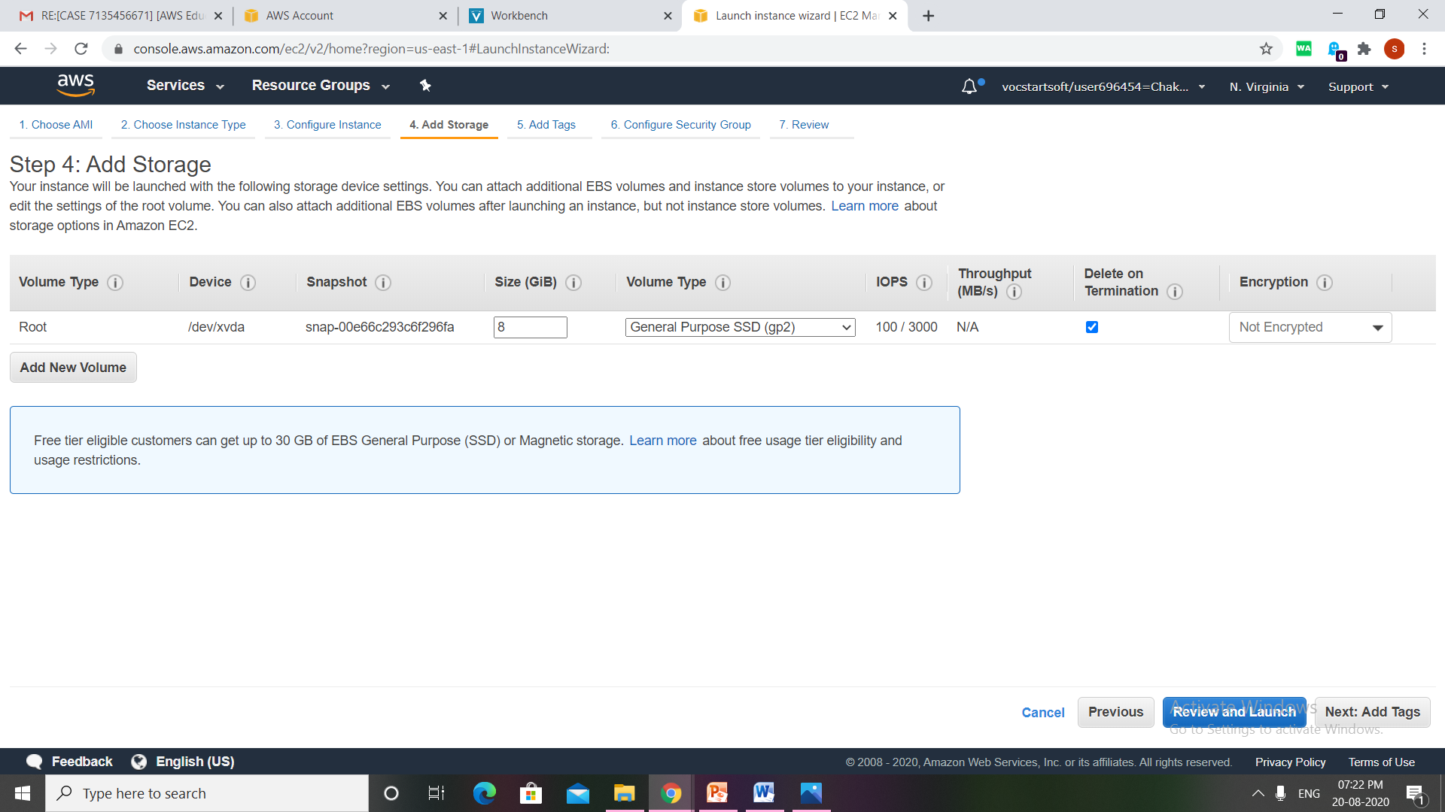

Configure security groups ,click on select existing security groups in which I selected only ssh ,http,https ports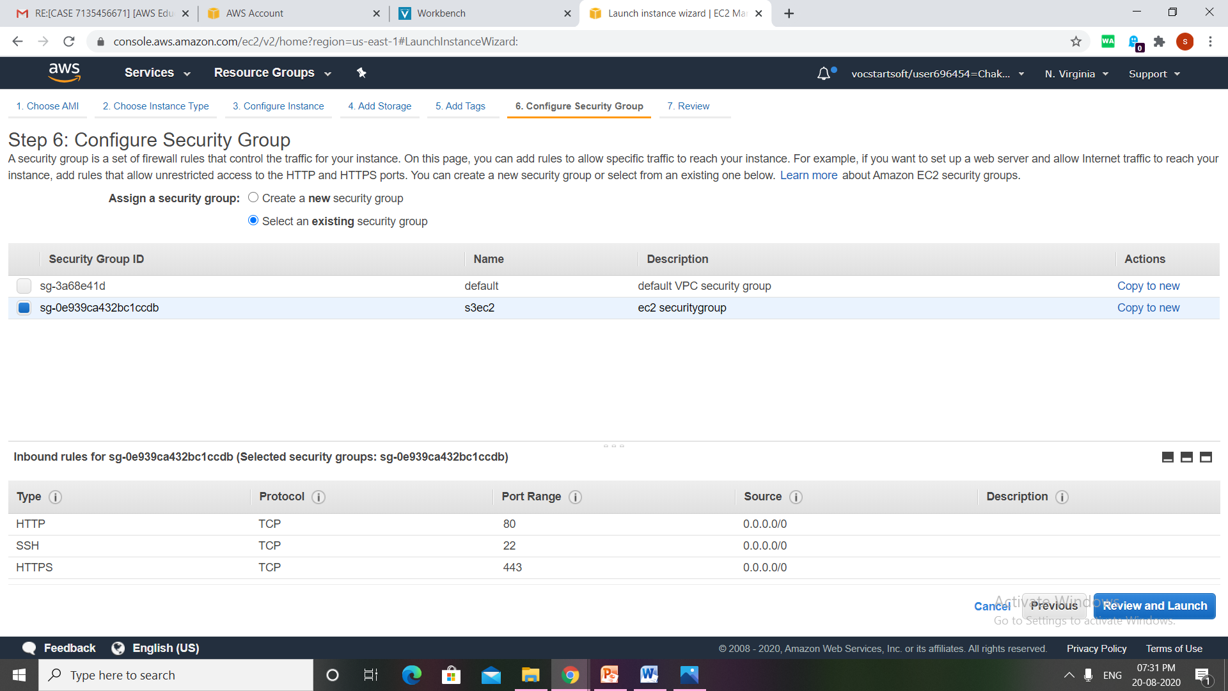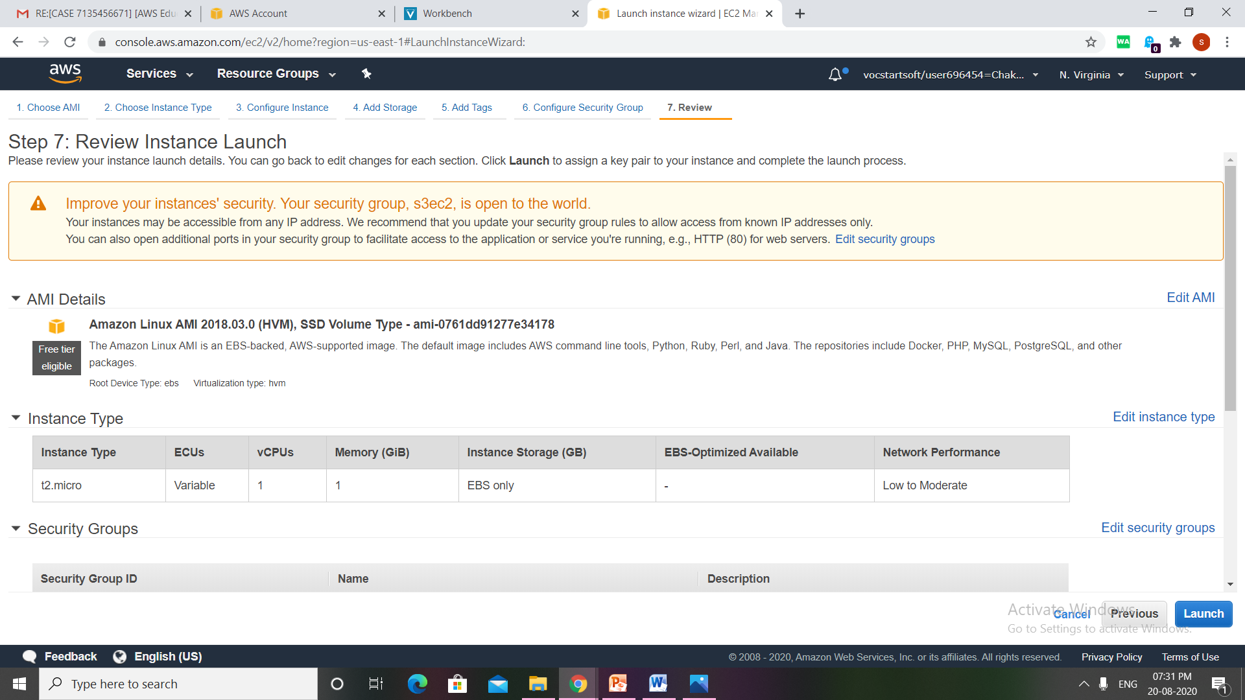next review instance 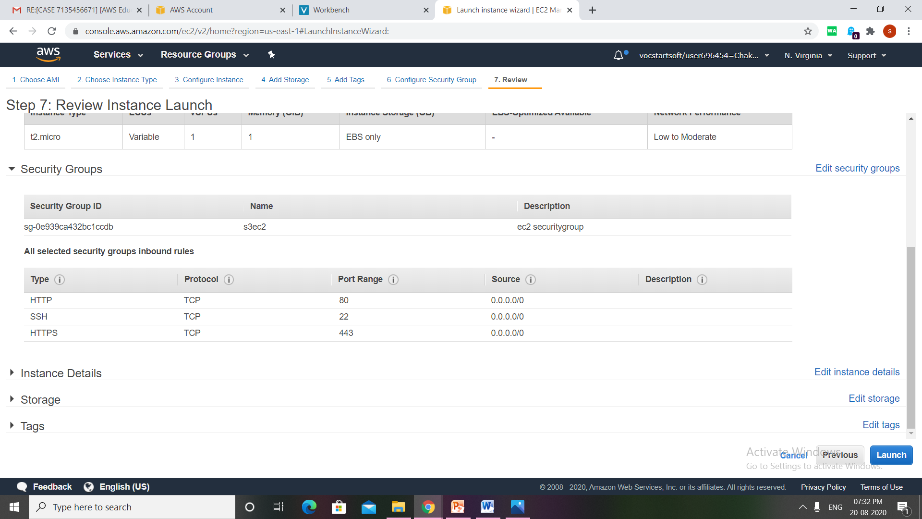

Now click on view instance ,so that we will return to the instance page

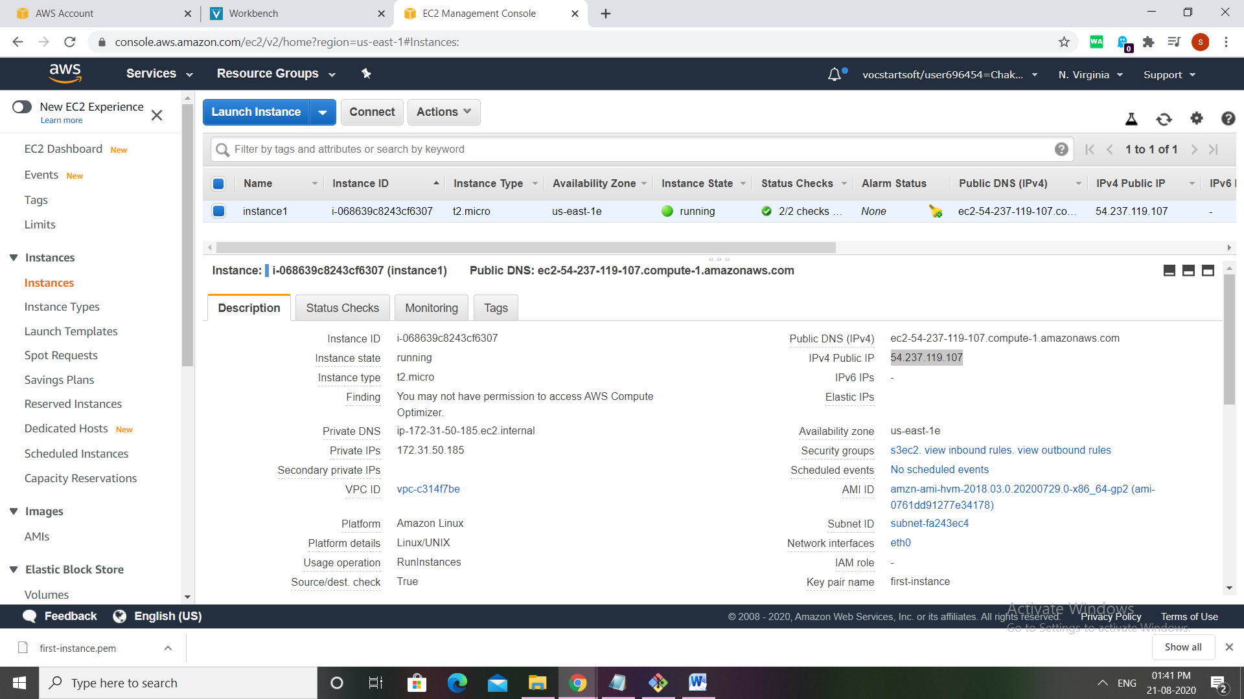

Now to run this we use git bash, install git in pc. Open git bash type :

1)ssh -i {key location} ec2-user@{public dns}

eg: ssh -i ~/downloads/jalaj.pem [ec2-user@ec2-34-205-77-249.compute-1.amazonaws.com](mailto:ec2-user@ec2-34-205-77-249.compute-1.amazonaws.com)

3)sudo su

4)yum install httpd –y

5) service httpd status

6)service httpd start

7) service httpd status

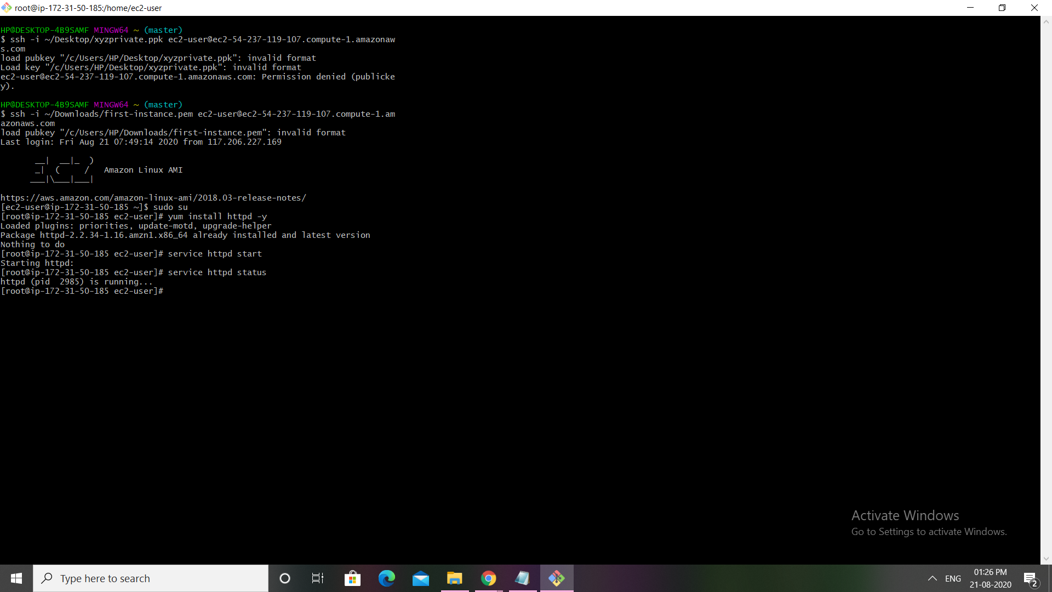

Now open the browser and then we copy the IPv4 Public IP,then we can find this output: