**BEEE LAB EVALUATION**

**Exp. 2**8

**. Design a system for car stereo systems such that whenever the increase volume button is pressed, a Green Light is emitted for 20 ms & whenever the decrease volume button is pressed, a Red Light is emitted for 40 ms.**

**Circuit Diagram:**

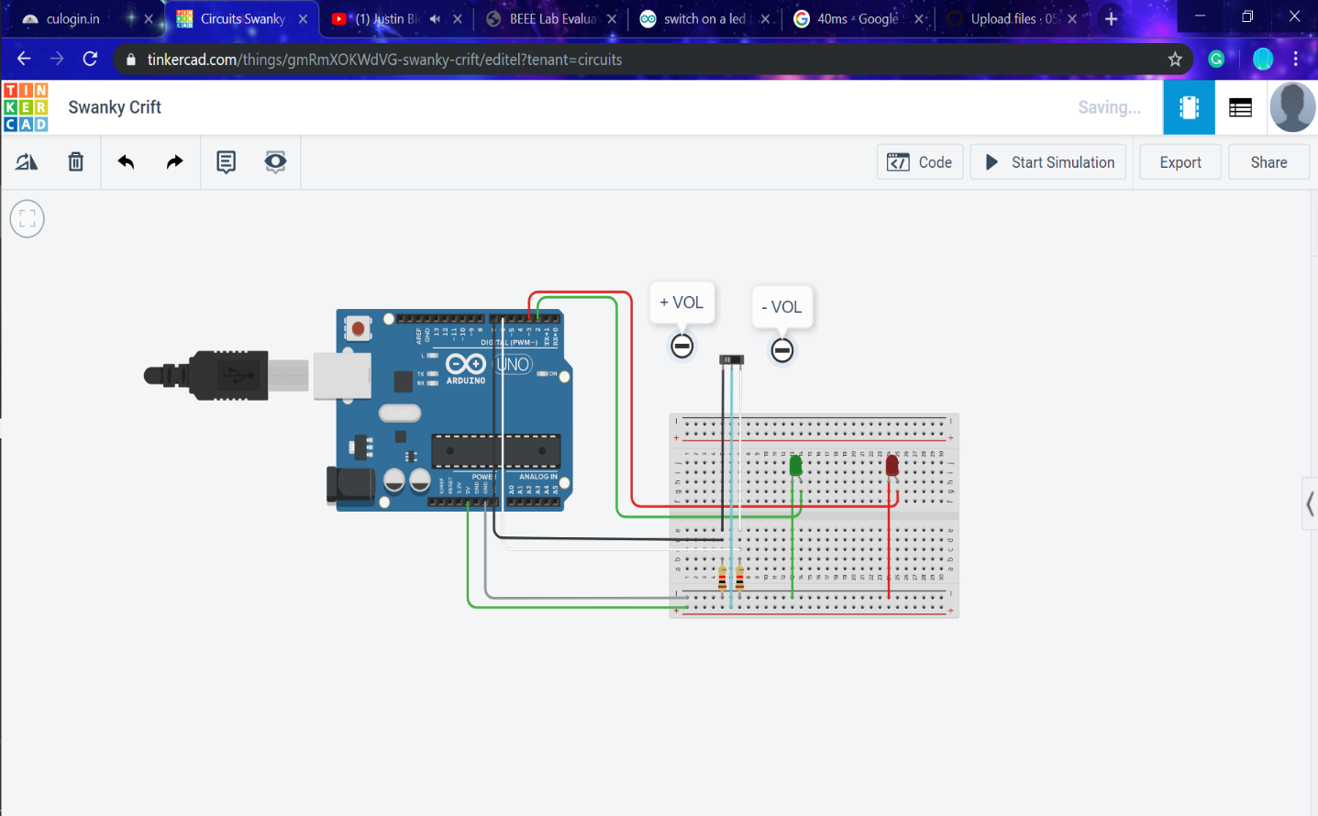

CODE DIAGRAM:

**Theory**

**Concept Used :**

In this Arduino circuit we are using the concept of LDR and Switch.

LED Chaser

**Apparatus Required :**

**1.**Arduino

**2.**Breadboard

**3.**Connecting Wire

**5.**Switch

**6.**Resistances

**7.** 2 LEDs

**Learning & Observations:**

Arduino is a prototype platform (open-source) based on an easy-to-use hardware and software. It consists of a circuit board, which can be programed (referred to as a microcontroller) and a ready-made software called Arduino IDE (Integrated Development Environment), which is used to write and upload the computer code to the physical board.

The key features are −

* Arduino boards are able to read analog or digital input signals from different sensors and turn it into an output such as activating a motor, turning LED on/off, connect to the cloud and many other actions.
* You can control your board functions by sending a set of instructions to the microcontroller on the board via Arduino IDE (referred to as uploading software).
* Unlike most previous programmable circuit boards, Arduino does not need an extra piece of hardware (called a programmer) in order to load a new code onto the board. You can simply use a USB cable.
* Additionally, the Arduino IDE uses a simplified version of C++, making it easier to learn to program.
* Finally, Arduino provides a standard form factor that breaks the functions of the micro-controller into a more accessible package.

**Problems & Troubleshooting**

* While connecting the wires one should check that whether the wires are connected on the right pin or not.

**Precautions**

**Note** − To find out the polarity of an LED, look at it closely. The shorter of the two legs, towards the flat edge of the bulb indicates the negative terminal.

* LED should be connected to the right pin and one should also check the polarity of Anode and Cathode while connecting to the breadboard.
* LDR should be used under certain light condition.

**Learning Outcomes**

Follow the circuit diagram and hook up the components on the breadboard as shown in the image given above.

The *LEDs* lights one by one for a period of 1second and the cycle repeats giving the running light appearance.

**BEEE LAB CU**