🔐
PHISHING WEBSITE DETECTION
Using Machine Learning Classification Techniques
PROJECT REPORT
Submitted by | [Your Name]
Batch | [Batch / Roll No.]
Date | 19 August 2026
Domain | Machine Learning / Cybersecurity

1. Abstract
Phishing websites imitate legitimate platforms to steal sensitive user information such as passwords and financial data, making automated detection a critical cybersecurity need. This project builds a machine learning system that classifies websites as phishing or legitimate using 20 URL, domain, and content-based features extracted from a labelled dataset of 25,000 websites. After data cleaning, exploratory analysis, and preprocessing, three classification models — Logistic Regression, Decision Tree, and Random Forest — were trained and compared. Random Forest was selected as the best-performing model and further improved through hyperparameter tuning with GridSearchCV. The tuned model achieved 97.16% accuracy and a 96.50% F1-score on unseen test data. The final model was deployed as an interactive Streamlit web application that lets a user input website features and receive a real-time phishing prediction with confidence score.
2. Introduction
Phishing is one of the most common cyberattack vectors, responsible for a large share of data breaches and financial fraud worldwide. Attackers craft fake websites that closely resemble trusted brands to trick users into revealing credentials. Manual detection through blacklists is slow and cannot keep pace with newly created phishing domains, which often exist for only a few hours. Machine learning offers a scalable alternative: by learning patterns from structural and behavioural characteristics of URLs and web pages — such as URL length, use of IP addresses, HTTPS presence, domain age, and embedded form counts — a trained model can flag suspicious websites automatically, even ones it has never seen before.
This project addresses that problem end-to-end: cleaning and exploring a real-world phishing dataset, engineering a reliable preprocessing pipeline, training and comparing multiple classifiers, tuning the best model, and packaging it into a usable prediction dashboard.
3. Objectives
● Clean and preprocess the raw phishing website dataset, resolving missing values, invalid entries, and out-of-range values.
● Perform exploratory data analysis (EDA) to understand feature distributions and their relationship with the phishing label.
● Train and compare at least three classification algorithms using accuracy, precision, recall, and F1-score.
● Tune the best-performing model's hyperparameters using cross-validated grid search to maximize F1-score.
● Achieve a test-set F1-score of at least 0.90 for reliable phishing detection.
● Deploy the final model as an interactive Streamlit application with a real-time prediction interface.
4. Dataset
4.1 Source & Size
The dataset used is a structured, tabular phishing-website dataset containing 25,000 records and 21 columns (20 input features + 1 target label), provided in Excel format (phishing_website_raw.csv.xlsx, cleaned version saved as phishing_website_cleaned.xlsx). Each row represents one website, and each column represents a URL-level, domain-level, or page-content-level characteristic extracted from that website.
4.2 Feature Description
Features fall into four broad categories, summarised below:
Category | Features | What it captures
URL-based | URL_Length, Num_Dots, Num_Hyphens, Num_Special_Chars, Num_Subdomains, URL_Entropy, Has_IP_Address | Structural oddities in the URL string itself
Domain-based | Domain_Age_Days, Domain_Registration_Length, Domain_Name_Length, Has_HTTPS | Trustworthiness / maturity of the domain
Content-based | Num_Redirects, External_Link_Ratio, Image_Link_Ratio, Form_Count, Iframe_Count, Popup_Count, Favicon_External | Behaviour and layout of the rendered page
Security-related | Has_Suspicious_Words, Password_Field_Present | Direct social-engineering / credential-harvesting cues
Phishing pages typically show longer, more chaotic URLs (more dots, hyphens, special characters, higher entropy), younger domains, missing HTTPS, and a higher density of forms, iframes, and pop-ups — patterns confirmed later in the EDA stage.
4.3 Target Variable & Class Balance
The target column Is_Phishing is binary: 0 = Legitimate, 1 = Phishing. Out of 25,000 records, 14,806 (59.2%) are legitimate and 10,194 (40.8%) are phishing — a moderate, workable class balance that did not require synthetic resampling (e.g. SMOTE) before modelling.
Class | Label | Count | Percentage
Legitimate | 0 | 14,806 | 59.2%
Phishing | 1 | 10,194 | 40.8%
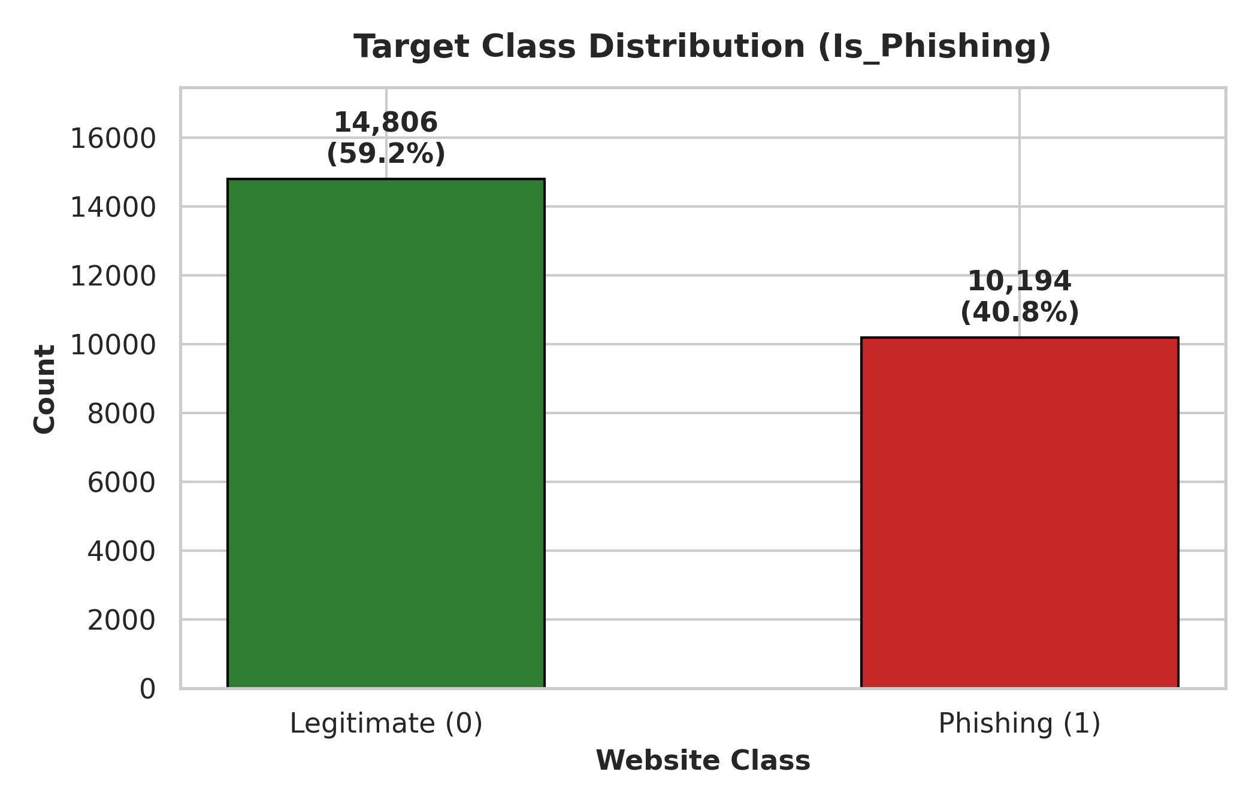
Figure 4.1 — Distribution of phishing vs legitimate websites
4.4 Data Quality Checks Performed
● Verified shape, column data types, and summary statistics (df.info(), df.describe()).
● Checked for missing values column-by-column and in total.
● Checked and removed exact duplicate rows.
● Validated the target column only contained {0, 1}.
● Flagged out-of-range values in count columns (negative lengths/counts) and ratio columns (outside 0–1).
5. Exploratory Data Analysis
Before modelling, the cleaned dataset was explored visually and statistically to understand feature behaviour, spot outliers, and identify which features most strongly separate phishing from legitimate websites. The full analysis (46+ plots covering every feature) is available in the notebook; the key visuals are summarised here.
5.1 Feature Distributions
Histograms with KDE overlays were plotted for every numerical feature to check skewness and spread. Several features (URL_Length, Num_Redirects, Popup_Count) showed a right-skewed distribution typical of count data, while URL_Entropy was closer to normally distributed.
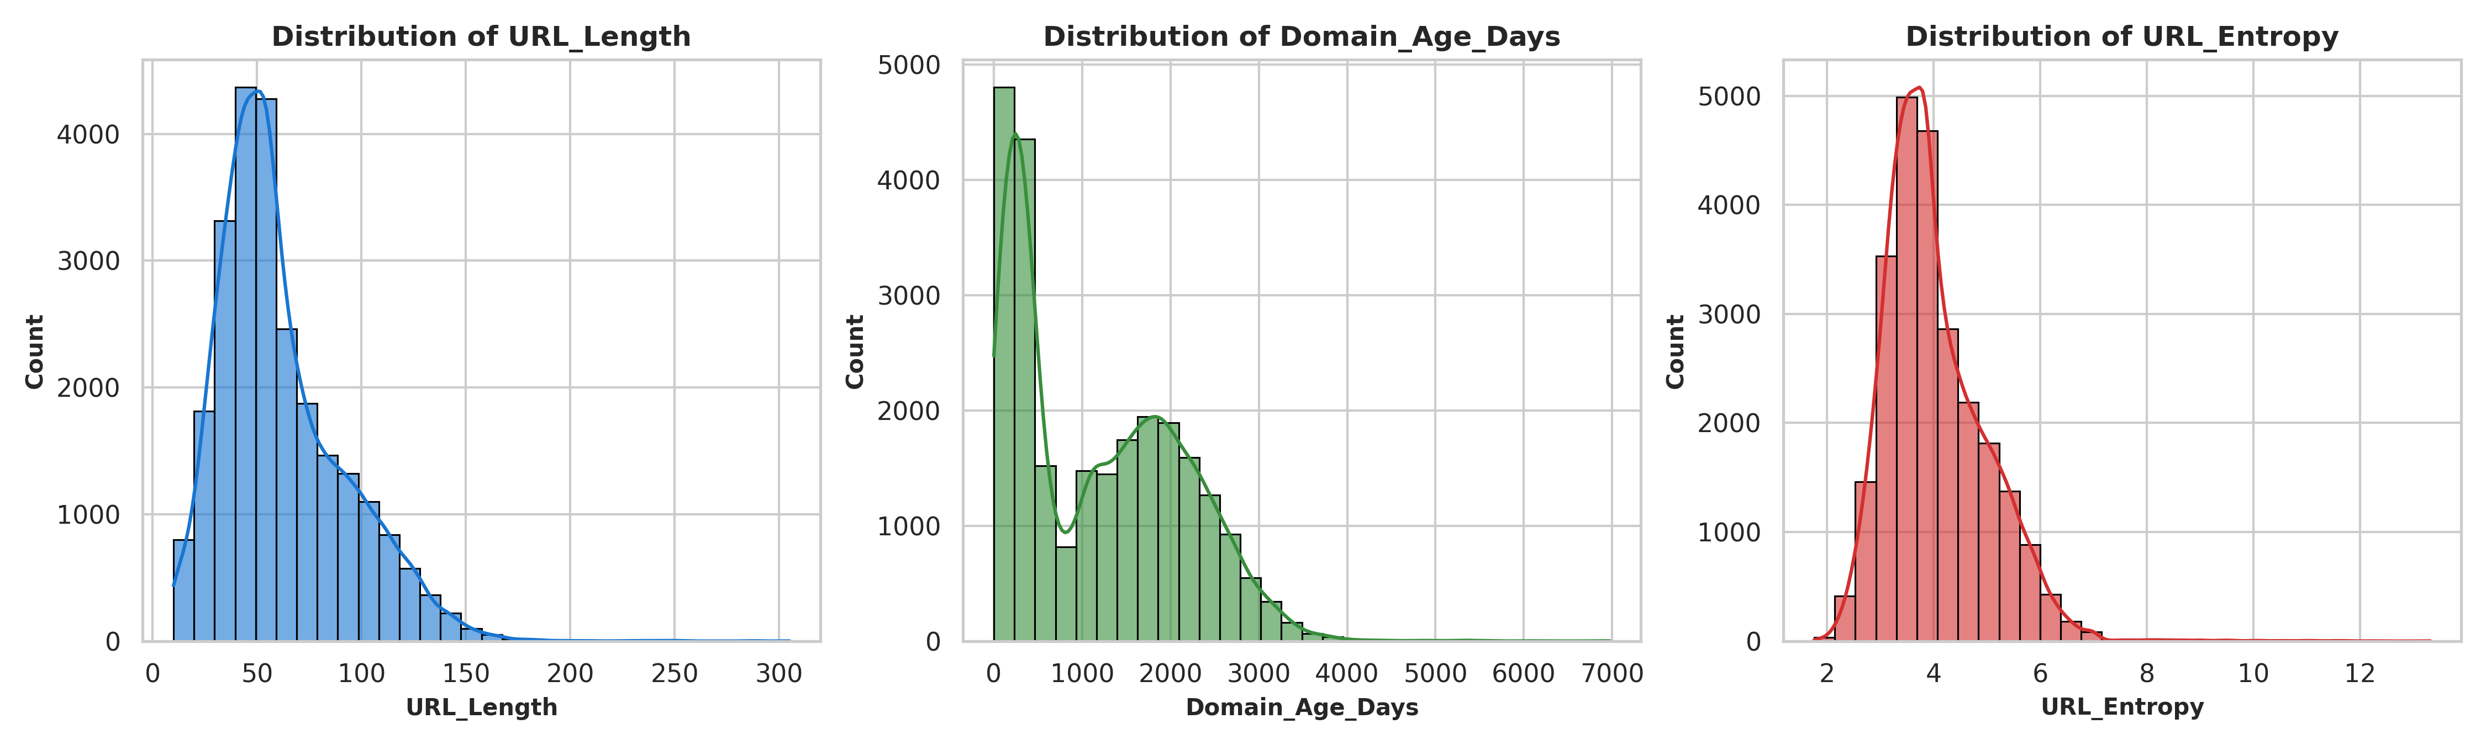
Figure 5.1 — Example distributions: URL_Length, Domain_Age_Days, URL_Entropy
5.2 Outlier Detection
Boxplots were generated per feature to visually detect outliers. A small number of extreme values were observed in Domain_Age_Days and Num_Redirects, consistent with real websites having unusually long-lived domains or heavily redirected pages; these were kept as they represent genuine, informative variation rather than data errors.
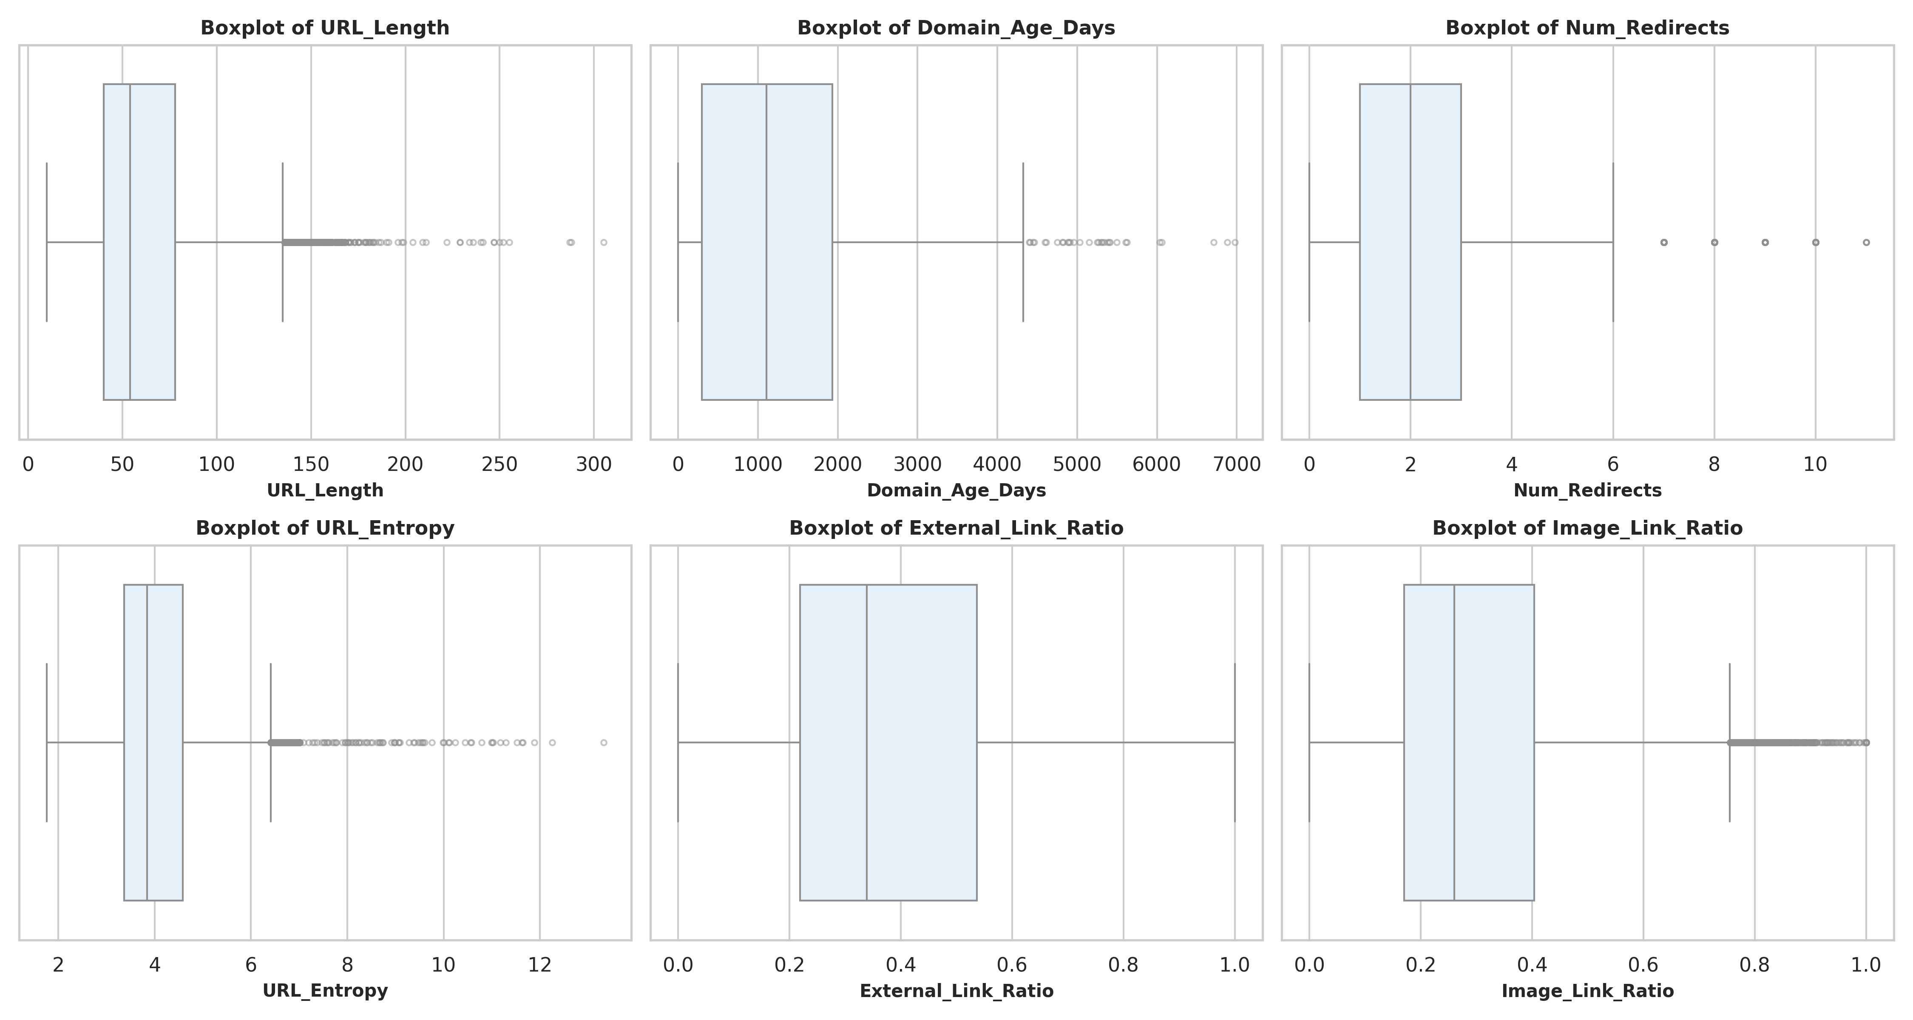
Figure 5.2 — Outlier check across key numeric features
5.3 Correlation Analysis
A full correlation heatmap across all 20 features was generated to check for multicollinearity and to rank features by their linear relationship with the target. No feature pairs exceeded the 0.70 correlation threshold used to flag redundancy, so no features were dropped prior to modelling.
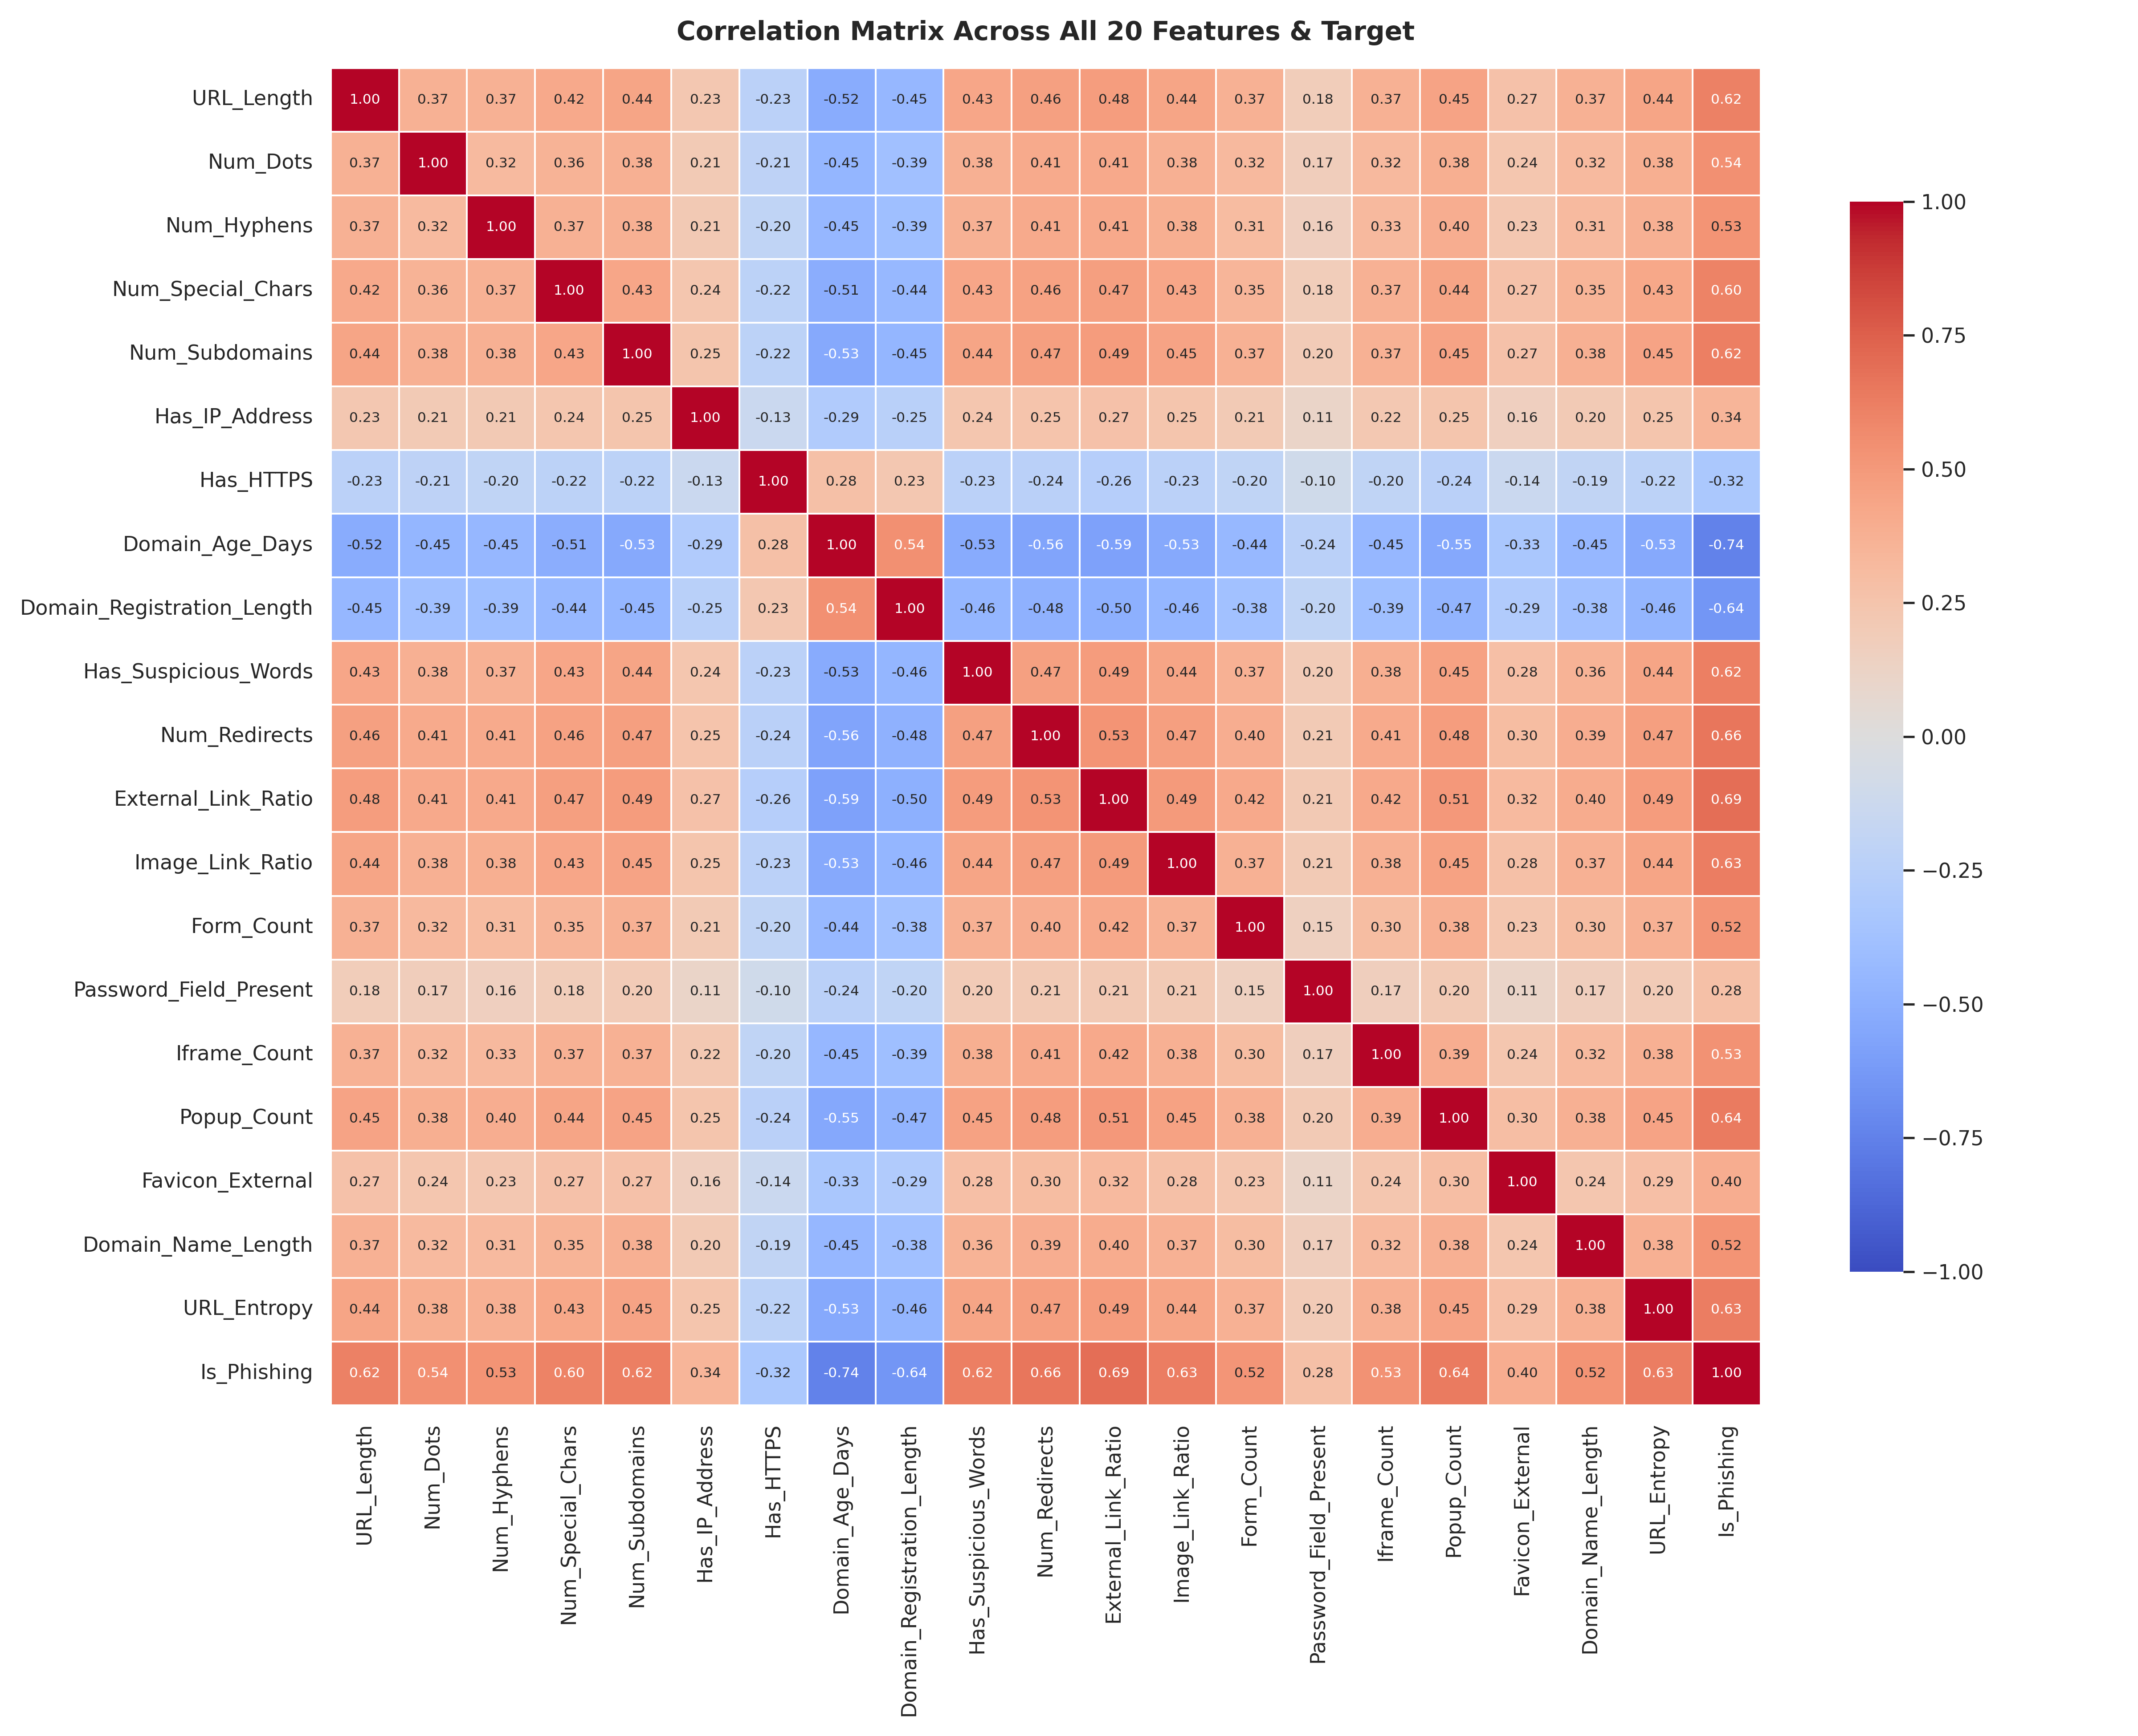
Figure 5.3 — Correlation matrix across all 20 features
5.4 Feature vs Target Relationship
Features were individually compared against Is_Phishing using boxplots and mean-difference analysis. URL_Entropy, Domain_Age_Days, and Has_HTTPS emerged as some of the strongest discriminators — phishing sites showed markedly higher entropy, lower domain age, and far lower HTTPS adoption than legitimate ones.
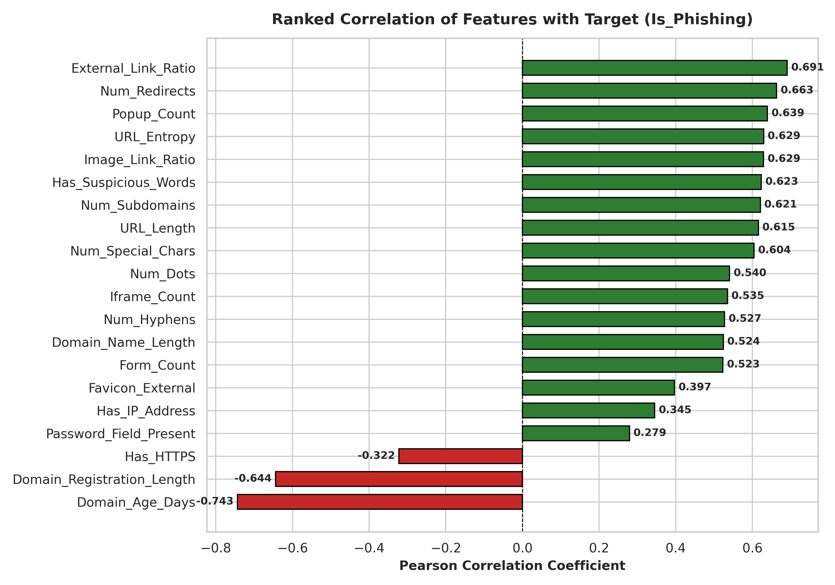
Figure 5.4 — Ranked correlation of each feature with Is_Phishing
6. Methodology
6.1 Data Cleaning Pipeline
The raw dataset was passed through a structured cleaning pipeline before any analysis or modelling, ensuring downstream results are trustworthy:
● Checked and confirmed zero missing values and zero duplicate rows after the initial pass; verified the target column contained only valid 0/1 labels.
● Replaced invalid negative values in 13 count/length columns (e.g. URL_Length, Domain_Age_Days, Form_Count) with NaN, since a negative count/length is not physically meaningful.
● Corrected 5 binary columns (Has_IP_Address, Has_HTTPS, Has_Suspicious_Words, Password_Field_Present, Favicon_External) so that only valid {0, 1} values remain, converting any invalid entries to NaN.
● Clipped 2 ratio columns (External_Link_Ratio, Image_Link_Ratio) to their valid 0–1 range, converting out-of-range values to NaN.
● Filled all resulting missing numeric values using median imputation (robust to outliers, unlike mean imputation).
● Cast count/length columns and binary columns to integer type, and the target column to integer type, for a clean, model-ready schema.
● Ran a final verification pass confirming zero missing values, zero duplicates, and a valid target distribution before exporting phishing_website_cleaned.xlsx.
6.2 Preprocessing & Feature Representation
● Defined X (20 features) and y (Is_Phishing) from the cleaned dataframe.
● Train/test split: 80% / 20% (20,000 / 5,000 rows), stratified on the target to preserve the 59/41 class ratio in both splits.
● Feature scaling: StandardScaler fit on the training set and applied to both train and test sets, used specifically for the Logistic Regression pipeline since distance/gradient-based models are scale-sensitive. Tree-based models (Decision Tree, Random Forest) were trained on the unscaled features, since split-based trees are scale-invariant.
6.3 Model Training & Evaluation Strategy
Three classifiers were trained on the training split and evaluated on the held-out test split using accuracy, precision, recall, and F1-score (F1 was the primary selection metric given the moderate class imbalance):
Model | Accuracy | Precision | Recall | F1-Score
Logistic Regression | 0.9710 | 0.9697 | 0.9588 | 0.9642
Decision Tree | 0.9224 | 0.9013 | 0.9093 | 0.9053
Random Forest | 0.9712 | 0.9693 | 0.9598 | 0.9645
Random Forest achieved the highest F1-score and was selected as the best model.
5.5 Hyperparameter Tuning
GridSearchCV (5-fold cross-validation, scoring = F1) was used to tune Random Forest. Best parameters found: max_depth = 20, min_samples_leaf = 2, min_samples_split = 5, n_estimators = 100, giving a cross-validated F1-score of 0.9622.
7. Applications
● Browser security extensions that warn users before they submit data on a suspicious site.
● Email security gateways that scan links in incoming emails for phishing risk.
● Enterprise network firewalls / DNS filtering to block malicious domains automatically.
● Banking and e-commerce platforms adding a real-time URL risk-check at checkout or login.
● Security-awareness training tools that demonstrate phishing indicators to employees.
8. Functional Requirements
● Accept a set of website/URL features as input (manual entry or via the dashboard form).
● Return a binary prediction (Phishing / Legitimate) along with a confidence/probability score.
● Display dataset overview, EDA visuals, preprocessing summary, and model comparison in the dashboard.
● Allow the trained model artifact to be downloaded from the app.
● Show evaluation visuals: confusion matrix, ROC curve, precision-recall curve, feature importance.
9. Non-Functional Requirements
● Performance: prediction latency under 1 second per request on standard hardware.
● Usability: simple, guided Streamlit UI usable without ML expertise.
● Reliability: consistent predictions via a fixed, versioned, serialized model (.pkl).
● Scalability: pipeline can be retrained on larger datasets without code changes to the app layer.
● Maintainability: modular notebook (cleaning → EDA → modeling → tuning → export) for easy updates.
10. Implementation Strategy
9.1 Pipeline / Architecture
Raw Dataset → Data Cleaning → EDA → Train/Test Split → Scaling (for Logistic Regression) → Model Training (3 models) → Comparison → Hyperparameter Tuning (GridSearchCV) → Final Model Export (joblib .pkl) → Streamlit Prediction App.
9.2 Tools & Libraries
● Language: Python 3
● Data handling: pandas, numpy, openpyxl
● Visualization: matplotlib, seaborn
● Modeling: scikit-learn (LogisticRegression, DecisionTreeClassifier, RandomForestClassifier, GridSearchCV)
● Model persistence: joblib
● Deployment: Streamlit (multi-tab dashboard with sidebar controls)
10.3 Dashboard Overview
The Streamlit app is organized into seven tabs, each mirroring a stage of the notebook pipeline so a non-technical reviewer can follow the entire project visually:
Tab | Purpose
Dataset Overview | Preview, column types, numerical vs categorical split, target distribution, descriptive statistics
Exploratory Data Analysis | Target distribution, missing-value check, duplicates, feature distributions, boxplots, correlation heatmap, feature-vs-target analysis
Preprocessing Pipeline | Pipeline summary and final feature list used for training
Model Training | Live training status and any training errors for each model
Model Comparison | Sorted comparison table and per-metric / combined comparison charts
Best Model | Confusion matrix, ROC curve, precision-recall curve, feature importance, classification report, model download
Predict Website | Interactive form to enter feature values and get a live phishing prediction
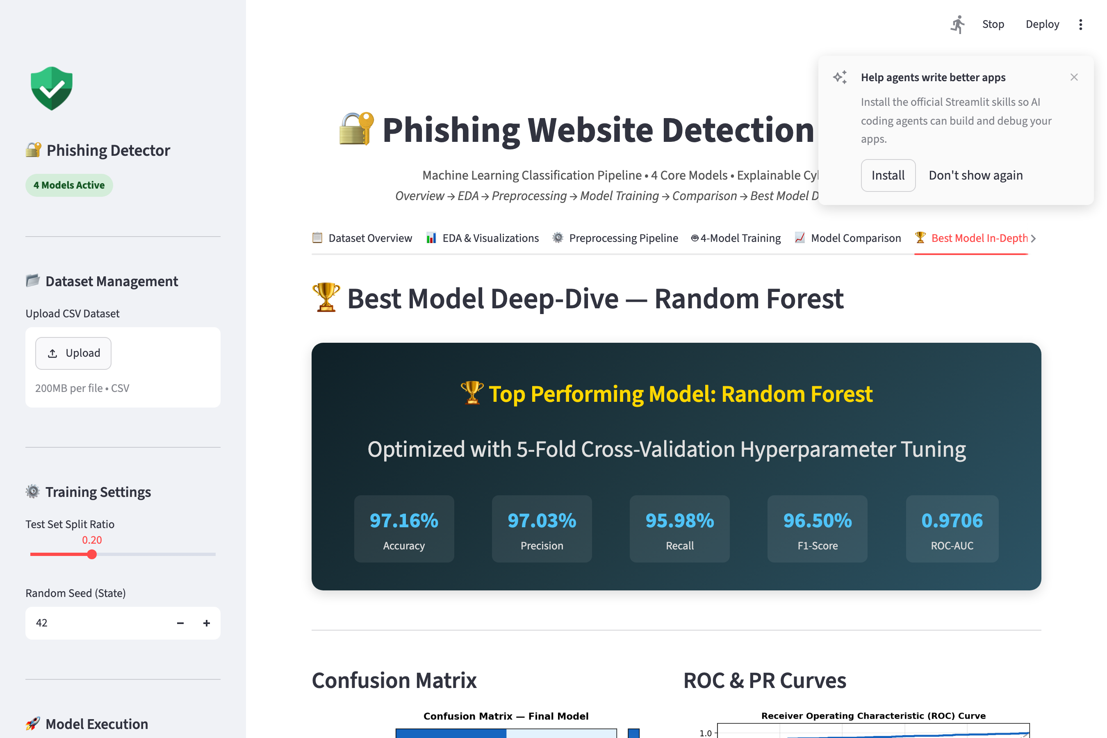
Figure 10.1 — Phishing Website Detection dashboard overview
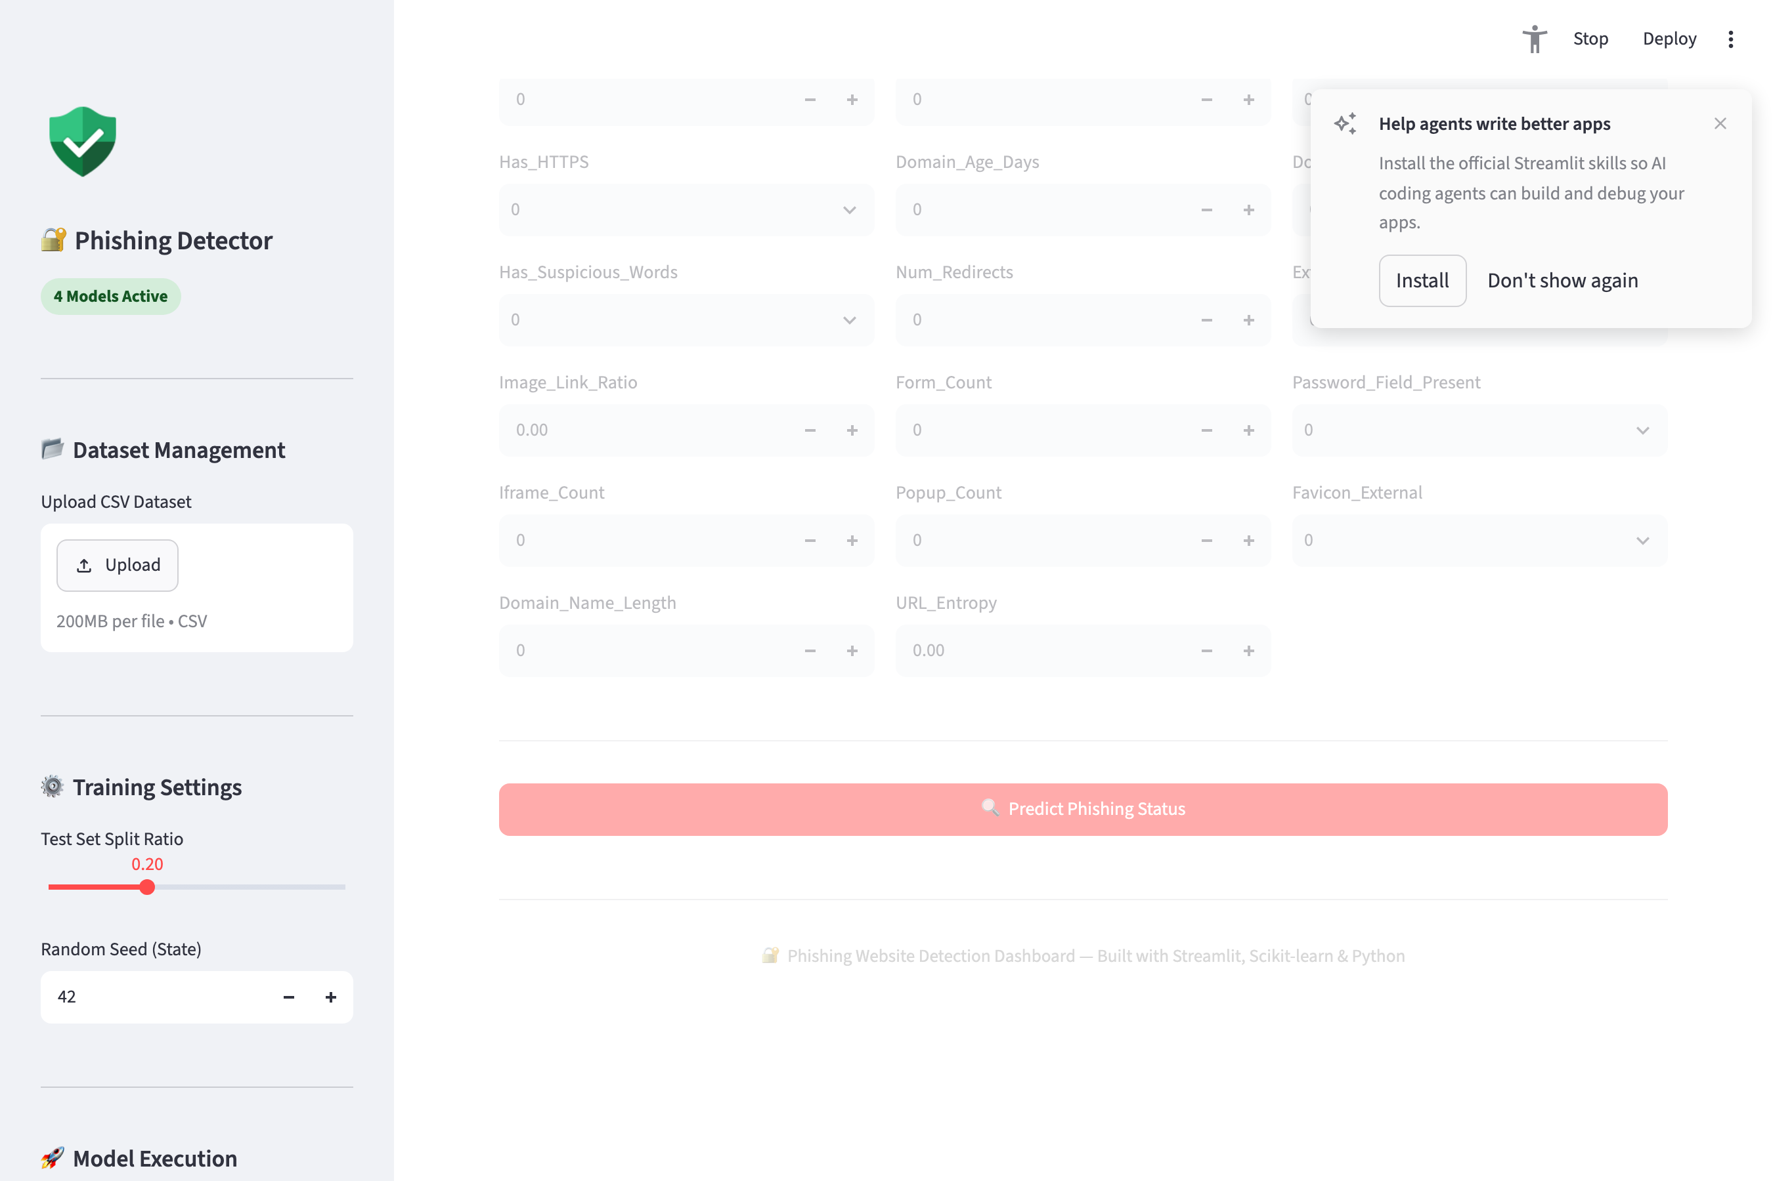
Figure 10.2 — Real-time prediction interface with confidence score
11. Outcomes / Results
The tuned Random Forest model was evaluated on the 5,000-row held-out test set with the following final results:
Metric | Score
Accuracy | 97.16%
Precision | 97.03%
Recall | 95.98%
F1-Score | 96.50%
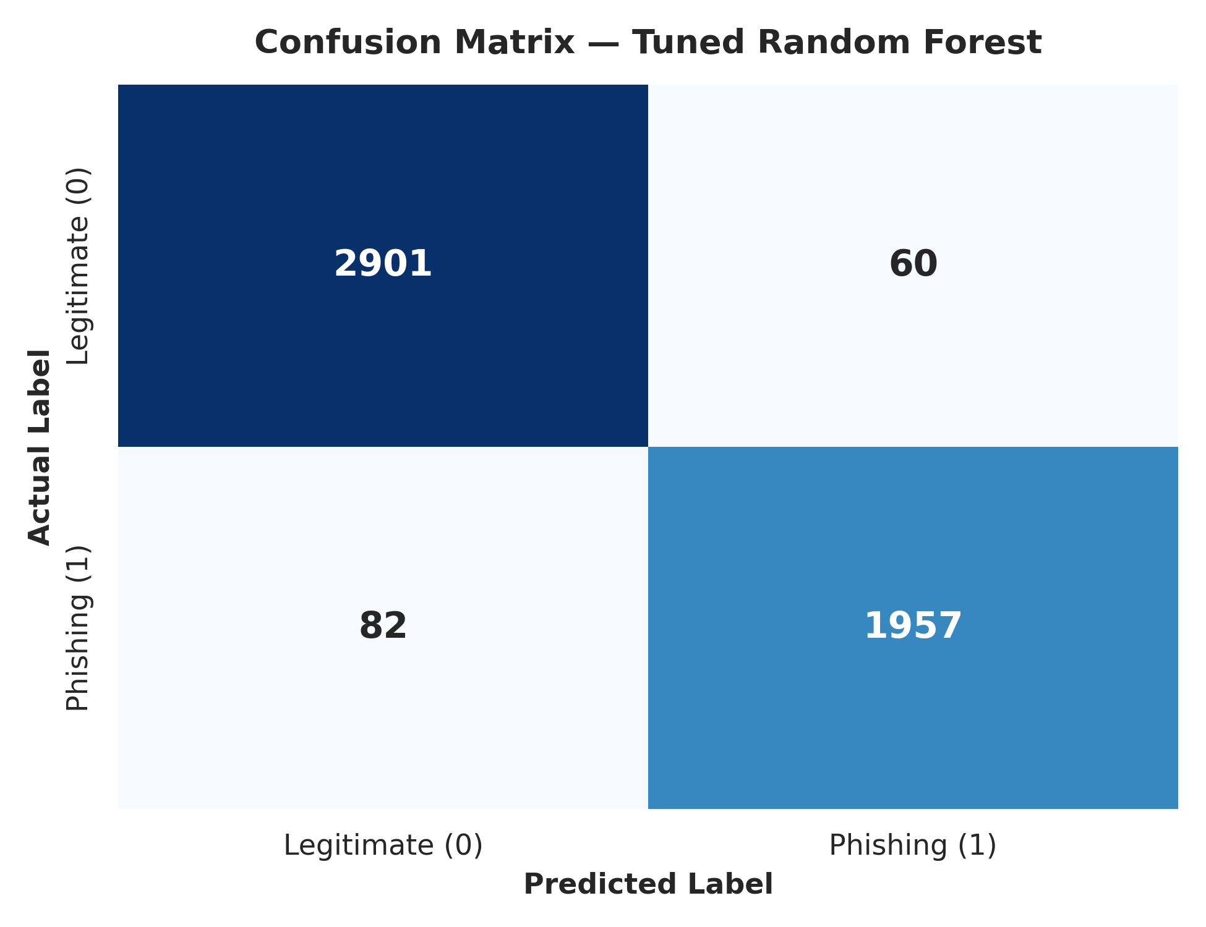
Figure 11.1 — Confusion matrix on test data
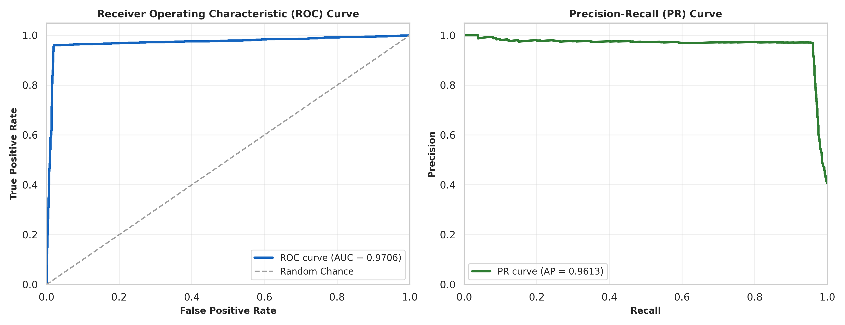
Figure 11.2 — ROC curve and Precision-Recall curve
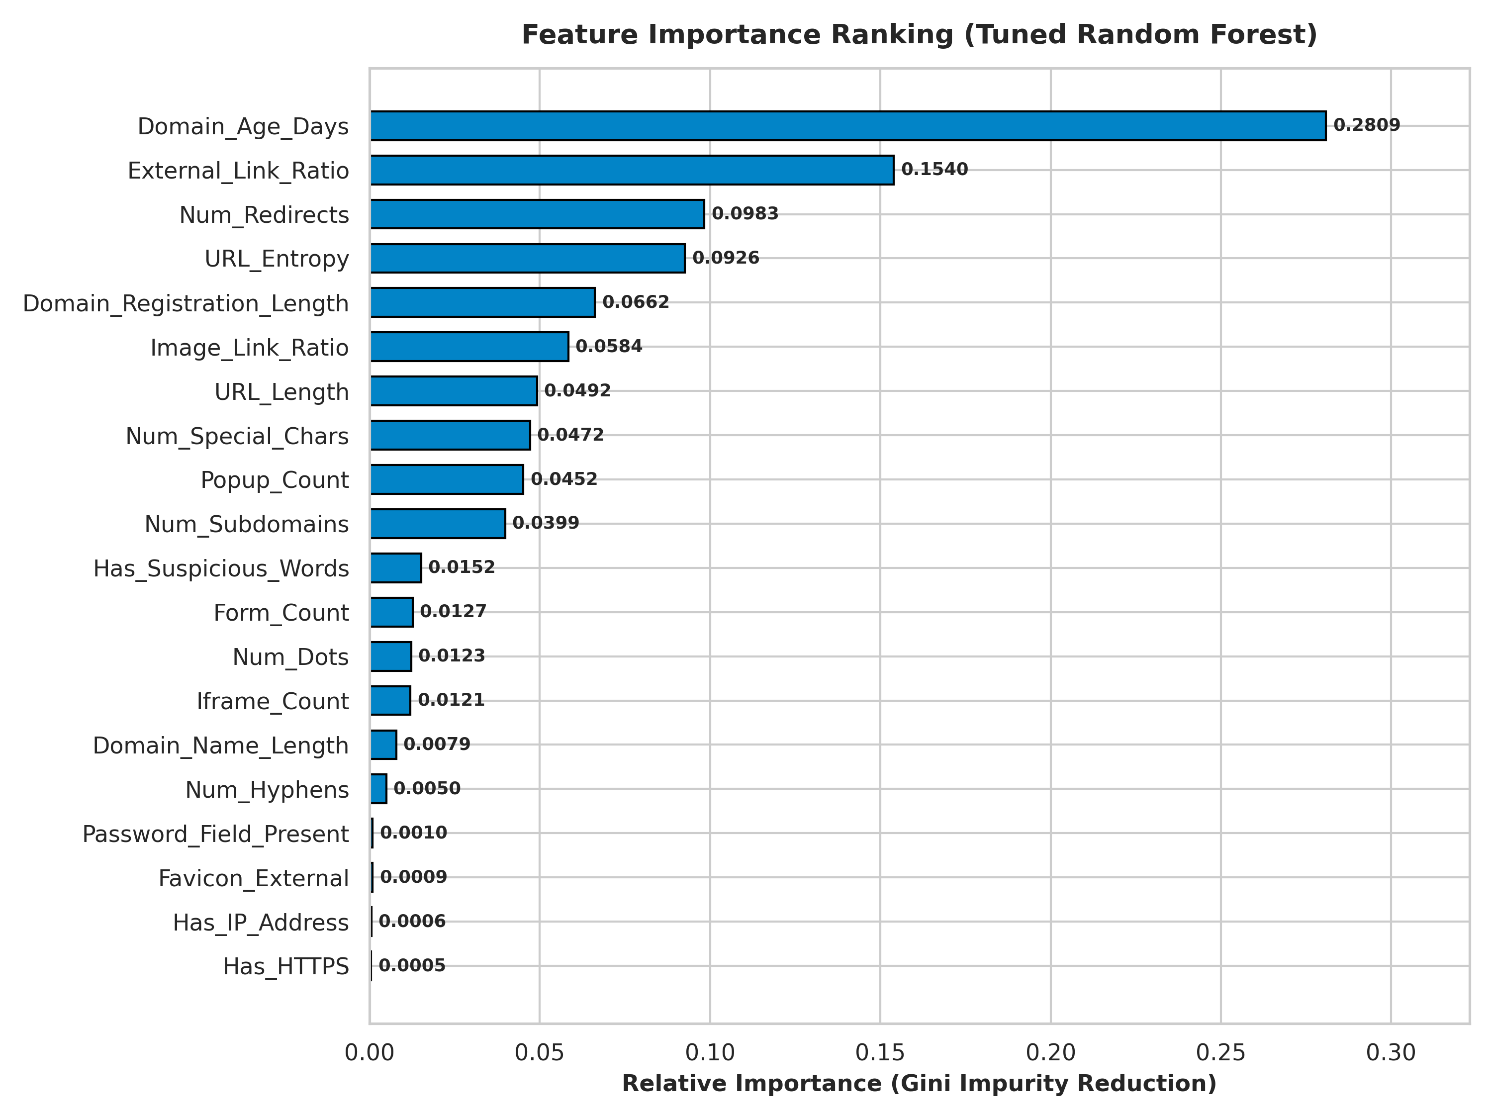
Figure 11.3 — Top features driving phishing predictions
The classification report confirms balanced performance across both classes (Legitimate: precision 0.97, recall 0.98; Phishing: precision 0.97, recall 0.96), showing the model does not favour one class at the expense of the other.
11.1 Detailed Classification Report
Class | Precision | Recall | F1-Score | Support
Legitimate (0) | 0.97 | 0.98 | 0.98 | 2,961
Phishing (1) | 0.97 | 0.96 | 0.96 | 2,039
Weighted Avg | 0.97 | 0.97 | 0.97 | 5,000
These results meet and exceed the project objective of an F1-score of at least 0.90, confirming the model is reliable enough for practical phishing-detection use cases.
12. Limitations
● Trained on a static dataset; may not generalize perfectly to newly evolved phishing techniques.
● Relies on pre-extracted numeric features rather than raw URLs/HTML, requiring a feature-extraction step before real-world use.
● Domain-age and registration-length features depend on external WHOIS-type data that may be unavailable or delayed for very new domains.
● No real-time retraining mechanism; model can go stale as phishing patterns change.
● ~4% of phishing sites are still misclassified as legitimate (false negatives), which carries real security risk.
13. Future Scope
● Incorporate NLP-based analysis of raw URL strings and page content instead of only engineered features.
● Add ensemble/boosting models (XGBoost, LightGBM) and compare against Random Forest.
● Build a browser extension for real-time URL scanning using the trained model.
● Set up periodic retraining with freshly labelled phishing data to reduce model drift.
● Add explainability (SHAP/LIME) to the dashboard so predictions are transparent to end users.
14. Conclusion
This project successfully developed a machine learning pipeline that detects phishing websites with 97.16% accuracy and a 96.50% F1-score using a tuned Random Forest classifier. Rigorous data cleaning and exploratory analysis ensured a reliable modeling foundation, while comparing multiple algorithms and applying hyperparameter tuning maximized detection performance. The final model was successfully packaged into an interactive Streamlit dashboard, making it usable for real-time phishing prediction and demonstrating a practical, deployable cybersecurity ML solution.
15. References
● Dataset: phishing_website_raw.csv.xlsx (project-provided dataset), cleaned as phishing_website_cleaned.xlsx.
● Pedregosa, F. et al., "Scikit-learn: Machine Learning in Python", Journal of Machine Learning Research, 2011.
● Streamlit Documentation — https://docs.streamlit.io
● Scikit-learn Documentation — https://scikit-learn.org
AI-tool disclosure: Portions of code documentation and this report structure were drafted with the assistance of an AI writing tool, reviewed and verified against the actual project notebook and app outputs.

