NEWS APPLICATION

A PROJECT REPORT

Submitted in partial fulfilment of the

requirement for the award of the degree

of

Master Of Computer Application (MCA)

By

Vikash Kumar Dubey

23FS20MCA00042



Department of computer application

MANIPAL UNIVERSITY JAIPUR

JAIPUR-303007

RAJASTHAN, INDIA

**CERTIFICATE**

This is to certify that the project titled NEWS APPLICATION is a record of the bonafide work done by Vikash Kumar Dubey 23FS20MCA00042 submitted in partial fulfilment of the requirements for the award of the Degree of Master of Computer Application (MCA) in computer application of Manipal University Jaipur, during the academic year 2025

Divya Sharma

Project Guide, Dept of Computer Application

Manipal University Jaipur

Shilpa Sharma

HOD, Dept of Computer Application

ACKNOWLEDGMENTS

In extending my gratitude, I find myself indebted to Divya Sharma, whose guidance has been the beacon lighting my path through the intricate realms of my project work. Her unwavering support has not only enriched my understanding but has also ignited within me a fervent curiosity to delve deeper into the subject matter. My journey at Manipal University Jaipur, Jaipur has been profoundly shaped by her encouragement and steadfast mentorship

To Shilpa Sharma, Head of the Department of Computer Application at Manipal University Jaipur, Jaipur. I owe a debt of gratitude for the provision of essential resources that facilitated the completion of my project. The collective efforts of the faculty members of the Computer Application department, both seen and unseen, have contributed significantly to my academic growth. I extend my appreciation to them, as well as to the dedicated staff and supportive friends who have stood by me throughout this journey.

Lastly, but most importantly, my deepest thanks are reserved for my parents, whose unwavering support and encouragement have been the cornerstone of my achievements. To all those whose contributions have been instrumental in my success, though their names may remain unsung, I offer my heartfelt appreciation

Thank You

Date

**ABSTRACT**

The "NEWS APPLICATION" initiative tackles a crucial challenge in the ease of news reading by introducing a MERN stack-based news portal web application. This pioneering effort aims to propel both news readers and editors into the digital age, presenting a user-friendly platform that simplifies the news reading process, streamlines readers, and nurtures meaningful professional reading.

Built on a solid foundation of MongoDB, Express.js, React, and Node.js, supplemented by essential tools and libraries such as React Bootstrap, Express Validator, Axios, JWT, and bcryptjs, this project delivers a secure and efficient solution. The intuitive interface enhances user navigation, ensuring a seamless experience for exploring news reading and managing applications. Meanwhile, the backend infrastructure focuses on data security and efficiency, establishing a robust link with MongoDB Atlas for optimized database management.

In essence, this project showcases the transformative potential of technology in reshaping the recruitment landscape. By harnessing advanced tools and frameworks, the "News Application" platform not only boosts the digital presence of news readers and employers but also fosters a supportive ecosystem for professional growth. Its impact extends beyond individual users, contributing to the vitality of local economies and opening doors to career advancement and economic prosperity

LIST OF FIGURES

Figure 1.1 Level 0 DFD

Figure 1.2 Level 1 DFD

Figure 1.3 Level 2 DFD

Figure 1.4 ER Diagram

Figure 2.1 Home Page

Figure 2.2 User Dashboard

Figure 2.3 Admin Dashboard

Figure 2.4 Manage News Page

Figure 2.5 News Creation Page

Figure 2.6 Posted News Page

Figure 2.7 News Detail Page

Figure 2.8 Manage Comment page

Figure 2.8 News Dashboard

**Contents**

* Certificate
* Acknowledgments
* Abstract
* List of Figures

**Chapter 1: Introduction**

* 1.1 Background and Objectives
  + 1.1.1 Introduction to the News Application
  + 1.1.2 Objectives of the Project
* 1.2 Overview of the News Application
  + 1.2.1 Understanding News Application
  + 1.2.2 Features and Functionality Overview
  + 1.2.3 Market Analysis and Need for News Application
* 1.3 Tech Stack Overview
  + 1.3.1 Frontend Technologies Employed
  + 1.3.2 Backend Technologies Utilized
  + 1.3.3 Development Environment and Tools

**Chapter 2: Literature Review**

* 2.1 Evolution of Technologies and Frameworks
  + 2.1.1 Progression of Frontend Technologies
  + 2.1.2 Advancements in Backend Technologies
  + 2.1.3 Comparative Analysis of Frameworks
  + 2.1.4 Emerging Trends in Web Development
* 2.2 Current State of News Applications
  + 2.2.1 User-Centric Features in News Portals
  + 2.2.2 Trends in Security and Authentication
  + 2.2.3 Integration of Real-Time Updates
  + 2.2.4 Emphasis on Mobile Responsiveness
  + 2.2.5 Impact of COVID-19 on News Delivery and Remote Work Trends

**Chapter 3: Methodology**

* 3.1 Rationale behind Full-Stack Development
* 3.2 Implementation of Agile Methodology
  + 3.2.1 Principles of Agile Methodology Applied
  + 3.2.2 Agile Tools and Techniques Utilized
* 3.3 System Architecture Design
  + Level 0 DFD
  + Level 1 DFD
  + Level 2 DFD
  + ER Diagram
* 3.4 Development Environment Setup
  + Frontend and Backend Development Tools
* 3.5 Implementation Process
  + Methodology for Frontend and Backend Development
  + Challenges Faced and Solutions Adopted
  + Version Control and Collaboration Tools

**Chapter 4: Analysis of User Interface**

* Home Page
* User Dashboard
* Admin Dashboard
* Manage News Page
* News Creation Page
* Posted News Page
* News Detail Page
* Manage Comment Page
* News Dashboard

**Chapter 5: Conclusion**

* 5.1 Summary of Findings and Achievements
* 5.2 Future Enhancements and Directions

**References**

Chapter 1

1. INTRODUCTION

In this chapter, we introduce a revolutionary MERN stack-based News Application designed to address the evolving challenges in the news and media landscape. The news application aims to revolutionize the way readers and content creators connect by providing a user-friendly platform that streamlines news dissemination, facilitates efficient content management, and fosters meaningful information sharing. This chapter provides an overview of the background, objectives, and key features of the News Application, along with a detailed exploration of the technologies and tools utilized in its development

**1.1 Background and 0bjectives**

**1.1.1 Introduction to the News Application**

In today's fast-paced and digitally-driven world, the news and media industry undergoes constant transformations due to technological advancements, evolving audience expectations, and changing content consumption patterns. Amidst these changes, traditional methods of news distribution and consumption often prove inadequate in effectively delivering timely, relevant, and engaging content to users. Recognizing this pressing need for innovation, the news application emerges as a beacon of change, poised to revolutionize the news media landscape.

**1.1.2 Objectives of the Project**

At the heart of the news application lies a set of ambitious objectives aimed at transforming the news consumption and content delivery experience for both readers and content creators:

Empowering Readers: The news application is committed to empowering readers by providing them with a comprehensive platform that simplifies access to timely, accurate, and relevant news content, while equipping them with the tools and features needed to stay informed in today’s fast-paced information environment. From personalized news feeds based on user interests and reading preferences to access to multimedia-rich articles and real-time updates, the news application endeavors to be the ultimate companion in every reader’s pursuit of knowledge and awareness.

Supporting Content Creators: For content creators, the news application serves as a strategic partner in content publishing and audience engagement. By offering a suite of powerful publishing tools and analytics-driven insights, the news application enables journalists, writers, and media organizations to streamline their content creation workflows, measure audience reach and engagement, and deliver impactful stories that resonate with their readers. Whether it's publishing breaking news, managing multimedia content, or building a strong digital presence and loyal readership, the news application is designed to be the go-to platform for creators aiming to share meaningful content with the world.

Fostering Meaningful Engagement: Beyond delivering news content, the news application recognizes the importance of fostering meaningful engagement and dialogue within the community. Through features like commenting, user polls, discussion forums, and live updates, the news application aims to create an interactive ecosystem where individuals can exchange perspectives, debate important issues, and contribute to public discourse. By nurturing a vibrant and inclusive reader community, the news application seeks to redefine the way people perceive and engage with the news, emphasizing the value of participation, transparency, and informed citizenship.

1.2 **Overview of the News Application**

**1.2.1 Understanding News Application**

At its core, News Application is more than just a news platform; it's a dynamic ecosystem that brings together readers, content creators, and real-time information under one digital roof. By leveraging state-of-the-art technology and user-centric design principles, News Application aims to create a seamless and intuitive platform where individuals can stay informed with the latest headlines, engage with curated news content, and access a variety of features to enhance their reading experience. Upon accessing the platform, users are welcomed with a smooth navigation interface, tailored to their interests and preferences

**For Readers:**

1. The Reader Dashboard serves as the central hub for accessing personalized news feeds, saving favorite articles, and managing reading preferences.
2. The Explore News section provides readers with a comprehensive collection of news articles, categorized by topic, region, and publication date.
3. The My Feed feature allows readers to track their reading history, receive real-time updates, and interact with content through likes, comments, or bookmarks.

**For Admins:**

1. Admin Dashboard:

The Admin Dashboard serves as a comprehensive control panel where platform administrators can monitor content submissions, user activity, and platform-wide engagement metrics. This interface provides tools to oversee creator performance, moderate articles, and enforce platform policies effectively.

1. Moderate & Highlight Articles:

Admins can review submitted articles before they go live, ensuring that all published content aligns with News Application editorial standards and community guidelines. They can approve, edit, or reject content as needed. Additionally, admins can mark specific articles as "Featured" to increase their visibility on the homepage or category pages.

1. Content & User Management System:

Through the Content and User Management System, admins can access and manage all user roles—readers, content creators, and fellow admins. They can also manage submitted articles platform-wide, moderate user interactions, handle reports, and maintain a safe and engaging environment by quickly acting on flagged content or violations.

**1.2.2 Features and Functionality Overview**

News Application is equipped with a wide range of features and functionalities designed to enhance the user experience and streamline the process of news consumption, content management, and platform administration. From real-time updates to personalized news feeds, the platform offers an intuitive and engaging environment for readers, content creators, and administrators alike.

**For Readers:**

● User Registration: Readers can easily sign up for a News Application account by providing basic details such as their name, email address, and a password. Registration unlocks personalized content features and enables user interaction within the platform.

● Profile Customization: Upon registration, readers can personalize their profile by selecting preferred news categories, regions, and topics of interest. This ensures their news feed is tailored to their unique preferences.

● Browse News Articles: News Application offers a vast collection of news articles from multiple categories such as politics, technology, sports, and entertainment. Readers can explore the content using filters like category, publication date, or keyword search to quickly find relevant news.

● Engage with Content: Readers can interact with articles by liking, bookmarking for later, or sharing them. The platform may also support features like commenting or reactions, enabling greater engagement with the news.

● Track Reading Activity: News Application provides a personalized dashboard where readers can view their reading history, revisit saved articles, and receive suggestions based on their reading habits.

**For Admins:**

● Admin Registration:

Administrators can create an account with elevated privileges that allow them to oversee and manage the entire News Application ecosystem. During registration, they provide credentials and verification details to ensure secure access to backend features, user management, and moderation tools.

● Moderate Submissions:

Admins play a key role in maintaining the integrity of the platform. They have access to a moderation panel where they can review submitted articles before publication. This includes checking for accuracy, relevance, and compliance with community guidelines. Admins can approve, reject, or send articles back to the creators for revision.

● Monitor Platform Activity:

Through a powerful admin dashboard, platform administrators can monitor overall activity across the site. This includes tracking user registrations, article submissions, reader engagement, and flagged content. Real-time analytics and system logs help admins detect unusual behavior and ensure smooth platform performance.

● User and Role Management:

Admins have the ability to manage both reader and creator accounts. This includes viewing user profiles, updating user roles (e.g., promoting a reader to a creator), resetting passwords, or deactivating accounts if terms of service are violated. They also handle user reports and take action on any flagged or abusive content.

● Content Oversight:

Beyond article moderation, admins can edit or remove any content across the platform to maintain quality and accuracy. They ensure the news feed remains up-to-date, fact-checked, and aligned with News Application editorial standards. Admins may also schedule or highlight featured articles to promote important news.

The Admin Dashboard acts as the control center for managing users, monitoring platform activity, and overseeing published news content.

The Manage Articles section enables admins to review, approve, edit, or remove submitted news pieces, ensuring content quality and relevance.

The User Management feature allows admins to view registered readers and content creators, control permissions, and handle reports or flagged content.

The Creator Dashboard is the main hub for drafting, editing, and publishing news articles, as well as tracking content performance.

The Submit News section allows creators to compose articles, add media, categorize content, and submit it for review or immediate publication.

The My Publications feature helps creators manage their published articles, view engagement metrics, and receive feedback from readers or editors.

**1.2.3 Market Analysis and Need for News Application**

The development of News Application is grounded in a comprehensive analysis of the evolving digital media landscape, including emerging trends, audience behaviors, and existing gaps within the online news ecosystem. Through detailed market research and feedback from both readers and content creators, News Application is designed to address fundamental challenges in the way p

**1.3 Tech Stack Overview**

**1.3.1 Frontend Technologies Employed**

News Application leverages a modern, responsive, and interactive frontend stack to ensure a seamless and personalized user experience for readers, creators, and administrators:

React.js:  
React.js serves as the foundation of News Application’s frontend architecture. Its component-based design and virtual DOM rendering enable the development of modular, efficient, and interactive user interfaces. By breaking down the UI into reusable components—such as article cards, category filters, and dashboards—React.js simplifies UI development and promotes maintainability.

Axios:  
Axios is used for handling asynchronous HTTP requests between the client and server. With its promise-based interface, Axios ensures reliable communication for operations such as fetching news articles, submitting content, logging in users, and updating user preferences—ensuring smooth and responsive frontend-backend integration.

Tailwind CSS:

Tailwind CSS is used to build a modern, mobile-responsive, and accessible UI. Its utility-first approach allows for rapid development and customization of visual components, ensuring consistent styling across the application.

**1.3.2 Backend Technologies Utilized**

News Application’s backend architecture is designed for high performance, scalability, and maintainability—enabling it to support dynamic content creation, real-time updates, and robust user management.

Node.js:  
Node.js powers the backend logic of News Application, leveraging its event-driven, non-blocking I/O model to handle multiple simultaneous requests efficiently. This ensures the platform can scale to support heavy read/write operations as traffic grows.

Express.js:  
Express.js is used as the web framework for building RESTful APIs and handling server-side logic. It enables developers to define secure routes for fetching news, submitting articles, managing users, and moderating content, all while keeping the backend modular and maintainable.

MongoDB:  
News Application utilizes MongoDB, a NoSQL database well-suited for storing diverse types of content including articles, user data, and interaction logs. Its schema-less nature allows the platform to evolve and adapt quickly, especially when new content types or metadata fields are introduced.

Mongoose:  
Mongoose provides a structured schema-based interface to MongoDB, offering robust validation, population, and query-building features. It allows News Application to define strict data models for news articles, user accounts, and comment threads, promoting consistency and enforcing business rules at the database layer.

JWT (JSON Web Tokens):

JWT is employed for secure authentication across the platform. It facilitates role-based access control, allowing different permissions for readers, creators, and administrators while maintaining stateless and scalable user sessions.

**1.3.3 Development Environment and Tools**

To maintain productivity and code quality, News Application is built and maintained in a professional-grade development environment using industry-standard tools:

Nodemon:  
Nodemon is integrated into the development workflow to automatically restart the server on file changes. This enables rapid iteration during development and quick feedback when debugging backend logic.

Dotenv:  
Dotenv is used to manage environment variables securely and efficiently. It centralizes configurations such as database URLs, API keys, and secret tokens, allowing News Application to maintain flexibility across local, staging, and production environments.

Git:  
Git powers version control and collaboration within the News Application development team. Its branching model supports feature isolation, bug fixes, and pull requests, ensuring a clean and reliable codebase.

Visual Studio Code:

Visual Studio Code is the primary IDE for developing News Application. Its lightweight footprint, extensive extensions (such as Prettier, ESLint, and Git integration), and built-in terminal streamline the development process.

Postman:  
Postman is used for designing, testing, and documenting News Application’s APIs. It helps developers test endpoints (e.g., article CRUD operations, user login, like/dislike systems) and debug issues quickly during integration.

By combining this robust and flexible tech stack with modern development practices, News Application is positioned to deliver a high-performance, user-first experience in the world of digital journalism—empowering creators to share, readers to explore, and communities to connect through impactful news.

One of the most significant insights gathered through this research is the increasing demand for personalized, real-time, and reliable news experiences. Traditional news platforms often fall short in offering customization, real-time interactivity, and user engagement features that modern audiences expect. In response to this, News Application focuses on delivering a user-centric news experience—one that adapts to individual interests, reading habits, and content preferences. By utilizing technologies such as artificial intelligence and content filtering algorithms, News Application provides tailored news feeds and relevant article recommendations to enhance reader satisfaction and retention.

Furthermore, News Application addresses the growing need for trustworthy and democratized news creation. In an era where misinformation is prevalent, the platform is designed to ensure editorial quality, content moderation, and creator accountability. Through a hybrid model that supports both professional journalists and verified independent contributors, News Application fosters a more balanced and credible news environment.

Equally important is News Application’s commitment to inclusivity and accessibility. Recognizing the underrepresentation of diverse voices in mainstream media, News Application empowers creators from varied backgrounds to contribute and be heard. The platform actively promotes regional, community-based, and minority perspectives to ensure a more inclusive media landscape. Through strategic partnerships and outreach efforts, News Application aims to make quality news content accessible to readers of all demographics and to provide publishing opportunities to voices that are often overlooked.

By addressing these key market needs—personalization, trust, and inclusivity—News Application positions itself not just as another news portal, but as a dynamic, people-first platform designed to redefine the way news is consumed and shared in the digital age.

CHAPTER 2

**2. LITERATURE REVIEW**

In this chapter, we explore the existing landscape of web development technologies and frameworks, focusing on their evolution and relevance to news-based web applications. By examining the progression of both frontend and backend technologies, conducting a comparative analysis of popular frameworks, and identifying emerging trends in digital journalism and real-time content delivery, we gain valuable insights into the current state of online news platforms. This analysis helps us understand the key technological drivers that shape the design, scalability, and user engagement strategies of modern news applications.

**2.1 Evolution of Technologies and Frameworks**

**2.1.1 Progression of Frontend Technologies**

The progression of frontend technologies has played a pivotal role in shaping the modern digital news experience. Initially dominated by static web pages, news platforms gradually embraced dynamic interfaces through tools like jQuery, which simplified content manipulation and user interaction. However, the emergence of single-page application (SPA) frameworks such as React.js, Vue.js, and Angular revolutionized frontend development. These frameworks introduced a component-based architecture and virtual DOM rendering, allowing developers to create highly responsive, real-time interfaces—crucial for delivering breaking news and live updates. As users increasingly expect seamless and interactive experiences, especially on content-rich platforms like news applications, frontend technologies continue to evolve with performance optimizations, improved state management, and enhanced rendering techniques tailored for rapid content delivery and reader engagement

**2.1.2 Advancements in Backend Technologies**

In parallel with frontend advancements, backend technologies have also undergone significant evolution to support the increasing complexity and scalability requirements of web applications. Traditional server-side languages like PHP and Ruby on Rails paved the way for more efficient and scalable solutions like Node.js and Python's Django framework. Node.js, with its event-driven architecture and non-blocking I/O model, emerged as a popular choice for building fast and scalable backend services. Similarly, Django's batteries-included approach and robust ORM make it well-suited for rapid development and deployment of web applications. These advancements in backend technologies have empowered developers to build robust, scalable, and performant web applications that can handle large volumes of traffic and complex business logic.

**2.1.3 Comparative Analysis of Frameworks**

A comparative analysis of frontend and backend frameworks provides valuable insights into their respective strengths, weaknesses, and use cases. Frontend frameworks like React.js, Vue.js, and Angular offer different approaches to building user interfaces, each with its own set of advantages and trade-offs. React.js, known for its simplicity and

flexibility, excels in building reusable UI components and managing complex state logic. Vue.js, on the other hand, prioritizes ease of integration and offers a gentle learning curve, making it an ideal choice for beginners and small-scale projects. Angular, with its opinionated approach and comprehensive feature set, is well-suited for large-scale enterprise applications requiring strict architecture and scalability requirements. Similarly, backend frameworks like Express.js, Django, and Flask offer different levels of abstraction and functionality, catering to diverse project requirements and developer preferences.

**2.1.4 Emerging Trends in Web Development**

The landscape of web development continues to evolve rapidly, driven by emerging trends and technologies that redefine how digital news content is created, delivered, and consumed. One prominent trend is serverless architecture, which abstracts server management and infrastructure complexities—enabling developers of news platforms to build scalable, event-driven systems with reduced operational overhead. Progressive Web Apps (PWAs) are also gaining traction, allowing news portals to offer users a native app-like experience directly in their browsers, with support for offline reading, push notifications for breaking news, and home screen shortcuts for instant access. The continued rise of Single-Page Applications (SPAs) has improved user engagement through faster load times and seamless navigation—essential for readers accessing dynamic news content. Additionally, innovations like microservices architecture and headless CMS are empowering content teams to decouple content management from delivery, offering greater flexibility and scalability. Furthermore, the integration of Artificial Intelligence (AI) and Machine Learning (ML) is transforming how users discover and interact with news, enabling personalized recommendations, sentiment analysis, and automated content tagging. These trends are not only enhancing the technical foundation of modern news applications but are also shaping the future of digital journalism and content delivery.

**2.2 Current State of News Applications**

**2.2.1 User-Centric Features in News Portals**

Modern news applications are distinguished by their focus on user-centric features that enhance the way audiences consume and interact with information. These platforms often deliver personalized news feeds based on user preferences, reading history, and selected categories, ensuring relevance and engagement. Advanced search and filtering options allow users to easily navigate through vast amounts of content, while intuitive user interfaces promote seamless browsing across devices. Additionally, many news applications incorporate tools such as bookmarking articles, custom notification settings, and reader modes to improve accessibility and convenience. Some even include fact-checking indicators, comment sections, or AI-driven summarizations to foster trust and deeper engagement. The overarching goal of these user-centric features is to streamline the news consumption experience, empower users with timely and relevant content, and promote informed decision-making in a fast-moving digital world.

**2.2.2 Trends in Security and Authentication**

Security and authentication are critical components of modern news applications, especially as users increasingly engage with personalized content, subscribe to services, or interact with features that require account creation. A growing trend is the use of multi-factor authentication (MFA) to enhance account security and prevent unauthorized access. MFA typically combines traditional passwords with secondary methods such as OTP via SMS/email, biometric login, or authentication apps. To protect user data—such as saved preferences, bookmarks, or comments—many platforms also employ end-to-end encryption for both data in transit and at rest, safeguarding it from cyber threats and data breaches. Moreover, with the rise of fake news and bot activity, some news applications are integrating identity verification systems to authenticate user accounts and maintain platform integrity. These measures highlight the industry's commitment to maintaining the privacy, authenticity, and trustworthiness of digital news platforms in an era where information security is more crucial than ever

**2.2.3 Integration of Real-Time Updates**

Real-time updates are essential for modern news applications, ensuring users receive the latest headlines, breaking news, and alerts the moment they are published. These platforms utilize real-time technologies such as WebSockets, Server-Sent Events (SSE), or Socket.IO to push instant updates directly to users' dashboards or mobile notifications without requiring a manual refresh. This capability keeps users continuously informed about emerging stories, live events, or trending topics as they unfold. Real-time functionality also powers features like live news tickers, comment updates, and interactive polling, significantly enhancing user engagement. For subscribed users, real-time push notifications ensure that they receive immediate alerts on personalized topics, regional updates, or important announcements. By integrating real-time update systems, news applications can deliver fast, relevant, and engaging content, positioning themselves as reliable sources of up-to-the-minute information in a rapidly evolving media landscape

**2.2.4 Emphasis on Mobile Responsiveness**

With the widespread use of mobile devices, news applications are increasingly prioritizing mobile responsiveness to serve users who access the platform via smartphones and tablets. A mobile-responsive design ensures that the news interface automatically adjusts to various screen sizes and resolutions, delivering a consistent and user-friendly experience across all devices. This includes optimizing layout structures, font scaling, and interactive elements such as menus, buttons, and article previews to ensure readability and smooth navigation on smaller screens. In addition to responsive web design, many news platforms offer native mobile applications or progressive web apps (PWAs) to provide users with enhanced mobile experiences. These versions often include features like push notifications for breaking news, offline reading, and device-level integrations such as dark mode or voice search. By focusing on mobile responsiveness, news applications can effectively expand their reach, improve accessibility, and keep users informed and engaged wherever they are.

**2.2.5 Impact of COVID-19 on News Delivery and Remote Work Trends**

The COVID-19 pandemic significantly reshaped the media landscape, prompting rapid changes in news consumption habits and digital content delivery. With lockdowns, social distancing measures, and a surge in remote activities, audiences turned to digital news platforms for timely and reliable updates. News applications became essential in delivering real-time information about health guidelines, government policies, and global developments. This period also accelerated the shift toward remote journalism, virtual interviews, and digital-first content strategies. News apps introduced specialized features like COVID-19 news dashboards, location-based alerts, and fact-checking tools to combat misinformation and provide credible updates. The demand for instant, mobile-accessible news increased, leading to innovations in push notifications, personalized news feeds, and multimedia content formats (e.g., podcasts, live streams). As the world adjusts to a post-pandemic reality, news applications continue to play a vital role in keeping the public informed, supporting remote newsroom operations, and fostering a more agile, connected media environment

**Chapter 3: Methodology**

**3. Approach to Full-Stack Development**

**3.1 Rationale behind Full-Stack Development**

For the News Application project, adopting a full-stack development approach was essential to ensure seamless integration between the frontend and backend components. This allowed for real-time updates, consistent data handling, and secure communication across features like JWT-based authentication, admin-controlled news management, and user interactions such as likes and dislikes. The approach streamlined development, improved collaboration, and enhanced the overall functionality of the application

**Advantages of Full-Stack Development in News Applications**

Full-stack development offers numerous benefits for a news application, including accelerated development cycles, better control over both frontend and backend workflows, and more effective team collaboration. These advantages were crucial in building features like admin-controlled news posting, real-time content updates, and secure user interactions. Collectively, this approach led to faster iterations and the delivery of a scalable and high-quality application.

**Implementation of Agile Methodology**

**Principles of Agile Methodology Applied**

Throughout the development of the News Application, Agile principles were followed to support an iterative, flexible, and user-focused development process. Key practices such as continuous integration, frequent feedback loops, and adaptive planning enabled the team to respond swiftly to evolving requirements—especially for features like real-time news updates, admin content control, and user engagement mechanisms.

**Agile Tools and Techniques Utilized**

To effectively implement Agile practices, several tools and techniques were utilized. Project management tools like **Jira** were used for sprint planning and task tracking, **Slack** facilitated team communication and quick decision-making, and **Git** with **GitHub** handled version control and collaboration. Regular stand-up meetings and sprint reviews ensured ongoing alignment, rapid iteration, and continuous improvement throughout the project lifecycle.

System Architecture Design

DFD Diagram

Level 0 Diagram

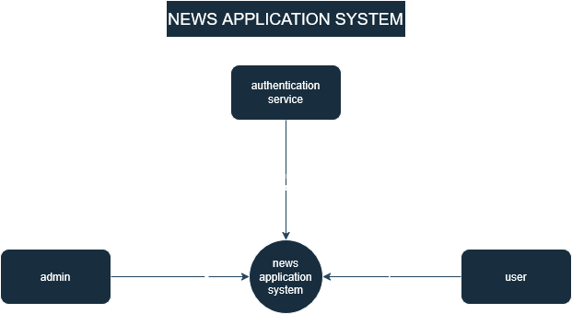

Figure 1.1

Level 1 Diagram

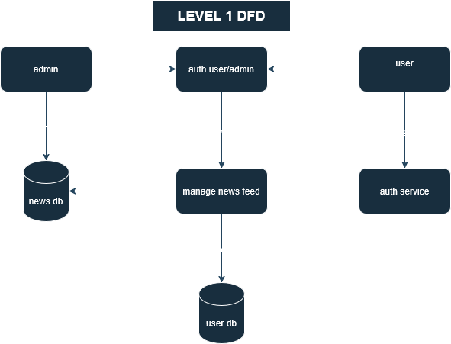

Figure 1.2

Level 2 Diagram

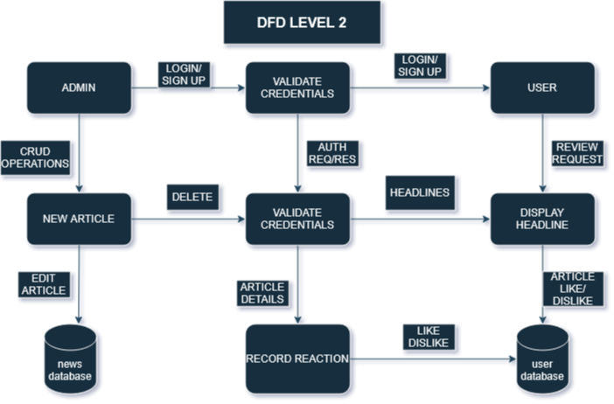

Figure 1.3

ER-Diagram:

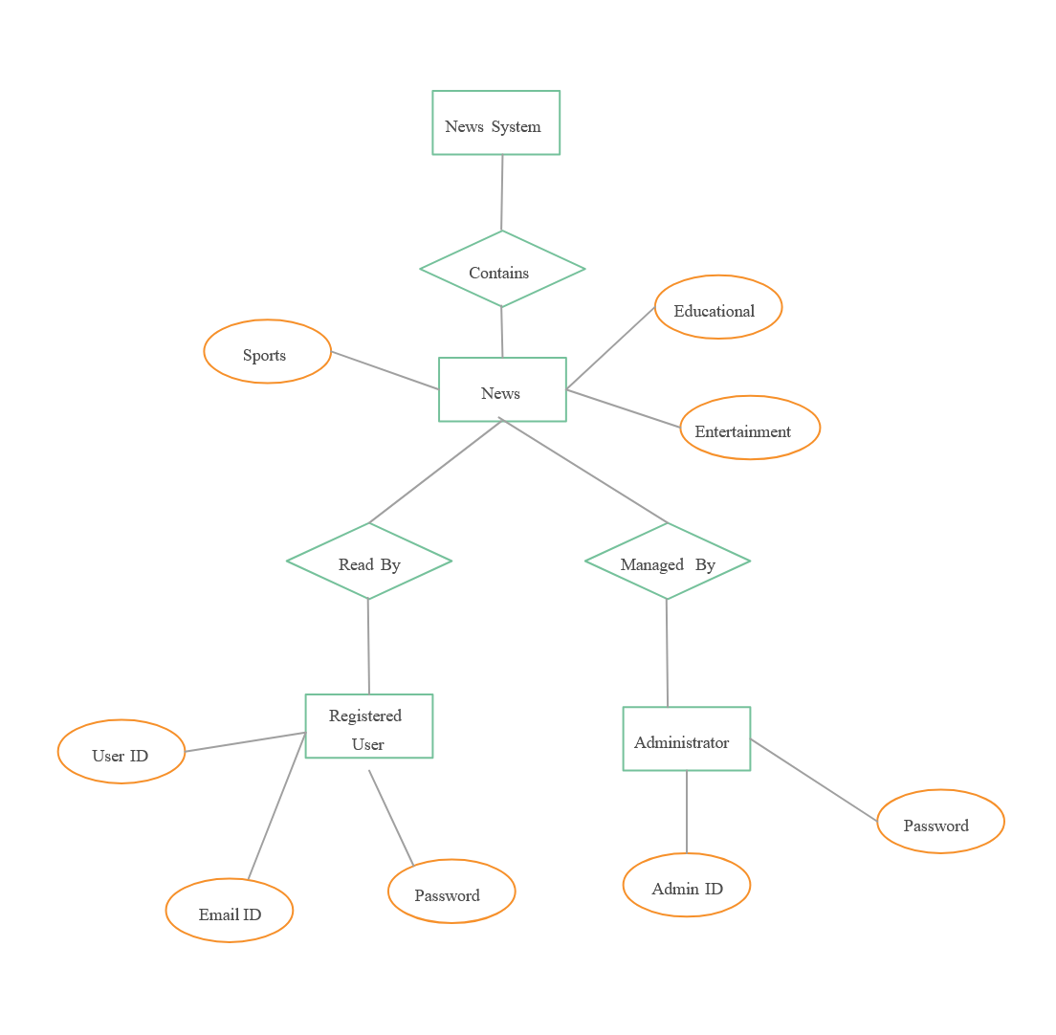

Figure 1.4

**Development Environment Setup**

Frontend and Backend Development Tools

In the development of the News Application, a variety of tools and technologies were employed to ensure a smooth and scalable full-stack architecture. React.js was used to build an interactive and responsive frontend, while Node.js powered the backend server. MongoDB served as the primary database for storing user data, news articles, and reactions. Development was carried out using Visual Studio Code, and version control was managed efficiently with Git and GitHub, enabling seamless collaboration and code tracking throughout the project.

**Implementation Process**

**Methodology for Frontend and Backend Development**

Frontend and backend development were carried out concurrently, guided by Agile practices. Regular integration and testing ensured compatibility and functionality.

**Challenges Faced and Solutions Adopted**

Challenges encountered during implementation, such as integration issues and performance bottlenecks, were addressed through collaboration and best practices.

**Version Control and Collaboration Tools**

Version control systems like Git and collaboration tools like Slack facilitated code management and communication among team members, ensuring code quality and consistency.

**CHAPTER 4**

**Analysis of User Interface**

Home page

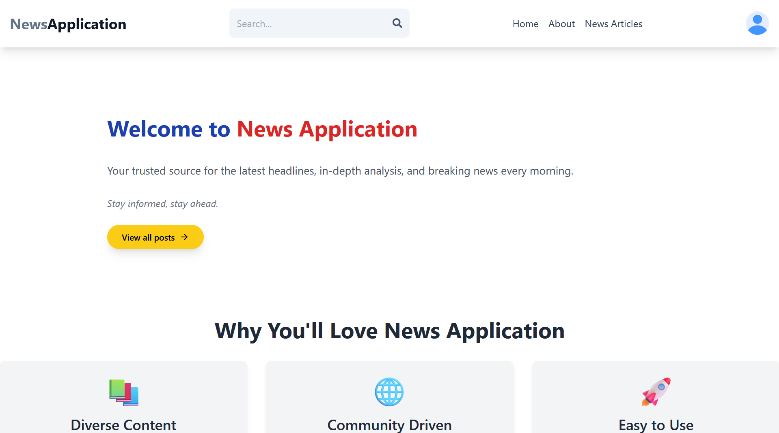

Figure 2.1

User Dashboard

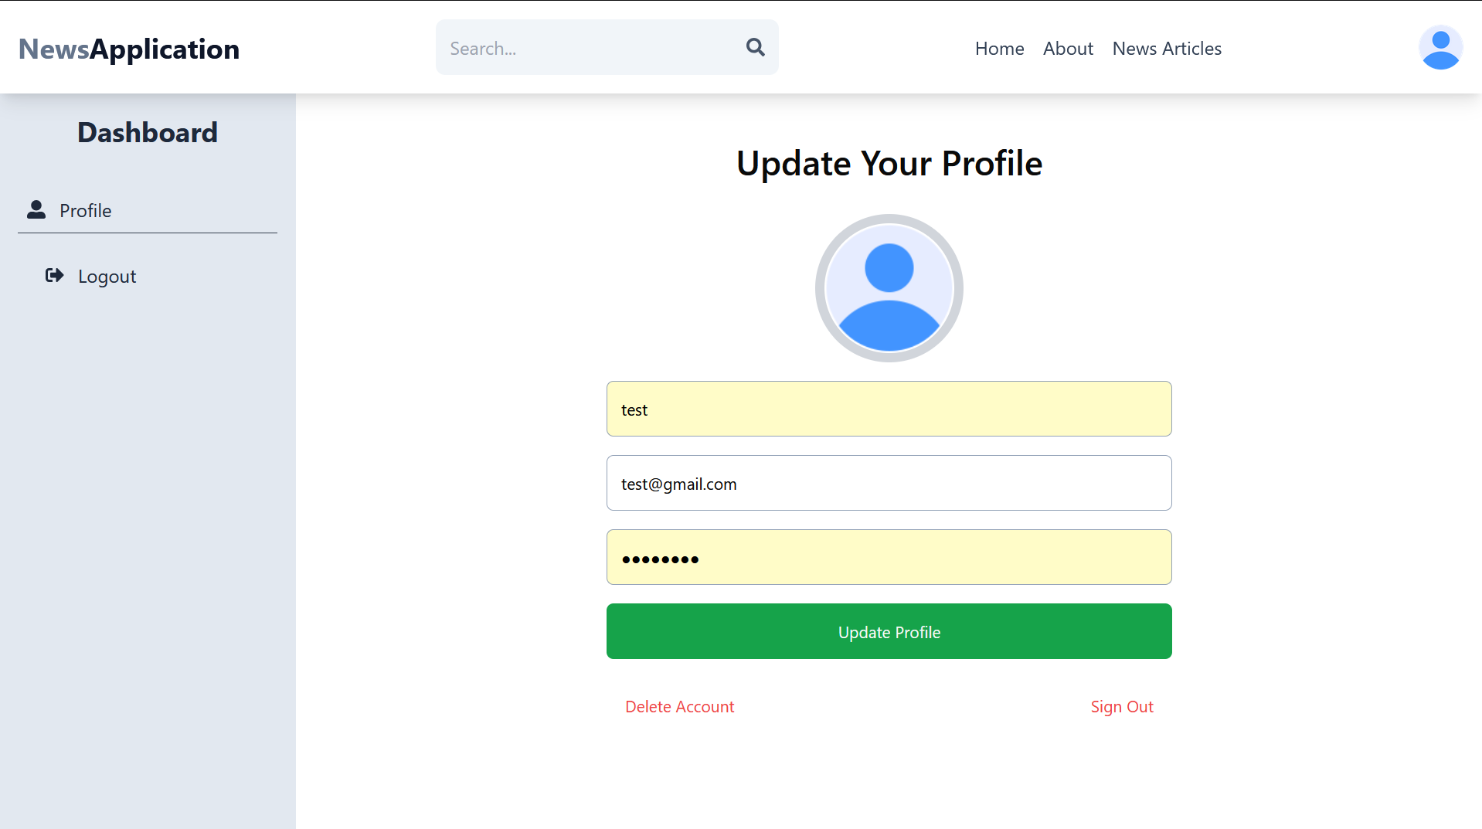 Figure 2.2

Admin Dashboard

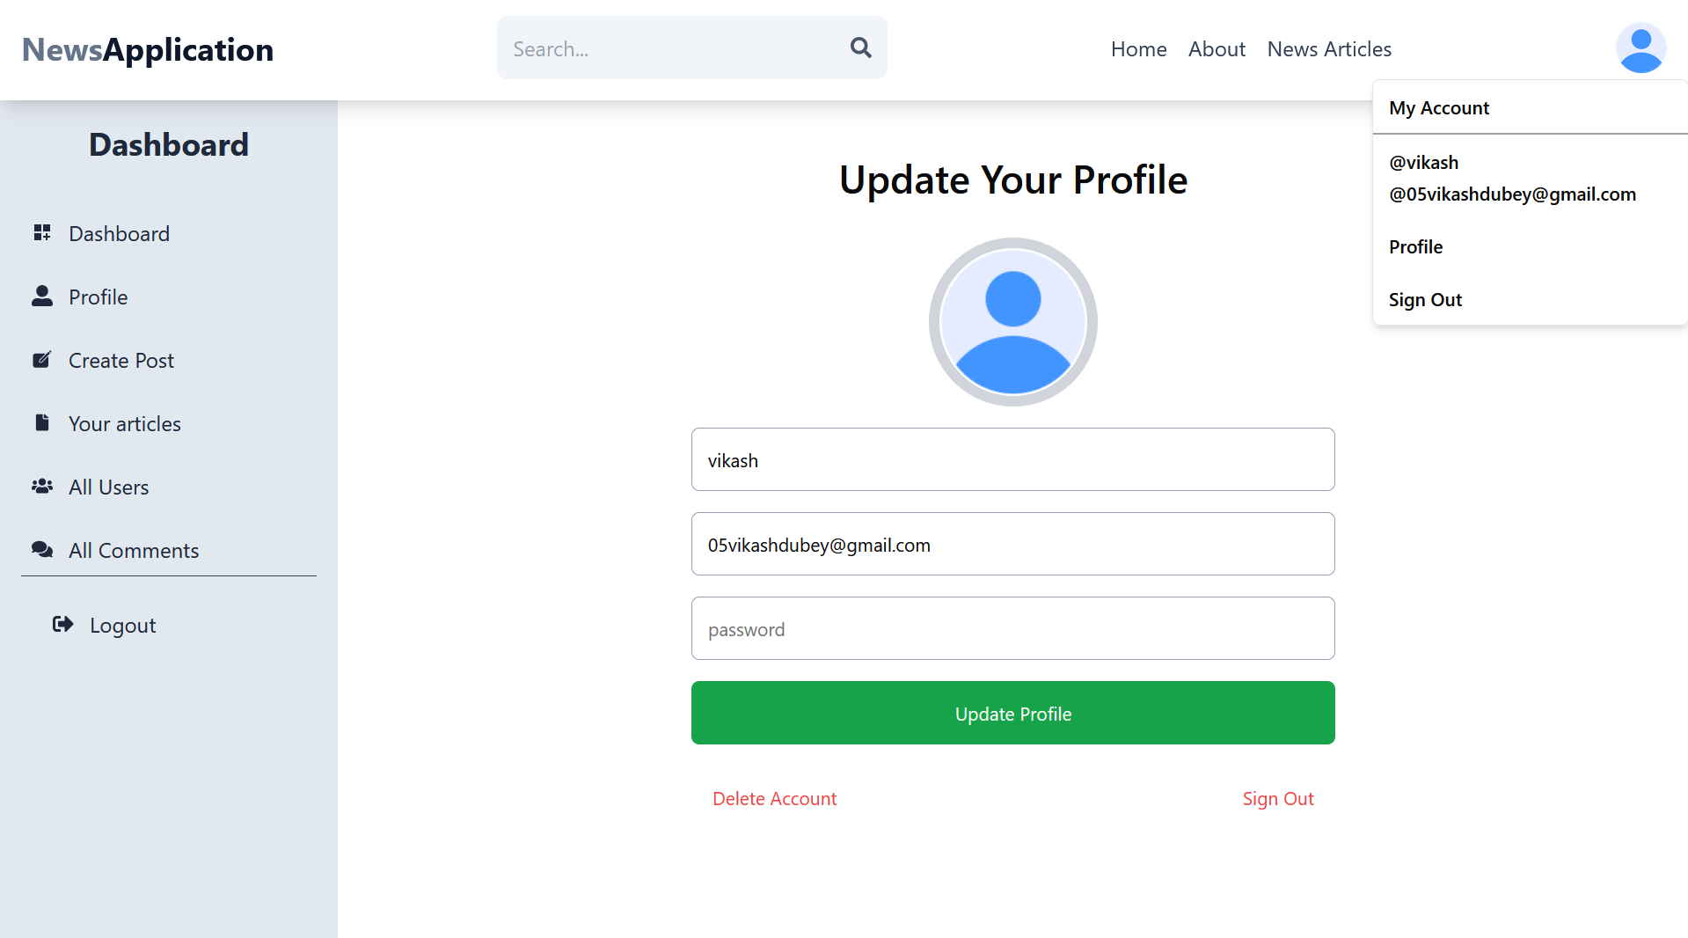

Figure 2.3

Manage News Page

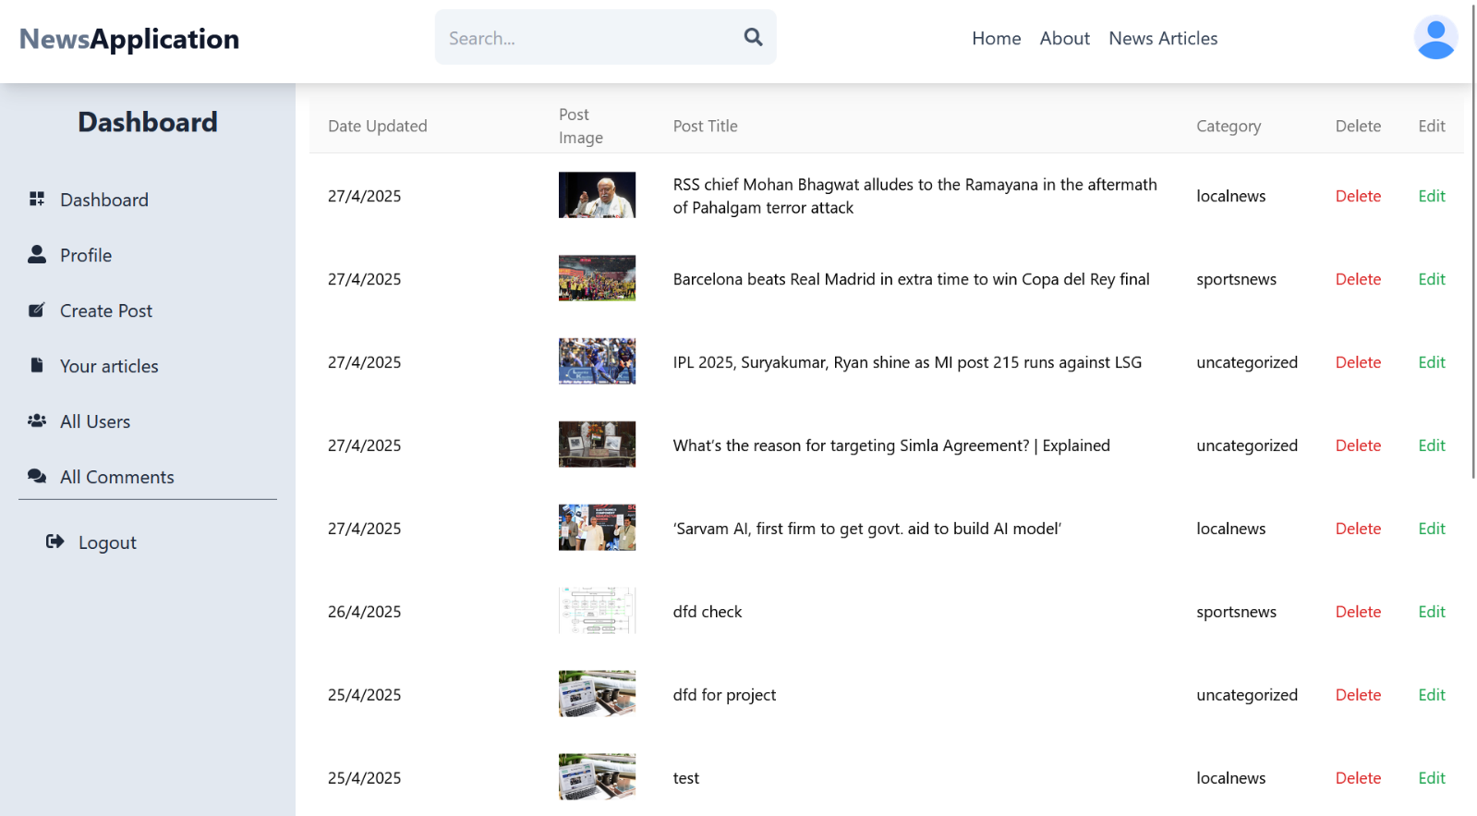

Figure 2.4

News Creation Page

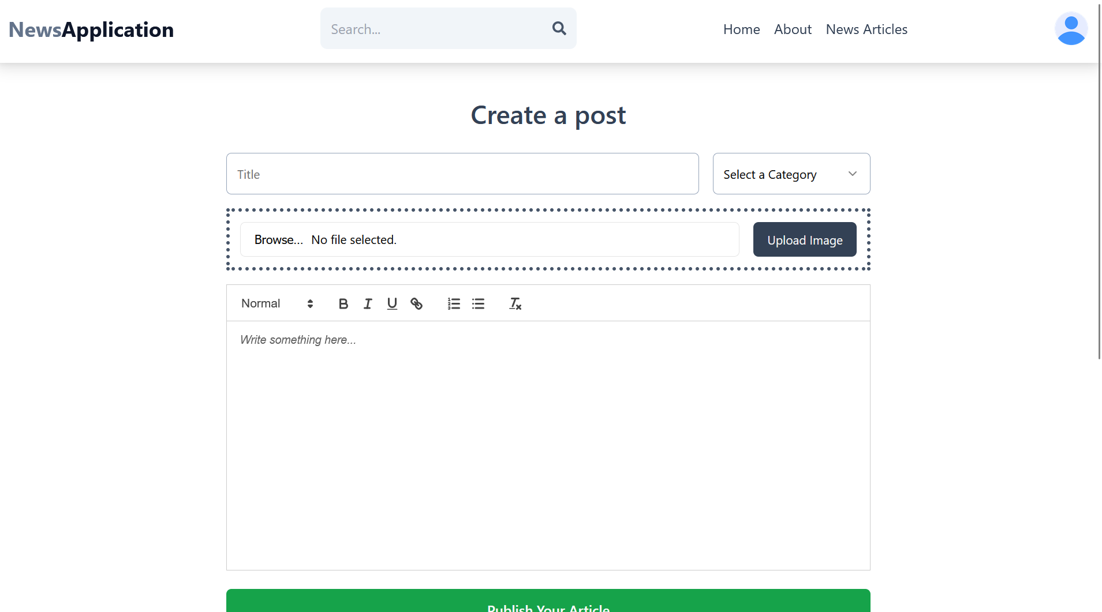

Figure 2.5

Posted News Page

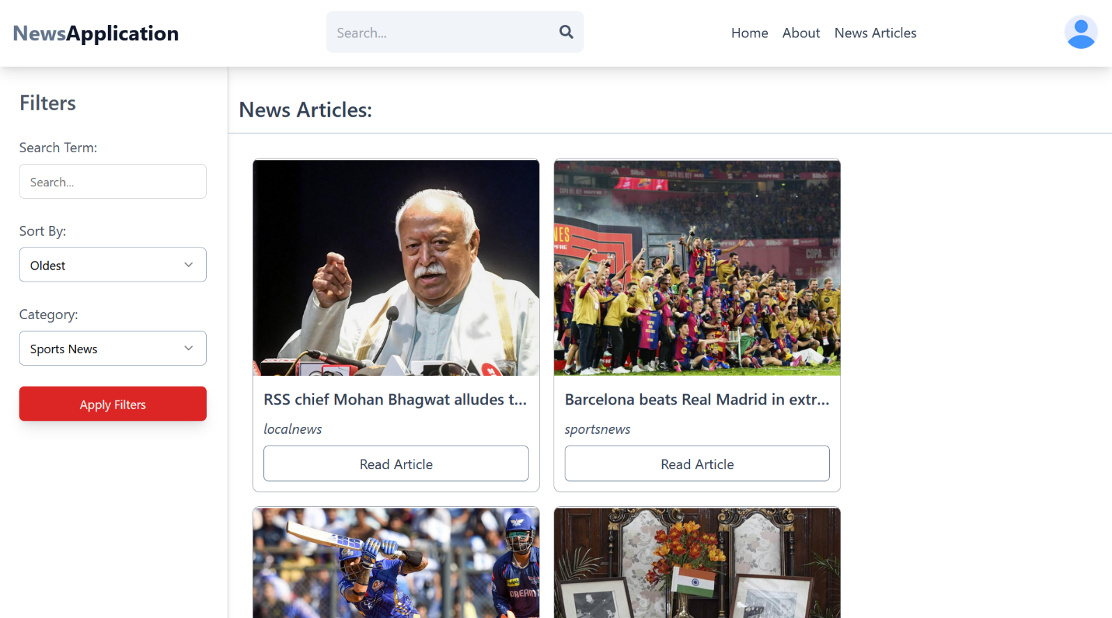

Figure 2.6

News Detail Page



Figure 2.7

Manage Comment Page

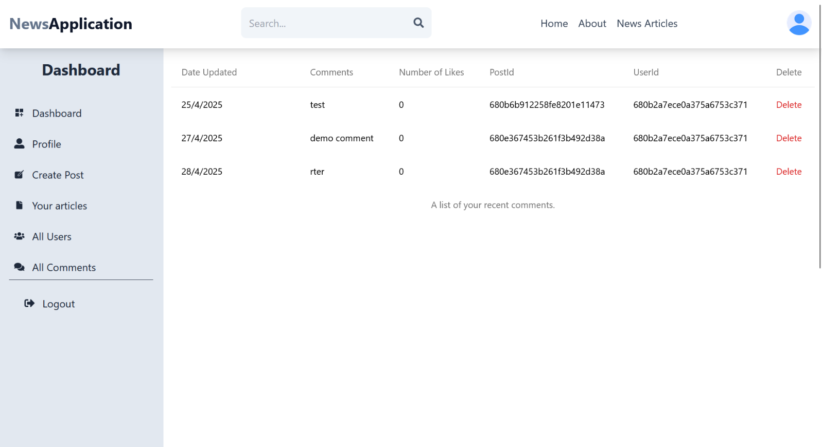

Figure 2.8

News Dashboard

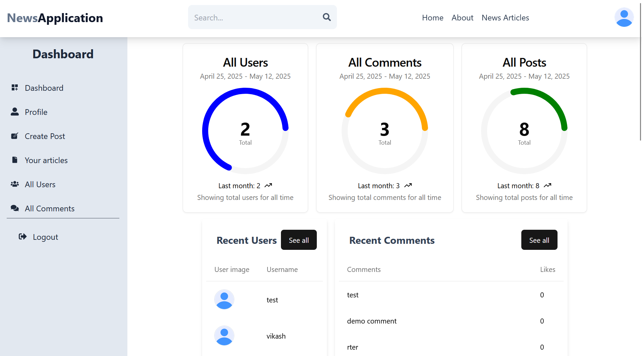

Figure 2.9

**CHAPTER 5**

**5. CONCLUSION**

In this concluding chapter, we explore the key accomplishments and forward-looking goals of the News Application, emphasizing its potential to revolutionize how users engage with digital news. From real-time updates to interactive features like reactions and personalized feeds, the platform marks a significant step toward redefining the modern news consumption experience**.**

**5.1 Summary of Findings and Achievements**

The News Application has accomplished significant milestones throughout its development journey, offering a modern and interactive approach to digital news consumption. Below is a detailed summary of the key findings and achievements:

* **Enhanced User Engagement:**

The platform emphasizes a user-centric design, delivering a seamless experience through features like real-time news updates, categorized feeds, and a clean, responsive interface. Personalized news delivery ensures users stay informed about topics that matter most to them.

* **Interactive and Dynamic Features:**

The application redefines how users interact with news by incorporating like/dislike reactions, search filters, and live updates powered by Socket.IO. These features foster real-time engagement and create a more immersive browsing experience.

* **Robust Authentication and Access Control:**

User data and session security are safeguarded through JWT-based authentication. This ensures that only authorized users can access specific functionalities, such as creating profiles, reacting to news, or managing personalized feeds.

* **Admin-Managed Content:**

Admins can seamlessly create, update, and manage news articles from a centralized dashboard. This structured content management system enables timely publication and easy moderation of headlines and stories.

* **Data Integrity and Performance:**

The backend architecture, built on the MERN stack, ensures high performance and data consistency. All user interactions, including reactions and comments, are securely stored in the database, maintaining both integrity and accessibility.

* **Fostering a News Community:**

The News Application promotes a sense of community among its users by enabling interaction through reactions and potentially comments (if implemented). This encourages healthy discussion and sharing of diverse perspectives on current events, turning passive readers into active participants in the news ecosystem.

* **Continuous Improvement Through Feedback:**

The platform embraces an agile, feedback-driven development cycle. Regular input from users has guided feature enhancements, UI/UX optimizations, and performance tuning—ensuring the application stays aligned with user expectations and technological advancements.

* **Adherence to Best Practices and Standards:**

Built with the MERN stack, the application follows modern web development best practices. These include secure coding standards, modular architecture, RESTful API design, and mobile responsiveness. Commitment to scalability, maintainability, and security positions the News Application as a reliable and forward-thinking news delivery platform.

**5.2 Future Enhancements and Directions**

While the current version of the **News Application** marks a significant step forward in digital news delivery, the journey is ongoing. Looking ahead, we foresee several opportunities to expand the platform’s capabilities and deliver even greater value to users:

* **User Commenting and Discussions:**

Introducing a commenting system will allow users to engage in meaningful discussions on news topics, fostering a more interactive and community-driven environment.

* **AI-Powered News Recommendations:**

Leveraging machine learning to analyze user preferences and reading behavior can help deliver personalized news recommendations, improving content relevance and user retention.

* **Multilingual Support:**

To cater to a broader audience, the application will explore support for multiple languages, making regional and local news more accessible and inclusive.

* **Push Notifications and Alerts:**

Implementing real-time notifications for breaking news or topic-specific alerts will enhance user engagement and ensure timely updates.

* **Offline Reading Mode:**

An offline mode will enable users to save articles and access them without an internet connection, offering flexibility and convenience.

* **Analytics Dashboard for Admins:**

A future enhancement includes a detailed analytics dashboard for admins to monitor user engagement, popular articles, and content performance, aiding in data-driven decisions.

**REFERENCES**

MongoDB Inc (2023). - MongoDB Atlas Documentation

[https://docs.mongodb.com/atlas]

Express.js. (2021). Express - Node.js web application framework. [https://expressjs.com]

React.js. (2022). React - A JavaScript library for building user interfaces.

[https://reactjs.org]

MongoDB Inc. (2021). MongoDB - The database for modern applications.

[https://www.mongodb.com]

Node.js Foundation. (2021). Node.js. Retrieved from [https://nodejs.org/]

Axios. (2023). Axios - Promise based HTTP client for the browser and node.js.

Retrieved from [https://axios-http.com/]

JWT.io. (2022). JWT.io - JSON Web Tokens. Retrieved from [https://jwt.io/]