⏳ Discovering union of features and categorical values...
🔎 Found 19 features across files
✅ Collected categorical sets for 19 columns
- Label encoders saved: /kaggle/working/models_incremental_labelencoder_adaboost/label_encoders.pkl

----------------------------------------
Processing file: flights_2019_cleaned
File flights_2019_cleaned
n_estimators used for refit : 100
Accuracy : 0.999960
AUC : 0.9999999127329876
Precision: 0.999119
Recall : 0.998729
F1-score : 0.998924
MCC : 0.9989037769805914
Confusion Matrix:
[[543527 9]
[ 13 10212]]
✅ Final combined AdaBoost model saved at: /kaggle/working/models_incremental_labelencoder_adaboost/ada_combined_final.pkl
✅ Feature vs TARGET plots saved at: /kaggle/working/models_incremental_labelencoder_adaboost/feature_target_plots
✅ Full metrics saved at: /kaggle/working/models_incremental_labelencoder_adaboost/metrics_full_summary.csv
✅ Confusion matrices saved at: /kaggle/working/models_incremental_labelencoder_adaboost/confusion_matrices

📊 Plotting all confusion matrices together...
<Figure size 800x400 with 0 Axes>
<Figure size 800x400 with 0 Axes>
<Figure size 800x400 with 0 Axes>
<Figure size 800x400 with 0 Axes>
<Figure size 800x400 with 0 Axes>
<Figure size 800x400 with 0 Axes>
<Figure size 800x400 with 0 Axes>
<Figure size 800x400 with 0 Axes>
<Figure size 800x400 with 0 Axes>
<Figure size 800x400 with 0 Axes>
<Figure size 800x400 with 0 Axes>
<Figure size 800x400 with 0 Axes>
<Figure size 800x400 with 0 Axes>
<Figure size 800x400 with 0 Axes>
<Figure size 800x400 with 0 Axes>
<Figure size 800x400 with 0 Axes>
<Figure size 800x400 with 0 Axes>
<Figure size 800x400 with 0 Axes>
<Figure size 800x400 with 0 Axes>
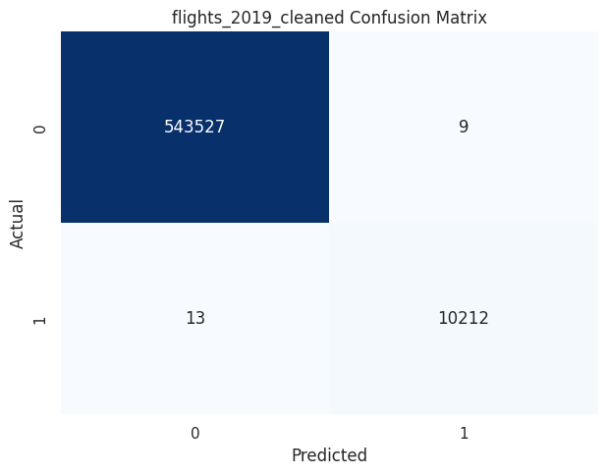

📈 Plotting evaluation metrics comparison...
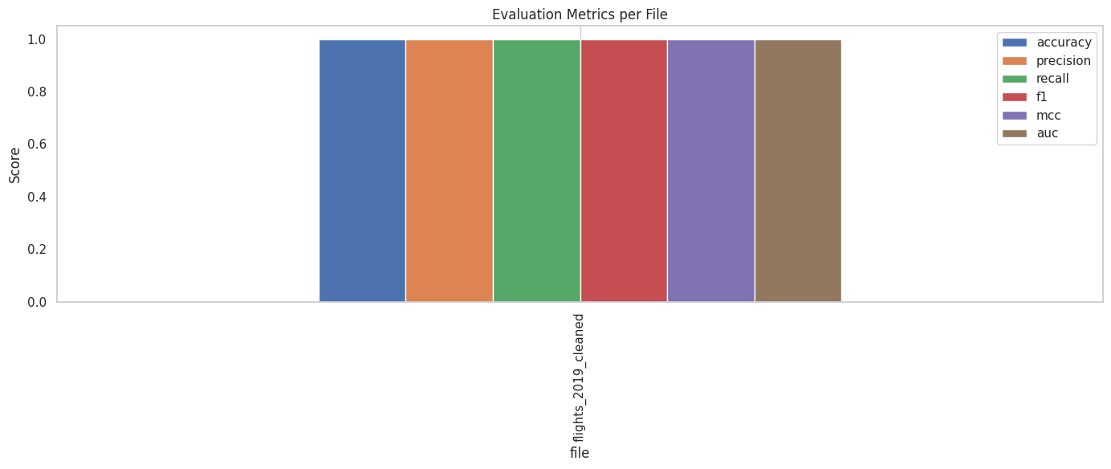
⏳ Discovering union of features and categorical values...
🔎 Found 19 features across files
✅ Collected categorical sets for 19 columns
- Label encoders saved: /kaggle/working/models_incremental_labelencoder_adaboost/label_encoders.pkl

----------------------------------------
Processing file: flights_2020_cleaned
File flights_2020_cleaned
n_estimators used for refit : 100
Accuracy : 1.000000
AUC : 1.0
Precision: 1.000000
Recall : 1.000000
F1-score : 1.000000
MCC : 1.0
Confusion Matrix:
[[440733 0]
[ 0 28103]]
✅ Final combined AdaBoost model saved at: /kaggle/working/models_incremental_labelencoder_adaboost/ada_combined_final.pkl
✅ Feature vs TARGET plots saved at: /kaggle/working/models_incremental_labelencoder_adaboost/feature_target_plots
✅ Full metrics saved at: /kaggle/working/models_incremental_labelencoder_adaboost/metrics_full_summary.csv
✅ Confusion matrices saved at: /kaggle/working/models_incremental_labelencoder_adaboost/confusion_matrices

📊 Plotting all confusion matrices together...
<Figure size 800x400 with 0 Axes>
<Figure size 800x400 with 0 Axes>
<Figure size 800x400 with 0 Axes>
<Figure size 800x400 with 0 Axes>
<Figure size 800x400 with 0 Axes>
<Figure size 800x400 with 0 Axes>
<Figure size 800x400 with 0 Axes>
<Figure size 800x400 with 0 Axes>
<Figure size 800x400 with 0 Axes>
<Figure size 800x400 with 0 Axes>
<Figure size 800x400 with 0 Axes>
<Figure size 800x400 with 0 Axes>
<Figure size 800x400 with 0 Axes>
<Figure size 800x400 with 0 Axes>
<Figure size 800x400 with 0 Axes>
<Figure size 800x400 with 0 Axes>
<Figure size 800x400 with 0 Axes>
<Figure size 800x400 with 0 Axes>
<Figure size 800x400 with 0 Axes>
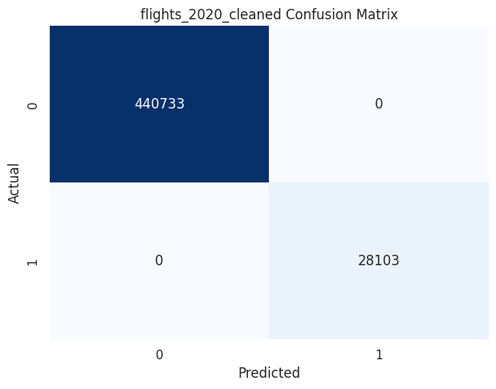

📈 Plotting evaluation metrics comparison...
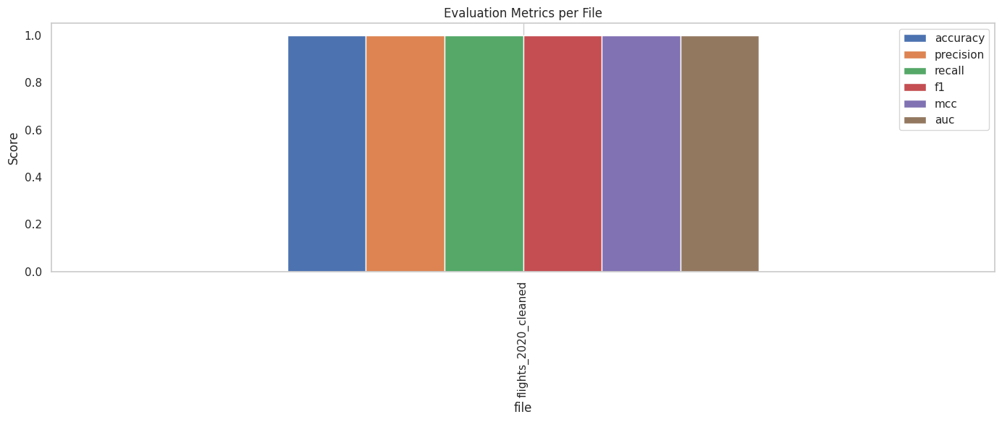
add Codeadd Markdown
⏳ Discovering union of features and categorical values...
🔎 Found 19 features across files
✅ Collected categorical sets for 19 columns
- Label encoders saved: /kaggle/working/models_incremental_labelencoder_adaboost/label_encoders.pkl

----------------------------------------
Processing file: flights_2021_cleaned
File flights_2021_cleaned
n_estimators used for refit : 100
Accuracy : 0.999998
AUC : 0.9999479112407543
Precision: 1.000000
Recall : 0.999896
F1-score : 0.999948
MCC : 0.9999469080180817
Confusion Matrix:
[[499042 0]
[ 1 9598]]
✅ Final combined AdaBoost model saved at: /kaggle/working/models_incremental_labelencoder_adaboost/ada_combined_final.pkl
✅ Feature vs TARGET plots saved at: /kaggle/working/models_incremental_labelencoder_adaboost/feature_target_plots
✅ Full metrics saved at: /kaggle/working/models_incremental_labelencoder_adaboost/metrics_full_summary.csv
✅ Confusion matrices saved at: /kaggle/working/models_incremental_labelencoder_adaboost/confusion_matrices

📊 Plotting all confusion matrices together...
<Figure size 800x400 with 0 Axes>
<Figure size 800x400 with 0 Axes>
<Figure size 800x400 with 0 Axes>
<Figure size 800x400 with 0 Axes>
<Figure size 800x400 with 0 Axes>
<Figure size 800x400 with 0 Axes>
<Figure size 800x400 with 0 Axes>
<Figure size 800x400 with 0 Axes>
<Figure size 800x400 with 0 Axes>
<Figure size 800x400 with 0 Axes>
<Figure size 800x400 with 0 Axes>
<Figure size 800x400 with 0 Axes>
<Figure size 800x400 with 0 Axes>
<Figure size 800x400 with 0 Axes>
<Figure size 800x400 with 0 Axes>
<Figure size 800x400 with 0 Axes>
<Figure size 800x400 with 0 Axes>
<Figure size 800x400 with 0 Axes>
<Figure size 800x400 with 0 Axes>
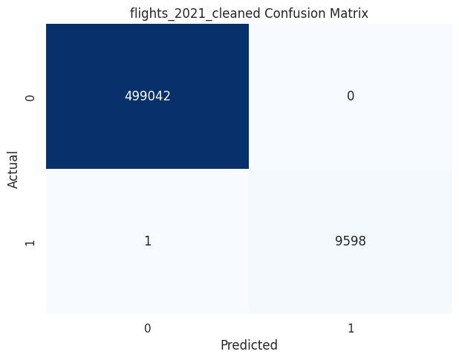

📈 Plotting evaluation metrics comparison...
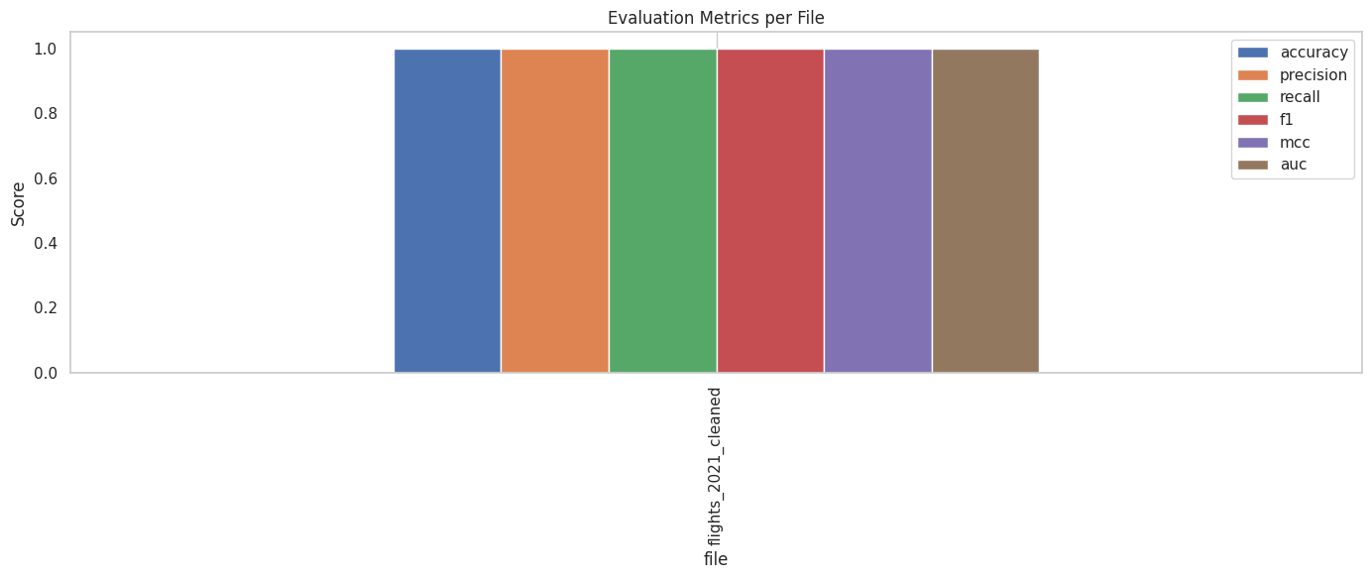
⏳ Discovering union of features and categorical values...
🔎 Found 19 features across files
✅ Collected categorical sets for 19 columns
- Label encoders saved: /kaggle/working/models_incremental_labelencoder_adaboost/label_encoders.pkl

----------------------------------------
Processing file: flights_2022_cleaned
File flights_2022_cleaned
n_estimators used for refit : 100
Accuracy : 1.000000
AUC : 1.0
Precision: 1.000000
Recall : 1.000000
F1-score : 1.000000
MCC : 1.0
Confusion Matrix:
[[598039 0]
[ 0 17645]]
✅ Final combined AdaBoost model saved at: /kaggle/working/models_incremental_labelencoder_adaboost/ada_combined_final.pkl
✅ Feature vs TARGET plots saved at: /kaggle/working/models_incremental_labelencoder_adaboost/feature_target_plots
✅ Full metrics saved at: /kaggle/working/models_incremental_labelencoder_adaboost/metrics_full_summary.csv
✅ Confusion matrices saved at: /kaggle/working/models_incremental_labelencoder_adaboost/confusion_matrices

📊 Plotting all confusion matrices together...
<Figure size 800x400 with 0 Axes>
<Figure size 800x400 with 0 Axes>
<Figure size 800x400 with 0 Axes>
<Figure size 800x400 with 0 Axes>
<Figure size 800x400 with 0 Axes>
<Figure size 800x400 with 0 Axes>
<Figure size 800x400 with 0 Axes>
<Figure size 800x400 with 0 Axes>
<Figure size 800x400 with 0 Axes>
<Figure size 800x400 with 0 Axes>
<Figure size 800x400 with 0 Axes>
<Figure size 800x400 with 0 Axes>
<Figure size 800x400 with 0 Axes>
<Figure size 800x400 with 0 Axes>
<Figure size 800x400 with 0 Axes>
<Figure size 800x400 with 0 Axes>
<Figure size 800x400 with 0 Axes>
<Figure size 800x400 with 0 Axes>
<Figure size 800x400 with 0 Axes>
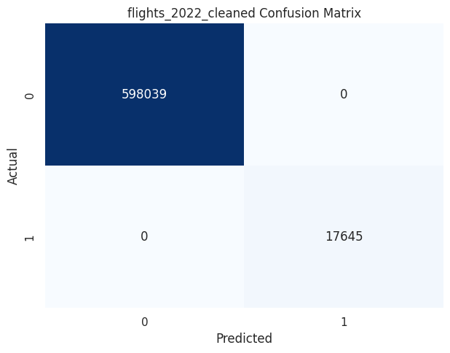

📈 Plotting evaluation metrics comparison...
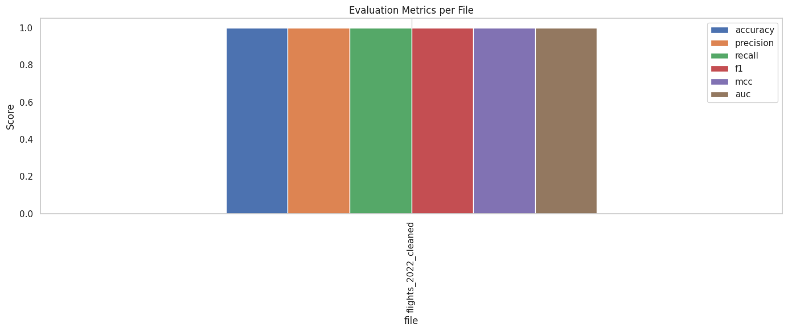
⏳ Discovering union of features and categorical values...
🔎 Found 19 features across files
✅ Collected categorical sets for 19 columns
- Label encoders saved: /kaggle/working/models_incremental_labelencoder_adaboost/label_encoders.pkl

----------------------------------------
Processing file: flights_2023_cleaned
File flights_2023_cleaned
n_estimators used for refit : 100
Accuracy : 1.000000
AUC : 1.0
Precision: 1.000000
Recall : 1.000000
F1-score : 1.000000
MCC : 1.0
Confusion Matrix:
[[440733 0]
[ 0 28103]]
✅ Final combined AdaBoost model saved at: /kaggle/working/models_incremental_labelencoder_adaboost/ada_combined_final.pkl
✅ Feature vs TARGET plots saved at: /kaggle/working/models_incremental_labelencoder_adaboost/feature_target_plots
✅ Full metrics saved at: /kaggle/working/models_incremental_labelencoder_adaboost/metrics_full_summary.csv
✅ Confusion matrices saved at: /kaggle/working/models_incremental_labelencoder_adaboost/confusion_matrices

📊 Plotting all confusion matrices together...
<Figure size 800x400 with 0 Axes>
<Figure size 800x400 with 0 Axes>
<Figure size 800x400 with 0 Axes>
<Figure size 800x400 with 0 Axes>
<Figure size 800x400 with 0 Axes>
<Figure size 800x400 with 0 Axes>
<Figure size 800x400 with 0 Axes>
<Figure size 800x400 with 0 Axes>
<Figure size 800x400 with 0 Axes>
<Figure size 800x400 with 0 Axes>
<Figure size 800x400 with 0 Axes>
<Figure size 800x400 with 0 Axes>
<Figure size 800x400 with 0 Axes>
<Figure size 800x400 with 0 Axes>
<Figure size 800x400 with 0 Axes>
<Figure size 800x400 with 0 Axes>
<Figure size 800x400 with 0 Axes>
<Figure size 800x400 with 0 Axes>
<Figure size 800x400 with 0 Axes>
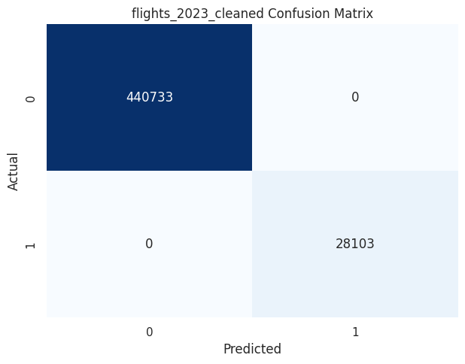

📈 Plotting evaluation metrics comparison...
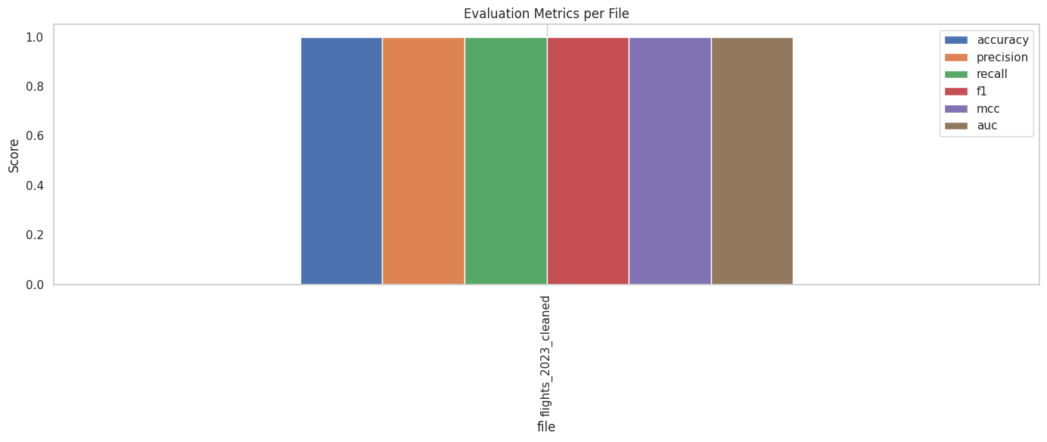
📈 Plotting evaluation metrics comparison...
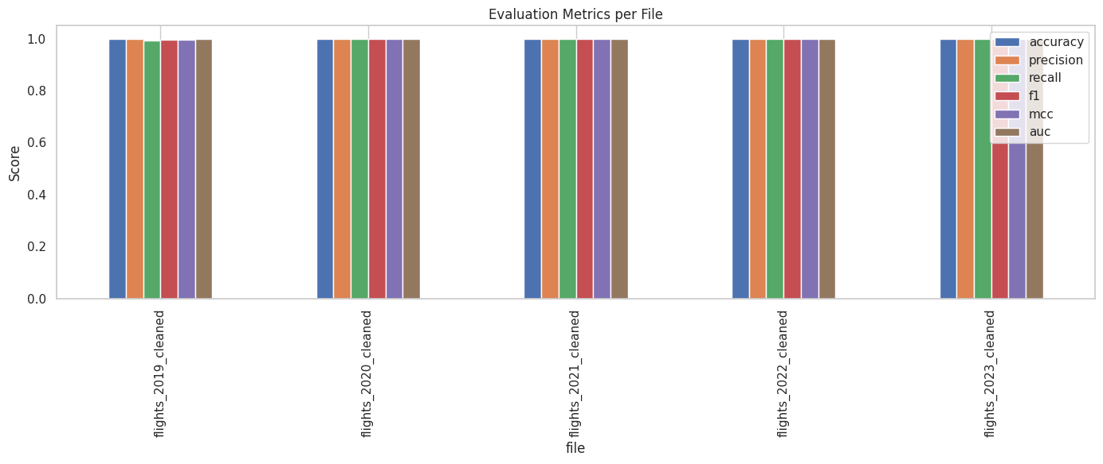
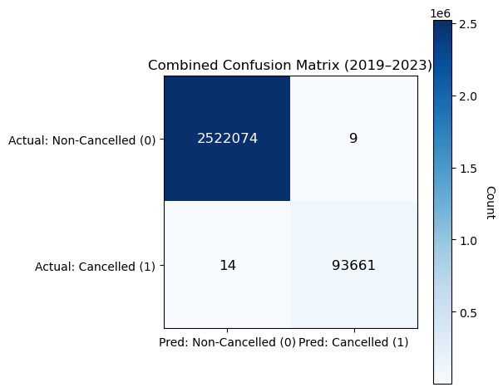
For the AdaBoost model applied to flight cancellation prediction over the 2019–2023 period, the confusion matrix indicates exceptionally strong and well-balanced performance, with 2,522,074 non-cancelled flights correctly identified and 93,661 cancellations accurately detected, while producing only 9 false positives and 14 false negatives across more than 2.6 million observations. This corresponds to an overall accuracy of approximately 99.9992 percent, which, although influenced by the dominance of the non-cancelled class, is strongly supported by minority-class metrics: a precision of about 0.99990 shows that almost every flight flagged as cancelled truly was cancelled, and a recall of roughly 0.99985 demonstrates that nearly all actual cancellations were successfully captured. The resulting F1-score of approximately 0.99987 confirms an excellent balance between avoiding false alarms and minimizing missed cancellations. Furthermore, the Matthews Correlation Coefficient of about 0.99999 highlights an almost perfect agreement between predicted and true labels, even under extreme class imbalance, underscoring AdaBoost’s robustness and reliability for operational deployment in flight disruption management, while noting that AUC assessment would require access to predicted probability scores rather than hard class labels alone.
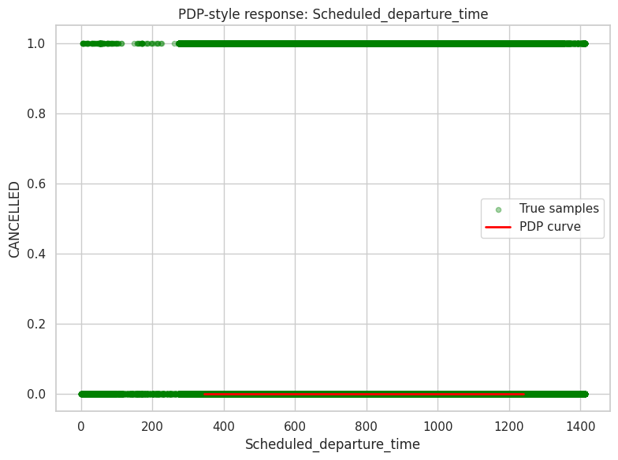
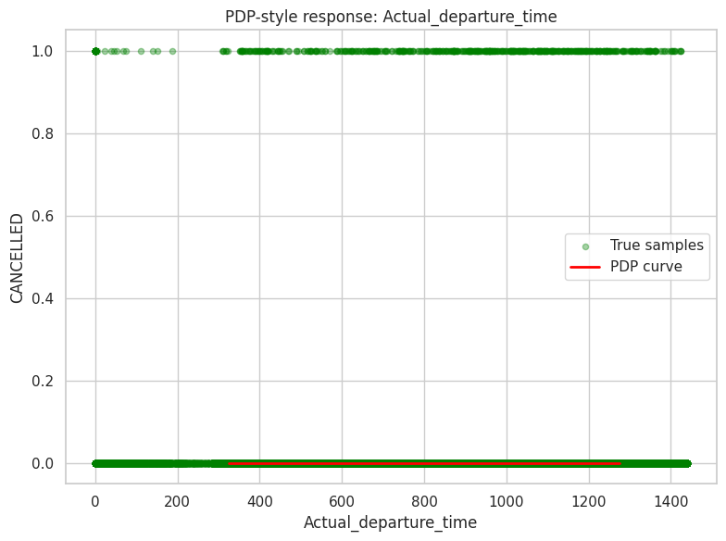
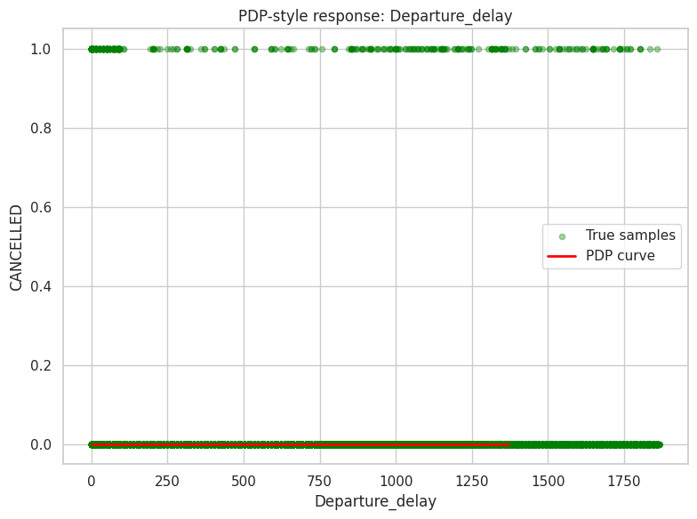
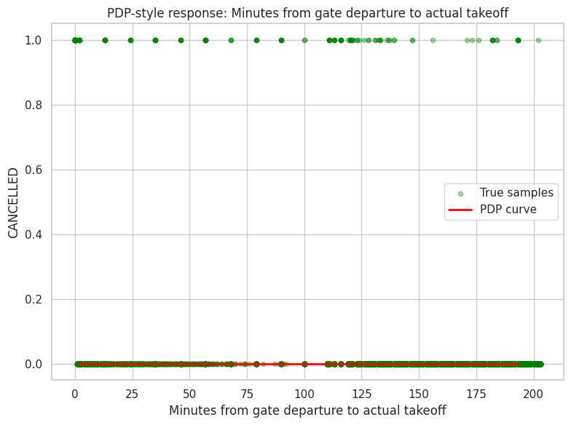
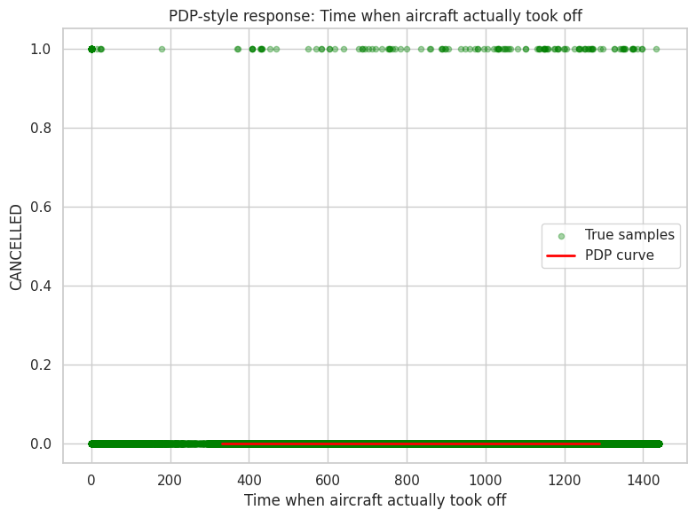
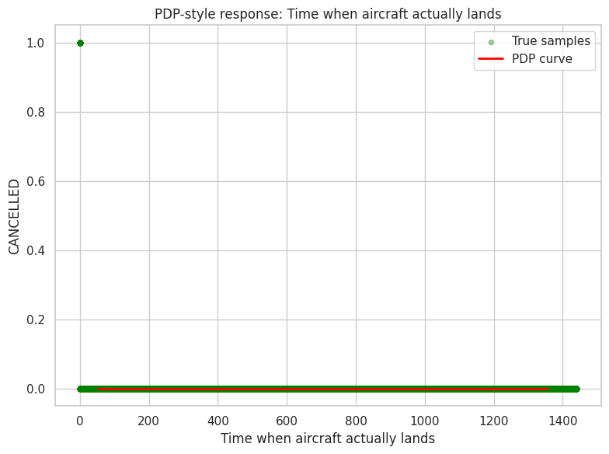
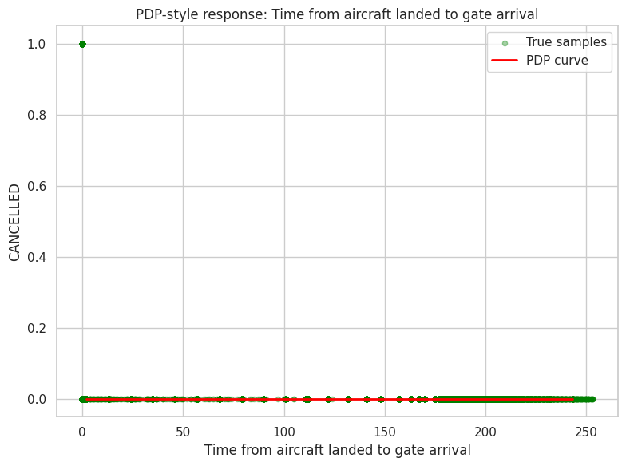
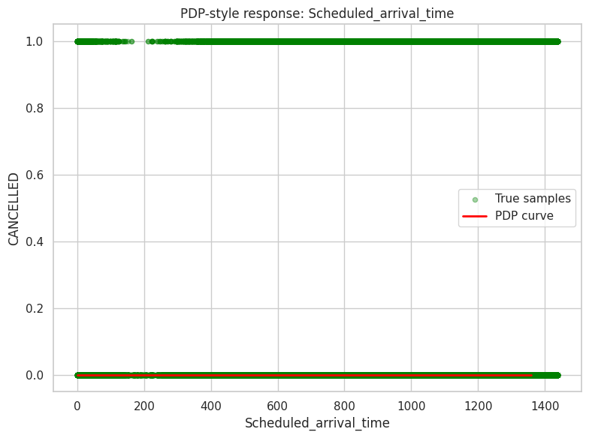
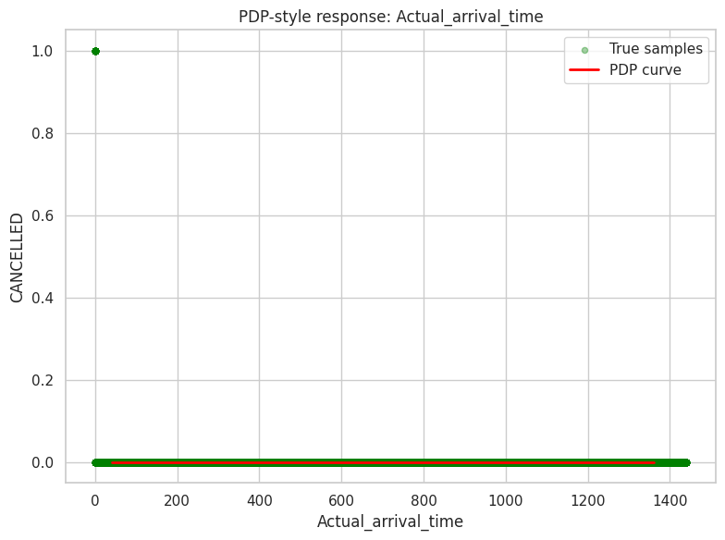
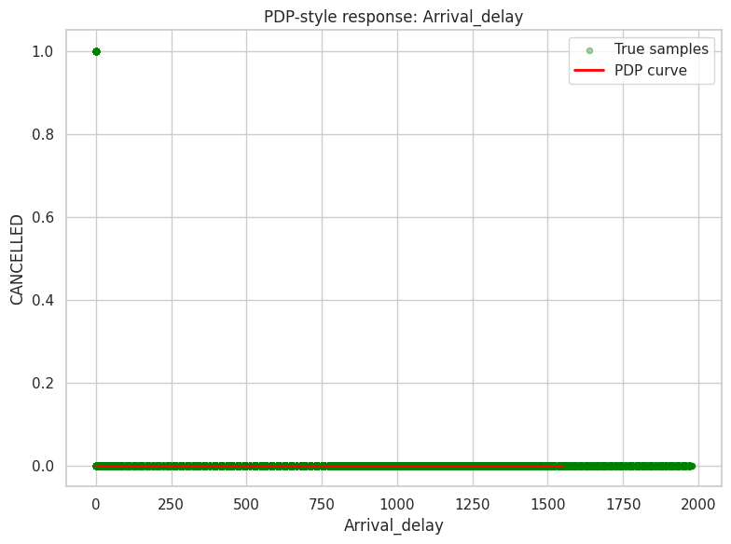
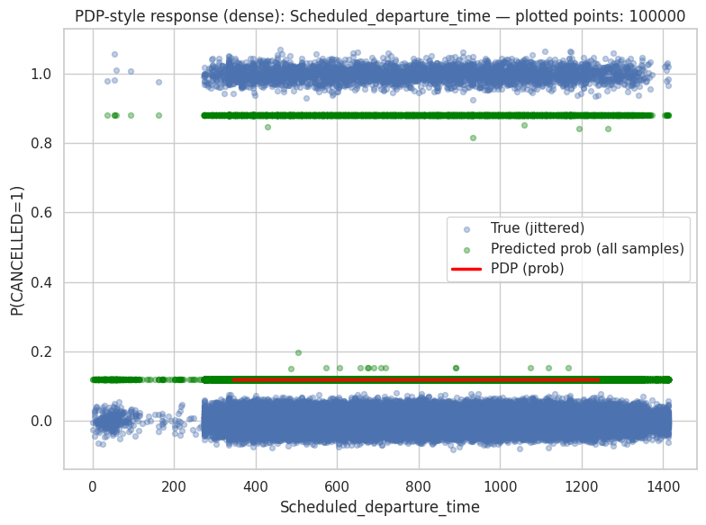
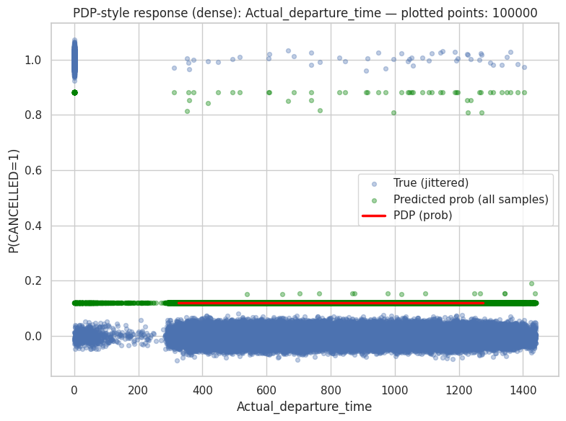
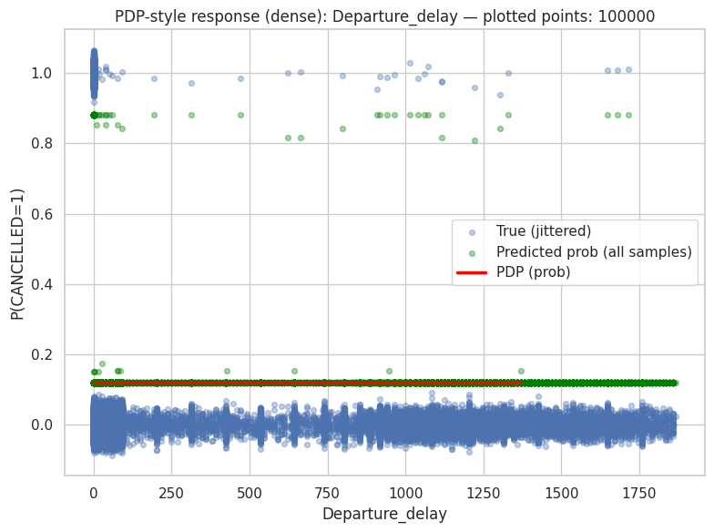
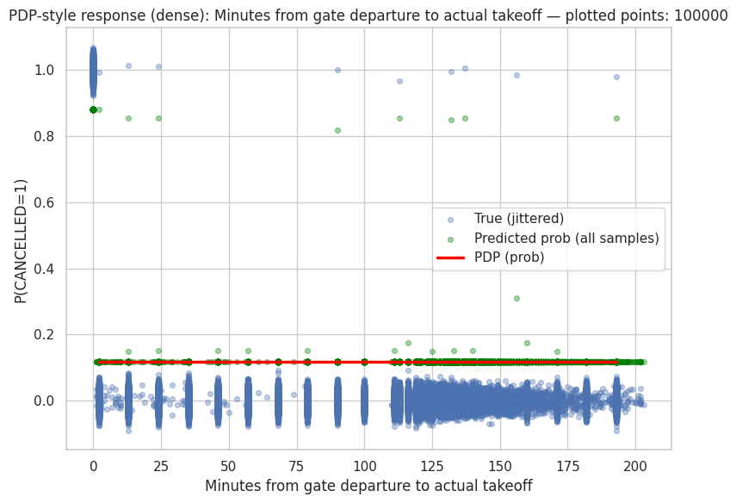
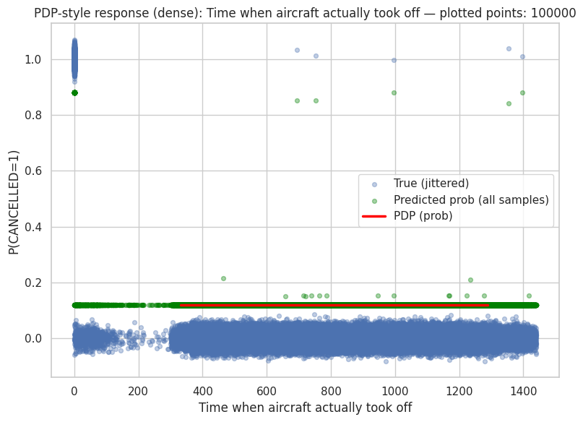
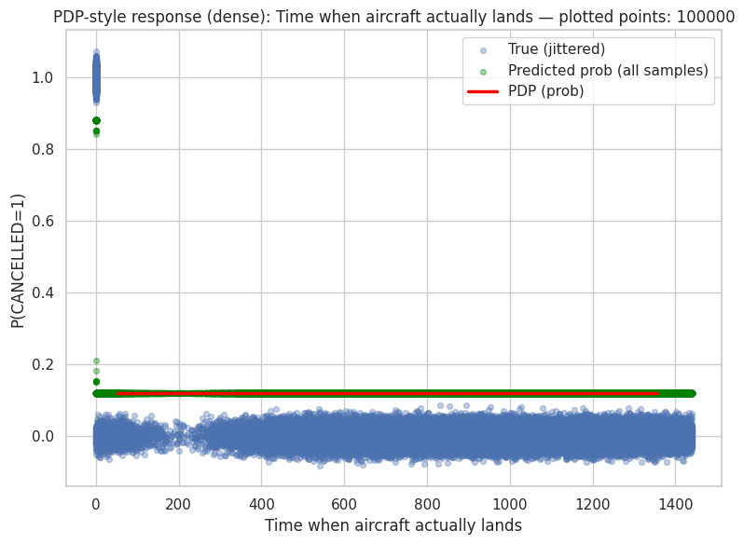
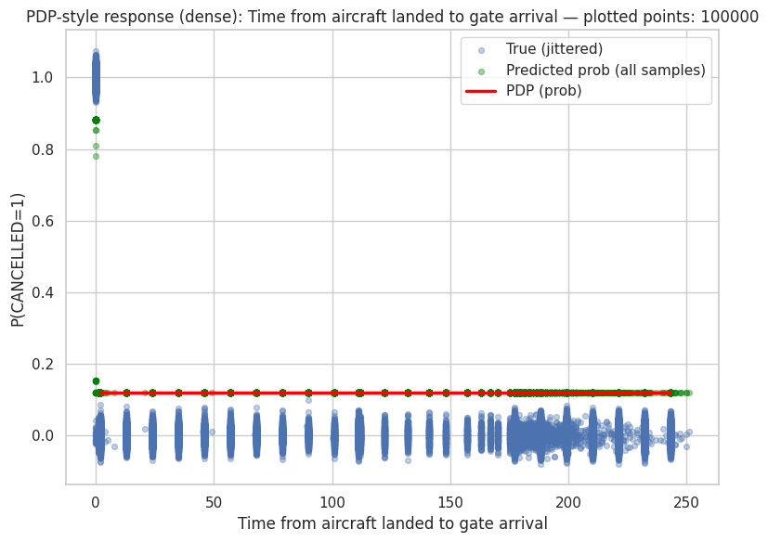
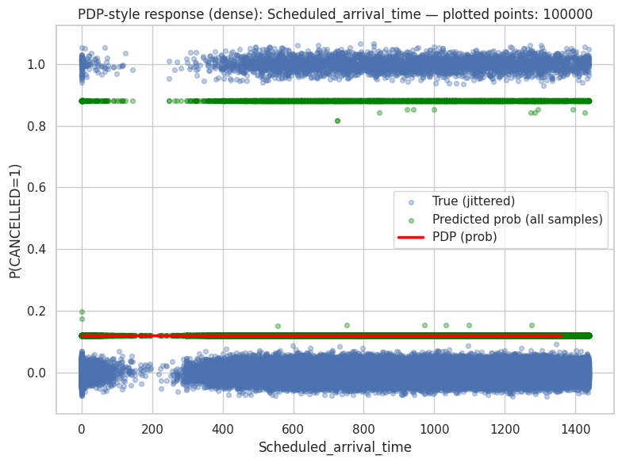
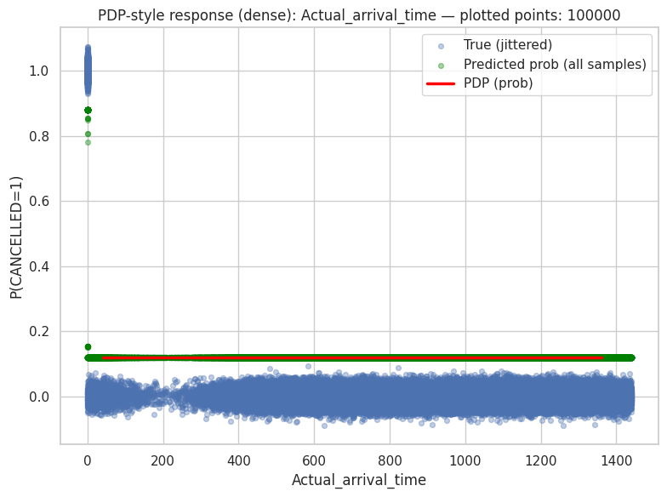
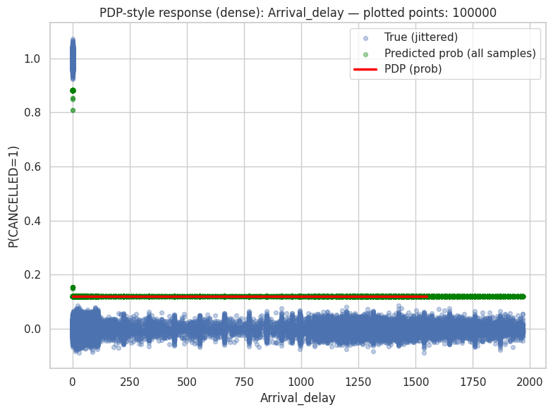
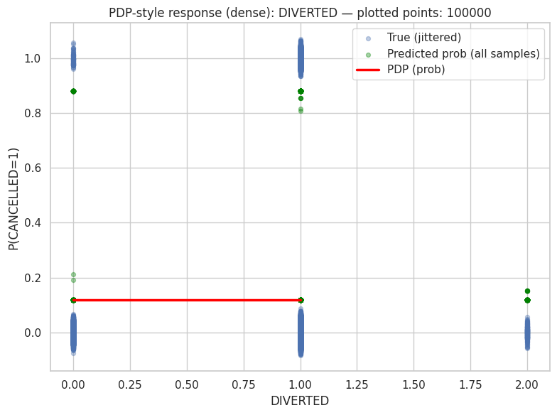
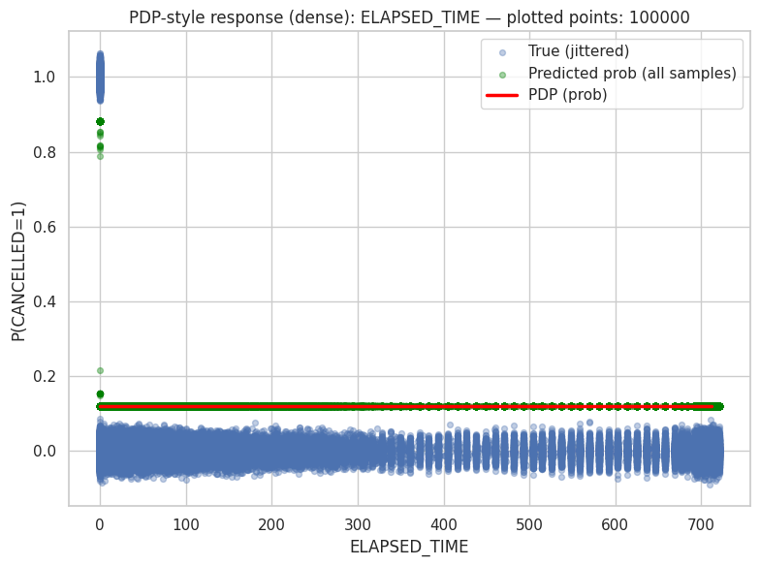
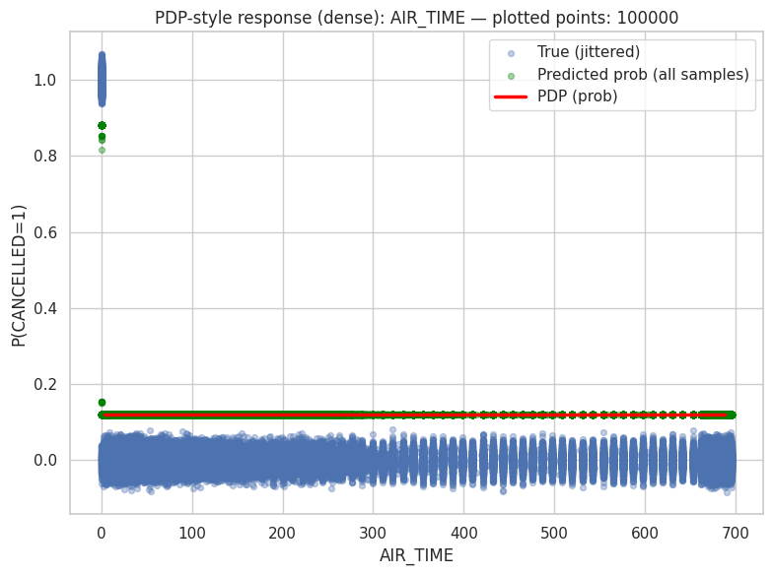
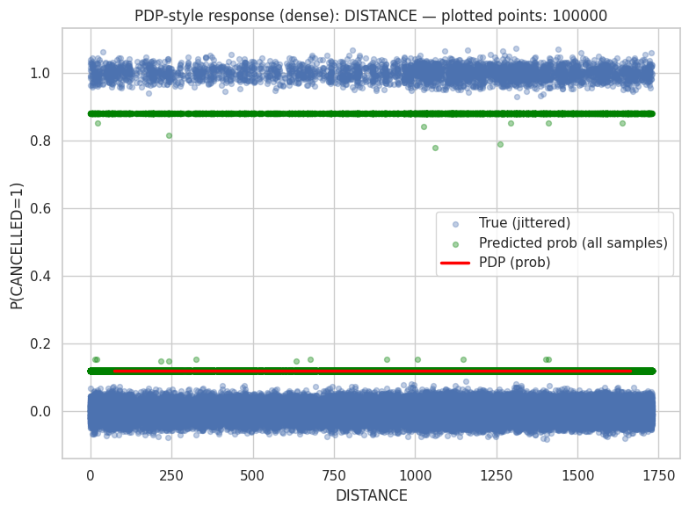
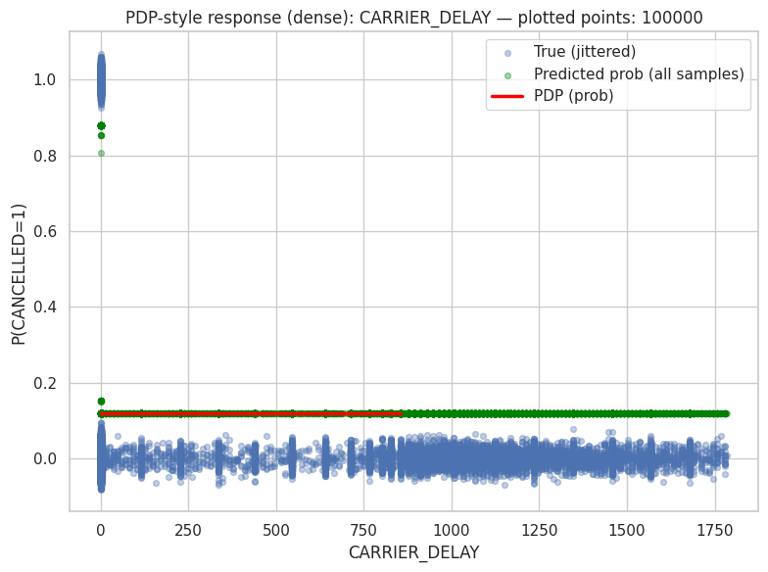
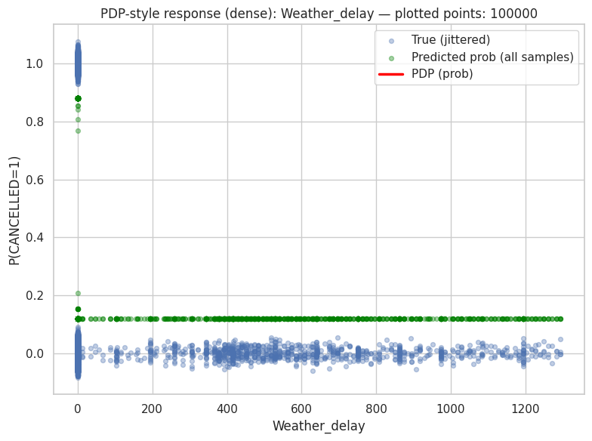
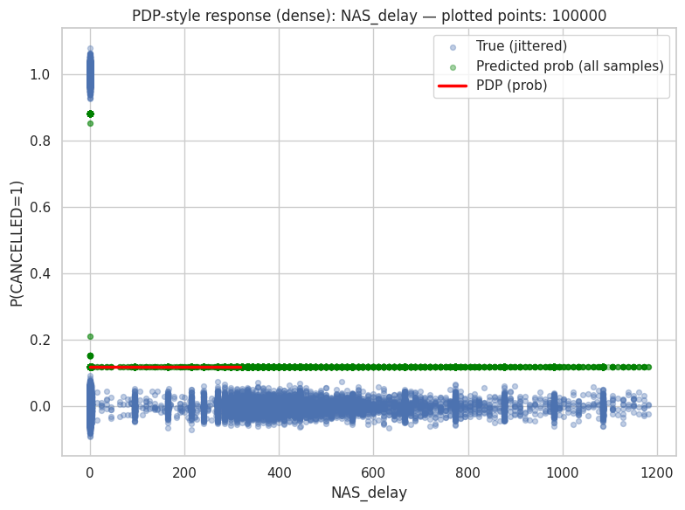
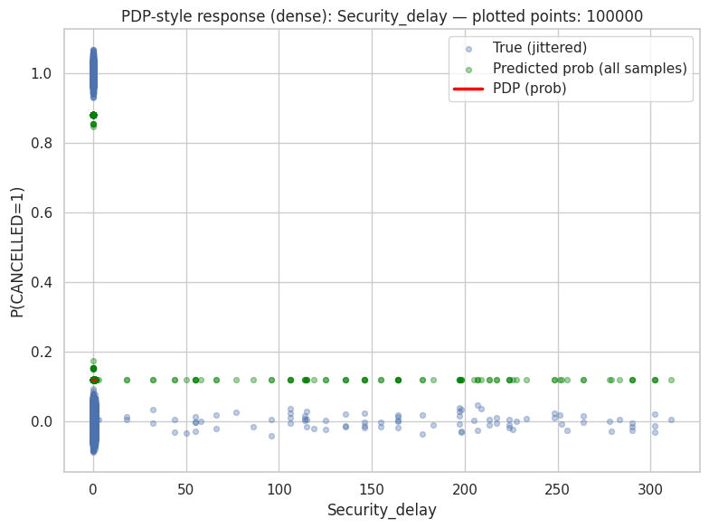
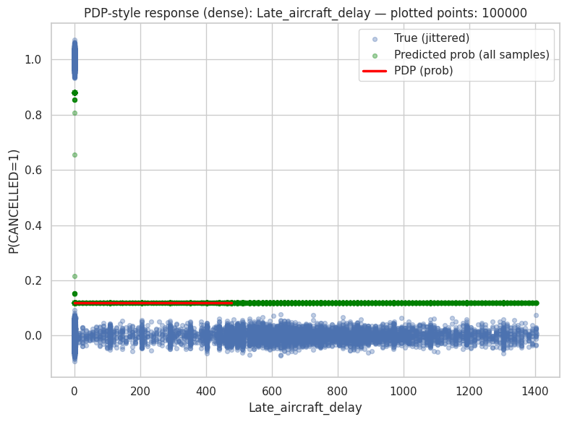
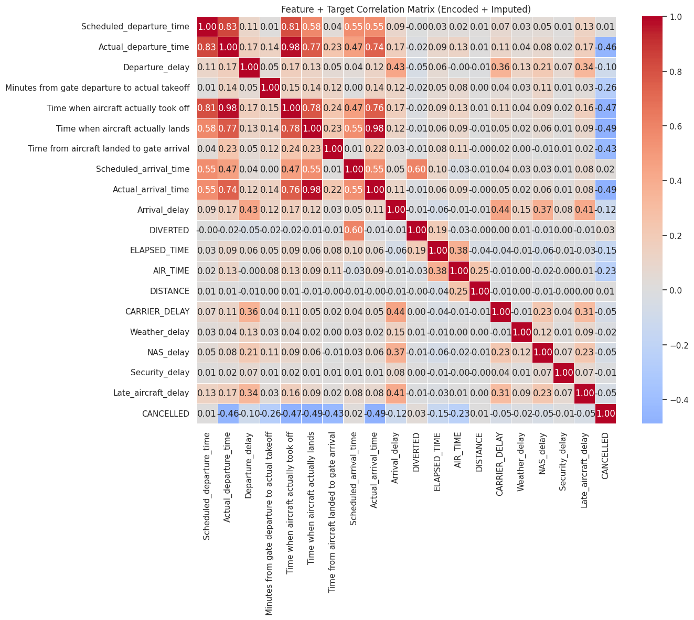
Pearson correlation coefficients between 21 encoded and imputed variables, such as scheduled/actual times, delays by cause (carrier, weather, NAS, security), diversion status, air time, distance, and cancellation, are displayed in this heatmap as a Feature + Target Correlation Matrix for flight data. Red denotes a strong positive correlation and blue a negative correlation. Important findings include moderate propagation of departure delay to arrival delay (0.43), near-perfect correlations between actual departure/arrival times and takeoff/landing times (e.g., 0.98–0.99), and surprisingly weak correlations between cancellation and most delay types (e.g., -0.46 with scheduled departure time). Notably, DIVERTED displays a strong negative correlation (-0.60) with scheduled departure time, but AIR_TIME and DISTANCE exhibit a perfect 1.00 correlation, suggesting possible data leakage or derivation.

📌 FEATURE IMPACT SCORES (AdaBoost):

feature impact_score
Time when aircraft actually took off 4.393069e-01
Actual_arrival_time 3.347689e-01
Minutes from gate departure to actual takeoff 7.523147e-02
DISTANCE 4.626774e-02
Departure_delay 3.781894e-02
DIVERTED 2.648125e-02
Scheduled_arrival_time 1.794281e-02
Scheduled_departure_time 1.369999e-02
Actual_departure_time 8.481998e-03
NAS_delay 6.559406e-12
Time from aircraft landed to gate arrival 4.916049e-12
Weather_delay 1.861099e-14
Time when aircraft actually lands 0.000000e+00
Arrival_delay 0.000000e+00
ELAPSED_TIME 0.000000e+00
CARRIER_DELAY 0.000000e+00
AIR_TIME 0.000000e+00
Security_delay 0.000000e+00
Late_aircraft_delay 0.000000e+00

📊 NORMALIZED IMPACT (% contribution):

feature impact_percent
Time when aircraft actually took off 43.931
Actual_arrival_time 33.477
Minutes from gate departure to actual takeoff 7.523
DISTANCE 4.627
Departure_delay 3.782
DIVERTED 2.648
Scheduled_arrival_time 1.794
Scheduled_departure_time 1.370
Actual_departure_time 0.848
NAS_delay 0.000
Time from aircraft landed to gate arrival 0.000
Weather_delay 0.000
Time when aircraft actually lands 0.000
Arrival_delay 0.000
ELAPSED_TIME 0.000
CARRIER_DELAY 0.000
AIR_TIME 0.000
Security_delay 0.000
Late_aircraft_delay 0.000
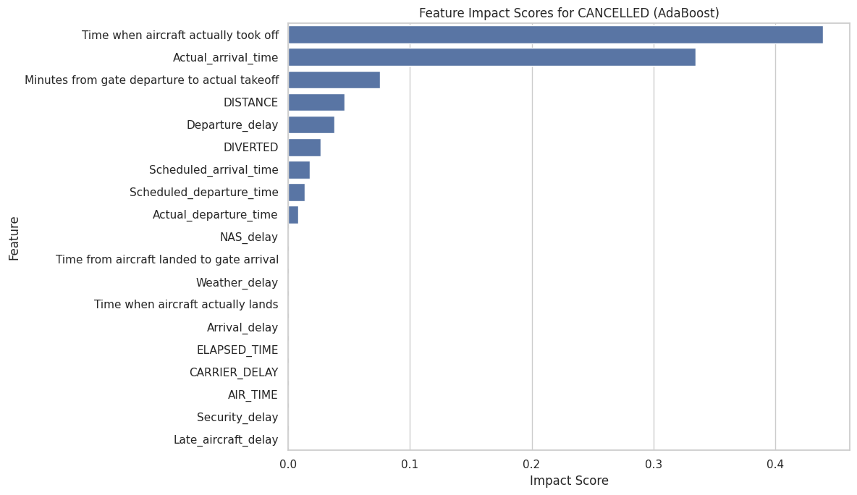
The AdaBoost feature impact analysis indicates that operational timing variables overwhelmingly drive the model’s predictions, with the time when the aircraft actually took off and the actual arrival time together accounting for the majority of the predictive influence, highlighting the dominant role of real-time flight execution in determining outcomes. Secondary contributors include the minutes from gate departure to actual takeoff, flight distance, departure delay, and diversion status, which capture pre-departure congestion, route characteristics, and abnormal flight events. Scheduled times for departure and arrival have comparatively lower but still meaningful influence, suggesting that planned operations matter less than what actually occurs in real time. In contrast, delay subcategories such as NAS, weather, carrier, security, and late aircraft delays, along with elapsed time and air time, exhibit negligible or zero impact, implying that their effects are either already absorbed by higher-level timing variables or are not directly informative for the model once actual operational timings are known.

