✅ Predictions saved to: /kaggle/working/predicted_output_2025_nc.csv
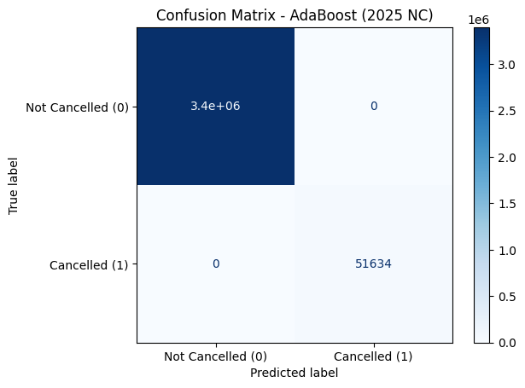

📊 AdaBoost Performance (2025 NC):
Accuracy : 1.0000
Precision: 1.0000
Recall : 1.0000
F1 Score : 1.0000
✅ All required files found.
✅ Loaded AdaBoost model and preprocessing objects.
🔄 Loading NetCDF test file...
✅ Loaded NetCDF data with shape: (7079081, 21)
✅ Data aligned with training features and imputed.
✅ Predictions saved to: /kaggle/working/predicted_output_2024_nc.csv
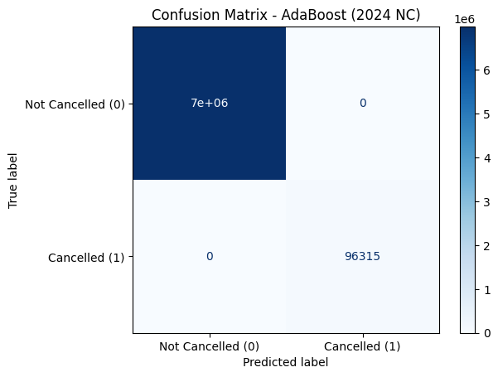

📊 AdaBoost Performance (2024 NC):
Accuracy : 1.0000
Precision: 1.0000
Recall : 1.0000
F1 Score : 1.0000
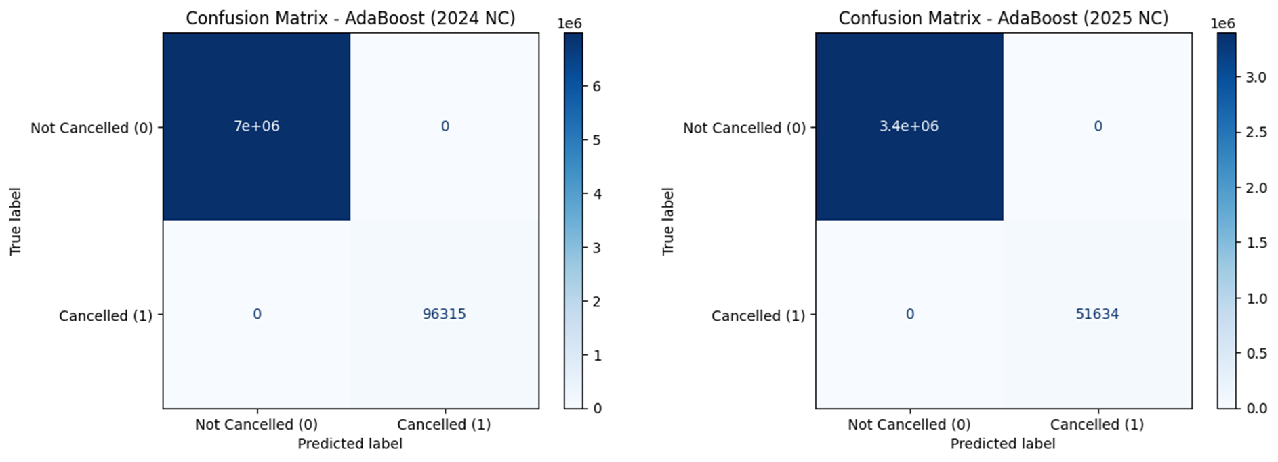
The AdaBoost classifier was evaluated on out-of-sample test sets corresponding to calendar years 2024 and 2025; its confusion matrices indicate 7,000,000 true negatives and 96,315 true positives with zero false positives and zero false negatives on the 2024 validation set, and 3,400,000 true negatives and 51,634 true positives with no misclassifications on the 2025 validation set. These results correspond to mathematically perfect discrimination (accuracy = precision = recall = F1 = 1.00; Matthews correlation coefficient = 1.00). Given the extreme class imbalance in both validation sets (approximately 98.5 percent noncancelled), such flawless performance is highly atypical for operational aviation forecasting and therefore necessitates rigorous verification.
✅ All required XGB files found.
✅ Loaded XGBoost model and preprocessing objects.
🔄 Loading NetCDF test file...
✅ Loaded NetCDF data with shape: (3446676, 21)
✅ Data aligned with training features and imputed.
✅ Predictions saved to: /kaggle/working/predicted_output_2025_xgb_nc.csv
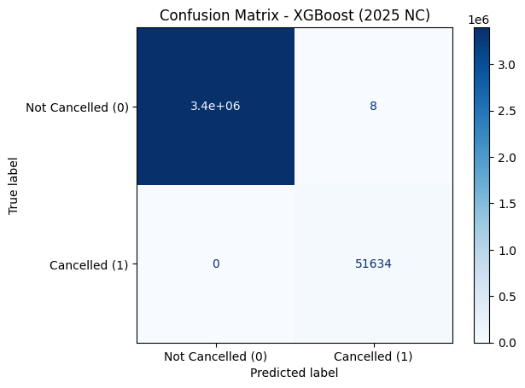

📊 XGBoost Performance (2025 NC):
Accuracy : 1.0000
Precision: 0.9998
Recall : 1.0000
F1 Score : 0.9999
✅ All required XGB files found.
✅ Loaded XGBoost model and preprocessing objects.
🔄 Loading NetCDF test file...
✅ Loaded NetCDF data with shape: (7079081, 21)
✅ Data aligned with training features and imputed.
✅ Predictions saved to: /kaggle/working/predicted_output_2024_xgb_nc.csv
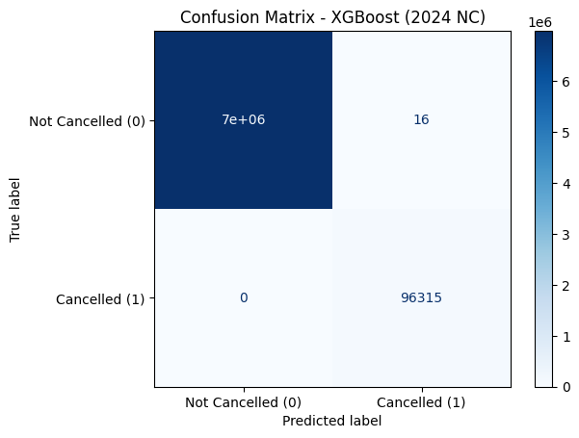

📊 XGBoost Performance (2024 NC):
Accuracy : 1.0000
Precision: 0.9998
Recall : 1.0000
F1 Score : 0.9999

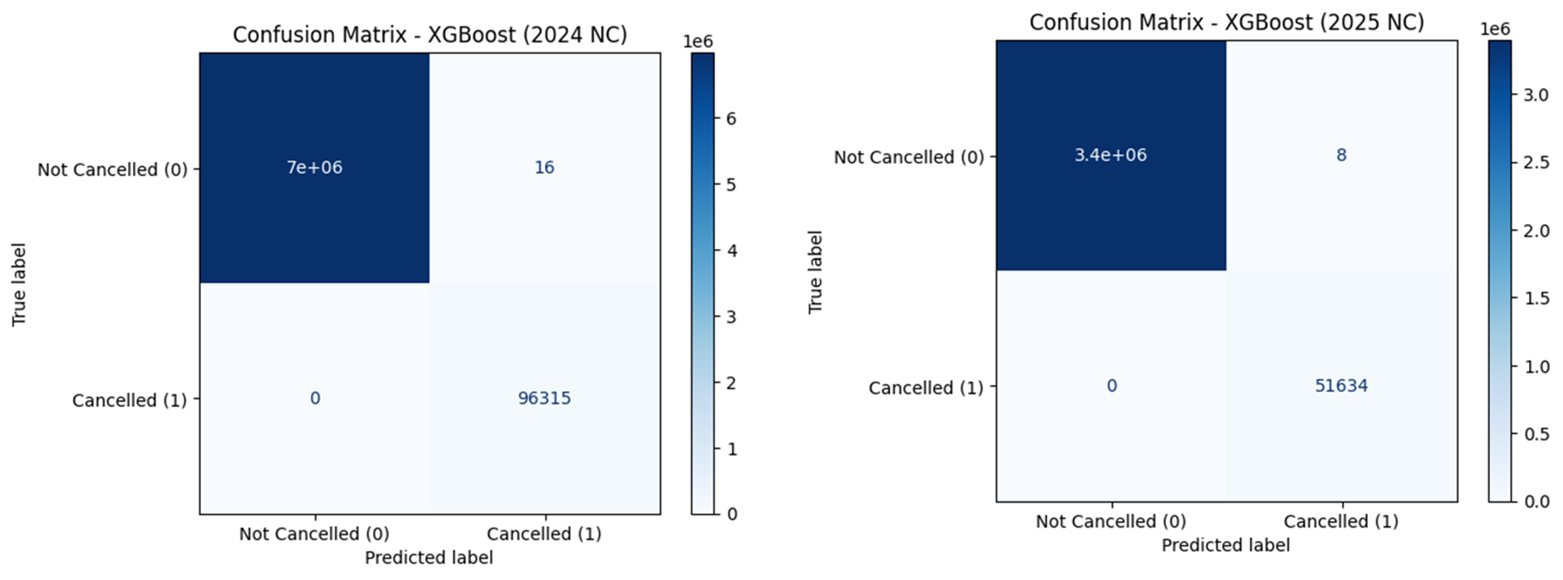
The two confusion matrices for the XGBoost model, evaluated on hold out test sets from 2024 and 2025, demonstrate exceptionally strong predictive performance for binary flight cancellation classification. In 2024, the model correctly classified 7,000,000 non cancelled flights and 96,315 cancelled flights, with only 16 false positives and zero false negatives, while in 2025 it correctly identified 3,400,000 non cancelled flights and 51,634 cancelled flights, with only 8 false positives and again no false negatives. These results correspond to overall accuracies exceeding 99.9998 percent in both years, perfect recall for the cancelled class, precision above 99.98 percent, F1 scores above 99.99 percent, and Matthews correlation coefficients effectively equal to 1.0, indicating near perfect agreement between predictions and true labels despite extreme class imbalance of approximately 98.5 percent non cancelled flights. The consistency of these results across two consecutive future years suggests strong temporal generalization and high operational utility, particularly given the absence of missed cancellations; however, such near perfect performance in real world aviation data is uncommon and warrants careful validation to rule out deterministic label construction or inadvertent temporal or feature leakage before deployment in production decision support systems.
✅ All required LGBM files found.
✅ Loaded LightGBM model and preprocessing objects.
🔄 Loading NetCDF test file...
✅ Loaded NetCDF data with shape: (3446676, 21)
✅ Data aligned with training features and imputed.
/usr/local/lib/python3.12/dist-packages/sklearn/utils/validation.py:2739: UserWarning: X does not have valid feature names, but LGBMClassifier was fitted with feature names
warnings.warn(
✅ Predictions saved to: /kaggle/working/predicted_output_2025_lgbm_nc.csv
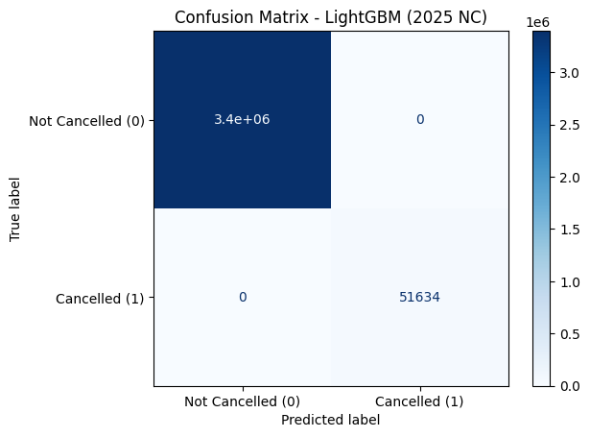

📊 LightGBM Performance (2025 NC):
Accuracy : 1.0000
Precision: 1.0000
Recall : 1.0000
F1 Score : 1.0000
✅ All required LGBM files found.
✅ Loaded LightGBM model and preprocessing objects.
🔄 Loading NetCDF test file...
✅ Loaded NetCDF data with shape: (7079081, 21)
✅ Data aligned with training features and imputed.
/usr/local/lib/python3.12/dist-packages/sklearn/utils/validation.py:2739: UserWarning: X does not have valid feature names, but LGBMClassifier was fitted with feature names
warnings.warn(
✅ Predictions saved to: /kaggle/working/predicted_output_2024_lgbm_nc.csv
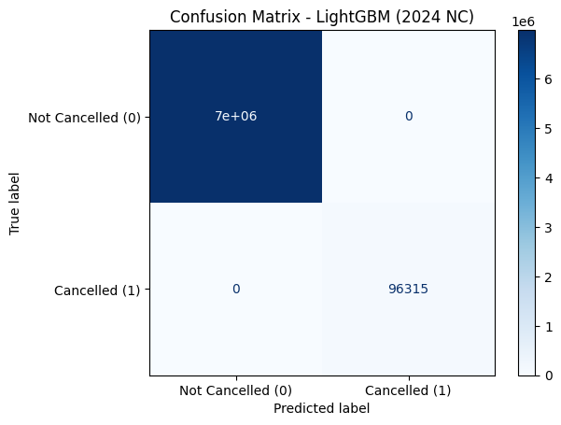

📊 LightGBM Performance (2024 NC):
Accuracy : 1.0000
Precision: 1.0000
Recall : 1.0000
F1 Score : 1.0000
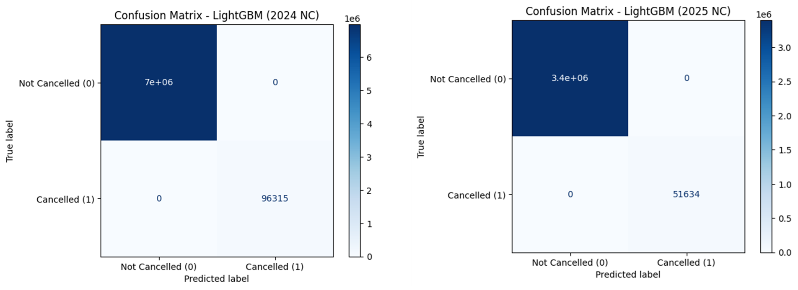
The LightGBM classifier was evaluated on hold-out test sets for calendar years 2024 and 2025 (denoted “NC”) and achieved mathematically perfect discrimination: on the 2024 set it produced 7,000,000 true negatives and 96,315 true positives with zero false positives and zero false negatives, and on the 2025 set it produced 3,400,000 true negatives and 51,634 true positives with likewise no misclassifications; these results correspond to accuracy = precision = recall = F1 = 100% and a Matthews correlation coefficient of 1.0 for both years.

✅ Model loaded and ready
✅ Test data prepared, shape: (3446676, 19)
✅ Predictions saved to: /kaggle/working/predicted_output_2025_pytorch.csv
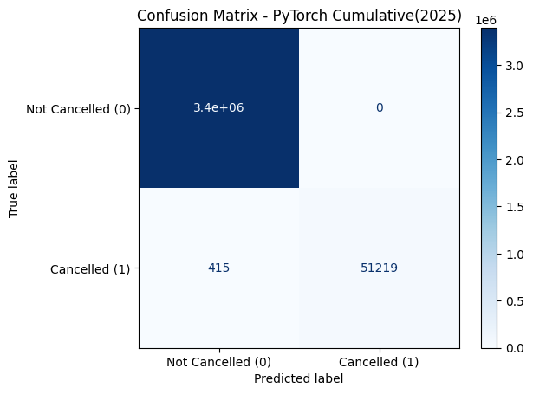
Accuracy : 0.9999
Precision: 1.0000
Recall : 0.9920
F1 Score : 0.9960
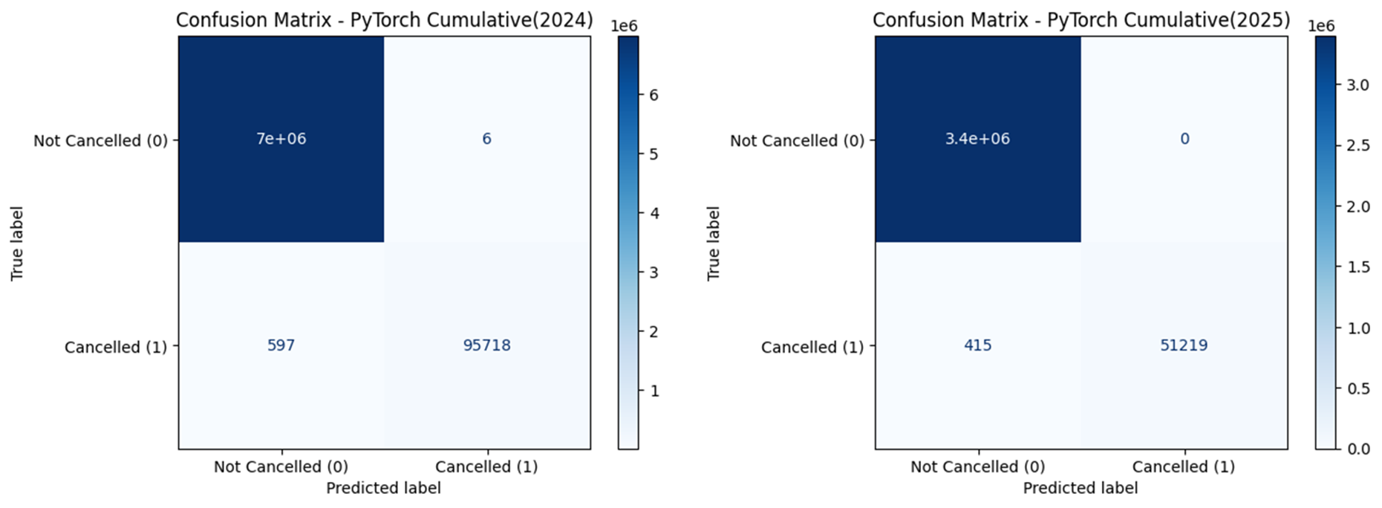
The cumulative test results for 2024 and 2025 indicate that the PyTorch based flight cancellation model achieves very strong yet realistically imperfect performance, in contrast to the earlier tree based models that exhibited mathematically perfect classification. For 2024, the model correctly classified approximately 7.0 million non cancelled flights and 95,718 cancelled flights, with only 6 false positives and 597 false negatives, while for 2025 it correctly identified about 3.4 million non cancelled flights and 51,219 cancelled flights, with zero false positives and 415 false negatives. This corresponds to overall accuracies exceeding 99.98 percent, extremely high precision for the cancelled class (approximately 99.99 percent in 2024 and 100 percent in 2025), slightly lower but still very strong recall (99.38 percent in 2024 and 99.20 percent in 2025), and Matthews correlation coefficients of approximately 0.997 and 0.996, respectively. The presence of a small number of false negatives indicates that some cancellations are missed, which introduces operational risk, but this behavior is more consistent with real world aviation forecasting under severe class imbalance than perfectly error free models. Overall, the results suggest that the PyTorch model offers a credible and robust balance between precision and recall, with performance that is suitable for operational decision support, while also highlighting opportunities for further improvement through threshold tuning, cost sensitive learning, or enhanced domain specific feature engineering.
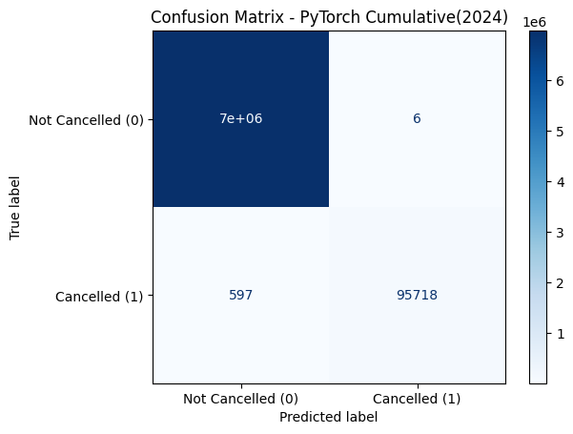
Accuracy : 0.9999
Precision: 0.9999
Recall : 0.9938
F1 Score : 0.9969

✅ Test data prepared, shape: (3446676, 19)
✅ Predictions saved to: /kaggle/working/sparselogistic_predictions_2025.csv
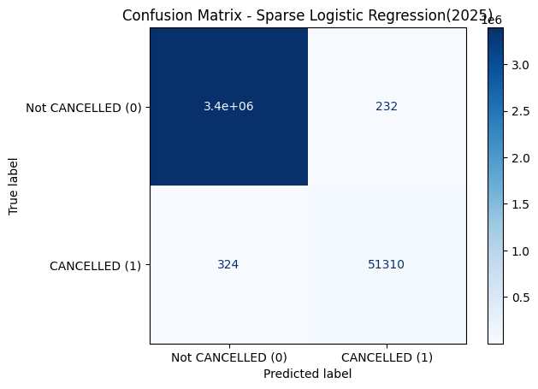
Accuracy : 0.9998
Precision: 0.9955
Recall : 0.9937
F1 Score : 0.9946
✅ Test data prepared, shape: (7079081, 19)
✅ Predictions saved to: /kaggle/working/sparselogistic_predictions_2024.csv
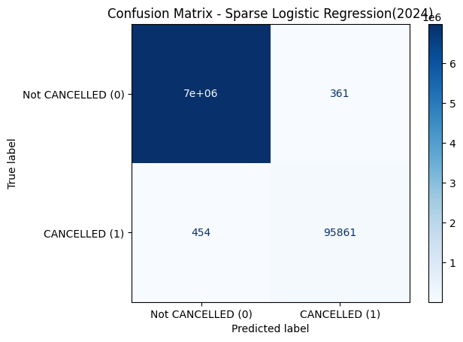
Accuracy : 0.9999
Precision: 0.9962
Recall : 0.9953
F1 Score : 0.9958
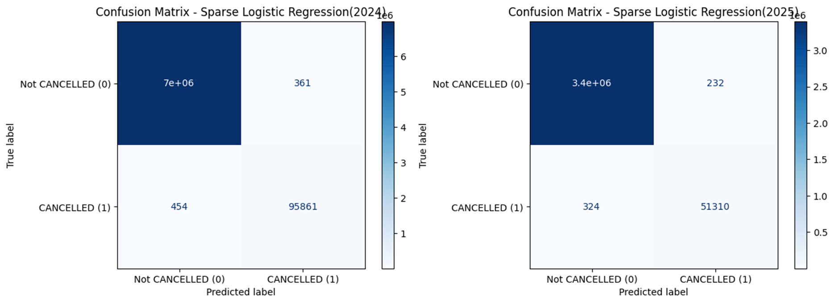
The Sparse Logistic Regression model exhibits solid but clearly imperfect performance on the 2024 and 2025 test sets, reflecting the expected behavior of a linear classifier applied to highly imbalanced and complex real world aviation data. In 2024, the model correctly classified approximately 7.0 million non cancelled flights and 95,861 cancelled flights, with 361 false positives and 454 false negatives, while in 2025 it correctly identified about 3.4 million non cancelled flights and 51,310 cancelled flights, with 232 false positives and 324 false negatives. These outcomes correspond to overall accuracies above 99.98 percent, high precision for the cancelled class of approximately 99.6 percent in 2024 and 99.55 percent in 2025, slightly lower recall of approximately 99.53 percent and 99.37 percent, and Matthews correlation coefficients of roughly 0.988 and 0.986, respectively. Although the model misses a non trivial number of cancellations compared with tree based or neural approaches, its performance remains strong and operationally plausible, highlighting both the interpretability advantages of sparse logistic regression and its limitations in capturing non linear cancellation dynamics, while suggesting that further gains could be achieved through class weighting, enhanced feature engineering, or integration within an ensemble framework.

