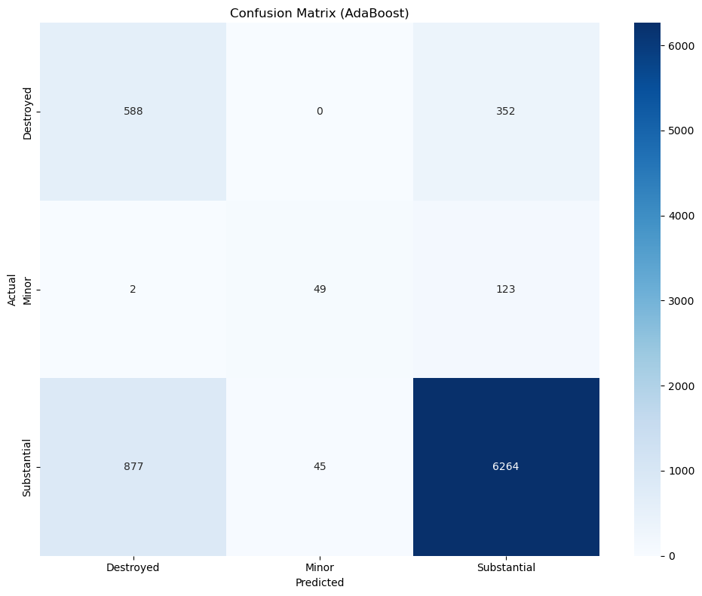
precision recall f1-score support

Destroyed 0.40 0.63 0.49 940
Minor 0.52 0.28 0.37 174
Substantial 0.93 0.87 0.90 7186

accuracy 0.83 8300
macro avg 0.62 0.59 0.58 8300
weighted avg 0.86 0.83 0.84 8300
The AdaBoost multi-class confusion matrix (8,300 samples) shows that while the model achieves a reasonable overall accuracy of about 83.1% with weighted F1 ≈ 0.866 and Cohen’s Kappa ≈ 0.61, its performance is highly imbalanced across classes: it predicts the majority class “Substantial (2)” very well (Precision ≈ 0.929, Recall ≈ 0.872, F1 ≈ 0.899), but performs poorly on minority classes, especially “Destroyed (0)” (Recall ≈ 0.40, F1 ≈ 0.49) and “Minor (1)” (very low Precision ≈ 0.28, F1 ≈ 0.37), meaning many true Destroyed cases are misclassified as Substantial and many predicted Minor cases are false positives.
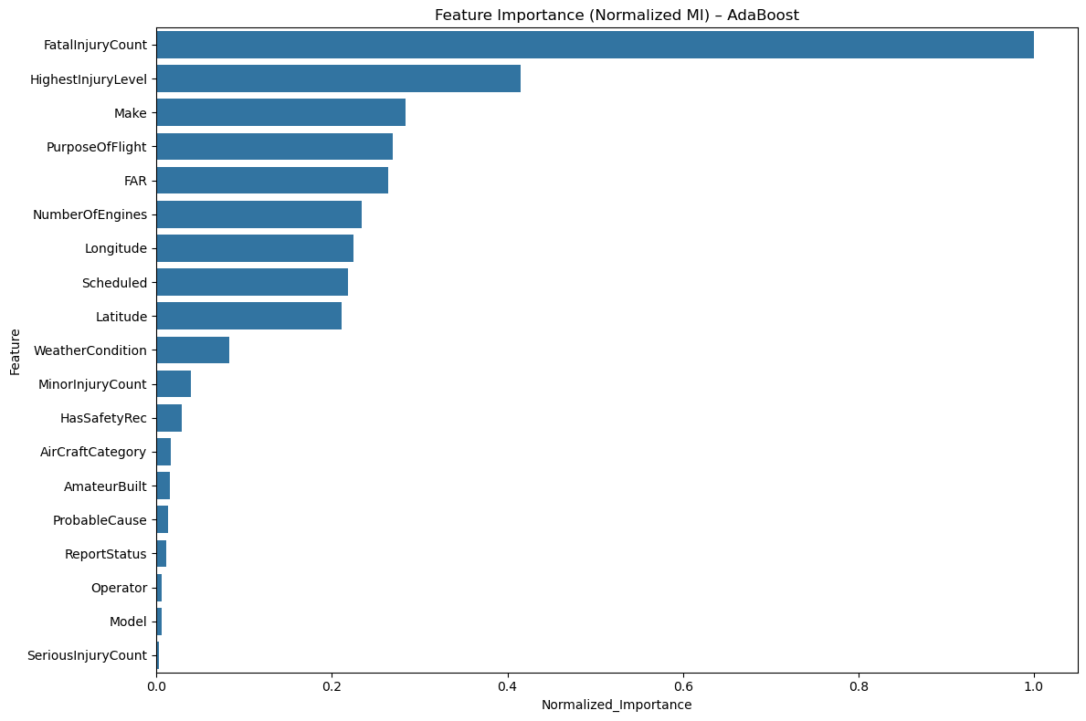

The AdaBoost feature-importance bar chart (based on Normalized Mutual Information) shows that FatalInjuryCount overwhelmingly drives the model’s predictions (≈0.98–1.0), with HighestInjuryLevel as a distant second (≈0.42), indicating that injury severity—especially fatalities—is the dominant signal for classifying damage as Destroyed, Minor, or Substantial. Moderately important predictors include Make, PurposeOfFlight, FAR, and NumberOfEngines, suggesting that aircraft design and operational context matter, while geographic and operational variables such as Longitude, Latitude, Scheduled, and WeatherCondition contribute at a secondary level; meanwhile features like ReportStatus, Operator, Model, and SeriousInjuryCount add almost no discriminative power.

