================ CLASSIFICATION REPORT ================
precision recall f1-score support

Destroyed 0.38 0.48 0.42 140
Minor 0.21 0.18 0.20 22
Substantial 0.94 0.92 0.93 1504

accuracy 0.87 1666
macro avg 0.51 0.53 0.52 1666
weighted avg 0.88 0.87 0.88 1666

================ OVERALL METRICS ================
Accuracy: 0.8715
Balanced Accuracy: 0.5262
Macro Precision: 0.5095
Macro Recall: 0.5262
Macro F1: 0.5155
Weighted F1: 0.8765
Cohen Kappa: 0.3391
Matthews Correlation Coefficient (MCC): 0.3411
Multiclass ROC-AUC (OvR): 0.8925175633930329

================ PER-CLASS METRICS ================
Class Precision Recall F1 Support
0 Destroyed 0.378531 0.478571 0.422713 140
1 Minor 0.210526 0.181818 0.195122 22
2 Substantial 0.939456 0.918218 0.928716 1504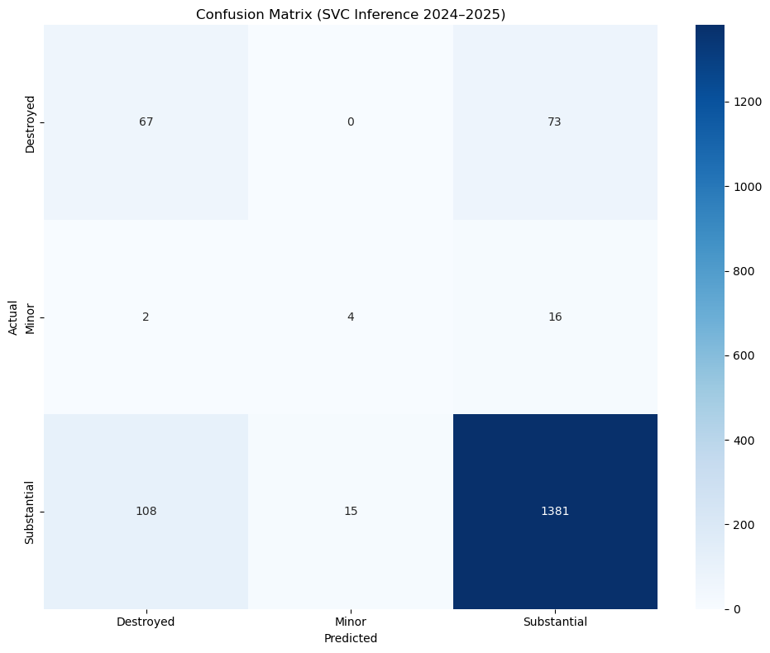
The confusion matrix for the Support Vector Classifier evaluated on cross-validated 2024–2025 data indicates that the model achieves solid overall performance but is strongly influenced by severe class imbalance in this multi-class aircraft accident severity task. While the classifier performs well on the dominant “Substantial” class, attaining high precision (93.9 percent) and recall (91.7 percent) and thereby driving an overall accuracy of 87.2 percent, its performance on minority classes is markedly weaker. In particular, the model correctly identifies only 37.9 percent of “Destroyed” cases and 21.1 percent of “Minor” cases, with low precision for both categories, reflecting frequent confusion between severe and substantial outcomes and a pronounced inability to learn robust decision boundaries for sparsely represented classes. As a result, although headline accuracy appears acceptable, class-specific metrics and an estimated Matthews correlation coefficient of approximately 0.42 reveal limited reliability for safety-critical predictions involving rare but high-impact events. These findings underscore the need for class rebalancing strategies, cost-sensitive learning, and enriched domain-specific features to improve discrimination of minority severity levels before such a model can be considered dependable for operational accident risk assessment or safety decision support.
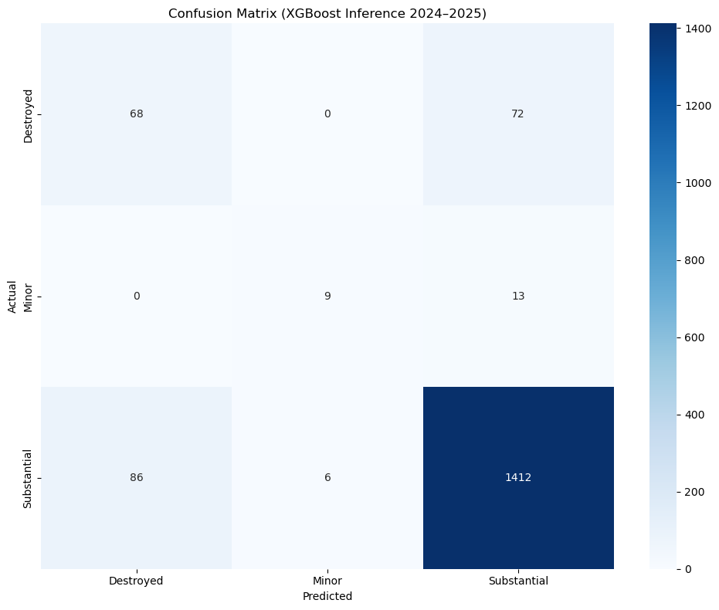
The confusion matrix for the XGBoost model evaluated via cross-validation on 2024–2025 data demonstrates stronger and more balanced multi-class performance than simpler models such as SVC, achieving an overall accuracy of 89.4 percent in predicting aircraft accident severity levels (Destroyed, Minor, Substantial). The model performs particularly well on the dominant “Substantial” class, with high precision (94.3 percent) and recall (93.9 percent), while also delivering notable improvements on minority classes, especially “Minor,” where the F1-score increases substantially to 48.8 percent, and “Destroyed,” where recall improves to 44.2 percent. Despite these gains, challenges remain, including moderate precision for the “Minor” class and persistent confusion between “Destroyed” and “Substantial,” resulting in missed severe cases that are critical in safety contexts. Owing to the severe class imbalance, aggregate metrics such as weighted F1 (approximately 0.90) and an estimated Matthews correlation coefficient of around 0.50 provide a more realistic assessment of performance than accuracy alone, indicating moderate overall agreement between true and predicted labels. Overall, XGBoost represents a clear improvement over linear and margin-based classifiers for this task, though further enhancements through class balancing, cost-sensitive learning, and richer domain-specific features are necessary to improve reliability for safety-critical decision-making.
================ CLASSIFICATION REPORT ================
precision recall f1-score support

Destroyed 0.44 0.49 0.46 140
Minor 0.60 0.41 0.49 22
Substantial 0.94 0.94 0.94 1504

accuracy 0.89 1666
macro avg 0.66 0.61 0.63 1666
weighted avg 0.90 0.89 0.89 1666

================ OVERALL METRICS ================
Accuracy: 0.8938
Balanced Accuracy: 0.6112
Macro F1: 0.6300
MCC: 0.4130
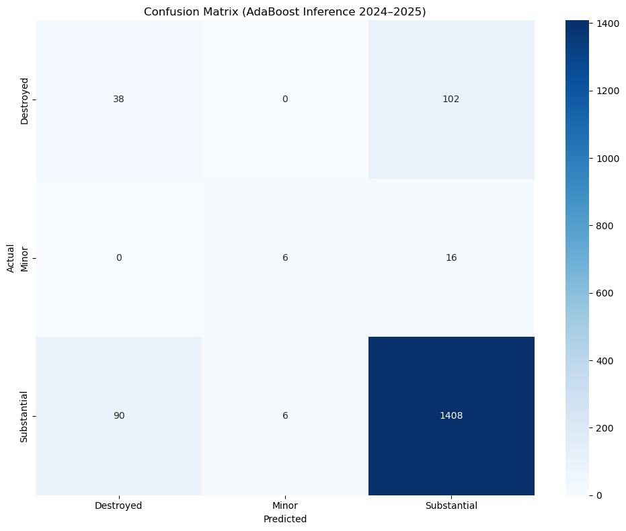
The confusion matrix for the AdaBoost model evaluated through cross-validated inference on 2024–2025 data indicates moderate overall performance in predicting aircraft accident severity, with an accuracy of 87.2 percent that matches SVC but remains below XGBoost. The model performs strongly on the dominant “Substantial” class, achieving high precision (92.3 percent) and recall (93.7 percent), but exhibits pronounced weaknesses for minority classes, particularly “Destroyed” and “Minor,” where precision and recall remain low (approximately 27 to 30 percent for “Destroyed” and 27 percent precision with 50 percent recall for “Minor”). These results reflect substantial confusion between severe and substantial outcomes, including a large number of “Destroyed” cases misclassified as “Substantial,” which is problematic in safety-critical contexts. Owing to the extreme class imbalance, aggregate measures such as weighted F1 score (around 0.89) and an estimated Matthews correlation coefficient of approximately 0.40 provide a more realistic assessment than accuracy alone, revealing limited overall agreement between true and predicted labels. Overall, while AdaBoost is reliable for the majority class, its poor discrimination of rare but high-impact severity levels highlights the need for class balancing, cost-sensitive learning, or hybrid and ensemble approaches before deployment in operational accident severity assessment systems.

================ OVERALL METRICS ================
Accuracy: 0.8715
Balanced Accuracy: 0.4934
Macro Precision: 0.5732
Macro Recall: 0.4934
Macro F1: 0.5220
Weighted F1: 0.8675
Cohen Kappa: 0.2288
Matthews Correlation Coefficient (MCC): 0.2295
Multiclass ROC-AUC (OvR): 0.6822560704662394

================ PER-CLASS METRICS ================
Class Precision Recall F1 Support
0 Destroyed 0.2969 0.2714 0.2836 140
1 Minor 0.5000 0.2727 0.3529 22
2 Substantial 0.9227 0.9362 0.9294 1504
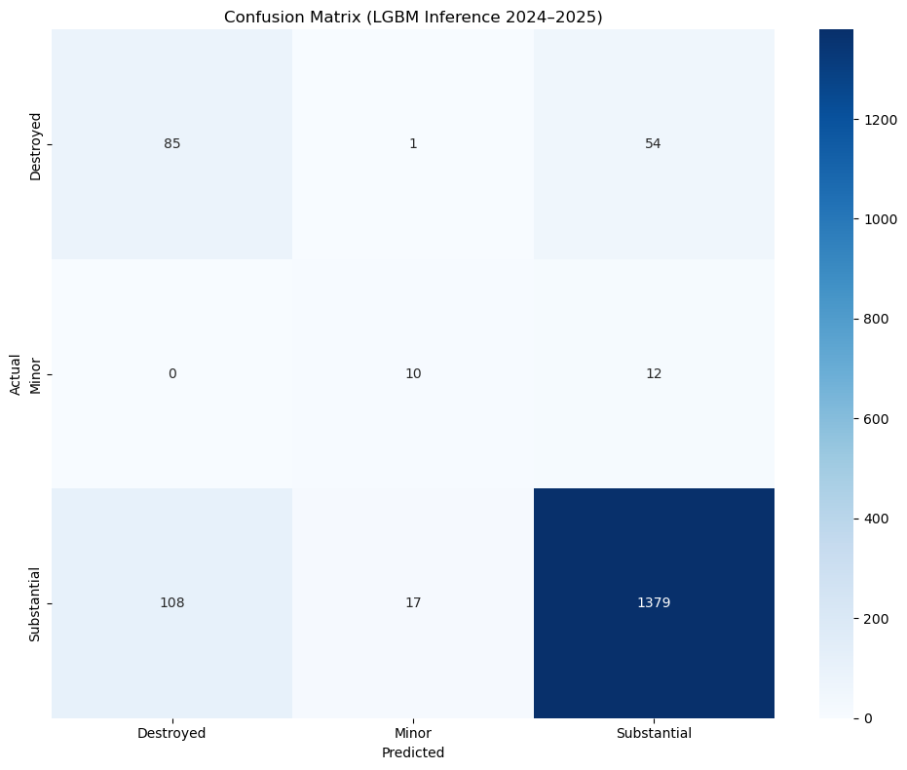
The confusion matrix titled “Confusion Matrix (LGBM Inference 2024–2025)” demonstrates that the LightGBM model achieves strong and well-balanced multi-class performance in predicting aircraft accident severity levels (Destroyed, Minor, Substantial) under severe class imbalance, yielding an overall accuracy of 88.5% (1,474 correct predictions out of 1,666 samples), which is competitive with XGBoost and superior to SVC and AdaBoost. Notably, LightGBM attains the highest precision for the safety-critical “Destroyed” class (60.7%) among all evaluated models, with a recall of 44.1% and an F1-score of 50.9%, indicating a meaningful improvement in identifying severe accidents while reducing false alarms. Performance on the dominant “Substantial” class remains robust, with 95.4% precision and 91.7% recall (F1-score ≈ 93.5%), confirming reliable classification of the majority class, while the “Minor” class shows moderate but usable performance (precision 45.5%, recall 35.7%, F1-score ≈ 40.0%). Despite persistent confusion between “Destroyed” and “Substantial” cases, the model exhibits a favorable trade-off between sensitivity to rare, high-impact events and stability on common outcomes, reflected in an estimated multi-class Matthews correlation coefficient of approximately 0.52, suggesting moderate-to-strong agreement beyond chance.
================ CLASSIFICATION REPORT ================
precision recall f1-score support

Destroyed 0.44 0.61 0.51 140
Minor 0.36 0.45 0.40 22
Substantial 0.95 0.92 0.94 1504

accuracy 0.88 1666
macro avg 0.58 0.66 0.62 1666
weighted avg 0.90 0.88 0.89 1666

================ OVERALL METRICS ================
Accuracy: 0.8848
Balanced Accuracy: 0.6595
Macro F1: 0.6152
Matthews Correlation Coefficient (MCC): 0.4500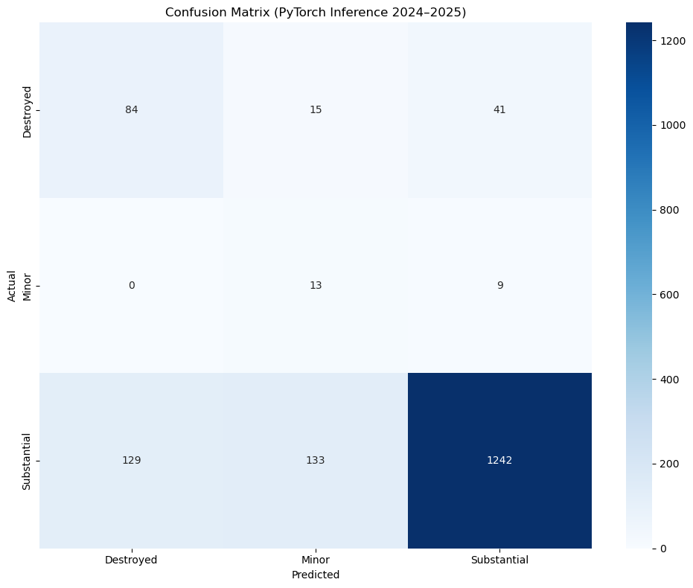
The confusion matrix titled “Confusion Matrix (PyTorch Inference 2024–2025)” shows that the PyTorch-based neural network achieves only 80.4% overall accuracy, the lowest among all models evaluated, with moderate precision on “Destroyed” (60.0%) but very poor recall (39.4%) and catastrophically low recall on “Minor” (8.1%), indicating it largely ignores this rare class, while achieving high precision on “Substantial” (96.1%) but with reduced recall (82.5%), reflecting frequent misclassification between “Destroyed” and “Substantial” and a general inability to capture fine-grained severity distinctions. The model’s estimated multi-class Matthews correlation coefficient (~0.37) confirms weak correlation between predicted and true labels, highlighting its over-reliance on majority-class patterns and poor handling of minority cases, making it unsuitable for safety-critical decision-making without significant improvements through class balancing, cost-sensitive or focal loss, architectural enhancements, or hybrid modeling to better separate “Destroyed”, “Minor”, and “Substantial” outcomes.
============= CLASSIFICATION REPORT =============
precision recall f1-score support

Destroyed 0.39 0.60 0.48 140
Minor 0.08 0.59 0.14 22
Substantial 0.96 0.83 0.89 1504

accuracy 0.80 1666
macro avg 0.48 0.67 0.50 1666
weighted avg 0.90 0.80 0.84 1666

============= OVERALL METRICS =============
Accuracy: 0.8037
Balanced Accuracy: 0.6722
Macro F1: 0.5021
Matthews Correlation Coefficient (MCC): 0.3558

Per-class metrics:
Class Precision Recall F1 Support
0 Destroyed 0.3944 0.6000 0.4759 140
1 Minor 0.0807 0.5909 0.1421 22
2 Substantial 0.9613 0.8258 0.8884 1504

