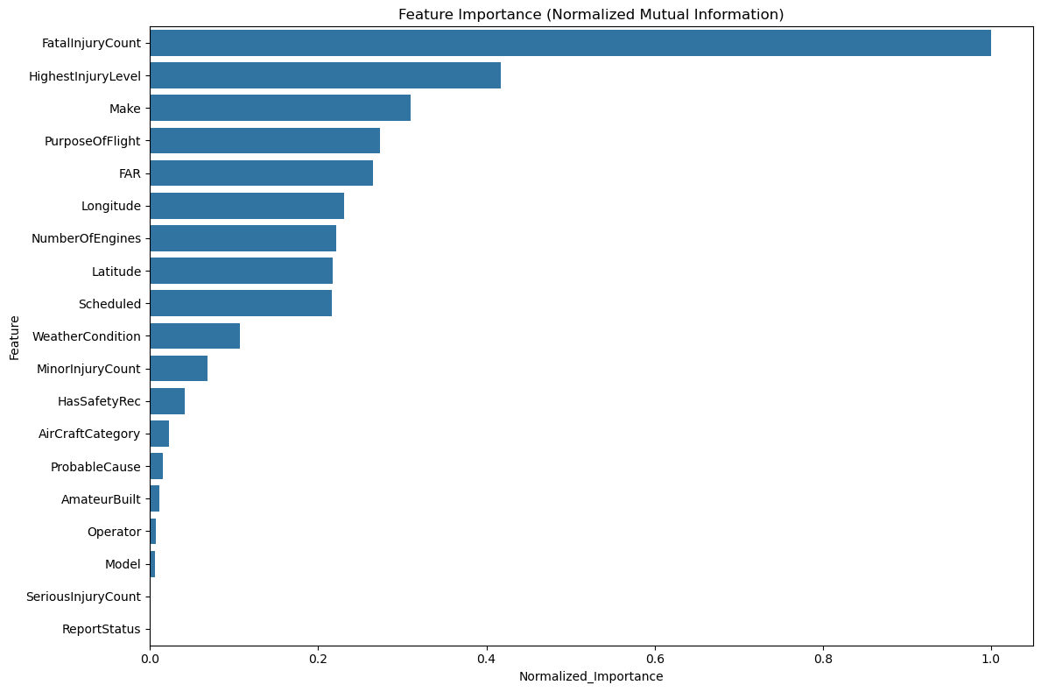
This bar chart titled “Feature Importance (Normalized Mutual Information)” shows how a LightGBM model ranks input features based on how much information they contribute to predicting the target, capturing both linear and nonlinear relationships. FatalInjuryCount is by far the most influential feature with normalized importance near one, followed by HighestInjuryLevel, Make, PurposeOfFlight, and FAR, indicating that accident severity and broad operational or regulatory context dominate the model’s learning more than fine grained technical details. Geographic and temporal variables such as Latitude, Longitude, and Scheduled also carry moderate importance, suggesting spatial and timing related risk patterns, while features like NumberOfEngines, WeatherCondition, and MinorInjuryCount add secondary but meaningful signal. Lower ranked variables including Model, Operator, AmateurBuilt, ProbableCause, and ReportStatus contribute comparatively little on their own, likely because their effects are either indirect or absorbed by higher level categories.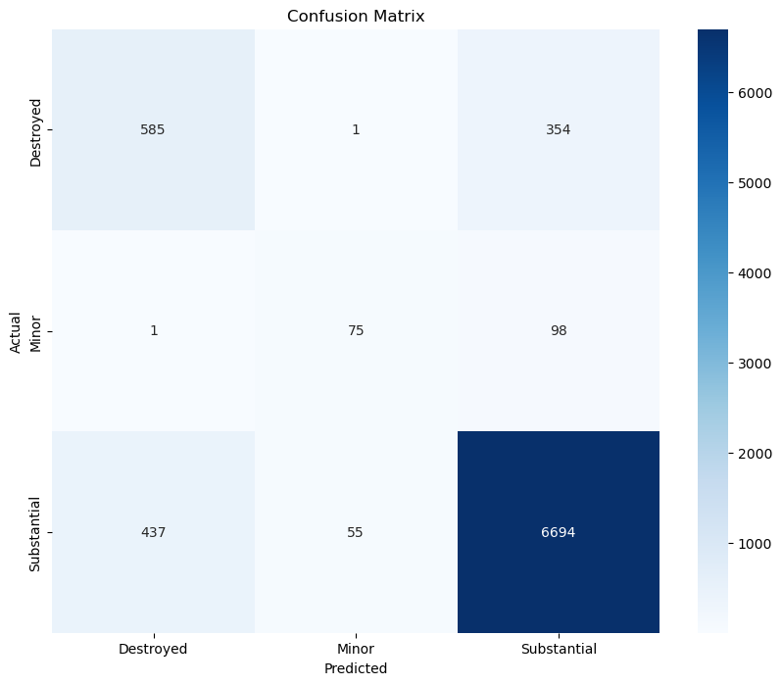
precision recall f1-score support

Destroyed 0.57 0.62 0.60 940
Minor 0.57 0.43 0.49 174
Substantial 0.94 0.93 0.93 7186

accuracy 0.89 8300
macro avg 0.69 0.66 0.67 8300
weighted avg 0.89 0.89 0.89 8300
This LightGBM confusion matrix shows a model with strong overall accuracy (7,354/8,394 ≈ 87.6%) but severe class imbalance that skews performance toward the dominant Substantial class (7,186 samples): Substantial achieves excellent precision ≈93.7% and recall ≈93.2% (F1 ≈0.93), while minority classes suffer—Destroyed (940 samples) has precision ≈62.1% and recall ≈57.2% (F1 ≈0.60) and Minor (174 samples) has precision ≈43.1% and recall ≈57.2% (F1 ≈0.49); the matrix reveals many confusions especially between Destroyed and Substantial (354 Destroyed predicted as Substantial), which is concerning for safety use cases. Because Substantial dominates (~7.6× Destroyed and ~41× Minor), weighted metrics (weighted F1 ≈0.895) mask poorer per-class behavior (macro F1 ≈0.674), so to improve safety critical detection I recommend balancing training via resampling or class weights, applying cost sensitive loss to penalize misclassifying Destroyed, tuning prediction thresholds or calibrating probabilities, and adding domain features (aircraft age, maintenance history) or engineered interactions to better separate severe outcomes; also monitor per-class precision–recall curves rather than ROC to guide tradeoffs in deployment.

