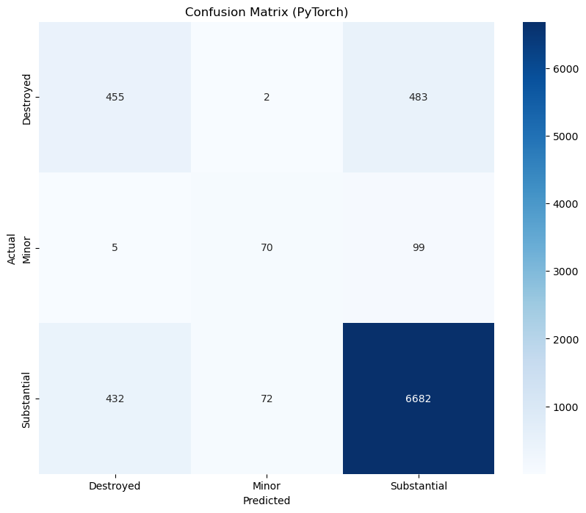 precision recall f1-score support

Destroyed 0.51 0.48 0.50 940
Minor 0.49 0.40 0.44 174
Substantial 0.92 0.93 0.92 7186

accuracy 0.87 8300
macro avg 0.64 0.61 0.62 8300
weighted avg 0.86 0.87 0.87 8300
This PyTorch confusion matrix shows a multi class accident severity model with 85.9 percent overall accuracy, driven largely by strong performance on the dominant Substantial class with about 91.9 percent precision and 92.9 percent recall, but noticeably weaker behavior on the minority classes. For Destroyed, the model achieves only 48.4 percent precision and 51.0 percent recall, meaning nearly half of severe cases are either missed or incorrectly flagged, while Minor performs even worse with 40.2 percent precision and 48.6 percent recall, indicating frequent false alarms and missed detections. As a result, macro averaged performance is low at 0.621 F1, despite a high weighted F1 of 0.878, which mainly reflects the overwhelming presence of the Substantial class. Compared with the LightGBM model, this PyTorch approach underperforms across all minority classes and shows greater confusion between Destroyed and Substantial cases, a concerning outcome in safety critical applications.
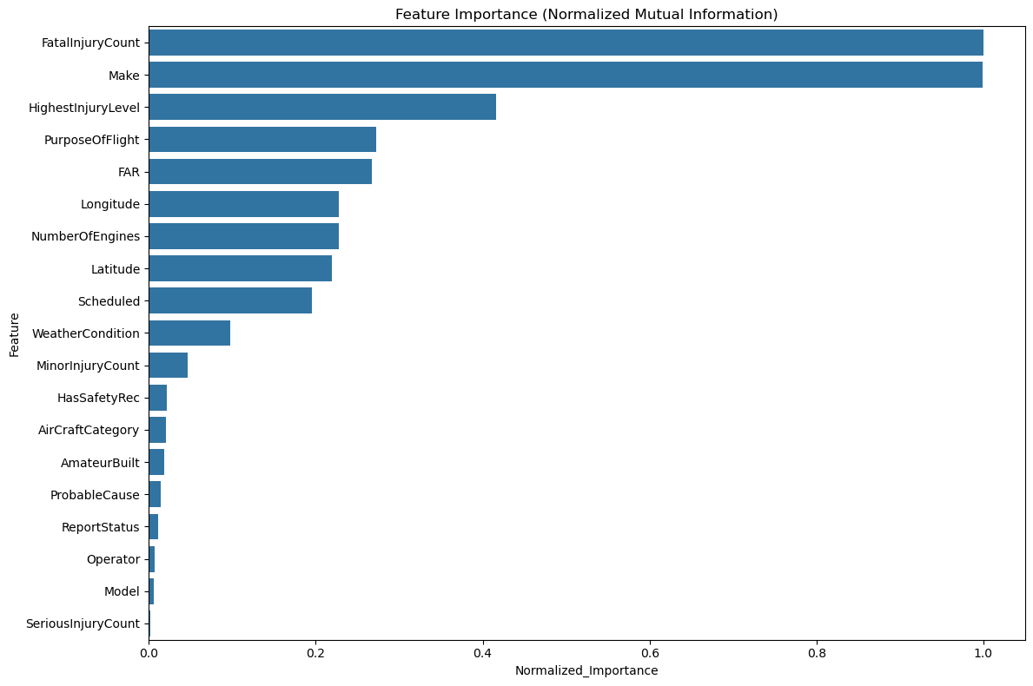
Feature MI_Score Normalized_Importance
8 FatalInjuryCount 0.124731 1.000000
14 Make 0.124646 0.999320
1 HighestInjuryLevel 0.051869 0.415847
18 PurposeOfFlight 0.034044 0.272940
15 FAR 0.033285 0.266858
12 Longitude 0.028461 0.228183
17 NumberOfEngines 0.028356 0.227334
11 Latitude 0.027378 0.219494
16 Scheduled 0.024310 0.194901
6 WeatherCondition 0.012231 0.098063
10 MinorInjuryCount 0.005839 0.046810
0 HasSafetyRec 0.002747 0.022021
4 AirCraftCategory 0.002589 0.020753
5 AmateurBuilt 0.002315 0.018556
2 ProbableCause 0.001797 0.014407
13 ReportStatus 0.001436 0.011516
7 Operator 0.000844 0.006764
3 Model 0.000781 0.006261
9 SeriousInjuryCount 0.000213 0.001705
This Normalized Mutual Information feature importance chart indicates that the model’s predictions are dominated by outcome severity and broad aircraft context, with FatalInjuryCount emerging as the single most informative feature and Make nearly as influential, showing that whether fatalities occurred and which manufacturer built the aircraft explain most of the uncertainty in the target. HighestInjuryLevel, PurposeOfFlight, and FAR add substantial signal, highlighting the role of injury severity beyond raw counts and the impact of operational and regulatory context on accident outcomes. Geographic and temporal variables such as Latitude, Longitude, and Scheduled contribute moderate information, suggesting spatial and timing related risk patterns, while features like NumberOfEngines, WeatherCondition, and MinorInjuryCount provide secondary support. Lower ranked attributes including Model, Operator, ReportStatus, and ProbableCause have limited standalone impact once higher level categories are known, though they may still matter through interactions.

