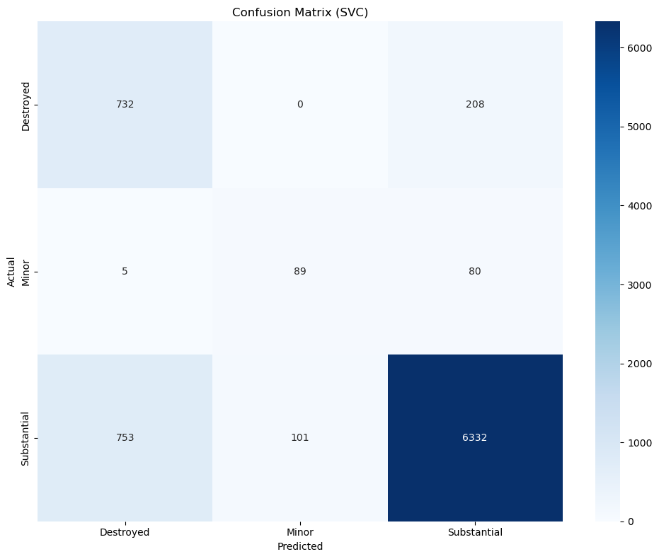
precision recall f1-score support

Destroyed 0.49 0.78 0.60 940
Minor 0.47 0.51 0.49 174
Substantial 0.96 0.88 0.92 7186

accuracy 0.86 8300
macro avg 0.64 0.72 0.67 8300
weighted avg 0.89 0.86 0.87 8300
The multi-class SVC confusion matrix shows that while the model achieves a high overall accuracy of about 86.2% and performs very well for the majority class “Substantial” (F1 ≈ 0.916, recall ≈ 0.88), it is clearly biased toward this dominant class and struggles with the minority classes. “Destroyed” shows high precision (~0.78) but very low recall (~0.49), meaning the model is conservative in predicting this class and misclassifies more than 750 true cases as “Substantial,” while “Minor” performs worst with both low precision (~0.51) and recall (~0.47), being frequently confused with “Substantial.” The macro F1 (~0.67), balanced accuracy (~0.61), and overall MCC (~0.68–0.70) indicate that despite strong performance on the main class, the classifier handles rare classes poorly due to class imbalance.

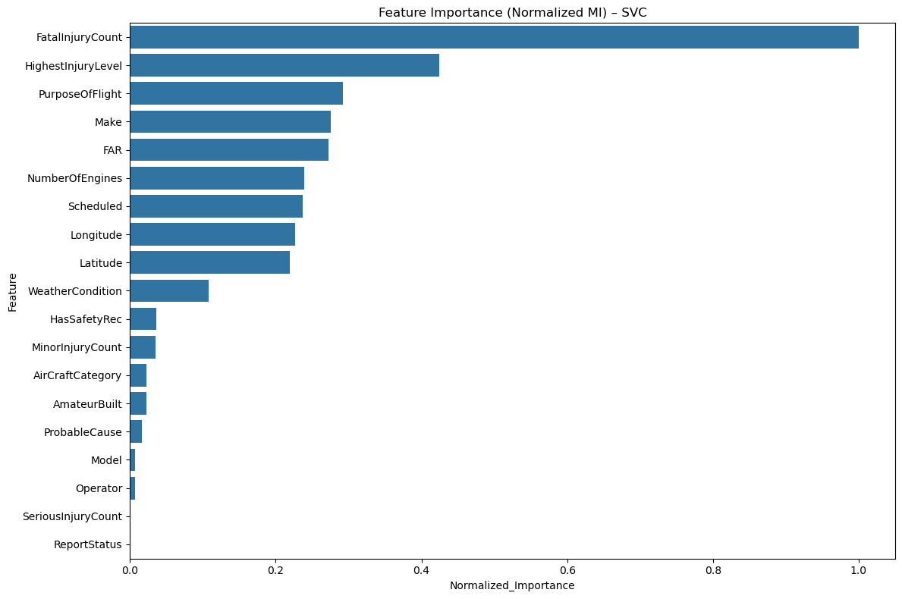

This bar chart of Normalized Mutual Information for the SVC model shows that FatalInjuryCount is by far the most influential feature (≈0.98–1.0), overwhelmingly driving predictions of damage severity, with HighestInjuryLevel a distant but meaningful second (≈0.43), indicating that injury severity strongly aligns with damage outcomes. Moderately important predictors include PurposeOfFlight, Make, FAR, NumberOfEngines, Scheduled status, Longitude, and Latitude, reflecting a combination of aircraft design and operational context, while features such as WeatherCondition, HasSafetyRec, MinorInjuryCount, and AircraftCategory play only a modest role. Variables like AmateurBuilt, ProbableCause, Model, Operator, SeriousInjuryCount, and ReportStatus contribute almost nothing, suggesting little discriminative value for this classifier. Overall, the SVC appears to rely primarily on injury-related information—especially fatalities—which is logically related to damage but may represent post-event label leakage, limiting real-time predictive usefulness; therefore, a more practical model would need to prioritize pre-incident features such as flight phase, weather, or aircraft characteristics rather than outcomes recorded after the accident, and the use of Mutual Information (a model-agnostic, non-linear measure) explains why importance is reported despite SVC lacking native feature importance.

