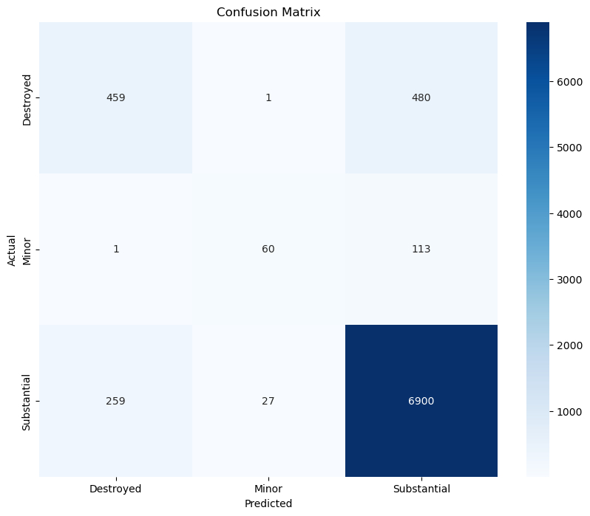
precision recall f1-score support

Destroyed 0.64 0.49 0.55 940
Minor 0.68 0.34 0.46 174
Substantial 0.92 0.96 0.94 7186

accuracy 0.89 8300
macro avg 0.75 0.60 0.65 8300
weighted avg 0.88 0.89 0.89 8300
The multi-class XGBoost model for predicting aircraft damage severity across three categories—Destroyed, Minor, and Substantial—achieves a respectable overall accuracy of about 89.4 percent, driven largely by its very strong performance on the dominant “Substantial” class (F1 ≈ 0.94, recall ≈ 0.96), while showing clear weaknesses on the two minority classes. For “Destroyed,” the model attains moderate recall (≈0.64) but low precision (≈0.49), indicating frequent confusion with “Substantial,” whereas the “Minor” class performs poorest overall, with low precision (≈0.345) despite reasonable recall (≈0.68), reflecting many false alarms. As a result, macro-level metrics that treat all classes equally—such as macro F1 (≈0.652), balanced accuracy (≈0.760), and macro MCC (≈0.526)—are substantially lower than the weighted averages, revealing that high overall accuracy mainly reflects class imbalance rather than uniformly strong performance. Cohen’s kappa (~0.705) suggests strong agreement beyond chance, and the estimated overall MCC (≈0.71–0.75) indicates solid but imperfect reliability.
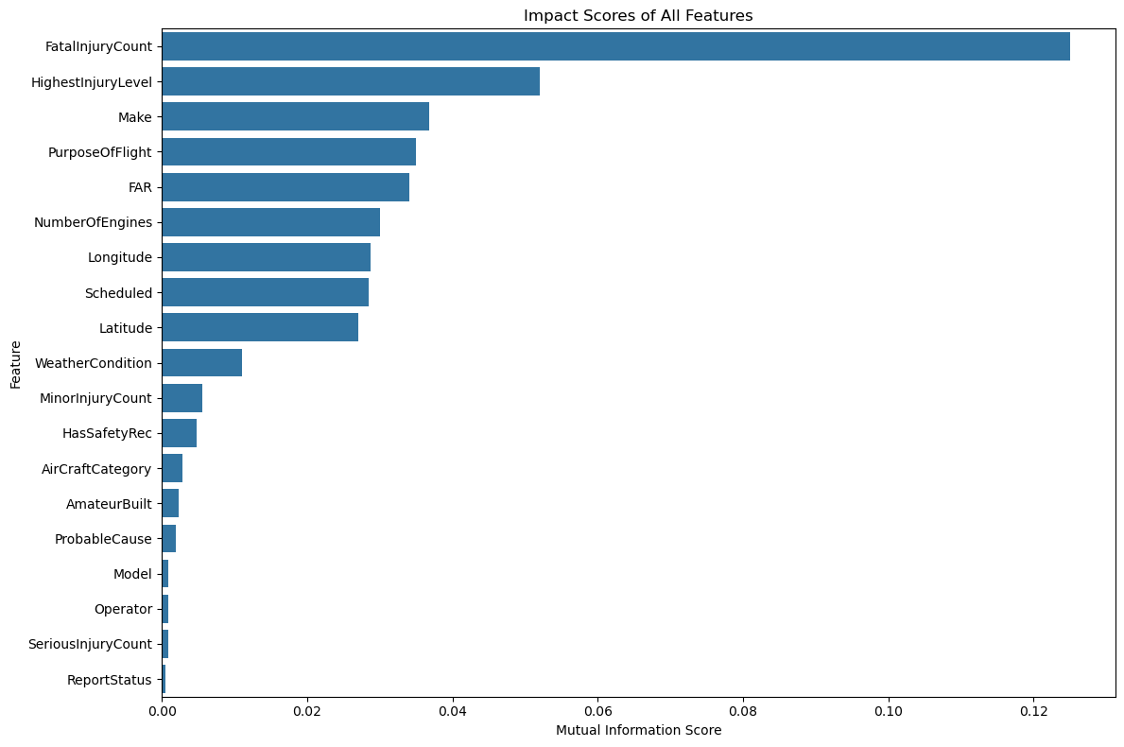
The mutual information analysis indicates that FatalInjuryCount is by far the most informative predictor, suggesting that the severity of outcomes carries the strongest signal for classification, followed by HighestInjuryLevel, which reinforces the central role of injury severity. Aircraft and operational characteristics such as Make, PurposeOfFlight, FAR, NumberOfEngines, and Scheduled status show moderate predictive relevance, implying that both technical design and mission type contribute meaningfully to damage or risk patterns. Geographic context (Longitude and Latitude) also holds notable information, reflecting spatial heterogeneity in incidents, while WeatherCondition provides secondary but non-trivial signal. In contrast, variables such as ProbableCause, Model, Operator, SeriousInjuryCount, and ReportStatus exhibit very low mutual information, indicating limited independent contribution once higher-level injury and operational features are considered.
ALL FEATURE IMPACT SCORES:
Feature MI_Score
8 FatalInjuryCount 0.125016
0 HighestInjuryLevel 0.052040
9 Make 0.036738
10 PurposeOfFlight 0.034996
11 FAR 0.034019
12 NumberOfEngines 0.030003
13 Longitude 0.028700
14 Scheduled 0.028509
15 Latitude 0.026989
1 WeatherCondition 0.011015
16 MinorInjuryCount 0.005606
2 HasSafetyRec 0.004792
3 AirCraftCategory 0.002882
4 AmateurBuilt 0.002317
5 ProbableCause 0.001886
6 Model 0.000861
7 Operator 0.000830
17 SeriousInjuryCount 0.000823
18 ReportStatus 0.000544

