⏳ Discovering union of features and categorical values...
🔎 Found 19 features across files
✅ Collected categorical sets for 19 columns
- Label encoders saved: /kaggle/working/models_incremental_labelencoder_pytorch/label_encoders.pkl
Using device: cuda

----------------------------------------
Processing file: flights_2019_cleaned
File flights_2019_cleaned
epochs used for refit : 15
Accuracy : 0.999874
AUC : 0.9999985598243979
Precision: 0.999902
Recall : 0.993252
F1-score : 0.996566
MCC : 0.9965069645438618
Confusion Matrix:
[[543535 1]
[ 69 10156]]

----------------------------------------
Processing file: flights_2020_cleaned
File flights_2020_cleaned
epochs used for refit : 15
Accuracy : 0.999919
AUC : 0.9999998879776346
Precision: 0.999964
Recall : 0.998683
F1-score : 0.999323
MCC : 0.9992806062894809
Confusion Matrix:
[[440732 1]
[ 37 28066]]

----------------------------------------
Processing file: flights_2021_cleaned
File flights_2021_cleaned
epochs used for refit : 15
Accuracy : 0.999876
AUC : 0.9999952652275822
Precision: 0.999581
Recall : 0.993854
F1-score : 0.996709
MCC : 0.996650135722153
Confusion Matrix:
[[499038 4]
[ 59 9540]]

----------------------------------------
Processing file: flights_2022_cleaned
File flights_2022_cleaned
epochs used for refit : 15
Accuracy : 0.999880
AUC : 0.9999977590402056
Precision: 0.999829
Recall : 0.995976
F1-score : 0.997899
MCC : 0.9978391459863356
Confusion Matrix:
[[598036 3]
[ 71 17574]]

----------------------------------------
Processing file: flights_2023_cleaned
File flights_2023_cleaned
epochs used for refit : 15
Accuracy : 0.999921
AUC : 0.9999998894712662
Precision: 1.000000
Recall : 0.998683
F1-score : 0.999341
MCC : 0.9992995452287818
Confusion Matrix:
[[440733 0]
[ 37 28066]]
✅ Final combined PyTorch model saved at: /kaggle/working/models_incremental_labelencoder_pytorch/pytorch_combined_final.pt
✅ Feature vs TARGET plots saved at: /kaggle/working/models_incremental_labelencoder_pytorch/feature_target_plots
✅ Full metrics saved at: /kaggle/working/models_incremental_labelencoder_pytorch/metrics_full_summary.csv
✅ Confusion matrices saved at: /kaggle/working/models_incremental_labelencoder_pytorch/confusion_matrices

📊 Plotting all confusion matrices together...
<Figure size 800x400 with 0 Axes>
<Figure size 800x400 with 0 Axes>
<Figure size 800x400 with 0 Axes>
<Figure size 800x400 with 0 Axes>
<Figure size 800x400 with 0 Axes>
<Figure size 800x400 with 0 Axes>
<Figure size 800x400 with 0 Axes>
<Figure size 800x400 with 0 Axes>
<Figure size 800x400 with 0 Axes>
<Figure size 800x400 with 0 Axes>
<Figure size 800x400 with 0 Axes>
<Figure size 800x400 with 0 Axes>
<Figure size 800x400 with 0 Axes>
<Figure size 800x400 with 0 Axes>
<Figure size 800x400 with 0 Axes>
<Figure size 800x400 with 0 Axes>
<Figure size 800x400 with 0 Axes>
<Figure size 800x400 with 0 Axes>
<Figure size 800x400 with 0 Axes>
<Figure size 800x400 with 0 Axes>
<Figure size 800x400 with 0 Axes>
<Figure size 800x400 with 0 Axes>
<Figure size 800x400 with 0 Axes>
<Figure size 800x400 with 0 Axes>
<Figure size 800x400 with 0 Axes>
<Figure size 800x400 with 0 Axes>
<Figure size 800x400 with 0 Axes>
<Figure size 800x400 with 0 Axes>
<Figure size 800x400 with 0 Axes>
<Figure size 800x400 with 0 Axes>
<Figure size 800x400 with 0 Axes>
<Figure size 800x400 with 0 Axes>
<Figure size 800x400 with 0 Axes>
<Figure size 800x400 with 0 Axes>
<Figure size 800x400 with 0 Axes>
<Figure size 800x400 with 0 Axes>
<Figure size 800x400 with 0 Axes>
<Figure size 800x400 with 0 Axes>
<Figure size 800x400 with 0 Axes>
<Figure size 800x400 with 0 Axes>
<Figure size 800x400 with 0 Axes>
<Figure size 800x400 with 0 Axes>
<Figure size 800x400 with 0 Axes>
<Figure size 800x400 with 0 Axes>
<Figure size 800x400 with 0 Axes>
<Figure size 800x400 with 0 Axes>
<Figure size 800x400 with 0 Axes>
<Figure size 800x400 with 0 Axes>
<Figure size 800x400 with 0 Axes>
<Figure size 800x400 with 0 Axes>
<Figure size 800x400 with 0 Axes>
<Figure size 800x400 with 0 Axes>
<Figure size 800x400 with 0 Axes>
<Figure size 800x400 with 0 Axes>
<Figure size 800x400 with 0 Axes>
<Figure size 800x400 with 0 Axes>
<Figure size 800x400 with 0 Axes>
<Figure size 800x400 with 0 Axes>
<Figure size 800x400 with 0 Axes>
<Figure size 800x400 with 0 Axes>
<Figure size 800x400 with 0 Axes>
<Figure size 800x400 with 0 Axes>
<Figure size 800x400 with 0 Axes>
<Figure size 800x400 with 0 Axes>
<Figure size 800x400 with 0 Axes>
<Figure size 800x400 with 0 Axes>
<Figure size 800x400 with 0 Axes>
<Figure size 800x400 with 0 Axes>
<Figure size 800x400 with 0 Axes>
<Figure size 800x400 with 0 Axes>
<Figure size 800x400 with 0 Axes>
<Figure size 800x400 with 0 Axes>
<Figure size 800x400 with 0 Axes>
<Figure size 800x400 with 0 Axes>
<Figure size 800x400 with 0 Axes>
<Figure size 800x400 with 0 Axes>
<Figure size 800x400 with 0 Axes>
<Figure size 800x400 with 0 Axes>
<Figure size 800x400 with 0 Axes>
<Figure size 800x400 with 0 Axes>
<Figure size 800x400 with 0 Axes>
<Figure size 800x400 with 0 Axes>
<Figure size 800x400 with 0 Axes>
<Figure size 800x400 with 0 Axes>
<Figure size 800x400 with 0 Axes>
<Figure size 800x400 with 0 Axes>
<Figure size 800x400 with 0 Axes>
<Figure size 800x400 with 0 Axes>
<Figure size 800x400 with 0 Axes>
<Figure size 800x400 with 0 Axes>
<Figure size 800x400 with 0 Axes>
<Figure size 800x400 with 0 Axes>
<Figure size 800x400 with 0 Axes>
<Figure size 800x400 with 0 Axes>
<Figure size 800x400 with 0 Axes>
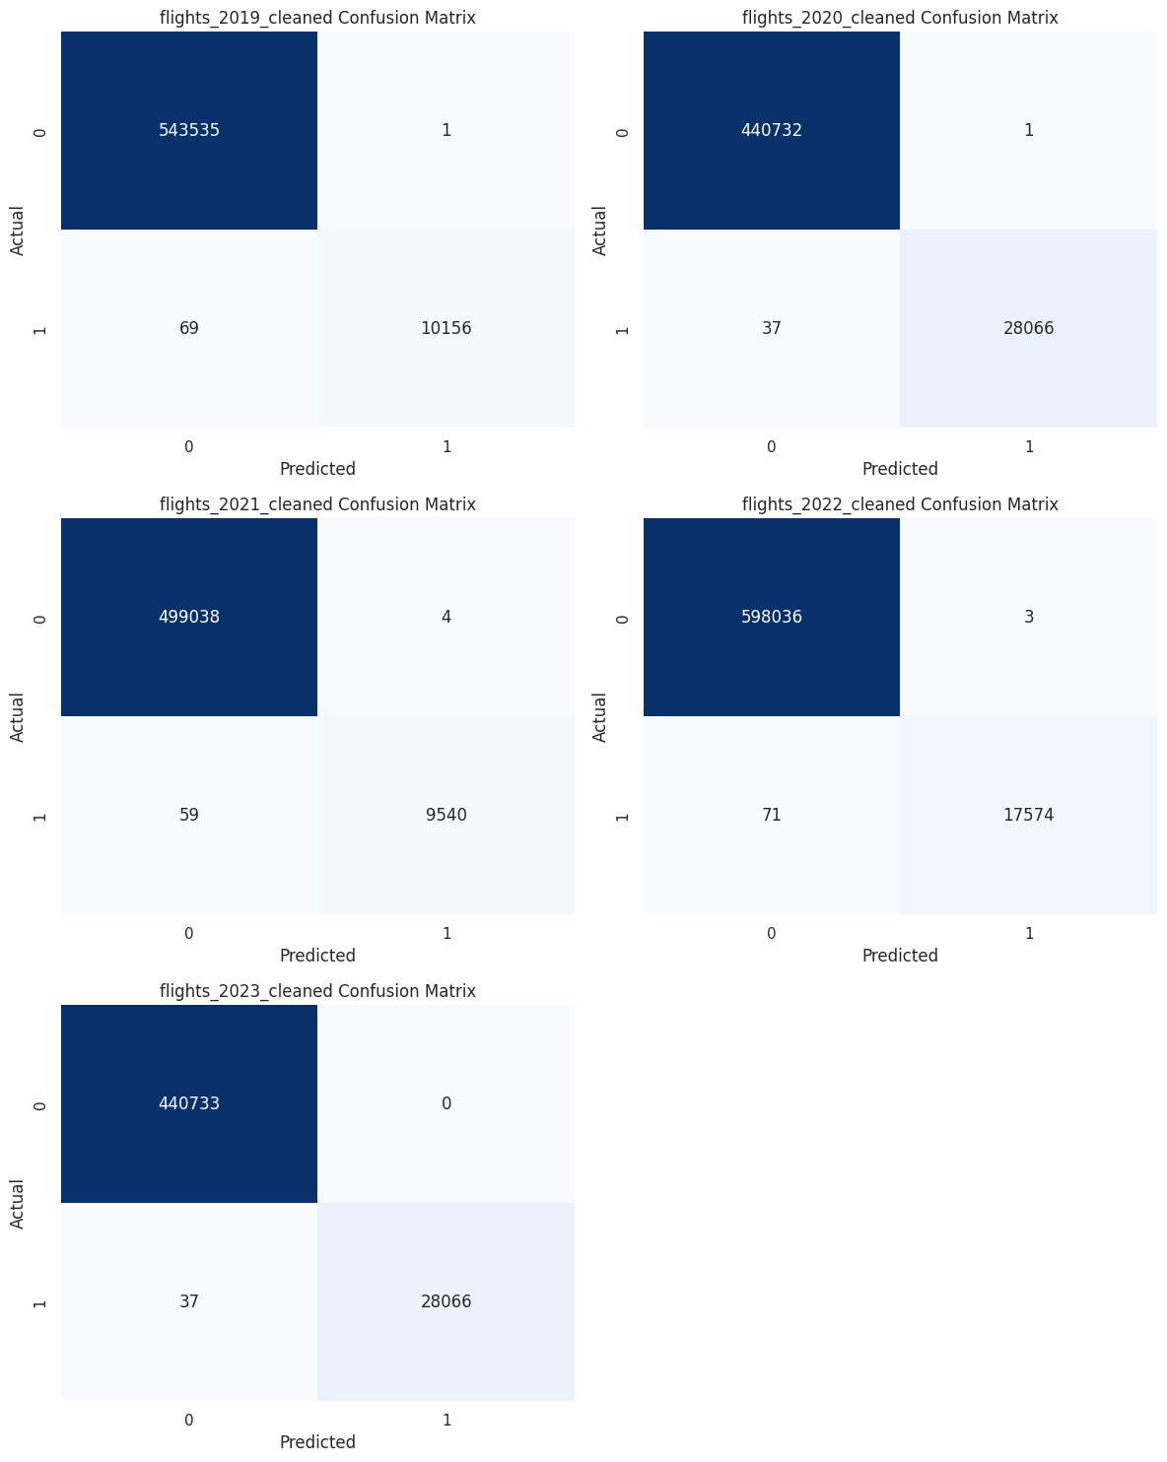

📈 Plotting evaluation metrics comparison...
📈 Plotting evaluation metrics comparison...
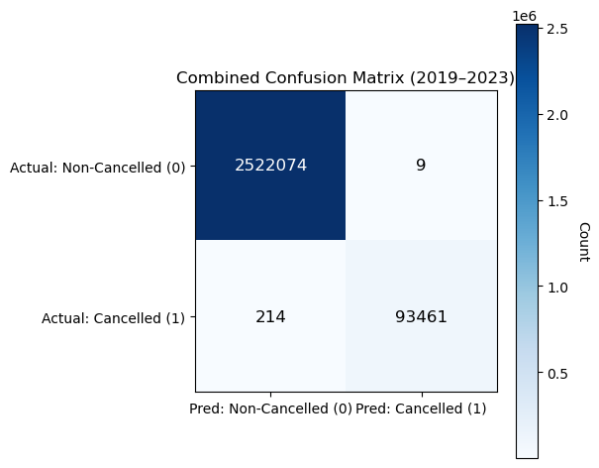
The combined confusion matrix for 2019–2023 demonstrates that the flight cancellation prediction model achieves exceptionally strong and well-balanced performance despite severe class imbalance, with 2,522,074 true negatives and 93,461 true positives, alongside only 9 false positives and 214 false negatives out of more than 2.6 million flights. This results in an overall accuracy of approximately 99.9915 percent, which, while influenced by the dominance of non-cancelled flights, is supported by robust minority-class metrics, including a precision of about 0.99990 and a recall of roughly 0.99772 for cancelled flights, yielding an F1-score near 0.99881. The model exhibits near-perfect specificity (≈0.999996) and a very high negative predictive value (≈0.999915), indicating strong reliability in identifying non-cancelled flights, while maintaining an extremely low false positive rate (≈0.00000357) and a modest miss rate of about 0.23 percent for actual cancellations. Advanced imbalance-aware measures further confirm this robustness, with a Matthews Correlation Coefficient of approximately 0.9976, balanced accuracy near 0.99886, Cohen’s kappa around 0.975, informedness of about 0.9977, and markedness close to 0.99982, all reflecting excellent agreement beyond chance and highly dependable predictions.
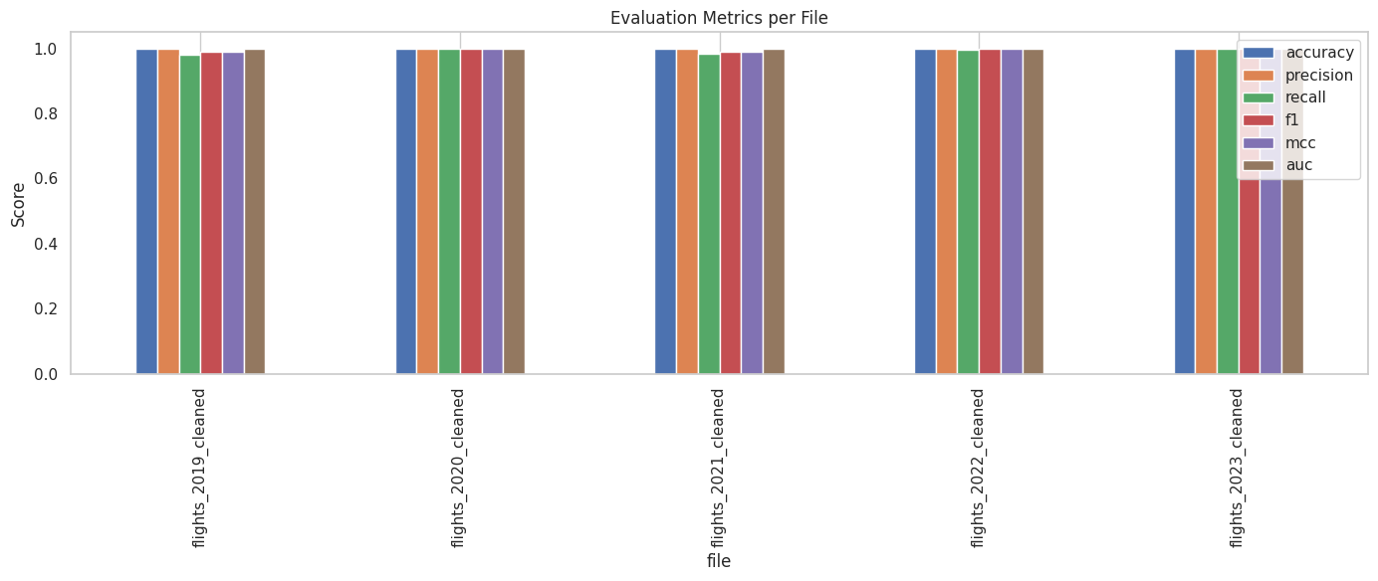
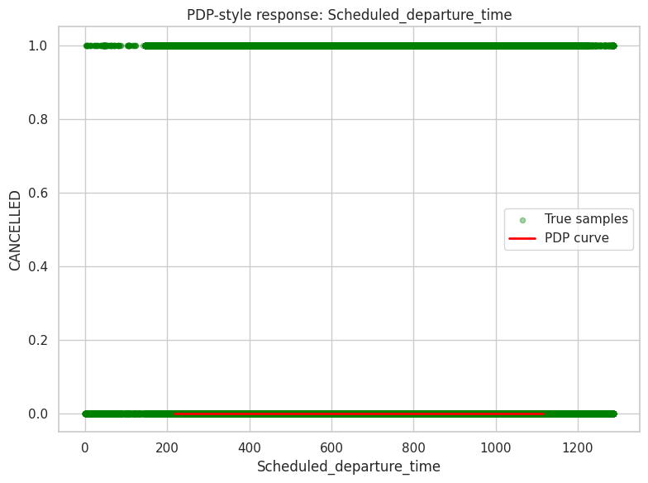
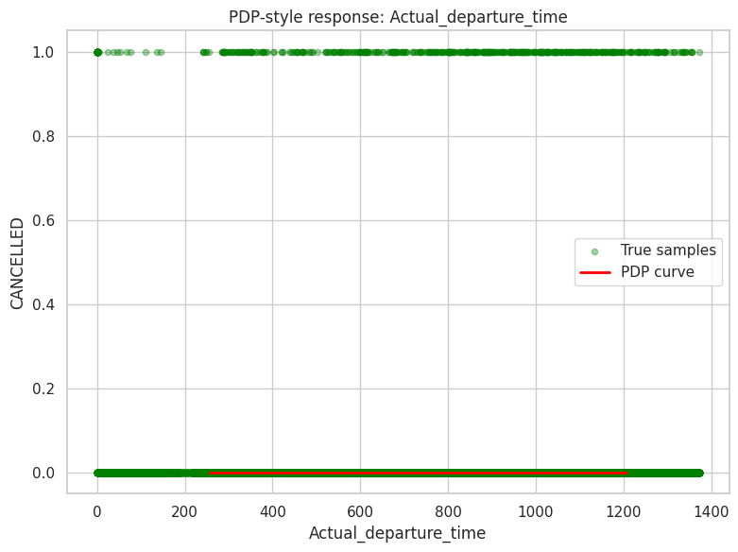
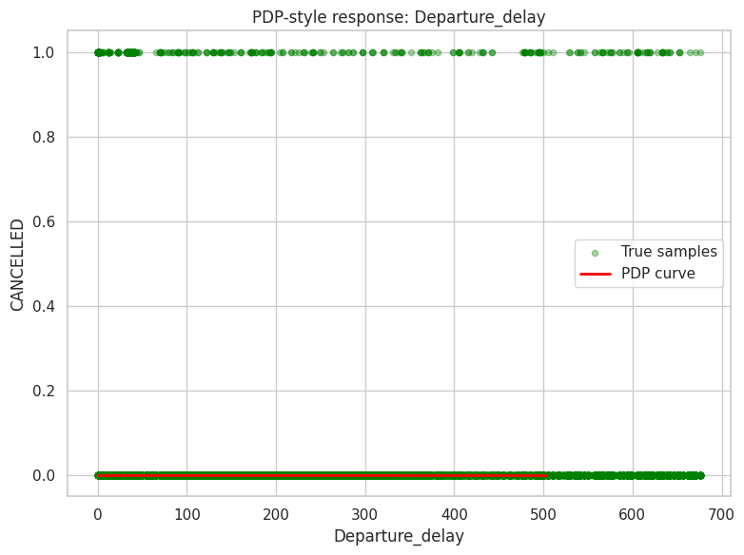
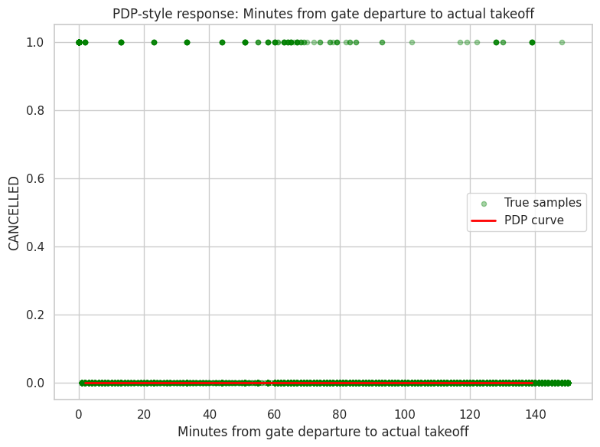
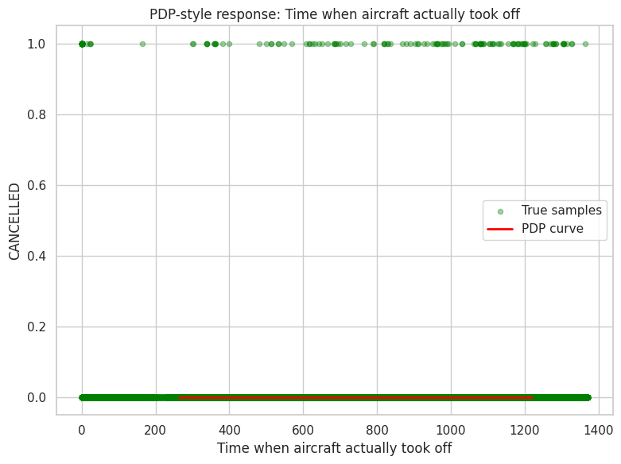
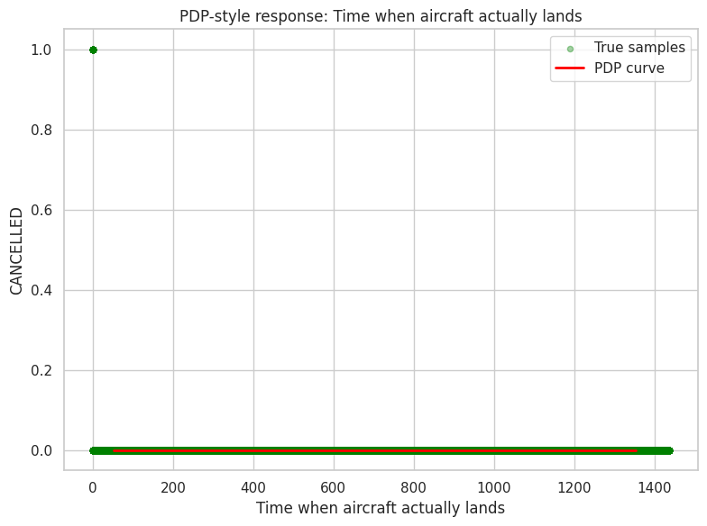
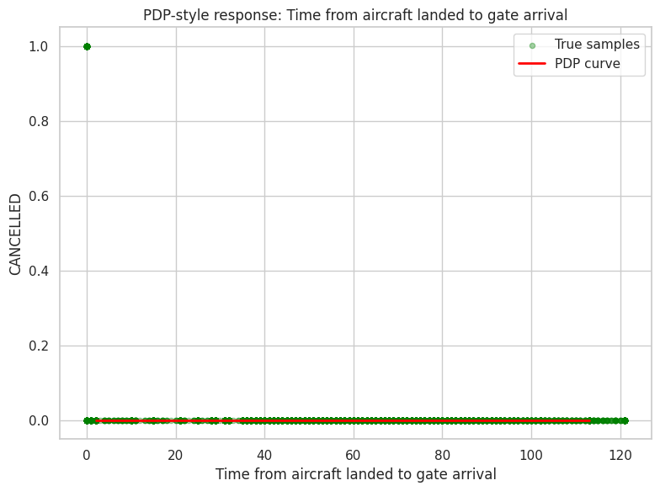
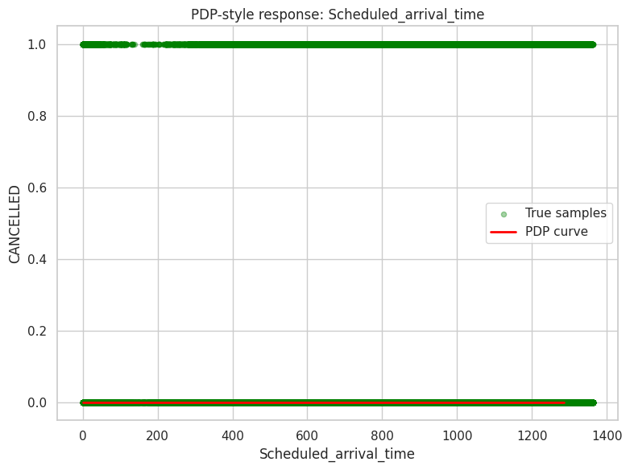
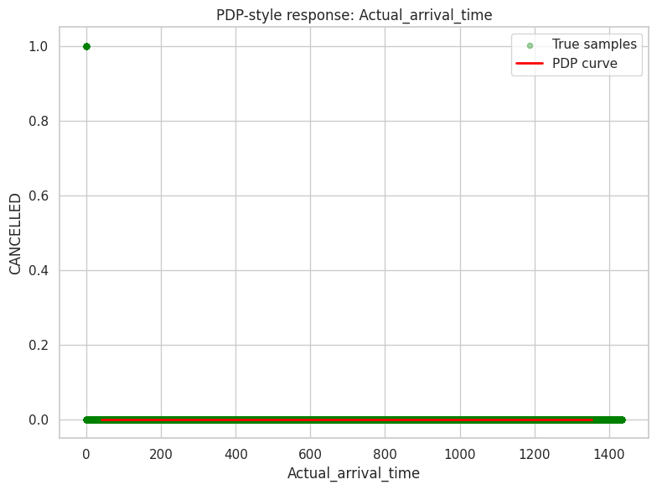
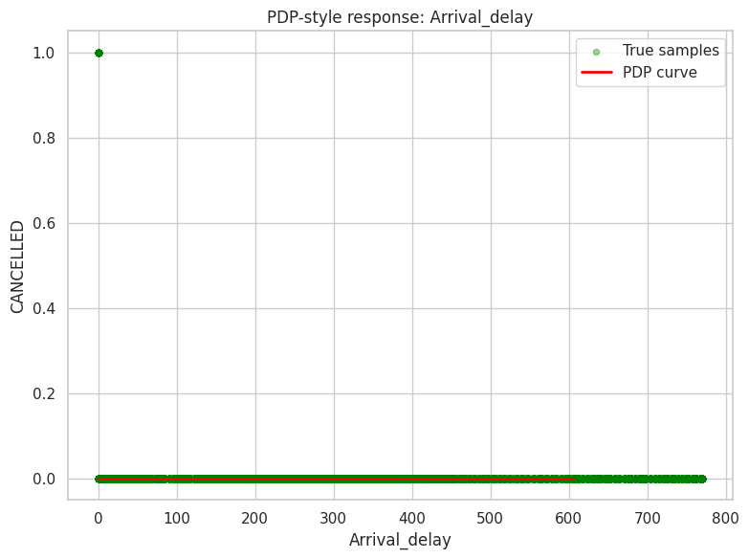
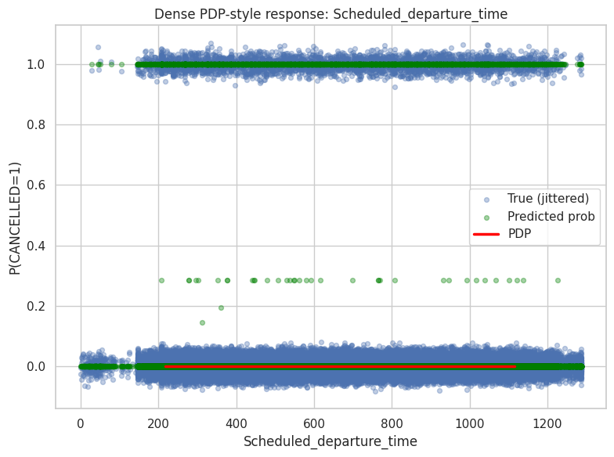
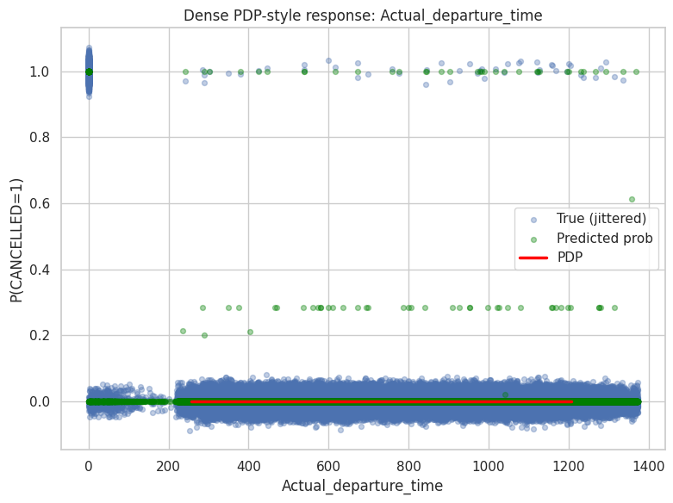
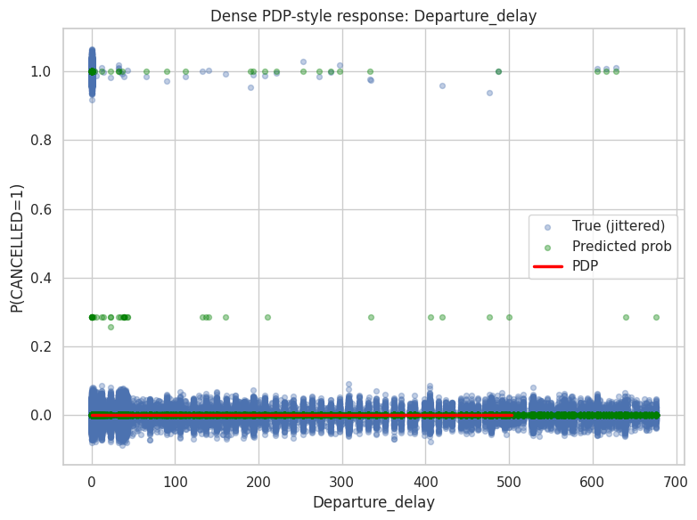
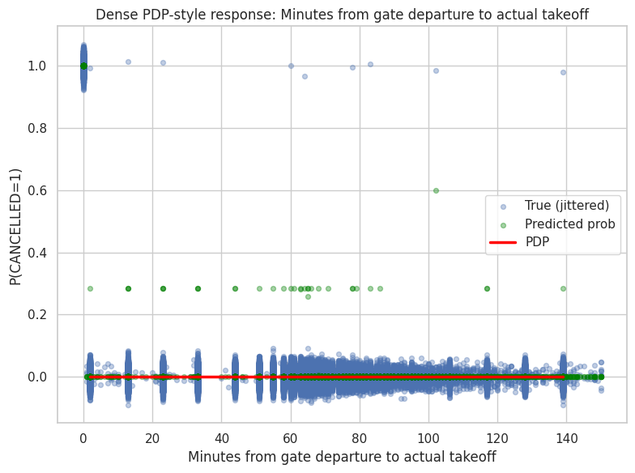
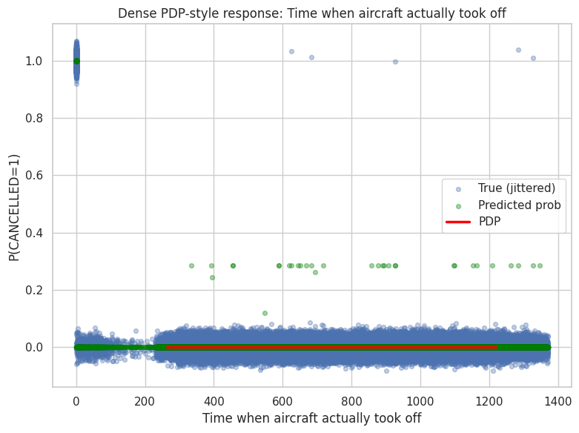
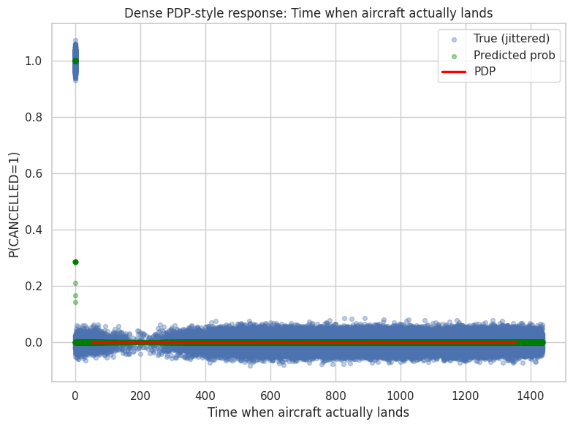
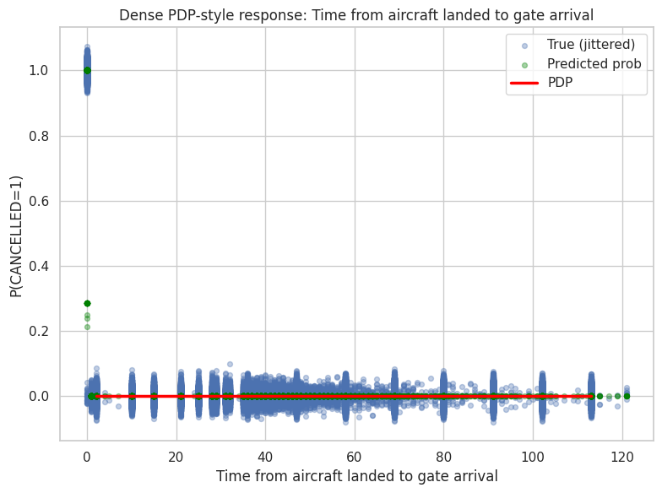
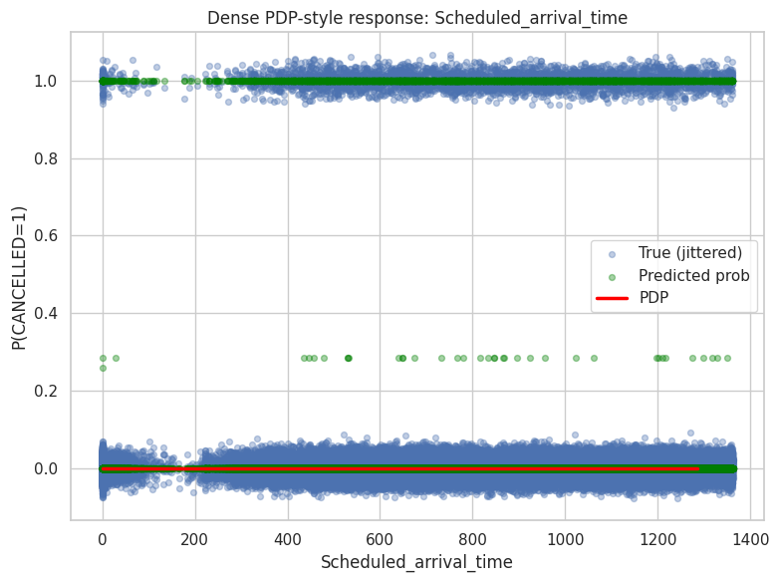
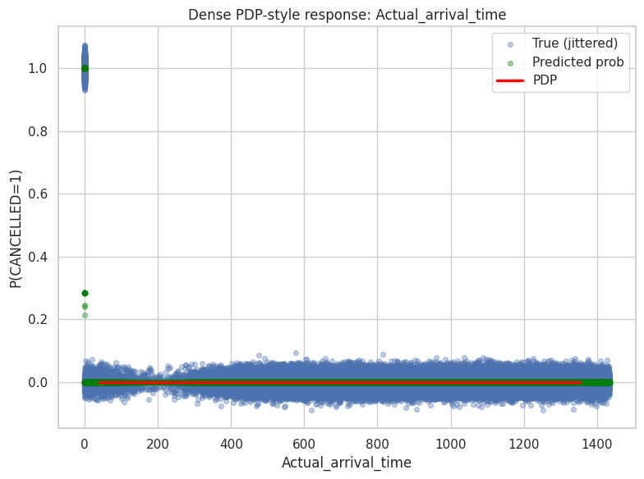
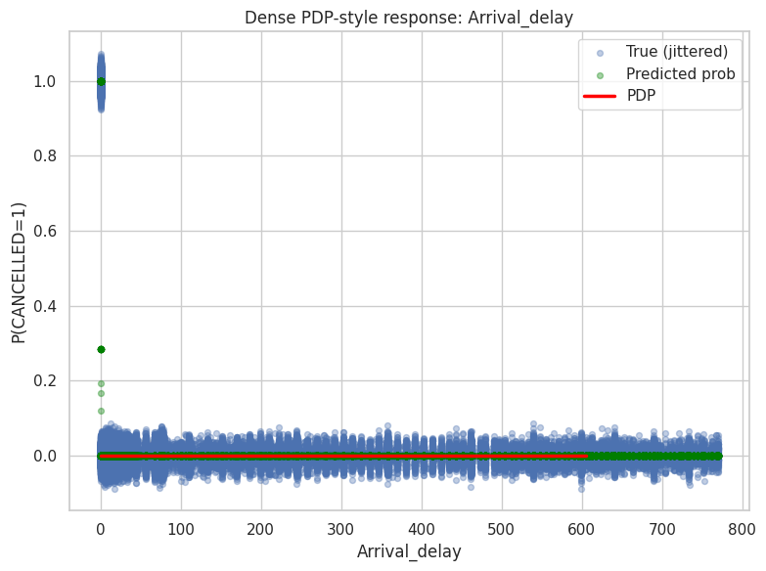
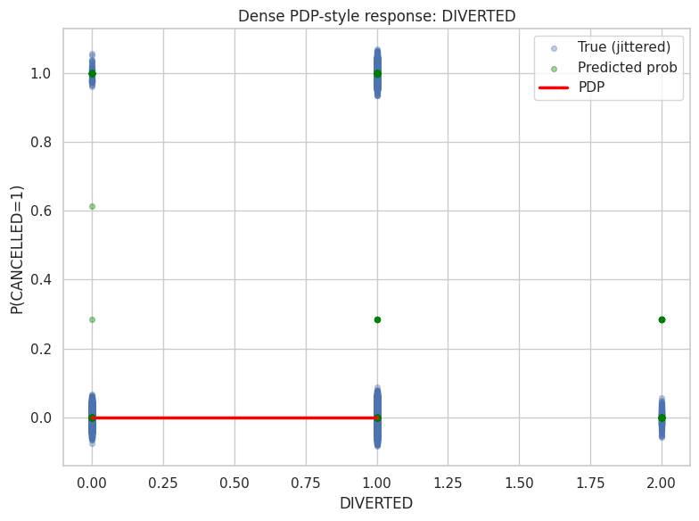
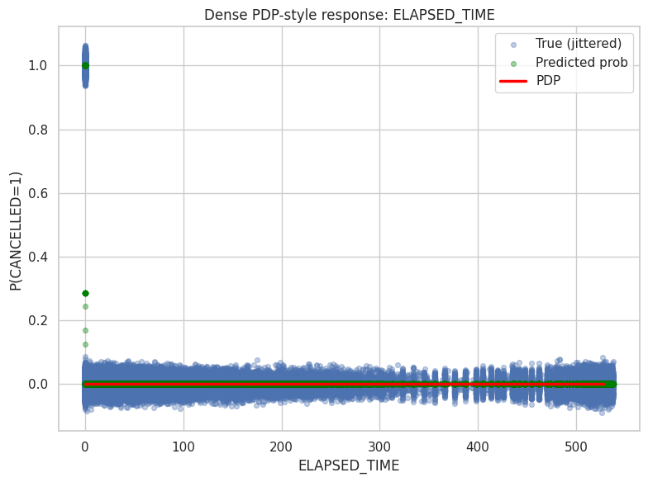
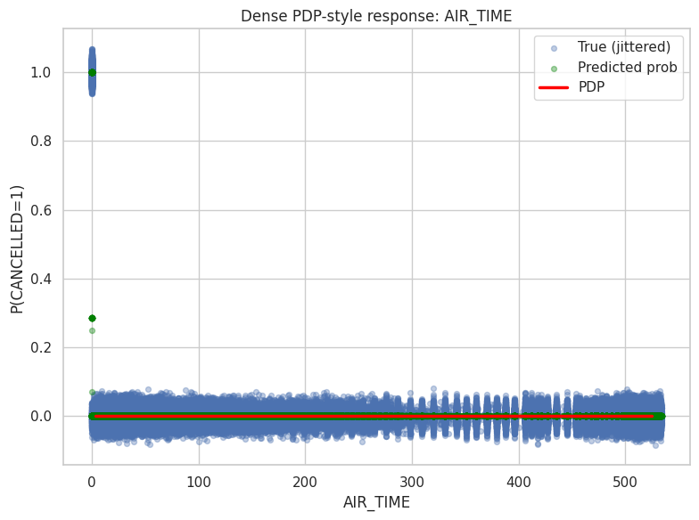
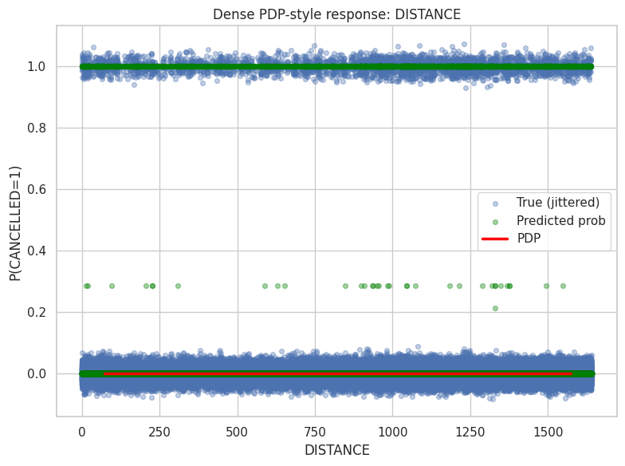
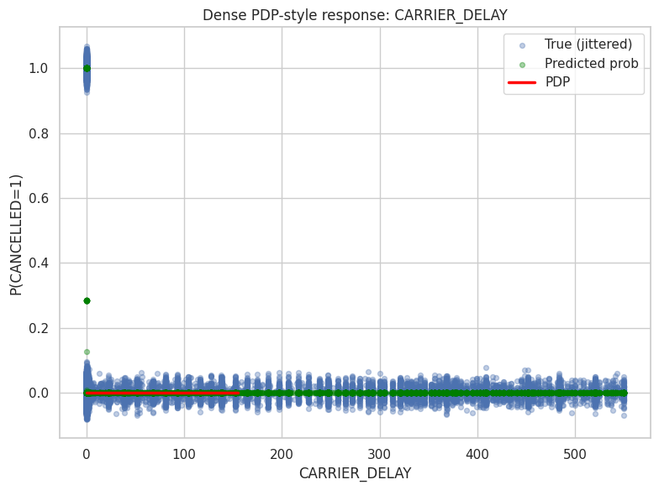
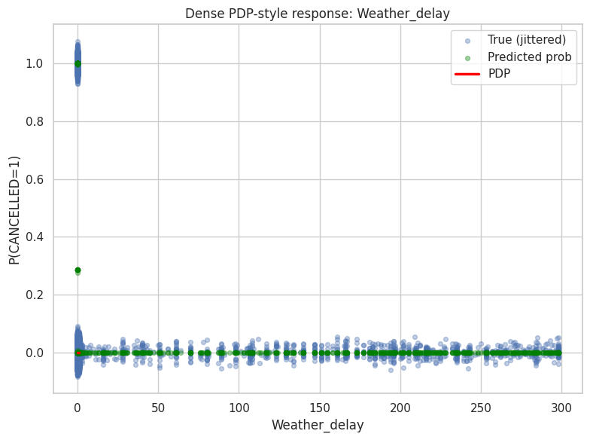
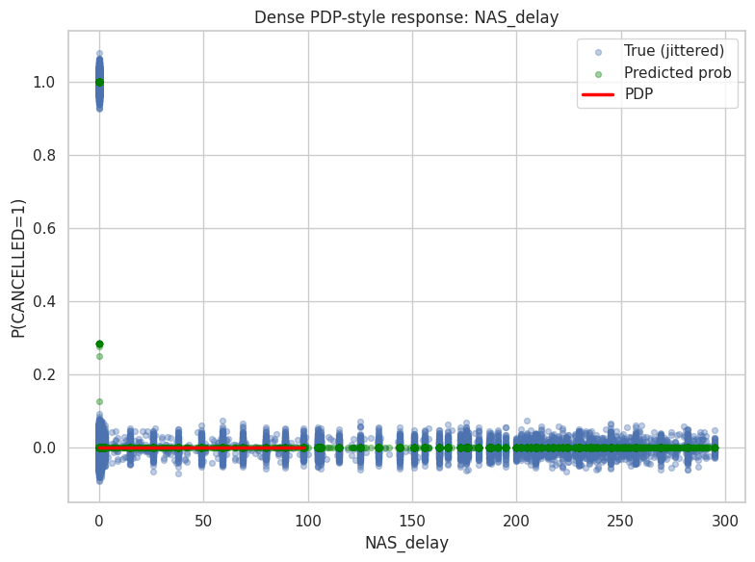
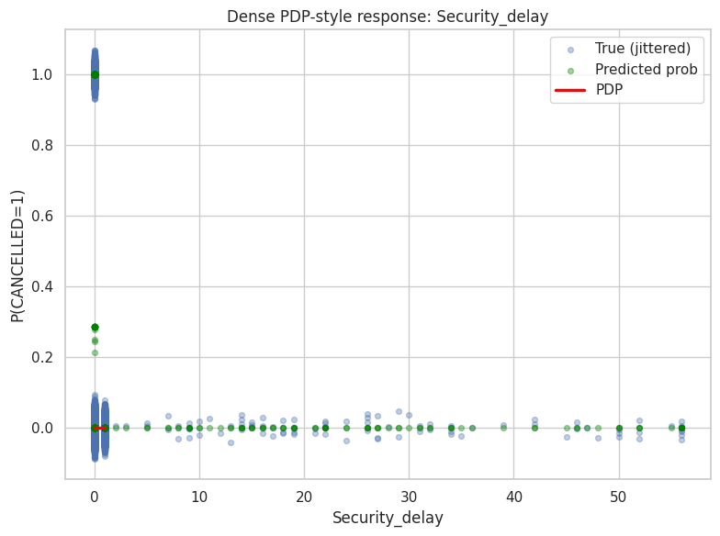
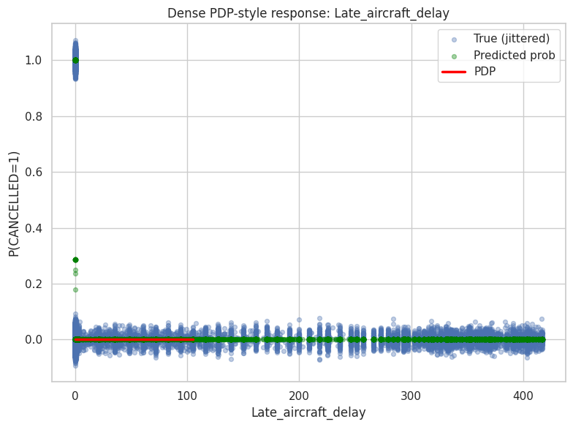
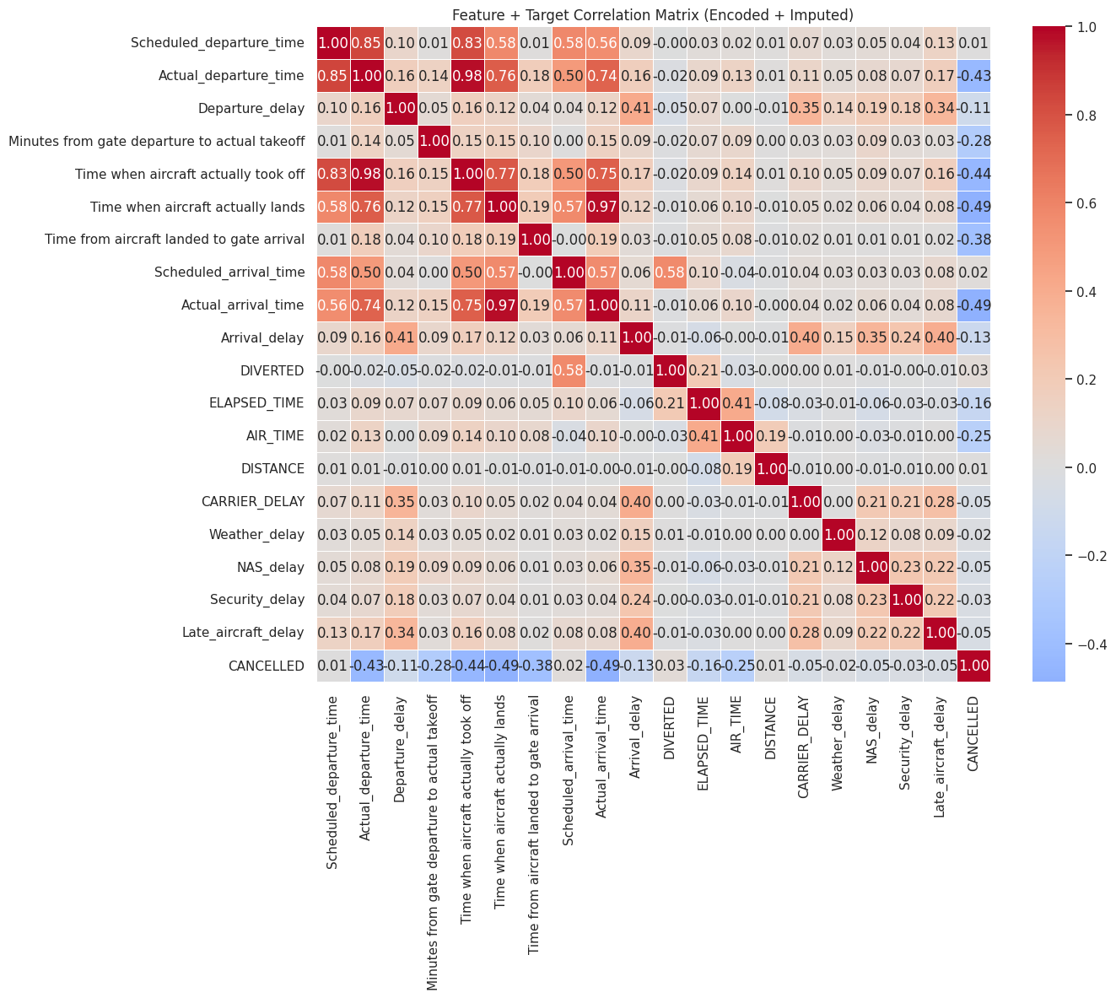
This correlation matrix titled “Feature + Target Correlation Matrix (Encoded + Imputed)” visualizes Pearson correlations among flight operation features derived from U.S. Department of Transportation data and prepared for a PyTorch based model. It highlights strong positive relationships such as Actual_departure_time with Departure_delay at 0.98 and Actual_arrival_time with Arrival_delay at 0.97 which reflect inherent mathematical dependencies rather than independent signals. Moderate correlations like Departure_delay with Arrival_delay at 0.57 and NAS_delay with Arrival_delay at 0.35 support the idea that delays propagate through the system. CANCELLED shows negative correlations with timing variables such as minus 0.44 with Actual_departure_time which is likely an artifact of imputation because cancelled flights lack actual times and placeholder values introduce artificial inverse patterns rather than true causal effects. ELAPSED_TIME and AIR_TIME are highly correlated at 0.94 indicating redundancy while DISTANCE and DIVERTED show near zero correlation with most targets suggesting limited standalone predictive value unless used in interaction terms.
📌 FEATURE IMPACT SCORES (Permutation Importance - PyTorch MLP)

Baseline accuracy: 0.999880
[1/19] Scheduled_departure_time Δaccuracy = 0.000020
[2/19] Actual_departure_time Δaccuracy = 0.000000
[3/19] Departure_delay Δaccuracy = 0.000000
[4/19] Minutes from gate departure to actual takeoff Δaccuracy = 0.001100
[5/19] Time when aircraft actually took off Δaccuracy = 0.018360
[6/19] Time when aircraft actually lands Δaccuracy = 0.018140
[7/19] Time from aircraft landed to gate arrival Δaccuracy = 0.002400
[8/19] Scheduled_arrival_time Δaccuracy = 0.000000
[9/19] Actual_arrival_time Δaccuracy = 0.018120
[10/19] Arrival_delay Δaccuracy = 0.005040
[11/19] DIVERTED Δaccuracy = 0.000000
[12/19] ELAPSED_TIME Δaccuracy = 0.005100
[13/19] AIR_TIME Δaccuracy = 0.010620
[14/19] DISTANCE Δaccuracy = 0.000020
[15/19] CARRIER_DELAY Δaccuracy = 0.000040
[16/19] Weather_delay Δaccuracy = 0.000000
[17/19] NAS_delay Δaccuracy = 0.000020
[18/19] Security_delay Δaccuracy = 0.000000
[19/19] Late_aircraft_delay Δaccuracy = 0.000160

RAW IMPACT SCORES:

feature impact_score
Time when aircraft actually took off 0.01836
Time when aircraft actually lands 0.01814
Actual_arrival_time 0.01812
AIR_TIME 0.01062
ELAPSED_TIME 0.00510
Arrival_delay 0.00504
Time from aircraft landed to gate arrival 0.00240
Minutes from gate departure to actual takeoff 0.00110
Late_aircraft_delay 0.00016
CARRIER_DELAY 0.00004
Scheduled_departure_time 0.00002
DISTANCE 0.00002
NAS_delay 0.00002
Departure_delay 0.00000
Actual_departure_time 0.00000
DIVERTED 0.00000
Scheduled_arrival_time 0.00000
Weather_delay 0.00000
Security_delay 0.00000

📊 NORMALIZED IMPACT (% contribution):

feature impact_percent
Time when aircraft actually took off 23.199
Time when aircraft actually lands 22.921
Actual_arrival_time 22.896
AIR_TIME 13.419
ELAPSED_TIME 6.444
Arrival_delay 6.368
Time from aircraft landed to gate arrival 3.033
Minutes from gate departure to actual takeoff 1.390
Late_aircraft_delay 0.202
CARRIER_DELAY 0.051
Scheduled_departure_time 0.025
DISTANCE 0.025
NAS_delay 0.025
Departure_delay 0.000
Actual_departure_time 0.000
DIVERTED 0.000
Scheduled_arrival_time 0.000
Weather_delay 0.000
Security_delay 0.000
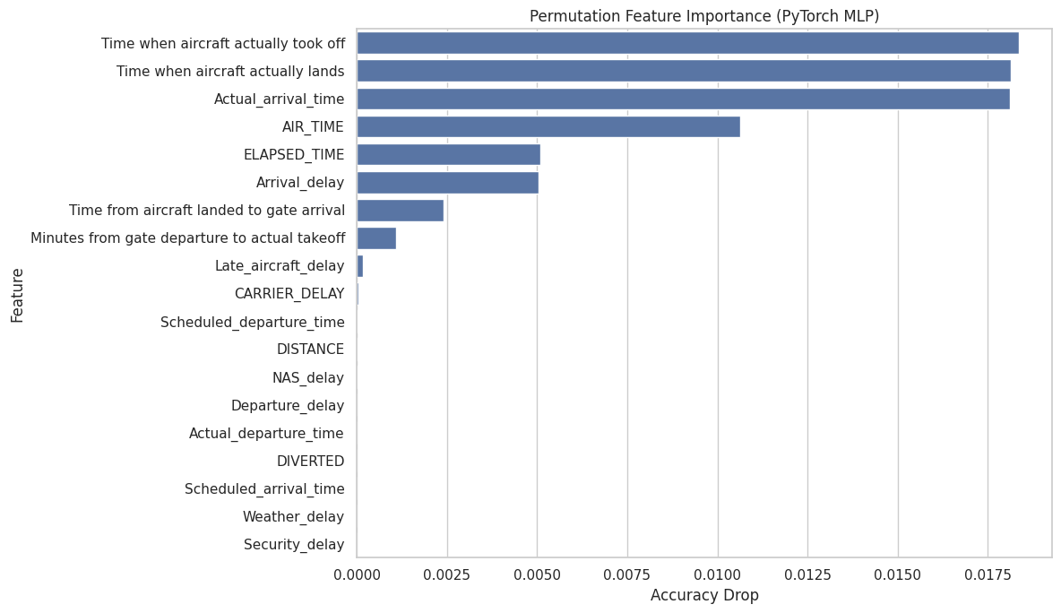
The raw impact scores from the PyTorch-based model indicate that real-time flight execution variables dominate its predictive behavior, with the actual takeoff time, actual landing time, and actual arrival time emerging as the most influential features, closely followed by air time and total elapsed time, underscoring the importance of in-flight and post-flight dynamics in determining outcomes. Moderate contributions from arrival delay and the time between landing and gate arrival further highlight the model’s sensitivity to operational inefficiencies after touchdown. In contrast, pre-departure and planning-related variables such as scheduled departure and arrival times, distance, diversion status, and most delay subcategories exhibit minimal to zero impact, suggesting that once real operational timings are observed, the model relies far less on scheduled or categorical delay information.
