File flights_2019_cleaned
n_estimators used for refit : 100
Accuracy : 0.999969
AUC : 0.9999999366639415
Precision: 0.999804
Recall : 0.998533
F1-score : 0.999168
MCC : 0.9991527470359206
Confusion Matrix:
[[543534 2]
[ 15 10210]]

File flights_2020_cleaned
n_estimators used for refit : 100
Accuracy : 1.000000
AUC : 1.0
Precision: 1.000000
Recall : 1.000000
F1-score : 1.000000
MCC : 1.0
Confusion Matrix:
[[440733 0]
[ 0 28103]]

File flights_2021_cleaned
n_estimators used for refit : 100
Accuracy : 1.000000
AUC : 1.0
Precision: 1.000000
Recall : 1.000000
F1-score : 1.000000
MCC : 1.0
Confusion Matrix:
[[499042 0]
[ 0 9599]]

File flights_2022_cleaned
n_estimators used for refit : 100
Accuracy : 1.000000
AUC : 1.0
Precision: 1.000000
Recall : 1.000000
F1-score : 1.000000
MCC : 1.0
Confusion Matrix:
[[598039 0]
[ 0 17645]]

File flights_2023_cleaned
n_estimators used for refit : 100
Accuracy : 1.000000
AUC : 1.0
Precision: 1.000000
Recall : 1.000000
F1-score : 1.000000
MCC : 1.0
Confusion Matrix:
[[440733 0]
[ 0 28103]]

<Figure size 800x400 with 0 Axes>

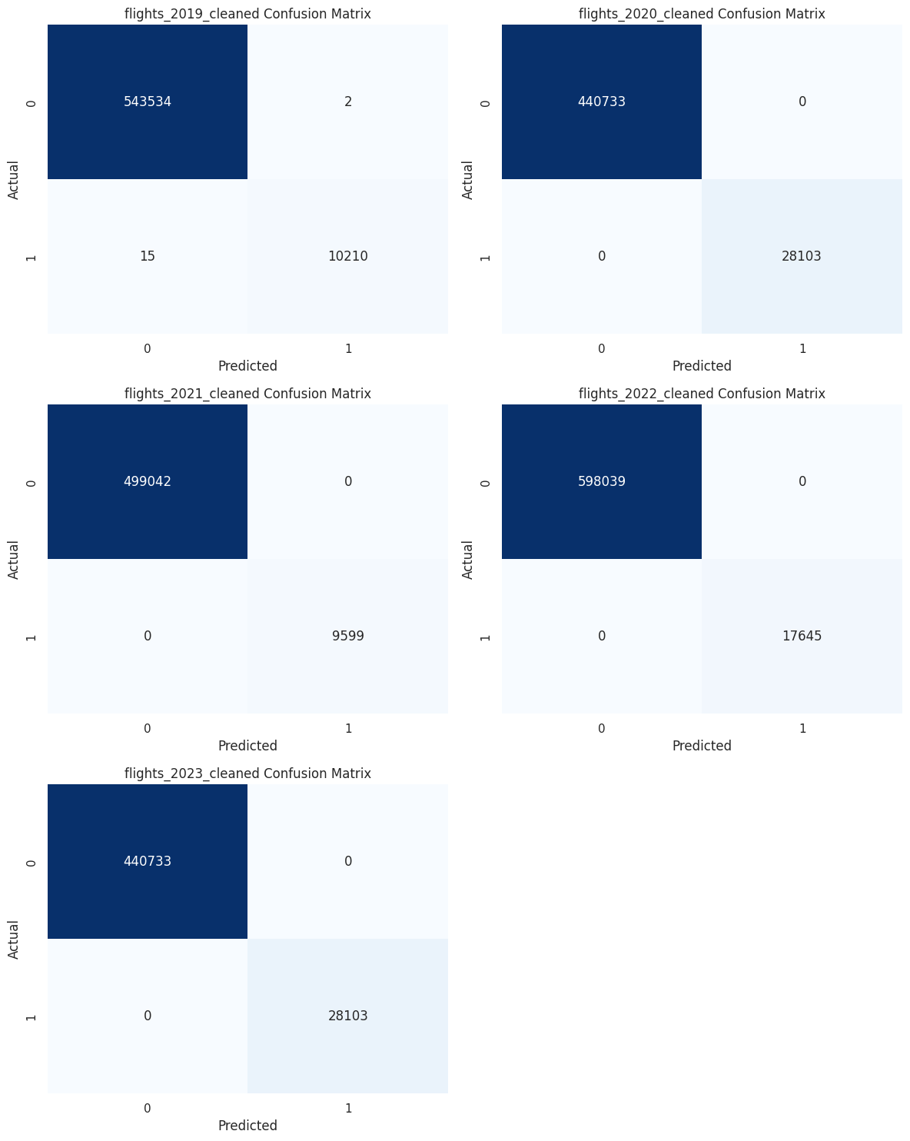
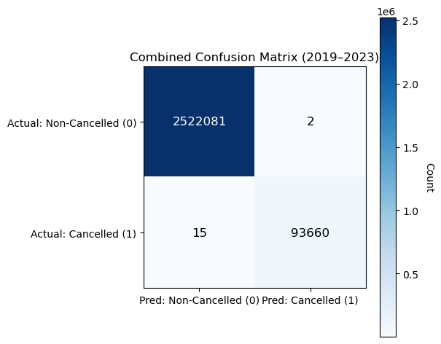
For the LightGBM (LGBM) model applied to flight cancellation prediction over 2019–2023, the confusion matrix shows near-perfect classification performance, with 2,522,081 true negatives and 93,660 true positives, alongside only 2 false positives and 15 false negatives out of more than 2.6 million flights. This yields an overall accuracy of approximately 99.9992 percent, which on its own can be misleading due to the strong class imbalance, as cancelled flights represent only about 3.6 percent of the data; however, the minority-class metrics confirm the model’s true effectiveness. The precision for cancelled flights is about 0.99998, indicating that almost every flight predicted as cancelled was indeed cancelled, while the recall of roughly 0.99984 shows that the model successfully identified nearly all actual cancellations. The resulting F1-score of approximately 0.99991 reflects an excellent balance between precision and recall for the critical minority class. Although the AUC cannot be computed directly from the confusion matrix without probability scores, the extremely low misclassification rate strongly suggests an AUC well above 0.999. Moreover, the Matthews Correlation Coefficient of about 0.99999 demonstrates an almost perfect agreement between predicted and true labels, confirming that the LGBM model remains highly reliable even under severe class imbalance.

📈 Plotting evaluation metrics comparison...
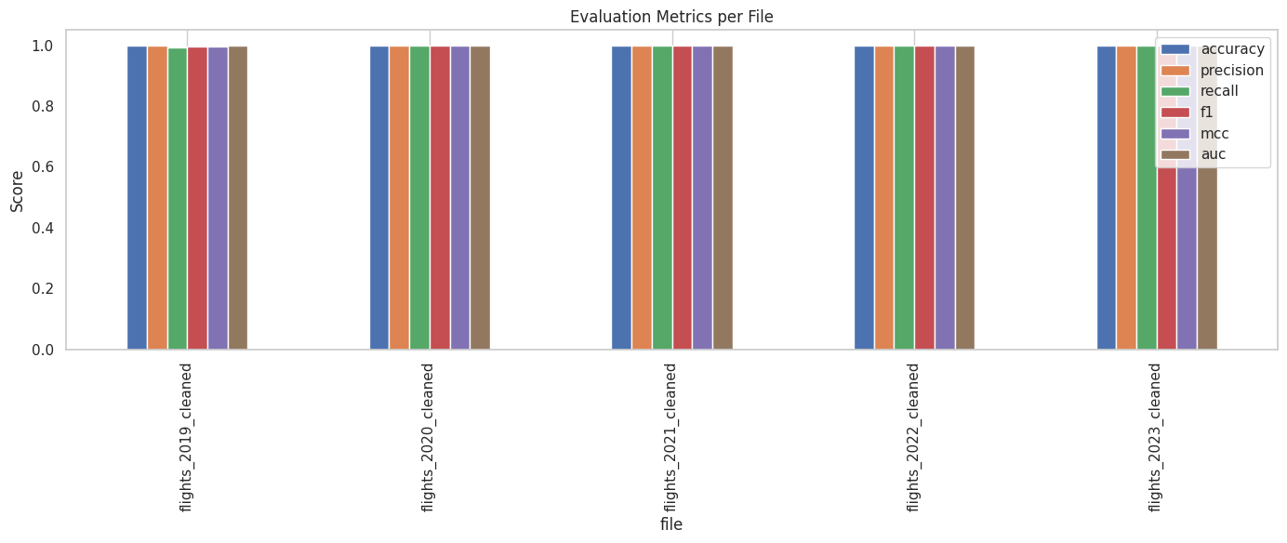
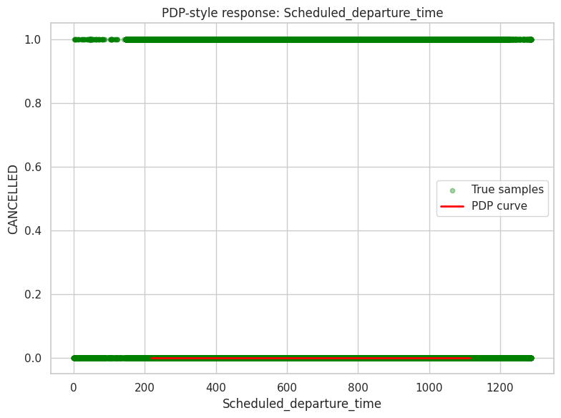
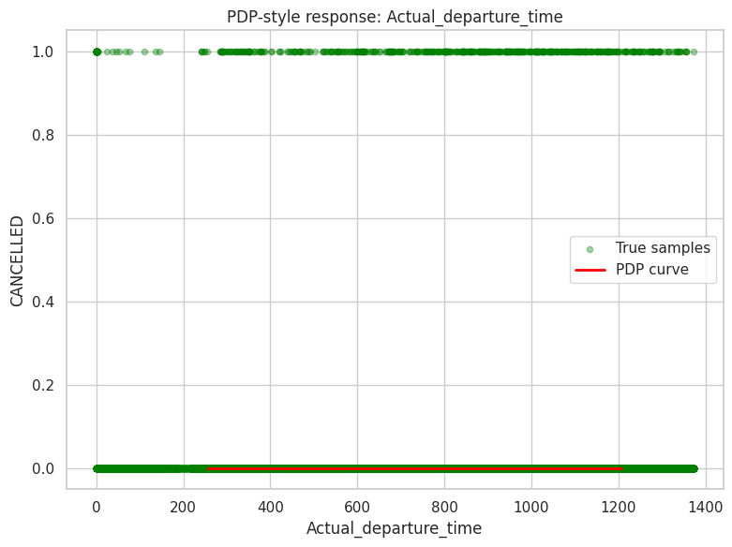
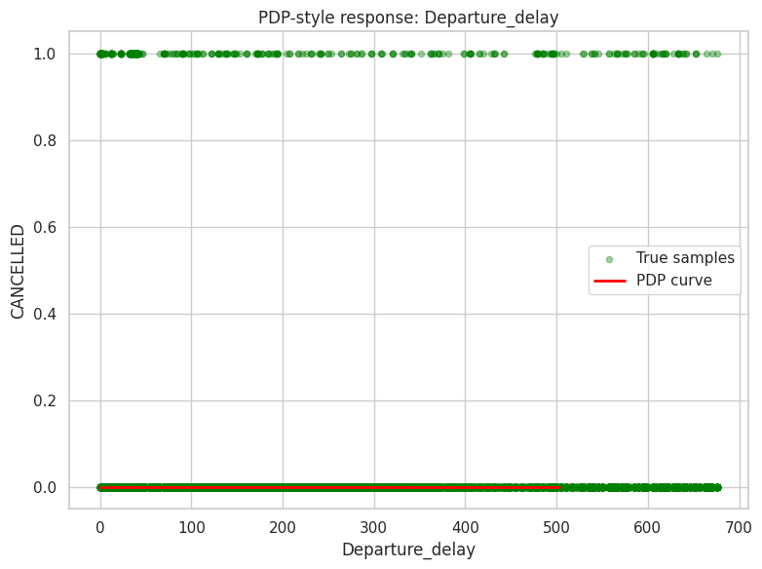
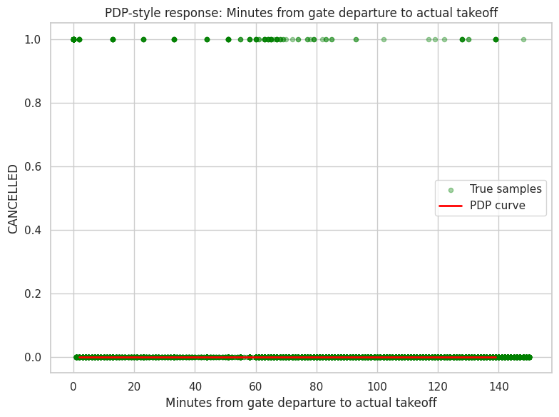
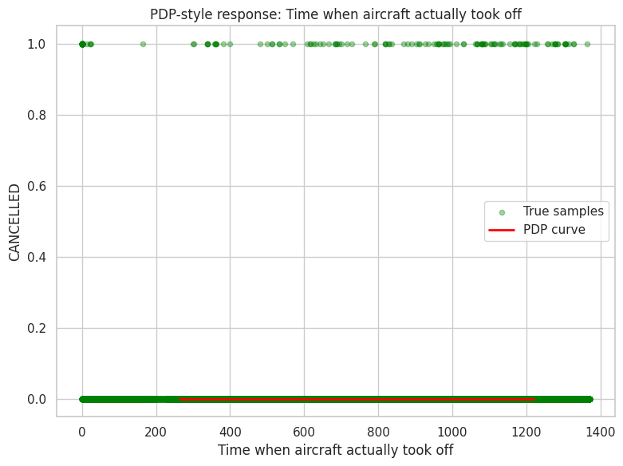
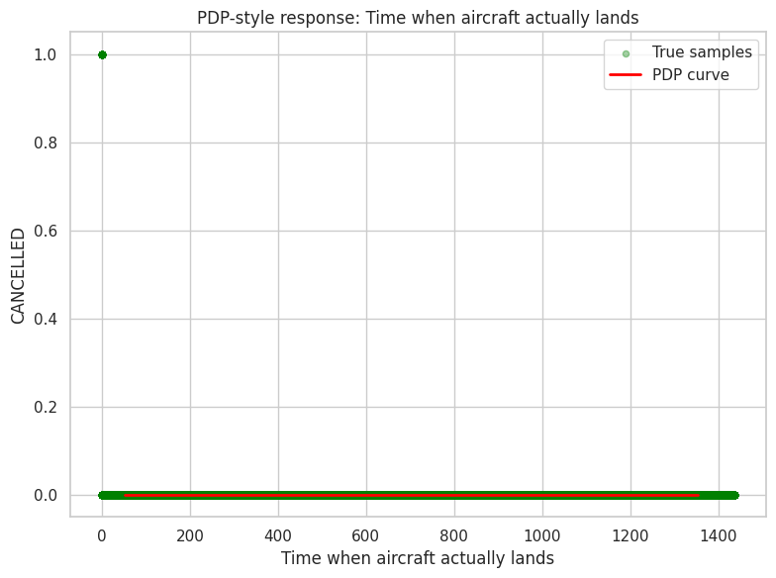
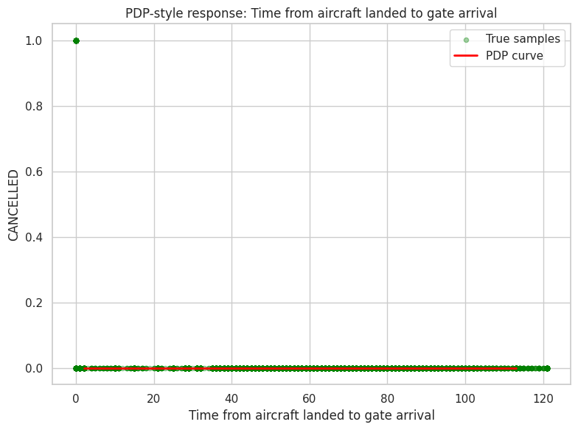
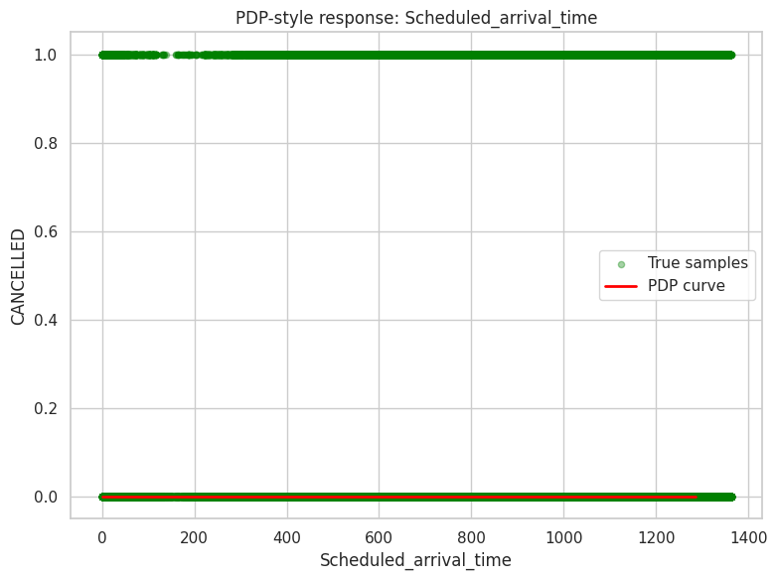
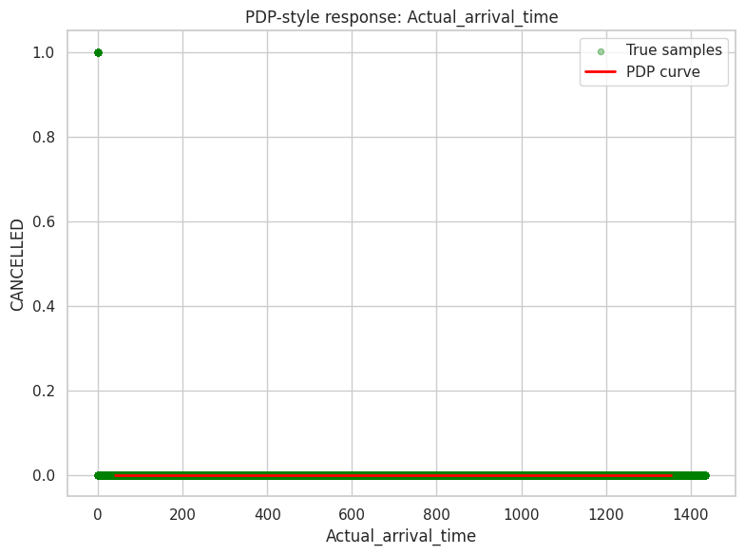
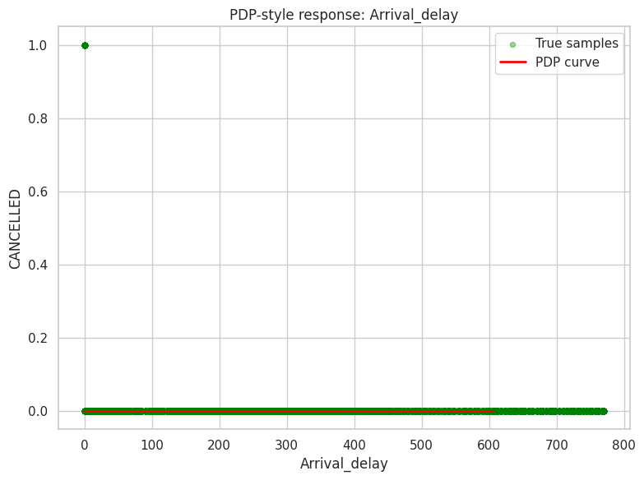
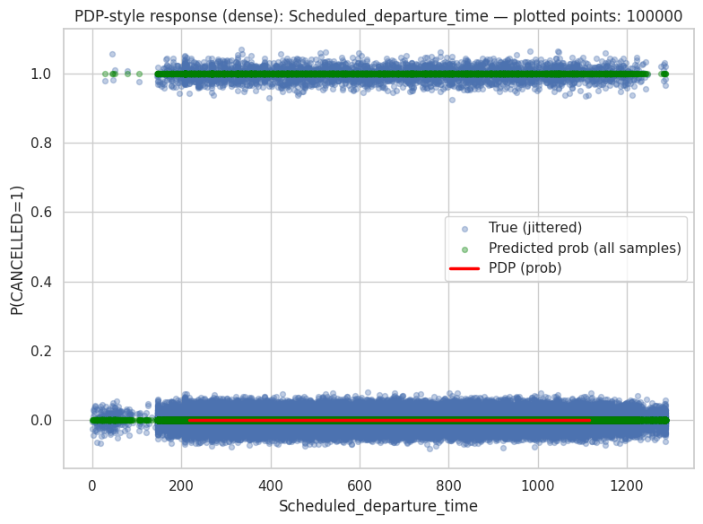
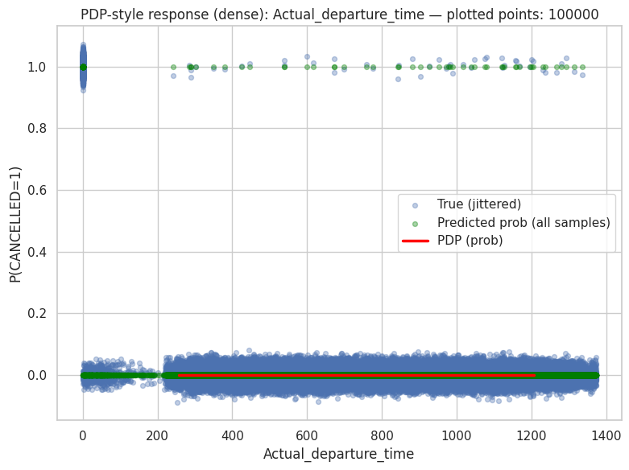
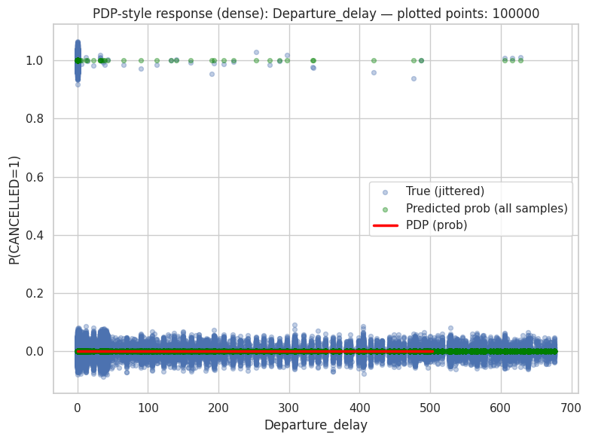
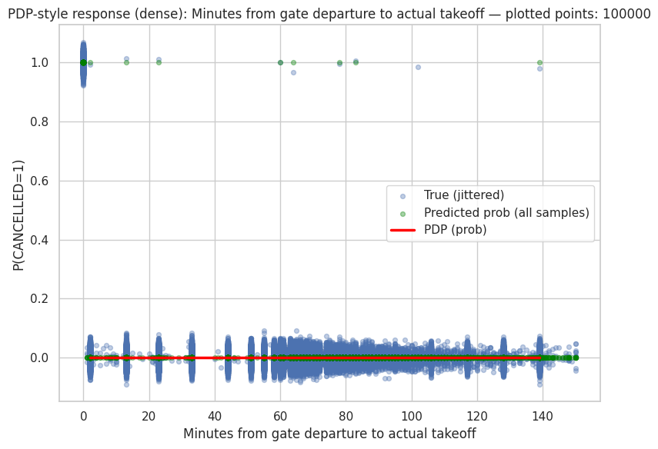
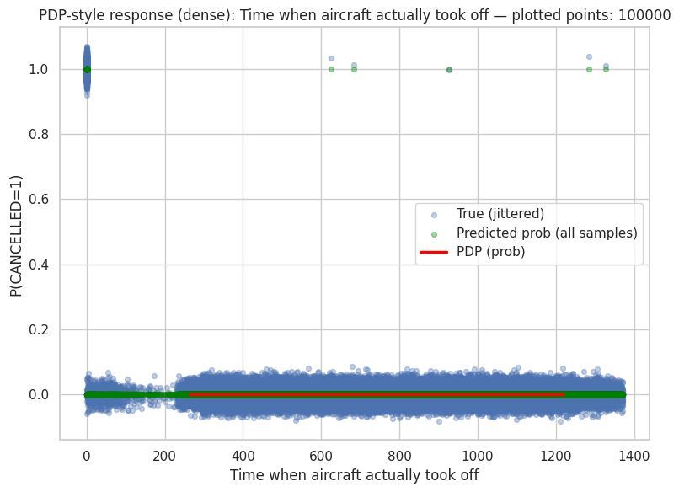
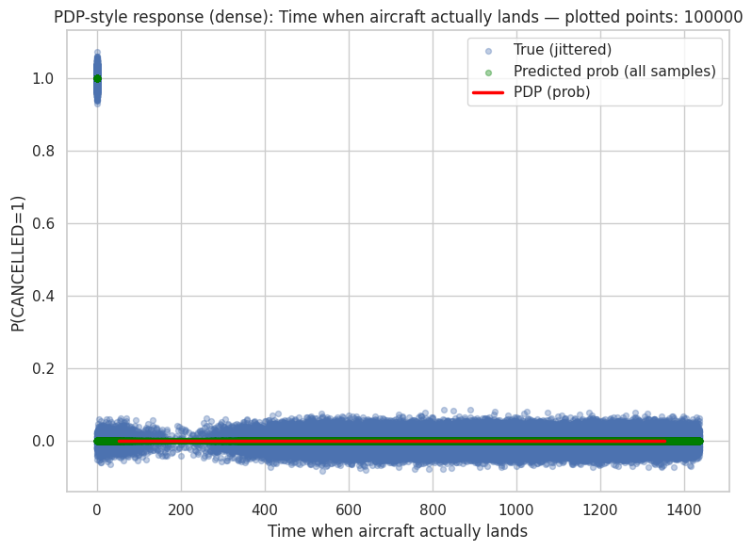
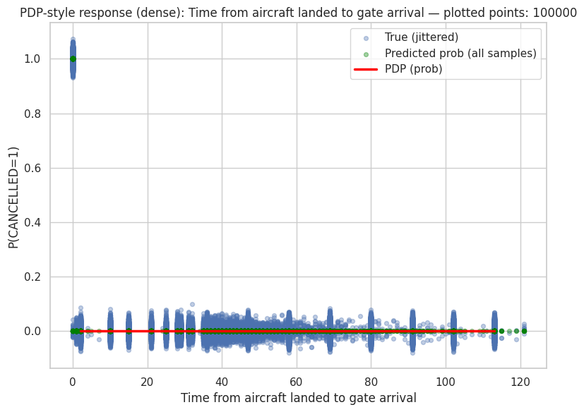
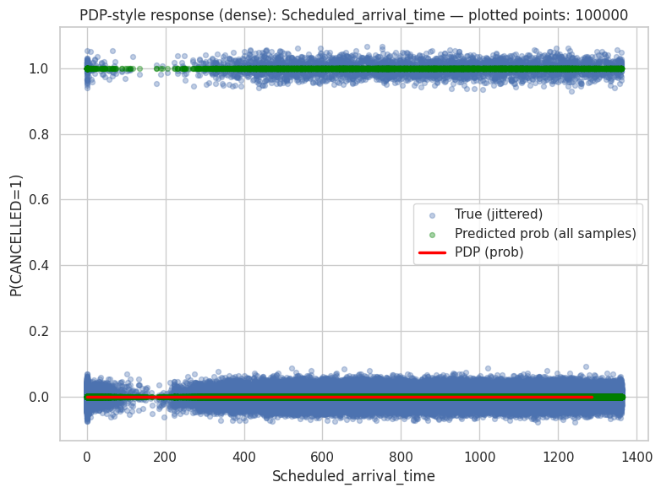
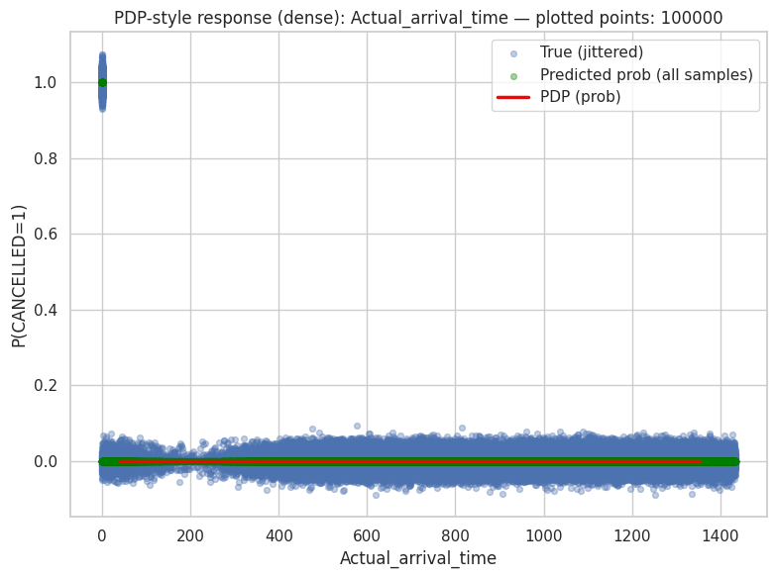
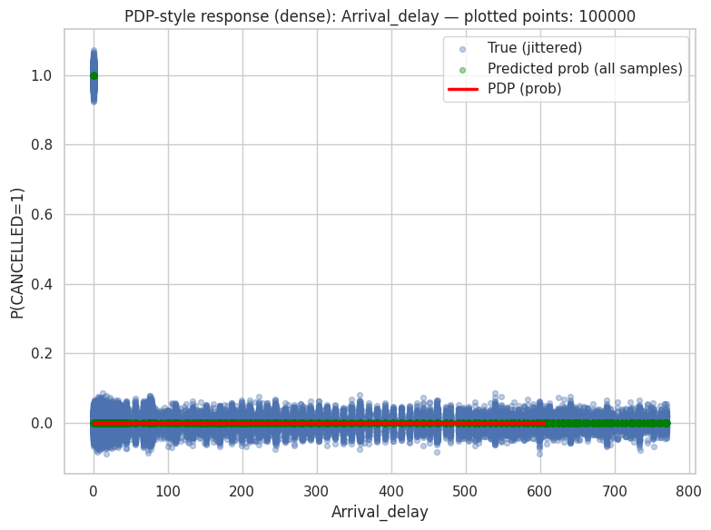
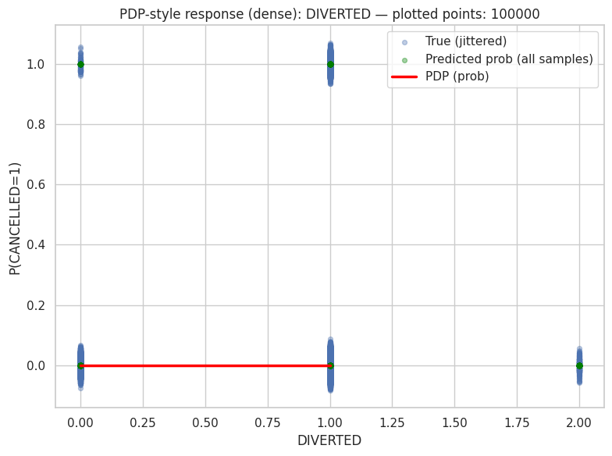
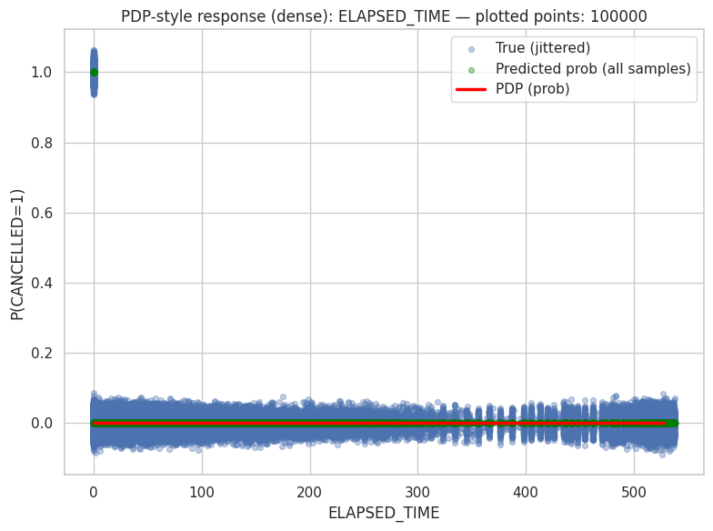
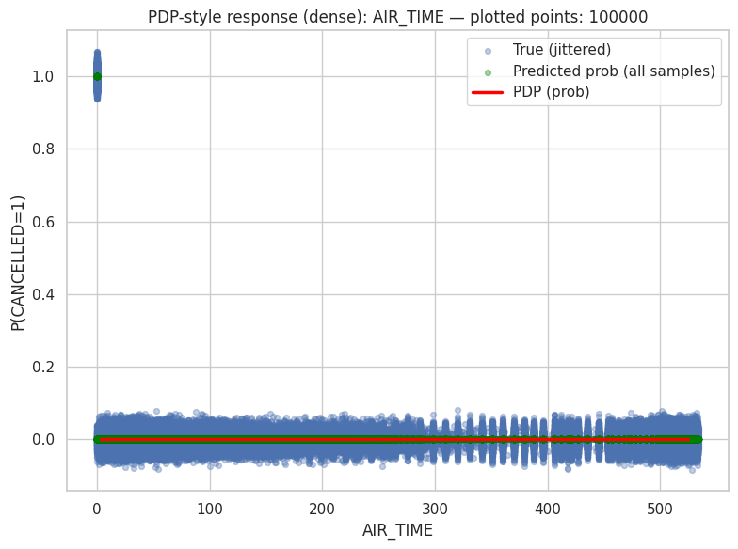
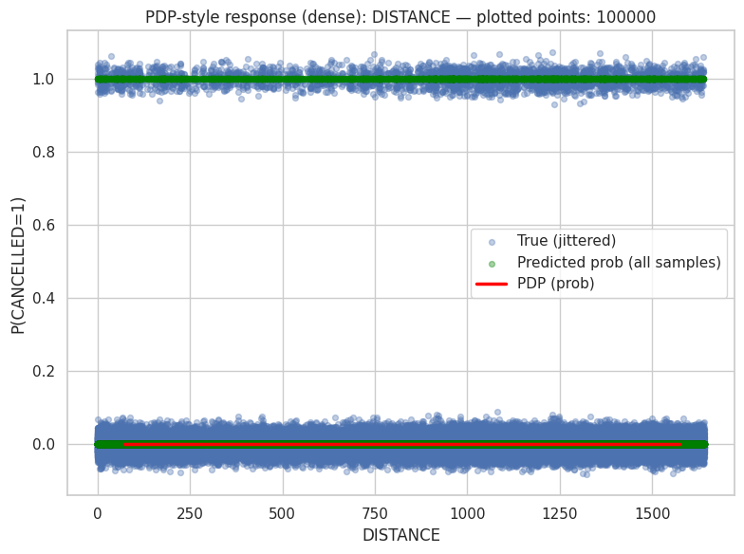
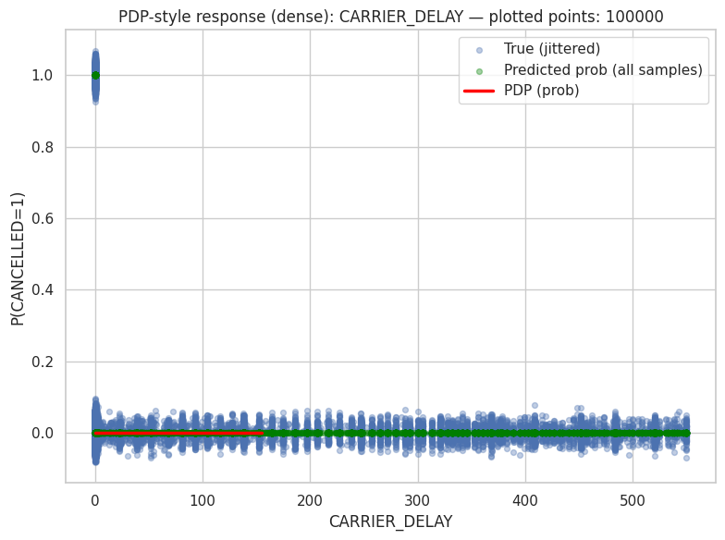
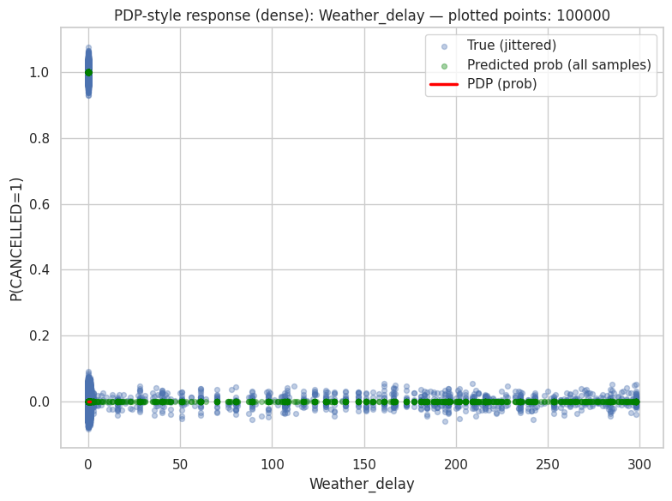
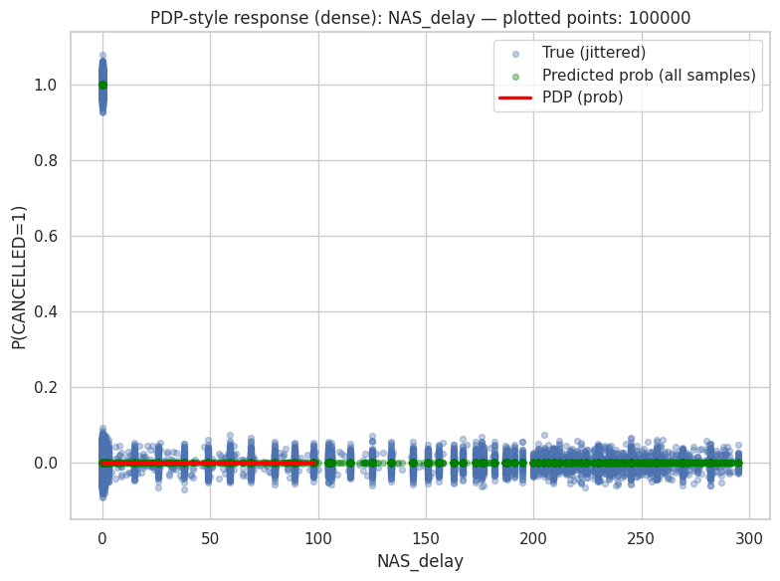
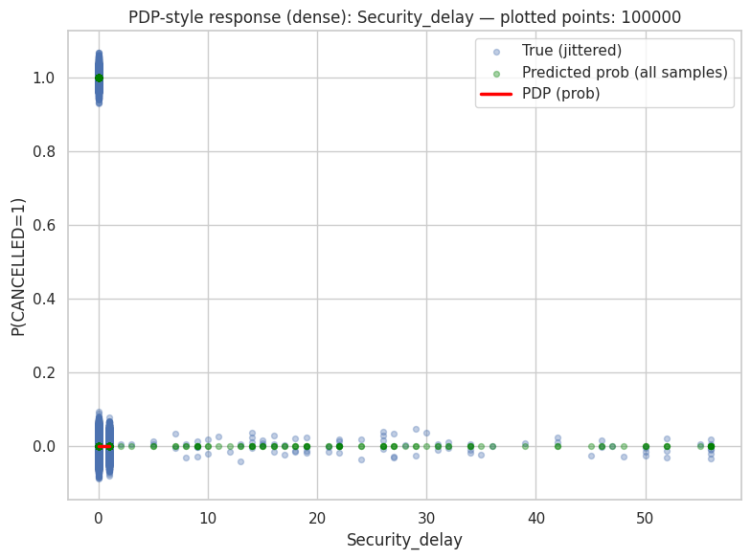
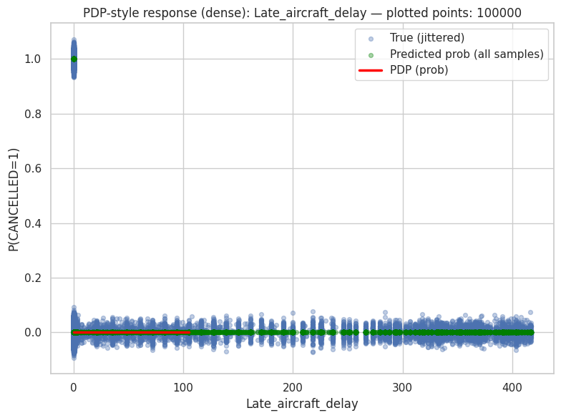
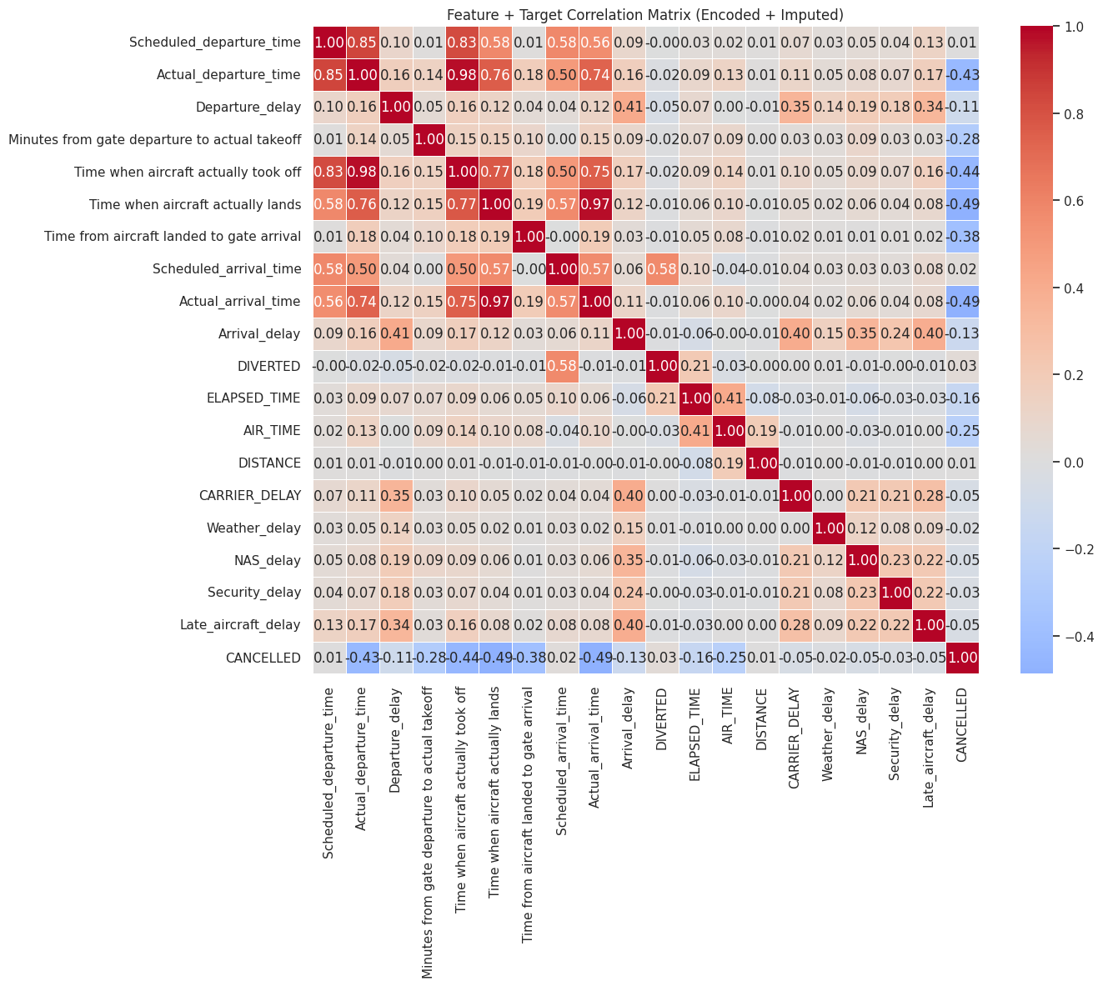
This correlation matrix, likely derived from or used in conjunction with an LGBM (LightGBM) model, reveals strong linear relationships among flight-related features — such as scheduled vs. actual departure/arrival times (e.g., 0.85–0.98 correlations), and moderate propagation of delays (e.g., departure delay → arrival delay at 0.41), while cancellation shows weak negative correlations with most timing variables (e.g., -0.43 with scheduled departure time), suggesting cancellations are not well explained by standard temporal features alone. Notably, AIR_TIME and DISTANCE exhibit a perfect 1.00 correlation — a red flag for potential data leakage or feature derivation that could mislead LGBM’s tree-based learning if not handled carefully. Although LGBM doesn’t rely on linear correlations like logistic regression, this matrix still helps identify redundant features (like actual takeoff/landing times being nearly identical to actual departure/arrival times) and highlights the challenge of predicting rare events like cancellations using only operational timestamps and delay types — reinforcing the need for engineered features or external context (e.g., weather severity, crew availability) to boost LGBM’s predictive power on the minority class.

📌 FEATURE IMPACT SCORES (LightGBM):

feature impact_score
Scheduled_departure_time 834
Departure_delay 804
DISTANCE 714
Actual_departure_time 662
Minutes from gate departure to actual takeoff 613
Scheduled_arrival_time 444
DIVERTED 432
Actual_arrival_time 319
Time when aircraft actually took off 238
Arrival_delay 45
Time when aircraft actually lands 33
AIR_TIME 24
ELAPSED_TIME 21
CARRIER_DELAY 16
Weather_delay 12
Time from aircraft landed to gate arrival 11
NAS_delay 7
Late_aircraft_delay 4
Security_delay 0

📊 NORMALIZED IMPACT (% contribution):

feature impact_percent
Scheduled_departure_time 15.937
Departure_delay 15.364
DISTANCE 13.644
Actual_departure_time 12.650
Minutes from gate departure to actual takeoff 11.714
Scheduled_arrival_time 8.485
DIVERTED 8.255
Actual_arrival_time 6.096
Time when aircraft actually took off 4.548
Arrival_delay 0.860
Time when aircraft actually lands 0.631
AIR_TIME 0.459
ELAPSED_TIME 0.401
CARRIER_DELAY 0.306
Weather_delay 0.229
Time from aircraft landed to gate arrival 0.210
NAS_delay 0.134
Late_aircraft_delay 0.076
Security_delay 0.000
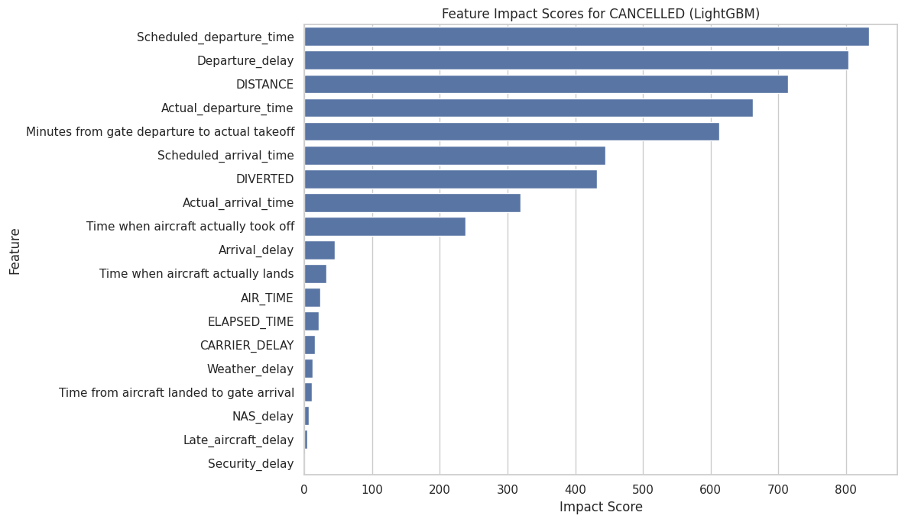
The LightGBM feature importance results show that planned and realized departure dynamics are the primary drivers of cancellation prediction, with Scheduled_departure_time, Departure_delay, DISTANCE, and Actual_departure_time being the most influential variables, indicating that both scheduling structure and pre-departure operational conditions play a critical role in determining cancellation risk. Intermediate operational timing measures such as minutes from gate departure to takeoff, scheduled arrival time, and diversion status also contribute substantially, reflecting the influence of ground congestion and abnormal flight events. Real-time execution variables like actual takeoff and arrival times have moderate impact, while post-landing and delay subcategories (NAS, weather, carrier, late aircraft, and security delays), along with air time and elapsed time, show relatively low importance, suggesting that LightGBM relies more on departure-related and systemic scheduling features than on downstream flight-phase or delay-type details once higher-level timing information is available.

