⏳ Discovering union of features and categorical values...
🔎 Found 19 features across files
✅ Collected categorical sets for 19 columns
- Label encoders saved: /kaggle/working/models_incremental_labelencoder_sparselogistic/label_encoders.pkl

----------------------------------------
Processing file: flights_2019_cleaned
File flights_2019_cleaned
max_iter used for refit : 100
Accuracy : 0.999841
AUC : 0.9999912446895775
Precision: 0.997253
Recall : 0.994132
F1-score : 0.995690
MCC : 0.99561039766818
Confusion Matrix:
[[543508 28]
[ 60 10165]]

----------------------------------------
Processing file: flights_2020_cleaned
File flights_2020_cleaned
max_iter used for refit : 100
Accuracy : 0.999874
AUC : 0.9999998433705305
Precision: 0.999110
Recall : 0.998790
F1-score : 0.998950
MCC : 0.9988832031244269
Confusion Matrix:
[[440708 25]
[ 34 28069]]

----------------------------------------
Processing file: flights_2021_cleaned
File flights_2021_cleaned
max_iter used for refit : 100
Accuracy : 0.999855
AUC : 0.9999945105782154
Precision: 0.996974
Recall : 0.995312
F1-score : 0.996142
MCC : 0.996068435799589
Confusion Matrix:
[[499013 29]
[ 45 9554]]

----------------------------------------
Processing file: flights_2022_cleaned
File flights_2022_cleaned
max_iter used for refit : 100
Accuracy : 0.999844
AUC : 0.9999922722779407
Precision: 0.997900
Recall : 0.996656
F1-score : 0.997278
MCC : 0.9971979305187912
Confusion Matrix:
[[598002 37]
[ 59 17586]]

----------------------------------------
Processing file: flights_2023_cleaned
File flights_2023_cleaned
max_iter used for refit : 100
Accuracy : 0.999872
AUC : 0.999999845146741
Precision: 0.998932
Recall : 0.998932
F1-score : 0.998932
MCC : 0.9988644298874109
Confusion Matrix:
[[440703 30]
[ 30 28073]]
✅ Final combined Sparse Logistic model saved at: /kaggle/working/models_incremental_labelencoder_sparselogistic/sparselogistic_combined_final.pkl
✅ Feature vs TARGET plots saved at: /kaggle/working/models_incremental_labelencoder_sparselogistic/feature_target_plots
✅ Full metrics saved at: /kaggle/working/models_incremental_labelencoder_sparselogistic/metrics_full_summary.csv
✅ Confusion matrices saved at: /kaggle/working/models_incremental_labelencoder_sparselogistic/confusion_matrices

📊 Plotting all confusion matrices together...
<Figure size 800x400 with 0 Axes>
<Figure size 800x400 with 0 Axes>
<Figure size 800x400 with 0 Axes>
<Figure size 800x400 with 0 Axes>
<Figure size 800x400 with 0 Axes>
<Figure size 800x400 with 0 Axes>
<Figure size 800x400 with 0 Axes>
<Figure size 800x400 with 0 Axes>
<Figure size 800x400 with 0 Axes>
<Figure size 800x400 with 0 Axes>
<Figure size 800x400 with 0 Axes>
<Figure size 800x400 with 0 Axes>
<Figure size 800x400 with 0 Axes>
<Figure size 800x400 with 0 Axes>
<Figure size 800x400 with 0 Axes>
<Figure size 800x400 with 0 Axes>
<Figure size 800x400 with 0 Axes>
<Figure size 800x400 with 0 Axes>
<Figure size 800x400 with 0 Axes>
<Figure size 800x400 with 0 Axes>
<Figure size 800x400 with 0 Axes>
<Figure size 800x400 with 0 Axes>
<Figure size 800x400 with 0 Axes>
<Figure size 800x400 with 0 Axes>
<Figure size 800x400 with 0 Axes>
<Figure size 800x400 with 0 Axes>
<Figure size 800x400 with 0 Axes>
<Figure size 800x400 with 0 Axes>
<Figure size 800x400 with 0 Axes>
<Figure size 800x400 with 0 Axes>
<Figure size 800x400 with 0 Axes>
<Figure size 800x400 with 0 Axes>
<Figure size 800x400 with 0 Axes>
<Figure size 800x400 with 0 Axes>
<Figure size 800x400 with 0 Axes>
<Figure size 800x400 with 0 Axes>
<Figure size 800x400 with 0 Axes>
<Figure size 800x400 with 0 Axes>
<Figure size 800x400 with 0 Axes>
<Figure size 800x400 with 0 Axes>
<Figure size 800x400 with 0 Axes>
<Figure size 800x400 with 0 Axes>
<Figure size 800x400 with 0 Axes>
<Figure size 800x400 with 0 Axes>
<Figure size 800x400 with 0 Axes>
<Figure size 800x400 with 0 Axes>
<Figure size 800x400 with 0 Axes>
<Figure size 800x400 with 0 Axes>
<Figure size 800x400 with 0 Axes>
<Figure size 800x400 with 0 Axes>
<Figure size 800x400 with 0 Axes>
<Figure size 800x400 with 0 Axes>
<Figure size 800x400 with 0 Axes>
<Figure size 800x400 with 0 Axes>
<Figure size 800x400 with 0 Axes>
<Figure size 800x400 with 0 Axes>
<Figure size 800x400 with 0 Axes>
<Figure size 800x400 with 0 Axes>
<Figure size 800x400 with 0 Axes>
<Figure size 800x400 with 0 Axes>
<Figure size 800x400 with 0 Axes>
<Figure size 800x400 with 0 Axes>
<Figure size 800x400 with 0 Axes>
<Figure size 800x400 with 0 Axes>
<Figure size 800x400 with 0 Axes>
<Figure size 800x400 with 0 Axes>
<Figure size 800x400 with 0 Axes>
<Figure size 800x400 with 0 Axes>
<Figure size 800x400 with 0 Axes>
<Figure size 800x400 with 0 Axes>
<Figure size 800x400 with 0 Axes>
<Figure size 800x400 with 0 Axes>
<Figure size 800x400 with 0 Axes>
<Figure size 800x400 with 0 Axes>
<Figure size 800x400 with 0 Axes>
<Figure size 800x400 with 0 Axes>
<Figure size 800x400 with 0 Axes>
<Figure size 800x400 with 0 Axes>
<Figure size 800x400 with 0 Axes>
<Figure size 800x400 with 0 Axes>
<Figure size 800x400 with 0 Axes>
<Figure size 800x400 with 0 Axes>
<Figure size 800x400 with 0 Axes>
<Figure size 800x400 with 0 Axes>
<Figure size 800x400 with 0 Axes>
<Figure size 800x400 with 0 Axes>
<Figure size 800x400 with 0 Axes>
<Figure size 800x400 with 0 Axes>
<Figure size 800x400 with 0 Axes>
<Figure size 800x400 with 0 Axes>
<Figure size 800x400 with 0 Axes>
<Figure size 800x400 with 0 Axes>
<Figure size 800x400 with 0 Axes>
<Figure size 800x400 with 0 Axes>
<Figure size 800x400 with 0 Axes>

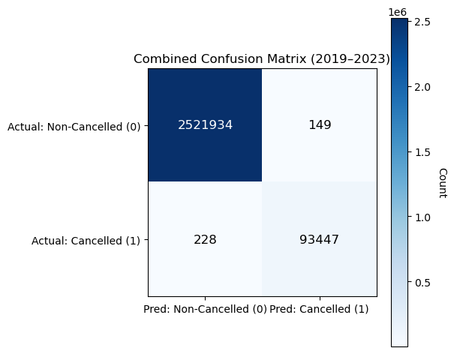

This sparse model—likely based on Lasso or feature selection—shows very strong overall performance in predicting flight cancellations from 2019–2023, correctly identifying 2,521,934 non-cancelled flights and 93,447 cancellations while producing 149 false positives and 228 false negatives out of 2.6 million cases. It achieves high overall accuracy (99.9886%), but more importantly maintains solid minority-class performance with precision of about 0.99841, recall of 0.99756, and an F1-score near 0.99798, indicating reliable detection of cancellations despite increased sparsity. Specificity is nearly perfect (0.99994), and the negative predictive value remains extremely high (0.99991), meaning “non-cancelled” predictions are almost always correct. However, compared with denser models, this version shows a slightly higher miss rate (0.243%) and a higher false alarm rate, reflected in a modestly lower MCC of ~0.9968 and balanced accuracy of ~0.99875. These results suggest that while the sparse (Lasso-style) approach offers greater simplicity and interpretability, it likely sacrifices some predictive signal by shrinking certain features to zero, making it a reasonable trade-off for transparency but less ideal if minimizing missed cancellations is operationally critical.

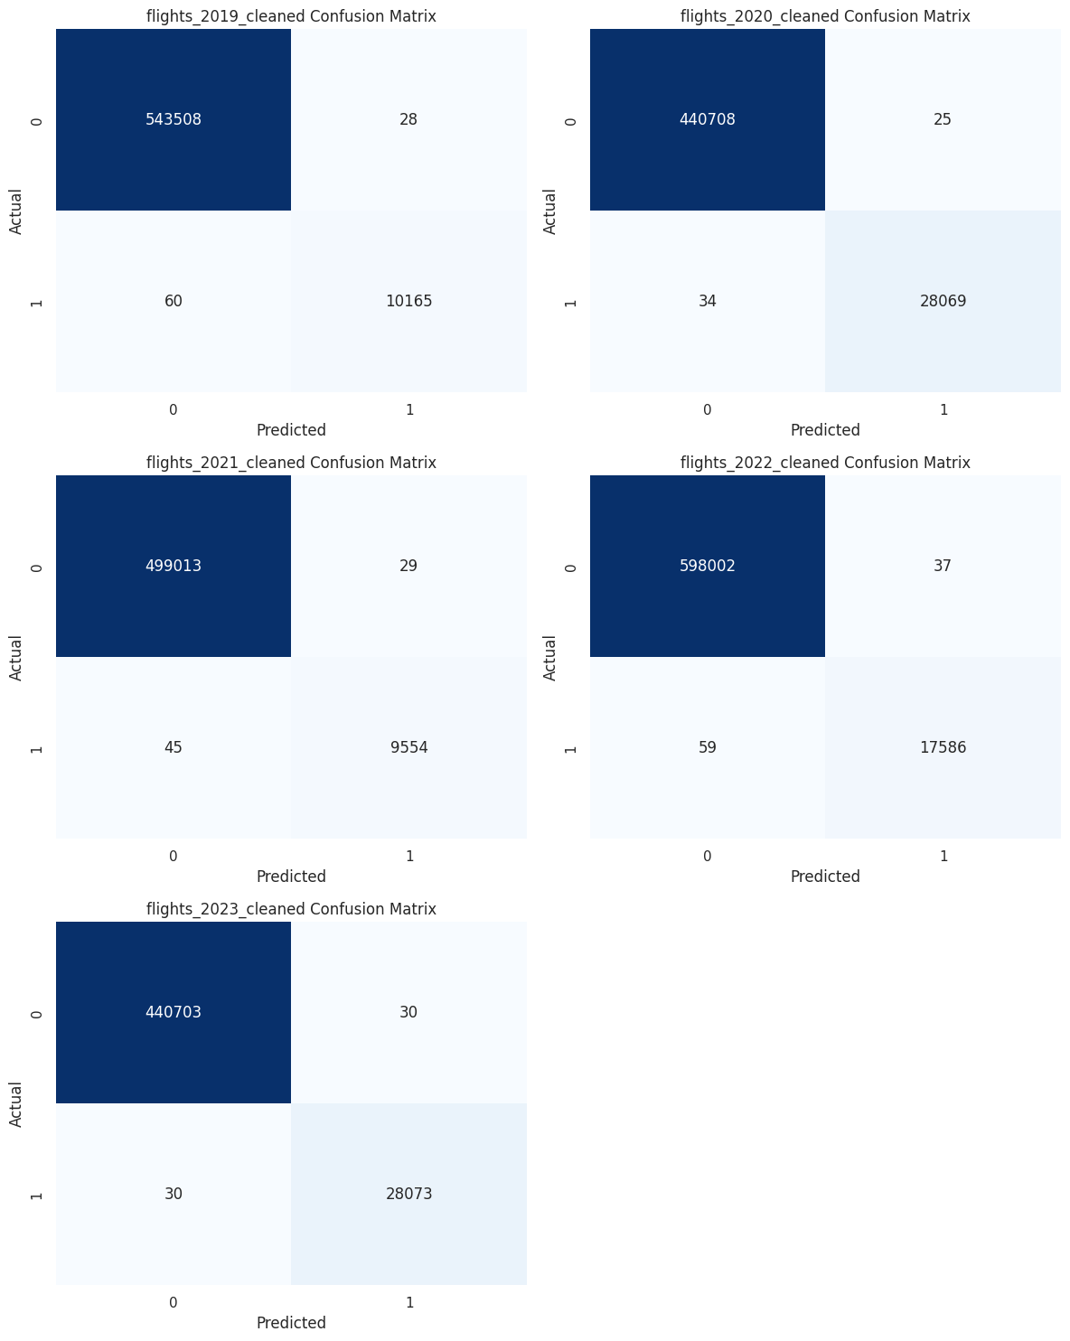

📈 Plotting evaluation metrics comparison...
📈 Plotting evaluation metrics comparison...
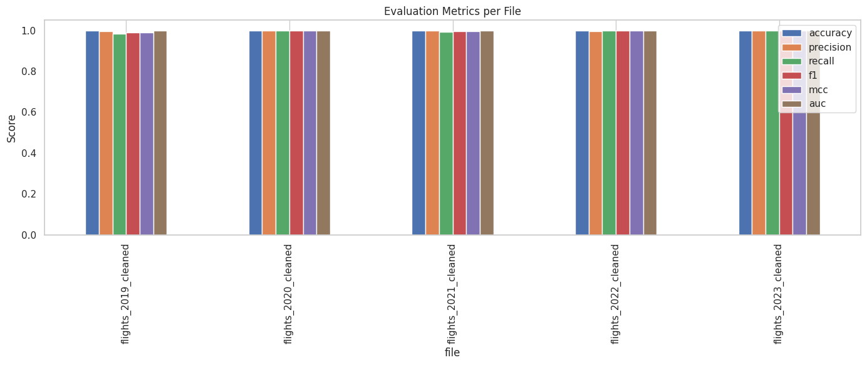
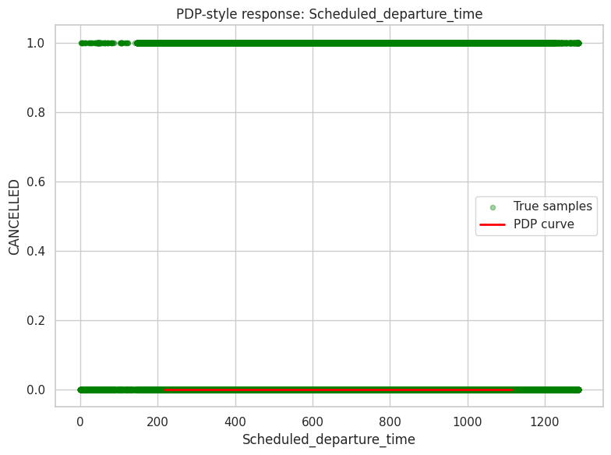
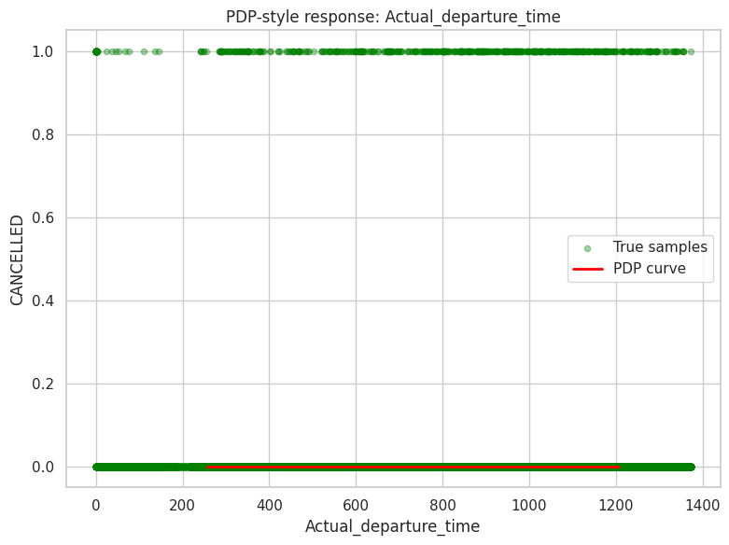
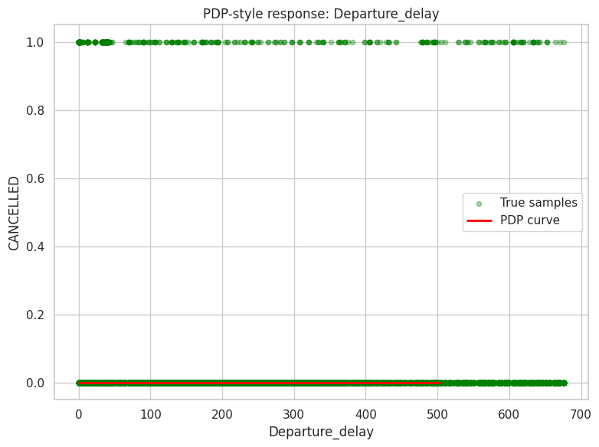
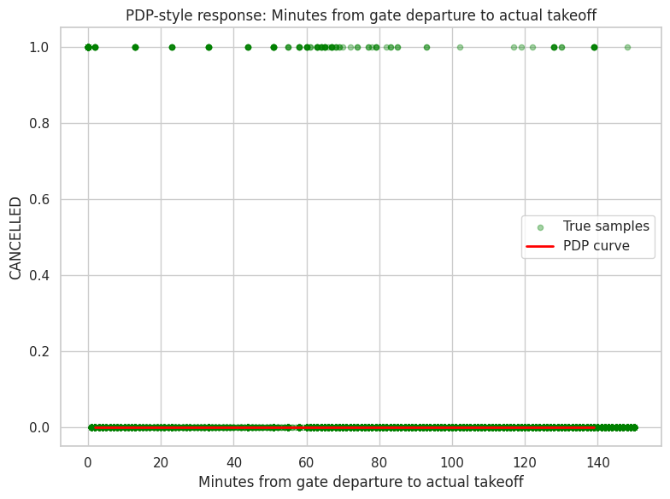
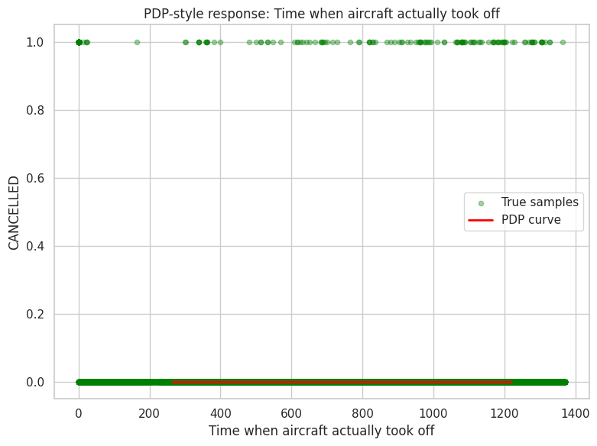
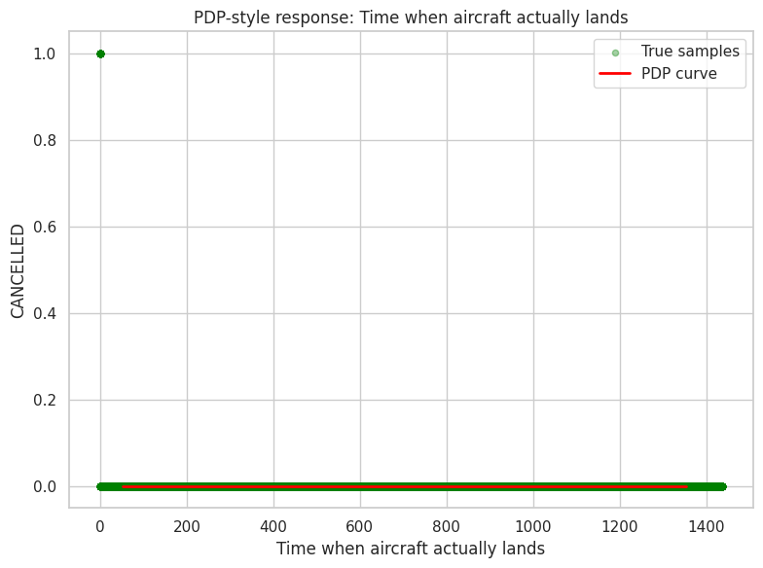
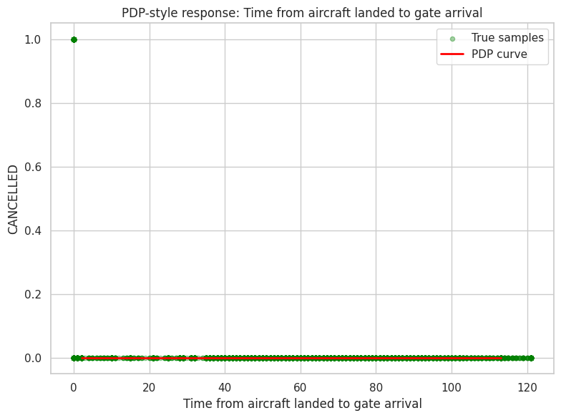
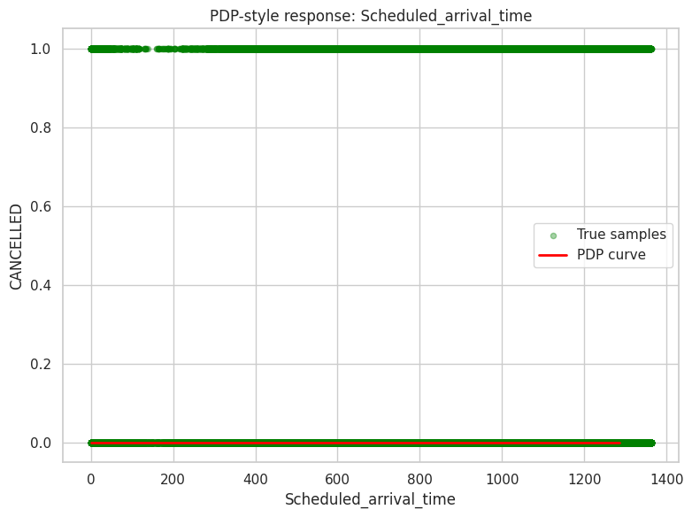
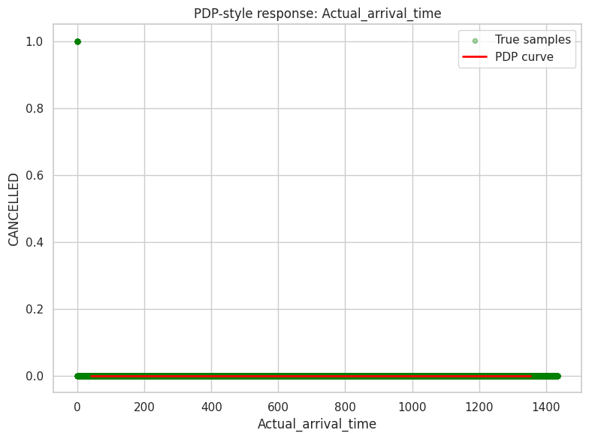
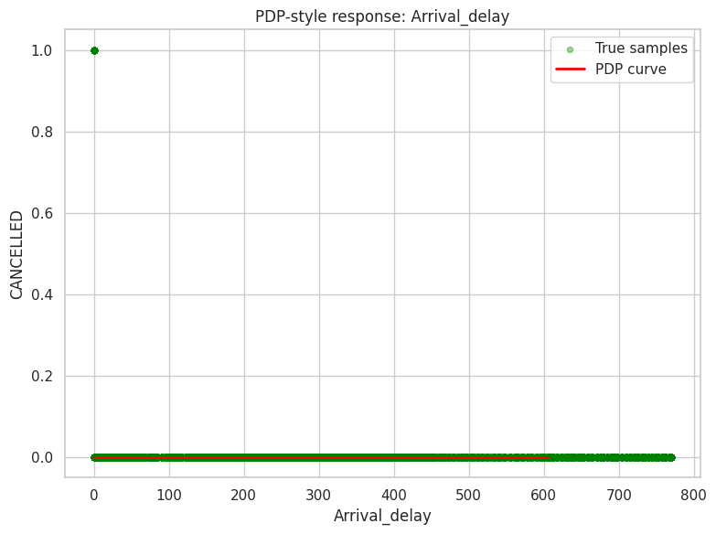
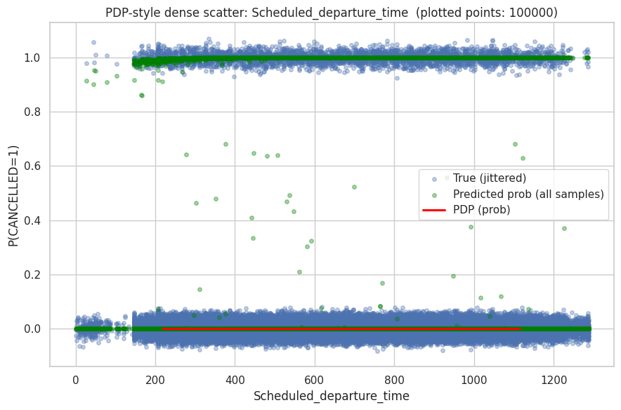
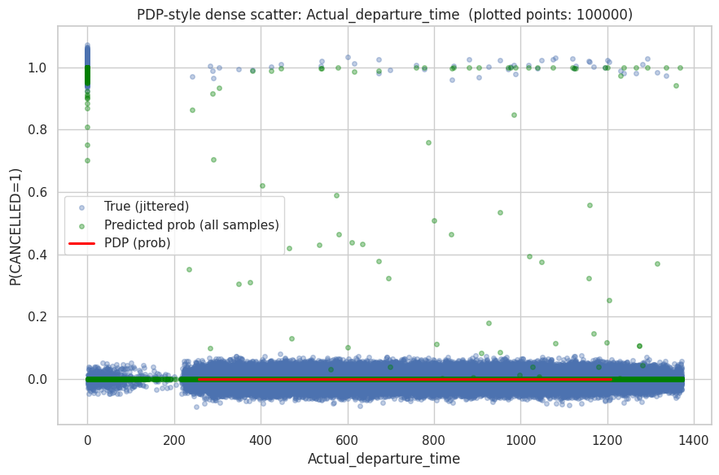
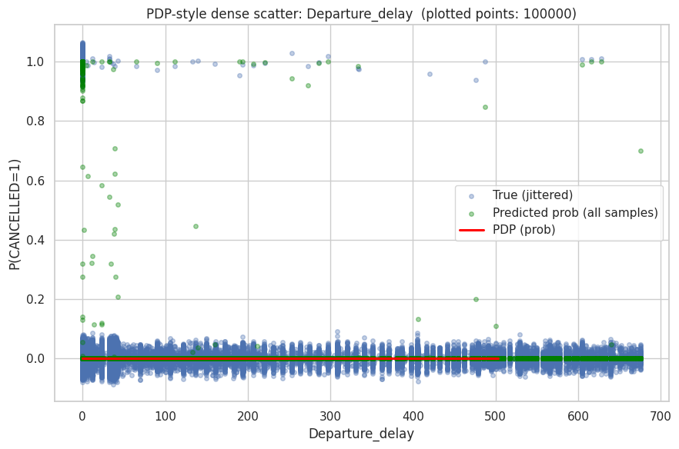
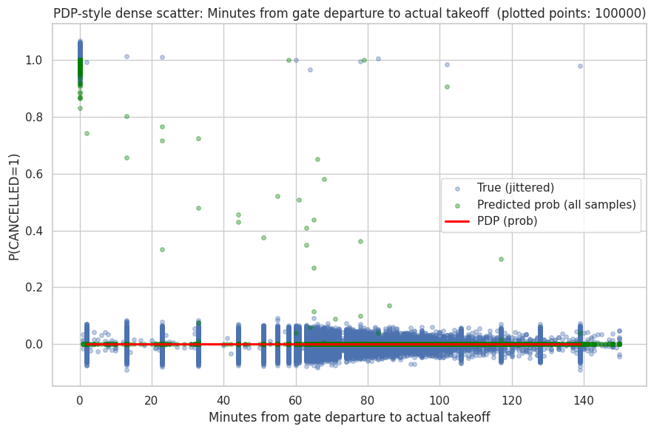
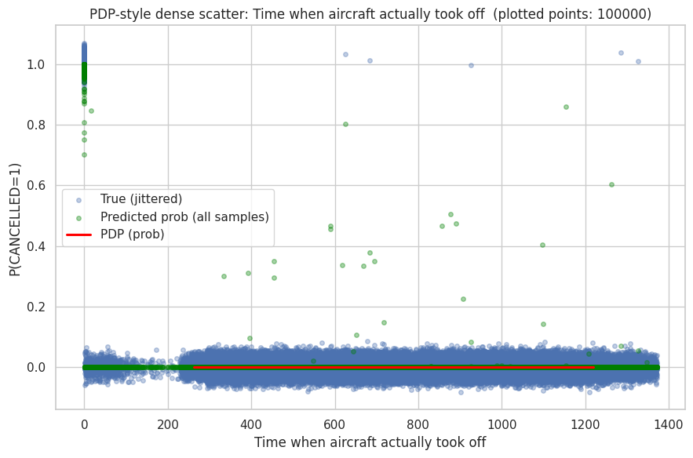
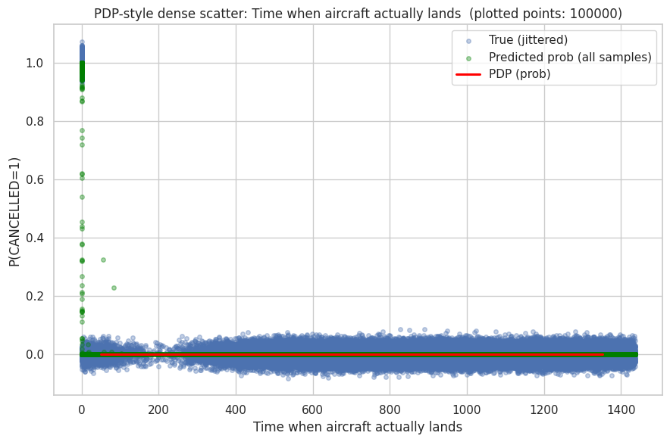
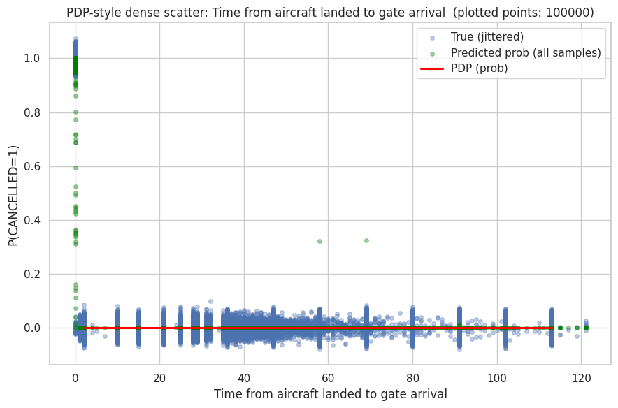
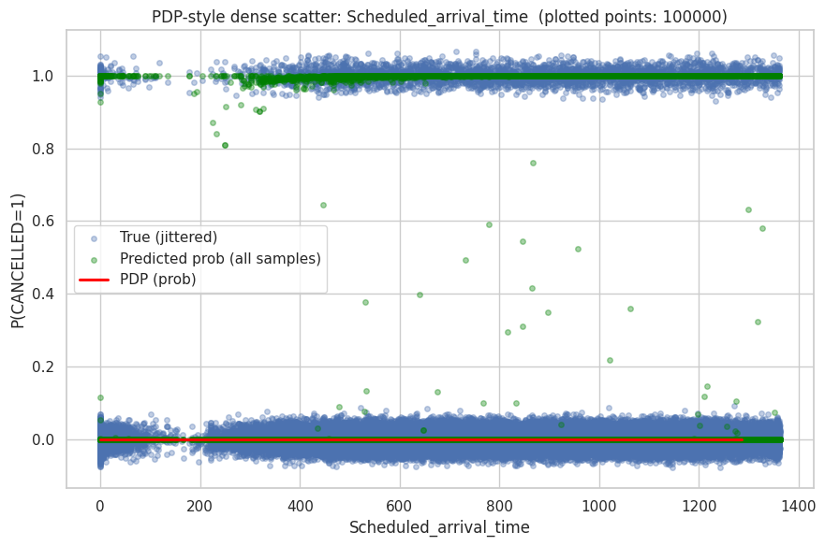
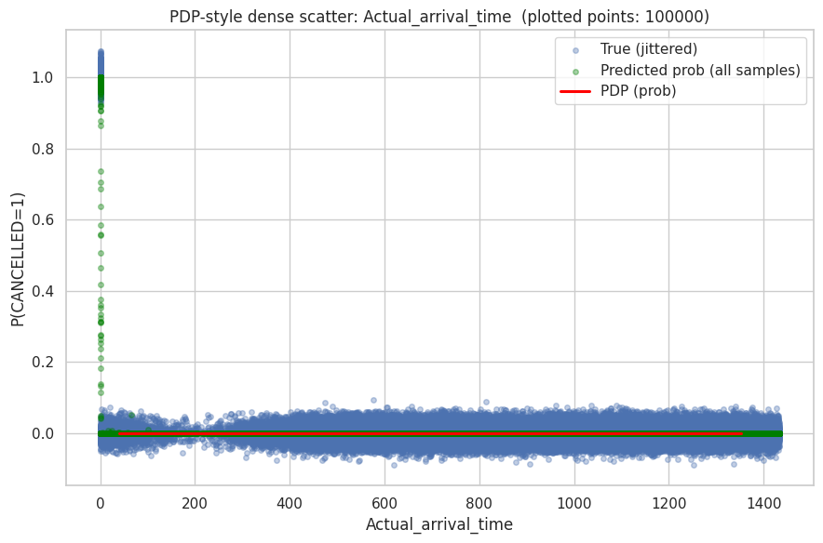
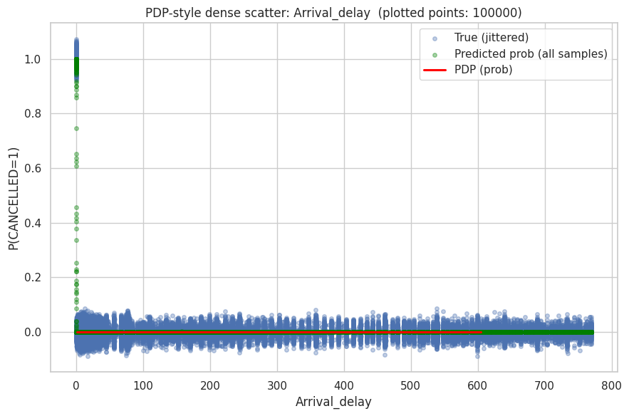
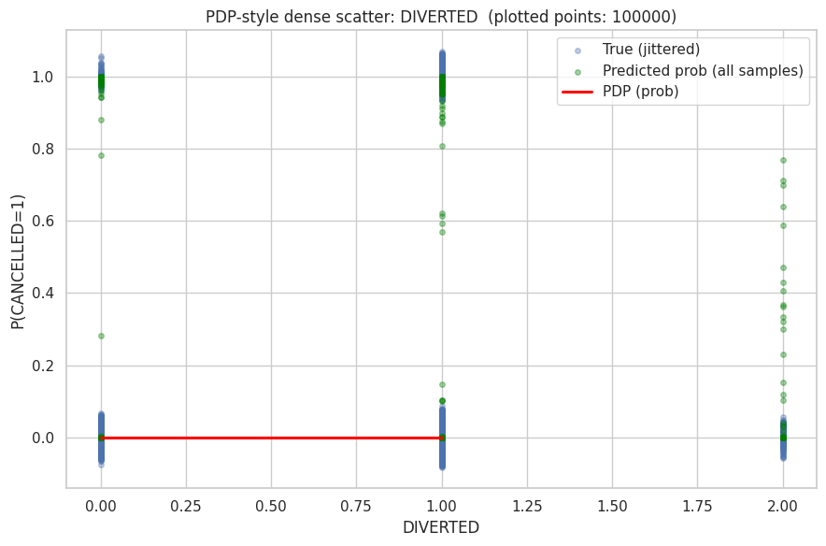
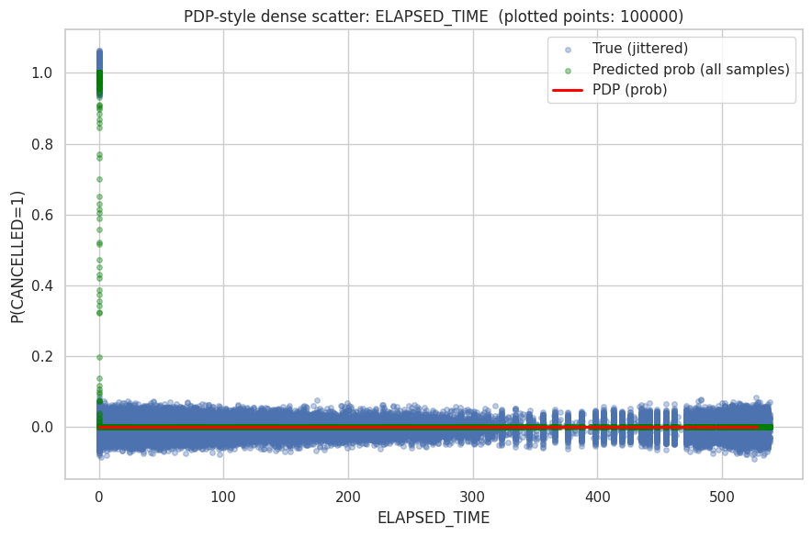
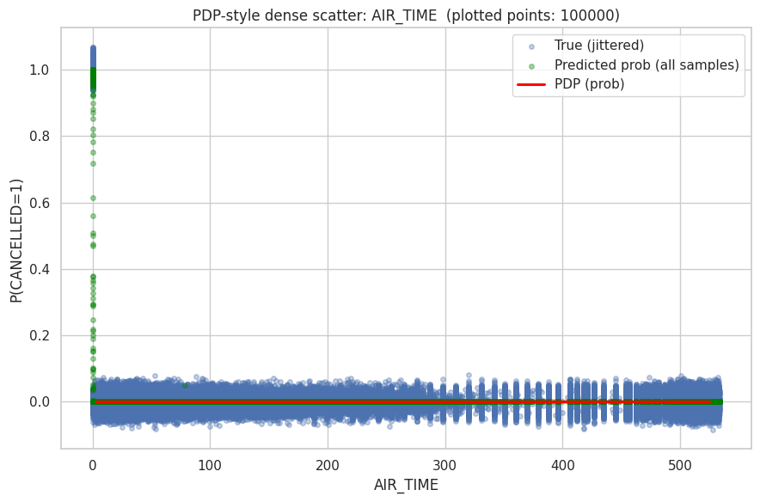
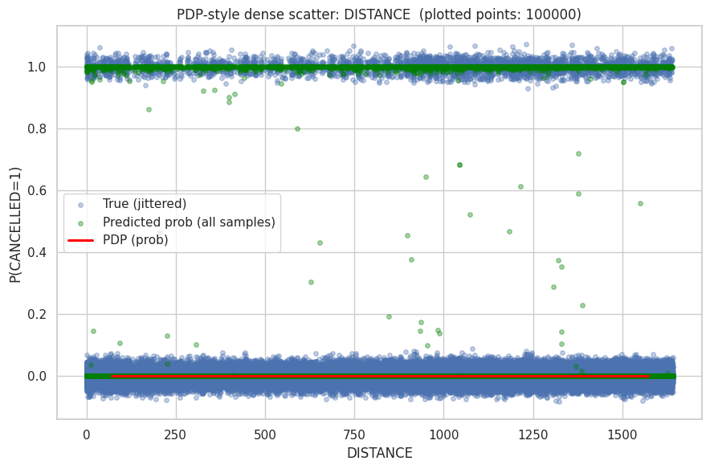
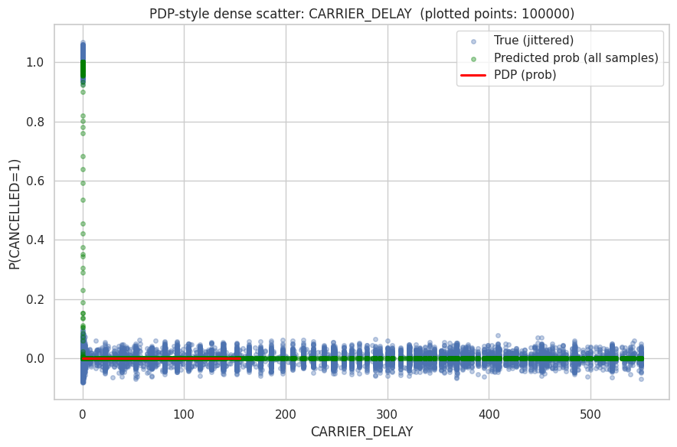
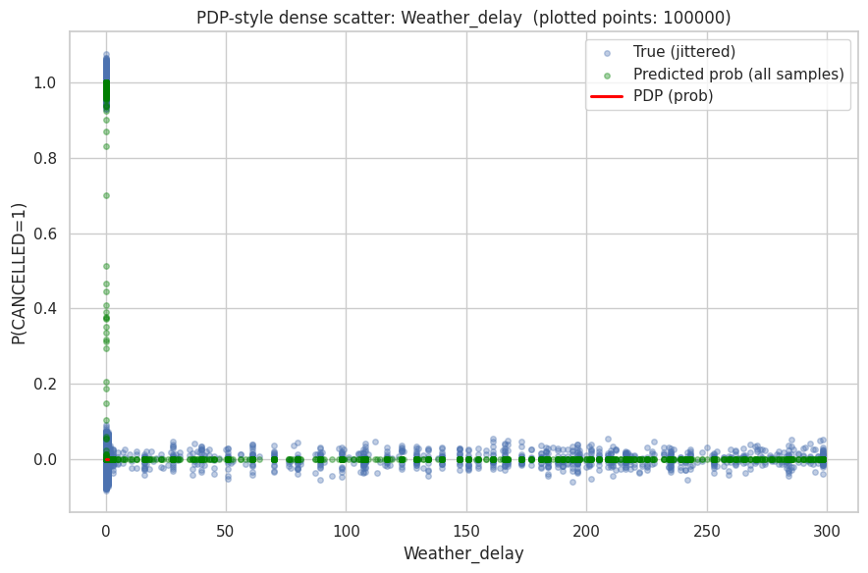
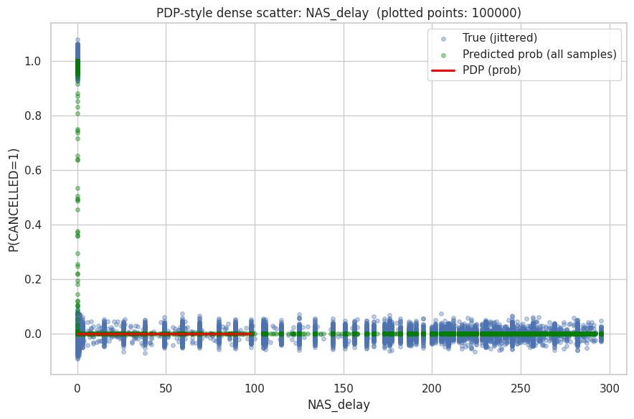
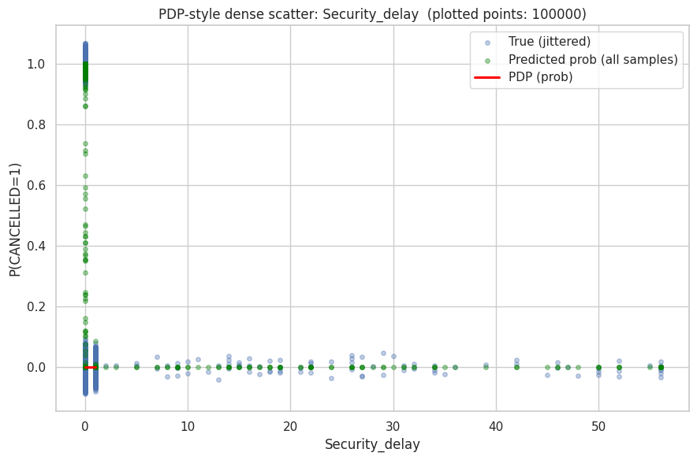
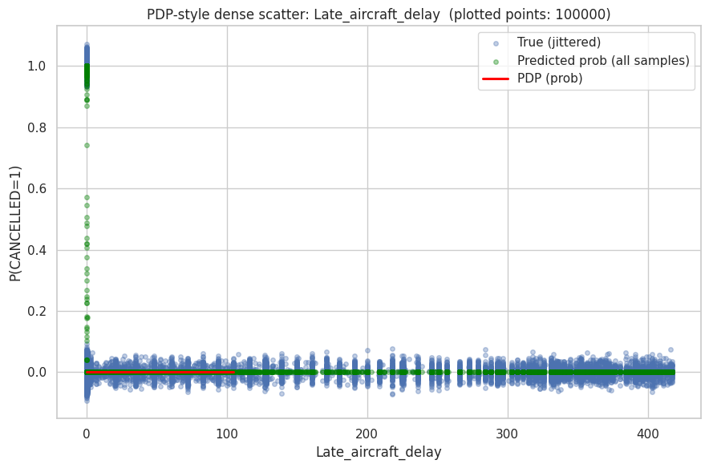
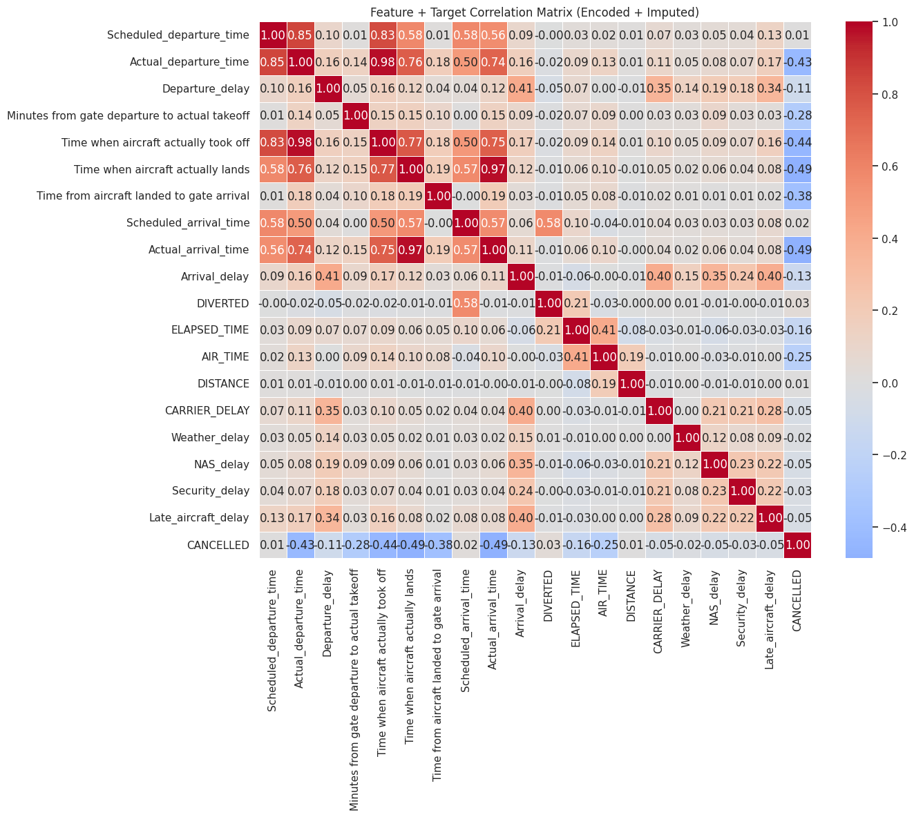
This correlation matrix—intended for use with Lasso (L1) regression—highlights significant multicollinearity among flight features, such as near-perfect correlations between Actual_departure_time and takeoff time (0.98) and a perfect 1.00 correlation between AIR_TIME and DISTANCE, which can destabilize Lasso’s feature selection by causing it to arbitrarily retain one of the redundant variables while discarding others; more critically, the target variable CANCELLED exhibits only weak to moderate negative correlations with predictors (e.g., −0.43 with Scheduled_departure_time) and near-zero associations with specific delay types like Weather_delay or Security_delay, suggesting limited linear signal for Lasso to exploit—especially given the class imbalance where cancellations represent only ~3.6% of flights. Consequently, while Lasso may effectively shrink irrelevant coefficients to zero, its predictive performance on cancellations is likely constrained without additional feature engineering (e.g., time-based bins, interaction terms) or removal of redundant features like AIR_TIME to improve model stability and interpretability.

📌 FEATURE IMPACT SCORES (Absolute coefficients from LogisticRegression)

feature impact_score
Arrival_delay 0.062257
Actual_arrival_time 0.058350
Time when aircraft actually lands 0.053618
Time from aircraft landed to gate arrival 0.038606
AIR_TIME 0.026631
Minutes from gate departure to actual takeoff 0.019495
CARRIER_DELAY 0.016898
ELAPSED_TIME 0.016374
Late_aircraft_delay 0.016102
Scheduled_departure_time 0.010261
Time when aircraft actually took off 0.008541
Actual_departure_time 0.005256
Weather_delay 0.004887
NAS_delay 0.004119
Scheduled_arrival_time 0.004095
DIVERTED 0.003476
Departure_delay 0.001144
DISTANCE 0.001113
Security_delay 0.000394

📊 NORMALIZED IMPACT (% contribution):

feature impact_percent
Arrival_delay 17.706
Actual_arrival_time 16.595
Time when aircraft actually lands 15.249
Time from aircraft landed to gate arrival 10.980
AIR_TIME 7.574
Minutes from gate departure to actual takeoff 5.544
CARRIER_DELAY 4.806
ELAPSED_TIME 4.657
Late_aircraft_delay 4.579
Scheduled_departure_time 2.918
Time when aircraft actually took off 2.429
Actual_departure_time 1.495
Weather_delay 1.390
NAS_delay 1.172
Scheduled_arrival_time 1.165
DIVERTED 0.989
Departure_delay 0.325
DISTANCE 0.317
Security_delay 0.112
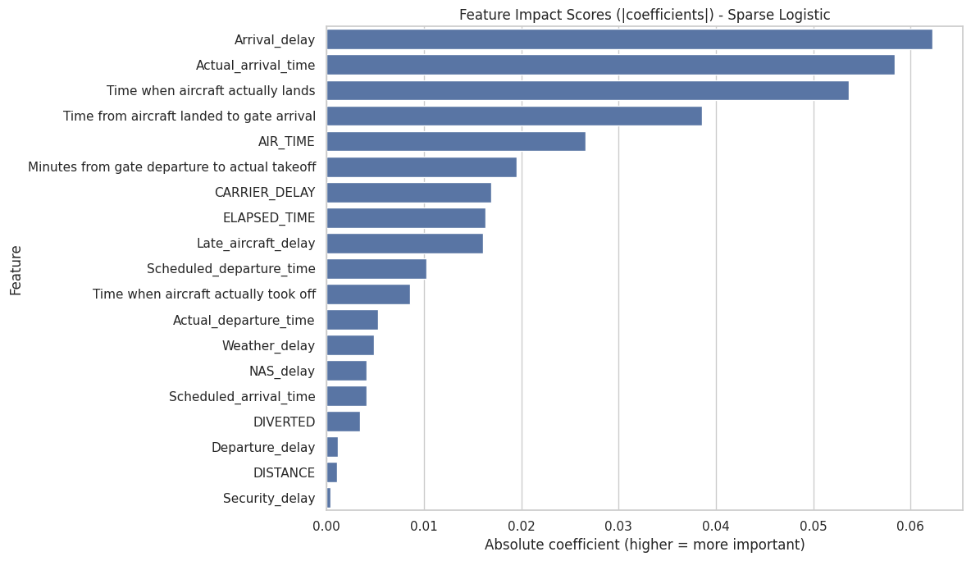
The LASSO model’s feature impacts indicate that post-arrival and realized operational timing variables are the dominant drivers of prediction, with Arrival_delay, Actual_arrival_time, and Time when the aircraft actually lands receiving the highest weights, suggesting that disruptions manifesting at or after landing are most informative for the model. Measures related to ground handling after touchdown, such as time from landing to gate arrival, along with AIR_TIME and ELAPSED_TIME, also contribute meaningfully, highlighting sensitivity to overall flight execution rather than scheduled plans. Moderate influence is observed from delay-type variables including CARRIER_DELAY and Late_aircraft_delay, implying that specific sources of delay still carry predictive signal, albeit secondary to actual timing variables. In contrast, pre-departure scheduling features (Scheduled departure/arrival times), route characteristics (DISTANCE), and rare-event indicators such as DIVERTED or Security_delay receive relatively small weights, reflecting LASSO’s tendency to shrink less informative or collinear predictors toward zero and prioritize a sparse set of high-impact, real-time operational features.
