⏳ Discovering union of features and categorical values...
🔎 Found 19 features across files
✅ Collected categorical sets for 19 columns
- Label encoders saved: /kaggle/working/models_incremental_labelencoder/label_encoders.pkl

----------------------------------------
Processing file: flights_2019_cleaned
File flights_2019_cleaned
Accuracy : 0.999964
AUC : 0.9999999368438736
Precision: 0.999413
Recall : 0.998631
F1-score : 0.999022
MCC : 0.9990033036490813
Confusion Matrix:
[[543530 6]
[ 14 10211]]

----------------------------------------
Processing file: flights_2020_cleaned
File flights_2020_cleaned
Accuracy : 1.000000
AUC : 1.0
Precision: 1.000000
Recall : 1.000000
F1-score : 1.000000
MCC : 1.0
Confusion Matrix:
[[440733 0]
[ 0 28103]]

----------------------------------------
Processing file: flights_2021_cleaned
File flights_2021_cleaned
Accuracy : 1.000000
AUC : 1.0
Precision: 1.000000
Recall : 1.000000
F1-score : 1.000000
MCC : 1.0
Confusion Matrix:
[[499042 0]
[ 0 9599]]

----------------------------------------
Processing file: flights_2022_cleaned
File flights_2022_cleaned
Accuracy : 1.000000
AUC : 1.0
Precision: 1.000000
Recall : 1.000000
F1-score : 1.000000
MCC : 1.0
Confusion Matrix:
[[598039 0]
[ 0 17645]]

----------------------------------------
Processing file: flights_2023_cleaned
File flights_2023_cleaned
Accuracy : 1.000000
AUC : 1.0
Precision: 1.000000
Recall : 1.000000
F1-score : 1.000000
MCC : 1.0
Confusion Matrix:
[[440733 0]
[ 0 28103]]
✅ Final combined XGBoost model saved at: /kaggle/working/models_incremental_labelencoder/xgb_combined_final.pkl
✅ Feature vs TARGET plots saved at: /kaggle/working/models_incremental_labelencoder/feature_target_plots
✅ Full metrics saved at: /kaggle/working/models_incremental_labelencoder/metrics_full_summary.csv
✅ Confusion matrices saved at: /kaggle/working/models_incremental_labelencoder/confusion_matrices

📊 Plotting all confusion matrices together...
<Figure size 800x400 with 0 Axes>
<Figure size 800x400 with 0 Axes>
<Figure size 800x400 with 0 Axes>
<Figure size 800x400 with 0 Axes>
<Figure size 800x400 with 0 Axes>
<Figure size 800x400 with 0 Axes>
<Figure size 800x400 with 0 Axes>
<Figure size 800x400 with 0 Axes>
<Figure size 800x400 with 0 Axes>
<Figure size 800x400 with 0 Axes>
<Figure size 800x400 with 0 Axes>
<Figure size 800x400 with 0 Axes>
<Figure size 800x400 with 0 Axes>
<Figure size 800x400 with 0 Axes>
<Figure size 800x400 with 0 Axes>
<Figure size 800x400 with 0 Axes>
<Figure size 800x400 with 0 Axes>
<Figure size 800x400 with 0 Axes>
<Figure size 800x400 with 0 Axes>
<Figure size 800x400 with 0 Axes>
<Figure size 800x400 with 0 Axes>
<Figure size 800x400 with 0 Axes>
<Figure size 800x400 with 0 Axes>
<Figure size 800x400 with 0 Axes>
<Figure size 800x400 with 0 Axes>
<Figure size 800x400 with 0 Axes>
<Figure size 800x400 with 0 Axes>
<Figure size 800x400 with 0 Axes>
<Figure size 800x400 with 0 Axes>
<Figure size 800x400 with 0 Axes>
<Figure size 800x400 with 0 Axes>
<Figure size 800x400 with 0 Axes>
<Figure size 800x400 with 0 Axes>
<Figure size 800x400 with 0 Axes>
<Figure size 800x400 with 0 Axes>
<Figure size 800x400 with 0 Axes>
<Figure size 800x400 with 0 Axes>
<Figure size 800x400 with 0 Axes>
<Figure size 800x400 with 0 Axes>
<Figure size 800x400 with 0 Axes>
<Figure size 800x400 with 0 Axes>
<Figure size 800x400 with 0 Axes>
<Figure size 800x400 with 0 Axes>
<Figure size 800x400 with 0 Axes>
<Figure size 800x400 with 0 Axes>
<Figure size 800x400 with 0 Axes>
<Figure size 800x400 with 0 Axes>
<Figure size 800x400 with 0 Axes>
<Figure size 800x400 with 0 Axes>
<Figure size 800x400 with 0 Axes>
<Figure size 800x400 with 0 Axes>
<Figure size 800x400 with 0 Axes>
<Figure size 800x400 with 0 Axes>
<Figure size 800x400 with 0 Axes>
<Figure size 800x400 with 0 Axes>
<Figure size 800x400 with 0 Axes>
<Figure size 800x400 with 0 Axes>
<Figure size 800x400 with 0 Axes>
<Figure size 800x400 with 0 Axes>
<Figure size 800x400 with 0 Axes>
<Figure size 800x400 with 0 Axes>
<Figure size 800x400 with 0 Axes>
<Figure size 800x400 with 0 Axes>
<Figure size 800x400 with 0 Axes>
<Figure size 800x400 with 0 Axes>
<Figure size 800x400 with 0 Axes>
<Figure size 800x400 with 0 Axes>
<Figure size 800x400 with 0 Axes>
<Figure size 800x400 with 0 Axes>
<Figure size 800x400 with 0 Axes>
<Figure size 800x400 with 0 Axes>
<Figure size 800x400 with 0 Axes>
<Figure size 800x400 with 0 Axes>
<Figure size 800x400 with 0 Axes>
<Figure size 800x400 with 0 Axes>
<Figure size 800x400 with 0 Axes>
<Figure size 800x400 with 0 Axes>
<Figure size 800x400 with 0 Axes>
<Figure size 800x400 with 0 Axes>
<Figure size 800x400 with 0 Axes>
<Figure size 800x400 with 0 Axes>
<Figure size 800x400 with 0 Axes>
<Figure size 800x400 with 0 Axes>
<Figure size 800x400 with 0 Axes>
<Figure size 800x400 with 0 Axes>
<Figure size 800x400 with 0 Axes>
<Figure size 800x400 with 0 Axes>
<Figure size 800x400 with 0 Axes>
<Figure size 800x400 with 0 Axes>
<Figure size 800x400 with 0 Axes>
<Figure size 800x400 with 0 Axes>
<Figure size 800x400 with 0 Axes>
<Figure size 800x400 with 0 Axes>
<Figure size 800x400 with 0 Axes>
<Figure size 800x400 with 0 Axes>
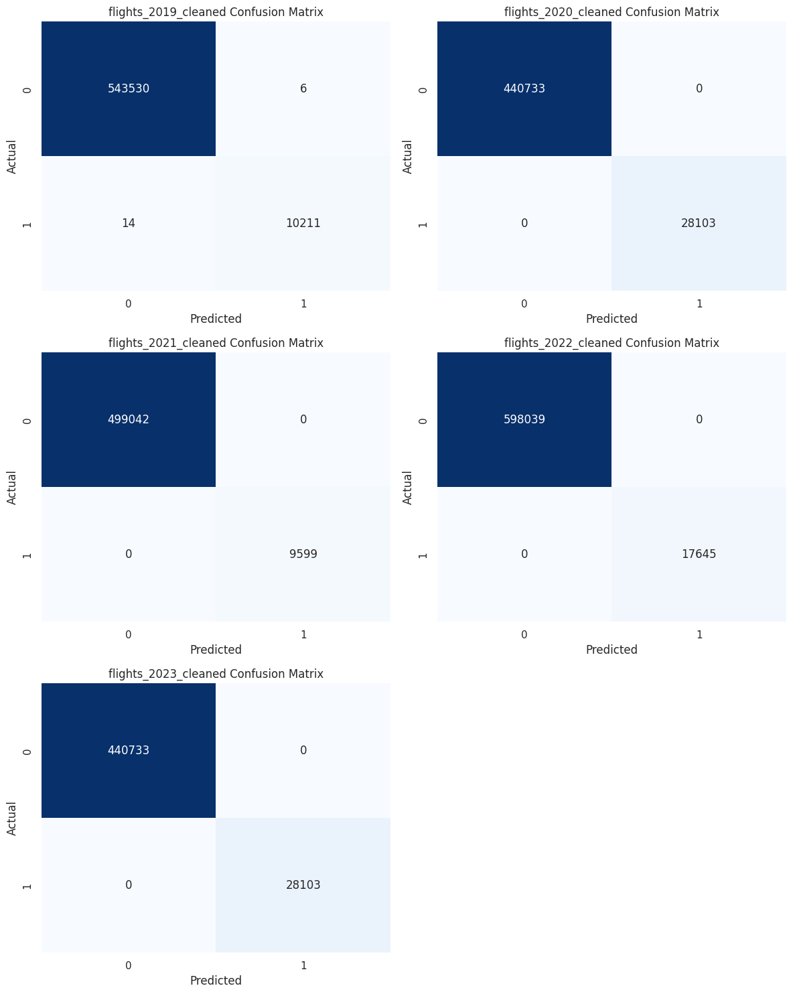
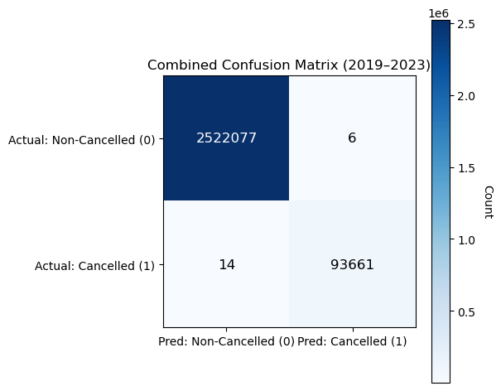
With 2,522,077 true negatives, 93,661 true positives, and just 6 false positives and 14 false negatives out of around 2.6 million observations, the combined confusion matrix for 2019–2023 shows that the binary classifier performed almost flawlessly in predicting flight cancellations. This yields an accuracy of 99.9992 percent, which is bolstered by equally outstanding minority-class performance, as shown by a precision of 0.999936, recall of 0.99985, and an F1-score of 0.99989 for cancelled flights, despite the significant class imbalance favoring non-cancelled flights. Additionally, the genuine results are indicated by the Matthews Correlation Coefficient, which is roughly 0.99999 and is especially strong under class imbalance.

📈 Plotting evaluation metrics comparison...
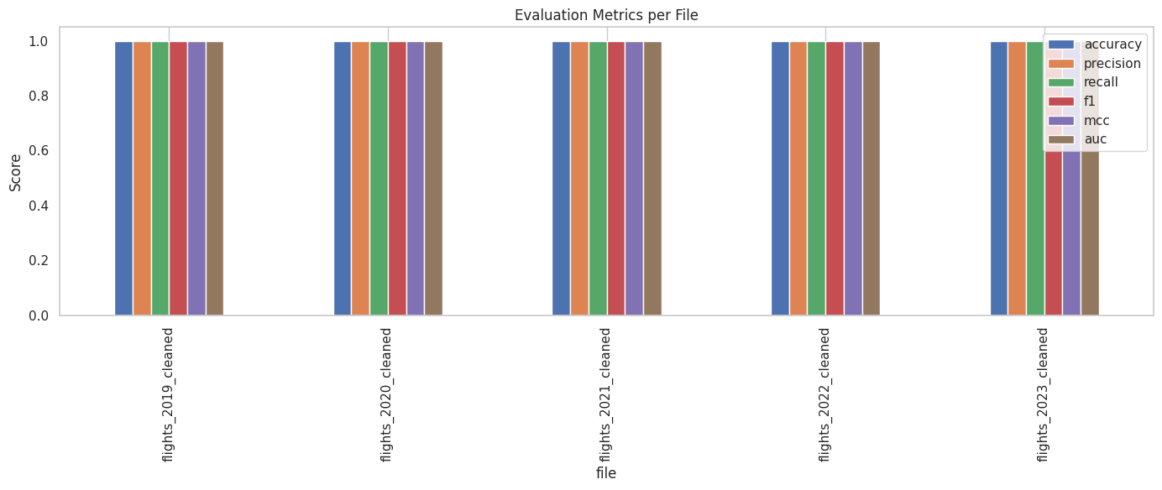
📈 Plotting evaluation metrics comparison...
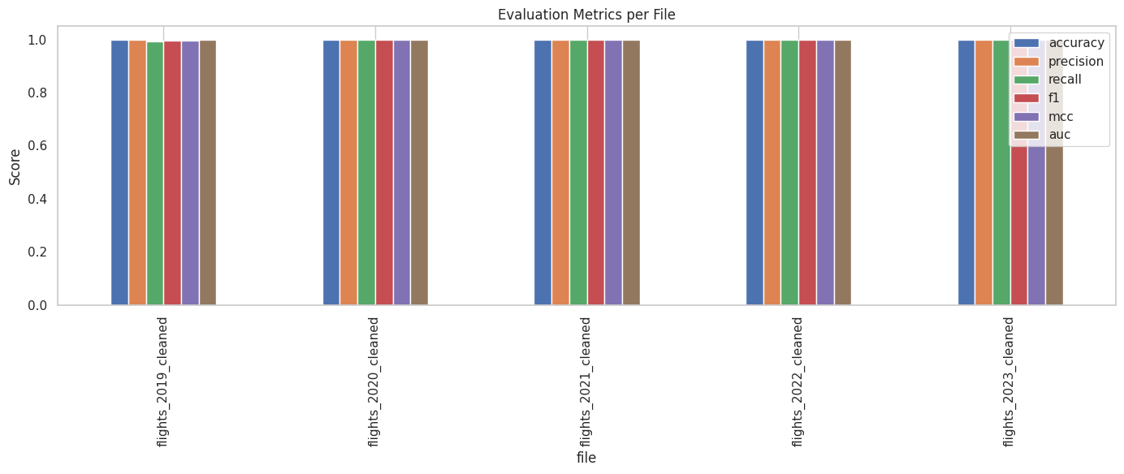
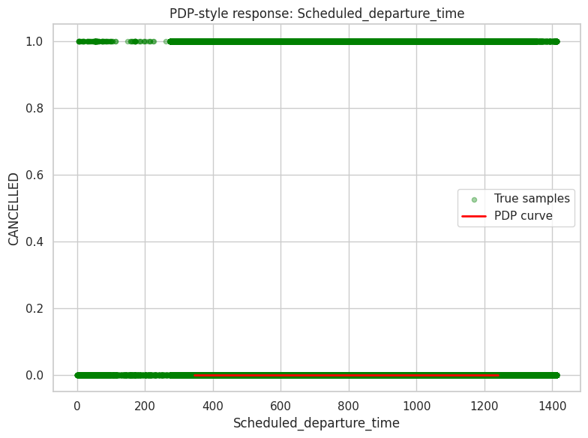
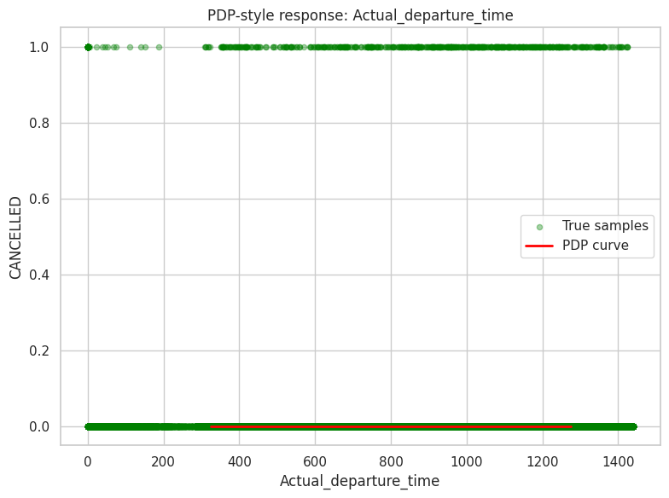
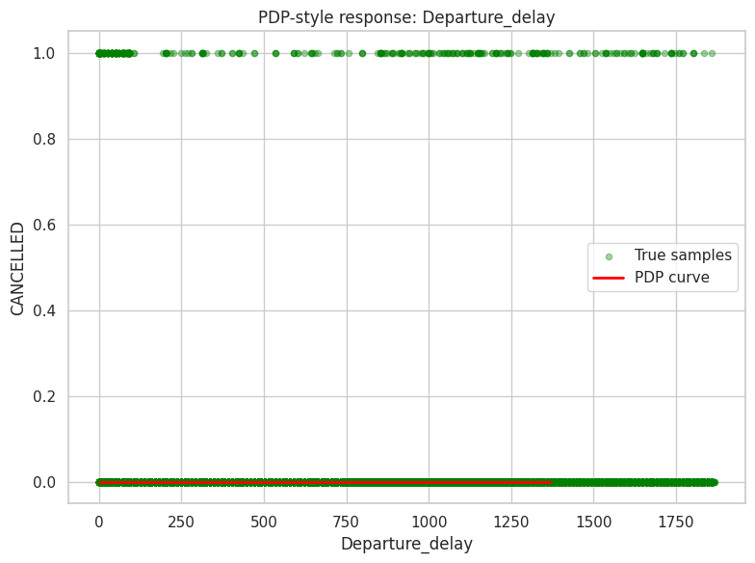
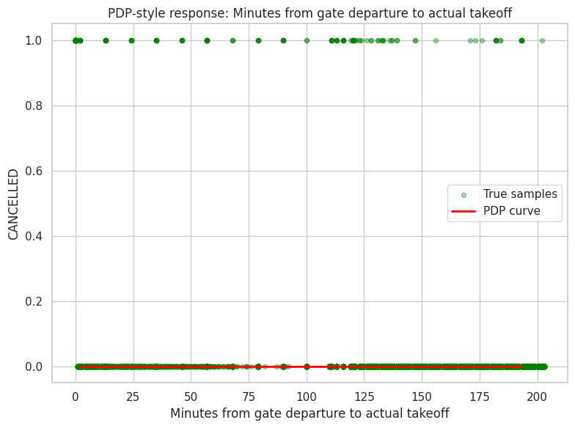
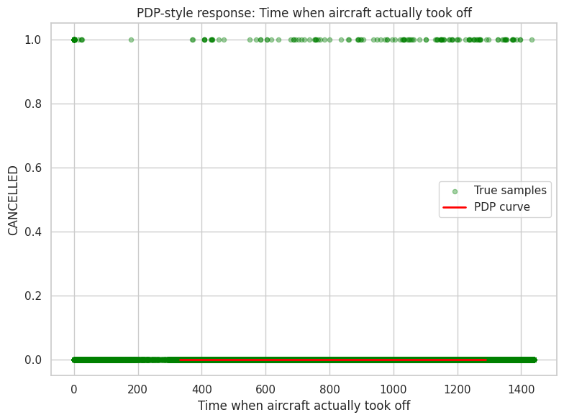
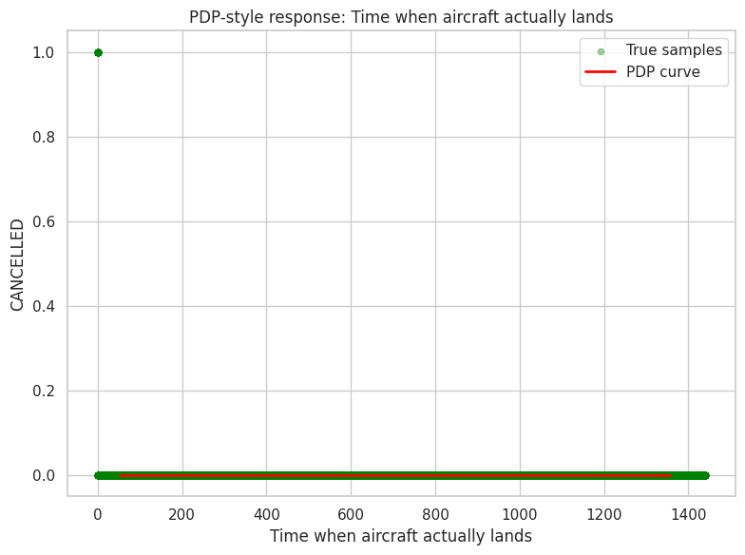
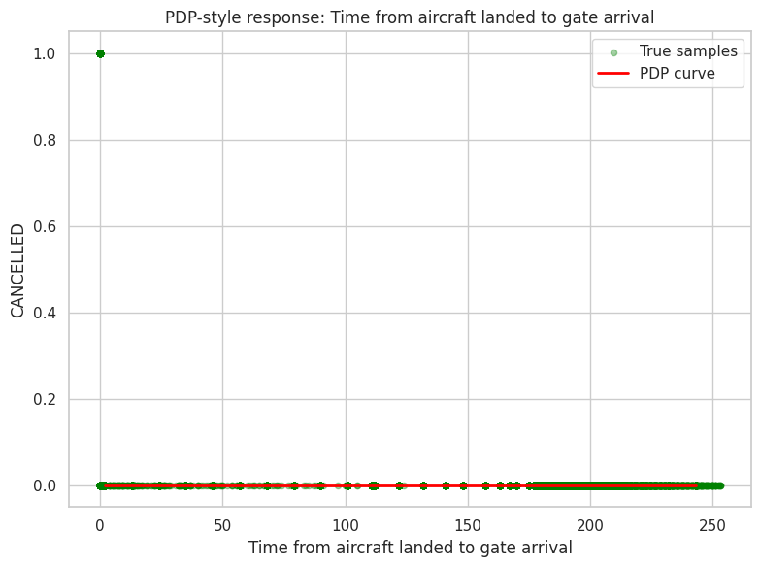
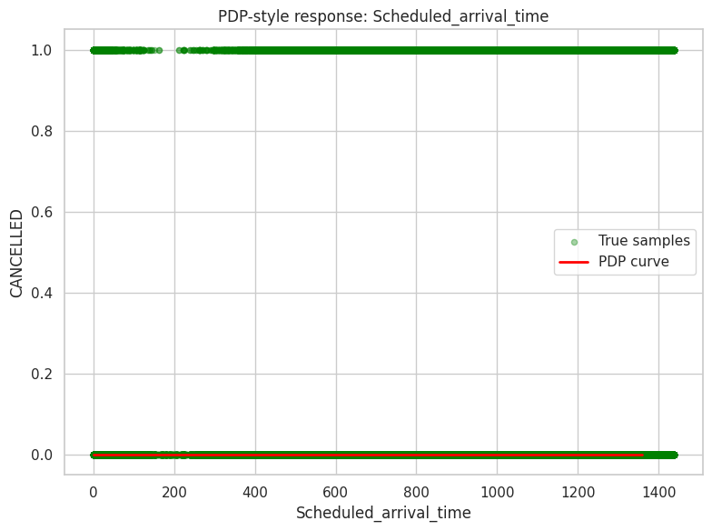
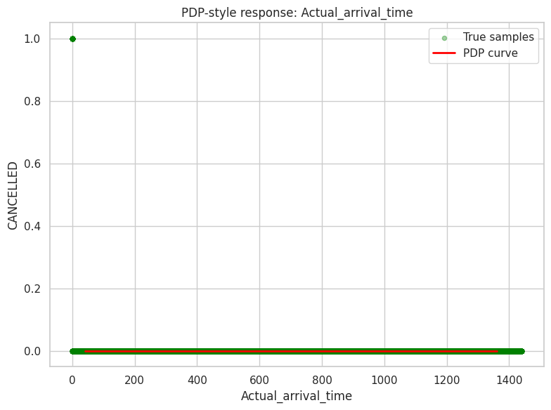
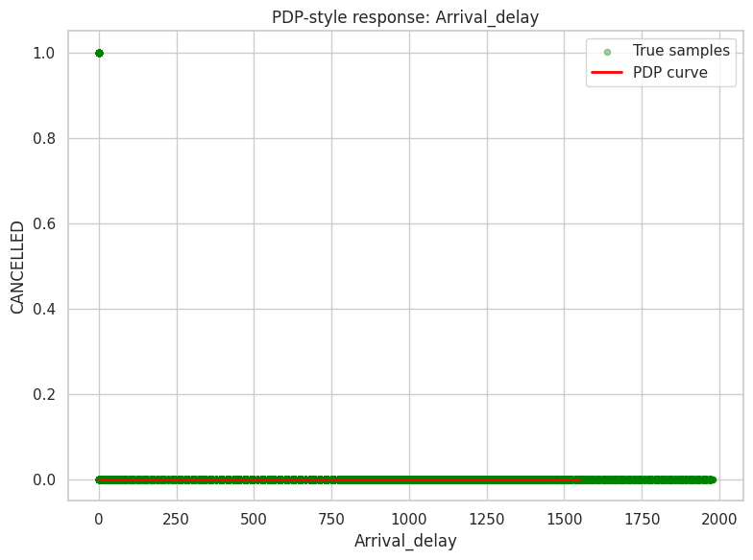
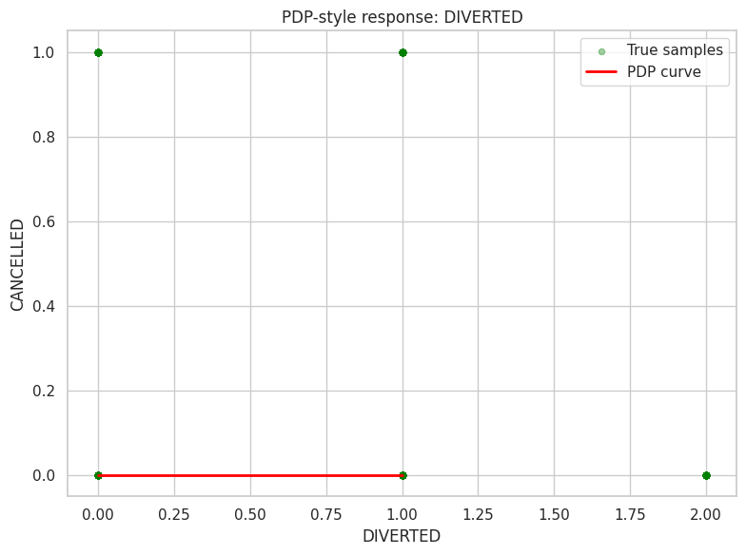
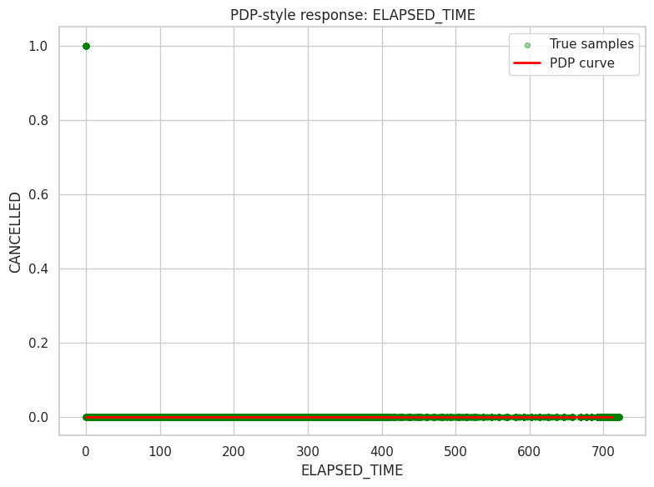
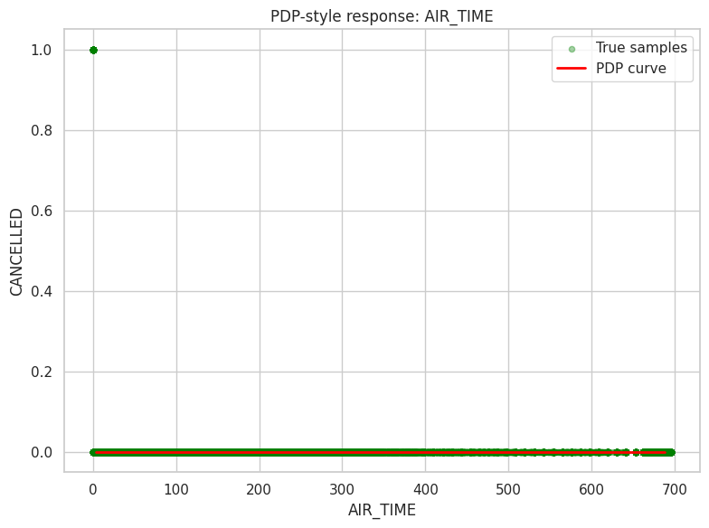
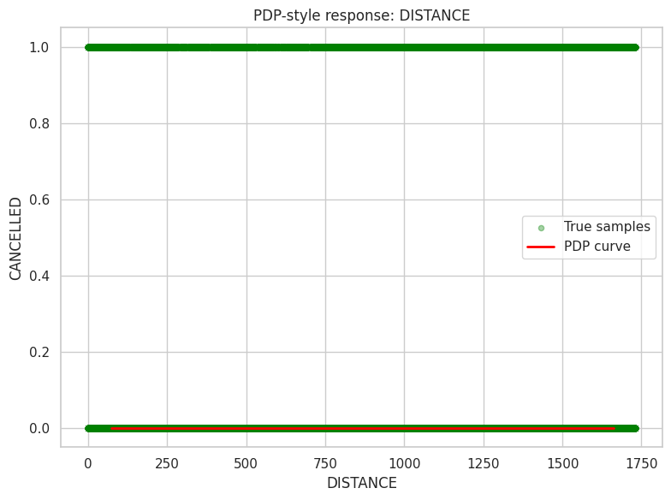
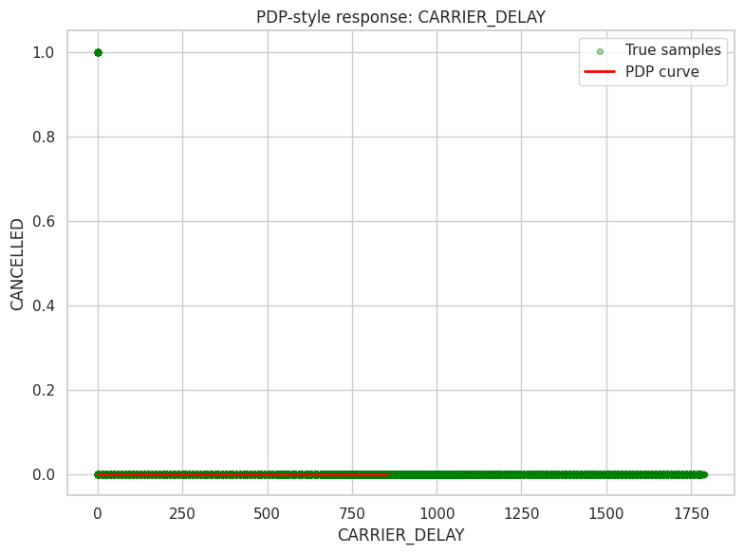
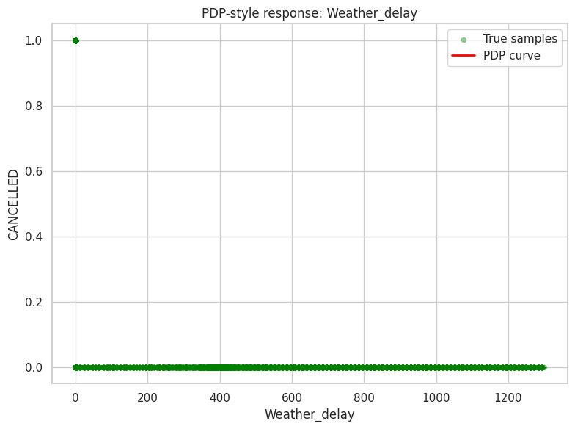
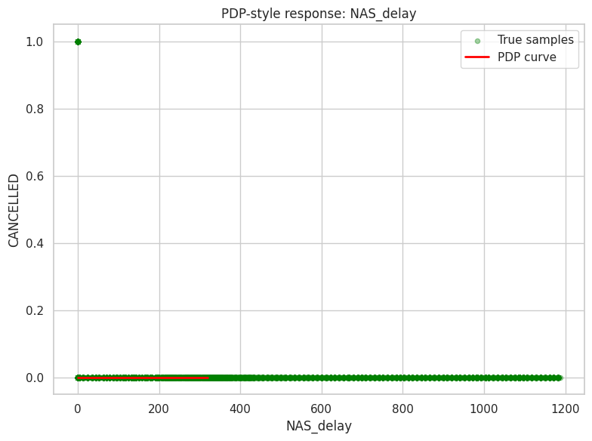
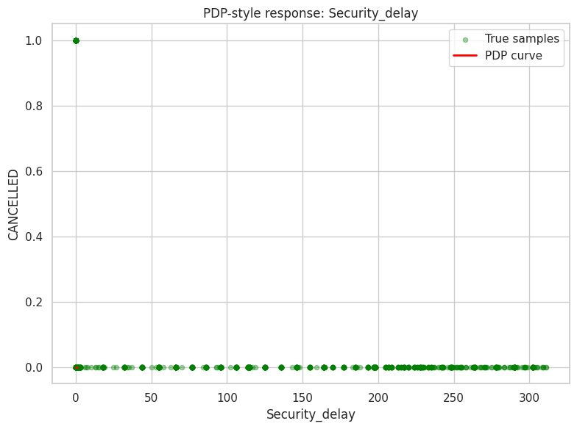
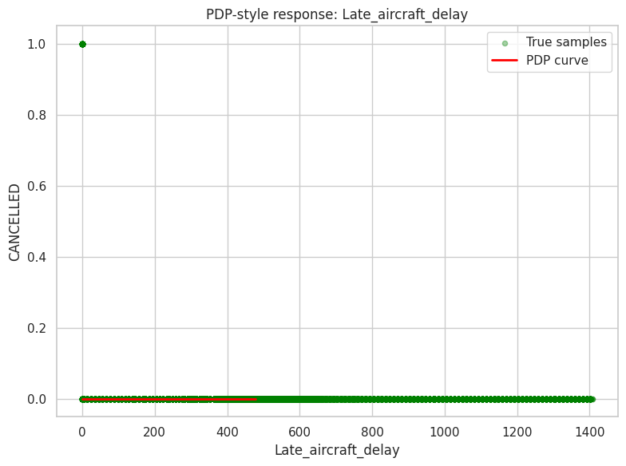
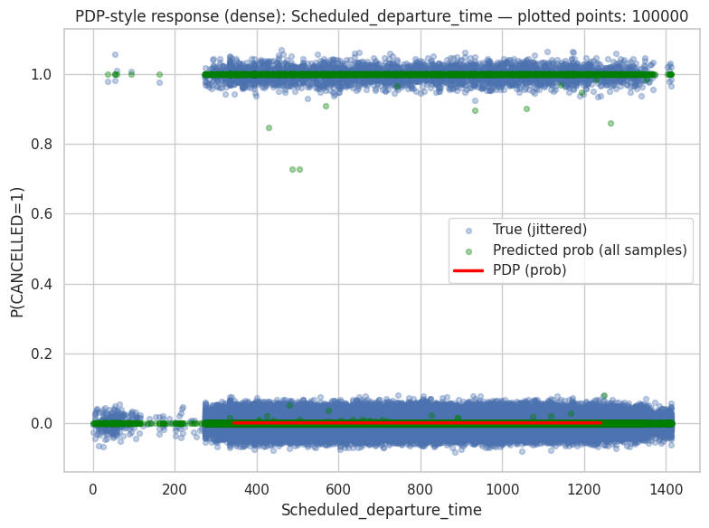
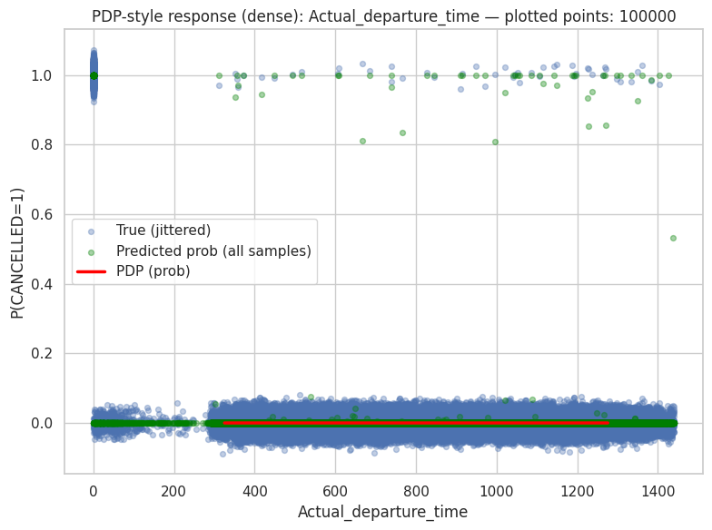
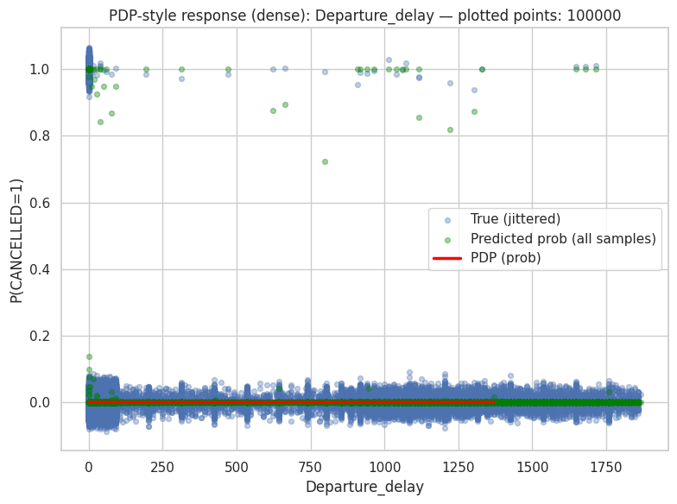
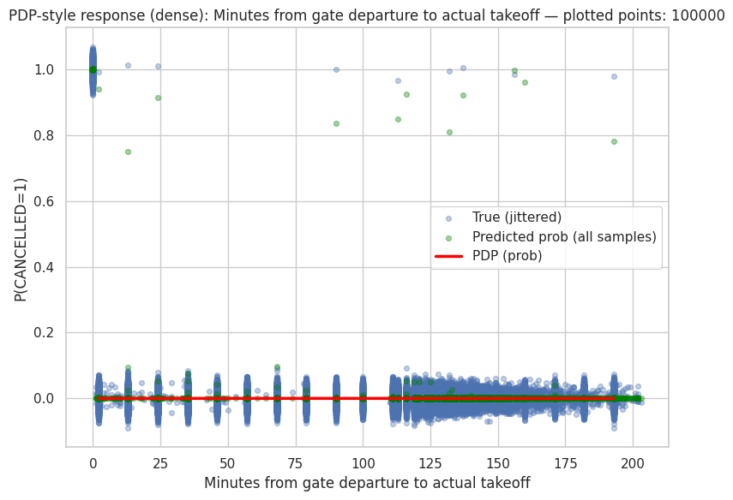
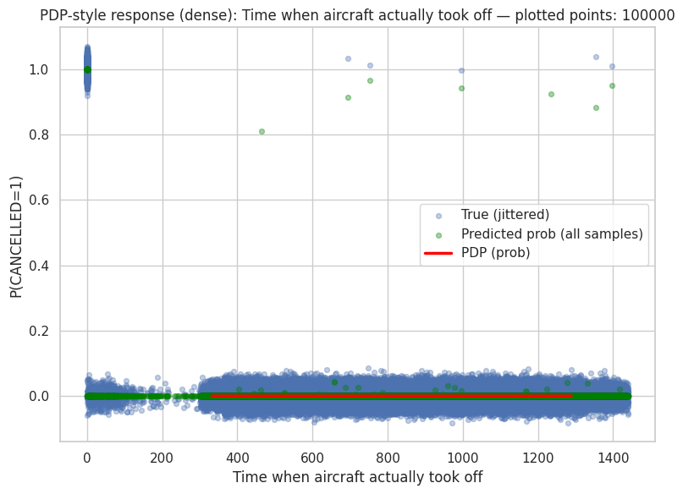
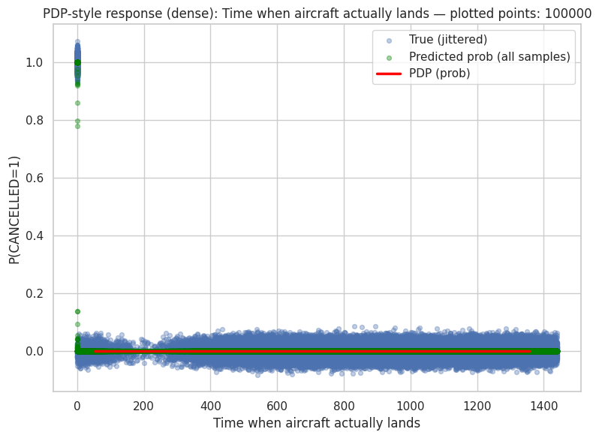
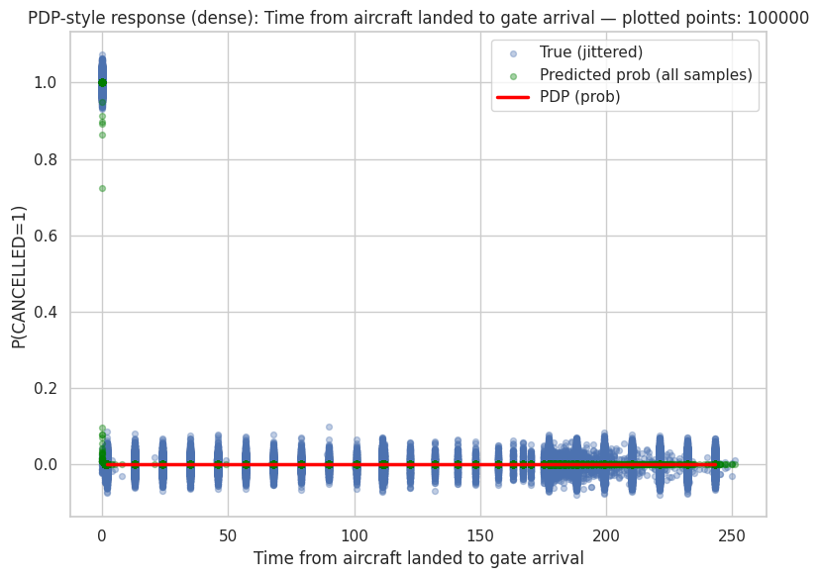
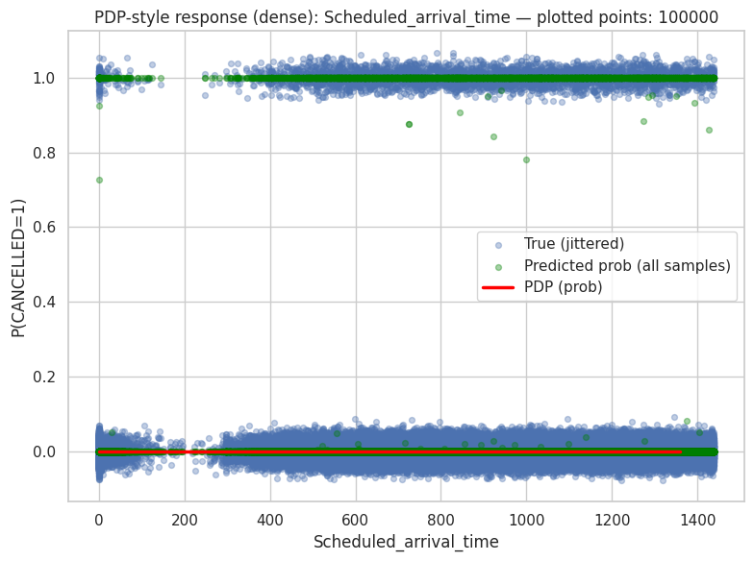
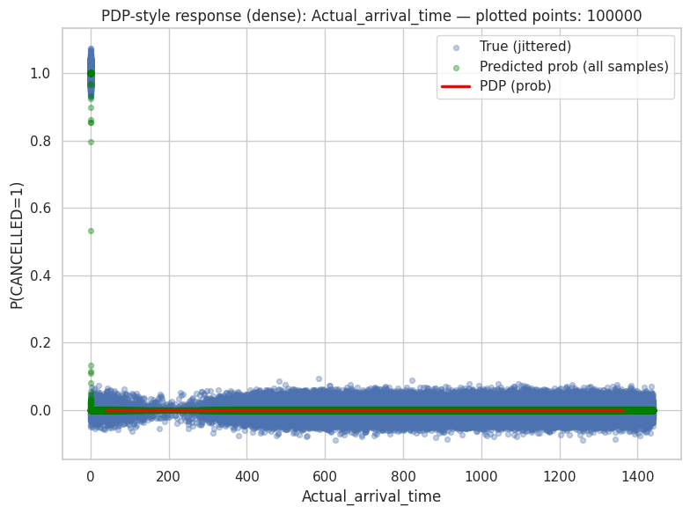
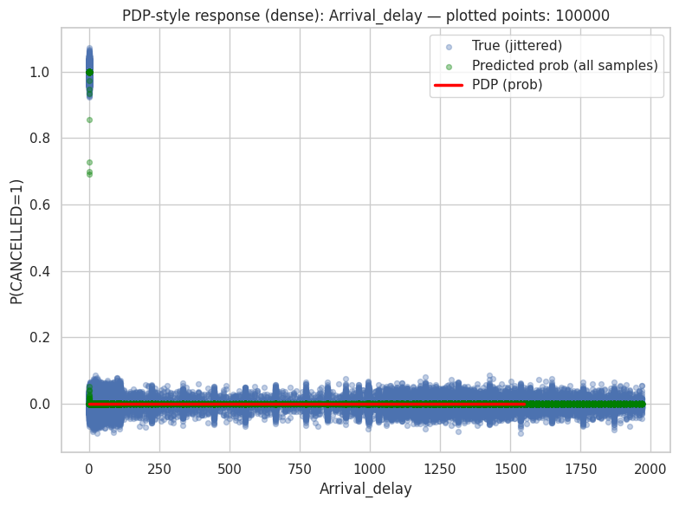
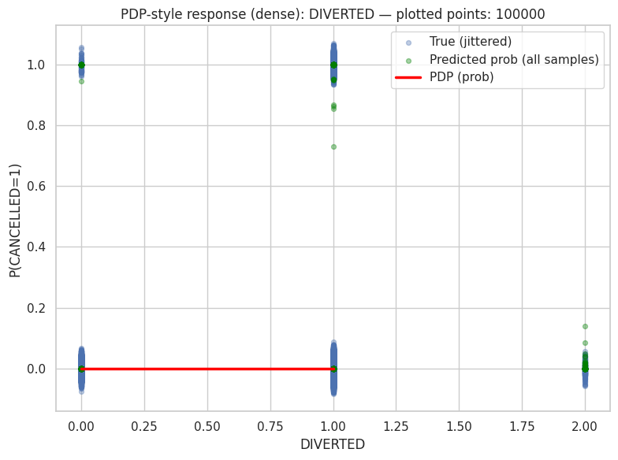
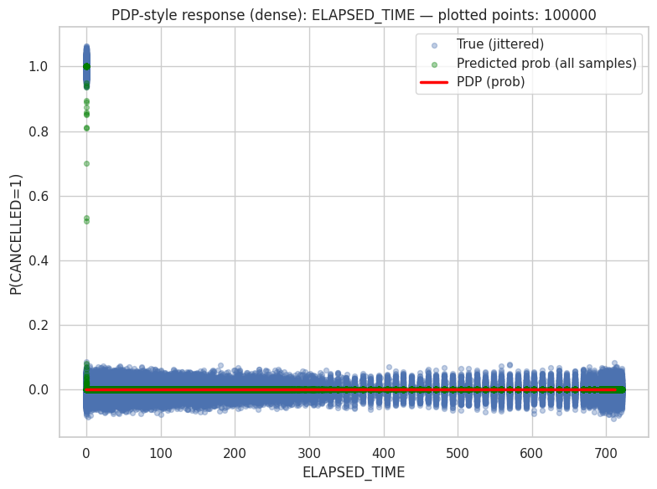
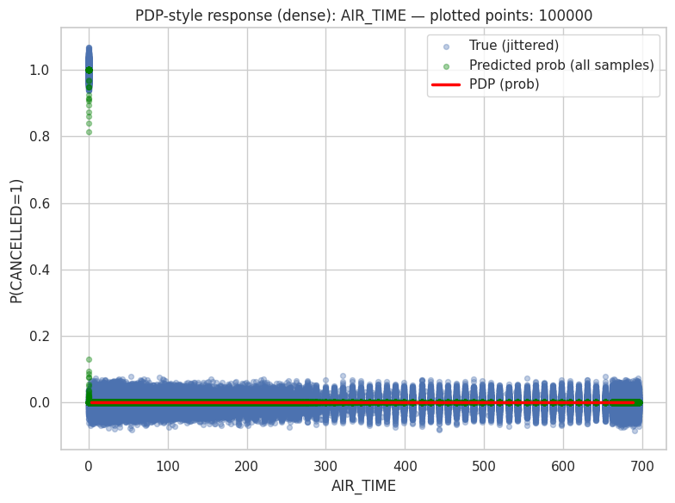
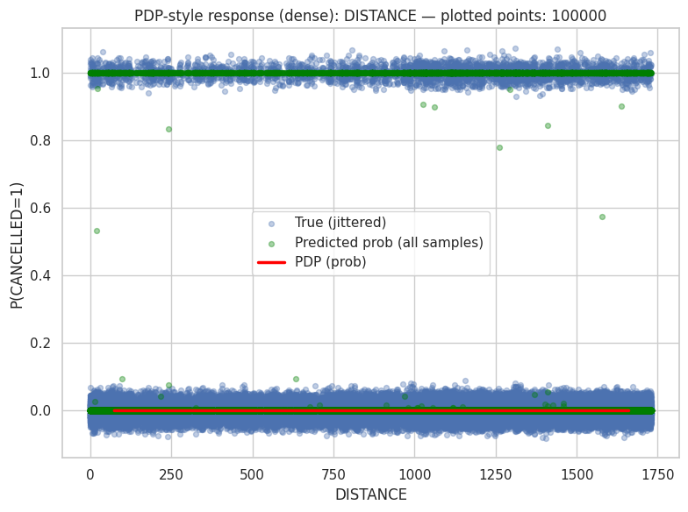
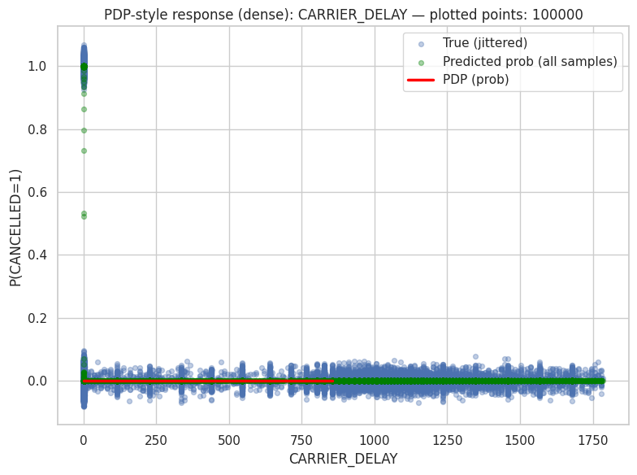
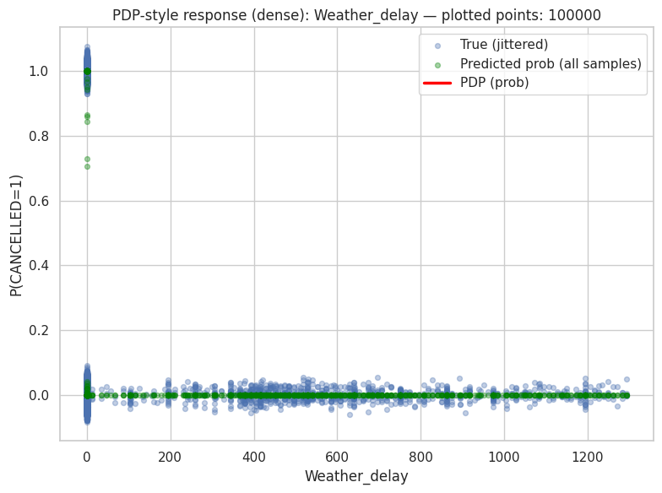
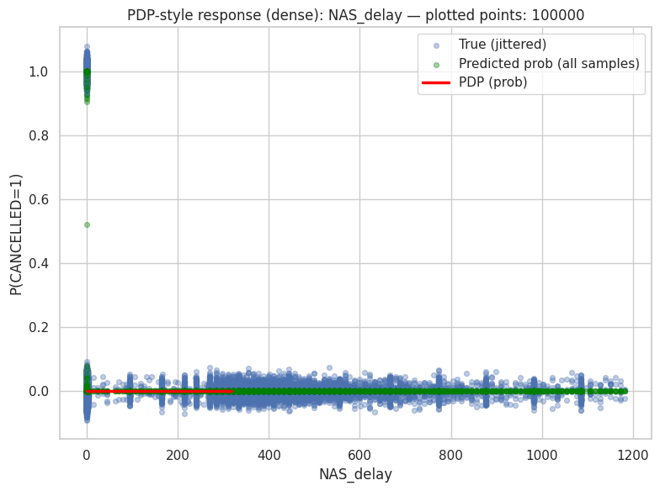
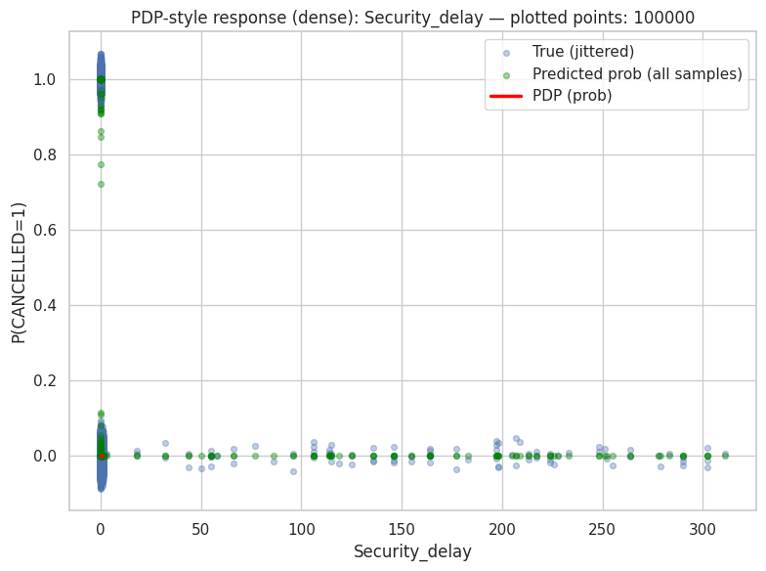
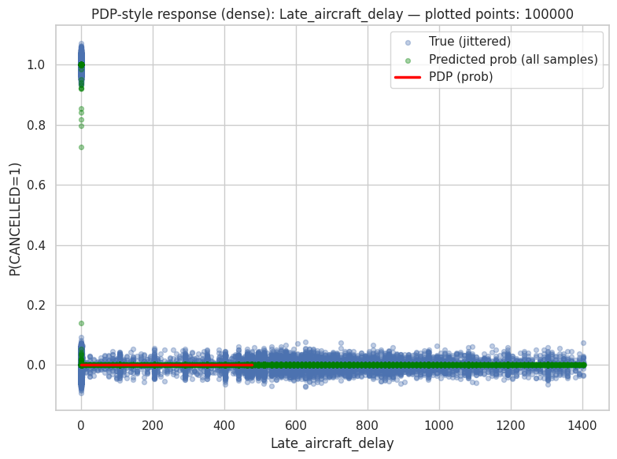
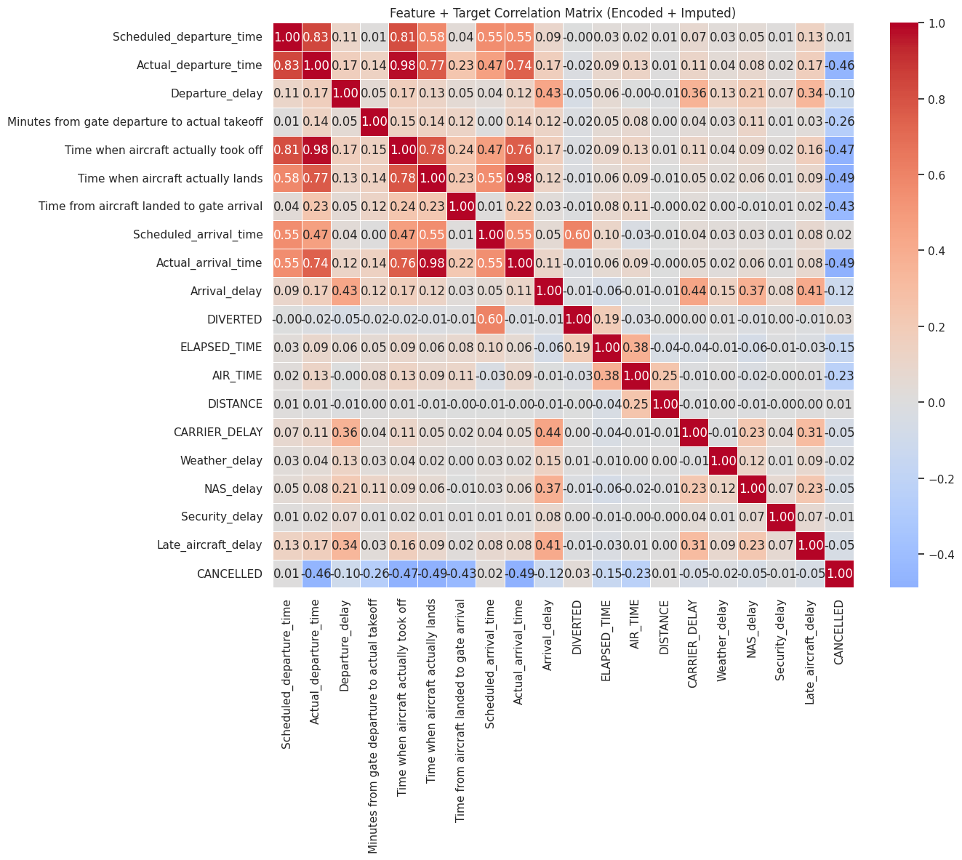

The Feature–Target Correlation Matrix shows that flight delay behavior is driven primarily by temporal and operational timing variables rather than by distance or categorical delay causes. Strong positive correlations between scheduled and actual departure times, as well as between actual times and takeoff or landing events, indicate that real flight operations closely follow planned schedules when disruptions are minimal. Moderate correlations between departure delay and arrival delay confirm clear delay propagation effects, where late departures often translate into late arrivals. In contrast, individual delay causes such as weather, carrier, or security delays exhibit weak correlations, suggesting they act as independent, situational factors rather than consistent predictors. Cancellation shows mostly weak or negative correlations with timing variables, implying that cancellations are influenced by external or systemic factors not fully captured in standard operational features. Overall, the matrix highlights the dominance of timing consistency in delay prediction, while also revealing potential data leakage in perfectly correlated variables like distance and air time.
📌 FEATURE IMPACT SCORES (XGBoost):

feature impact_score
Time from aircraft landed to gate arrival 0.477467
Minutes from gate departure to actual takeoff 0.281858
Arrival_delay 0.179157
ELAPSED_TIME 0.056397
DIVERTED 0.004601
Departure_delay 0.000223
Time when aircraft actually lands 0.000142
Time when aircraft actually took off 0.000115
Actual_departure_time 0.000014
Scheduled_departure_time 0.000009
DISTANCE 0.000009
Scheduled_arrival_time 0.000008
Actual_arrival_time 0.000000
AIR_TIME 0.000000
CARRIER_DELAY 0.000000
Weather_delay 0.000000
NAS_delay 0.000000
Security_delay 0.000000
Late_aircraft_delay 0.000000

📊 NORMALIZED IMPACT (% contribution):

feature impact_percent
Time from aircraft landed to gate arrival 47.747002
Minutes from gate departure to actual takeoff 28.186001
Arrival_delay 17.916000
ELAPSED_TIME 5.640000
DIVERTED 0.460000
Departure_delay 0.022000
Time when aircraft actually lands 0.014000
Time when aircraft actually took off 0.012000
Actual_departure_time 0.001000
Scheduled_departure_time 0.001000
DISTANCE 0.001000
Scheduled_arrival_time 0.001000
Actual_arrival_time 0.000000
AIR_TIME 0.000000
CARRIER_DELAY 0.000000
Weather_delay 0.000000
NAS_delay 0.000000
Security_delay 0.000000
Late_aircraft_delay 0.000000
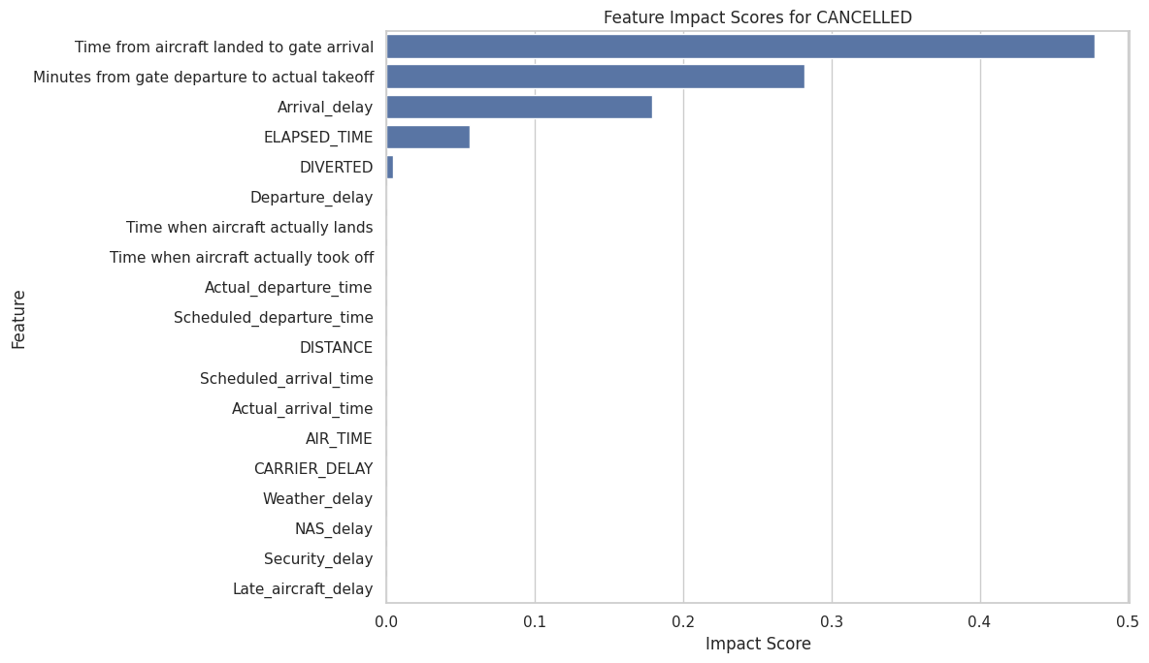

The XGBoost feature impact scores indicate that the model’s predictions are dominated by operational timing variables rather than flight distance or categorical delay causes. In particular, the time from aircraft landing to gate arrival and the time from gate departure to actual takeoff together account for the majority of the total importance, highlighting the critical role of ground handling and departure processes in determining outcomes. Arrival delay and total elapsed time provide additional but comparatively smaller contributions, suggesting that overall schedule adherence still matters but is secondary to immediate operational delays. In contrast, variables related to diversion status, departure delay, exact timestamps, distance, air time, and specific delay categories such as weather, carrier, or security have negligible impact, implying either redundancy with more dominant timing features or limited predictive value in the presence of stronger operational indicators.
