**Proposal Link:** [PokéLoot](https://docs.google.com/document/d/1KrbF5Rgf0dQBKBdmlUzqFxTDwbp9mf_wdSMe-UX-wAY/edit?usp=sharing)

**Team Members:** PokéLooters - Group 2

Mason Sanborn (Scrum Master)

Adrian Gonzalez

Christian Romero

Alain Duplan

**Sales Description:**

This application is a Game to attract Users for their interest in Pokemon and desire to grow a collection. This creates a platform for users to create and grow a Card Collection, connect with other users to exchange pokemon, and earn coins by engaging in various, repeatable tasks provided by the application. Users will have secure, personalized accounts that enable them to view and show off their collection to the display board. Users will be able to spend earned currency to buy and open Card loot boxes. All information and pictures for the specific Pokemon Cards will be obtained through the Pokemon API saving on database space and logic for the detailed information that the game is created upon.

**Minimum Viable Product**

* **Users are able create accounts and sign in**
  + Use azure database to hold all account information
  + Accounts hold collection of cards
  + Contains a Coin balance
  + Accounts have various level
  + Can have badges and achievements
* **Earn Coins**
  + Passive income depending on account level
  + Complete various tasks to earn Coins
* **Loot Boxes**
  + Brought with coin
  + Select 3 random cards
  + Adds to user collection
  + Add a special more expensive loot box that guarantee a rare card
  + Rare Cards have different look
* **Cards**
  + Uses Pokemon API
    - Takes pokemon image, name, base stat total, and id(dex number)
  + Cards have rarity based on base stat total
  + Have “Card Info” which can hold fun facts and details
* **Trading**
  + Sell/trade cards between users
  + Reflects on collection
  + Keep track of transaction levels
* **Message board**
  + Shows feed on all user activities
  + Can filter between trades, rare finding, and achievements
  + Users can make their own custom post
  + Sortable

**3rd Party APIs:**

[Pokemon Database](https://pokeapi.co/) - *“This is a full RESTful API linked to an extensive database detailing everything about the Pokémon main game series.”*

**User Stories**

1. As a user, I want to be able to have a collection of Pokemon Cards

2. As a user, I want to be able to unlock new Pokemon Cards to be added to my collection

3. As a user, I want to be able to earn coins to spend on other website interactions

4. As a user, I want to be able to display my collection and new unlocks to a display board

5. As a user, I want to be able to trade Cards from my collection with other users

**Stretch Goals:**

1. Increase options available to users to earn coins

2. Make earning new cards more exciting with css styling

3. Sort Message board by tags / descriptions

4. Improve card trading and selling features

5. Increase information displayed about specific Pokemon Cards to the user

6. Display discovered and undiscovered cards in a users collection view.

7. Allow users to see other users collections

8. Leaderboards and Achievements

9. User Statistics

10. Allow user to add a card to “purchase” Coins

**User Interaction Model:**

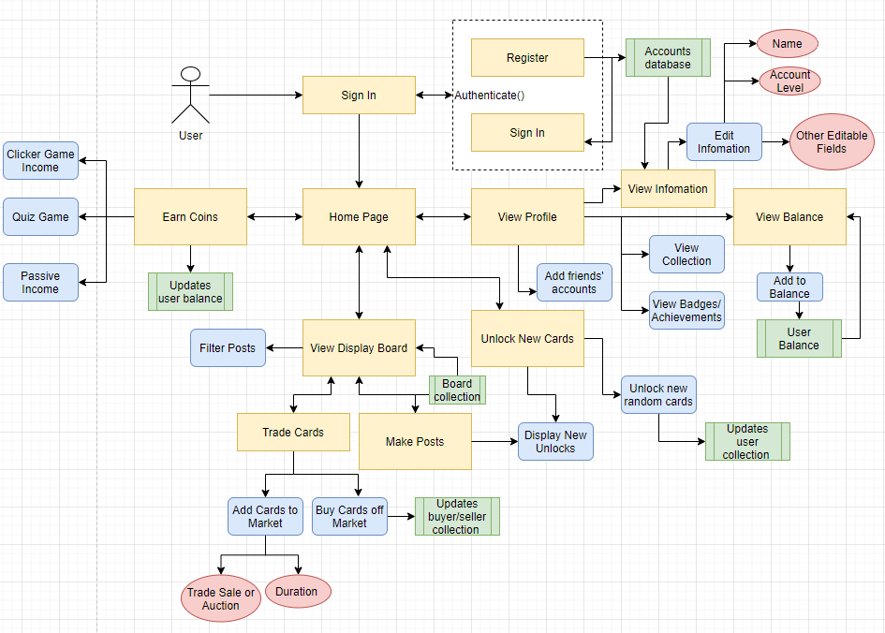

**Kanban Board:** [**Revature P2 | Trello**](https://trello.com/b/aF3PEwCW/revature-p2)

**Repo:** [**https://github.com/06012021-dotnet-uta/P2_ProjectName**](https://github.com/06012021-dotnet-uta/P2_ProjectName)