## 



Project 2 Proposal-“GameBook”

Version 2: Updated 7/2/2021

**─**

Winston Grant (Team Leader), Ethan Baker, Malia Labor, Adam Sepulveda

# Sales Description:

This application, GameBook, will display information about different video games to users as well as providing the ability to keep track of popular games and discussions. Information relating to video games, such as developers, companies, voice actors, etc. will be retrieved from a 3rd party API. Users will be able to rate games they have previously played and receive recommendations based on what genres are most common in their play history. Users can discuss related topics in a forum and connect socially with other users.

# Minimum Viable Product:

* Users can sign in to the site.
* Users can search for games, by words in the titles on the site.
* Users can add friends, a form of following other users on the site.
* Users can rate games on the site that other users can see.
* GameBook will display pages with information (3rd party API) for games.
* Users can comment on other posts.
* Users can add reviews when rating games.

# User Stories:

* As a user I want to search games by partial title to find games I may not know the full title of.
* As a user, I want to see recommendations based on my play history.
* As a user I want to see the community rating of a game, to find high quality games that I may be interested in.
* As a user I want to be able to rate games myself to share my opinion.
* As a user I want to have a discussion area where I can chat with others about games I am interested in.
* As a user I want to be able to follow other users and topics to stay up to date with the conversation.
* As a user, I want to be able to comment on posts from other users and my friends.
* As a user, I want to write a user review of games I’ve played.

# Stretch Goals:

* Receive friend suggestions based on user play history.
* Search for users with similar play histories for friend suggestions.
* Games wishlist, users can make a list of games they want to play but have not yet.

# User Interaction Model:

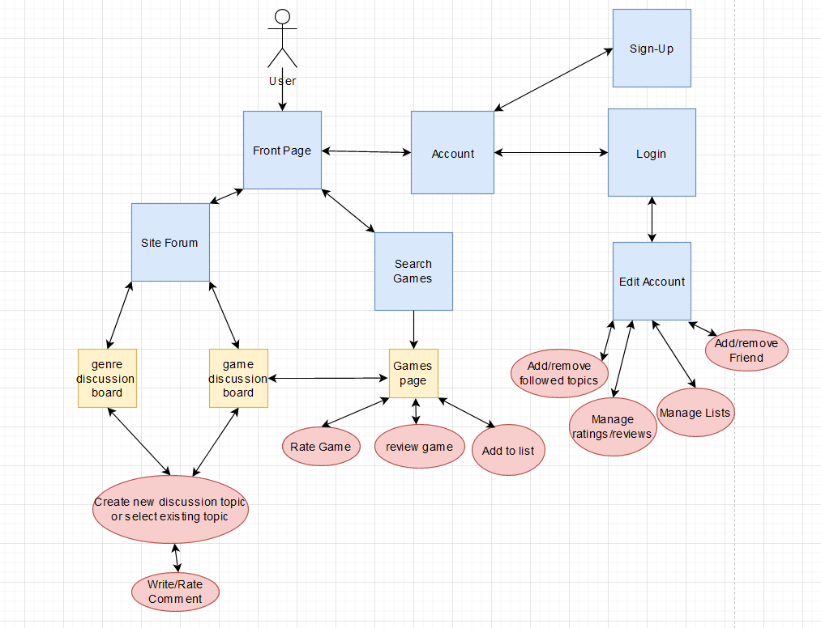

# 3rd Party APIs:

<https://www.igdb.com/api>

IGDB API will provide information and pictures of video games and related information as well as provide information on upcoming events related to video games.

# Kanban Board:

<https://trello.com/b/JZRbKuCE/kanban>

# Repo:

<https://github.com/06012021-dotnet-uta/P2_GameBook>

# Proposal Link:

<https://docs.google.com/document/d/18IK9HgvmBPpf45Zj7Pbt9Wu69HmVvSOY8yQbsevJjeE/edit?usp=sharing>