**NOT YET APPROVED**

**Proposal Link:** [P2MovieTheaterGroup](https://docs.google.com/document/d/1qwjFxl0NeiJMeLtXKw5ZEZfTpC4YNPF5cnTvUdIqesY/edit)

**Team:** MovieTheaterGroup - Gregory Agnew (Team Leader), Brian Corbett, Sekou Dossu, Stephen Silva

**Sales Description:**

Are you looking to get out of the house and go see a movie on the big screen? Where should you go? What movies are currently out in theaters? What are the available times that you can see a movie you are interested in? Or maybe you just want to see which movies are playing later tonight?

Well then look no further, Mr. Movie has all the answers for you!

Our application, Mr. Movie, is a great place to refer to for all your large-scale movie watching needs. Simply go browse our intuitive app and be amazed by how easy it is to find everything you want to know.

If you are having difficulty deciding which movie you want to watch, then just browse our app and check out our convenient movie descriptions. We even list which actors/actresses that are in a movie so you can decide if you like them enough to try out something you wouldn’t normally watch.

Still not enough? Once we have helped you make up your mind on which movie to watch you can even purchase your ticket(s) on Mr. Movie! We pride ourselves on providing you end-to-end support so that you can make movie night all about the movie!

**Technologies:**

.NET Framework [C#]

Entity Framework

ASP.NET

XUnit

Angular Framework

HTML

TypeScript

Azure

DevOps

SQL Server Database

Web Services

SonarCloud

**MVP:**

* Users can choose a theater by location and see if it is currently open or not.
* Users can see a schedule of times specific movies are being shown per theater.
* Users can see specific movie information (from 3rd party API) for a chosen movie.
* Users can select a specific instance of a movie by time and location shown.
* Users can buy tickets reserving their right to go to a theater room, for a specific time period and location, and watch the movie being shown.

**3rd Party APIs:**

[IMDb](https://rapidapi.com/apidojo/api/imdb8/)- Searches movies by title or ID and returns information such as genre, director(s), release date, and posters.

**User Stories:**

1. As a viewer, I want to find out which movie theaters are currently available so that I can find one to go see a movie in.
2. As a viewer, I want to see what movies are currently playing in a specific theater.
3. As a viewer, I want to see information about a specific movie so that I may know if it is a movie I would like to go see.
4. As a viewer, I would like to select a specific movie at a certain time and location that I would like to see.
5. As a viewer, I would like to purchase some tickets which reserve my right to see a specific movie at a certain time and location.

**Stretch Goals:**

1. Allow the user to reserve specific seats in a theater when purchasing a ticket.
2. Allow the user to purchase food and drink from the concession stand while purchasing a ticket.
3. Allow an administrator to add or remove theater locations to the webpage.
4. Allow an administrator to change the schedule of movies being shown per location.
5. Allow the user to filter movies by genre or based on how long the movie has been out.
6. Have more than one brand of theaters available.
7. Allow users to log in and apply discounts for customers with accounts.
8. Allow users to log in and keep track of purchase history.
9. Allow users to log in and accumulate points based on prior purchases.

**User Interaction Model:** [UID_Link](https://online.visual-paradigm.com/w/obdosffv/diagrams/#G1G8aI9qg-sI-7HaV2at4d5KIlk7UNrYuK)

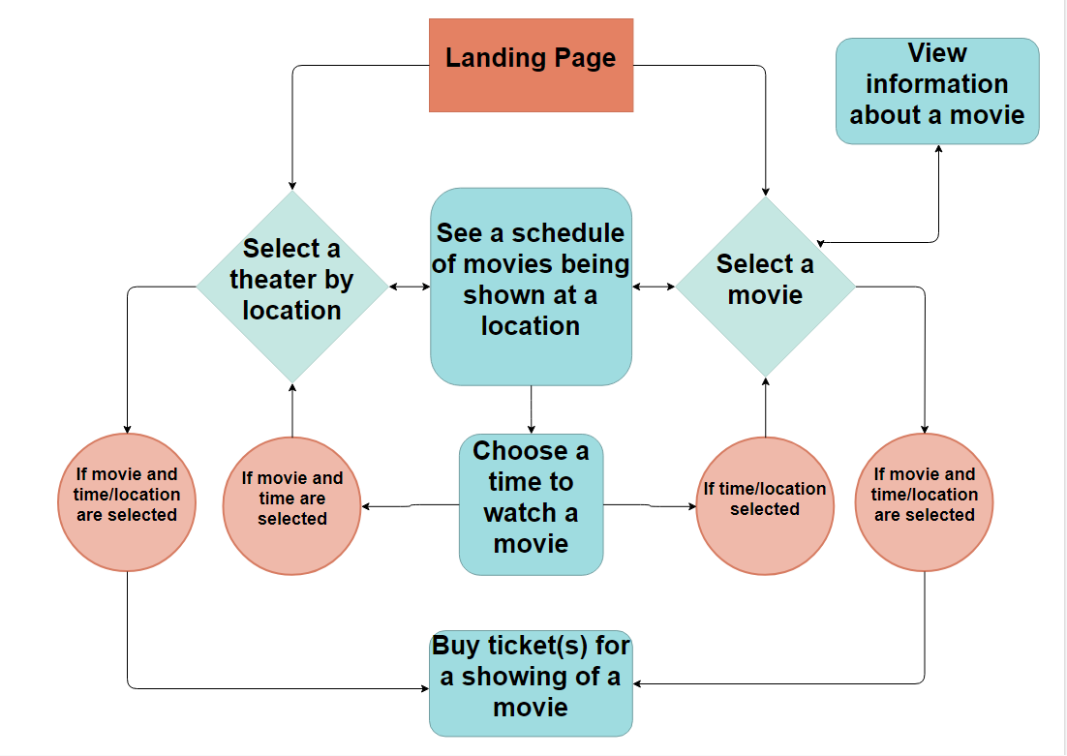

**Kanban Board:** <https://trello.com/movietheatergroup/>

**Repo:** <https://github.com/06012021-dotnet-uta/P2_MovieTheaterGroup>