**NOT YET APPROVED**

**Proposal Link:** [P2MovieTheaterGroup](https://docs.google.com/document/d/1qwjFxl0NeiJMeLtXKw5ZEZfTpC4YNPF5cnTvUdIqesY/edit)

**Team:** MovieTheaterGroup - Gregory Agnew (Team Leader), Brian Corbett, Sekou Dossu, Stephen Silva

**Sales Description:**

Are you looking to get out of the house and go see a movie on the big screen? Where should you go? What movies are currently out in theaters? What are the available times that you can see a movie you are interested in? Or maybe you just want to see which movies are playing later tonight?

Well then look no further, Mr. Movie has all the answers for you!

Our application, Mr. Movie, is a great place to refer to for all your large-scale movie watching needs. Simply go to our intuitive app and be amazed by how easy it is to find everything you want to know.

You can start by selecting which theater location you’d like to see a movie at. You can see a schedule of what movies are playing and at what times for each of our supported theater locations. Alternatively, you can start by filtering our extensive list of movies by genre. Select a movie you’d like to see and we’ll show you which locations are playing that movie and at what times. If you are having difficulty deciding which movie you want to watch, you can check out our convenient movie descriptions by clicking on a movie info link. We even list which actors/actresses that are in a movie so you can decide if you like them enough to try out something you wouldn’t normally watch. We pride ourselves on providing you end-to-end support so that you can make movie night all about the movie!

When you have finished enjoying your movie night, please don’t forget you can log in to Mr. Movie and leave a rating for the movie you saw. Speaking of logging in, Mr. Movie isn’t just great for folks who want to go watch a movie. If you have a local theater business and want to have your showings listed on our app, sign up for one of our administer accounts. Using an administer account, you can add or remove supported movies to your local theater schedule for all viewers to see! Of course, you can also add or remove which theater locations you’d like to have us support as well. Please contact fake@email.lol for more information.

**Technologies:**

.NET Framework [C#]

Entity Framework

ASP.NET

XUnit

Angular Framework

HTML

TypeScript

Azure

DevOps

SQL Server Database

Web Services

SonarCloud

**MVP:**

* Users and administrators can log into their account.
* Administrators can add or remove movies to a theater schedule and add or remove theater locations from the web page.
* Users can leave a rating and comments about a movie.
* Users can see a schedule of times specific movies are being shown per theater.
* Users can see specific movie information (from 3rd party API) for a chosen movie.

**3rd Party APIs:**

[IMDb](https://rapidapi.com/apidojo/api/imdb8/)- Searches movies by title or ID and returns information such as genre, director(s), release date, and posters.

**User Stories:**

1. As a viewer or an administrator, I can log in to my account.
2. As an administrator, I can add or remove a movie to a theater schedule.
3. As an administrator, I can add or remove theater locations to the web page.
4. As a viewer, I can select a movie at a certain time and location that I would like to see.
5. As a viewer, I can see information about a specific movie so that I may know if it is a movie I would like to go see.
6. As a viewer, I can rate a movie and post comments for it.

**Stretch Goals:**

1. Allow the user to filter movies based on how long the movie has been out or other filters besides genre.
2. Allow users to see all movies being shown at all locations for a limited time frame such as an hour.
3. Allow users to purchase some tickets which reserve their right to see a specific movie at a certain time and location.
4. Allow the user to reserve specific seats in a theater when purchasing a ticket.
5. Allow the user to purchase food and drink from the concession stand while purchasing a ticket.
6. Allow users to log in and apply discounts for customers with accounts.
7. Allow users to log in and keep track of purchase history.
8. Allow users to log in and accumulate points based on prior purchases.
9. Allow users to add movies to a favorites list.
10. Allow users to add movies to a watch list.

**User Interaction Model:** [UID_Link](https://online.visual-paradigm.com/w/obdosffv/diagrams/#G1G8aI9qg-sI-7HaV2at4d5KIlk7UNrYuK)

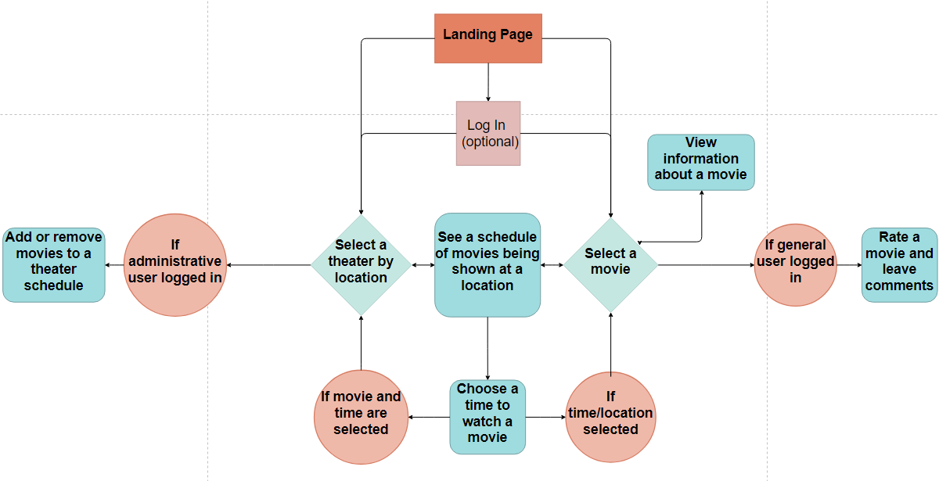

**Kanban Board:** <https://trello.com/movietheatergroup/>

**Repo:** <https://github.com/06012021-dotnet-uta/P2_MovieTheaterGroup>