**電通二乙微處理器實驗 實驗結報**

|  |  |  |  |
| --- | --- | --- | --- |
| **實驗名稱** | **Lab02** | | |
| **組別** | **06050102** | **組員** | **林鎮億** |

1. **實驗目的**

LinkIt 7697 D1 – D8 分別接到 LED，實作跑馬燈展示

1. **實驗步驟**
2. LED 向左及向右執行花色展示
3. 執行自定花色展示: 所有LED亮滅兩次 -> 左移八次 -> 所有LED亮滅兩次 -> 右移八次
4. 開關 OFF -> LED 向左及向右執行花色展示

開關 ON -> 執行自定花色展示

1. **程式碼**

**(1)**

void setup()

{

for (int i = 7; i < 15; i++) {

pinMode(i, OUTPUT);

}

void loop()

{

for(int j=0;j<2;j++)

{

digitalWrite(i, HIGH);

delay(50);

digitalWrite(i, LOW);

delay(50);

}

for (int i = 14; i >6; i--)

{

digitalWrite(i, HIGH);

delay(50);

digitalWrite(i, LOW);

delay(50);

}

}

**(2)**

void setup()

{

for (int i = 7; i < 15; i++) {

pinMode(i, OUTPUT);

}

}

void loop()

{

for(int j=0;j<2;j++)

{

{

digitalWrite(7, HIGH);

digitalWrite(8, HIGH);

digitalWrite(9, HIGH);

digitalWrite(10, HIGH);

digitalWrite(11, HIGH);

digitalWrite(12, HIGH);

digitalWrite(13, HIGH);

digitalWrite(14, HIGH);

}

delay(300);

{

digitalWrite(7, LOW);

digitalWrite(8, LOW);

digitalWrite(9, LOW);

digitalWrite(10, LOW);

digitalWrite(11, LOW);

digitalWrite(12, LOW);

digitalWrite(13, LOW);

digitalWrite(14, LOW);

}

delay(1000);

}

for(int n=0;n<8;n++)

{

for (int i = 7; i < 15; i++)

{

digitalWrite(i, HIGH);

delay(50);

digitalWrite(i, LOW);

delay(50);

}

}

for(int j=0;j<2;j++)

{

{

digitalWrite(7, HIGH);

digitalWrite(8, HIGH);

digitalWrite(9, HIGH);

digitalWrite(10, HIGH);

digitalWrite(11, HIGH);

digitalWrite(12, HIGH);

digitalWrite(13, HIGH);

digitalWrite(14, HIGH);

}

delay(300);

{

digitalWrite(7, LOW);

digitalWrite(8, LOW);

digitalWrite(9, LOW);

digitalWrite(10, LOW);

digitalWrite(11, LOW);

digitalWrite(12, LOW);

digitalWrite(13, LOW);

digitalWrite(14, LOW);

}

delay(1000);

}

for(int n=0;n<8;n++)

{

for (int i = 14; i >6; i--)

{

digitalWrite(i, HIGH);

delay(50);

digitalWrite(i, LOW);

delay(50);

}

}

}

**(3)**

const byte leds[]={8,9,10,11,12,13,14,15};

const byte NUM=sizeof(leds);

int i;

int count;

int t;

void setup()

{

for(int i=0;i<NUM;i++)

{

pinMode(leds[i],OUTPUT);

}

pinMode(6,INPUT);

}

void loop()

{

t = digitalRead(6);

if( t== HIGH)

{

for(i=0;i<NUM;i++)

{

digitalWrite(leds[i],HIGH);

delay(100);

digitalWrite(leds[i],LOW);

}

for(i=NUM-1;i>=0;i--)

{

digitalWrite(leds[i],HIGH);

delay(100);

digitalWrite(leds[i],LOW);

}

}

else

{

for(i=0;i<2;i++)

{

digitalWrite(8,HIGH);

digitalWrite(10,HIGH);

digitalWrite(12,HIGH);

digitalWrite(14,HIGH);

delay(400);

digitalWrite(8,LOW);

digitalWrite(10,LOW);

digitalWrite(12,LOW);

digitalWrite(14,LOW);

delay(400);

}

}

}

1. **實驗結果及分析**

**(1.2)**

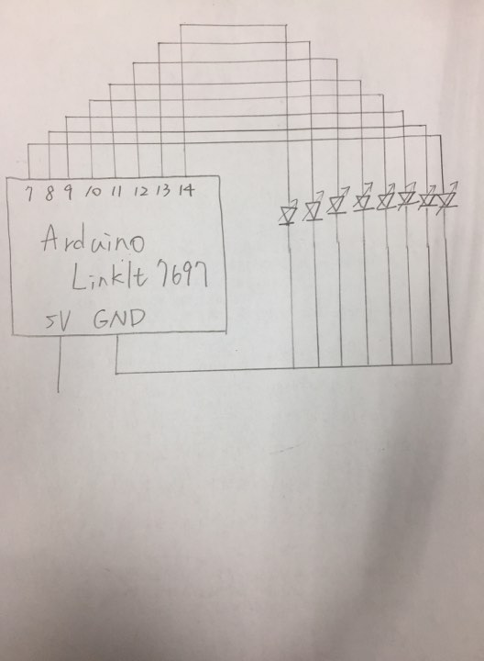

**(3)**

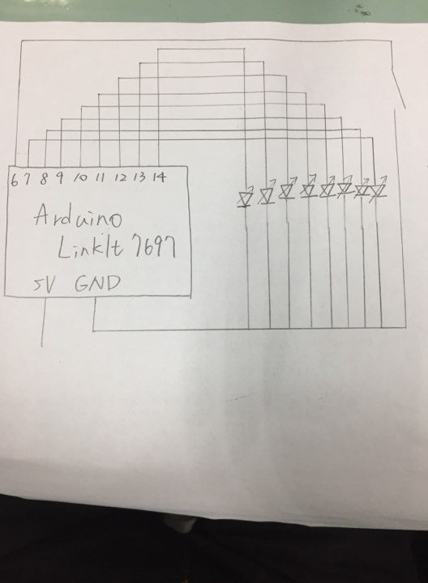

1. **心得討論**

今天這個實驗，前兩個步驟比較容易，第三個需要花比較多時間去思考，接上7697這顆IC時，要上傳比較多次才能燒錄成功，這次學到了跑馬燈的程式設計以及了解7697這顆IC的基本構造及使用功能。