電通二甲微處理器實驗 實驗結報

實驗名稱 | Lab11-MCS Cloud
組別 | 06050102 | 組員 | 林鎮億

- 實驗目的
透過實驗實際操作，學習MCS Cloud平台。
雲端平台，執行程式
例：Google App Engine、Amazon Web Services、Microsoft Azure
提供網頁介面，讓你「點按滑鼠」就能建立雲端程式
提供API程式存取介面
提供網頁介面，觀看與控制各種資料
- 實驗步驟
到MCS註冊帳號
建立網頁應用程式（web application）
透過MCS REST API進行溝通
LinkIt 家族開發板、手機、瀏覽器

下載程式範例，更改Device Id/Key，設定Wifi網路，接好電路，在網頁上顯示指定操作。

- 程式碼
(1)
#include <LWiFi.h>
#include <WiFiClient.h>
#include "MCS.h"

// Assign AP ssid / password here
#define _SSID "iPhone"
#define _KEY "zz0970857279"

// Assign device id / key of your test device
MCSDevice mcs("DXl5B8lw", "pidnZwgVpzu39pMl");

// Assign channel id
// The test device should have 2 channel
// the first channel should be "Controller" - "On/Off"
// the secord channel should be "Display" - "On/Off"
MCSControllerOnOff led("06050102");
MCSDisplayOnOff remote("a06050102");
MCSDisplayInteger Temp("Temp");

#define LED_PIN 7

void setup() {
// setup Serial output at 9600
Serial.begin(9600);

// setup LED/Button pin
pinMode(LED_PIN, OUTPUT);

// setup Wifi connection
while(WL_CONNECTED != WiFi.status())
{
Serial.print("WiFi.begin(");
Serial.print(_SSID);
Serial.print(",");
Serial.print(_KEY);
Serial.println(")...");
WiFi.begin(_SSID, _KEY);
}
Serial.println("WiFi connected !!");

// setup MCS connection
mcs.addChannel(led);
mcs.addChannel(remote);
while(!mcs.connected())
{
Serial.println("MCS.connect()...");
mcs.connect();
}
Serial.println("MCS connected !!");

// read LED value from MCS server
while(!led.valid())
{
Serial.println("read LED value from MCS...");
led.value();
}
Serial.print("done, LED value = ");
Serial.println(led.value());
digitalWrite(LED_PIN, led.value() ? HIGH : LOW);
}

void loop() {
// call process() to allow background processing, add timeout to avoid high cpu usage
Serial.print("process(");
Serial.print(millis());
Serial.println(")");
mcs.process(100);

// updated flag will be cleared in process(), user must check it after process() call.
if(led.updated())
{
Serial.print("LED updated, new value = ");
Serial.println(led.value());
digitalWrite(LED_PIN, led.value() ? HIGH : LOW);
if(!remote.set(led.value()))
{
Serial.print("Failed to update remote");
Serial.println(remote.value());
}
}
if(!Temp.set(analogRead(A0)))
{
Serial.print("Temp:");
Serial.println(Temp.value());
}
// check if need to re-connect
while(!mcs.connected())
{
Serial.println("re-connect to MCS...");
mcs.connect();
if(mcs.connected())
Serial.println("MCS connected !!");
}
}

(2)
#include "MCS.h"

// Assign AP ssid / password here
#define _SSID "iPhone"
#define _KEY "zz0970857279"

// Assign device id / key of your test device
MCSDevice mcs("DXl5B8lw", "pidnZwgVpzu39pMl");

// Assign channel id
// The test device should have 2 channel
// the first channel should be "Controller" - "On/Off"
// the secord channel should be "Display" - "On/Off"

MCSControllerOnOff led("06050102");
MCSDisplayOnOff remote("a06050102");
MCSDisplayInteger Temp("Temp");

#define LED_PIN 7

void setup() {
// setup Serial output at 9600
Serial.begin(9600);

// setup LED/Button pin
pinMode(LED_PIN, OUTPUT);

// setup Wifi connection
while(WL_CONNECTED != WiFi.status())
{
Serial.print("WiFi.begin(");
Serial.print(_SSID);
Serial.print(",");
Serial.print(_KEY);
Serial.println(")...");
WiFi.begin(_SSID, _KEY);
}
Serial.println("WiFi connected !!");

// setup MCS connection
mcs.addChannel(led);
mcs.addChannel(remote);
mcs.addChannel(Temp);
while(!mcs.connected())
{
Serial.println("MCS.connect()...");
mcs.connect();
}
Serial.println("MCS connected !!");

// read LED value from MCS server
while(!led.valid())
{
Serial.println("read LED value from MCS...");
led.value();
}
Serial.print("done, LED value = ");
Serial.println(led.value());
digitalWrite(LED_PIN, led.value() ? HIGH : LOW);
}

void loop() {
// call process() to allow background processing, add timeout to avoid high cpu usage
Serial.print("process(");
Serial.print(millis());
Serial.println(")");
mcs.process(100);

// updated flag will be cleared in process(), user must check it after process() call.
if(led.updated())
{
Serial.print("LED updated, new value = ");
Serial.println(led.value());
digitalWrite(LED_PIN, led.value() ? HIGH : LOW);
if(!remote.set(led.value()))
{
Serial.print("Failed to update remote");
Serial.println(remote.value());
}
}

if(!Temp.set(analogRead(A0)))
{
Serial.print("Temp: ");
Serial.println(Temp.value());
}

// check if need to re-connect
while(!mcs.connected())
{
Serial.println("re-connect to MCS...");
mcs.connect();
if(mcs.connected())
Serial.println("MCS connected !!");
}
}
- 實驗結果及分析
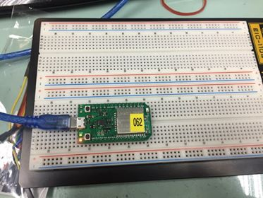

- led.value() 如為1，則上述判斷結果為 HIGH
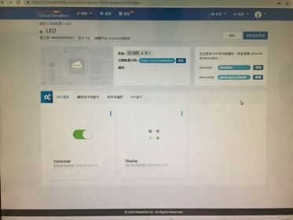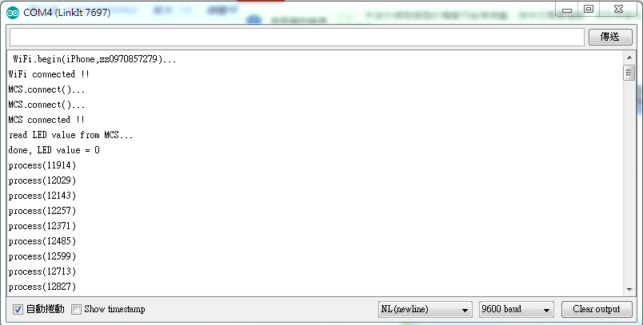
- led.value() 如為0，則上述判斷結果為 LOW
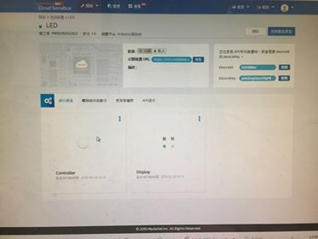

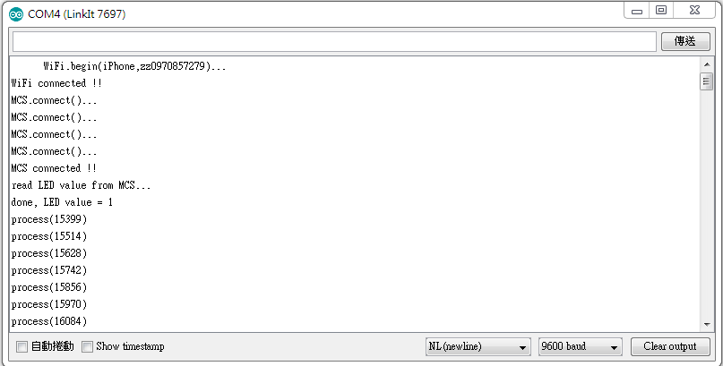

(1)接上可變電阻
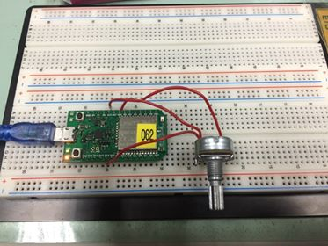
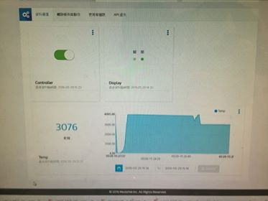

- 心得討論
今天這個實驗還算簡單，學到很多東西，認識到MCS Cloud這個平台，第二個接可變電阻弄比較久，不過最後還是順利做出來了。

