電通二甲微處理器實驗 實驗結報

實驗名稱 | Lab12溫濕度感測器
組別 | 06050102 | 組員 | 林鎮億

- 實驗目的
Arduion連接溫濕度感測器，透過下載程式庫，修改程式，從PC觀測周遭
溫濕度感測值之改變。
- 實驗步驟
- 安裝DHT-11 Library
Arduino程式庫管理員選擇DHT sensor library by Adafruit 及 Adafruit_Sensor library 安裝

(2)測試DHT-11
Example→DHT→DHTtester
更改DHTTYPE及DHTPIN

→讓DHT-11可以一直測量溫濕度
(3)修改Timer1之_callback1,測量DHT-11之溫濕度
修改timer1.start,使其1秒鐘量一次

→整合Timer與DHT-11測量溫濕度
(4)參考Lab11程式碼
→使用Timer每隔10秒將溫濕度上傳至MCS Cloud
- 程式碼
(1)
// Example testing sketch for various DHT humidity/temperature sensors
// Written by ladyada, public domain

// REQUIRES the following Arduino libraries:
// - DHT Sensor Library: https://github.com/adafruit/DHT-sensor-library
// - Adafruit Unified Sensor Lib: https://github.com/adafruit/Adafruit_Sensor

#include "DHT.h"

#define DHTPIN 2 // Digital pin connected to the DHT sensor
// Feather HUZZAH ESP8266 note: use pins 3, 4, 5, 12, 13 or 14 --
// Pin 15 can work but DHT must be disconnected during program upload.

// Uncomment whatever type you're using!
//#define DHTTYPE DHT11 // DHT 11
#define DHTTYPE DHT11 // DHT 11 (AM2302), AM2321
//#define DHTTYPE DHT21 // DHT 21 (AM2301)

// Connect pin 1 (on the left) of the sensor to +5V
// NOTE: If using a board with 3.3V logic like an Arduino Due connect pin 1
// to 3.3V instead of 5V!
// Connect pin 2 of the sensor to whatever your DHTPIN is
// Connect pin 4 (on the right) of the sensor to GROUND
// Connect a 10K resistor from pin 2 (data) to pin 1 (power) of the sensor

// Initialize DHT sensor.
// Note that older versions of this library took an optional third parameter to
// tweak the timings for faster processors. This parameter is no longer needed
// as the current DHT reading algorithm adjusts itself to work on faster procs.
DHT dht(DHTPIN, DHTTYPE);

void setup() {
Serial.begin(9600);
Serial.println(F("DHTxx test!"));

dht.begin();
}

void loop() {
// Wait a few seconds between measurements.
delay(2000);

// Reading temperature or humidity takes about 250 milliseconds!
// Sensor readings may also be up to 2 seconds 'old' (its a very slow sensor)
float h = dht.readHumidity();
// Read temperature as Celsius (the default)
float t = dht.readTemperature();
// Read temperature as Fahrenheit (isFahrenheit = true)
float f = dht.readTemperature(true);

// Check if any reads failed and exit early (to try again).
if (isnan(h) || isnan(t) || isnan(f)) {
Serial.println(F("Failed to read from DHT sensor!"));
return;
}

// Compute heat index in Fahrenheit (the default)
float hif = dht.computeHeatIndex(f, h);
// Compute heat index in Celsius (isFahreheit = false)
float hic = dht.computeHeatIndex(t, h, false);

Serial.print(F("Humidity: "));
Serial.print(h);
Serial.print(F("% Temperature: "));
Serial.print(t);
Serial.print(F("°C "));
Serial.print(f);
Serial.print(F("°F Heat index: "));
Serial.print(hic);
Serial.print(F("°C "));
Serial.print(hif);
Serial.println(F("°F"));
}
(2)
#include "Arduino.h"
#include "LTimer.h"

#include "DHT.h"

#define DHTPIN 2
#define DHTTYPE DHT11
DHT dht(DHTPIN, DHTTYPE);
// instantiation
LTimer timer0(LTIMER_0);

// callback function for timer0
void _callback0(void *usr_data)
{
float h = dht.readHumidity();
// Read temperature as Celsius (the default)
float t = dht.readTemperature();
// Read temperature as Fahrenheit (isFahrenheit = true)
float f = dht.readTemperature(true);

// Check if any reads failed and exit early (to try again).
if (isnan(h) || isnan(t) || isnan(f)) {
Serial.println(F("Failed to read from DHT sensor!"));
return;
}

// Compute heat index in Fahrenheit (the default)
float hif = dht.computeHeatIndex(f, h);
// Compute heat index in Celsius (isFahreheit = false)
float hic = dht.computeHeatIndex(t, h, false);
Serial.print(F("Humidity: "));
Serial.print(h);
Serial.print(F("% Temperature: "));
Serial.print(t);
Serial.print(F("°C "));
Serial.print(f);
Serial.print(F("°F Heat index: "));
Serial.print(hic);
Serial.print(F("°C "));
Serial.print(hif);
Serial.println(F("°F"));
}

void setup() {
Serial.begin(9600);
Serial.println(F("DHTxx test!"));

dht.begin();

// initialization
timer0.begin();

// start the execution
timer0.start(1000, LTIMER_REPEAT_MODE, _callback0, NULL);

}

void loop() {
float h = dht.readHumidity();
// Read temperature as Celsius (the default)
float t = dht.readTemperature();
// Read temperature as Fahrenheit (isFahrenheit = true)
float f = dht.readTemperature(true);

// Check if any reads failed and exit early (to try again).
if (isnan(h) || isnan(t) || isnan(f)) {
Serial.println(F("Failed to read from DHT sensor!"));
return;
}

// Compute heat index in Fahrenheit (the default)
float hif = dht.computeHeatIndex(f, h);
// Compute heat index in Celsius (isFahreheit = false)
float hic = dht.computeHeatIndex(t, h, false);

}

- 實驗結果及分析
(1)
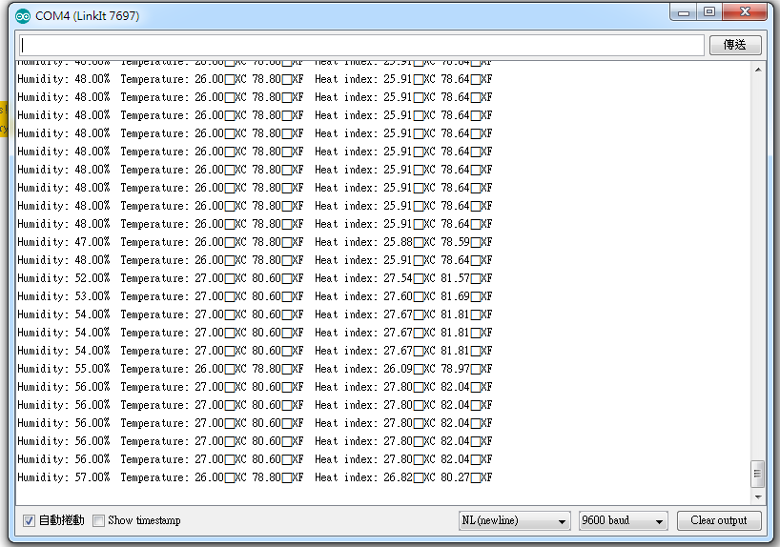

(2)
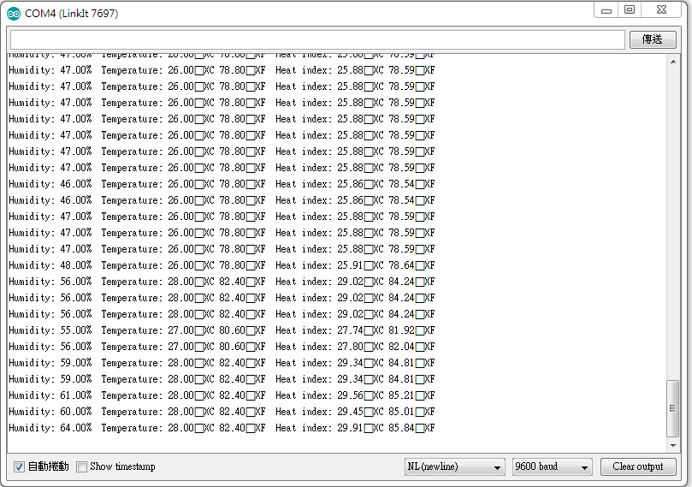
- 心得討論
今天這個實驗第一、第二小題還算簡單，第三小題比較難沒有做出來，不過
了解到透過Arduino平台連接溫濕度感測器來讀值，觀察周遭的溫濕度變
化。

