**電通二甲微處理器實驗 實驗結報**

|  |  |  |  |
| --- | --- | --- | --- |
| **實驗名稱** | **Arduino lab05** | | |
| **組別** | **電通二甲** | **組員** | **06050136陳庭薇** |

1. **實驗目的**

* **了解4*4鍵盤的公作原理**

1. **實驗步驟**

CHECK POINT 1

* 4*4鍵盤之按鍵值經由串列傳輸，顯示在PC上

CHECK POINT 2

* 4*4鍵盤之按鍵值顯示在七段顯示器上

1. **程式碼**

CHECK POINT 1

#include<Keypad.h>

const byte ROWS=4,COLS=4;

char keys[ROWS][COLS] = {{'7','8','9','C'},{'4','5','6','D'},{'1','2','3','E'},{'0','A','B','F'}};

byte rowPins[ROWS] = {8,9,10,11};

byte colPins[COLS] = {2,3,4,5};

Keypad keypad = Keypad(makeKeymap(keys),rowPins,colPins,ROWS,COLS);

void setup()

{

Serial.begin(9600);

}

void loop()

{

char key = keypad.getKey();

if(key!=NO_KEY)

{

Serial.println(key);

}

}

CHECK POINT 2

#include<Keypad.h>

#include "SevSeg.h"

const byte ROWS=4,COLS=4;

SevSeg sevseg;

char keys[ROWS][COLS] = {{'7','8','9','C'},{'4','5','6','D'},{'1','2','3','E'},{'0','A','B','F'}};

byte rowPins[ROWS] = {8,9,10,11};

byte colPins[COLS] = {2,3,4,5};

Keypad keypad = Keypad(makeKeymap(keys),rowPins,colPins,ROWS,COLS);

void setup()

{

byte numDigits = 1;

byte digitPins[] = {7};

byte segmentPins[] = {6,12,13,14,15,16,17};

sevseg.begin(COMMON_CATHODE,numDigits,digitPins,segmentPins);

Serial.begin(9600);

}

void loop()

{

char key = keypad.getKey();

if(key!=NO_KEY)

{

Serial.println(key);

if(key>='0' && key <='9')

sevseg.setNumber(key-'0',1);

}

sevseg.refreshDisplay();

}

1. **實驗結果及分析**

CHECK POINT **1**

**按下相對應的數值螢幕上就會顯示相對應的數**

CHECK POINT **2**

**按下相對應的數值，就會顯示結果在七段顯示器上**

1. **心得討論**

**這次的實驗比較有趣。但是接腳要對好尤其在畫電路圖要看得很仔細，一個接錯就要充新接一次，能做出實驗真的很有成就感。希望下次的考試可以很順利。**

1. **修正電路圖**

CHECK POINT 1

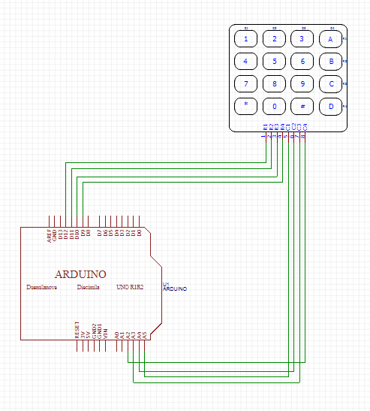

CHECK POINT 2

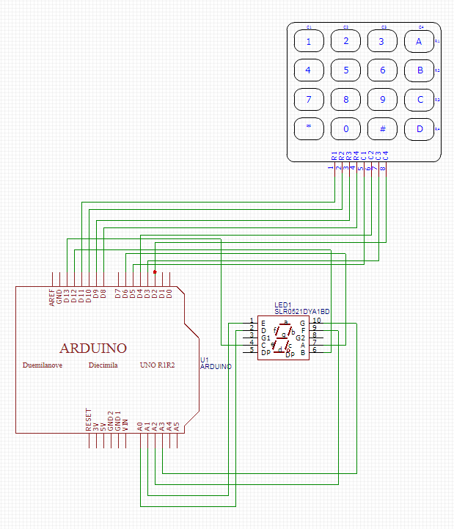**修正程式碼**

CHECK POINT 1

#include<Keypad.h>

const byte ROWS=4,COLS=4;

char keys[ROWS][COLS] = {{'7','8','9','C'},{'4','5','6','D'},{'1','2','3','E'},{'0','A','B','F'}};

byte rowPins[ROWS] = {8,9,10,11};

byte colPins[COLS] = {2,3,4,5};

Keypad keypad = Keypad(makeKeymap(keys),rowPins,colPins,ROWS,COLS);

void setup(){

Serial.begin(9600);

}

void loop(){

char key = keypad.getKey();

if(key!=NO_KEY){

Serial.println(key);

}

}

CHECK POINT 2

#include<Keypad.h>

#include "SevSeg.h"

const byte ROWS=4,COLS=4;

SevSeg sevseg;

char keys[ROWS][COLS] = {{'7','8','9','C'},{'4','5','6','D'},{'1','2','3','E'},{'0','A','B','F'}};

byte rowPins[ROWS] = {8,9,10,11};

byte colPins[COLS] = {2,3,4,5};

Keypad keypad = Keypad(makeKeymap(keys),rowPins,colPins,ROWS,COLS);

void setup(){

byte numDigits = 1;

byte digitPins[] = {7};

byte segmentPins[] = {6,12,13,14,15,16,17};

sevseg.begin(COMMON_CATHODE,numDigits,digitPins,segmentPins);

Serial.begin(9600);

}

void loop(){

char key = keypad.getKey();

if(key!=NO_KEY){

Serial.println(key);

if(key>='0' && key <='9')

sevseg.setNumber(key-'0',1);

}

sevseg.refreshDisplay();

}