電通二甲微處理器實驗 實驗結報

實驗名稱 | Arduino lab06
組別 | 電通二甲 | 組員 | 陳庭薇

- 實驗目的
- 了解利用 Arduino 發出特定旋律
- 了解Arduino 接喇叭如何接線
- 了解tone library
- 了解如何演奏一段音樂
- 使用 4x4 鍵盤演奏音樂
- 了解如何發報摩斯電碼

- 實驗步驟
CHECK POINT 1
Arduino 演奏一段特定的音樂
CHECK POINT 2
使用 4x4 鍵盤演奏音樂
CHECK POINT 3
發報摩斯電碼

- 程式碼
CHECK POINT 1
#define NOTE_C3 131
#define NOTE_CS3 139
#define NOTE_D3 147
#define NOTE_DS3 156
#define NOTE_E3 165
#define NOTE_F3 175
#define NOTE_FS3 185
#define NOTE_G3 196
#define NOTE_GS3 208
#define NOTE_A3 220
#define NOTE_AS3 233
#define NOTE_B3 247
#define NOTE_C4 262
#define NOTE_CS4 277
#define NOTE_D4 294
#define NOTE_DS4 311
#define NOTE_E4 330
#define NOTE_F4 349
#define NOTE_FS4 370
#define NOTE_G4 392
#define NOTE_GS4 415
#define NOTE_A4 440
#define NOTE_AS4 466
#define NOTE_B4 494
#define WHOLE 1 //全分符
#define HALF 0.5 //半分符
#define QUARTER 0.25
#define EIGHTH 0.125
#define SIXTEENTH 0.0625
#define pin 8
#define beat 500
void setup()
{
pinMode(8, OUTPUT);

}
void xx(int a,int b,int c)
{
tone(a,b,c);
delay(b);
noTone(c);
}
void loop()
{
xx(pin,NOTE_C4,beat);//1
xx(pin,NOTE_C4,beat);//1
xx(pin,NOTE_D4,beat);//2
xx(pin,NOTE_E4,beat);//3
xx(pin,NOTE_E4,beat);//3

xx(pin,NOTE_D4,beat);
xx(pin,NOTE_C4,beat);
xx(pin,NOTE_D4,beat);
xx(pin,NOTE_E4,beat);//3
xx(pin,NOTE_C4,beat);//1

xx(pin,NOTE_E4,beat);//3
xx(pin,NOTE_E4,beat);//3
xx(pin,NOTE_F4,beat);//4
xx(pin,NOTE_G4,beat);//5
xx(pin,NOTE_G4,beat);//5

xx(pin,NOTE_F4,beat);//4
xx(pin,NOTE_E4,beat);//3
xx(pin,NOTE_F4,beat);//4
xx(pin,NOTE_G4,beat);//5
xx(pin,NOTE_E4,beat);//3

xx(pin,NOTE_C4,beat*2);//1
xx(pin,NOTE_B4,beat);//7
xx(pin,NOTE_A4,beat);//6
xx(pin,NOTE_G4,beat);//5
xx(pin,NOTE_E4,beat);//3

xx(pin,NOTE_C4,beat*2);//1
xx(pin,NOTE_B4,beat);//7
xx(pin,NOTE_A4,beat);//6
xx(pin,NOTE_G4,beat);//5
xx(pin,NOTE_G4,beat);//5

xx(pin,NOTE_A4,beat);//6
xx(pin,NOTE_B4,beat);//7
xx(pin,NOTE_C4,beat*2);//1
xx(pin,NOTE_G4,beat);//5
xx(pin,NOTE_E4,beat);//3

xx(pin,NOTE_G4,beat);//5
xx(pin,NOTE_F4,beat);//4
xx(pin,NOTE_D4,beat);//2
xx(pin,NOTE_C4,beat);//1
xx(pin,NOTE_C4,beat);//1
}
CHECK POINT 2
#include <Keypad.h>
#define beat 500
#define pin 8
#define NOTE_C3 131
#define NOTE_CS3 139
#define NOTE_D3 147
#define NOTE_DS3 156
#define NOTE_E3 165
#define NOTE_F3 175
#define NOTE_FS3 185
#define NOTE_G3 196
#define NOTE_GS3 208
#define NOTE_A3 220
#define NOTE_AS3 233
#define NOTE_B3 247
#define NOTE_C4 262
#define NOTE_CS4 277
#define NOTE_D4 294
#define NOTE_DS4 311
#define NOTE_E4 330
#define NOTE_F4 349
#define NOTE_FS4 370
#define NOTE_G4 392
#define NOTE_GS4 415
#define NOTE_A4 440
#define NOTE_AS4 466
#define NOTE_B4 494
#define WHOLE 1 //全分符
#define HALF 0.5 //半分符
#define QUARTER 0.25
#define EIGHTH 0.125
#define SIXTEENTH 0.0625

const byte ROWS = 4, COLS = 4;

char keys[ROWS][COLS] = {{'7', '8', '9', 'C'}, {'4', '5', '6', 'D'}, {'1', '2', '3', 'E'}, {'0', 'A', 'B', 'F'}};

byte rowPins[ROWS] = {2, 3, 4, 5};
byte colPins[COLS] = {10 ,11, 12, 13};
Keypad keypad = Keypad(makeKeymap(keys), rowPins, colPins, ROWS, COLS);

void setup() {
pinMode(8, OUTPUT);
Serial.begin(9600);
}

void aa(int a, int b, int c) {
tone(a, b, c);
delay(c);
noTone(a);
}

void loop() {
char key = keypad.getKey();

if (key != NO_KEY)
{
if (key == '0')
{
aa(pin, NOTE_AS3, 500);
}

else if (key == '1')
{
aa(pin, NOTE_CS3, 500);
}

else if (key == '2')
{
aa(pin,NOTE_G4, 500);
}

else if (key == '3')
{
aa(pin, NOTE_DS3, 500);
}

else if (key == '4')
{
aa(pin, NOTE_E3, 500);
}

else if (key == '5')
{
aa(pin, NOTE_B4, 500);
}

else if (key == '6')
{
aa(pin, NOTE_FS3, 500);
}

else if (key == '7')
{
aa(pin, NOTE_G3, 500);
}

else if (key == '8')
{
aa(pin, NOTE_GS3, 500);
}

else if (key == '9')
{
aa(pin, NOTE_G4, 500);
}
}

}
CHECK POINT 3
char a=0;
void setup()
{
Serial.begin(9600);
}
void loop()
{
if(Serial.available()>0)
{
a=Serial.read();
Serial.println(a);
GetChar(a);
delay(300);
}
}
void x()
{
tone(8 ,440 ,150);
delay(300);
}
void y()
{
tone(8 ,440 ,500);
delay(300);
}
void GetChar(char tmpChar)
{
switch(tmpChar)
{
case'a':
x();
y();
break;
case'b':
y();
x();
x();
x();
break;
case'c':
y();
x();
y();
x();
break;
case'd':
y();
x();
x();
break;
case'e':
x();
break;
case'f':
x();
x();
y();
x();
break;
case'g':
y();
y();
x();
break;
case'h':
x();
x();
x();
x();
break;
case'i':
x();
x();
break;
case'j':
x();
y();
y();
y();
break;
case'k':
y();
x();
y();
break;
case'l':
x();
y();
x();
x();
break;
case'm':
y();
y();
break;
case'n':
y();
x();
break;
case'o':
y();
y();
y();
break;
case'p':
x();
y();
y();
x();
break;
case'q':
y();
y();
x();
y();
break;
case'r':
x();
y();
x();
break;
case's':
x();
x();
x();
break;
case't':
y();
break;
}
}
- 實驗結果及分析
利用Arduino裡的tone library或宣告不同聲音的相對數字來撰寫程式，在接上喇叭發出聲音。

- 心得討論
這次的實驗不是很難，但是也是蠻多的，要一個一個對照，看英文字母對應到的摩斯電碼是長音還是短音，又或者CHECK POINT 1的唱一首歌，要先找到歌譜，在一個一個找音，雖然有點麻煩，但蠻好玩的。

- 修正電路圖
CHECK POINT 1
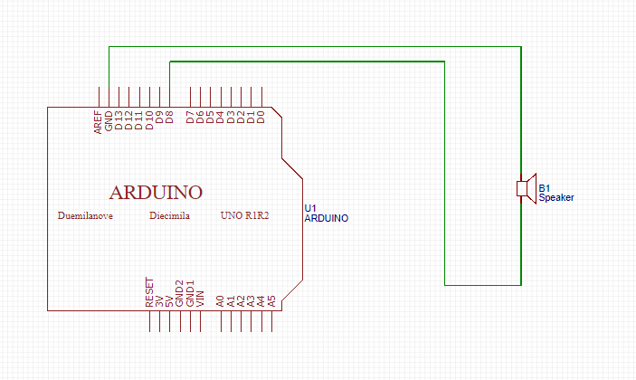
CHECK POINT 2
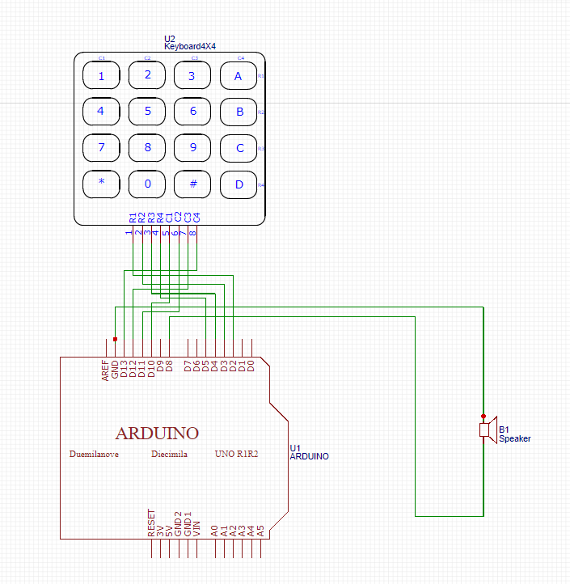
CHECK POINT 3
7. 修正程式碼
CHECK POINT 1
#define NOTE_C3 131
#define NOTE_CS3 139
#define NOTE_D3 147
#define NOTE_DS3 156
#define NOTE_E3 165
#define NOTE_F3 175
#define NOTE_FS3 185
#define NOTE_G3 196
#define NOTE_GS3 208
#define NOTE_A3 220
#define NOTE_AS3 233
#define NOTE_B3 247
#define NOTE_C4 262
#define NOTE_CS4 277
#define NOTE_D4 294
#define NOTE_DS4 311
#define NOTE_E4 330
#define NOTE_F4 349
#define NOTE_FS4 370
#define NOTE_G4 392
#define NOTE_GS4 415
#define NOTE_A4 440
#define NOTE_AS4 466
#define NOTE_B4 494
#define WHOLE 1 //全分符
#define HALF 0.5 //半分符
#define QUARTER 0.25
#define EIGHTH 0.125
#define SIXTEENTH 0.0625
#define pin 8
#define beat 500
void setup()
{
pinMode(8, OUTPUT);

}
void xx(int a,int b,int c)
{
tone(a,b,c);
delay(b);
noTone(c);
}
void loop()
{
xx(pin,NOTE_C4,beat);//1
xx(pin,NOTE_C4,beat);//1
xx(pin,NOTE_D4,beat);//2
xx(pin,NOTE_E4,beat);//3
xx(pin,NOTE_E4,beat);//3

xx(pin,NOTE_D4,beat);
xx(pin,NOTE_C4,beat);
xx(pin,NOTE_D4,beat);
xx(pin,NOTE_E4,beat);//3
xx(pin,NOTE_C4,beat);//1

xx(pin,NOTE_E4,beat);//3
xx(pin,NOTE_E4,beat);//3
xx(pin,NOTE_F4,beat);//4
xx(pin,NOTE_G4,beat);//5
xx(pin,NOTE_G4,beat);//5

xx(pin,NOTE_F4,beat);//4
xx(pin,NOTE_E4,beat);//3
xx(pin,NOTE_F4,beat);//4
xx(pin,NOTE_G4,beat);//5
xx(pin,NOTE_E4,beat);//3

xx(pin,NOTE_C4,beat*2);//1
xx(pin,NOTE_B4,beat);//7
xx(pin,NOTE_A4,beat);//6
xx(pin,NOTE_G4,beat);//5
xx(pin,NOTE_E4,beat);//3

xx(pin,NOTE_C4,beat*2);//1
xx(pin,NOTE_B4,beat);//7
xx(pin,NOTE_A4,beat);//6
xx(pin,NOTE_G4,beat);//5
xx(pin,NOTE_G4,beat);//5

xx(pin,NOTE_A4,beat);//6
xx(pin,NOTE_B4,beat);//7
xx(pin,NOTE_C4,beat*2);//1
xx(pin,NOTE_G4,beat);//5
xx(pin,NOTE_E4,beat);//3

xx(pin,NOTE_G4,beat);//5
xx(pin,NOTE_F4,beat);//4
xx(pin,NOTE_D4,beat);//2
xx(pin,NOTE_C4,beat);//1
xx(pin,NOTE_C4,beat);//1
}
CHECK POINT 2
#include <Keypad.h>
#define beat 500
#define pin 8
#define NOTE_C3 131
#define NOTE_CS3 139
#define NOTE_D3 147
#define NOTE_DS3 156
#define NOTE_E3 165
#define NOTE_F3 175
#define NOTE_FS3 185
#define NOTE_G3 196
#define NOTE_GS3 208
#define NOTE_A3 220
#define NOTE_AS3 233
#define NOTE_B3 247
#define NOTE_C4 262
#define NOTE_CS4 277
#define NOTE_D4 294
#define NOTE_DS4 311
#define NOTE_E4 330
#define NOTE_F4 349
#define NOTE_FS4 370
#define NOTE_G4 392
#define NOTE_GS4 415
#define NOTE_A4 440
#define NOTE_AS4 466
#define NOTE_B4 494
#define WHOLE 1 //全分符
#define HALF 0.5 //半分符
#define QUARTER 0.25
#define EIGHTH 0.125
#define SIXTEENTH 0.0625

const byte ROWS = 4, COLS = 4;

char keys[ROWS][COLS] = {{'7', '8', '9', 'C'}, {'4', '5', '6', 'D'}, {'1', '2', '3', 'E'}, {'0', 'A', 'B', 'F'}};

byte rowPins[ROWS] = {2, 3, 4, 5};
byte colPins[COLS] = {10 ,11, 12, 13};
Keypad keypad = Keypad(makeKeymap(keys), rowPins, colPins, ROWS, COLS);

void setup() {
pinMode(8, OUTPUT);
Serial.begin(9600);
}

void aa(int a, int b, int c) {
tone(a, b, c);
delay(c);
noTone(a);
}

void loop() {
char key = keypad.getKey();

if (key != NO_KEY)
{
if (key == '0')
{
aa(pin, NOTE_AS3, 500);
}

else if (key == '1')
{
aa(pin, NOTE_CS3, 500);
}

else if (key == '2')
{
aa(pin,NOTE_G4, 500);
}

else if (key == '3')
{
aa(pin, NOTE_DS3, 500);
}

else if (key == '4')
{
aa(pin, NOTE_E3, 500);
}

else if (key == '5')
{
aa(pin, NOTE_B4, 500);
}

else if (key == '6')
{
aa(pin, NOTE_FS3, 500);
}

else if (key == '7')
{
aa(pin, NOTE_G3, 500);
}

else if (key == '8')
{
aa(pin, NOTE_GS3, 500);
}

else if (key == '9')
{
aa(pin, NOTE_G4, 500);
}
}

}
CHECK POINT 3
char a=0;
void setup()
{
Serial.begin(9600);
}
void loop()
{
if(Serial.available()>0)
{
a=Serial.read();
Serial.println(a);
GetChar(a);
delay(300);
}
}
void x()
{
tone(8 ,440 ,150);
delay(300);
}
void y()
{
tone(8 ,440 ,500);
delay(300);
}
void GetChar(char tmpChar)
{
switch(tmpChar)
{
case'a':
x();
y();
break;
case'b':
y();
x();
x();
x();
break;
case'c':
y();
x();
y();
x();
break;
case'd':
y();
x();
x();
break;
case'e':
x();
break;
case'f':
x();
x();
y();
x();
break;
case'g':
y();
y();
x();
break;
case'h':
x();
x();
x();
x();
break;
case'i':
x();
x();
break;
case'j':
x();
y();
y();
y();
break;
case'k':
y();
x();
y();
break;
case'l':
x();
y();
x();
x();
break;
case'm':
y();
y();
break;
case'n':
y();
x();
break;
case'o':
y();
y();
y();
break;
case'p':
x();
y();
y();
x();
break;
case'q':
y();
y();
x();
y();
break;
case'r':
x();
y();
x();
break;
case's':
x();
x();
x();
break;
case't':
y();
break;
}
}

