電通二乙微處理器實驗 實驗結報

實驗名稱 | Lab01
組別 |  | 組員 | 陳柏融

- 實驗目的
使用tinkercad模擬Arduino UNO電路及程式 讓led發出SOS求救訊號
- 實驗步驟
使用tinkercad模擬Arduino UNO街上LED電路,修改程式,將LED輸出改為Pin 9 修改程式,使LED閃爍間格分別增加為2倍及1/2倍,重新量測並截圖
- 程式碼

void setup()
{
pinMode(9, OUTPUT);
}

void loop()
{
digitalWrite(9, HIGH);
delay(100); // Wait for 1000 millisecond(s)
digitalWrite(9, LOW);
delay(100); // Wait for 1000 millisecond(s)

digitalWrite(9, HIGH);
delay(100); // Wait for 1000 millisecond(s)
digitalWrite(9, LOW);
delay(100); // Wait for 1000 millisecond(s)

digitalWrite(9, HIGH);
delay(100); // Wait for 1000 millisecond(s)
digitalWrite(9, LOW);
delay(100); // Wait for 1000 millisecond(s)

digitalWrite(9, HIGH);
delay(300); // Wait for 1000 millisecond(s)
digitalWrite(9, LOW);
delay(100); // Wait for 1000 millisecond(s)

digitalWrite(9, HIGH);
delay(300); // Wait for 1000 millisecond(s)
digitalWrite(9, LOW);
delay(100); // Wait for 1000 millisecond(s)

digitalWrite(9, HIGH);
delay(300); // Wait for 1000 millisecond(s)
digitalWrite(9, LOW);
delay(100); // Wait for 1000 millisecond(s)

digitalWrite(9, HIGH);

delay(100); // Wait for 1000 millisecond(s)
digitalWrite(9, LOW);
delay(100); // Wait for 1000 millisecond(s)

digitalWrite(9, HIGH);
delay(100); // Wait for 1000 millisecond(s)
digitalWrite(9, LOW);
delay(100); // Wait for 1000 millisecond(s)

digitalWrite(9, HIGH);
delay(100); // Wait for 1000 millisecond(s)
digitalWrite(9, LOW);
delay(100); // Wait for 1000 millisecond(s)
}
- 實驗結果及分析
LED可以發出SOS訊號
- 心得討論
這次上課老是給我們用tinkercad模擬Arduino UNO電路及程式,裡面的網站都是英文,而且有些一年級的東西都忘了,所以每一步驟幾乎都問同學怎麼做,可是做出來以後很有成就感,非常好玩!
- 修正電路圖
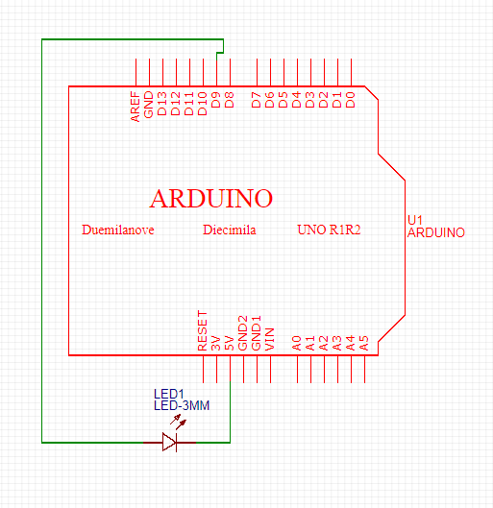
- 修正程式碼

