電通二甲微處理器實驗 實驗結報

實驗名稱 | Lab02
組別 |  | 組員

- 實驗目的
Linklt7697K1-D8分別接到LED，實作跑馬燈展示

- 實驗步驟
1.LED 向左及向右執行花色展示
2.執行自定花色展示: 所有LED亮滅兩次 -> 左移八次 -> 所有LED亮滅兩次 -> 右移八次
3.LinkIt 7697 接上一個開關
4. 開關 OFF -> LED 向左及向右執行花色展示 3. 開關 ON -> 執行自定花色展示

- 程式碼
CHECK POINT 1

const byte LEDs[] = {8,9,10,11,12,13,14,15};
const byte total = sizeof(LEDs);
byte index = 0;
int i;

void setup()
{
for (byte i=0;i<total;i++)
{
pinMode(LEDs[i], OUTPUT);
}
}
void loop()
{
for (i=0;i<8;i++)

{ digitalWrite(LEDs[i], HIGH);
delay(100);
digitalWrite(LEDs[i], LOW);

}
for (i=7;i>=0;i--)
{
digitalWrite(LEDs[i], HIGH);
delay(100);
digitalWrite(LEDs[i], LOW);

}

}

LAB02
const byte LEDs[] = {8,9,10,11,12,13,14,15};
const byte total = sizeof(LEDs);
byte index = 0;
int i;
void setup()
{

for (byte i=0;i<total;i++)
{
pinMode(LEDs[i], OUTPUT);
}
}

void loop()
{

for(byte i=0;i<8;i++)
{
digitalWrite( LEDs[i],HIGH);
}
delay(1000);
for(byte i=0;i<8;i++)
{
digitalWrite( LEDs[i],LOW);
}
delay(1000);
for(byte i=0;i<8;i++)
{
digitalWrite( LEDs[i],HIGH);
}
delay(1000);
for(byte i=0;i<8;i++)
{
digitalWrite( LEDs[i],LOW);
}
delay(1000);
for( i=0;i<8;i++)
{
digitalWrite( LEDs[i],HIGH);
delay(100);
digitalWrite( LEDs[i],LOW);
}
for (i=0;i<8;i++)
{
digitalWrite( LEDs[i],HIGH);
delay(100);
digitalWrite( LEDs[i],LOW);
}
for( i=0;i<8;i++)
{
digitalWrite( LEDs[i],HIGH);
delay(100);
digitalWrite( LEDs[i],LOW);
}
for( i=0;i<8;i++)
{
digitalWrite( LEDs[i],HIGH);
delay(100);
digitalWrite( LEDs[i],LOW);
}
for( i=0;i<8;i++)
{
digitalWrite( LEDs[i],HIGH);
delay(100);
digitalWrite( LEDs[i],LOW);
}
for( i=0;i<8;i++)
{
digitalWrite( LEDs[i],HIGH);
delay(100);
digitalWrite( LEDs[i],LOW);
}
for( i=0;i<8;i++)
{
digitalWrite( LEDs[i],HIGH);
delay(100);
digitalWrite( LEDs[i],LOW);
}
for( i=0;i<8;i++)
{
digitalWrite( LEDs[i],HIGH);
delay(100);
digitalWrite( LEDs[i],LOW);
}
for(byte i=0;i<8;i++)
{
digitalWrite( LEDs[i],HIGH);
}
delay(1000);
for(byte i=0;i<8;i++)
{
digitalWrite( LEDs[i],LOW);
}
delay(1000);
for(byte i=0;i<8;i++)
{
digitalWrite( LEDs[i],HIGH);
}
delay(1000);
for(byte i=0;i<8;i++)
{
digitalWrite( LEDs[i],LOW);
}
delay(1000);

for(i=7;i>=0;i--)
{
digitalWrite( LEDs[i],HIGH);
delay(100);
digitalWrite( LEDs[i],LOW);
}
for(i=7;i>=0;i--)
{
digitalWrite( LEDs[i],HIGH);
delay(100);
digitalWrite( LEDs[i],LOW);
}
for(i=7;i>=0;i--)
{
digitalWrite( LEDs[i],HIGH);
delay(100);
digitalWrite( LEDs[i],LOW);
}
for(i=7;i>=0;i--)
{
digitalWrite( LEDs[i],HIGH);
delay(100);
digitalWrite( LEDs[i],LOW);
}
for(i=7;i>=0;i--)
{
digitalWrite( LEDs[i],HIGH);
delay(100);
digitalWrite( LEDs[i],LOW);
}
for(i=7;i>=0;i--)
{
digitalWrite( LEDs[i],HIGH);
delay(100);
digitalWrite( LEDs[i],LOW);
}
for(i=7;i>=0;i--)
{
digitalWrite( LEDs[i],HIGH);
delay(100);
digitalWrite( LEDs[i],LOW);
}
for(i=7;i>=0;i--)
{
digitalWrite( LEDs[i],HIGH);
delay(100);
digitalWrite( LEDs[i],LOW);
}
delay(2000);
}

LAB03
const byte LEDs[] = {8, 9, 10, 11, 12, 13, 14, 15};
const byte total = sizeof(LEDs);
byte index = 0;
int i;
void setup()
{
pinMode(6, INPUT);
for (byte i = 0; i < total; i++)
{
pinMode(LEDs[i], OUTPUT);
}
}

void loop()
{
if (digitalRead(6))
{
for (i = 0; i < 8; i++)
{
digitalWrite(LEDs[i], HIGH);
delay(100);
digitalWrite(LEDs[i], LOW);

}
for (i = 7; i >= 0; i--)
{
digitalWrite(LEDs[i], HIGH);
delay(100);
digitalWrite(LEDs[i], LOW);

}
}
else
{
for (byte i = 0; i < 8; i++)
{
digitalWrite( LEDs[i], HIGH);
}
delay(1000);
for (byte i = 0; i < 8; i++)
{
digitalWrite( LEDs[i], LOW);
}
delay(1000);
for (byte i = 0; i < 8; i++)
{
digitalWrite( LEDs[i], HIGH);
}
delay(1000);
for (byte i = 0; i < 8; i++)
{
digitalWrite( LEDs[i], LOW);
}
delay(1000);
for ( i = 0; i < 8; i++)
{
digitalWrite( LEDs[i], HIGH);
delay(100);
digitalWrite( LEDs[i], LOW);
}
for (i = 0; i < 8; i++)
{
digitalWrite( LEDs[i], HIGH);
delay(100);
digitalWrite( LEDs[i], LOW);
}
for ( i = 0; i < 8; i++)
{
digitalWrite( LEDs[i], HIGH);
delay(100);
digitalWrite( LEDs[i], LOW);
}
for ( i = 0; i < 8; i++)
{
digitalWrite( LEDs[i], HIGH);
delay(100);
digitalWrite( LEDs[i], LOW);
}
for ( i = 0; i < 8; i++)
{
digitalWrite( LEDs[i], HIGH);
delay(100);
digitalWrite( LEDs[i], LOW);
}
for ( i = 0; i < 8; i++)
{
digitalWrite( LEDs[i], HIGH);
delay(100);
digitalWrite( LEDs[i], LOW);
}
for ( i = 0; i < 8; i++)
{
digitalWrite( LEDs[i], HIGH);
delay(100);
digitalWrite( LEDs[i], LOW);
}
for ( i = 0; i < 8; i++)
{
digitalWrite( LEDs[i], HIGH);
delay(100);
digitalWrite( LEDs[i], LOW);
}
for (byte i = 0; i < 8; i++)
{
digitalWrite( LEDs[i], HIGH);
}
delay(1000);
for (byte i = 0; i < 8; i++)
{
digitalWrite( LEDs[i], LOW);
}
delay(1000);
for (byte i = 0; i < 8; i++)
{
digitalWrite( LEDs[i], HIGH);
}
delay(1000);
for (byte i = 0; i < 8; i++)
{
digitalWrite( LEDs[i], LOW);
}
delay(1000);

for (i = 7; i >= 0; i--)
{
digitalWrite( LEDs[i], HIGH);
delay(100);
digitalWrite( LEDs[i], LOW);
}
for (i = 7; i >= 0; i--)
{
digitalWrite( LEDs[i], HIGH);
delay(100);
digitalWrite( LEDs[i], LOW);
}
for (i = 7; i >= 0; i--)
{
digitalWrite( LEDs[i], HIGH);
delay(100);
digitalWrite( LEDs[i], LOW);
}
for (i = 7; i >= 0; i--)
{
digitalWrite( LEDs[i], HIGH);
delay(100);
digitalWrite( LEDs[i], LOW);
}
for (i = 7; i >= 0; i--)
{
digitalWrite( LEDs[i], HIGH);
delay(100);
digitalWrite( LEDs[i], LOW);
}
for (i = 7; i >= 0; i--)
{
digitalWrite( LEDs[i], HIGH);
delay(100);
digitalWrite( LEDs[i], LOW);
}
for (i = 7; i >= 0; i--)
{
digitalWrite( LEDs[i], HIGH);
delay(100);
digitalWrite( LEDs[i], LOW);
}
for (i = 7; i >= 0; i--)
{
digitalWrite( LEDs[i], HIGH);
delay(100);
digitalWrite( LEDs[i], LOW);
}
delay(2000);
}
}

- 實驗結果及分析
第一個作業，燈泡會從左到又跑8次，再從右到左跑8次
第二個作業，全部燈泡會先閃兩次，再從左到右跑8次，然後在全不閃兩次，再從右到左跑8次
第三個作業，就是將兩個程式結合

- 心得討論
這次的作業真的是超級難的，做了兩個禮拜，一開始真的很不敢直接接電路板，因為很怕一接下去7697就燒掉了，不過還好後來稍微修改程式後就都完成啦，模擬器的跟接電路板的感覺真的很不一樣呢！

6.修正電路圖
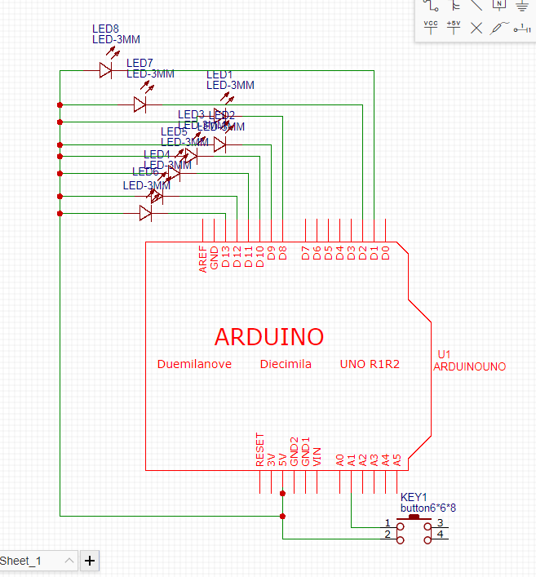
- 修正程式碼

