電通二甲微處理器實驗 實驗結報

實驗名稱 | LED-MCS
組別 |  | 組員 | 劉倢妤

- 實驗目的
了解MCS的功用
- 實驗步驟

- 建立Prototype
- 依照所需功能，新增Data channel，記下Data channel Id
- 建立Test device，記下DeviceId與DeviceKey
- 請新增 Integer顯示頻道，id “Temp”
- 一樣要建立 test device

- 程式碼
Lab01
#include <LWiFi.h>
#include <WiFiClient.h>
#include "MCS.h"

// Assign AP ssid / password here
#define _SSID "123"
#define _KEY "sherry880703"

// Assign device id / key of your test device
MCSDevice mcs("DqNIQCWj", "7TgYLs13EuM8mZrW");

// Assign channel id
// The test device should have 2 channel
// the first channel should be "Controller" - "On/Off"
// the secord channel should be "Display" - "On/Off"
MCSControllerOnOff led("123");
MCSDisplayOnOff remote("456");

#define LED_PIN 7

void setup() {
// setup Serial output at 9600
Serial.begin(9600);

// setup LED/Button pin
pinMode(LED_PIN, OUTPUT);

// setup Wifi connection
while(WL_CONNECTED != WiFi.status())
{
Serial.print("WiFi.begin(");
Serial.print(_SSID);
Serial.print(",");
Serial.print(_KEY);
Serial.println(")...");
WiFi.begin(_SSID, _KEY);
}
Serial.println("WiFi connected !!");

// setup MCS connection
mcs.addChannel(led);
mcs.addChannel(remote);
while(!mcs.connected())
{
Serial.println("MCS.connect()...");
mcs.connect();
}
Serial.println("MCS connected !!");

// read LED value from MCS server
while(!led.valid())
{
Serial.println("read LED value from MCS...");
led.value();
}
Serial.print("done, LED value = ");
Serial.println(led.value());
digitalWrite(LED_PIN, led.value() ? HIGH : LOW);
}

void loop() {
// call process() to allow background processing, add timeout to avoid high cpu usage
Serial.print("process(");
Serial.print(millis());
Serial.println(")");
mcs.process(100);

// updated flag will be cleared in process(), user must check it after process() call.
if(led.updated())
{
Serial.print("LED updated, new value = ");
Serial.println(led.value());
digitalWrite(LED_PIN, led.value() ? HIGH : LOW);
if(!remote.set(led.value()))
{
Serial.print("Failed to update remote");
Serial.println(remote.value());
}
}

// check if need to re-connect
while(!mcs.connected())
{
Serial.println("re-connect to MCS...");
mcs.connect();
if(mcs.connected())
Serial.println("MCS connected !!");
}
}

Lab02
#include <LWiFi.h>
#include <WiFiClient.h>
#include "MCS.h"

// Assign AP ssid / password here
#define _SSID "123"
#define _KEY "sherry880703"

// Assign device id / key of your test device
MCSDevice mcs("DenK0je1", "SbQsOEPVfGNbhkiX");

// Assign channel id
// The test device should have 2 channel
// the first channel should be "Controller" - "On/Off"
// the secord channel should be "Display" - "On/Off"
MCSControllerOnOff led("123");
MCSDisplayOnOff remote("456");
MCSDisplayInteger Temp("789");

#define LED_PIN 7

void setup() {
// setup Serial output at 9600
Serial.begin(9600);

// setup LED/Button pin
pinMode(LED_PIN, OUTPUT);
pinMode(A0,INPUT);

// setup Wifi connection
while(WL_CONNECTED != WiFi.status())
{
Serial.print("WiFi.begin(");
Serial.print(_SSID);
Serial.print(",");
Serial.print(_KEY);
Serial.println(")...");
WiFi.begin(_SSID, _KEY);
}
Serial.println("WiFi connected !!");

// setup MCS connection
mcs.addChannel(led);
mcs.addChannel(remote);
mcs.addChannel(Temp);

while(!mcs.connected())
{
Serial.println("MCS.connect()...");
mcs.connect();
}
Serial.println("MCS connected !!");

// read LED value from MCS server
while(!led.valid())
{
Serial.println("read LED value from MCS...");
led.value();
}
Serial.print("done, LED value = ");
Serial.println(led.value());
digitalWrite(LED_PIN, led.value() ? HIGH : LOW);
}

void loop() {
// call process() to allow background processing, add timeout to avoid high cpu usage
Serial.print("process(");
Serial.print(millis());
Serial.println(")");
mcs.process(100);
Temp.set(analogRead(A0));

// updated flag will be cleared in process(), user must check it after process() call.
if(led.updated())
{
Serial.print("LED updated, new value = ");
Serial.println(led.value());
digitalWrite(LED_PIN, led.value() ? HIGH : LOW);
if(!remote.set(led.value()))
{
Serial.print("Failed to update remote");
Serial.println(remote.value());
}
}

if(!Temp.set(analogRead(A0)))
{
Serial.print("Temp: ");
Serial.println(Temp.value());
}
// check if need to re-connect
while(!mcs.connected())
{
Serial.println("re-connect to MCS...");
mcs.connect();
if(mcs.connected())
Serial.println("MCS connected !!");
}
}
- 實驗結果及分析
MCS可顯示電阻值
- 心得討論
這次的實驗也簡單的，只是在傳電阻值的時候會卡卡的
- 修正電路圖

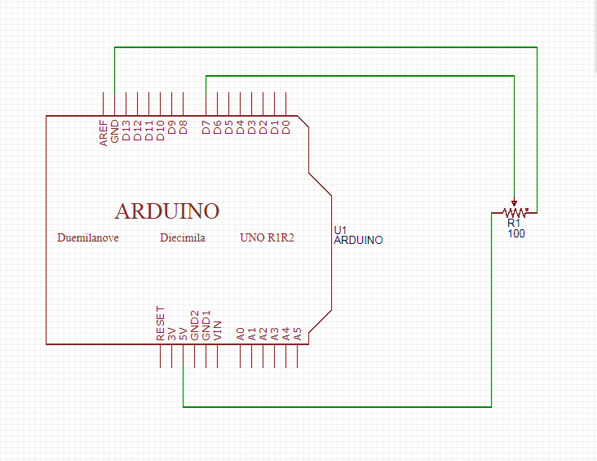
- 修正程式碼

