電通二甲微處理器實驗 實驗結報

實驗名稱 | 第二次
組別 | 無 | 組員 | 曾箴

- 實驗目的
LinkIt 7697 D1 – D8 分別接到 LED，實作跑馬燈展示。
- 實驗步驟
- LED 向左及向右執行花色展示 2. 執行自定花色展示: 所有LED亮滅兩次 -> 左移八次 -> 所有LED亮滅兩次 -> 右移八次
- . LinkIt 7697 接上一個開關 2. 開關 OFF -> LED 向左及向右執行花色展 示 3. 開關 ON -> 執行自定花色展示
- 程式碼
CHECK POINT 1

const byte LEDs[] = {4,5,8,9,10,11,12,13};
const byte total = sizeof(LEDs);
byte index = 0;
int i;

void setup()
{
for (byte i=0;i<total;i++)
{
pinMode(LEDs[i], OUTPUT);
}
}
void loop()
{
for (i=0;i<8;i++)
{
digitalWrite(LEDs[i], HIGH);
delay(100);
digitalWrite(LEDs[i], LOW);

}
for (i=7;i>=0;i--)
{
digitalWrite(LEDs[i], HIGH);
delay(100);
digitalWrite(LEDs[i], LOW);

}

}

CHECK POINT 1

const byte LEDs[] = {13,12,10,8,7,5,3,2};
const byte total = sizeof(LEDs);
byte index = 0;
int i;
void setup()
{

for (byte i=0;i<total;i++)
{
pinMode(LEDs[i], OUTPUT);
}
}

void loop()
{

for(byte i=0;i<8;i++)
{
digitalWrite( LEDs[i],HIGH);
}
delay(1000);
for(byte i=0;i<8;i++)
{
digitalWrite( LEDs[i],LOW);
}
delay(1000);
for(byte i=0;i<8;i++)
{
digitalWrite( LEDs[i],HIGH);
}
delay(1000);
for(byte i=0;i<8;i++)
{
digitalWrite( LEDs[i],LOW);
}
delay(1000);
for( i=0;i<8;i++)
{
digitalWrite( LEDs[i],HIGH);
delay(100);
digitalWrite( LEDs[i],LOW);
}
for (i=0;i<8;i++)
{
digitalWrite( LEDs[i],HIGH);
delay(100);
digitalWrite( LEDs[i],LOW);
}
for( i=0;i<8;i++)
{
digitalWrite( LEDs[i],HIGH);
delay(100);
digitalWrite( LEDs[i],LOW);
}
for( i=0;i<8;i++)
{
digitalWrite( LEDs[i],HIGH);
delay(100);
digitalWrite( LEDs[i],LOW);
}
for( i=0;i<8;i++)
{
digitalWrite( LEDs[i],HIGH);
delay(100);
digitalWrite( LEDs[i],LOW);
}
for( i=0;i<8;i++)
{
digitalWrite( LEDs[i],HIGH);
delay(100);
digitalWrite( LEDs[i],LOW);
}
for( i=0;i<8;i++)
{
digitalWrite( LEDs[i],HIGH);
delay(100);
digitalWrite( LEDs[i],LOW);
}
for( i=0;i<8;i++)
{
digitalWrite( LEDs[i],HIGH);
delay(100);
digitalWrite( LEDs[i],LOW);
}
for(byte i=0;i<8;i++)
{
digitalWrite( LEDs[i],HIGH);
}
delay(1000);
for(byte i=0;i<8;i++)
{
digitalWrite( LEDs[i],LOW);
}
delay(1000);
for(byte i=0;i<8;i++)
{
digitalWrite( LEDs[i],HIGH);
}
delay(1000);
for(byte i=0;i<8;i++)
{
digitalWrite( LEDs[i],LOW);
}
delay(1000);

for(i=7;i>=0;i--)
{
digitalWrite( LEDs[i],HIGH);
delay(100);
digitalWrite( LEDs[i],LOW);
}
for(i=7;i>=0;i--)
{
digitalWrite( LEDs[i],HIGH);
delay(100);
digitalWrite( LEDs[i],LOW);
}
for(i=7;i>=0;i--)
{
digitalWrite( LEDs[i],HIGH);
delay(100);
digitalWrite( LEDs[i],LOW);
}
for(i=7;i>=0;i--)
{
digitalWrite( LEDs[i],HIGH);
delay(100);
digitalWrite( LEDs[i],LOW);
}
for(i=7;i>=0;i--)
{
digitalWrite( LEDs[i],HIGH);
delay(100);
digitalWrite( LEDs[i],LOW);
}
for(i=7;i>=0;i--)
{
digitalWrite( LEDs[i],HIGH);
delay(100);
digitalWrite( LEDs[i],LOW);
}
for(i=7;i>=0;i--)
{
digitalWrite( LEDs[i],HIGH);
delay(100);
digitalWrite( LEDs[i],LOW);
}
for(i=7;i>=0;i--)
{
digitalWrite( LEDs[i],HIGH);
delay(100);
digitalWrite( LEDs[i],LOW);
}
delay(2000);
}
CHECK POINT 3

const byte leds[]={4,5,8,9,10,11,12,13};
const byte NUM=sizeof(leds);
int i;
int count;
int t;
void setup()
{
for(int i=0;i<NUM;i++)
{
pinMode(leds[i],OUTPUT);

}
pinMode(6,INPUT);
}

void loop()
{
t = digitalRead(6);
if( t== HIGH)
{
for(i=0;i<NUM;i++)
{
digitalWrite(leds[i],HIGH);
delay(100);
digitalWrite(leds[i],LOW);
}
for(i=NUM-1;i>=0;i--)
{
digitalWrite(leds[i],HIGH);
delay(100);
digitalWrite(leds[i],LOW);
}

}
else
{
for(i=0;i<2;i++)
{
digitalWrite(4,HIGH);
digitalWrite(5,HIGH);
digitalWrite(8,HIGH);
digitalWrite(9,HIGH);
digitalWrite(10,HIGH);
digitalWrite(11,HIGH);
digitalWrite(12,HIGH);
digitalWrite(13,HIGH);
delay(400);
digitalWrite(4,LOW);
digitalWrite(5,LOW);
digitalWrite(8,LOW);
digitalWrite(9,LOW);
digitalWrite(10,LOW);
digitalWrite(11,LOW);
digitalWrite(12,LOW);
digitalWrite(13,LOW);
delay(400);
}
}
}
- 實驗結果及分析
- 心得討論

做完感覺好難
- 修正電路圖

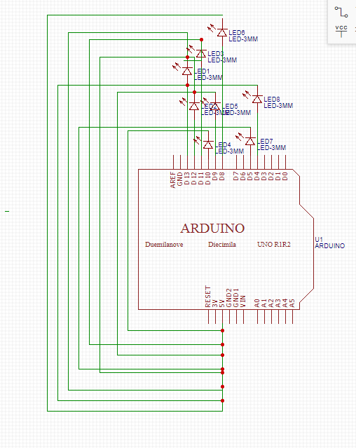
- 修正程式碼

