電通二甲微處理器實驗 實驗結報

實驗名稱
組別 |  | 組員 | 曾箴

- 實驗目的
使用Tinkercad 模擬Arduino UNO 電路及程式
繪製電路圖
觀察Arduino UNO 之輸出
學習程式碼及實驗報告上傳至Github
- 實驗步驟
啟動Arduino IDE 載入BLINK程式碼Arduino模擬器
接上led電路
修改程式將led輸出改為pin9
觀察led之閃爍間隔
修改程式,使led閃爍間格分別增加為2倍,及1/2倍,重新量測並截圖
畫出電路圖
- 程式碼
void setup()
{
pinMode(9, OUTPUT);
}

void loop()
{
digitalWrite(9, HIGH);
delay(1000); // Wait for 1000 millisecond(s)
digitalWrite(9, LOW);
delay(1000); // Wait for 1000 millisecond(s)
}
- 實驗結果及分析
燈泡會如預測的一樣閃爍
- 心得討論
第一次使用難免有些不熟,但是是一個蠻新奇的程式
- 修改程式碼
- void setup()
- {
- pinMode(9, OUTPUT);
- }

- void loop()
- {
- digitalWrite(9, HIGH);
- delay(100); // Wait for 1000 millisecond(s)
- digitalWrite(9, LOW);
- delay(100); // Wait for 1000 millisecond(s)
- digitalWrite(9, HIGH);
- delay(100); // Wait for 1000 millisecond(s)
- digitalWrite(9, LOW);
- delay(100); // Wait for 1000 millisecond(s)
- digitalWrite(9, HIGH);
- delay(100); // Wait for 1000 millisecond(s)
- digitalWrite(9, LOW);
- delay(100); // Wait for 1000 millisecond(s)
- digitalWrite(9, HIGH);
- delay(300); // Wait for 1000 millisecond(s)
- digitalWrite(9, LOW);
- delay(100); // Wait for 1000 millisecond(s)
- digitalWrite(9, HIGH);
- delay(300); // Wait for 1000 millisecond(s)
- digitalWrite(9, LOW);
- delay(100); // Wait for 1000 millisecond(s)
- digitalWrite(9, HIGH);
- delay(300); // Wait for 1000 millisecond(s)
- digitalWrite(9, LOW);
- delay(100); // Wait for 1000 millisecond(s)
- digitalWrite(9, HIGH);
- delay(100); // Wait for 1000 millisecond(s)
- digitalWrite(9, LOW);
- delay(100); // Wait for 1000 millisecond(s)
- digitalWrite(9, HIGH);
- delay(100); // Wait for 1000 millisecond(s)
- digitalWrite(9, LOW);
- delay(100); // Wait for 1000 millisecond(s)
- digitalWrite(9, HIGH);
- delay(100); // Wait for 1000 millisecond(s)
- digitalWrite(9, LOW);
- delay(100); // Wait for 1000 millisecond(s)
- digitalWrite(9, LOW);
- delay(300); // Wait for 1000 millisecond(s)
- }

- 修正電路圖
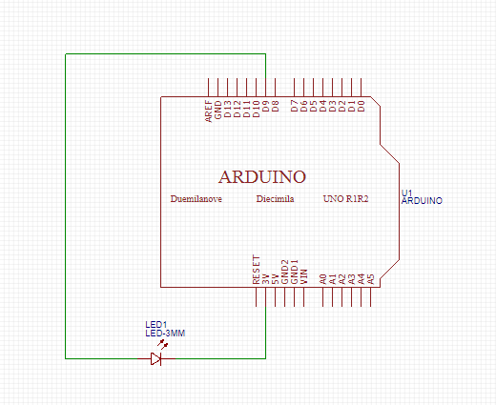
- 修正程式碼

