電通二乙微處理器實驗 實驗結報

實驗名稱 | Lab06
組別 |  | 組員 | 林楷桓

- 實驗目的
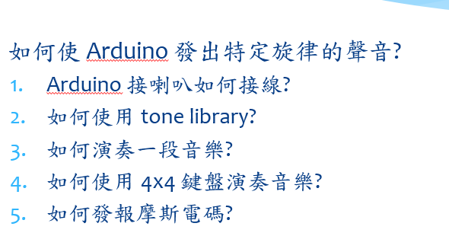
- 實驗步驟
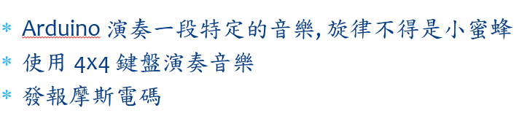
- 程式碼
01:
#define beat 500
#define pin 8
#define NOTE_C3 131
#define NOTE_CS3 139
#define NOTE_D3 147
#define NOTE_DS3 156
#define NOTE_E3 165
#define NOTE_F3 175
#define NOTE_FS3 185
#define NOTE_G3 196
#define NOTE_GS3 208
#define NOTE_A3 220
#define NOTE_AS3 233
#define NOTE_B3 247
#define NOTE_C4 262
#define NOTE_CS4 277
#define NOTE_D4 294
#define NOTE_DS4 311
#define NOTE_E4 330
#define NOTE_F4 349
#define NOTE_FS4 370
#define NOTE_G4 392
#define NOTE_GS4 415
#define NOTE_A4 440
#define NOTE_AS4 466
#define NOTE_B4 494
#define WHOLE 1 //全分符
#define HALF 0.5 //半分符
#define QUARTER 0.25
#define EIGHTH 0.125
#define SIXTEENTH 0.0625

void setup()
{
pinMode(8,OUTPUT);
}
void aa(int a,int b, int c)
{
tone(a,b,c);
delay(c);
noTone(a);
}

void loop()
{
aa(pin,NOTE_G3,beat);
aa(pin,NOTE_A3,beat);
aa(pin,NOTE_G3,beat);
aa(pin,NOTE_F3,beat);

aa(pin,NOTE_E3,beat);
aa(pin,NOTE_F3,beat);
aa(pin,NOTE_G3,beat);
delay(100);
aa(pin,NOTE_D3,beat);
aa(pin,NOTE_E3,beat);
aa(pin,NOTE_F3,beat);
delay(10);
aa(pin,NOTE_E3,beat);
aa(pin,NOTE_F3,beat);
aa(pin,NOTE_G3,beat);
delay(50);

aa(pin,NOTE_G3,beat);
aa(pin,NOTE_A3,beat);
aa(pin,NOTE_G3,beat);
aa(pin,NOTE_F3,beat);

aa(pin,NOTE_E3,beat);
aa(pin,NOTE_F3,beat);
aa(pin,NOTE_G3,beat);
delay(100);
aa(pin,NOTE_E3,beat);
aa(pin,NOTE_G3,beat);
delay(10);
aa(pin,NOTE_E3,beat);
aa(pin,NOTE_E3,beat);
aa(pin,NOTE_C3,beat);
delay(30);
}
03: char *morse[]={"01","1000","1010","100",
"0","0010","110","0000",
"00","0111","101","0100",
"11","10","111","0110",
"1101","010","000","1",
"001","0001","11","1001",
"1011","1100"};
const byte Buzzer =10;
char chr,index;
char *ptr;

void setup()
{
pinMode(Buzzer,OUTPUT);
Serial.begin(9600);
}

void loop()
{
if(Serial.available())
{
chr=Serial.read();
Serial.println(chr);
if((chr-'A')>=0 && (chr-'Z')<=0)
{
index=chr-'A';
ptr=morse[index];

while(*ptr!='\0')
{
if(*ptr=='0')
{
tone(Buzzer,440,100);
delay(100);
}
else
{
tone(Buzzer,440,300);
delay(300);
}
ptr++;
delay(100);
}
}
delay (300);
}
}
- 實驗結果及分析
01:
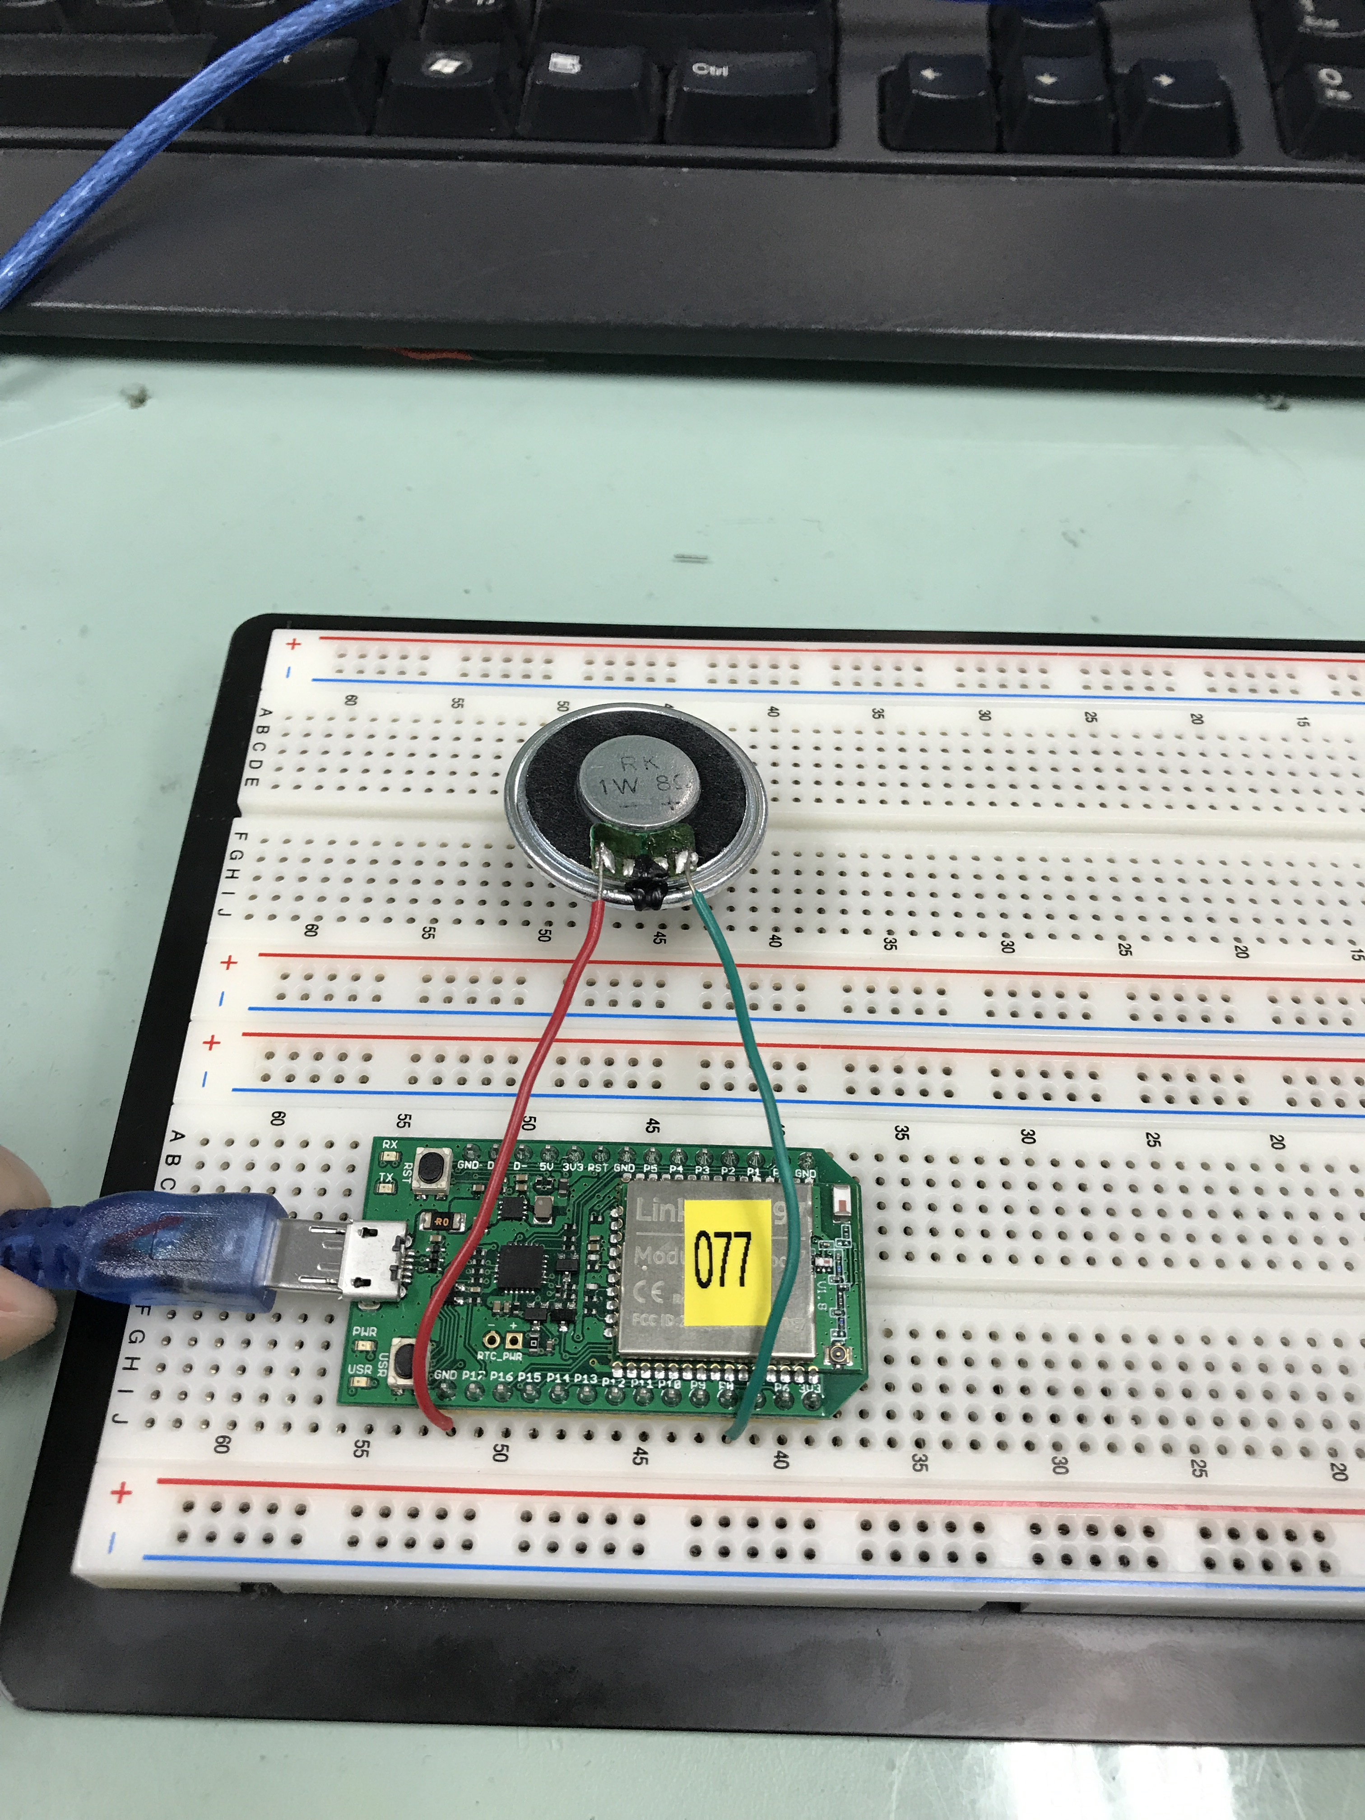
- 心得討論
- 修正電路圖
- 修正程式碼

