電通二甲微處理器實驗 實驗結報

實驗名稱 | Lab04-06053033
組別 |  | 組員 | 丁瑜楷

- 實驗目的
了解七段顯示器的原理
共陰極與共陽極七段顯示器的不同
如何讓7段顯示器顯示 0-F
如何控制四合一7段顯示器
如何讓四合一7段顯示器顯示四位數字
- 實驗步驟
將Arduino與7段顯示器連接後,寫入題目所需之程式。
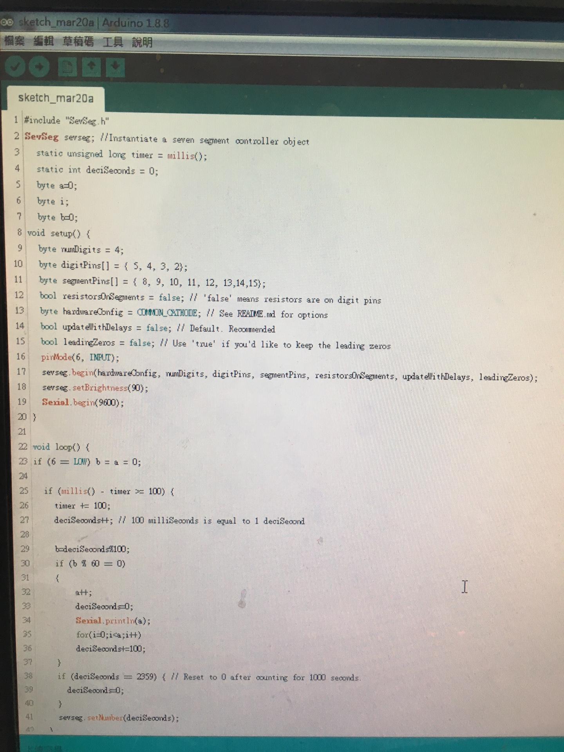

- 程式碼
1.

#include "SevSeg.h"
SevSeg sevseg; //Instantiate a seven segment controller object
static unsigned long timer = millis();
static int deciSeconds = 0;
byte a=0;
byte i;
byte b=0;
void setup() {
byte numDigits = 4;
byte digitPins[] = {5,4,3,2};
byte segmentPins[] = { 8, 9, 10, 11, 12, 13,14,15};
bool resistorsOnSegments = false; // 'false' means resistors are on digit pins
byte hardwareConfig = COMMON_CATHODE; // See README.md for options
bool updateWithDelays = false; // Default. Recommended
bool leadingZeros = false; // Use 'true' if you'd like to keep the leading zeros
pinMode(6, INPUT);
sevseg.begin(hardwareConfig, numDigits, digitPins, segmentPins, resistorsOnSegments, updateWithDelays, leadingZeros);
sevseg.setBrightness(90);
Serial.begin(9600);
}

void loop() {
if (millis() - timer >= 100) {
timer += 100;
deciSeconds++; // 100 milliSeconds is equal to 1 deciSecond

b=deciSeconds%100;
if (b % 60 == 0)
{
a++;
deciSeconds=0;
Serial.println(a);
for(i=0;i<a;i++)
deciSeconds+=100;
}
if (deciSeconds == 2359) { // Reset to 0 after counting for 1000 seconds.
deciSeconds=0;
}
sevseg.setNumber(deciSeconds);
}

sevseg.refreshDisplay(); // Must run repeatedly
}

2.
#include "SevSeg.h"
SevSeg sevseg; //Instantiate a seven segment controller object
static unsigned long timer = millis();
static int deciSeconds = 0;
byte a=0;
byte i;
byte b=0;
void setup() {
byte numDigits = 4;
byte digitPins[] = {5,4,3,2};
byte segmentPins[] = { 8, 9, 10, 11, 12, 13,14,15};
bool resistorsOnSegments = false; // 'false' means resistors are on digit pins
byte hardwareConfig = COMMON_CATHODE; // See README.md for options
bool updateWithDelays = false; // Default. Recommended
bool leadingZeros = false; // Use 'true' if you'd like to keep the leading zeros
pinMode(6, INPUT);
sevseg.begin(hardwareConfig, numDigits, digitPins, segmentPins, resistorsOnSegments, updateWithDelays, leadingZeros);
sevseg.setBrightness(90);
Serial.begin(9600);
}

void loop() {
if (6 == LOW) b = a = 0;

if (millis() - timer >= 100) {
timer += 100;
deciSeconds++; // 100 milliSeconds is equal to 1 deciSecond

b=deciSeconds%100;
if (b % 60 == 0)
{
a++;
deciSeconds=0;
Serial.println(a);
for(i=0;i<a;i++)
deciSeconds+=100;
}
if (deciSeconds == 2359) { // Reset to 0 after counting for 1000 seconds.
deciSeconds=0;
}
sevseg.setNumber(deciSeconds);
}

sevseg.refreshDisplay(); // Must run repeatedly
}

/// END ///

3.
#include "SevSeg.h"
SevSeg sevseg;

void setup() {
byte num2[]={14,13,12,11};
// 千 百 十 個
// byte pin[]={15,10,9,8,5,4,3,2};
byte pin[]={2,3,4,5,8,9,10,15};
// a,b,c,d,e,f,g,h

sevseg.begin(COMMON_CATHODE,4,num2,pin,false,false,false);
sevseg.setBrightness(90);
pinMode(6,INPUT);
pinMode(7,INPUT);
}

void loop() {
static int Min=0,Hour=0;
static unsigned long timer = millis();
int sum=0;

/*if(digitalRead(6))
{
Min=0;
Hour=0;
}*/

if(digitalRead(6))//另一腳位接按鈕倒數計時
{

if(millis()-timer>100)
{
timer+=100;
sevseg.setNumber(Hour*100+Min,2);
if(--Min<=0)
{
Min=59;
if(--Hour<=0)
Hour=23;
}
}
sevseg.refreshDisplay();
}

else
{
if(millis()-timer>100) //delay(300)
{
timer+=100;
sevseg.setNumber(Hour*100+Min,2);
if(++Min>=60)
{
Min=0;
if(++Hour>=24)
Hour=0;
}

}
sevseg.refreshDisplay();
}
}

- 實驗結果及分析
- 2.
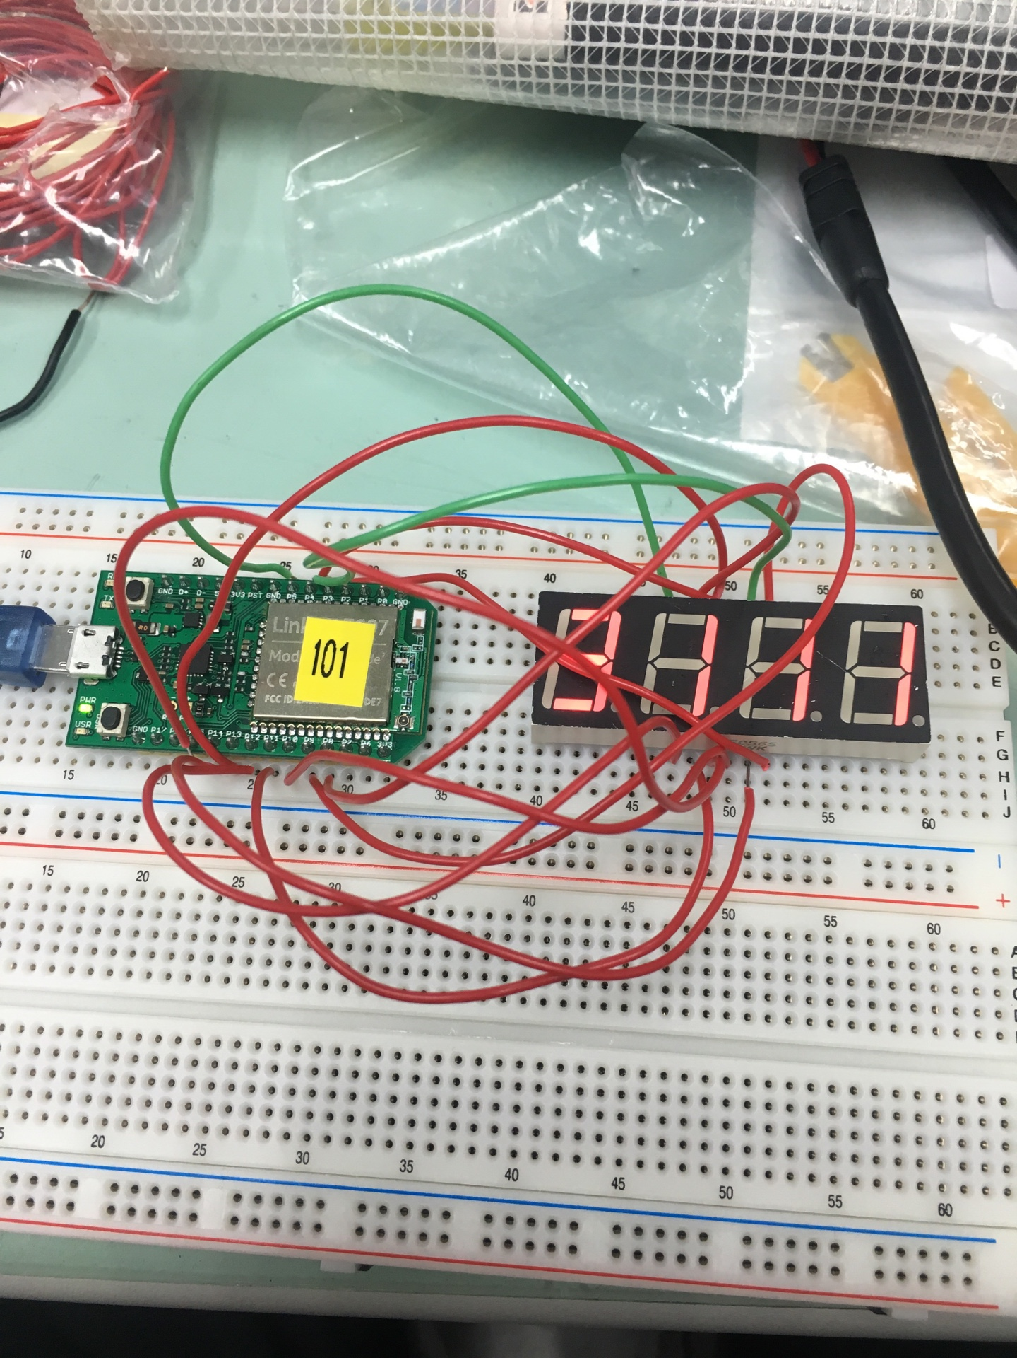
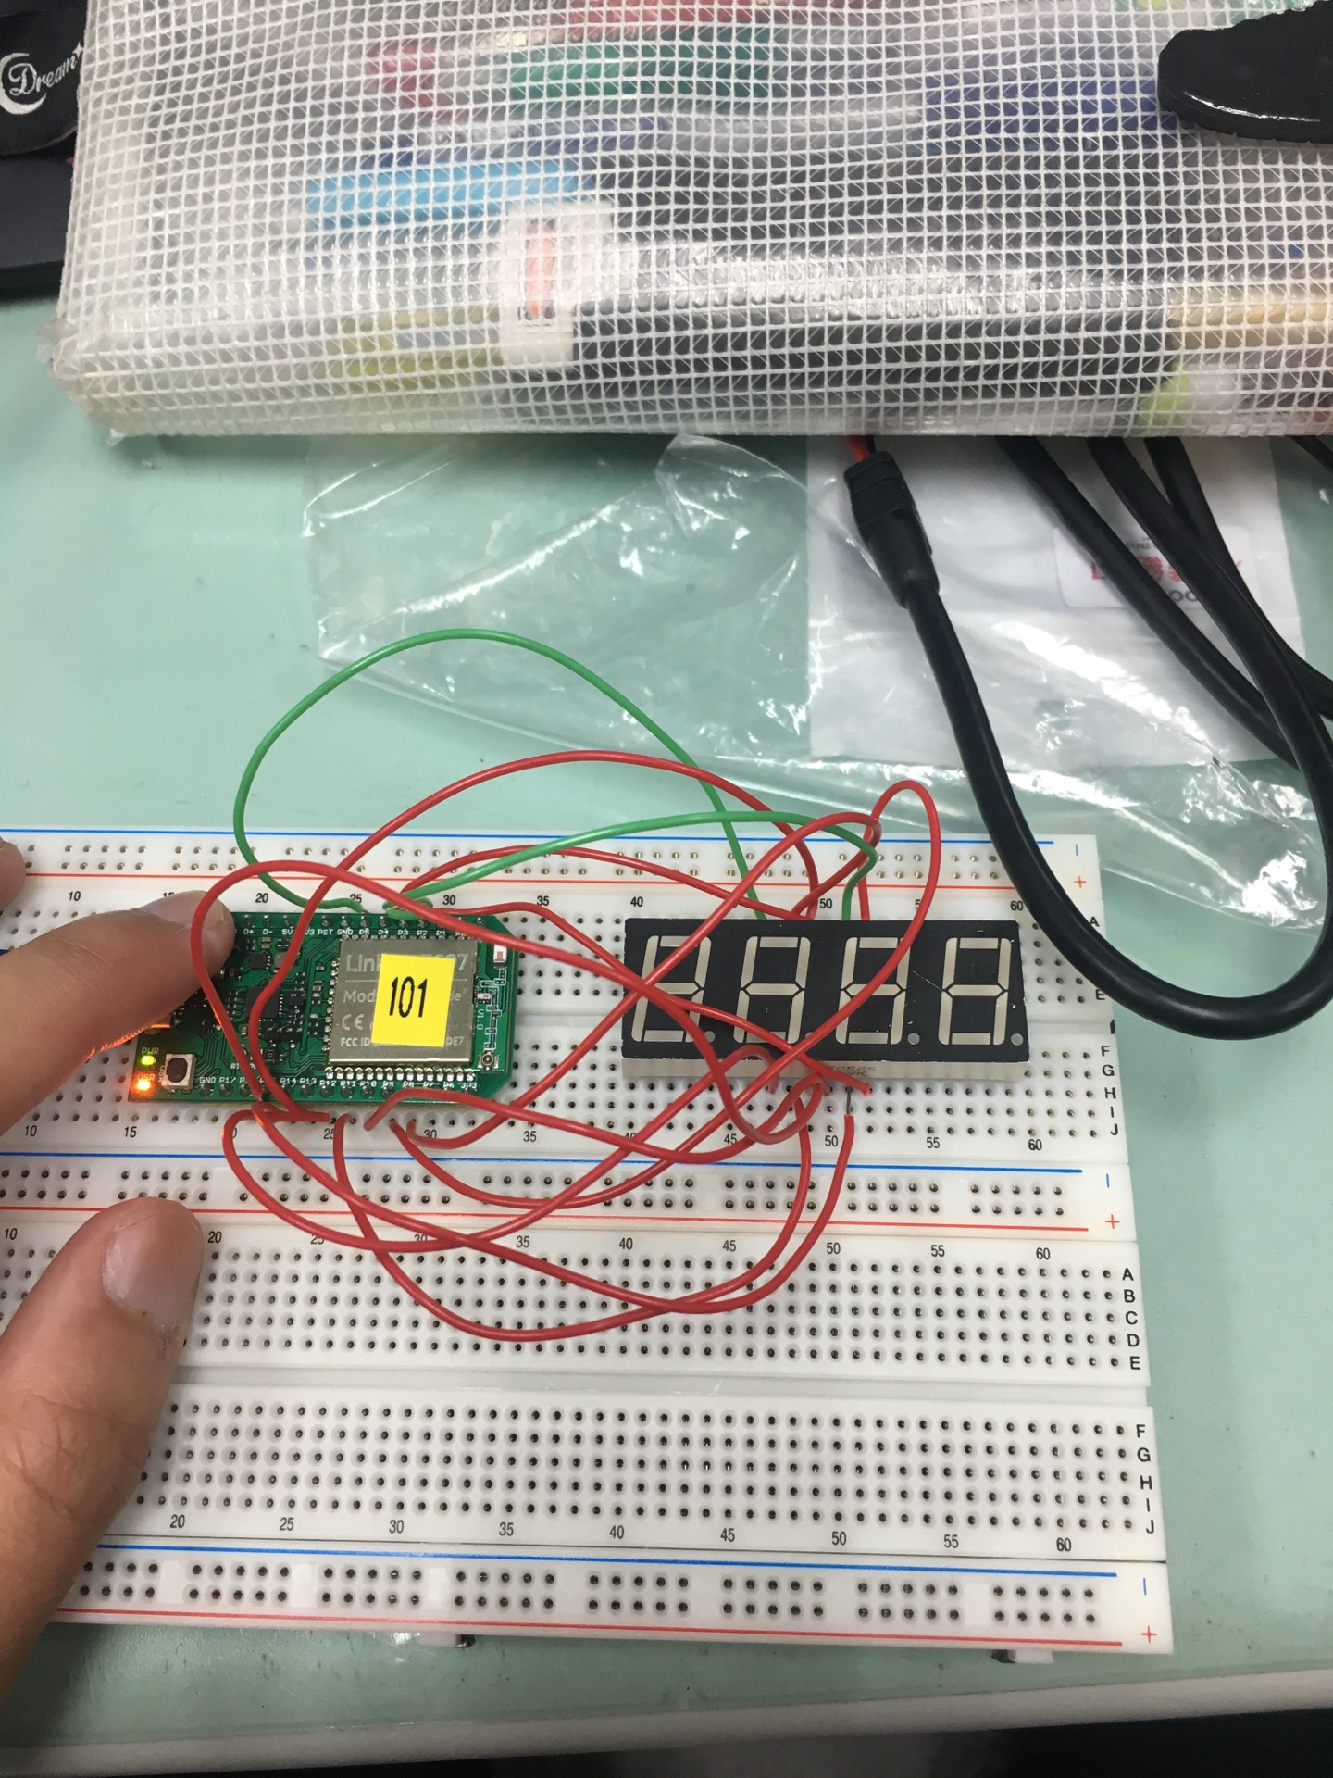
- 心得討論
這次的實驗在接線方面比較複雜,需要比較多耐心以及專注,也學到了4位數7段顯示器的用法。

