電通二甲微處理器實驗 實驗結報

實驗名稱 | Labn11-MCS Cloud
組別 |  | 組員 | 06053033 丁瑜楷

- 實驗目的
(1)透過MCS REST API進行溝通
(2)LinkIt 家族開發板、手機、瀏覽器
- 實驗步驟
(1)建立Prototype
(2)依照所需功能，新增Data channel，記下Data channel Id
(3)建立Test device，記下DeviceId與DeviceKey

- 程式碼
#1
#include <LWiFi.h>

#include <WiFiClient.h>

#include "MCS.h"

// Assign AP ssid / password here

#define _SSID "001"

#define _KEY "00000000"

// Assign device id / key of your test device

MCSDevice mcs("DeuQ1VHM", "AMk0qaauln9pZjQW");

// Assign channel id

// The test device should have 2 channel

// the first channel should be "Controller" - "On/Off"

// the secord channel should be "Display" - "On/Off"

MCSControllerOnOff led("01");

MCSDisplayOnOff remote("02");

#define LED_PIN 7

void setup() {

// setup Serial output at 9600

Serial.begin(9600);

// setup LED/Button pin

pinMode(LED_PIN, OUTPUT);

// setup Wifi connection

while(WL_CONNECTED != WiFi.status())

{

Serial.print("WiFi.begin(");

Serial.print(_SSID);

Serial.print(",");

Serial.print(_KEY);

Serial.println(")...");

WiFi.begin(_SSID, _KEY);

}

Serial.println("WiFi connected !!");

// setup MCS connection

mcs.addChannel(led);

mcs.addChannel(remote);

while(!mcs.connected())

{

Serial.println("MCS.connect()...");

mcs.connect();

}

Serial.println("MCS connected !!");

// read LED value from MCS server

while(!led.valid())

{

Serial.println("read LED value from MCS...");

led.value();

}

Serial.print("done, LED value = ");

Serial.println(led.value());

digitalWrite(LED_PIN, led.value() ? HIGH : LOW);

}

void loop() {

// call process() to allow background processing, add timeout to avoid high cpu usage

Serial.print("process(");

Serial.print(millis());

Serial.println(")");

mcs.process(100);

// updated flag will be cleared in process(), user must check it after process() call.

if(led.updated())

{

Serial.print("LED updated, new value = ");

Serial.println(led.value());

digitalWrite(LED_PIN, led.value() ? HIGH : LOW);

if(!remote.set(led.value()))

{

Serial.print("Failed to update remote");

Serial.println(remote.value());

}

}

// check if need to re-connect

while(!mcs.connected())

{

Serial.println("re-connect to MCS...");

mcs.connect();

if(mcs.connected())

Serial.println("MCS connected !!");

}

}
#2
#include "MCS.h"

// Assign AP ssid / password here

#define _SSID "001"

#define _KEY "00000000"

// Assign device id / key of your test device

MCSDevice mcs("D5m2K7Ix", "7ZzEjOWSEfBcoLsy");

// Assign channel id

// The test device should have 2 channel

// the first channel should be "Controller" - "On/Off"

// the secord channel should be "Display" - "On/Off"

MCSControllerOnOff led("01");

MCSDisplayOnOff remote("02");

MCSDisplayInteger Temp("03");

#define LED_PIN 7

void setup() {

// setup Serial output at 9600

Serial.begin(9600);

// setup LED/Button pin

pinMode(LED_PIN, OUTPUT);

// setup Wifi connection

while(WL_CONNECTED != WiFi.status())

{

Serial.print("WiFi.begin(");

Serial.print(_SSID);

Serial.print(",");

Serial.print(_KEY);

Serial.println(")...");

WiFi.begin(_SSID, _KEY);

}

Serial.println("WiFi connected !!");

// setup MCS connection

mcs.addChannel(led);

mcs.addChannel(remote);

mcs.addChannel(Temp);

while(!mcs.connected())

{

Serial.println("MCS.connect()...");

mcs.connect();

}

Serial.println("MCS connected !!");

// read LED value from MCS server

while(!led.valid())

{

Serial.println("read LED value from MCS...");

led.value();

}

Serial.print("done, LED value = ");

Serial.println(led.value());

digitalWrite(LED_PIN, led.value() ? HIGH : LOW);

}

void loop() {

// call process() to allow background processing, add timeout to avoid high cpu usage

Serial.print("process(");

Serial.print(millis());

Serial.println(")");

mcs.process(100);

// updated flag will be cleared in process(), user must check it after process() call.

if(led.updated())

{

Serial.print("LED updated, new value = ");

Serial.println(led.value());

digitalWrite(LED_PIN, led.value() ? HIGH : LOW);

if(!remote.set(led.value()))

{

Serial.print("Failed to update remote");

Serial.println(remote.value());

}

}

if(!Temp.set(analogRead(A0)))

{

Serial.print("Temp: ");

Serial.println(Temp.value());

}

// check if need to re-connect

while(!mcs.connected())

{

Serial.println("re-connect to MCS...");

mcs.connect();

if(mcs.connected())

Serial.println("MCS connected !!");

}

}
- 實驗結果及分析
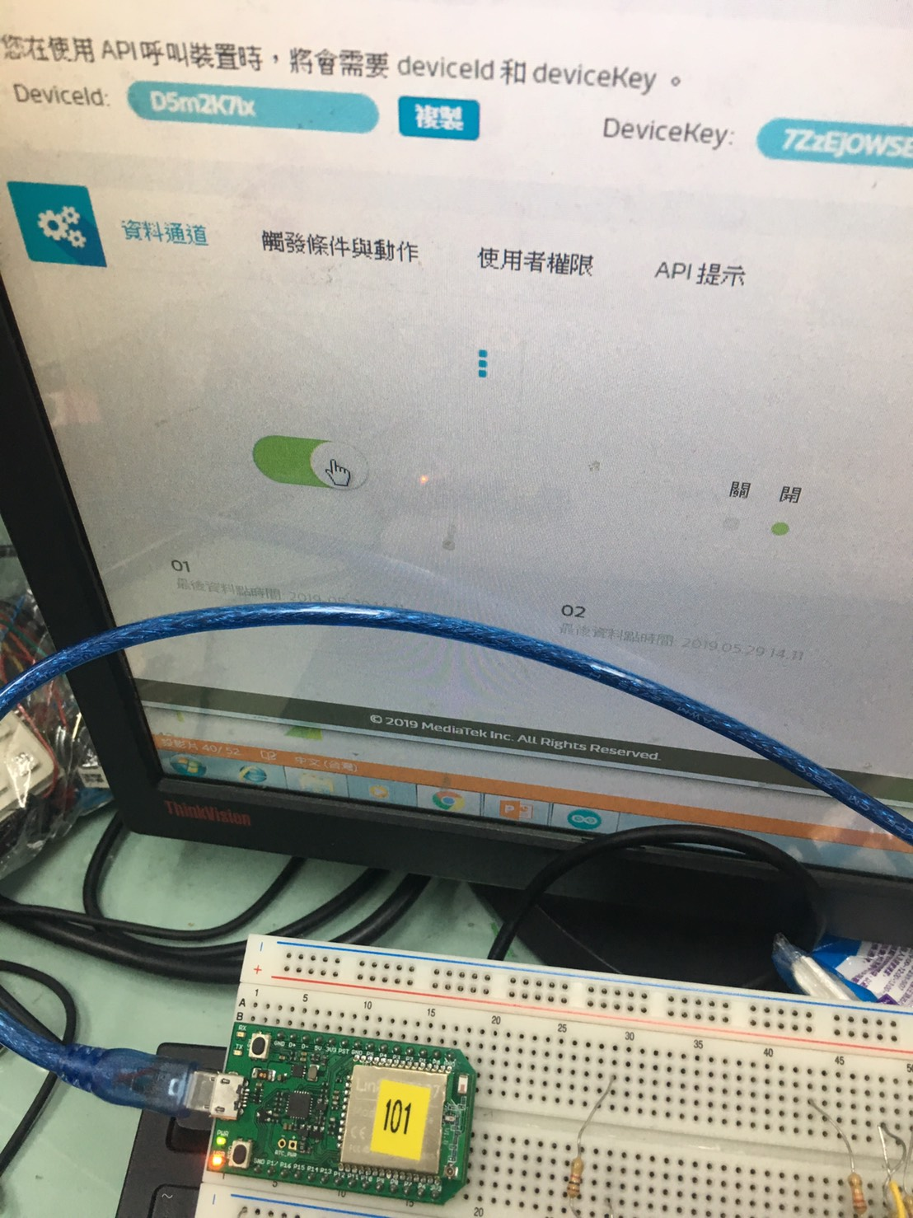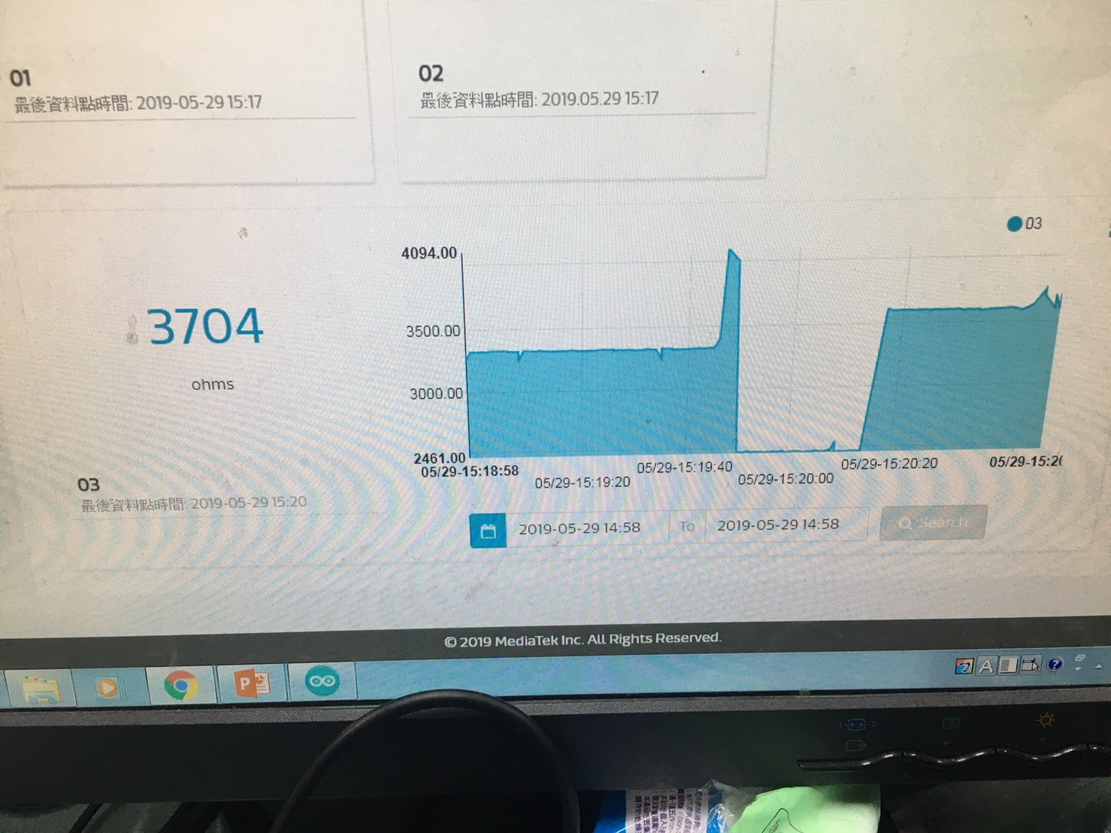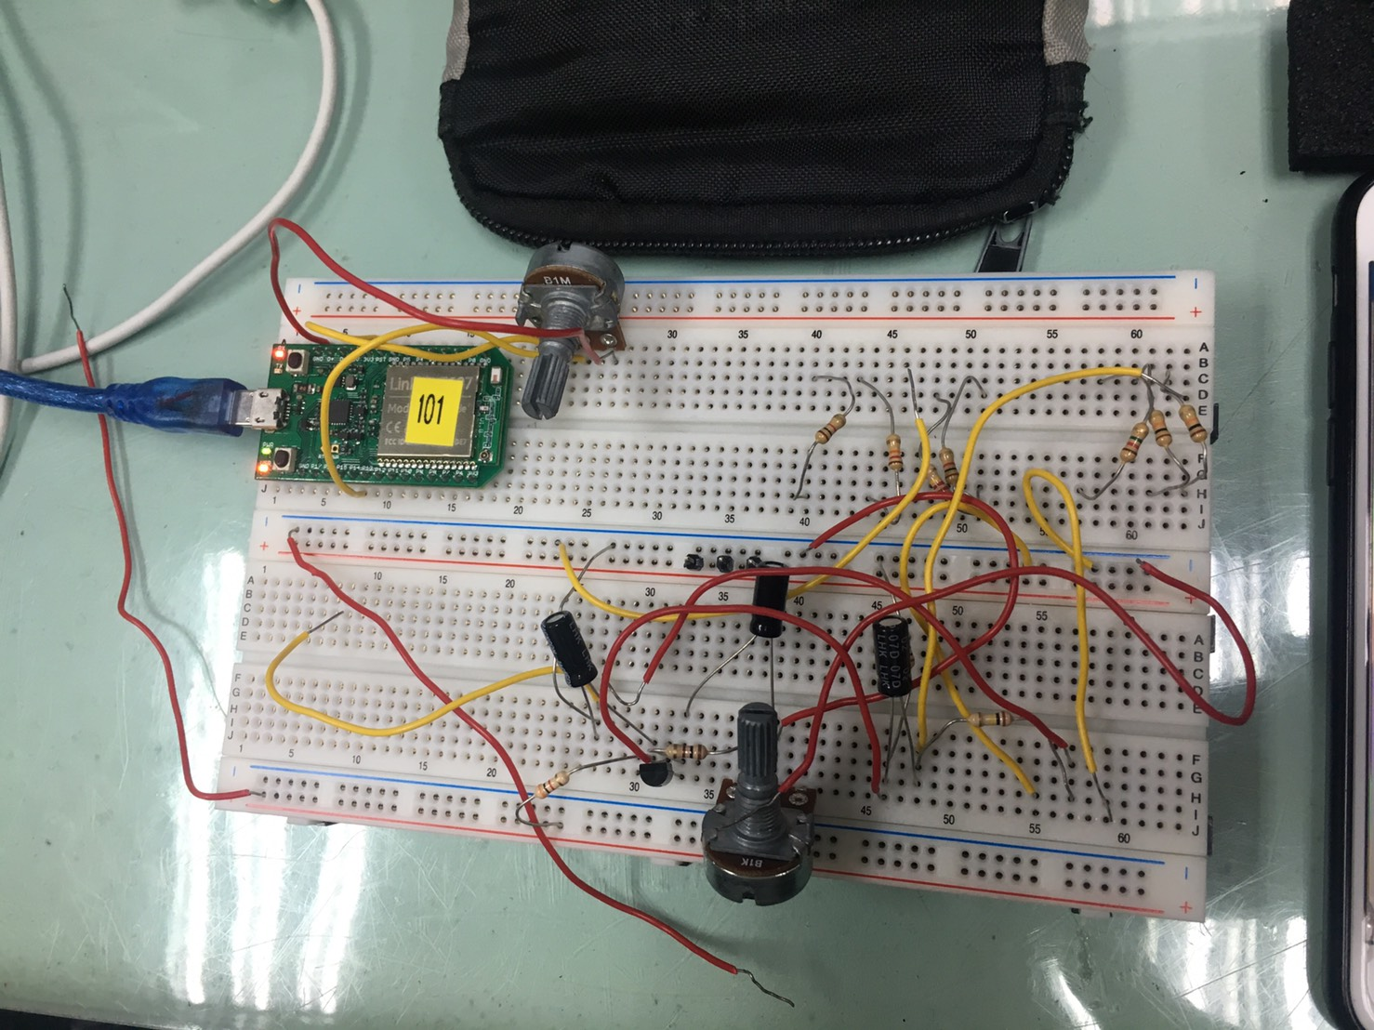
- 心得討論

這次的實驗蠻有趣的,學到很多,也都有順利做完。

