電通二甲微處理器實驗 實驗結報

實驗名稱 | Lab 12 溫溼度感應器
組別 |  | 組員 | 06053033 丁瑜楷

- 實驗目的
(1) 讓DHT-11測量溫度後回傳至pc
(2) 整合 Timer 和 DHT-11 測量溫溼度
(3)使用Timer每隔10秒上傳至 MCS Cloud
- 實驗步驟
(1)將Arduino與溫溼度感應器連接
(2)撰寫程式碼

- 程式碼
#1
// Example testing sketch for various DHT humidity/temperature sensors

// Written by ladyada, public domain

// REQUIRES the following Arduino libraries:

// - DHT Sensor Library: https://github.com/adafruit/DHT-sensor-library

// - Adafruit Unified Sensor Lib: https://github.com/adafruit/Adafruit_Sensor

#include "DHT.h"

#define DHTPIN 2 // Digital pin connected to the DHT sensor

// Feather HUZZAH ESP8266 note: use pins 3, 4, 5, 12, 13 or 14 --

// Pin 15 can work but DHT must be disconnected during program upload.

// Uncomment whatever type you're using!

//#define DHTTYPE DHT11 // DHT 11

#define DHTTYPE DHT11 // DHT 22 (AM2302), AM2321

//#define DHTTYPE DHT21 // DHT 21 (AM2301)

// Connect pin 1 (on the left) of the sensor to +5V

// NOTE: If using a board with 3.3V logic like an Arduino Due connect pin 1

// to 3.3V instead of 5V!

// Connect pin 2 of the sensor to whatever your DHTPIN is

// Connect pin 4 (on the right) of the sensor to GROUND

// Connect a 10K resistor from pin 2 (data) to pin 1 (power) of the sensor

// Initialize DHT sensor.

// Note that older versions of this library took an optional third parameter to

// tweak the timings for faster processors. This parameter is no longer needed

// as the current DHT reading algorithm adjusts itself to work on faster procs.

DHT dht(DHTPIN, DHTTYPE);

void setup() {

Serial.begin(9600);

Serial.println(F("DHTxx test!"));

dht.begin();

}

void loop() {

// Wait a few seconds between measurements.

delay(2000);

// Reading temperature or humidity takes about 250 milliseconds!

// Sensor readings may also be up to 2 seconds 'old' (its a very slow sensor)

float h = dht.readHumidity();

// Read temperature as Celsius (the default)

float t = dht.readTemperature();

// Read temperature as Fahrenheit (isFahrenheit = true)

float f = dht.readTemperature(true);

// Check if any reads failed and exit early (to try again).

if (isnan(h) || isnan(t) || isnan(f)) {

Serial.println(F("Failed to read from DHT sensor!"));

return;

}

// Compute heat index in Fahrenheit (the default)

float hif = dht.computeHeatIndex(f, h);

// Compute heat index in Celsius (isFahreheit = false)

float hic = dht.computeHeatIndex(t, h, false);

Serial.print(F("Humidity: "));

Serial.print(h);

Serial.print(F("% Temperature: "));

Serial.print(t);

Serial.print(F("¢XC "));

Serial.print(f);

Serial.print(F("¢XF Heat index: "));

Serial.print(hic);

Serial.print(F("¢XC "));

Serial.print(hif);

Serial.println(F("¢XF"));

}
#include <LWiFi.h>

#include <WiFiClient.h>

#include "MCS.h"

// Assign AP ssid / password here

#define _SSID "001"

#define _KEY "00000000"

// Assign device id / key of your test device

MCSDevice mcs("DeuQ1VHM", "AMk0qaauln9pZjQW");

// Assign channel id

// The test device should have 2 channel

// the first channel should be "Controller" - "On/Off"

// the secord channel should be "Display" - "On/Off"

MCSControllerOnOff led("01");

MCSDisplayOnOff remote("02");

#define LED_PIN 7

void setup() {

// setup Serial output at 9600

Serial.begin(9600);

// setup LED/Button pin

pinMode(LED_PIN, OUTPUT);

// setup Wifi connection

while(WL_CONNECTED != WiFi.status())

{

Serial.print("WiFi.begin(");

Serial.print(_SSID);

Serial.print(",");

Serial.print(_KEY);

Serial.println(")...");

WiFi.begin(_SSID, _KEY);

}

Serial.println("WiFi connected !!");

// setup MCS connection

mcs.addChannel(led);

mcs.addChannel(remote);

while(!mcs.connected())

{

Serial.println("MCS.connect()...");

mcs.connect();

}

Serial.println("MCS connected !!");

// read LED value from MCS server

while(!led.valid())

{

Serial.println("read LED value from MCS...");

led.value();

}

Serial.print("done, LED value = ");

Serial.println(led.value());

digitalWrite(LED_PIN, led.value() ? HIGH : LOW);

}

void loop() {

// call process() to allow background processing, add timeout to avoid high cpu usage

Serial.print("process(");

Serial.print(millis());

Serial.println(")");

mcs.process(100);

// updated flag will be cleared in process(), user must check it after process() call.

if(led.updated())

{

Serial.print("LED updated, new value = ");

Serial.println(led.value());

digitalWrite(LED_PIN, led.value() ? HIGH : LOW);

if(!remote.set(led.value()))

{

Serial.print("Failed to update remote");

Serial.println(remote.value());

}

}

// check if need to re-connect

while(!mcs.connected())

{

Serial.println("re-connect to MCS...");

mcs.connect();

if(mcs.connected())

Serial.println("MCS connected !!");

}

}
#2
#include "Arduino.h"

#include "LTimer.h"

#include "DHT.h"

#define DHTPIN 2

#define DHTTYPE DHT11

DHT dht(DHTPIN, DHTTYPE);

int led0 =7;

int led1 =6;

int val0 = 0;

int val1 = 0;

// instantiation

LTimer timer0(LTIMER_0);

LTimer timer1(LTIMER_1);

// callback function for timer0

void _callback0(void *usr_data)

{

val0 = !val0;

digitalWrite(led0, val0);

}

// callback function for timer1

void _callback1(void *usr_data)

{

val1 = !val1;

digitalWrite(led1, val1);

}

void setup() {

Serial.begin(9600);

Serial.println(F("DHTxx test!"));

dht.begin();

// initialization

timer0.begin();

timer1.begin();

// start the execution

timer0.start(1000, LTIMER_REPEAT_MODE, _callback0, NULL);

timer1.start(1000, LTIMER_REPEAT_MODE, _callback1, NULL);

}

void loop() {

// Wait a few seconds between measurements.

delay(2000);

// Reading temperature or humidity takes about 250 milliseconds!

// Sensor readings may also be up to 2 seconds 'old' (its a very slow sensor)

float h = dht.readHumidity();

// Read temperature as Celsius (the default)

float t = dht.readTemperature();

// Read temperature as Fahrenheit (isFahrenheit = true)

float f = dht.readTemperature(true);

// Check if any reads failed and exit early (to try again).

if (isnan(h) || isnan(t) || isnan(f)) {

Serial.println(F("Failed to read from DHT sensor!"));

return;

}

// Compute heat index in Fahrenheit (the default)

float hif = dht.computeHeatIndex(f, h);

// Compute heat index in Celsius (isFahreheit = false)

float hic = dht.computeHeatIndex(t, h, false);

Serial.print(F("Humidity: "));

Serial.print(h);

Serial.print(F("% Temperature: "));

Serial.print(t);

Serial.print(F("¢XC "));

Serial.print(f);

Serial.print(F("¢XF Heat index: "));

Serial.print(hic);

Serial.print(F("¢XC "));

Serial.print(hif);

Serial.println(F("¢XF"));

}
#include "MCS.h"

// Assign AP ssid / password here

#define _SSID "001"

#define _KEY "00000000"

// Assign device id / key of your test device

MCSDevice mcs("D5m2K7Ix", "7ZzEjOWSEfBcoLsy");

// Assign channel id

// The test device should have 2 channel

// the first channel should be "Controller" - "On/Off"

// the secord channel should be "Display" - "On/Off"

MCSControllerOnOff led("01");

MCSDisplayOnOff remote("02");

MCSDisplayInteger Temp("03");

#define LED_PIN 7

void setup() {

// setup Serial output at 9600

Serial.begin(9600);

// setup LED/Button pin

pinMode(LED_PIN, OUTPUT);

// setup Wifi connection

while(WL_CONNECTED != WiFi.status())

{

Serial.print("WiFi.begin(");

Serial.print(_SSID);

Serial.print(",");

Serial.print(_KEY);

Serial.println(")...");

WiFi.begin(_SSID, _KEY);

}

Serial.println("WiFi connected !!");

// setup MCS connection

mcs.addChannel(led);

mcs.addChannel(remote);

mcs.addChannel(Temp);

while(!mcs.connected())

{

Serial.println("MCS.connect()...");

mcs.connect();

}

Serial.println("MCS connected !!");

// read LED value from MCS server

while(!led.valid())

{

Serial.println("read LED value from MCS...");

led.value();

}

Serial.print("done, LED value = ");

Serial.println(led.value());

digitalWrite(LED_PIN, led.value() ? HIGH : LOW);

}

void loop() {

// call process() to allow background processing, add timeout to avoid high cpu usage

Serial.print("process(");

Serial.print(millis());

Serial.println(")");

mcs.process(100);

// updated flag will be cleared in process(), user must check it after process() call.

if(led.updated())

{

Serial.print("LED updated, new value = ");

Serial.println(led.value());

digitalWrite(LED_PIN, led.value() ? HIGH : LOW);

if(!remote.set(led.value()))

{

Serial.print("Failed to update remote");

Serial.println(remote.value());

}

}

if(!Temp.set(analogRead(A0)))

{

Serial.print("Temp: ");

Serial.println(Temp.value());

}

// check if need to re-connect

while(!mcs.connected())

{

Serial.println("re-connect to MCS...");

mcs.connect();

if(mcs.connected())

Serial.println("MCS connected !!");

}

}
- 實驗結果及分析
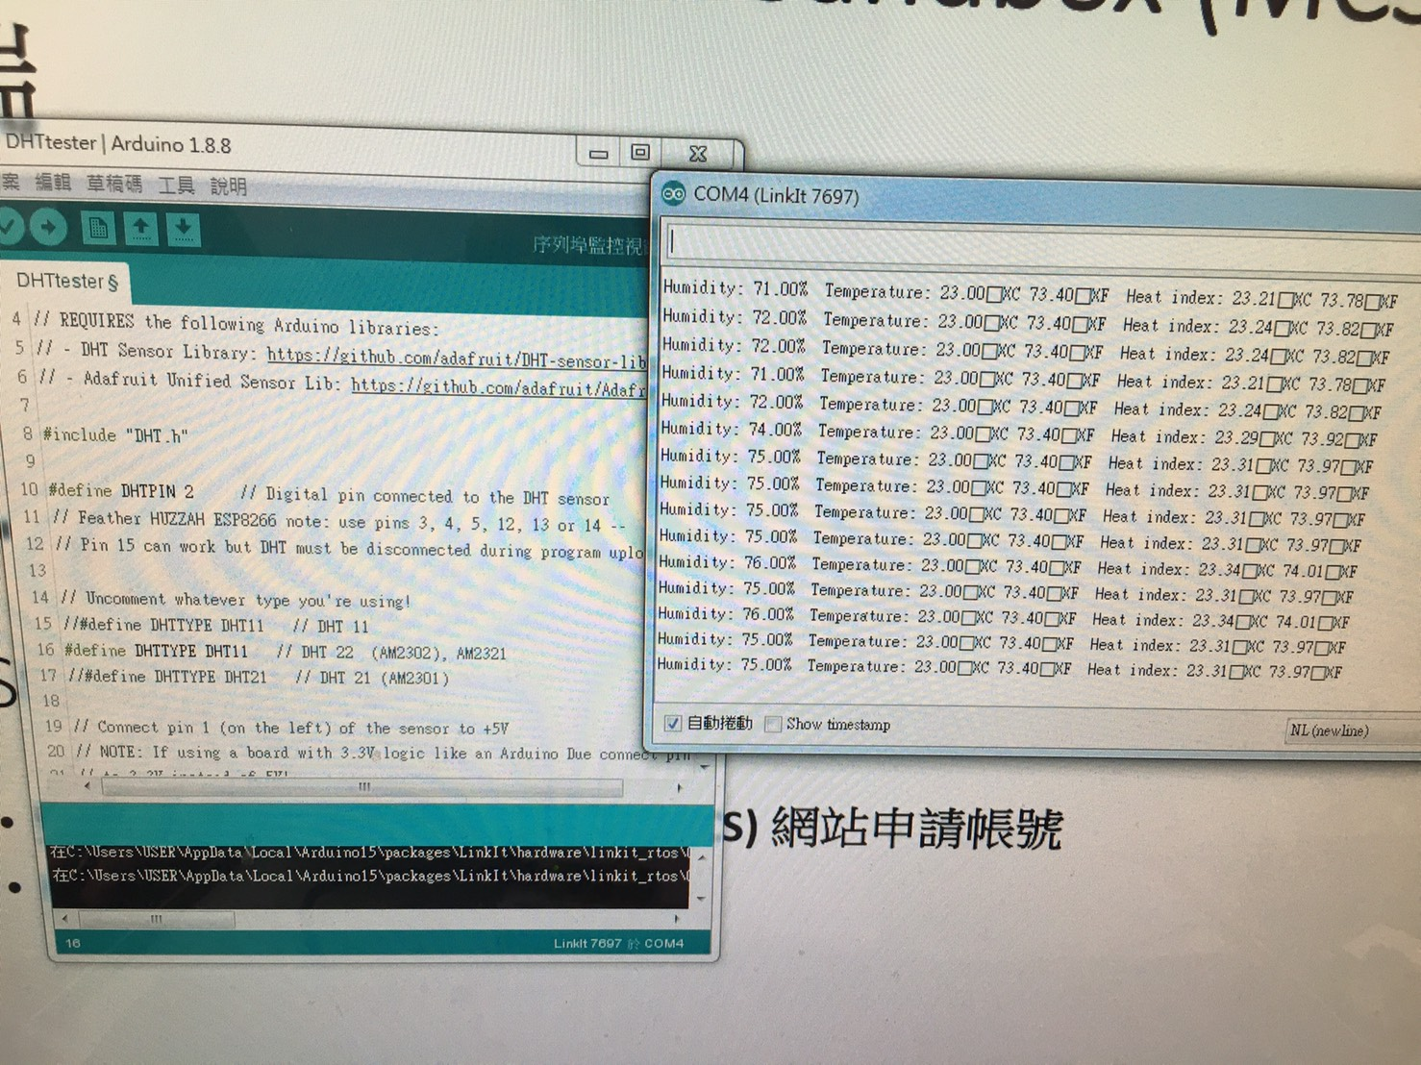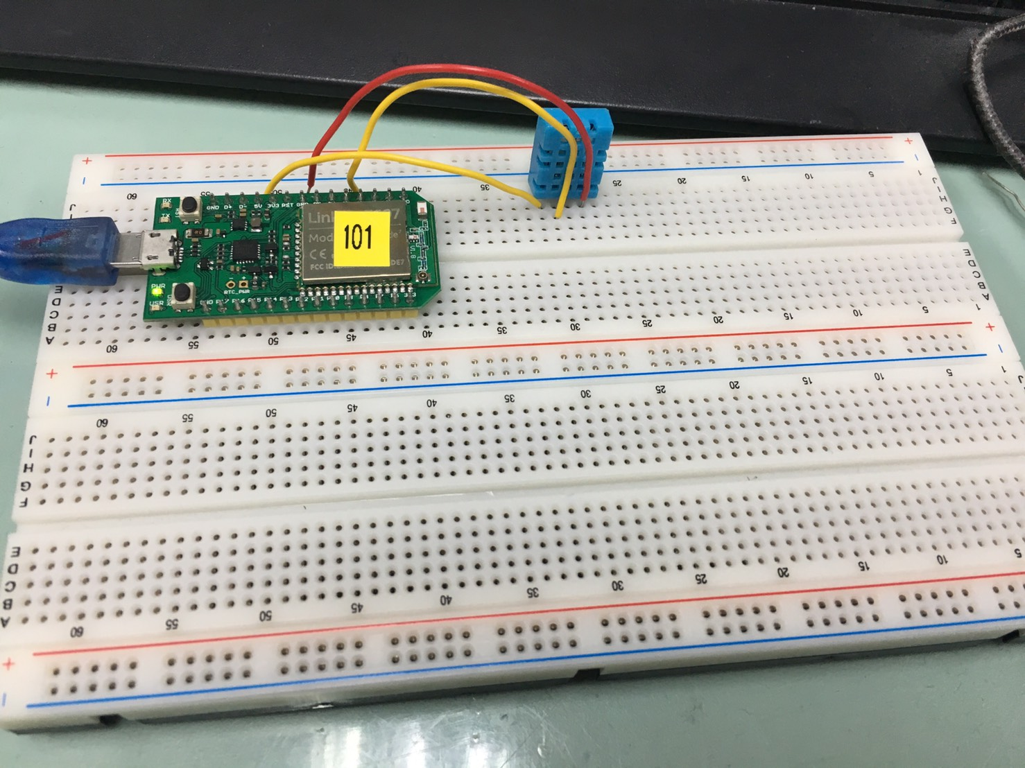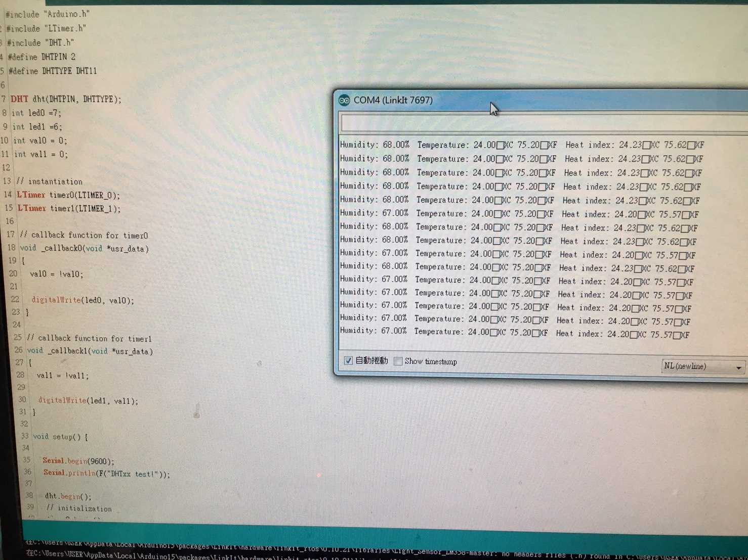
- 心得討論
這次的實驗使用到了溫溼度感測器,蠻有趣的很實用。

