電通二乙微處理器實驗 實驗結報

實驗名稱 | Arduino LED閃爍設計
組別 |  | 組員 | 丁瑜楷

- 實驗目的
用Tinkercad來模擬Arduino電路設計
製作電路圖
- 實驗步驟
至Tinkercad註冊帳號
利用裡面的原件來製作電路
將Led接至Pin9
觀察其閃爍
修改程式碼使其閃爍間隔增加2倍以及0.5倍
修改電路設計SOS閃爍頻率
最後畫出電路圖
- 程式碼
Led閃爍增加2倍
void setup()
{
pinMode(9, OUTPUT);
}

void loop()
{
digitalWrite(9, HIGH);
delay(2000); // Wait for 1000 millisecond(s)
digitalWrite(9, LOW);
delay(2000); // Wait for 1000 millisecond(s)
}
Led閃爍增加1/2倍
void setup()
{
pinMode(9, OUTPUT);
}

void loop()
{
digitalWrite(9, HIGH);
delay(2000); // Wait for 1000 millisecond(s)
digitalWrite(9, LOW);
delay(2000); // Wait for 1000 millisecond(s)
}

SOS
void setup()
{
pinMode(9, OUTPUT);
}

void loop()
{
digitalWrite(9, HIGH);
delay(100); // Wait for 1000 millisecond(s)
digitalWrite(9, LOW);
delay(100); // Wait for 1000 millisecond(s)
digitalWrite(9, HIGH);
delay(100); // Wait for 1000 millisecond(s)
digitalWrite(9, LOW);
delay(100); // Wait for 1000 millisecond(s)
digitalWrite(9, HIGH);
delay(100); // Wait for 1000 millisecond(s)
digitalWrite(9, LOW);
delay(100); // Wait for 1000 millisecond(s)

digitalWrite(9, HIGH);
delay(300); // Wait for 1000 millisecond(s)
digitalWrite(9, LOW);
delay(100); // Wait for 1000 millisecond(s)
digitalWrite(9, HIGH);
delay(300); // Wait for 1000 millisecond(s)
digitalWrite(9, LOW);
delay(100); // Wait for 1000 millisecond(s)
digitalWrite(9, HIGH);
delay(300); // Wait for 1000 millisecond(s)
digitalWrite(9, LOW);
delay(100); // Wait for 1000 millisecond(s)

digitalWrite(9, HIGH);
delay(100); // Wait for 1000 millisecond(s)
digitalWrite(9, LOW);
delay(100); // Wait for 1000 millisecond(s)
digitalWrite(9, HIGH);
delay(100); // Wait for 1000 millisecond(s)
digitalWrite(9, LOW);
delay(100); // Wait for 1000 millisecond(s)
digitalWrite(9, HIGH);
delay(100); // Wait for 1000 millisecond(s)
digitalWrite(9, LOW);
delay(100); // Wait for 1000 millisecond(s)

digitalWrite(9, LOW);
delay(300); // Wait for 1000 millisecond(s)
}
- 實驗結果及分析
2倍
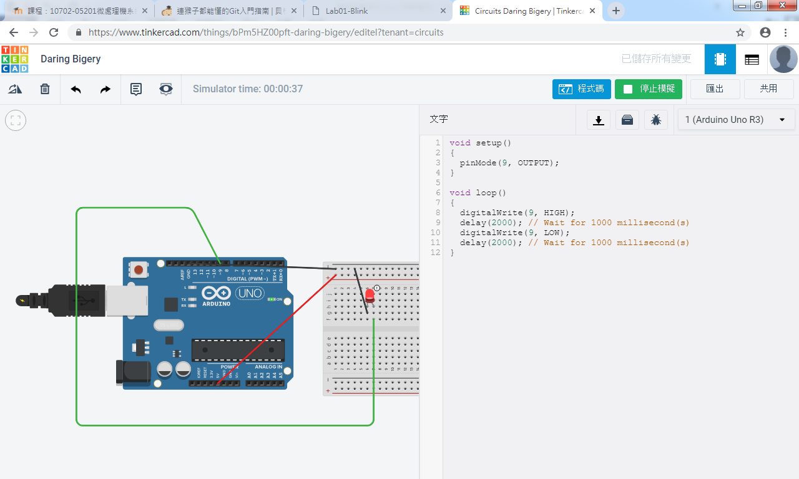
1/2倍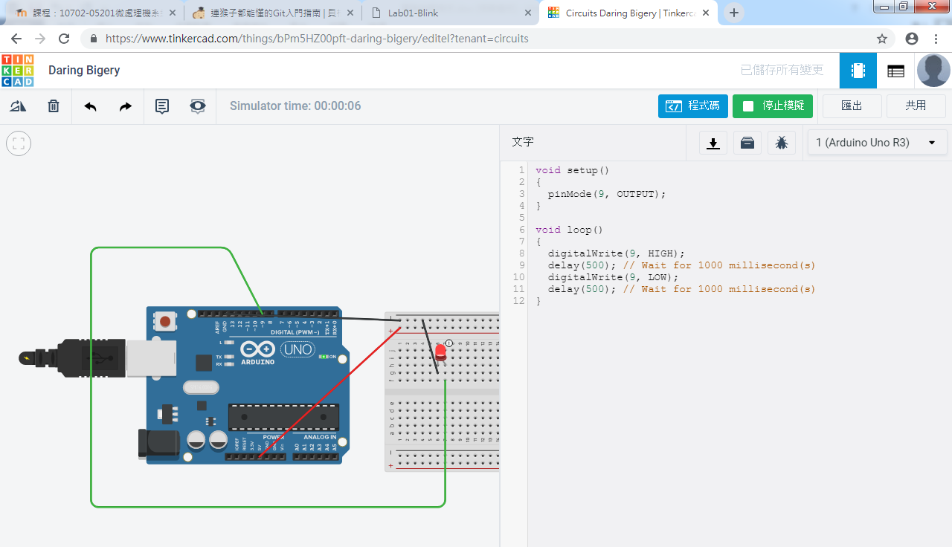

Sos
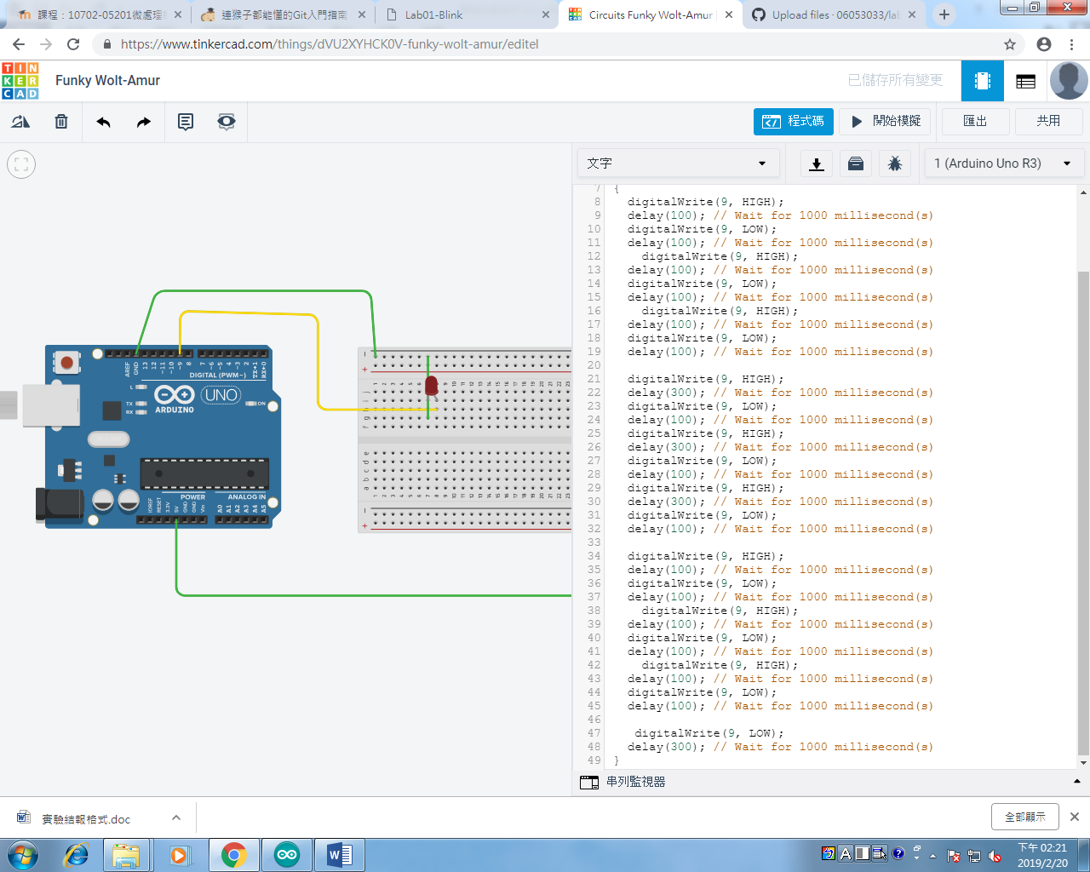
- 心得討論
這是第一次使用Tinkercad來做模擬Arduino電路,覺得很方便也很容易上手,再修改程式碼成SOS時,遇到了一些困難,但是在和同學們一起討論後,也很快就解決了,希望在未來的這堂課上能學到很多。
- 修正電路圖
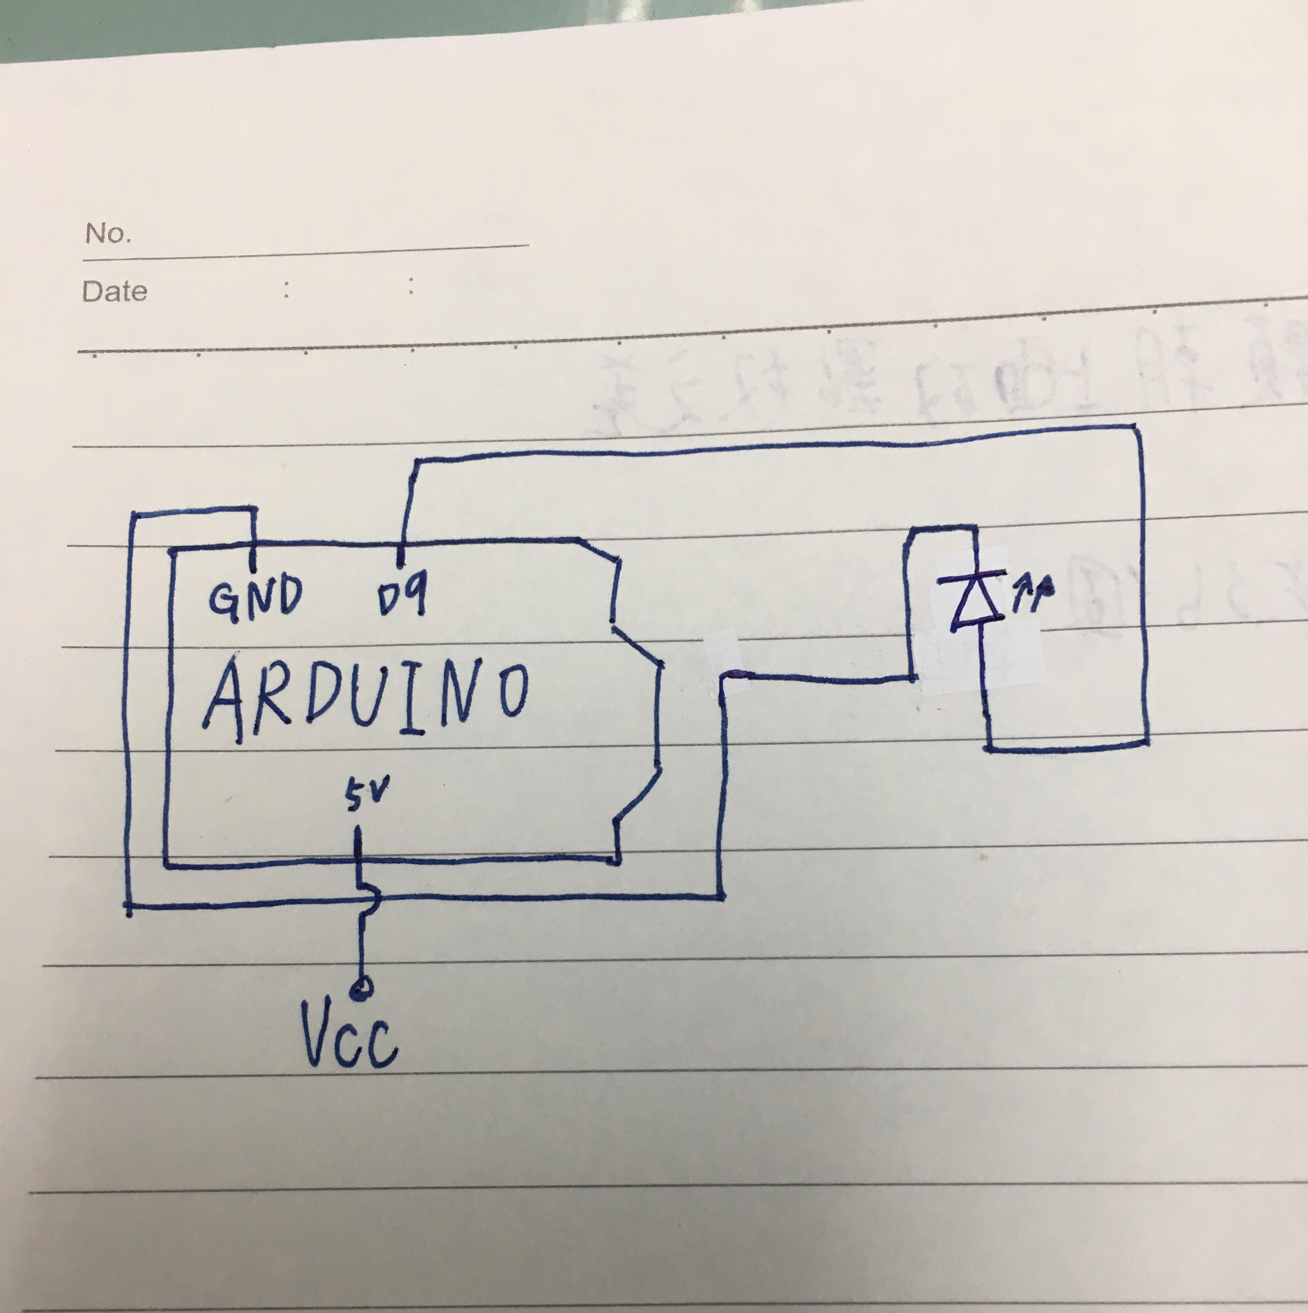
- 修正程式碼

