**Aim:**

To draw flowchart and write algorithm, program to exchange two values using third variable.

**Algorithm:**

**Step 1 :** Start

**Step 2 :** read values of a and b

**Step 3 :** assign c=a

**Step 4 :** assign a=b

**Step 5 :** assign b=c

**Step 6 :** display a, b

**Step 7 :** Stop

**Program:**

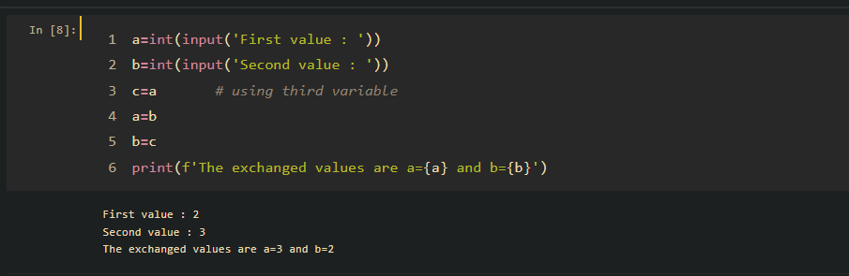

**Flowchart:**

S

t

a

r

t

r

e

a

d

a

,

b

c

~~=~~

a

a

=

b

b

=

c

d

i

s

p

l

a

y

a

,

b

S

t

o

p

**Result:**

The python program is executed and output is verified successfully.

**Aim:**

To draw flowchart and write algorithm, program to exchange two values using comma operator.

**Algorithm:**

**Step 1 :** Start

**Step 2 :** read values of x, y

**Step 3 :** assign x, y=y, x

**Step 4 :** display x, y

**Step 5 :** Stop

**Program:**

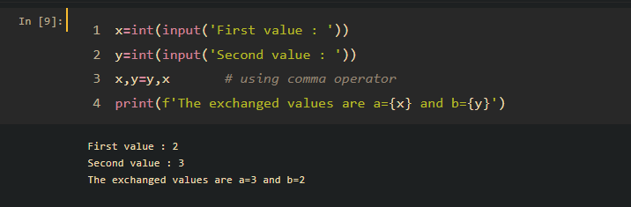

**Flowchart:**

S

t

a

r

t

r

e

a

d

x

,

y

x

,

y

=

y

,

x

d

i

s

p

l

a

y

x

,

y

S

t

o

p

**Result:**

The python program is executed and output is verified successfully.

**Aim:**

To draw flowchart and write algorithm, program to exchange two values using arithmetic operator.

**Algorithm:**

**Step 1 :** Start

**Step 2 :** read values of a, b

**Step 3 :** compute a=a + b

**Step 4 :** compute b=a-b

**Step 5 :** compute a=a-b

**Step 6 :** display a, b

**Step 7 :** Stop

**Program:**

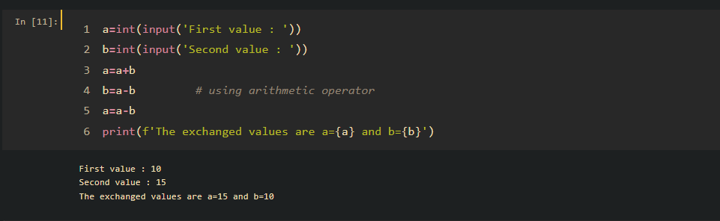

**Flowchart:**

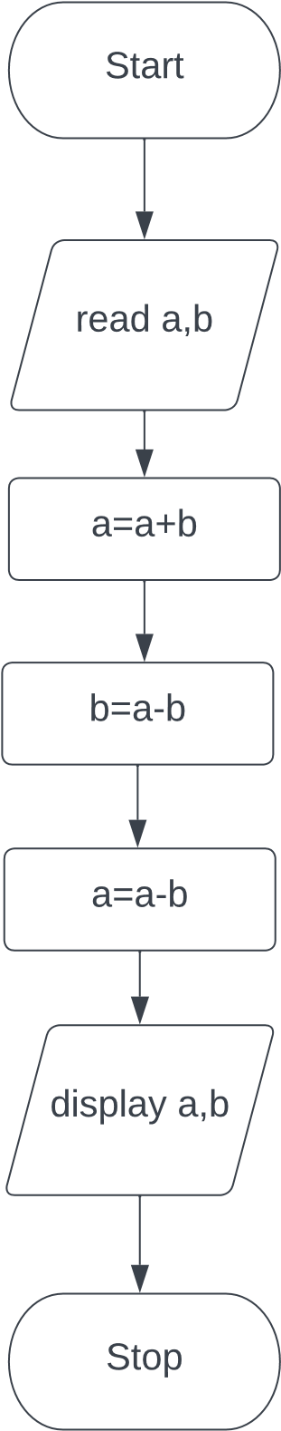

**Result:**

The python program is executed and output is verified successfully.

**Aim:**

To draw flowchart and write algorithm, program to exchange two values using XOR operator.

**Algorithm:**

**Step 1 :** Start

**Step 2 :** read values of a, b

**Step 3 :** compute a=a ^ b

**Step 4 :** compute b=a ^ b

**Step 5 :** compute a=a ^ b

**Step 6 :** display a, b

**Step 7 :** Stop

**Program:**

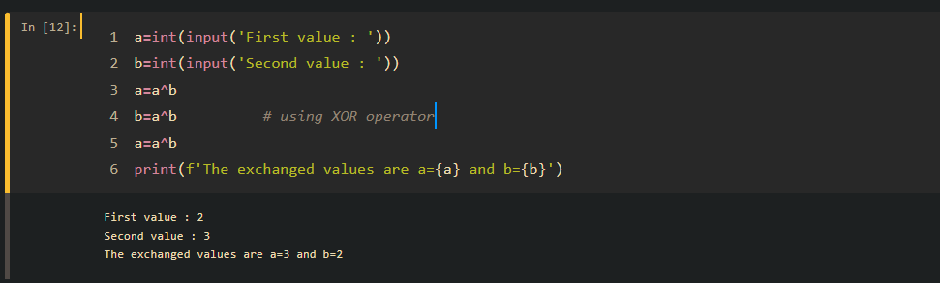

**Flowchart:**

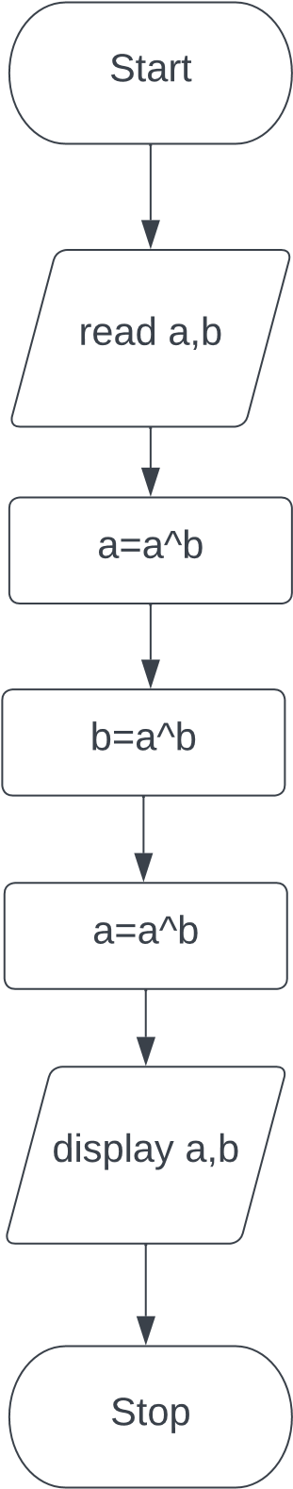

**Result:**

The python program is executed and output is verified successfully.

**Aim:**

To draw flowchart and write algorithm, program to circulating the list of values usng in-build functions in python.

**Algorithm:**

**Step 1 :** Start

**Step 2 :** read list a

**Step 3 :** display a

**Step 4 :** assign i=0, n=size of a

**Step 5 :** Check if i<n

**Step 5.1 :** If Yes, then a.append(a[0]), a.pop(0), i=i+1

**Step 5.2 :** display a and go to step 5

**Step 5.3 :** If No, then go to step 6

**Step 6 :** Stop

**Program:**

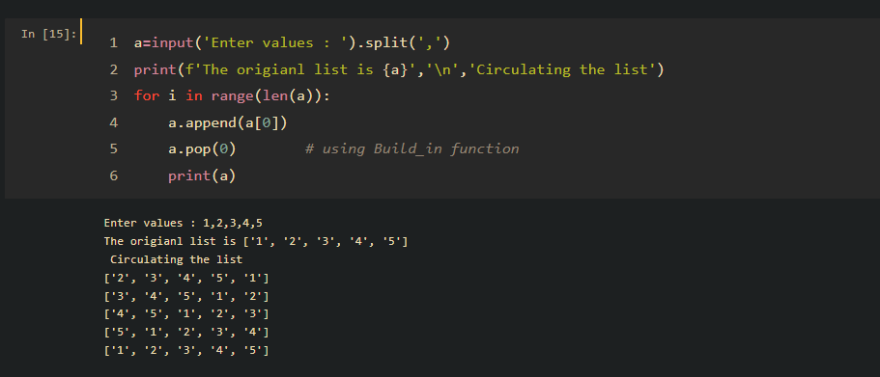

**Flowchart:**

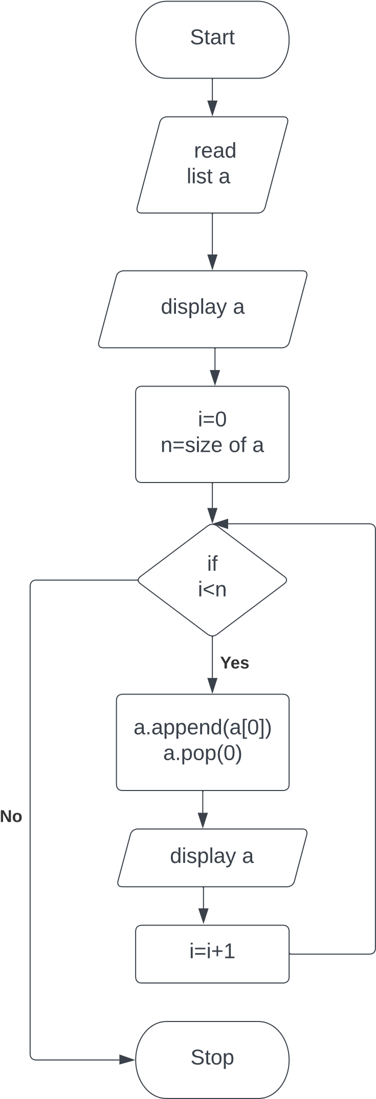

**Result:**

The python program is executed and output is verified successfully.

**Aim:**

To draw flowchart and write algorithm, program to circulating the list of values using slicing operator.

Algorithm:

**Step 1 :** Start

**Step 2 :** read list a

**Step 3 :** display a

**Step 4 :** assign i=0, n=size of a

**Step 5 :** Check if I < n

**Step 5.1 :** If Yes, then compute cir=a[1:]+[a[0]], i=i+1

**Step 5.2 :** display cir and go to step 5

**Step 5.3 :** If No, then go to step 6

**Step 6 :** Stop

**Program:**

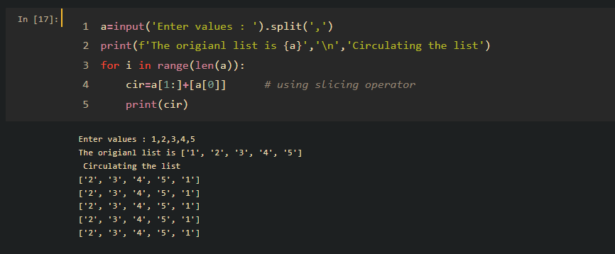

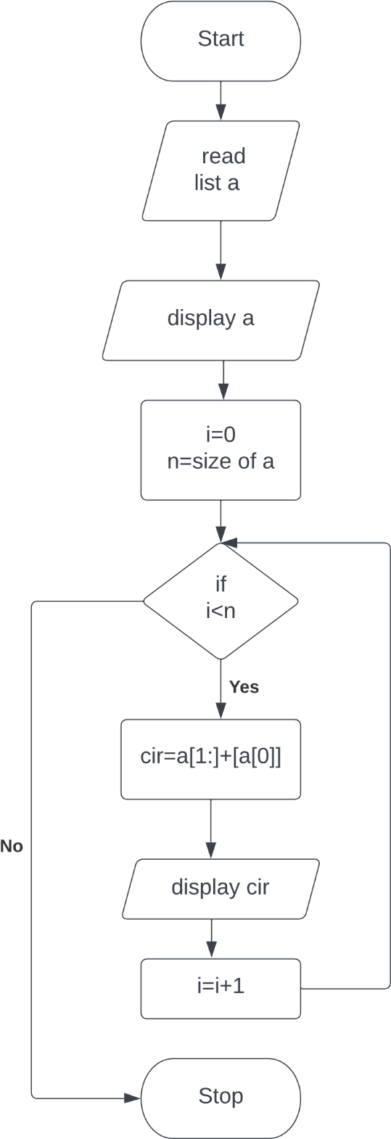**Flowchart**

**Result:**

The python program is executed and output is verified successfully.

**Aim:**

To draw flowchart and write algorithm, program to calculate the distance between two points.

**Algorithm:**

**Step 1 :** Start

**Step 2 :** read values of x1,x2, y1, y2

**Step 3 :** import math

**Step 4 :** compute d= math.sqrt((x2-x1)**2+(y2-y1)**2)

**Step 5 :** display d

**Step 6 :** Stop

**Program:**

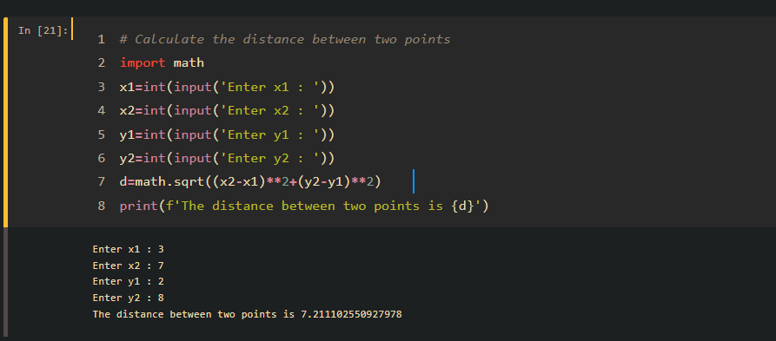

**Flowchart:**

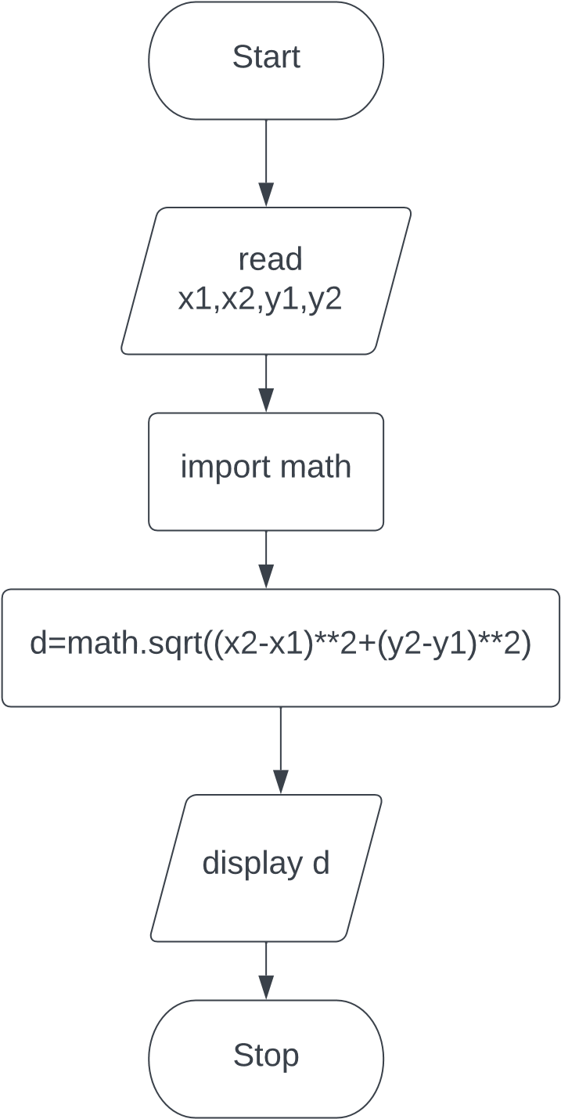

**Result:**

The python program is executed and output is verified successfully.

**Aim:**

To draw flowchart, and write algorithm, program to calculate total cost of apples.

**Program:**

# calculating total cost of apples

cost=50

apples=int(input('Enter number of apples : '))

total_cost=cost*apples

print(f'Total cost of {apples} is {total_cost}')

**Output:**

Enter number of apples : 10

Total cost of 10 is 500

**Result:**

The python program is executed and verified successfully.

**Aim:**

To write a program to calculate simple intrest .

**Program:**

# simple intrest

p=int(input('Enter principal amount : '))

t=int(input('Enter time period : '))

r=int(input('Enter rate  of intrest : '))

si=(p*t*r)/100

print('Simple intrest is',si)

**Output:**

Enter principal amount : 1000

Enter time period : 10

Enter rate of intrest : 3

Simple intrest is 300.0

**Result:**

The python program is executed and verified successfully.