Question 01

1.1. Project management, generally speaking; is a process of identifying a large problem, identifying and cataloging those activities. The system’s approach to management therefore, in addition to the organization itself, looks into the set of forces and conditions that operate beyond an organization’s boundaries but affect a manager’s ability to acquire and utilize resources their by improve productivity and market.

1.2.(a). Non-projects rarely have a resistance to change from  
 various stakeholders, and will be more likely to influence the culture of the organization, rather  
 ` than the organisational culture influencing the set of tasks, which is the case in a project.

(b). The difference between software and the products of other kinds of projects is it's not  
 physical. Software consists of ideas, designs, instructions and formulas. Still, software only  
 matters when it appears as something real, even as barely real as colored squiggles on a  
 computer screen.

1.3. Project management is important because it ensures there's rigor in architecting projects properly  
 so that they fit well within the broader context of our client's strategic frameworks.

1.4. A project scope, or project scope statement, is a tool used to describe the major deliverables of a   
 project including the key milestones, high level requirements, assumptions, and constraints.

Question 02

2.1. Boehm’s equation:

effort = c* (size)*k

Variables in Boehm’s equation:

Effort: measured in person months consisting of 152 working hours

Size: measured in thousands of delivered source code instructions (kdsi)

c and k are constants:

The constants, c and k, depended on whether the system could be classified, in Boehm’s terms, as  
 “organic”, “semi-detached” or “embedded”

These relate to the technical nature of the system and the development environment

2.2.

|  |  |  |  |  |  |  |
| --- | --- | --- | --- | --- | --- | --- |
| A | =3.0*(10762/1000)1.12 | = | 42.93 | Person months/12 = years | = | 3.58 years |
| B | =3.0*(17862/1000)1.12 | = | 75.73 | Person months/12 = years | = | 6.31 years |
| C | =2.4*(22132/1000)1.05 | = | 62.01 | Person months/12 = years | = | 5.17 years |

Question 03

3.1  
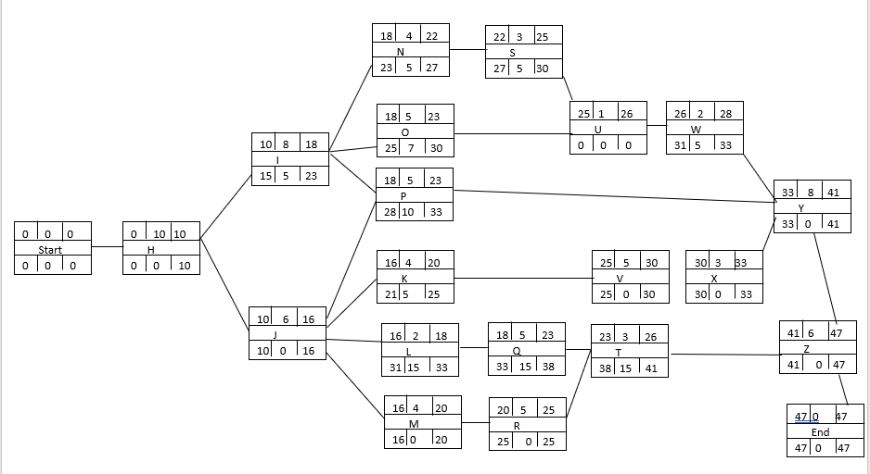

3.2. P = 10  
 Q = 15

3.3. Critical Path

The critical path is**: H-J-M-R-V-X-Y-Z**  
 10+6+4+5+5+3+8+6 = 47

The remaining paths: **H-I-N-S-U-W-Y-Z**  
 10+8+4+3+1+2+8+6 = 47  
 **: H-I-O-U-W-Y-Z**  
 10+8+5+1+2+8+6 = 40  
 : **H-I-P-Y-Z**  
 10+8+5+8+6 = 37  
 : **H-J-K-V-X-Y-Z**  
 10+6+4+5+3+8+6 = 42  
 : **H-J-L-Q-T-Z**  
 10+6+2+5+3+6 = 32

3.4. Free float is how long an activity can be delayed, without delaying the Early Start of its successor  
 activity.

3.5.

Question 04

4.1. Calculate time expected

A:te = (3+(4*4)+6)/6 = 4.16

B:te = (1+(4*2)+3)/6 = 2

C:te = (3+(4*2)+4)/6 = 2.5

D:te = (4+(4*5)+5)/6 = 4.82

Standard Deviation

S = b – a  
 6

A:S = (6-3)/6 = 0.5

B:S = (3-1)/6 = 0.33

C:S = (4-3)/6 = 0.16

D:S = (5-4)/6 = 0.16

4.2. The sd for event 2 is the s value for Activity A = 0.5

The sd for event 3 is total SO of A + B  
 = 0.52 + 0.332

= 0.36)

= 0.6

The sd for event 4 there are two possible routes: A + B + C and D

Sd for A + B + C = 0.52 + 0.332  + 0.162

= 0.03)

= 0.17

Sd for D = 0.16

The biggest is 0.17

4.3. 8.66 weeks

4.4. Z = T – te  
 s  
 = (12 – 8.66)/0.17

= 19.65

Question 05

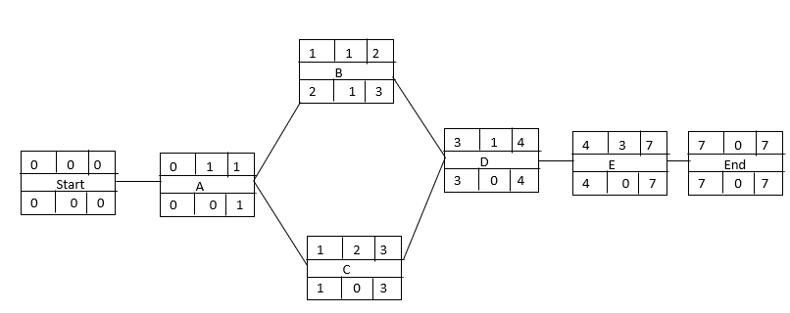

5.1.

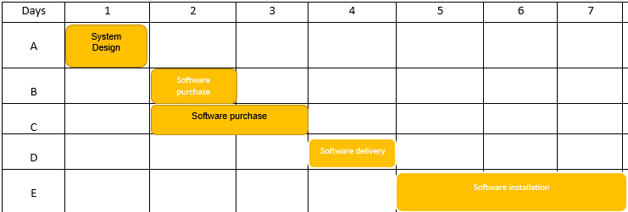

5.2.

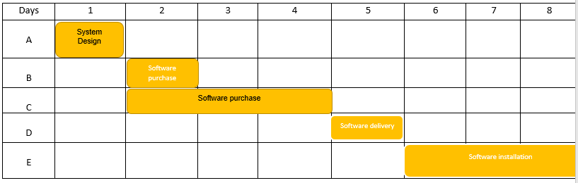

5.3. Yes. Project C was delayed by one day because of the limited resources.

Question 06

6.1. Earned value analysis is a method of performance measurement. Earned value integrates cost,   
 schedule and scope and can be used to forecast future performance and project completion dates.  
 It is calculated using the following formula:  
 Earned Value (EV): [Total modules completed] x [% of completed module]

The planned value (PV), also called the budget, is the portion of the approved  
 total cost estimate planned to be spent on an activity during a given period.

6.2. PV = (31,362*1)+( 138,571*1)+( 20,945*0.5)+( 21,272*1)+( 100,849*0.5)  
 = 252 102

6.3. EV = (31,362*1)+( 138,571*1)+( 20,945*0.3)+( 21,272*0.1)+( 100,849*0.7)  
 = 248 938

6.4. AC = 30,550 +155,180 + 8,933 + 20,644 + 73350   
 = 288 657

6.5. CPI = EV ÷ AC  
 = 248 938 / 288 657  
 = 0.86

6.6. 20,352 + 4,235 + 6,622  
 = 31 209