EDITH
A Verified Financial Analysis RAG System on Tata Steel's Annual Reports (FY2022-23 to FY2025-26)
Project report: architecture, implementation, evaluation and results
Akshit Kansal · Backend, data pipeline, agent, evaluation, deployment
Divisha Agarwal · Frontend design ("Edith" React application)
PGDM (Business Data Analytics)
FORE School of Management, New Delhi
September 2026

Table of contents
(In Microsoft Word: right-click the table below and choose Update Field to refresh page numbers after inserting screenshots.)

1. Executive summary
This project delivers Edith, a retrieval-augmented generation (RAG) system that answers financial questions about Tata Steel Limited and performs financial analysis from the company's four official Integrated Reports & Annual Accounts for FY2022-23, FY2023-24, FY2024-25 and FY2025-26 (2,311 pages in total). Because every annual report also prints the previous year as a comparative column, the system covers five fiscal years, FY2021-22 to FY2025-26, for both the consolidated group and the standalone company.
Edith works in two ways. As a chatbot, it answers plain-language questions: single-figure lookups, multi-year trends, ratios, year-on-year comparisons, DuPont analysis, composite scores (Altman Z'', Piotroski F, Beneish M), segment and regional performance, key audit matters, risk disclosures and an overall financial-health verdict, including follow-up questions that refer to earlier turns. As a dashboard, it presents verified metrics, ratios, composite scores, segments and regions for any selected year and reporting basis.
The central design principle is that the language model never produces a number by itself. Figures are extracted from the statements with a purpose-built parser, checked with accounting identities, stored as canonical items, and computed by deterministic tools. Before any answer is shown, every number in it is matched to a value a tool returned, every figure is cited to the report and page, and questions the reports cannot answer (forecasts, other companies, years not covered) are refused.
Table 1: Headline results of the final evaluation run (27 September 2026)
Measure | Result
Retrieval (filtered search probes) | Hit Rate@4 = 1.00, MRR = 1.00
Numeric questions fully correct | 24 / 24
Expected numbers found in answers | 60 / 60
Questions whose source pages were retrieved / expected pages cited | 26 / 26 and 55 / 56
Correct abstention (refuse only what cannot be answered) | 32 / 32
Answers fully grounded under strict checking | 31 / 32
Answer-key input figures found printed on their cited PDF pages | 118 / 118
Automated tests / average answer time / tool calls | 93 passing / 10 seconds / 2.6

The analysis itself produced a substantive finding: using page-verified retained earnings instead of a common proxy, Tata Steel's consolidated Altman Z'' moves from the safe zone in FY2021-22 (2.72) to the grey zone in FY2022-23 (1.48) and the distress zone from FY2023-24 (0.44, 0.87, 0.96), even while its Piotroski F-score recovers from 3 to 8 as profitability returns. The system is deployed with Docker Compose on the college machine and published through a Cloudflare tunnel.

2. Introduction and objectives

2.1 Problem
Annual reports are the most authoritative source on a listed company's financial position, but they are long (550 to 600 pages each), dense with tables, and change presentation between years through restatements and reclassifications. General-purpose large language models can read them, but in financial work they fail in characteristic ways: they misread table rows and columns, confuse fiscal years and the consolidated and standalone scopes, perform arithmetic in their heads, and state plausible figures that do not appear in any source. For analysis that a user must be able to trust, fluency is not enough: every number needs to be correct, reproducible and traceable to a page.

2.2 Objectives
- Build a RAG system over multiple years of real annual reports of one company, with table-aware parsing that preserves structure.
- Guarantee numerical correctness: extract statement figures deterministically, verify them with accounting identities, and compute all ratios and changes in code, never in the language model.
- Cite every figure to its report, statement and page, and refuse questions the reports cannot answer.
- Provide full financial analysis: ratios, trends, year-on-year changes, DuPont decomposition, composite scores, segments, audit matters, risks and a verdict.
- Evaluate rigorously, with a separate numeric-accuracy tier and an answer key verified against the PDFs.
- Deliver a usable product: a FastAPI backend, a React frontend and a reproducible Docker deployment with a public link.

2.3 Scope
In scope: the four Tata Steel Integrated Reports & Annual Accounts FY2022-23 to FY2025-26 (consolidated and standalone financial statements, notes, segment reporting, auditor's reports and narrative sections such as the management discussion and analysis and risk management). Out of scope: quarterly results filings, market data (share price and market capitalisation), other companies and forecasts. The system is designed for research and education, not investment advice.

3. Data sources
The four reports were downloaded from Tata Steel's investor website by a script (scripts/download_reports.sh) and stored locally. Because Tata Steel's server refuses direct links to the PDFs from other websites (HTTP 403), the backend later serves its own copies, so every citation in the application opens reliably.
Table 2: The four source documents
Report | Pages | Fiscal years presented | Primary statements (consolidated)
116th Integrated Report & Annual Accounts 2022-23 | 597 | FY2022-23; FY2021-22 (comparative) | P&L p. F142-F143
117th Integrated Report & Annual Accounts 2023-24 | 582 | FY2023-24; FY2022-23 | Balance sheet, P&L, cash flow (F140 onwards)
118th Integrated Report & Annual Accounts 2024-25 | 550 | FY2024-25; FY2023-24 | Balance sheet p. F150-F151, P&L p. F152
119th Integrated Report & Annual Accounts 2025-26 | 582 | FY2025-26; FY2024-25 | Balance sheet p. F142-F143, P&L p. F144

Why Tata Steel. Tata Steel is a large, diversified steel producer with operations in India, the Netherlands, the UK and Thailand, a combined capacity of 36 MTPA and more than 77,000 employees (FY2025-26 report, pp. 10-13). Its reports are demanding test material: two scopes, complex group restructuring (amalgamations of subsidiaries into the parent; the split of Tata Steel Europe into Netherlands and UK segments), restated comparatives and a loss year (FY2023-24). A system that handles these reliably is credible.
FY2021-22. There is no FY2021-22 report in the set; its figures come from the comparative column of the FY2022-23 report and are labelled as such throughout the application. Measures that compare a year with the previous one (Piotroski F, Beneish M and FY2021-22 year-on-year changes) are not available for FY2021-22, because FY2020-21 is outside the four reports; the application states this reason instead of showing a blank.

4. System architecture
The system has two halves. An offline pipeline turns the PDFs into verified structured data and a search index; an online system answers questions and serves the dashboard. Figure 1 shows the complete architecture.
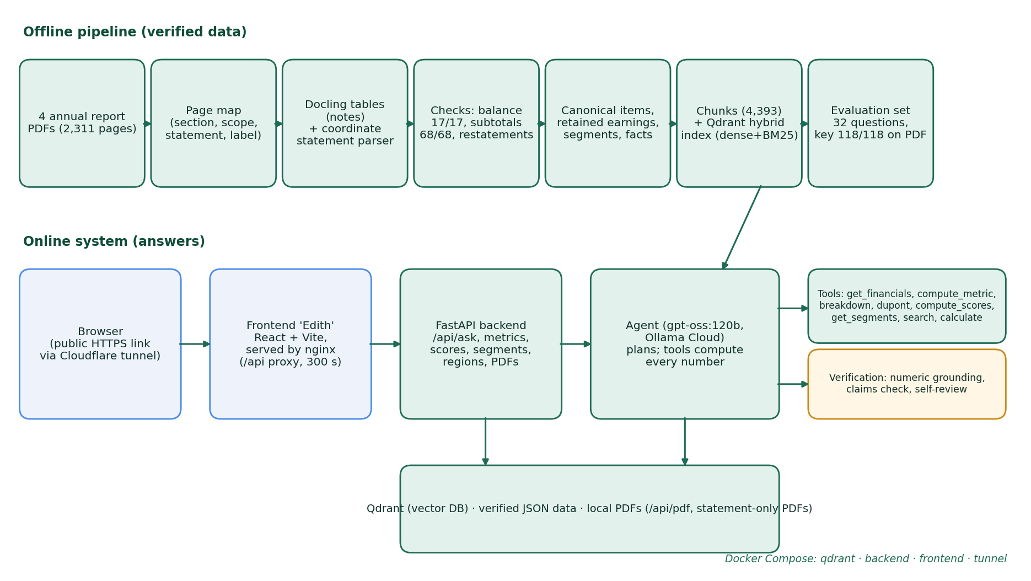
Figure 1: System architecture: offline verified-data pipeline (top) and online answering system (bottom)
Table 3: Pipeline stages and components
Stage | Implementation | Purpose and output
1. Page map | src/ingest/page_map.py (PyMuPDF) | Classifies every page by section, scope (standalone/consolidated), statement type and printed label (e.g. F143) from the visual header and footer strips. Output: data/interim/page_map_<FY>.json.
2. Notes tables | src/ingest/run_docling.py (Docling 2.130.0) | TableFormer in ACCURATE mode, OCR off, 24 threads, over all financial-statement pages: 373, 332, 330 and 336 tables for the four reports (about 8 minutes per report).
3. Primary statements | src/ingest/statement_lines.py, line_items.py | A coordinate-based parser for the balance sheet, profit and loss and cash flow statements (2,364 line-item records).
4. Verification | line_items.py, canonical.py | Balance-sheet identity 17/17, section subtotals 68/68, restatement detection (238 items differ from their original report), around 40 canonical items per year and scope.
5. Extra verified data | retained_earnings.py, segments.py, company_facts.py | Retained earnings (16/16 values on page), segment revenue and EBITDA (293/293 values on page, reconciled), company facts (5/5).
6. Chunking and index | build_chunks.py, build_index.py, search.py | 4,393 chunks in Qdrant with dense (BAAI/bge-base-en-v1.5) and sparse (BM25) vectors fused by reciprocal rank fusion, with metadata filters.
7. Agent | src/agent/agent.py, tools.py | gpt-oss:120b on Ollama Cloud (fallback gemma4:31b) with nine tools, numeric grounding, a claims check and a self-review pass.
8. Backend API | src/api/main.py (FastAPI) | Chat with conversation history, financials, metrics, scores, segments, regions, statements, PDFs, company facts, evaluation and reports.
9. Frontend | frontend/ (React + Vite, nginx) | Home, Ask Edith, Dashboard, Evaluation and Sources pages.
10. Deployment | Dockerfile, frontend/Dockerfile, docker-compose.yml | Four containers: qdrant, backend, frontend and a Cloudflare tunnel.

5. Data ingestion and parsing

5.1 Page map
Each report mixes narrative sections, the standalone financial statements and the consolidated financial statements. The page mapper reads the top and bottom strips of every page by position (not the body text, which is misleading on title pages) to assign a section, a scope, a statement type and the printed page label. This lets every later step ask precise questions such as "the consolidated balance sheet pages of the FY2024-25 report", and lets citations use the printed label (F143) that a reader sees, while links open the right physical PDF page.

5.2 Why a custom statement parser
Docling, a state-of-the-art document converter with a neural table-structure model, was benchmarked first (scripts/bench_docling.py; about 2.8 seconds per page on the 28-core CPU). It works well for the notes tables, but on the dense single-page primary statements it merged adjacent rows and shifted values between columns, which is unacceptable for financial figures. The primary statements are therefore parsed by a coordinate-based parser built on PyMuPDF word positions:
- Words are grouped into lines by vertical position and into columns by the right edge of numbers (figures are right-aligned).
- Indian digit grouping (1,00,920.21), brackets as negatives, dashes as nil values, wrapped labels and floating value lines are handled.
- Two-column and three-column statements are supported (some reports print a restated third balance sheet after amalgamations).
- A marker-aware hierarchy keeps "Current borrowings" distinct from "Non-current borrowings"; items printed as several rows, such as trade payables (MSME dues, other dues and acceptances), are summed from their components.

5.3 Verification of the extracted statements
Extraction is only trusted after accounting checks pass. The balance-sheet identity (total assets = total equity + total liabilities) holds in 17 of 17 balance sheets, and every section subtotal equals the sum of its lines in 68 of 68 checks. Figures that a later report restates are detected by comparing the same item and year across reports: 238 line items differ from their original report; the latest value is preferred and the original is kept and flagged. Year-on-year changes are computed with both years taken from the same (later) report, so a reclassification between reports is not mistaken for a business change.

5.4 Canonical financial items
Around 40 canonical items (for example revenue_from_operations, profit_before_tax, total_current_assets, non_current_borrowings, trade_payables, net_cash_from_operating) are defined by statement, section path and label patterns, so that exactly one row is selected per item, scope and year, with no fuzzy matching. The spot checks for FY2025-26 (consolidated) include: current borrowings 21,202.72, non-current borrowings 63,753.67, trade payables 34,810.14 (1,898.89 + 32,613.49 + 297.76), inventories 47,249.22, revenue from operations 2,32,139.94 and profit for the year 10,885.82 (INR crore).

5.5 Additional verified datasets
- Retained earnings (src/ingest/retained_earnings.py): the closing balance of the "A. Retained earnings" movement table in each report's "Other equity" note, for both scopes and both years of each report. Each column must satisfy opening balance + movements = closing balance, and each value must be found on its cited page: 16 of 16 pass. Example: consolidated FY2025-26 = 39,674.80, FY2024-25 = 33,698.53 (FY2025-26 report, p. F197).
- Segments (src/ingest/segments.py): segment revenue, inter-segment revenue, external revenue and segment results (EBITDA) for every segment and year, placed in columns by position because cells may be blank or "-". Checks: every value found on its page (293/293); segments plus eliminations equal the printed total (31/31); total external revenue equals consolidated revenue from operations (8/8); external plus inter-segment revenue equals segment revenue (74/74).
- Company facts (src/ingest/company_facts.py): five short statements about Tata Steel from the corporate overview, each number and proper noun verified on its cited page (5/5).

6. Chunking, indexing and retrieval
The index serves questions that the structured data does not cover: notes to the accounts, the auditor's report, risk and strategy narrative, and management commentary. Four chunk types are built, each carrying metadata (report, fiscal year, scope, section, statement, printed page label, PDF page, note title and topic tags):
Table 4: Chunk types (4,393 chunks in total)
Chunk type | Source | Content
statement_table | Verified line items | Primary statement tables rendered with Indian number formatting and restatement markers.
note_table | Docling | Notes tables with their note titles (for example "22. Borrowings > A. Non-current"); continuation markers removed.
fs_text | Docling text | Narrative paragraphs inside the financial statements (accounting policies, the auditor's report).
narrative | PyMuPDF blocks | Management discussion and analysis, risk management, strategy and the directors' report, tagged by topic.

Retrieval is hybrid: a dense embedding (BAAI/bge-base-en-v1.5, 768 dimensions) captures meaning, and a sparse BM25 vector captures exact terms such as note names and line-item labels; the two rankings are fused with reciprocal rank fusion in Qdrant. Metadata filters restrict search to a report, scope, section, type or topic; if a filtered search is empty, the search tool relaxes filters step by step. Long tables are compacted and stacked two-year rows are stamped with their fiscal year before being shown to the model (see the F1 case study in section 12). In the filtered-retrieval tier, the correct page was ranked first for every probe (Hit Rate@4 = 1.00, MRR = 1.00), for example "key audit matters" → F131 and "current borrowings" → F204.

7. The agent
The agent is a tool-using loop (up to 24 steps) around gpt-oss:120b served by Ollama Cloud, with gemma4:31b as a fallback; the model was selected with a small bake-off script (scripts/model_bakeoff.py). The model plans the answer and writes the explanation, while deterministic tools supply every figure.
Table 5: Agent tools
Tool | What it returns
get_financials | Exact canonical figures for any items, years and scope, with sources and year-on-year changes on a same-report basis.
compute_metric | A formula over canonical items for each year (supports averages and prior-year values), with the intermediate values and sources.
breakdown | Every component of a total, ranked by its contribution to the change between two years, reconciled to the reported total.
dupont | Three-step and five-step DuPont decomposition with every intermediate value, a product check and the composition of the change in equity.
compute_scores | Altman Z'', Piotroski F and Beneish M with all components, inputs, disclosed proxies and interpretation.
get_segments | Segment revenue and segment EBITDA for every segment and year, with pages and restatement flags.
search_documents / get_line_items / list_risk_disclosures | Hybrid search with filters; fuzzy line-item lookup for items outside the canonical set; the risk pages of a report.
calculate | A safe expression evaluator (no code execution) for any other arithmetic, batched in one call.

7.1 Behaviour rules
A system prompt of 25 rules governs the agent. The most important are: every number must come from a tool; never do arithmetic in the head; default to consolidated figures and always state the scope; cite every figure (report, statement or section, page); flag restated values; use compute_metric for ratios and the reported subtotals for margins; use breakdown to explain a change; search the narrative before attributing an explanation to management; refuse questions outside the reports; FY2023-24 means the year ended 31 March 2024; composite scores only from compute_scores; plain-text formulas (the chat renders Markdown, not LaTeX); no approximations such as "≈"; and, for follow-up questions, use the conversation only to understand what is being asked while re-fetching every figure.

7.2 Conversation memory
The chat endpoint accepts the earlier turns of the conversation (the last eight messages are used). This lets the user ask "And in FY2023-24?" after a question about the current ratio, or "How much did it grow?" after a revenue question. Numbers from earlier answers are not treated as verified sources: the agent must fetch them again, so accuracy cannot drift over a long conversation. Two follow-up questions are part of the evaluation (J1, J2) and both pass.

8. Verification and grounding
Every answer passes three checks before it is returned. Anything that fails is sent back to the model to fix (up to two rounds), then the answer is reviewed once more; if figures still cannot be matched, the answer is shown as "partially verified" with the unmatched figures listed.

Numeric grounding
All numbers are extracted from the answer text, including Indian and Western digit grouping, lakh spacing ("3 01 254.11"), brackets and signs. Page labels, fiscal years and year ranges, dates, note numbers, accounting-standard references and constants in formulas (such as "× 100") are ignored. Each remaining number must match a value that a tool returned in the same turn, exactly or correctly rounded to 0-4 decimals, with an explicit sign that matches. Since the task-05 hardening, numbers that the model typed into the calculator do not count as verified; only the calculator's result does.

Claims check
Rule-based checks reject answers that attribute an explanation to management without having searched the narrative, discuss a driver without fetching the item, state figures without a page citation, use approximations next to numbers, or discuss Altman, Piotroski or Beneish without calling compute_scores.

Self-review
A final pass asks the model to remove any causal claim that the retrieved evidence does not support, without changing numbers.

9. Financial analysis results
All figures below are consolidated, in INR crore unless stated, computed by the system's tools from the verified statements, and reproducible through the API and the dashboard.
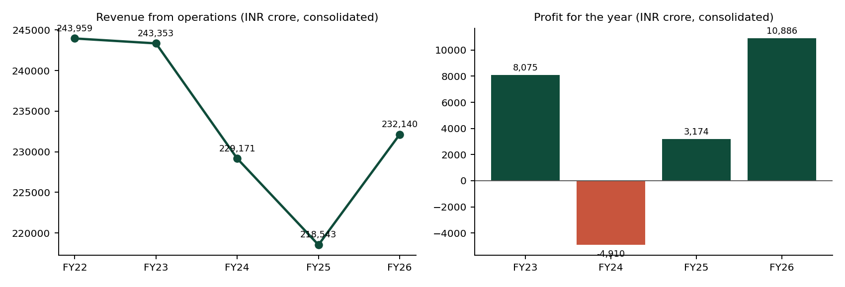
Figure 2: Revenue from operations and profit for the year, consolidated
Table 6: Key metrics, FY2025-26 (consolidated)
Measure (FY2025-26, consolidated) | Value | Definition / source
Revenue from operations | 2,32,139.94 (+6.22% vs FY2024-25) | Statement of profit and loss, FY2025-26 report p. F144
Profit for the year | 10,885.82 (+242.99%) | Statement of profit and loss, p. F144
Total assets | 3,01,254.11 | Balance sheet, p. F142
Operating cash flow | 35,064.46 (+51.55%) | Cash flow statement
Current ratio | 0.75x (0.79x in FY2024-25, 0.72x in FY2023-24) | Total current assets / total current liabilities
Debt-to-equity | 0.82x (0.88x in FY2023-24) | (Non-current + current borrowings) / total equity
Interest coverage | 3.23x | Earnings before interest and tax / finance costs
Net profit margin / EBITDA margin | 4.69% / 14.96% | Profit for the year / revenue; EBITDA = profit before exceptional items and tax + finance costs + D&A - other income
Return on equity | 11.16% | Profit for the year / average total equity
Net debt | 81,320.61 (51,138.00 in FY2021-22) | Borrowings + lease liabilities - cash, other bank balances and current investments

9.1 Composite scores
Altman Z'' (book-equity version, used because market value is not in the reports) = 6.56·X1 + 3.26·X2 + 6.72·X3 + 1.05·X4, where X1 = working capital / total assets, X2 = retained earnings / total assets, X3 = EBIT / total assets and X4 = book equity / total liabilities; zones: above 2.60 safe, 1.10-2.60 grey, below 1.10 distress. Piotroski F counts nine pass/fail signals of profitability, leverage, liquidity and efficiency. Beneish M combines eight indices; a value above -1.78 flags possible earnings manipulation.
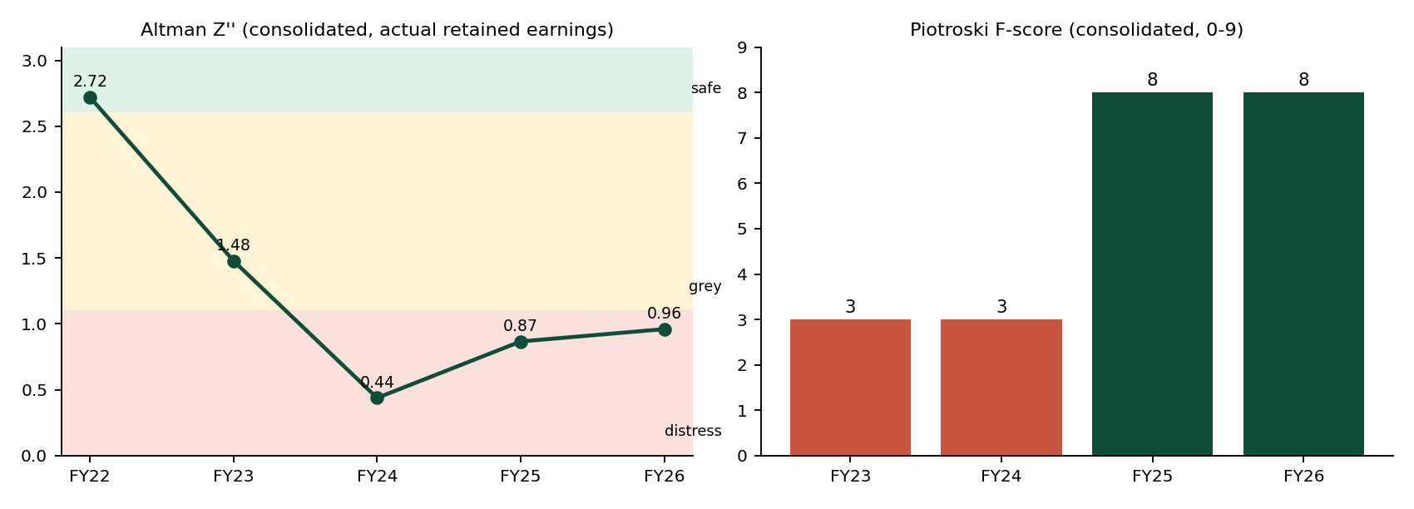
Figure 3: Altman Z'' zones and Piotroski F-score, consolidated
Table 7: Composite scores by year and scope
Score | FY2021-22 | FY2022-23 | FY2023-24 | FY2024-25 | FY2025-26
Altman Z'' consolidated | 2.7197 safe | 1.4781 grey | 0.4383 distress | 0.8666 distress | 0.9604 distress
Altman Z'' standalone | 3.2455 safe | 2.9008 safe | 3.0090 safe | 2.5227 grey | 2.4124 grey
Piotroski F consolidated | needs FY2020-21 | 3 weak | 3 weak | 8 strong | 8 strong
Piotroski F standalone | needs FY2020-21 | 3 weak | 4 weak | 5 average | 7 average
Beneish M consolidated | needs FY2020-21 | -2.9170 | -3.2359 | -2.9533 | -2.9793
Beneish M standalone | needs FY2020-21 | -2.2613 | -3.4646 | -2.7433 | -2.8691

The retained-earnings finding. An earlier version used "other equity" as a proxy for retained earnings, a common shortcut. During evaluation the agent cited the actual retained earnings from the "Other equity" note, which revealed that consolidated retained earnings are only about 37-47% of other equity (the rest is securities premium, general reserve and other reserves, and consolidated retained earnings were reduced by pension remeasurement losses). With the page-verified figure, X2 falls by about 0.2 and consolidated Z'' moves from the grey to the distress zone for FY2023-24 to FY2025-26 (for FY2025-26, from 1.6232 to 0.9604). The proxy therefore changed the conclusion, and the verified value is now used.
Reading. Profitability and operating quality recovered strongly after the FY2023-24 loss (Piotroski 3 → 8; profit 10,885.82 in FY2025-26), but balance-sheet strength did not: current liabilities exceed current assets in every year (negative X1; current ratio 0.75x) and leverage remains material, which keeps the consolidated Altman score in the distress zone. The standalone company is stronger (grey to safe zone). No year is flagged by Beneish M.

9.2 Segments and regions
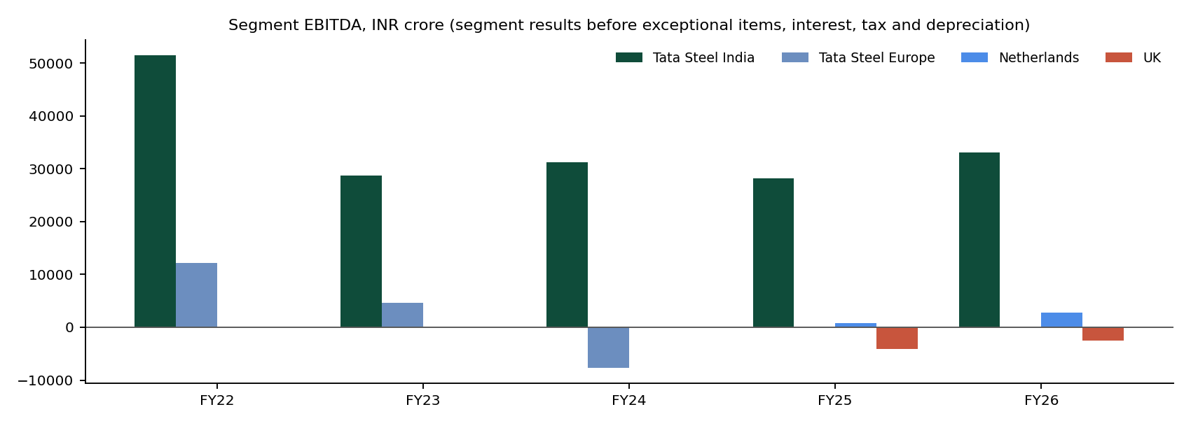
Figure 4: Segment EBITDA by year (Europe until FY2023-24; Netherlands and UK from FY2024-25)
Table 8: Segment results before exceptional items, interest, tax and depreciation (R = restated)
Segment EBITDA (INR crore) | FY2021-22 | FY2022-23 | FY2023-24 | FY2024-25 | FY2025-26
Tata Steel India | 51,456.30 | 28,753.76 R | 31,166.78 R | 28,217.36 | 33,035.63
Neelachal Ispat Nigam Limited | not a segment | -773.23 | 52.88 | 1,067.17 | 1,236.29
Tata Steel Europe | 12,163.85 | 4,632.06 | -7,612.44 | split | split
Tata Steel Netherlands | within Europe | within Europe | within Europe | 825.38 | 2,721.52
Tata Steel UK | within Europe | within Europe | within Europe | -4,134.20 | -2,568.99
South-East Asia | 1,255.26 | 473.64 | 109.53 | 131.61 | 774.55
Total (after eliminations) | 63,829.58 | 32,697.51 | 23,401.66 | 25,801.80 | 34,847.73

India is the profit engine; Europe's swing from 12,163.85 in FY2021-22 to -7,612.44 in FY2023-24 is the main driver of the FY2023-24 group loss, and the UK remains loss-making after the split. For the dashboard's region filter, segments are grouped into regions (India, Netherlands, UK, Europe, South-East Asia, rest of the world) and the backend computes each region's EBITDA margin and share of group revenue and EBITDA; in every year the regions plus eliminations reconcile exactly to the group total (for example FY2025-26: 35,679.67 - 831.94 = 34,847.73).

10. Backend API
The FastAPI backend exposes the system to the frontend and to any client. All money values are INR crore; fiscal years are written "FY2025-26"; every response that carries figures also carries their sources.
Table 9: Backend endpoints
Endpoint | Purpose
GET /api/health | Status, model, index size (4,393 points) and reports.
POST /api/ask | Question (and optional conversation history) → answer in Markdown, verification status, citations with PDF links, the steps used, model and time.
GET /api/financials, /api/items | Canonical items with values, sources and same-basis year-on-year changes; the list of items.
GET /api/metrics | Current ratio, debt-to-equity, interest coverage, net margin, EBITDA margin, ROE and net debt for every year.
GET /api/scores | Altman Z'', Piotroski F and Beneish M by year, with components, inputs and proxies.
GET /api/segments, /api/regions | Segment data by year; regional aggregates with margins, shares and reconciliation.
GET /api/statements, /api/statement-pdf | Pages of each primary statement per year and scope; a PDF containing only that statement.
GET /api/pdf/{report} | The locally stored report PDF (citations open it at the cited page).
GET /api/company, /api/evaluation, /api/reports | Page-verified company facts; the latest full evaluation run; the four reports.

The backend has 93 automated tests (pytest) covering the scores, segments, regions, PDF and statement endpoints, the company facts, and the agent's verification functions, all without network or model calls.

11. Frontend: the Edith application
The frontend was designed by the teammate as a React prototype named "Edith": a dark green header and footer, teal-to-blue accents, pastel cards and a clean sans-serif typography, with Home, Ask Edith, Dashboard and Evaluation pages. It was initially static, with honest placeholders and no connection to data. It was then connected to the live API and completed without changing its design: every new element reuses her classes, colours and components, and her sections were preserved.

11.1 Home
The hero introduces Edith and fits on one screen at 100% zoom. Below it, "Tata Steel at a glance" has a year selector, five live KPI tiles (revenue and profit with their year-on-year change, net debt, Altman Z'' with its zone and Piotroski F), five page-verified facts about the company and a short factual summary of the selected year built only from API values, followed by two example questions.
[ INSERT SCREENSHOT ]
Screenshot 1: Home page hero, with the public tunnel URL visible in the address bar
Figure 5: Home page: hero (deployed, public link)
[ INSERT SCREENSHOT ]
Screenshot 2: "Tata Steel at a glance": About Tata Steel facts and the five KPI tiles
Figure 6: Home page: live KPIs and page-verified company facts
[ INSERT SCREENSHOT ]
Screenshot 3: "How its financials look" summary and the "Try asking" questions
Figure 7: Home page: year summary and example questions

11.2 Ask Edith
A full-height chat layout with a sidebar of short suggested questions (profit trend, DuPont, composite scores, segments, overall verdict and a refusal test) and recent conversations. Each answer is rendered with its tables and shows a verification badge (for example "Verified · 61/61 figures"), citation chips that open the report at the cited page, and a collapsible list of the steps used, with the model and time. Follow-up questions use the conversation, and answers can be copied or cancelled.
[ INSERT SCREENSHOT ]
Screenshot 4: Ask Edith welcome screen with the full-height sidebar
Figure 8: Ask Edith: welcome screen and suggestions
[ INSERT SCREENSHOT ]
Screenshot 5: the DuPont answer with its verification badge and tables
Figure 9: Ask Edith: DuPont analysis answer, fully verified
[ INSERT SCREENSHOT ]
Screenshot 6: citation chips and the expanded "How this answer was produced" section
Figure 10: Ask Edith: citations and the steps behind an answer
[ INSERT SCREENSHOT ]
Screenshot 7: "What was the consolidated current ratio in FY2025-26?" followed by "And in FY2023-24?"
Figure 11: Ask Edith: a follow-up question resolved from the conversation
[ INSERT SCREENSHOT ]
Screenshot 8: "What will Tata Steel's revenue be in FY2027-28?" refused
Figure 12: Ask Edith: refusal of a question the reports cannot answer
[ INSERT SCREENSHOT ]
Screenshot 9: a citation opened in the report PDF at the cited page
Figure 13: A citation opening the source page in the locally served PDF

11.3 Dashboard
A control bar selects the reporting basis (consolidated or standalone), the year (FY2021-22 to FY2025-26) and the region. All cards follow the selection: metric cards with year-on-year change, a five-year chart with the selected year highlighted, six ratios with trend lines, composite scores, a financial-health summary with a button that asks Edith for the full verdict, segments (revenue or EBITDA) and statement coverage, whose links open a PDF containing only that statement. Missing values state their reason, for example "Reported within Europe then" or "Needs FY2020-21 data"; selecting the UK for FY2022-23 explains that the UK was reported within Tata Steel Europe until FY2023-24 and offers to show Europe instead.
[ INSERT SCREENSHOT ]
Screenshot 10: Dashboard top: filters, KPI cards, chart and ratios
Figure 14: Dashboard: filters, KPIs, performance chart and ratios
[ INSERT SCREENSHOT ]
Screenshot 11: composite scores table and financial-health summary
Figure 15: Dashboard: composite scores and financial-health summary
[ INSERT SCREENSHOT ]
Screenshot 12: segments table and the region view for United Kingdom, FY2022-23
Figure 16: Dashboard: segments and the region view with its explanation
[ INSERT SCREENSHOT ]
Screenshot 13: a statement-coverage link opened as a statement-only PDF
Figure 17: Dashboard: statement-only PDF (only the selected statement's pages)

11.4 Evaluation and Sources
The Evaluation page shows the latest full evaluation run: the headline numeric score, the five measures, results by question category with a filter, and a review queue with the known limitations. The Sources page lists the four reports (served locally, with the official link), explains how FY2021-22 is covered, describes the six-step method from parsing to citation, and states the limitations.
[ INSERT SCREENSHOT ]
Screenshot 14: Evaluation page
Figure 18: Evaluation page with the live results
[ INSERT SCREENSHOT ]
Screenshot 15: Sources page
Figure 19: Sources and methodology page

11.5 Readability
After two rounds of review by the team, readability was measured rather than judged by eye: an automated audit in headless Chrome measured the font size of every visible text element (3,003 elements across all pages and states). Before the final round, 2,796 elements at 1366×768 were below the agreed minimums (18 px body text, 15 px secondary text, 13 px labels); after it, zero at both 1366×768 and 1920×1080.

12. Evaluation

12.1 Question set and answer key
The evaluation set (eval/questions.json, built by eval/build_questions.py) has 32 questions in 13 categories, designed to exercise every capability and failure mode: lookups (6), table-grounded (1), trends (3), ratios (5), year-on-year (2), composite analysis (4), segments (1), risk evolution (1), narrative (2), a scope trap (1), abstention (3), a verdict (1) and follow-ups using conversation history (2). Expected numbers are computed from the verified data, and every raw input behind every expected answer was located in the text of its cited PDF page: 118 of 118 found. This makes the answer key independent of the system under test.

12.2 Scoring tiers
Table 10: Evaluation tiers
Tier | What it measures | How
1. Filtered retrieval | Whether search finds the right page | Search only, correct filters given; Hit Rate@4 and MRR against the expected page labels
2a. Numeric accuracy | Whether the answer contains the expected numbers | Every expected number must appear (tolerant to rounding, x100 and ÷100 forms)
2b. Citations | Whether the right sources were retrieved and cited | Expected page labels among the pages retrieved and those cited in the answer
2c. Abstention | Refuse only what cannot be answered | Refusal detected by phrasing on the three traps; no refusal elsewhere
2d. Grounding | Whether every number in the answer is supported | The same checker the system uses, reported per answer

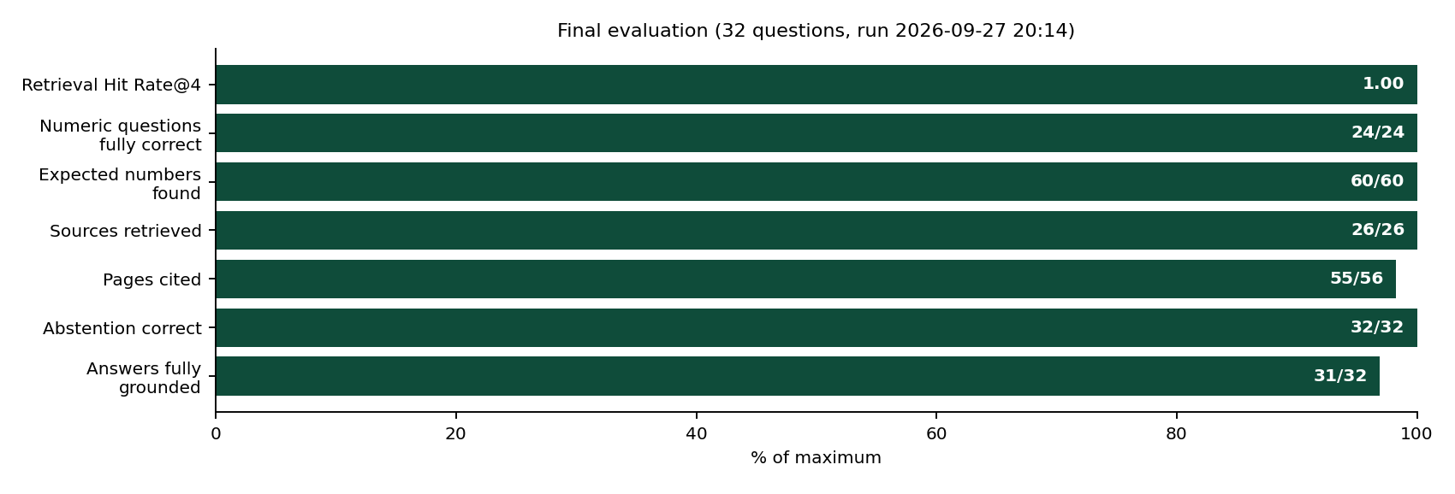
Figure 20: Final evaluation results
The final run (27 September 2026, 20:14) achieved 24/24 numeric questions fully correct with 60/60 expected numbers, 26/26 questions retrieving their source pages and 55/56 expected pages cited, 32/32 correct abstention and 31/32 answers fully grounded, at 10 seconds and 2.6 tool calls per answer on average. The one answer that is not fully grounded is I1, the overall verdict (168 of 178 figures matched): the longest answer, with 11 tool calls. The per-question results are listed in Appendix A.
[ INSERT SCREENSHOT ]
Screenshot 16: terminal with the evaluation summary (tail -12 eval/results/full_run_final5.log)
Figure 21: Terminal: final evaluation summary

12.3 Qualitative (hand-graded) results
Table 11: Hand-graded questions
Question | Grade | Notes
F1 segment EBITDA | Correct | India 33,035.63; Netherlands 2,721.52; UK (2,568.99); reconciles to 34,847.73.
G3 key audit matters | Correct | Both key audit matters identified, with page F131.
I1 overall verdict | Correct | Covers liquidity, leverage, profitability and cash flow; 168/178 figures matched.
G1 risk evolution | Method correct, conclusions unreliable | Compares named risks from both reports, but called some risks new that FY2022-23 also discusses.
G2 UK losses | Partial | Correct segment figures and government support; misattributed an Indian labour-code charge and omitted the electric-arc-furnace transition.

12.4 Error analysis: failures traced to their true cause
Every failure found during development was traced to its root cause before being fixed. Several apparent reasoning errors turned out to be data or checker problems, and one apparent pass hid a real error:
- F1 "segment EBITDA not disclosed". Four layers: the report calls it "segment results before exceptional items, interest, tax and depreciation"; the search result was truncated at 2,500 characters with the row at character 3,416; after compaction the table's two stacked year rows, with a split label, pointed the model to the prior year; a rule was not enough, so the data was fixed by stamping each stacked row with its fiscal year (verified by the external-revenue total 2,32,139.94).
- A5 wrong year. "As at 31 March 2024" was mapped to FY2024-25; fixed with an explicit fiscal-year convention in the prompt and in tool outputs.
- E1 scored 2/6. The scorer did not recognise 81.636% as 0.8164x; the scorer now compares percentage and fraction forms.
- H2, H4 "failed" abstention. Correct refusals phrased as "cannot be provided" were not recognised by the scorer's refusal detector.
- Unverified "-31", "-26", "1254.11". Checker artefacts: dates, bare year ranges and Indian lakh spacing ("3 01 254.11") were split into wrong numbers.
- E2 Altman 3.31. The model mixed the original five-variable Altman Z into Z''; composite scores are now only allowed from compute_scores.
- DuPont partially verified. Numbers typed into the calculator counted as verified; a dupont tool now returns every intermediate value and calculator inputs are no longer trusted.
- B3 EBITDA margin 14.07% instead of 14.96%. Exposed by the stricter checker: the model rebuilt profit before exceptional items from profit before tax with the sign of exceptional items reversed; margins must now use the reported subtotal.

13. Deployment and execution environment
The complete application runs from one command on the college machine: docker compose --profile full up -d --build. Four containers start: qdrant (vector database, its storage bound to a folder on disk), backend (FastAPI, reading the verified data read-only, with models loaded offline), frontend (the production build served by nginx, which proxies /api/ to the backend with a 300-second timeout) and tunnel (a Cloudflare quick tunnel that publishes the frontend at a public HTTPS address). Ports are bound to localhost only, so nothing is exposed on the college network except through the tunnel.
Table 12: Execution environment
Item | Value
Machine | College PC, hostname "ashok"
IP address (LAN) | 192.240.4.105
Public IP (outbound) | 203.122.28.226
Operating system | Ubuntu 22.04.5 LTS
Hardware | 28 CPU cores, 62 GiB RAM, no GPU (all parsing and embedding on CPU)
Python / Node | Python 3.11 and Node.js 22 in a Conda environment inside the project folder
Key software | Docling 2.130.0, PyMuPDF 1.28.2, PyTorch 2.14.0 (CPU), fastembed 0.8.1, qdrant-client 1.19.1, FastAPI 0.141.1, React 19, Vite 8
Language model | gpt-oss:120b via Ollama Cloud (fallback gemma4:31b); API key kept in .env, never committed
Public access | https://<random>.trycloudflare.com (printed by the tunnel container; changes on each start)

[ INSERT SCREENSHOT ]
Screenshot 17: terminal with docker compose ps (four containers running) and the pytest result (93 passed)
Figure 22: Terminal: running containers and test results
Installation steps for the parsing software and the full pipeline are in INSTALL_PARSING.md, and the exact environment is in requirements-full.txt. Two reliability issues were solved during deployment: Tata Steel's website blocks direct PDF links (HTTP 403), so the backend serves local copies; and the backend crashed on the college network while the embedding library checked for model updates online, so models are loaded offline (a mismatch between the library and the published BM25 model, which lists two files the model does not contain, was diagnosed and handled).

14. Development process and tools
Platform: neither VS Code nor Antigravity. Development took place in the Ubuntu terminal of the execution machine with two AI tools:
- Claude (chat assistant): the design, the step-by-step construction of the pipeline, index, agent, API, evaluation and deployment, every diagnosis from real output, and the independent verification of all results.
- Claude Code (Anthropic's agentic coding tool, version 2.1.283, model Opus 5.5, run in the terminal): seven well-specified tasks where an agent can plan, implement, test and iterate on its own. Each was given a written brief with a definition of done and strict boundaries (no git, no access to keys, limited model calls), and each result was verified independently before being committed.
Table 13: Claude Code tasks
Task | Scope | Time | Independent verification
01 | Composite scores module, agent tool, API endpoint, 32 tests | 5 min 48 s | Altman Z'' recomputed by hand (1.6232); all nine Piotroski signals checked against known figures
02 | Page-verified retained earnings for Altman X2 | 3 min 51 s | Values located directly on the PDF pages; Z'' recomputed (0.9604)
03 | Segment results for all years | 6 min 58 s | Four values located on pages of four reports; every year reconciles to the total
04 | Frontend connected to the live API | 20 min 10 s | On-screen review by the team, page by page
05 | Local PDFs, statement PDFs, regions, facts, DuPont, stricter grounding | 13 min 34 s | Endpoints tested live; full evaluation re-run
06 | 33 frontend review items | 13 min 54 s | On-screen review by the team
07 | Readability and layout | 14 min 20 s | Font-size audit: 2,796 → 0 elements below the minimum

The seven briefs and the exact instructions typed into Claude Code are in docs/claude_code/ and PROMPTS.md; how each result was verified is recorded in docs/claude_code/README.md. The independent checks mattered: in task 01 the check confirmed the code and found a small arithmetic slip in the brief itself, and task 02 was triggered by an evaluation finding that changed the analytical conclusion.

15. Security, limitations and future work

15.1 Security and reliability
- The model API key lives only in a local .env file (never committed) and inside the running containers; the containers are removed at the end of each session on the shared machine.
- All service ports are bound to localhost; only the tunnel publishes the application.
- The backend starts without network access to model repositories; PDFs are served locally.

15.2 Limitations
- Annual data only; quarterly analysis would need Tata Steel's quarterly results filings, reconciled to the annual figures.
- Comparing long narrative sections (risk evolution, management explanations) is the weakest capability (G1, G2).
- Altman Z'' uses book equity because market value is not in the reports; other disclosed proxies are listed in docs/SCORES.md.
- FY2021-22 has no two-year scores (Piotroski F, Beneish M) because FY2020-21 is outside the four reports.
- Answers take about 10-60 seconds (the first may take 2-3 minutes on a cold model); the quick-tunnel address changes on each start.

15.3 Future work
- Add quarterly results with a four-quarters-equal-the-year check.
- Stronger narrative comparison: structured extraction of named risks per report before comparison.
- A named Cloudflare tunnel with a fixed address, and streaming of the agent's steps to the chat while it works.
- Extend to peer companies for comparative analysis, using the same verified pipeline.

16. Conclusion
Edith shows that a RAG system can be trusted with financial figures when the language model is used for what it does well (understanding the question, choosing the right analysis, explaining the result) and deterministic, verified components do everything else. Statement figures pass accounting identities before use; every ratio, change and score is computed in code; every number in an answer is matched to its source and cited to a page; and the system refuses what the reports cannot support. The evaluation, with an answer key verified against the PDFs, confirms this: all numeric questions correct, all abstentions correct, and all but one answer fully grounded under strict checking.
Equally important was the process: every failure was traced to its true cause, several apparent reasoning errors turned out to be data or checker problems, and the stricter checker caught a real error that a looser one had let through. The analysis also produced a genuine insight, the Altman distress classification that a common proxy would have hidden. The system is complete end to end, from the PDFs to a deployed, public web application.

Appendix A: Per-question results (final run)
Table 14: Per-question results of the final run (run_20260927_2014)
ID | Category | Question (abridged) | Numeric | Cited | Grounded | Sec
A1 | lookup | Consolidated revenue from operations, FY2025-26 | 1/1 | 1/1 | 1/1 | 4
A2 | lookup | Consolidated total assets, 31 March 2026 | 1/1 | 1/1 | 1/1 | 4
A3 | lookup | Standalone profit for the year, FY2025-26 | 1/1 | 1/1 | 2/2 | 4
A4 | lookup | Consolidated non-current borrowings, 31 March 2026 | 1/1 | 1/1 | 1/1 | 3
A5 | lookup | Consolidated inventories, 31 March 2024 | 1/1 | 1/1 | 1/1 | 3
A6 | lookup | Consolidated finance costs, FY2023-24 | 1/1 | 1/1 | 1/1 | 3
A7 | table | Trade payables, 31 March 2026, and components | 4/4 | 1/1 | 5/5 | 5
B1 | trend | Revenue FY2021-22 to FY2025-26 and trend | 5/5 | 4/4 | 16/16 | 12
B2 | trend | Net profit margin FY2022-23 to FY2025-26 | 4/4 | 3/3 | 22/22 | 17
B3 | trend | EBITDA margin FY2022-23 to FY2025-26 (stated definition) | 4/4 | 3/3 | 48/48 | 19
C1 | ratio | Current ratio, each year FY2022-23 to FY2025-26 | 4/4 | 6/6 | 160/160 | 21
C2 | ratio | Debt-to-equity, each year | 4/4 | 3/3 | 50/50 | 23
C3 | ratio | Interest coverage, each year | 4/4 | 3/3 | 26/26 | 8
C4 | ratio | ROE FY2025-26 on average equity | 1/1 | 2/2 | 12/12 | 15
C5 | ratio | Receivable days, FY2024-25 and FY2025-26 | 2/2 | 2/2 | 15/15 | 12
D1 | yoy | Change in total borrowings, FY2024-25 to FY2025-26 | 4/4 | 1/1 | 24/24 | 11
D2 | yoy | Standalone vs consolidated revenue growth, FY2025-26 | 2/2 | 2/2 | 18/18 | 9
E1 | composite | DuPont ROE, FY2023-24 and FY2025-26 | 6/6 | 6/6 | 94/94 | 8
E2 | composite | Altman Z'', FY2024-25 and FY2025-26, with zone | 2/2 | 3/3 | 31/31 | 7
E3 | composite | Piotroski F, FY2025-26 | 8/9 strong ✓ | 2/3 | 18/18 | 10
E4 | composite | Beneish M, FY2025-26 | 1/1 | 2/2 | 11/11 | 6
F1 | segment | EBITDA of India, Netherlands and UK segments, FY2025-26 | 3/3 | 1/1 | 3/3 | 5
G1 | risk | New risks in FY2025-26 vs FY2022-23 | hand-graded | - | 0/0 | 13
G2 | narrative | Management's explanation of UK losses | hand-graded | - | 16/16 | 27
G3 | narrative | Key audit matters, FY2025-26 consolidated | hand-graded | 1/1 | 3/3 | 12
H1 | scope trap | "Revenue in FY2025-26" (scope stated) | 1/1 | 1/1 | 1/1 | 4
H2 | abstain | Revenue in FY2027-28 (forecast): refused | refused ✓ | - | 0/0 | 6
H3 | abstain | JSW Steel's total debt: refused | refused ✓ | - | 0/0 | 4
H4 | abstain | Revenue in FY2009-10: refused | refused ✓ | - | 0/0 | 2
I1 | verdict | Overall financial-health verdict, FY2022-23 to FY2025-26 | hand-graded | - | 168/178 | 38
J1 | follow-up | "And in FY2023-24?" (after current ratio) | 1/1 | 2/2 | 7/7 | 8
J2 | follow-up | "How much did it grow?" (after revenue) | 2/2 | 1/1 | 4/4 | 4

Appendix B: Submission checklist
Table 15: Where each submission item is
Requirement | Where
a) Prompts used with coding agents | PROMPTS.md; the seven briefs in docs/claude_code/TASK_01 to TASK_07
b) Platform used | Claude Code in the Ubuntu terminal, with the Claude chat assistant; not VS Code or Antigravity (section 14)
c) Full code | financial-rag.zip (repository snapshot; data, index and keys excluded); GitHub repository financial-rag
d) Installation steps for parsing software | INSTALL_PARSING.md and requirements-full.txt
e) IP of the machine executing the project | 192.240.4.105 (LAN), 203.122.28.226 (public); section 13
f) Report on architecture and results | This document

Repository structure
Table 16: Repository structure
Folder / file | Contents
scripts/ | Report download, Docling benchmark, model bake-off
src/ingest/ | Page map, Docling runner, statement parser, retained earnings, segments, company facts, chunk builder
src/analysis/ | Canonical items, composite scores, segments, regions
src/index/, src/retrieval/ | Qdrant index builder; hybrid search
src/agent/ | Agent loop, verification, tools
src/api/ | FastAPI application
frontend/ | The Edith React application, Dockerfile and nginx configuration
eval/ | Question builder, runner, results and evaluation notes
tests/ | 93 automated tests
docs/ | API contract, scores, segments, Claude Code briefs and write-up
Dockerfile, docker-compose.yml | Backend image and the four-service deployment

