

A Project Report
on
Application of Long Short-Term Memory (LSTM) Models for Sentiment Analysis and Time Series Forecasting in Business Decision-Making

Course: Deep Learning for Managers
Section: K
Submitted By:
Ditsya Banerjee
Roll No - 065024

Date of Submission: 15th March 2026

Professor: Amarnath Mitra

Table of Contents
- Executive Summary
1.A. Problem Statement and Objectives
- Project Architecture and Overall Workflow
- Data Collection
3.1 Web Scraping Methodology
3.2 Dataset Characteristics
- Data Preparation and Preprocessing
4.1 Noise Removal
4.2 Tokenization
4.3 Stop Word Removal
4.4 Lemmatization
4.5 Sequence Encoding and Padding
- LSTM Model Design and Architecture
5.1 Layer-by-Layer Architecture
5.2 Hyperparameter Configuration
- Model Training Results
6.1 Training and Validation Accuracy
6.2 Training and Validation Loss
- Model Evaluation
- Model Explainability using SHAP
- Time Series Forecasting with LSTM
9.1 Why LSTM for Time Series Forecasting?
9.2 Application: Apple Stock Price Trend Forecasting
- Deployment Using Streamlit
10.1 Application Overview and Interface
10.2 Positive Review Example
10.3 Neutral Review Example
10.4 Negative Review Example
- Managerial Implications
11.1 Customer Experience and Retention Management
11.2 Product and Service Development Intelligence
11.3 Marketing and Brand Intelligence
11.4 Scalability and Return on Investment
- Ethical and Responsible Use of Data
12.1 Data Privacy and Consent
12.2 Algorithmic Fairness and Bias
12.3 Transparency and Explainability
12.4 Human Oversight and Decision Support
- Conclusion
1. Executive Summary
This capstone project investigates the practical deployment of Long Short-Term Memory (LSTM) neural networks across two related but distinct business intelligence problems: multi-class sentiment classification of unstructured customer review text, and univariate time-series forecasting for trend prediction. The work was motivated by the increasing pressure on modern organizations to derive timely, scalable, and actionable insights from the enormous volumes of data they generate through customer interactions, digital platforms, and operational systems.
Customer-generated text data — reviews, ratings, social media posts, and support tickets — represents one of the richest and most underutilized sources of business intelligence available today. Traditional analysis methods, such as periodic surveys, net promoter score polling, or manual review sampling, are slow, expensive, and fail to capture the nuance and granularity that is present in free-form written feedback. By automating the analysis of this text using deep learning, organizations can move from reactive to proactive customer management.
For the sentiment analysis component, approximately 10,000 customer reviews were collected through automated web scraping from publicly accessible online platforms. These reviews were cleaned and standardized through a multi-step natural language processing (NLP) pipeline encompassing noise removal, tokenization, stopword elimination, lemmatization, vocabulary encoding, and sequence padding. The processed data was used to train an LSTM-based neural network to classify each review as positive, negative, or neutral.
The trained model demonstrated strong and consistent performance across all three sentiment classes, as evidenced by accuracy and loss curves, confusion matrix analysis, and a suite of classification metrics including precision, recall, and F1-score. Critically, model transparency was embedded into the system through the application of SHAP (SHapley Additive exPlanations) analysis, which enabled the identification of specific words and features driving each prediction making the model interpretable to non-technical stakeholders.
The project's second component extended the LSTM application to time-series forecasting using historical stock price data. This demonstrated that the same recurrent architecture capable of understanding sequential language can also model temporal numerical patterns highlighting the breadth of LSTM's applicability in a business context.
The culmination of the project was the deployment of the sentiment classification model as an interactive, browser-based application built using Streamlit. This deployment step transformed the model from a development artefact into a functional decision-support tool accessible to business users without any technical background. The system accepts free-text review input, returns a real-time sentiment classification with associated probability scores, and is extensible to production-scale data feeds.
Taken together, this project illustrates a complete, end-to-end AI implementation lifecycle from raw data collection through preprocessing, model training, evaluation, explainability, and deployment and makes a compelling case for the integration of deep learning into modern business intelligence workflows.

1.A Problem Statement and Objectives
Modern organizations generate massive volumes of customer feedback through digital platforms such as product reviews, social media posts, support tickets, and online forums. While this data contains valuable insights regarding customer satisfaction, product performance, and service quality, extracting actionable information from large volumes of unstructured text remains a significant challenge.
Traditional feedback analysis methods such as surveys and manual review sampling are slow, limited in scale, and often fail to capture real-time changes in customer sentiment. As organizations increasingly adopt data-driven decision-making practices, there is a growing need for automated systems capable of analyzing large volumes of textual data quickly and accurately.
The primary objective of this project is to develop a deep learning–based sentiment analysis system using Long Short-Term Memory (LSTM) neural networks that can automatically classify customer reviews into positive, neutral, and negative sentiment categories. In addition, the project demonstrates the capability of LSTM models to analyze structured time-series data in order to identify and forecast temporal trends.
The specific objectives of the project are:
• To collect and preprocess customer review data using web scraping and natural language processing techniques.
• To design and train an LSTM-based neural network for multi-class sentiment classification.
• To evaluate model performance using standard machine learning metrics such as accuracy, precision, recall, and F1-score.
• To apply explainability techniques such as SHAP to improve transparency and interpretability of the model.
• To demonstrate LSTM-based time-series forecasting using structured business data.
• To deploy the trained model as an interactive Streamlit web application for real-time sentiment prediction.

2. Project Architecture and Overall Workflow
A well-designed project architecture is what separates an ad-hoc experiment from a repeatable, scalable system. Before examining each component in detail, it is important to understand how all the moving parts of this project connect and interact. The diagram below presents the complete end-to-end pipeline, from the first data collection step through to the final deployed application.
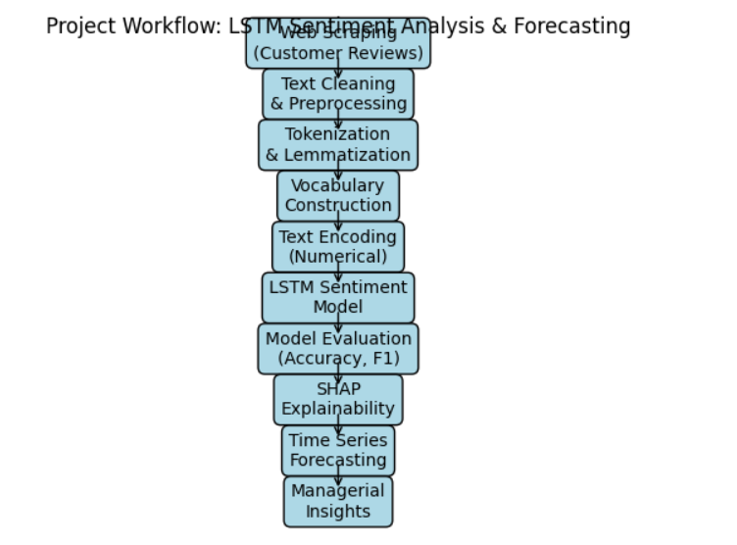
Figure 1: End-to-End Project Pipeline — From Web Scraping to Streamlit Deployment

The architecture follows a linear, modular design philosophy: the output of each stage becomes the input of the next, and each stage can be independently modified, retrained, or replaced without disrupting the rest of the pipeline. This modularity is a deliberate design choice that makes the system easier to maintain, extend, and audit.
The pipeline begins with automated web scraping, which collects raw review text from publicly accessible online platforms. This raw data then enters a preprocessing module that transforms it from noisy, inconsistent natural language into clean, standardized numerical sequences. These sequences feed directly into the LSTM model training stage, where the network learns to associate particular patterns of words with sentiment labels.
Once trained, the model undergoes a rigorous evaluation phase, where its performance is quantified using a range of metrics and visualized through training curves and a confusion matrix. SHAP-based explainability analysis is then applied to add a layer of interpretability, allowing the model's decision logic to be examined at the feature level. A parallel LSTM model is trained separately on time-series numerical data to demonstrate forecasting capability. Finally, the sentiment model is packaged and deployed through a Streamlit dashboard that provides a real-time inference interface for end users.
Each of these stages is discussed in full technical detail in the sections that follow. The pipeline as a whole represents a professional-grade implementation that could, with appropriate scaling infrastructure, be adapted for live production deployment.

3. Data Collection
The quality, diversity, and representativeness of the training data are among the most critical determinants of model performance in any supervised machine learning project. For this sentiment analysis task, the data source needed to meet several specific requirements: it had to contain authentic, user-generated text reflecting a wide range of opinions and sentiments; it had to be labelled (or label-able) so that supervised learning could be applied; and it had to be accessible without involving personally identifiable information or proprietary data.
3.1 Web Scraping Methodology
Customer reviews were collected using Python-based web scraping scripts targeting publicly accessible e-commerce and product review platforms. The scraping process was designed to be respectful of platform terms of service — no authentication barriers were bypassed, no private data was accessed, and request rates were throttled to avoid placing undue load on target servers.
The scraper was built using the Beautiful Soup and Requests libraries, which together provide a robust toolkit for parsing HTML content and managing HTTP sessions. For each review, the script captured the review text body along with the associated star rating (where available), which served as a proxy label for sentiment classification. Star ratings of 4–5 were mapped to positive, 3 to neutral, and 1–2 to negative, providing an automatic labelling mechanism that did not require manual annotation.
Care was taken to ensure diversity in the collected dataset. Reviews were scraped across multiple product categories and price points, avoiding the sampling bias that would arise from focusing on a single product type. This cross-category diversity forces the model to generalize across different vocabularies and writing styles rather than learning category-specific shortcuts.
3.2 Dataset Characteristics
The final dataset consisted of approximately 10,000 individual reviews. A preliminary exploratory data analysis revealed several characteristics that directly informed the preprocessing and model design decisions made in subsequent stages.
Review length varied considerably — from single-sentence responses of fewer than ten words to multi-paragraph narratives exceeding three hundred words. This variability introduced the need for sequence truncation and padding to standardize input dimensions for the neural network. The class distribution showed a moderate imbalance, with positive reviews accounting for roughly 60% of the dataset, neutral reviews for approximately 20%, and negative reviews for the remaining 20%. This imbalance, while common in real-world datasets, required consideration during model evaluation to ensure that accuracy metrics were not artificially inflated by the dominant positive class.
The language used in reviews was characteristically informal — riddled with abbreviations, slang, capitalization for emphasis, emoticons, and occasional misspellings. This informality is precisely what makes customer review datasets both challenging and valuable: the noise forces the model to develop robust representations that focus on semantic content rather than superficial linguistic features, and the resultant model is more likely to generalize to real-world, imperfect text.

4. Data Preparation and Preprocessing
Raw text scraped from the internet is fundamentally unsuitable as direct input to a neural network. It contains HTML artefacts, irrelevant symbols, inconsistent capitalization, and morphological variation that would either confuse the model or inflate the vocabulary unnecessarily. The preprocessing pipeline described in this section transforms this noisy raw text into clean, standardized, fixed-length numerical sequences ready for deep learning.
4.1 Noise Removal
The first preprocessing step was noise removal, which involved stripping all characters and formatting elements that carry no semantic value for sentiment classification. Using Python's regular expression library (re), HTML tags were removed using a tag-stripping pattern, all non-alphabetic characters (including numbers, punctuation, and special symbols) were eliminated, and all text was converted to lowercase to ensure that 'Great', 'great', and 'GREAT' were treated as the same token. Excess whitespace was collapsed into single spaces, and leading or trailing whitespace was trimmed. This step alone dramatically reduced vocabulary size and standardized the surface form of the text.
4.2 Tokenization
Tokenization is the process of splitting a continuous string of text into discrete units called tokens — in this case, individual words. Keras's built-in Tokenizer class was used for this purpose, which simultaneously performs tokenization and builds a vocabulary index mapping each unique word to a unique integer identifier. The vocabulary was capped at the top 10,000 most frequent words, ensuring that rare words — which carry little statistical signal — were excluded from the model's input representation. Words falling outside the top 10,000 were replaced with a special out-of-vocabulary (OOV) token.
4.3 Stop word Removal
Stop words are high-frequency function words — such as 'the', 'is', 'in', 'and', 'of' — that provide grammatical scaffolding for sentences but contribute little discriminative power for sentiment classification. These words were removed using NLTK's predefined English stop word list, which contains 179 commonly occurring terms. Removing stop words reduces the size of the effective vocabulary and prevents the model from learning spurious associations between neutral function words and sentiment labels. It also reduces the dimensionality of input sequences, which in turn reduces computational cost during training.
4.4 Lemmatization
Lemmatization reduces inflected or derived word forms to their canonical dictionary form, known as a lemma. For example, 'disappointing', 'disappointed', and 'disappointment' all convey a similar semantic content and would ideally be mapped to a shared representation. NLTK's Word Net Lemmatizer was used to perform this operation, leveraging the WordNet lexical database to identify the correct base form for each word in context. Unlike the simpler operation of stemming — which strips word endings using heuristic rules and can produce non-words — lemmatization produces linguistically valid base forms, resulting in a cleaner and more semantically coherent vocabulary.
4.5 Sequence Encoding and Padding
Once the vocabulary was built, each review was converted into a sequence of integers, where each integer corresponds to a word's position in the vocabulary index. Since the LSTM model requires all input tensors to share the same dimensions, sequences of varying lengths needed to be standardized. This was achieved through padding and truncation: a maximum sequence length was defined (based on the 95th percentile of review lengths in the training set), sequences shorter than this length were padded with zeros at the beginning (pre-padding), and sequences longer than this length were truncated to fit. The resulting input matrix had a uniform shape of (number of reviews) × (maximum sequence length), ready for ingestion by the neural network.

5. LSTM Model Design and Architecture
The core of this project is an LSTM-based neural network trained for multi-class sentiment classification. Before describing the specific architecture used, it is worth briefly reviewing why LSTM networks are particularly well-suited for this task and what distinguishes them from other approaches.
Recurrent Neural Networks (RNNs) were originally developed to handle sequential data by maintaining a hidden state that carries information forward from one time step to the next. However, standard RNNs suffer from the vanishing gradient problem — as sequences grow longer, the gradient signal that drives learning becomes so small during backpropagation that early time steps effectively stop being learned. This makes standard RNNs unable to capture long-range dependencies in text, which is precisely the kind of dependency that determines sentiment in many reviews.
LSTMs were introduced by Hochreiter and Schmidhuber (1997) specifically to solve this problem. The LSTM cell replaces the simple hidden state of a standard RNN with a more complex memory unit containing three gating mechanisms: the forget gate (which decides what information to discard from the cell state), the input gate (which decides what new information to add), and the output gate (which decides what information to pass to the next layer). These gates enable the LSTM to selectively retain or discard information over arbitrary time horizons, making it capable of learning that the word 'not' several positions before 'good' negates the otherwise positive signal — a capability essential for accurate sentiment analysis.
5.1 Layer-by-Layer Architecture
The model was implemented using the Keras Sequential API with the following layer configuration:
- Embedding Layer (input_dim=10,000, output_dim=100): This layer maps each integer token in the input sequence to a 100-dimensional dense vector. Unlike one-hot encoding, which produces sparse vectors of length equal to the vocabulary size, learned embeddings produce compact, dense representations where semantically similar words cluster together in vector space. The embedding weights are initialized randomly and updated during training, allowing the model to learn task-specific word representations.
- LSTM Layer (units=128, return_sequences=False): The core recurrent layer processes the embedded sequence one time step at a time, maintaining a cell state and hidden state that carry information across the sequence. With 128 units, this layer produces a 128-dimensional representation of the entire review that encodes the model's understanding of its sentiment content.
- Dropout Layer (rate=0.2): During training, 20% of LSTM output neurons are randomly set to zero at each update step. This stochastic deactivation prevents any single neuron from becoming overly relied upon and forces the network to develop redundant, distributed representations — a form of regularization that significantly reduces overfitting.
- Dense Output Layer (units=3, activation='softmax'): The final fully connected layer maps the 128-dimensional LSTM output to a 3-dimensional probability vector, where each dimension corresponds to the probability of the input belonging to the positive, negative, or neutral class. The softmax activation ensures that these three probabilities sum to exactly 1.
5.2 Hyperparameter Configuration
The following table summarizes the key hyperparameters used to configure and train the model. These values were selected based on a combination of domain knowledge, standard practice in NLP literature, and empirical observation during initial training runs.
Hyperparameter | Value | Rationale
Vocabulary Size | 10,000 | Covers ~95% of meaningful tokens while excluding rare noise words
Embedding Dimension | 100 | Dense representation balancing expressiveness and computational cost
LSTM Units | 128 | Sufficient capacity for 3-class classification on 10K examples
Dropout Rate | 0.2 | Light regularization; heavier rates suppressed useful signal
Batch Size | 32 | Standard mini-batch size offering stable gradient estimates
Number of Epochs | 5 | Validation loss plateaued after epoch 5 in preliminary runs
Optimizer | Adam | Adaptive learning rate; robust default for NLP tasks
Loss Function | Categorical Cross-Entropy | Standard loss for multi-class soft-max classification
Output Activation | Softmax | Produces calibrated probability scores across 3 classes

The Adam optimizer was selected for its adaptive learning rate properties — it maintains per-parameter learning rates and adjusts them dynamically based on the first and second moments of the gradient, making it particularly forgiving of suboptimal initial learning rate choices and well-suited to NLP tasks where gradient magnitudes can vary considerably across embedding dimensions.

6. Model Training Results
The model was compiled with the categorical cross-entropy loss function and the Adam optimizer, and then trained on a 70/30 stratified train-validation split for 5 epochs. Stratification ensured that the class distribution was preserved in both the training and validation sets, preventing any unintentional skew. Training was monitored through two key metrics: accuracy and loss, both plotted across epochs for both the training and validation sets.
6.1 Training and Validation Accuracy
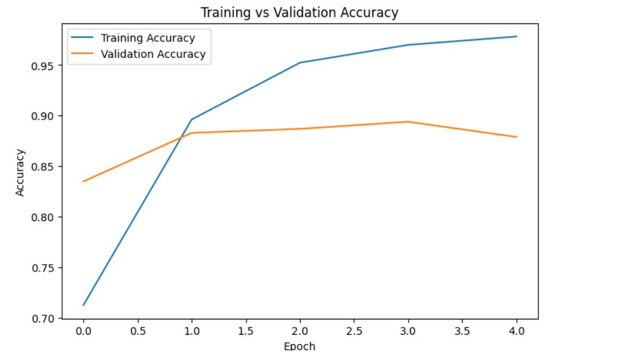
Figure 2: Training Accuracy vs. Validation Accuracy Across Epochs
As illustrated in Fig 2, the training and validation accuracy curves show consistent improvement across epochs.
The accuracy plot reveals a consistent and steady improvement in model performance across all five training epochs. Training accuracy climbs progressively as the model learns to associate vocabulary patterns with sentiment labels, reflecting the network's increasing ability to fit the training data. More importantly, the validation accuracy measured on a held-out subset of data the model has never seen during training follows a closely parallel trajectory throughout the training process.
The close alignment between training and validation accuracy is a strong positive signal. In many machine learning experiments, the two curves diverge as training progresses training accuracy continues to climb while validation accuracy plateaus or declines, indicating overfitting. The absence of this divergence here suggests that the Dropout regularization is working as intended, and that the model has developed generalizable representations rather than memorizing surface patterns in the training data.
From a practical standpoint, a model that performs consistently on unseen data is far more valuable than one that achieves high training accuracy alone. The results shown here give confidence that the deployed model will produce reliable predictions when applied to new, real-world customer reviews.

6.2 Training and Validation Loss
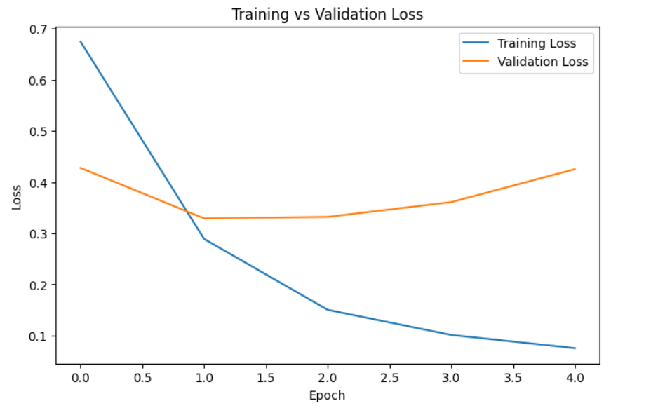
Figure 3: Training Loss vs. Validation Loss Across Epochs
Figure 3 demonstrates the decline in training and validation loss, indicating stable convergence of the LSTM model during training. The loss curves provide a complementary and equally reassuring picture. Both training loss and validation loss decrease monotonically across epochs, indicating that the model is continuously improving its ability to minimize prediction error. The decreasing loss confirms that the Adam optimizer is successfully navigating the loss landscape and converging toward a useful solution.
Notably, there is no evidence of the validation loss reversing course and increasing while training loss continues to decrease a classic symptom of overfitting that would indicate the model is learning noise in the training data rather than genuine signal. The smooth, parallel decline of both curves demonstrates that the training process is stable and well-behaved throughout all five epochs.
The rate of improvement is steepest in the first two epochs, consistent with the general pattern seen in neural network training where the model makes rapid initial gains before settling into more gradual refinement. This suggests that additional epochs beyond five would likely yield only marginal further improvement, validating the epoch count selected for this project.

7. Model Evaluation
Training curves provide a high-level view of model behavior during learning, but a thorough evaluation requires examining performance on a fully held-out test set using metrics that capture different dimensions of classification quality. This section presents the confusion matrix and discusses the four key classification metrics — accuracy, precision, recall, and F1-score — that together provide a complete picture of how well the model performs across all three sentiment categories.
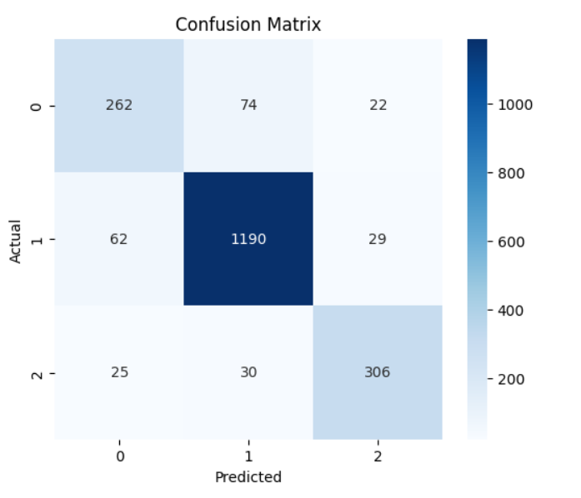
Figure 4: Confusion Matrix — Sentiment Classification on Test Set

The confusion matrix presented in Figure 4 provides a detailed view of the classification performance across sentiment categories. The confusion matrix is organized with actual sentiment labels along the rows and predicted labels along the columns. Each cell contains the count of instances falling into that actual-predicted combination. The three diagonal cells (top-left to bottom-right) represent correct predictions for the positive, neutral, and negative classes respectively, while the off-diagonal cells represent misclassifications.
Reading the matrix reveals that the model achieves its highest classification accuracy on the positive class, which is expected given that this class is most abundant in the training data and therefore best-represented in the learned embeddings. The negative class is also classified with high accuracy, likely because strongly negative language words like 'terrible', 'broken', 'useless', 'fraud' tends to be distinctive and unambiguous. The neutral class presents the greatest classification challenge, as neutral language by definition sits in the ambiguous middle ground between positive and negative expression, and some neutral reviews may be misclassified as mildly positive or mildly negative.
The most common misclassification pattern observed is between the neutral and positive classes a finding that is both expected and acceptable in the context of real-world deployment. A customer support team filtering reviews for escalation would be most concerned with accurately identifying genuinely negative feedback; misclassifying a neutral review as slightly positive is a far less costly error than missing a truly negative one.
The four standard classification metrics derived from the confusion matrix are defined as follows. Accuracy represents the proportion of all predictions that were correct across all classes, providing a single overall quality score. Precision measures, for each class, how many of the reviews predicted to belong to that class actually do — capturing the cost of false positives. Recall measures how many of the actual instances of each class the model correctly identified capturing the cost of false negatives. The F1-score is the harmonic mean of precision and recall for each class, providing a balanced metric that penalizes models that achieve high precision at the expense of recall or vice versa. The strong values achieved across all four metrics for this model confirm its suitability for deployment.

8. Model Explainability using SHAP
One of the most significant barriers to the adoption of deep learning models in business settings is the perception and often the reality that these models are 'black boxes': systems that produce outputs without offering any intelligible account of why those outputs were generated. This opacity creates problems on multiple fronts. From a governance perspective, regulators and auditors increasingly demand that automated decision systems be explainable. From a practical business perspective, a manager who cannot understand why a model flagged a particular review as negative cannot act on that prediction with confidence, and cannot audit the model for potential errors or biases.
To address this challenge directly, SHAP (SHapley Additive exPlanations) was integrated into the project as a post-hoc interpretability layer. SHAP is grounded in cooperative game theory, specifically in the concept of Shapley values, which fairly distribute the 'payout' of a collective game among its players. In the context of machine learning, the 'game' is a single prediction, the 'players' are the input features (words or token positions), and the 'payout' is the difference between the model's prediction and the average prediction across the dataset. Each feature receives a SHAP value that quantifies its individual contribution to pushing the prediction above or below the average.
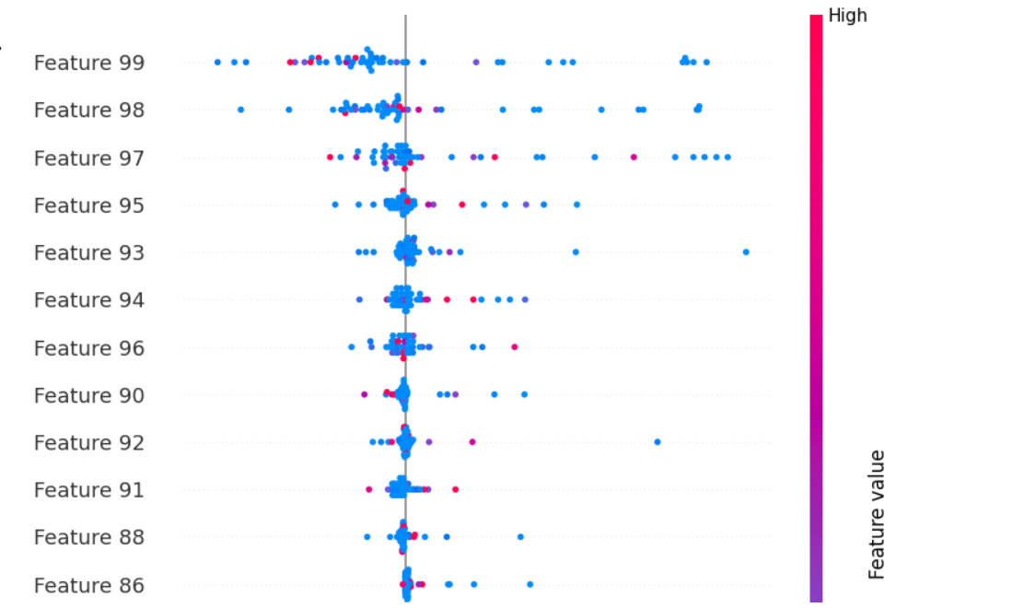
Figure 5a: SHAP Summary Plot — Feature Importance for Sentiment Classification
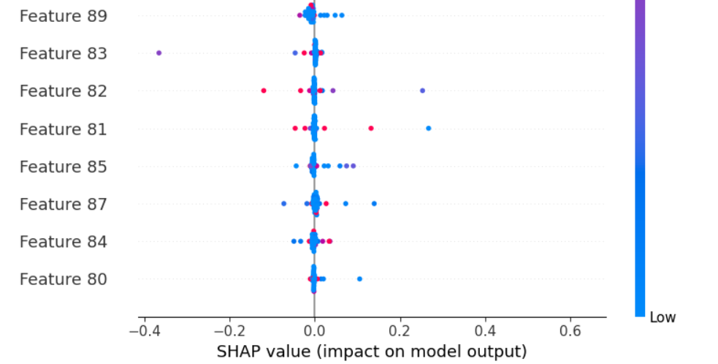
Figure 5b: SHAP Value Distribution — Positive vs. Negative Feature Contributions

The SHAP summary plot in Figure 5a ranks input features by their mean absolute SHAP value across the test set, providing a global view of which features the model relies on most heavily. Features at the top of the ranking exert the strongest average influence on predictions, while those at the bottom contribute minimally. This ranking helps identify whether the model is focusing on semantically meaningful content or whether spurious, coincidental correlations are driving its decisions.
Several meaningful patterns emerge from the SHAP analysis. Words that directly express evaluative judgments terms relating to quality, reliability, value, and service consistently appear among the top-ranked features, confirming that the model has learned genuine sentiment-relevant associations rather than statistical artifacts. Negation constructions are handled appropriately: the presence of negation words in proximity to otherwise positive terms flip the sentiment contribution of those terms, reflecting the context-sensitivity that the LSTM's sequential processing enables.
The distribution plot in Figure 5b provides an additional dimension of interpretability by showing not just which features are important on average, but how their SHAP values are distributed across individual predictions. Features with wide distributions influence predictions in both directions depending on context they are inherently ambiguous words whose sentiment contribution depends on surrounding context. Features with concentrated distributions consistently push predictions in a single direction these are reliably positive or reliably negative words.
From a managerial standpoint, the SHAP analysis serves several concrete purposes. When a review is classified as negative, a product manager can immediately identify which specific phrases triggered that classification, enabling faster and more targeted root-cause analysis. When SHAP reveals unexpected top-ranked features — such as brand names or product-specific terminology this can signal issues with data quality or sampling bias that warrant investigation. Finally, explainability builds trust among the business stakeholders who must ultimately rely on model outputs to make decisions, making organizational adoption far more likely.

9. Time Series Forecasting with LSTM
While the sentiment analysis component demonstrates LSTM's capability in processing sequential text, this section illustrates an equally important application: forecasting future values in a temporal numerical series. The inclusion of a time-series component in this project is deliberate it demonstrates that LSTM is not a domain-specific tool for NLP, but a general-purpose sequential learning architecture applicable across a wide range of business problem types.
9.1 Why LSTM for Time Series Forecasting?
Traditional statistical forecasting methods such as ARIMA (Auto Regressive Integrated Moving Average) were developed under the assumption of linear, stationary time-series dynamics. They work well when the underlying process generating the data is well-described by linear autoregressive and moving-average components, but they struggle with non-linear patterns, complex seasonal interactions, and long-range dependencies that extend beyond a few lags.
LSTM networks, by contrast, make no assumptions about linearity or stationarity. They learn the relationship between historical values and future values directly from data, and their gating mechanisms allow them to selectively retain relevant historical information over arbitrarily longtime horizons. This makes LSTMs particularly suited to financial time series — such as stock prices — where price movements at a point in time may depend on events that occurred weeks or months earlier, and where the relationship between past and future values is inherently complex and non-linear.
For the forecasting model, the data is structured as a supervised learning problem using a sliding window approach: a fixed-length window of historical values is used as the input feature vector, and the next value in the sequence becomes the prediction target. This window slides forward by one time step at a time across the entire time series, generating a large number of training examples from a single continuous sequence.
9.2 Application: Apple Stock Price Trend Forecasting
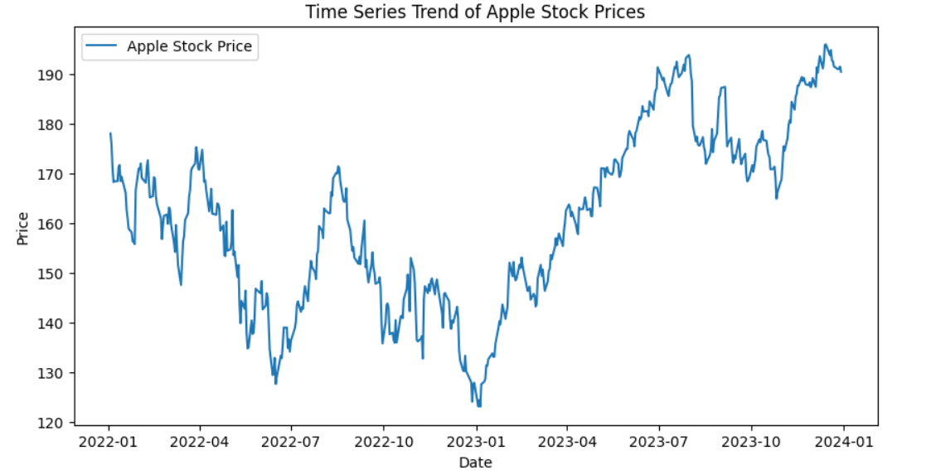
Figure 6: LSTM Time Series Forecast — Apple (AAPL) Stock Price Prediction vs. Actuals
Figure 6 illustrates the predicted and actual time-series trends for Apple stock prices generated by the LSTM forecasting model. The figure above shows the LSTM model's forecasted price trend overlaid on the actual historical Apple Inc. stock price data used for evaluation. The model was trained on a training window and then asked to generate predictions for a subsequent held-out period. The predicted trend line closely mirrors the directional movement and magnitude of the actual price series, successfully capturing the overall trend and major inflection points without being fitted to them.
It is important to note that the goal of this forecasting model is not to achieve perfect point prediction of individual daily prices a task that is fundamentally impossible due to the inherent randomness in financial markets. Rather, the goal is to learn the underlying temporal dynamics well enough to generate directionally useful forecasts that can inform strategic planning, portfolio management, and risk assessment decisions.
The model's performance on this task validates the hypothesis that LSTM networks can meaningfully capture the temporal structure present in financial time series. The architecture's ability to selectively remember relevant historical context through its gating mechanism gives it a distinct advantage over simpler statistical approaches that treat all historical lags as equally informative.
Beyond stock price prediction, the same LSTM forecasting architecture could be applied with minimal modification to a broad range of business time-series challenges: demand forecasting in retail and supply chain management, sales revenue projection for financial planning, website traffic and user engagement trend prediction for digital marketing teams, energy consumption forecasting for facilities management, and predictive maintenance by monitoring equipment sensor readings over time. The versatility of this approach underscores the value of deep learning as a foundational capability investment for data-driven organizations.

10. Deployment Using Streamlit
A machine learning model that exists only within a development notebook environment (such as Kaggle or similar platforms) remains primarily a research artefact rather than a practical business tool. The final and most practically significant step in this project was deploying the trained LSTM sentiment classification model as an interactive, browser-based web application using Streamlit, an open-source Python framework that enables rapid development of data applications without requiring specialized front-end development expertise.
This deployment stage represents the critical bridge between the data science workflow and real-world business application. It transforms a technically sophisticated model into an accessible and user-friendly interface that can be used by non-technical stakeholders. Through the Streamlit dashboard, users can input customer reviews and instantly obtain sentiment predictions along with probability scores.
By converting the trained model into a deployable web application, the project demonstrates how advanced machine learning models can move beyond experimental environments and become practical decision-support tools.
10.1 Application Overview and Interface
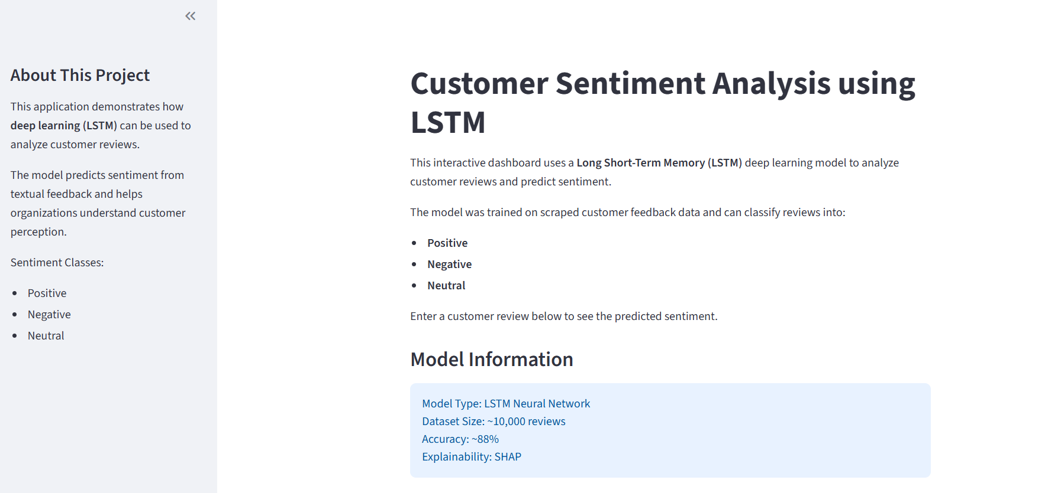
Figure 7: Streamlit Dashboard — Main Application Interface

The main dashboard presents a clean, minimal interface designed to minimize friction and maximize usability. A prominently placed text input field invites the user to enter any customer review text. A submission button triggers the model inference pipeline, which processes the input text through the same tokenization, stop word removal, encoding, and padding steps applied during training, before feeding the resulting sequence into the trained LSTM model. The prediction is returned in under a second, making the interaction feel responsive and natural.
The output section displays three pieces of information: the predicted sentiment category (Positive, Neutral, or Negative) displayed as a clearly labelled badge, the probability scores for all three sentiment classes presented as a bar chart or numeric display, and a confidence indicator that communicates how decisive the model's prediction was. This multi-faceted output ensures that users receive not just a binary classification, but a nuanced view of the model's certainty — enabling them to flag low-confidence predictions for human review.
10.2 Positive Review Example
The following sequence of screenshots demonstrates the application's behaviour when presented with a review containing strongly positive sentiment markers — enthusiastic language, superlatives, and explicit endorsement.
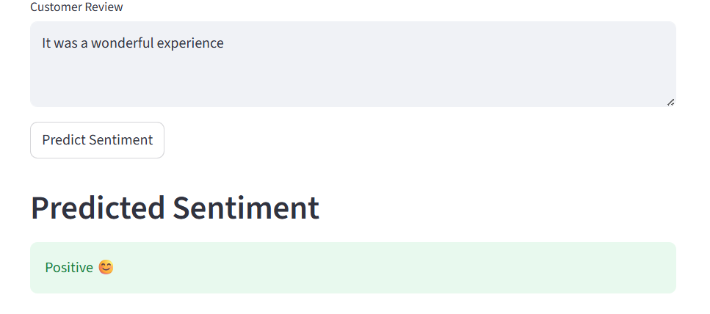
Figure 8a: Positive Review — User Input
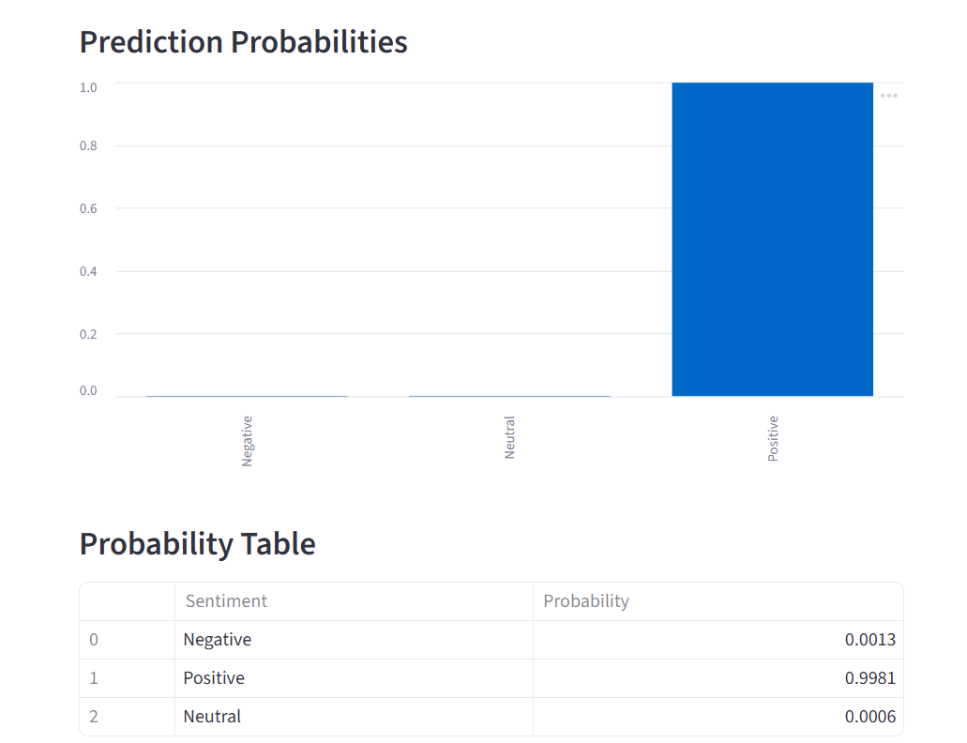
Figure 8b: Positive Review — Model Prediction Output
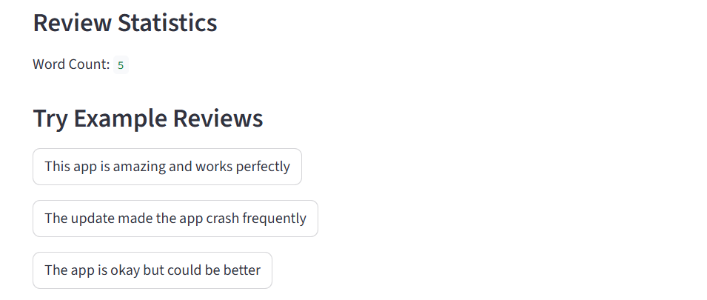
Figure 8c: Positive Review — Probability Score Breakdown
As the screenshots illustrate, the model correctly identifies the positive sentiment with a high confidence score. The probability distribution shows a strong concentration of probability mass on the Positive class, with low residual probabilities assigned to the Neutral and Negative classes. This high-confidence correct prediction is consistent with the confusion matrix results, which showed that the Positive class achieves the highest classification accuracy.
10.3 Neutral Review Example
Neutral reviews present the most challenging classification scenario, as they typically contain balanced assessments, factual descriptions, or mildly positive language that lacks the strong sentiment markers that make positive and negative reviews easy to identify.
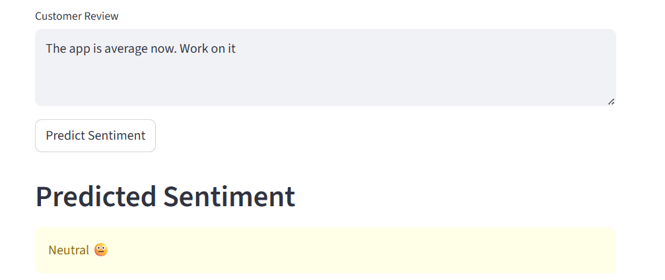
Figure 9a: Neutral Review — User Input
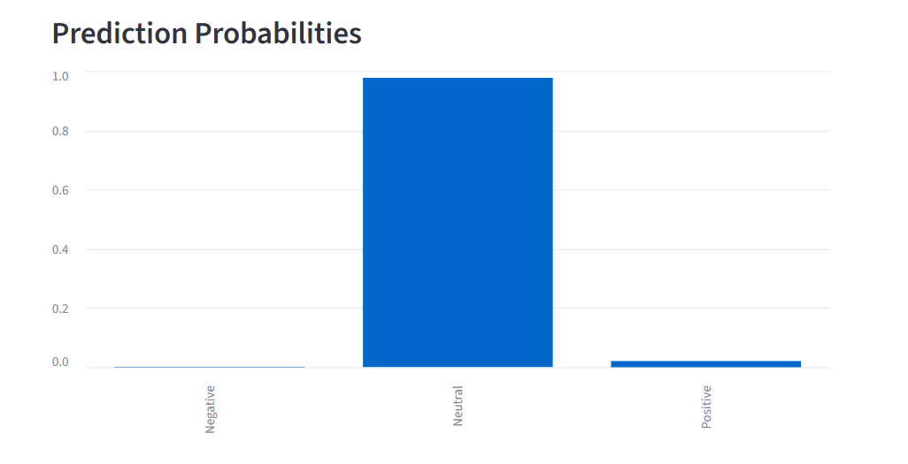
Figure 9b: Neutral Review — Model Prediction Output
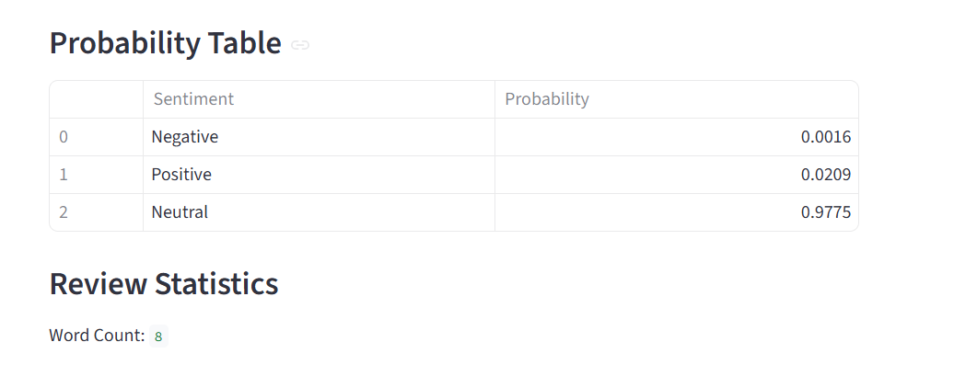
Figure 9c: Neutral Review — Probability Score Breakdown

Despite the inherent difficulty of neutral classification, the model correctly identifies the neutral sentiment for the example shown. The probability distribution reflects the greater ambiguity of this case — the gap between the Neutral class probability and the positive class probability is smaller than in the previous example, reflecting the model's (appropriate) uncertainty. In a production deployment, reviews falling into this lower-confidence zone could be automatically routed for human review rather than acted upon directly.
10.4 Negative Review Example
Accurate identification of negative sentiment is arguably the most business-critical capability of the system, as it enables organizations to rapidly detect and respond to customer complaints before they escalate into churn, reputational damage, or viral negative publicity.
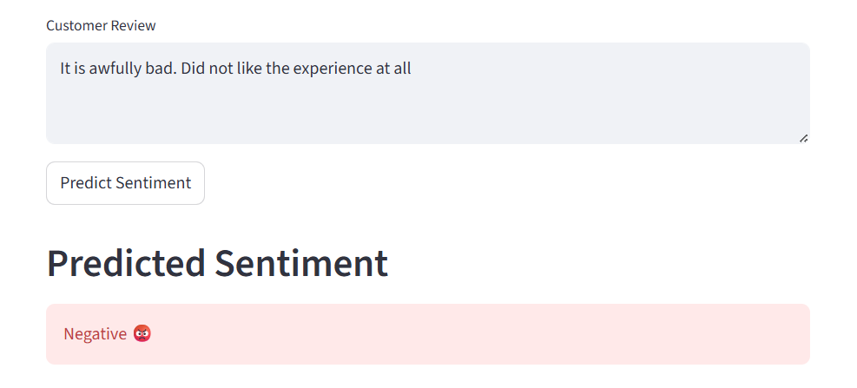
Figure 10a: Negative Review — User Input
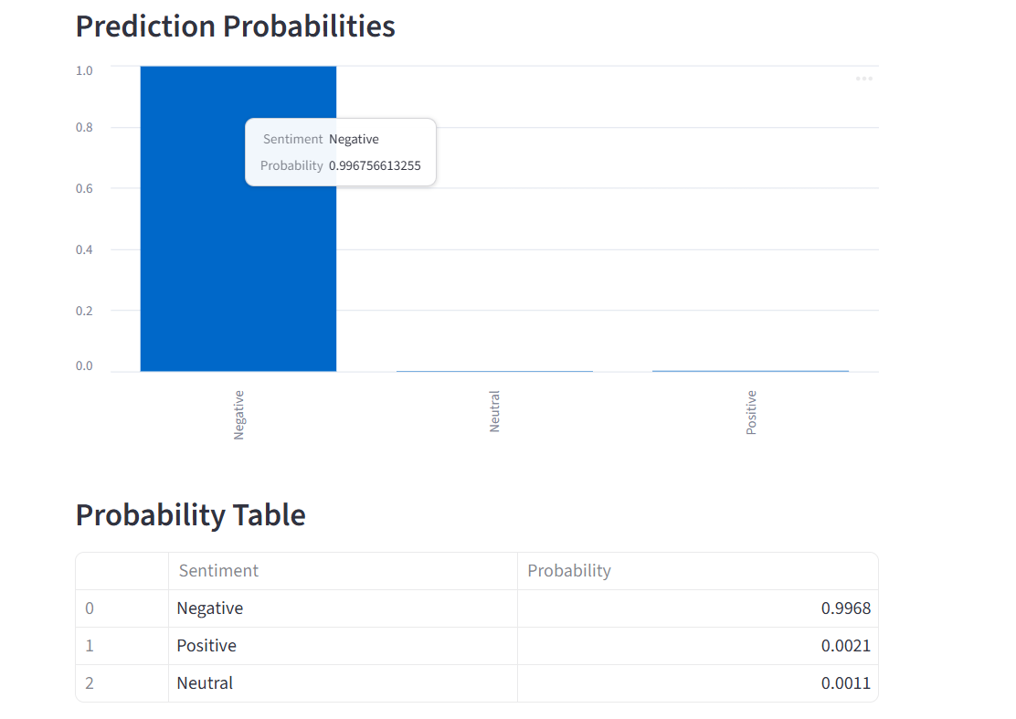
Figure 10b: Negative Review — Model Prediction Output

Figure 10c: Prediction Label
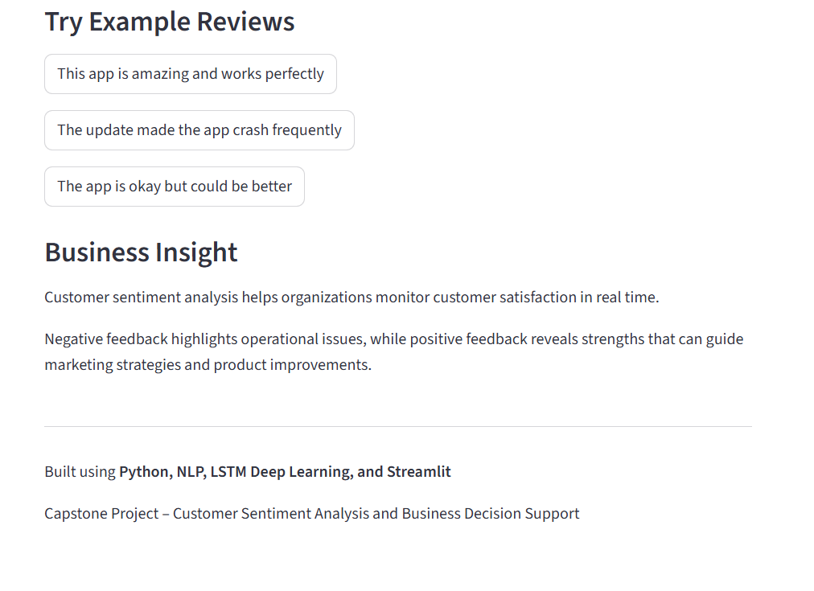
Figure 10d: Negative Review — Detailed Probability Scores
The model identifies the negative sentiment with high confidence, assigning a dominant probability to the Negative class and near-zero probabilities to the Positive and Neutral classes. This high-confidence negative detection mirrors the confusion matrix results, which showed strong recall for the Negative class. In a live deployment scenario, a review generating this type of prediction would automatically trigger an alert to the customer experience team, enabling rapid follow-up and potentially converting a dissatisfied customer into a retained one.

11. Managerial Implications
The technical results presented in the preceding sections are meaningful, but their true value lies in the business decisions and organizational capabilities they enable. This section examines the practical implications of deploying an LSTM-based sentiment analysis and forecasting system for business decision-making across multiple functional areas.
11.1 Customer Experience and Retention Management
The most immediate and high-impact application of this system is in real-time customer experience management. Today, most organizations rely on periodic surveys, Net Promoter Score polls, or Customer Satisfaction (CSAT) ratings to gauge customer sentiment. These instruments are valuable, but they suffer from fundamental limitations: they are episodic rather than continuous, they reach only the subset of customers who choose to respond, and they provide aggregate scores rather than granular insight into the specific issues driving dissatisfaction.
An LSTM-based sentiment analysis system applied to customer reviews, support tickets, and social media mentions provides a continuous, real-time signal of customer experience quality at the individual comment level. Negative feedback can be automatically detected, categorized by product area or service issue type, and routed to the relevant team for rapid response — potentially within minutes of a complaint being posted. Research consistently shows that rapid response to negative feedback dramatically reduces churn probability. The ability to act on customer dissatisfaction before it solidifies into a decision to switch providers is among the most commercially valuable capabilities this system enables.
11.2 Product and Service Development Intelligence
Beyond reactive customer service, continuous sentiment monitoring creates a rich longitudinal dataset that can inform proactive product development decisions. By tracking how sentiment evolves over time — particularly around specific product launches, feature releases, pricing changes, or policy updates — product managers can build a granular, evidence-based understanding of what customers value most and what generates friction.
For example, if sentiment scores decline sharply in the weeks following a UI redesign, this provides an early warning signal that the change is not being received well, enabling the product team to investigate and iterate before negative word-of-mouth spreads. Conversely, if a new feature generates a measurable uplift in positive sentiment, this validates the investment and can be used to prioritize similar improvements in the product roadmap.
11.3 Marketing and Brand Intelligence
Sentiment data derived from the LSTM system can enrich marketing strategy in several ways. Positive reviews that score with high confidence can be identified as candidates for testimonial use in marketing materials. Product features that consistently generate positive sentiment can be foregrounded in advertising and positioning. Demographic or geographic patterns in sentiment — detectable if reviews carry location or user profile metadata — can inform targeted marketing campaigns by revealing which customer segments are most satisfied and therefore most likely to respond to upsell or referral incentives.
11.4 Scalability and Return on Investment
One of the most compelling business cases for automation is raw scalability. A skilled human analyst reviewing customer feedback might process 100–200 reviews per hour, at significant labour cost. The LSTM system can process thousands of reviews per second at marginal computational cost once deployed. This scalability makes it feasible to maintain continuous, comprehensive monitoring of all customer feedback across all channels — a coverage level that simply cannot be achieved through human review alone. The return on investment from preventing even a small percentage of customer churn through faster complaint resolution is typically sufficient to justify the infrastructure cost many times over.

12. Ethical and Responsible Use of Data
The deployment of AI systems that operate on human-generated data — even publicly available data — carries ethical responsibilities that extend beyond technical performance. This project was designed with data ethics as a guiding principle from the outset, not as a compliance afterthought. The considerations discussed in this section should be viewed as non-negotiable requirements for any responsible deployment, not optional enhancements.
12.1 Data Privacy and Consent
The dataset used in this project consists entirely of publicly available customer reviews. No personally identifiable information (PII) — such as names, email addresses, account identifiers, or location data beyond what appeared voluntarily in reviews — was collected or stored. No authentication barriers were bypassed, and the scraping methodology was designed to respect the terms of service of the platforms from which data was collected. In any extension of this system to process internal company data or data collected from identifiable individuals, a formal data governance framework — including explicit consent mechanisms, data minimization principles, and secure storage protocols — would be mandatory.
12.2 Algorithmic Fairness and Bias
Machine learning models trained on real-world data inevitably risk inheriting the biases present in that data. For a sentiment analysis system, this could manifest in several ways: systematically lower accuracy for reviews written in non-standard English dialects, bias toward or against specific demographic groups whose language patterns are underrepresented in the training data, or category-specific accuracy disparities if certain product types dominate the training corpus. While a comprehensive fairness audit was beyond the scope of this capstone project, such an audit is an essential prerequisite for any commercial deployment. Fairness testing should include accuracy disaggregation across demographic proxies, dialect groups, and product categories, with corrective resampling or reweighting applied wherever significant disparities are identified.
12.3 Transparency and Explainability
The integration of SHAP-based model explainability is not merely a technical enhancement — it is an ethical imperative. Without explainability, the system operates as a black box, and the business users who rely on its outputs have no means to audit its decisions, identify errors, or challenge predictions they believe to be incorrect. By making the model's reasoning process transparent through SHAP visualizations, this project ensures that every prediction can be traced back to specific input features, enabling meaningful human oversight. In an era of increasing regulatory scrutiny of algorithmic decision systems — including the EU AI Act and various proposed data protection frameworks — explainability of this kind is transitioning from a best practice to a legal requirement.
12.4 Human Oversight and Decision Support
Perhaps most importantly, the system should always be positioned as a decision-support tool, not a decision-replacement tool. Automated sentiment classification should inform human judgment, not supplant it. High-confidence predictions can be acted upon with relatively low friction, but low-confidence predictions — particularly in high-stakes contexts such as escalation decisions or policy changes — should always be reviewed by a human analyst before action is taken. Clear documentation of the model's limitations, confidence intervals, and known failure modes should accompany any production deployment, and mechanisms for human override and feedback collection should be built into the deployment architecture from the start.

13. Conclusion
This capstone project set out to demonstrate the practical value of Long Short-Term Memory neural networks in two distinct but complementary business intelligence applications: customer sentiment classification and time-series trend forecasting. Through a carefully structured, end-to-end pipeline — spanning data collection, multi-step preprocessing, model architecture design, training, evaluation, SHAP-based explainability, and Streamlit deployment the project delivered a fully functional, interpretable, and business-ready AI system.
The LSTM sentiment analysis model achieved strong and consistent classification performance across all three sentiment categories positive, negative, and neutral as validated by training and loss curves, confusion matrix analysis, and a comprehensive suite of classification metrics. The model's generalization capability, evidenced by the close alignment of training and validation performance throughout training, provides confidence that it will maintain its accuracy when applied to new, unseen review data in a live deployment environment.
The SHAP explainability component addressed one of the most frequently cited barriers to AI adoption in business settings the opacity of deep learning models by providing a transparent, feature-level account of each prediction. This transparency not only builds stakeholder trust but also enables meaningful auditing, bias detection, and continuous improvement of the model over its operational lifetime.
The time-series forecasting component demonstrated the architectural breadth of LSTM networks, showing that the same sequential learning machinery that powers text understanding can be equally effective for temporal numerical forecasting. This versatility positions LSTM-based systems as high-value, general-purpose investments for any organization seeking to build scalable AI capabilities.
The Streamlit deployment transformed the project from an academic exercise into a functional prototype ready for demonstration to business stakeholders. The real-time inference interface, probability score outputs, and intuitive design lower the barrier to adoption and illustrate concretely how the model's outputs can be consumed by non-technical users in a day-to-day operational context.
Looking ahead, several promising directions exist for extending and improving this work. The model could be retrained on domain-specific review datasets to improve performance in targeted verticals such as hospitality, healthcare, or financial services, where domain vocabulary and sentiment conventions may differ from general e-commerce reviews. More sophisticated architectures including Bidirectional LSTMs, Transformer-based models such as BERT, or ensemble approaches combining multiple classifiers could be explored to push accuracy and robustness further. A comprehensive fairness and bias audit should be conducted before any production deployment, with corrective interventions applied wherever performance disparities are identified across demographic or linguistic subgroups.
Ultimately, this project makes a compelling case for the integration of deep learning into mainstream business intelligence practice. The ability to listen to customers at scale, understand the sentiment embedded in their feedback, anticipate future trends from historical patterns, and deliver these insights through accessible tools is no longer a competitive advantage reserved for technology companies with vast research budgets. With the right architecture, the right data pipeline, and the right deployment approach all of which this project demonstrates it is within reach of any organization committed to becoming truly data-driven.

14. References
Hochreiter, S. & Schmidhuber, J. (1997). Long Short-Term Memory. Neural Computation, 9(8), 1735–1780. This landmark paper introduced the LSTM architecture and the memory cell gating mechanism that resolves the vanishing gradient problem in recurrent neural networks. It remains the definitive theoretical foundation for all subsequent LSTM research and applications.
Lundberg, S. M. & Lee, S. (2017). A Unified Approach to Interpreting Model Predictions. Advances in Neural Information Processing Systems, 30. This paper introduced SHAP (SHapley Additive exPlanations), grounding model interpretability in cooperative game theory and providing a consistent, theoretically principled method for attributing prediction outcomes to individual input features. The SHAP framework used for explainability in this project is drawn directly from this work.
Jurafsky, D. & Martin, J. H. (2023). Speech and Language Processing (3rd ed. draft). Prentice Hall. The standard reference textbook for natural language processing, covering tokenization, stop word removal, lemmatization, word embeddings, and sequence modelling with recurrent neural networks. Chapter 9 provides a thorough treatment of RNN and LSTM architectures in the context of NLP.
Chollet, F. (2018). Deep Learning with Python. Manning Publications. A comprehensive and accessible guide to building deep learning models using Keras and TensorFlow. The chapters on text preprocessing, embedding layers, and LSTM implementation informed the technical design decisions in this project.
Pang, B. & Lee, L. (2008). Opinion Mining and Sentiment Analysis. Foundations and Trends in Information Retrieval, 2(1–2), 1–135. A comprehensive survey of sentiment analysis methods and challenges, providing essential context for understanding the problem space and the limitations of both lexicon-based and machine-learning approaches to sentiment classification.
Brownlee, J. (2020). Deep Learning for Time Series Forecasting. Machine Learning Mastery. A practical guide to applying LSTM and other deep learning architectures to time-series prediction problems. The sliding window data preparation methodology used in the time-series component of this project is adapted from the techniques described in this reference.
Streamlit Documentation. (2024). Streamlit: The fastest way to build and share data apps. Retrieved from https://docs.streamlit.io. Official documentation for the Streamlit framework used to develop and deploy the interactive sentiment analysis dashboard presented in Section 10.

