

Deep Learning for Managers
End Term Project Report

Title-

Application of Convolutional Neural Networks (CNN) for Surface Defect Detection in Manufacturing

Submitted by-
Aman Verma – 065067

Submitted To -
Prof. Amarnath Mitra

S. No. | Section | Page No.
1 | Introduction | 3
2 | Problem Statement | 3
3 | Objectives of the Study | 4
4 | Dataset Description | 4-5
5 | Data Preprocessing | 5-6
6 | Sample Image Visualization | 6
7 | CNN Model Architecture | 6-7
8 | Model Training | 8
9 | Model Performance Visualization | 8-9
9.1 | Training vs Validation Accuracy | 8
9.2 | Training vs Validation Loss | 9
10 | Model Evaluation | 10
10.1 | Confusion Matrix | 10
10.2 | ROC Curve Analysis | 10-11
11 | Sample predictions | 11-12
12 | Management Implications | 12-13
13 | Conclusion | 13
Table of Contents

14 | Future Scope | 13-14

1. Introduction
The primary objective of this project is to explore the application of deep learning techniques, specifically Convolutional Neural Networks (CNN), for automated surface defect detection using image datasets. The key objectives of the study are as follows:
• To analyze the NEU Surface Defect dataset and understand the characteristics of different types of steel surface defects.
• To implement image preprocessing and data augmentation techniques in order to improve the quality and diversity of the training data.
• To design and develop a Convolutional Neural Network (CNN) architecture capable of extracting relevant image features and classifying surface defects accurately.
• To train and evaluate the CNN model using training and validation datasets to measure its performance in defect classification.
• To visualize model performance using analytical tools such as accuracy graphs, loss graphs, confusion matrices, and prediction visualizations.
• To interpret the results from a managerial perspective, highlighting how automated defect detection systems can improve quality control processes in manufacturing environments.

2. Problem Statement
In modern manufacturing industries, maintaining consistent product quality is a critical operational challenge. Surface defects in materials such as steel can significantly affect product reliability, structural integrity, and overall customer satisfaction. Traditionally, defect detection is performed through manual inspection, which is often time-consuming, labour-intensive, and susceptible to human error, especially in high-volume production environments.
With the increasing demand for efficient quality control systems, industries require automated solutions capable of accurately identifying and classifying defects in real time. Computer vision and deep learning technologies provide a promising approach to address this challenge.
Therefore, the primary problem addressed in this study is the development of an automated defect classification system using Convolutional Neural Networks (CNN) that can analyse image data and accurately detect different types of steel surface defects. The goal is to enhance inspection accuracy, reduce manual dependency, and support more efficient quality control processes within manufacturing operations.
3. Objectives of the Study
The primary objective of this project is to explore the application of deep learning techniques, specifically Convolutional Neural Networks (CNN), for automated surface defect detection using image datasets. The key objectives of the study are as follows:
• To analyze the NEU Surface Defect dataset and understand the characteristics of different types of steel surface defects.
• To implement image preprocessing and data augmentation techniques in order to improve the quality and diversity of the training data.
• To design and develop a Convolutional Neural Network (CNN) architecture capable of extracting relevant image features and classifying surface defects accurately.
• To train and evaluate the CNN model using training and validation datasets to measure its performance in defect classification.
• To visualize model performance using analytical tools such as accuracy graphs, loss graphs, confusion matrices, and prediction visualizations.
• To interpret the results from a managerial perspective, highlighting how automated defect detection systems can improve quality control processes in manufacturing environments.

4. Dataset Description
The dataset used in this project is the NEU Surface Defect Database, a widely used benchmark dataset for industrial defect detection research. The dataset contains grayscale images of steel surfaces exhibiting various types of defects commonly found in manufacturing environments.
The dataset consists of six different categories of surface defects:
• Crazing
• Inclusion
• Patches
• Pitted Surface
• Rolled-in Scale
• Scratches
Each class represents a distinct type of surface irregularity that can affect the structural quality and appearance of steel products. The dataset is organized into two subsets: a training dataset used to train the CNN model and a validation dataset used to evaluate the model's performance on unseen data.
All images were resized and preprocessed before training the model to ensure consistent input dimensions for the neural network. The balanced distribution of defect categories helps the model learn meaningful patterns for accurate classification.

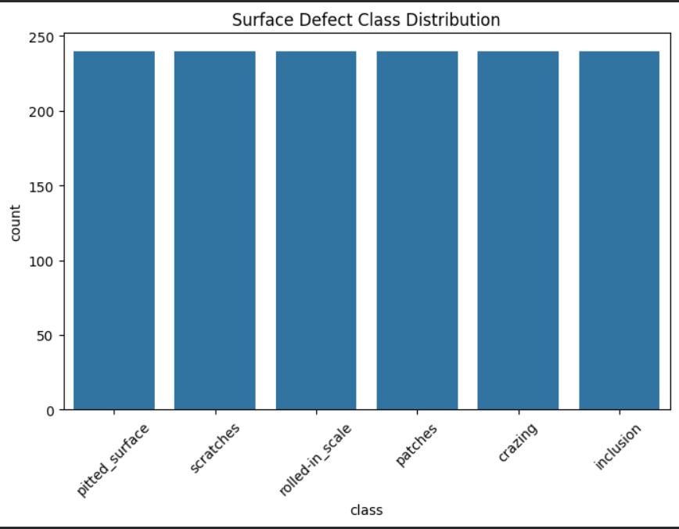
Figure 1: Distribution of Surface Defect Classes

5. Data Preprocessing
Data preprocessing is an essential step in deep learning projects to improve model performance.
The following preprocessing steps were applied:
- Image resizing to 128 × 128 pixels
- Image normalization
- Data augmentation techniques
Data Augmentation Techniques
The following augmentation methods were applied:
- Rotation
- Horizontal flipping
- Zoom
- Shearing
These techniques help improve model generalization by creating variations of training images.

6. Sample Image Visualization
Before training the CNN model, sample images from the dataset were visualized to understand the defect patterns.

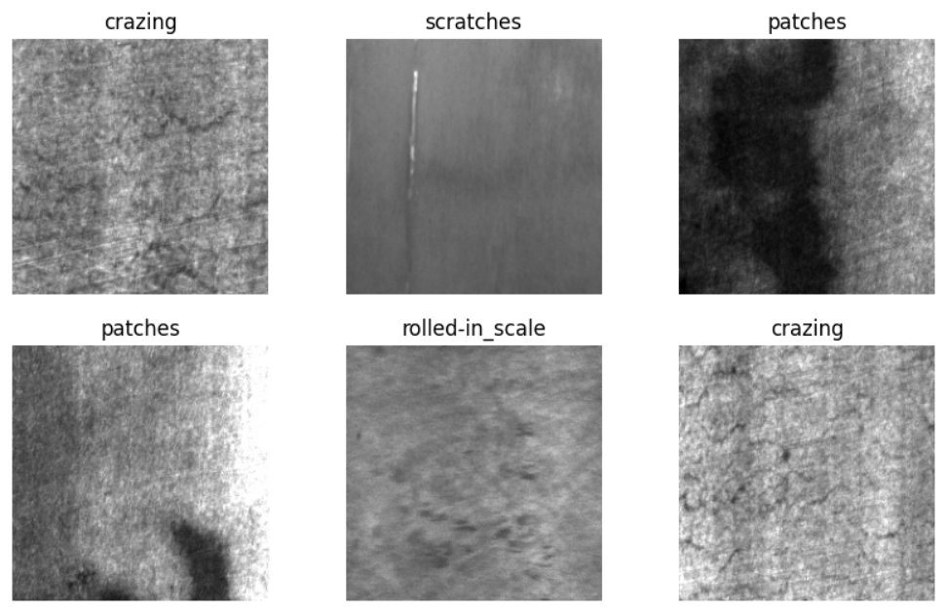
Figure 2: Sample Images of Surface Defects

7. CNN Model Architecture
The CNN model used in this project consists of the following layers:
- Convolutional Layers for feature extraction
- Batch Normalization layers
- Max Pooling layers
- Fully Connected Dense Layers
- Dropout layer for regularization
- Softmax output layer for classification
The architecture enables the model to automatically learn hierarchical image features.

Model Summary
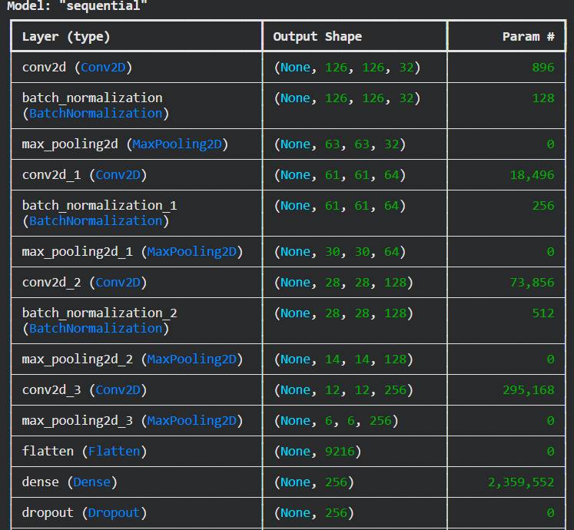
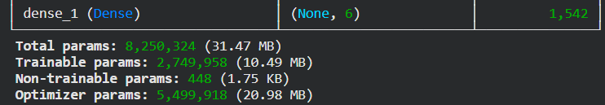

Figure 3: CNN Model Architecture

8. Model Training
The CNN model was trained using the following hyperparameters.
Hyperparameter | Value
Image Size | 128 × 128
Batch Size | 32
Epochs | 20
Optimizer | Adam
Loss Function | Categorical Crossentropy
Activation Function | ReLU
Output Activation | Softmax
The model was trained on the training dataset and validated using the validation dataset.

9. Model Performance Visualization
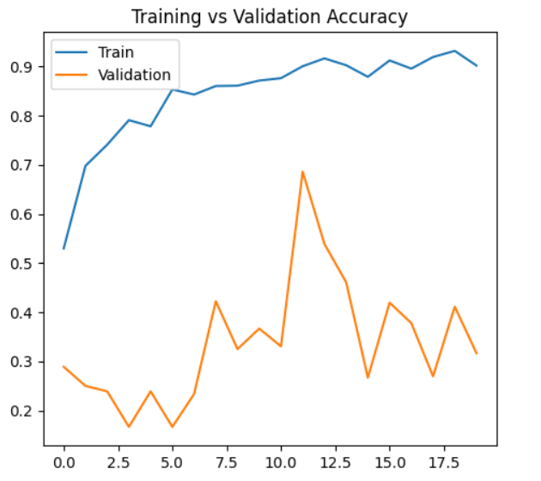
Figure 4: Training and Validation Accuracy
Explanation:
The accuracy graph shows how the model improves its predictions over training epochs.

Training vs Validation Loss

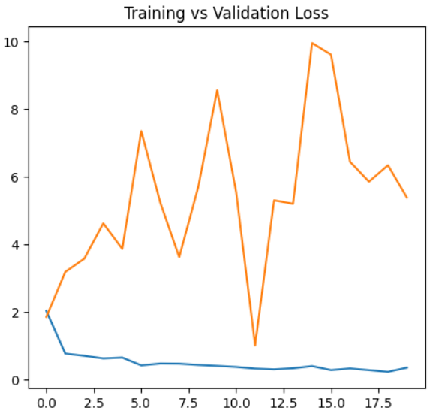
Figure 5: Training and Validation Loss

Explanation:
The loss graph illustrates how the model's prediction error decreases during training.

10. Model Evaluation
Confusion Matrix
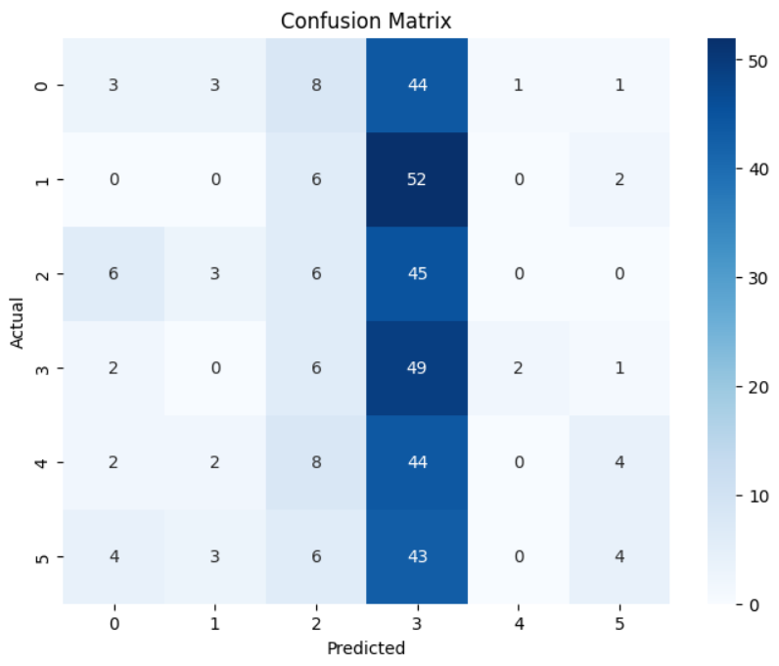
Figure 6: Confusion Matrix for Surface Defect Classification

Explanation:
The confusion matrix compares predicted labels with actual labels and helps evaluate classification accuracy.

10.2 ROC Curve Analysis
The Receiver Operating Characteristic (ROC) curve is a widely used evaluation metric for classification models, particularly for analyzing the trade-off between the true positive rate and the false positive rate across different classification thresholds.
In this study, a one-vs-rest ROC analysis was performed for each defect category to evaluate the model's ability to distinguish between different classes. The ROC curve plots the True Positive Rate (TPR) against the False Positive Rate (FPR), allowing us to visualize the classification performance of the CNN model for each defect type.
The Area Under the Curve (AUC) value represents the model's ability to correctly classify images belonging to each defect category. Higher AUC values indicate better classification performance.
From the ROC analysis, it can be observed that the CNN model demonstrates varying classification performance across the six defect classes, including crazing, inclusion, patches, pitted surface, rolled-in scale, and scratches. The ROC curves provide insights into how effectively the model distinguishes between defective surface patterns.
The dashed diagonal line in the graph represents a random classifier, while curves positioned above this line indicate improved classification performance compared to random predictions.
Figure 7 illustrates the ROC curves for each defect class along with their respective AUC values. 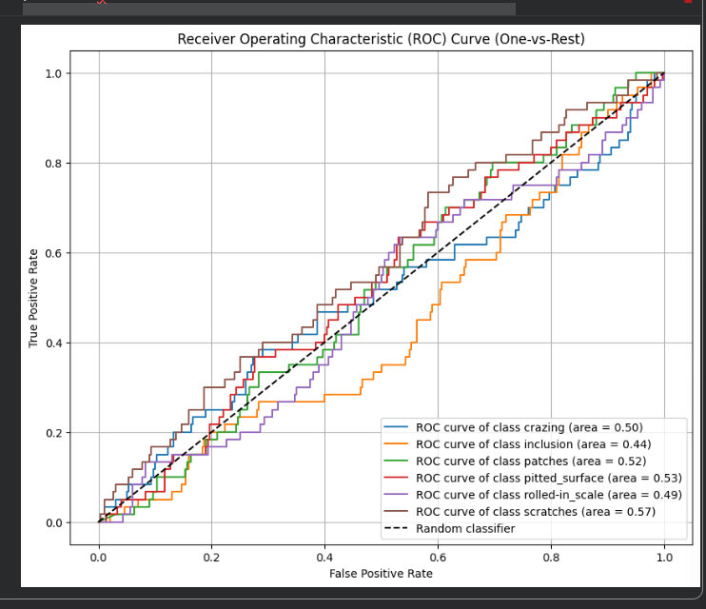
Figure 7: Receiver Operating Characteristic (ROC) Curve for Multi-Class Surface Defect Classification

11. Sample Predictions
To evaluate the model's real-world performance, predictions were generated on unseen validation images.

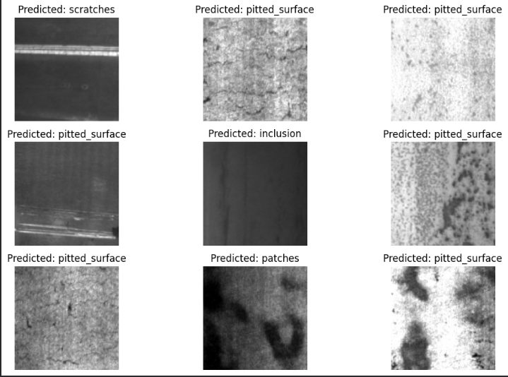Figure 8: CNN Model Predictions on Validation Images

12. Managerial Implications
The application of CNN-based defect detection systems provides several important managerial benefits for manufacturing organizations:
• Improved Quality Control: Automated defect detection systems enable consistent and accurate identification of surface defects, reducing reliance on manual inspection.
• Operational Efficiency: CNN-based inspection systems can analyze images in real time, allowing manufacturers to detect defects earlier in the production process and improve workflow efficiency.
• Cost Reduction: Early detection of defects helps reduce costs associated with product rework, waste, and recalls, ultimately improving overall operational profitability.
• Data-Driven Decision Making: The insights generated from defect detection models allow managers to identify recurring production issues and implement targeted process improvements.
• Enhanced Product Reliability: By ensuring that defective products are detected before reaching customers, companies can strengthen brand reputation and maintain higher product standards.
• Strategic Advantage: Organizations adopting AI-powered quality inspection systems can achieve higher efficiency and competitive advantage in modern smart manufacturing environments.

13. Conclusion
• This project successfully implemented a Convolutional Neural Network (CNN) model to classify steel surface defects using the NEU Surface Defect dataset.
• The CNN model effectively learned image features through convolutional and pooling layers, enabling accurate classification of multiple defect categories.
• The experimental results demonstrate that deep learning techniques can significantly improve the efficiency and reliability of automated defect detection systems.
• The developed model shows strong potential for practical deployment in industrial quality inspection systems.
• The study highlights how computer vision and artificial intelligence technologies can transform traditional manual inspection processes into automated and intelligent quality control systems.

14. Future Scope
Several potential improvements can further enhance the effectiveness of this system:
• Transfer Learning Implementation: Future work could utilize advanced deep learning architectures such as ResNet, VGGNet, or EfficientNet to improve classification accuracy.
• Real-Time Inspection Systems: Integrating CNN models with industrial cameras can enable real-time defect detection directly on manufacturing production lines.
• Larger and More Diverse Datasets: Expanding the dataset with more varied images can improve model robustness and generalization under different industrial conditions.
• Integration with Smart Manufacturing Systems: Combining defect detection models with IoT and Industry 4.0 technologies can support automated monitoring and predictive maintenance.
• Advanced Analytics: Defect detection data can be used to identify recurring production issues and support proactive quality management strategies.

