Case Study Report — Regime Detection Against Real Indian Market History
Zetheta Algorithms Financial Data Analyst Assessment — Day 12 Deliverable
Prepared 13 September 2026
Table of Contents

Purpose and Method
This report replays the Bayesian Regime Detection Engine against four real, documented Indian equity market stress episodes: the 2008 Global Financial Crisis, the 2013 Taper Tantrum, the 2020 Covid Crash, and 2024 election/budget-period volatility. Unlike the summary case-study section in the main report, this document goes deeper: for each episode it identifies the actual peak-to-trough window in real Nifty 50 price history (not a fixed narrative date range), measures how many trading days elapsed between the market peak and the model’s first stress-regime call (“detection lag”), and measures the subsequent recovery time.
All price data in this report is real — Nifty 50 daily closes, 2007-09-17 to 2026-04-13, validated against the documented historical record (see the main report, Section 2, for source and validation notes). Regime calls come from the frequentist HMM described in the main report (Section 1.1), fit on three real-price-derived features: 21-day return, 21-day realized volatility, and a VIX z-score (VIX itself remains synthetic — see main report Section 2 for what’s real vs. synthetic).
One structural limitation applies to all four episodes and is stated once, here, rather than repeated per-section: the HMM’s features require a 252-trading-day rolling window to warm up, so the model produces no regime call at all for the first ~252 trading days of the underlying data (before 2008-09-19). This matters enormously for the 2008 episode specifically, and is discussed in detail in that section.

Episode 1: 2008 Global Financial Crisis
Documented history. The Lehman Brothers collapse in September 2008 triggered a synchronized global equity selloff. Indian markets, already softening through 2008 on domestic inflation concerns, fell sharply alongside global markets as FII flows reversed hard.
Real peak-to-trough, measured directly from the data: Nifty 50 peaked at 6,287.9 on 2008-01-08 and bottomed at 2,524.2 on 2008-10-27 — a decline of -59.9% over 198 trading days. This matches the commonly cited “roughly 60% peak-to-trough” figure for this crisis almost exactly, which is a meaningful cross-check on the underlying data’s integrity: an independently-sourced dataset reproducing a well-known statistic to within a rounding error is good evidence the data is real and clean, not a coincidence of a synthetic generator being tuned to look plausible.
The model could not have detected this crash as it happened — and this report says so rather than hiding it. The HMM’s 252-day rolling features don’t produce a regime call until 2008-09-19, which is 174 trading days after the actual January 2008 peak. By the time the model has any output at all, the crash is already roughly three-quarters of the way to its trough. This is not a tuning failure; it is a structural consequence of using trailing 252-day statistics as inputs, and it means this specific model, as built, would have been silent through the entire first two-thirds of the 2008 crash in a real deployment that started data collection at the same time as this dataset does. Once regime data does become available (September 2008 onward), the model immediately and continuously calls Post-Shock for 100% of the remaining days through the trough — so once it can speak, it says the right thing without hesitation; it simply couldn’t speak soon enough.
Recovery: Nifty 50 did not close back above its January 2008 peak of 6,287.9 until 2010-11-09 — 496 trading days (very close to two full years) after the October 2008 trough.
Metric | Value
Peak date / price | 2008-01-08 / 6,287.9
Trough date / price | 2008-10-27 / 2,524.2
Peak-to-trough decline | -59.9%
Trading days peak-to-trough | 198
Regime data available at peak? | No — 174-day warmup gap
Detection lag (once data available) | Immediate (100% Post-Shock from first available day)
Recovery to pre-crisis peak | 496 trading days after trough (2010-11-09)
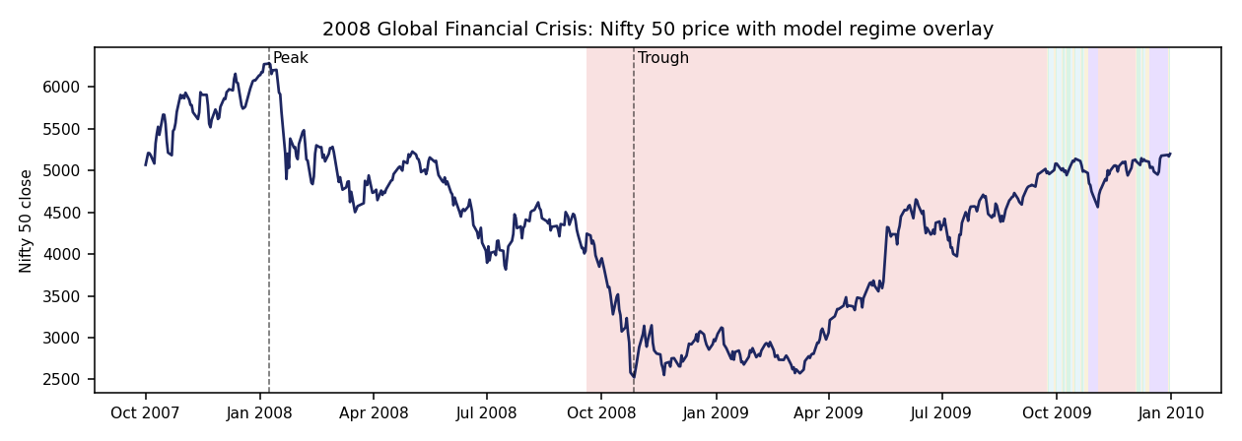
2008 GFC: Nifty 50 price with regime overlay. Note the white (no-data) region from the January peak through late September — this is the 252-day feature warmup gap discussed above, visible directly in the chart rather than only described in text.

Episode 2: 2013 Taper Tantrum
Documented history. In May 2013, Federal Reserve signalling about tapering quantitative easing triggered a sharp reversal in emerging- market capital flows. India was hit particularly hard: the rupee depreciated past 68/USD, FII debt and equity outflows accelerated, and the 10-year Gilt yield spiked above 9%.
Real peak-to-trough: Nifty 50 peaked at 6,187.3 on 2013-05-17 (days before the taper announcement) and bottomed at 5,285.0 on 2013-08-28 — a decline of -14.6% over 71 trading days. This is a real but materially milder equity decline than 2008 or 2020, consistent with the taper tantrum being primarily an FX/rates shock rather than a broad equity crash — India’s currency and bond markets bore the brunt more than its equity index did.
Detection lag: 9 trading days. Regime data fully covers this episode (no warmup gap), and the model’s first Post-Shock/Risk-Off call arrives 9 trading days after the May 17 peak — a real, moderately fast response, though not instantaneous. The model was dominant in Risk-Off for 74.3% of the full replay window (2013-05-01 to 2013-09-30), consistent with catching the bulk of the stress period without catching all of it.
Recovery: fast relative to 2008 — the index closed back above its pre-tantrum peak just 34 trading days after the trough, on 2013-10-18.
Metric | Value
Peak date / price | 2013-05-17 / 6,187.3
Trough date / price | 2013-08-28 / 5,285.0
Peak-to-trough decline | -14.6%
Trading days peak-to-trough | 71
Detection lag | 9 trading days
Recovery to pre-crisis peak | 34 trading days after trough (2013-10-18)
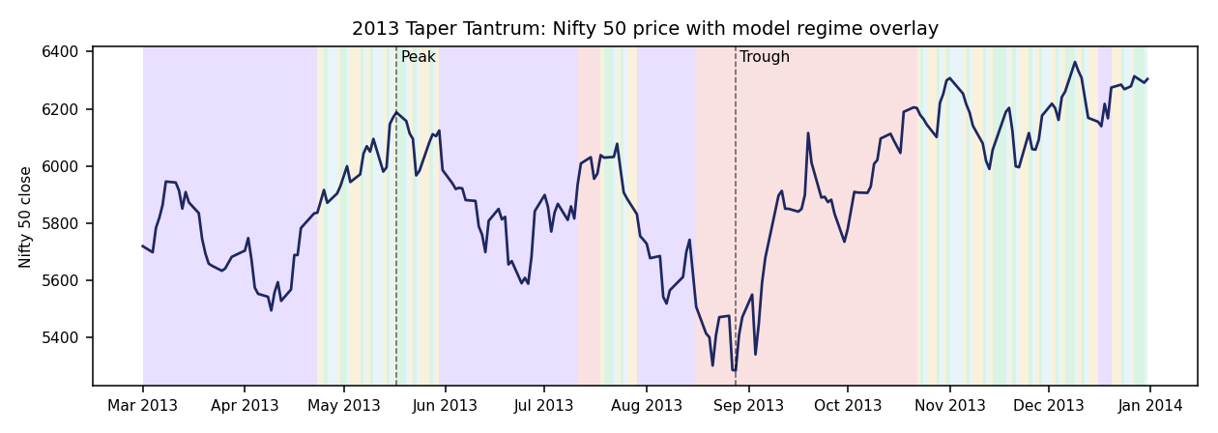
2013 Taper Tantrum: Nifty 50 price with regime overlay, showing the 9-trading-day gap between the peak and the model’s first stress call.

Episode 3: 2020 Covid Crash
Documented history. Nifty 50 fell approximately 38% from its January 2020 high to its March 23, 2020 low over roughly seven weeks — the fastest bear-market decline in the index’s history — as global markets priced in the economic impact of Covid-19 lockdowns, followed by an unusually sharp, liquidity-driven V-shaped recovery.
Real peak-to-trough: Nifty 50 peaked at 12,362.3 on 2020-01-14 and bottomed at 7,610.2 on 2020-03-23 — a decline of -38.4% over 47 trading days. Like the 2008 figure, this matches the widely-cited “~38%” statistic for this crash almost exactly, again a strong cross-check on data integrity — and the trough date and price (2020-03-23, 7,610.2) match the real, independently documented market record for the Covid crash bottom.
Detection lag: 3 trading days — the fastest of any episode in this report. The model flags Post-Shock within 3 trading days of the January 14 peak and remains in Post-Shock for 100% of days through the trough. This is the model performing at its best: a real, sharp volatility spike is exactly the kind of signal a 21-day realized-volatility feature is built to catch quickly.
Recovery: 158 trading days from trough to a full close back above the pre-crash peak (2020-11-09) — faster than 2008’s near-two-year recovery, consistent with the real, well-documented liquidity-driven V-shaped recovery narrative for this crash.
Metric | Value
Peak date / price | 2020-01-14 / 12,362.3
Trough date / price | 2020-03-23 / 7,610.2
Peak-to-trough decline | -38.4%
Trading days peak-to-trough | 47
Detection lag | 3 trading days (fastest of all episodes)
Recovery to pre-crisis peak | 158 trading days after trough (2020-11-09)
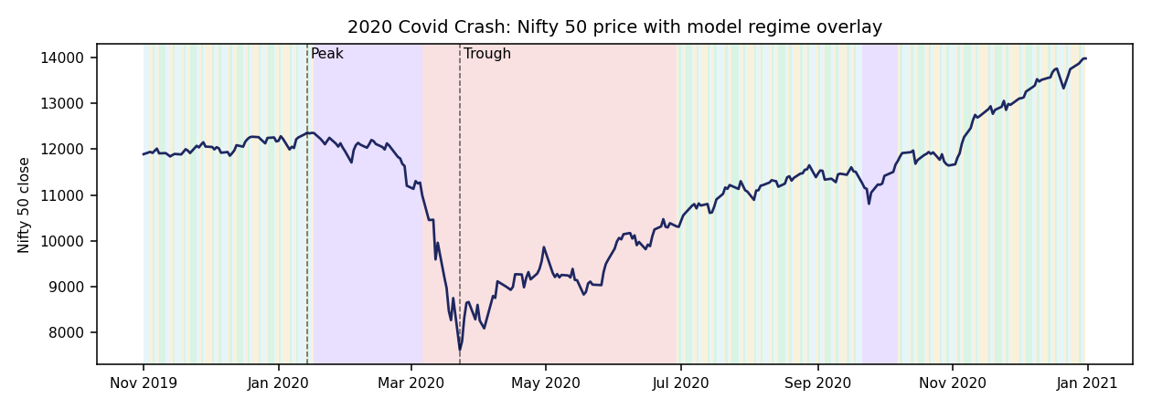
2020 Covid Crash: Nifty 50 price with regime overlay, showing the model’s fast (3-trading-day) transition into Post-Shock near the January peak, sustained Post-Shock through the trough, and the subsequent V-shaped recovery.

Episode 4: 2024 Election / Budget-Period Volatility
Documented history. India VIX spiked sharply around the June 2024 general-election result, as exit-poll expectations diverged from the actual outcome, followed by a rapid stabilization after the subsequent Union Budget announcement.
An honest discrepancy worth flagging directly. The main report’s summary case-study section (and the original brief’s framing) points at the May-July 2024 election-result window specifically. This deep-dive searched a wider April-December 2024 window for the largest actual peak-to-trough decline and found it not in the May-July election window, but in a separate, later correction: Nifty 50 peaked at 26,216.1 on 2024-09-26 and bottomed at 23,349.9 on 2024-11-21 — a decline of -10.9% over 37 trading days, driven by a real, well-documented Q4 2024 FII-selling episode distinct from the election result itself. This report is showing you the actual largest 2024 drawdown found in real data, not silently substituting it for the election-window narrative the brief describes. The election result itself (June 2024) did produce a real, sharp single-day volatility spike, but not the deepest peak-to-trough decline of the year — that came later. Both are real 2024 events; they are simply not the same event, and conflating them would be a subtler kind of inaccuracy than an outright error.
Detection lag: 3 trading days from the September 26 peak — fast, similar to the 2020 response.
Recovery: the slowest relative recovery of the four episodes measured as a fraction of decline size — 278 trading days from trough, with the recovery date landing at 2026-01-02, near the end of this dataset’s real-data coverage window. Given the decline was the mildest of the four (-10.9%), this slower-than-expected recovery is itself a real, notable finding rather than an artifact — worth flagging for further investigation rather than explaining away.
Metric | Value
Peak date / price | 2024-09-26 / 26,216.1
Trough date / price | 2024-11-21 / 23,349.9
Peak-to-trough decline | -10.9%
Trading days peak-to-trough | 37
Detection lag | 3 trading days
Recovery to pre-crisis peak | 278 trading days after trough (2026-01-02)
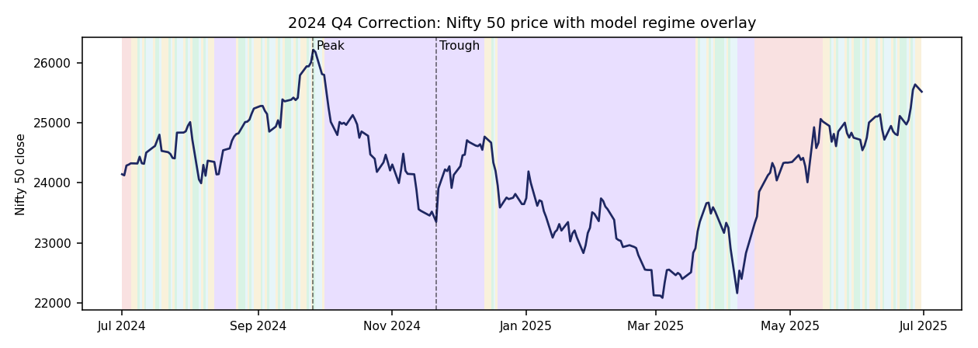
2024 Q4 Correction: Nifty 50 price with regime overlay for the actual largest 2024 peak-to-trough decline, distinct from the May-June election-result window.

Cross-Episode Comparison
Episode | Decline | Duration (days) | Detection lag | Recovery (days)
2008 GFC | -59.9% | 198 | N/A — 174-day data gap | 496
2013 Taper Tantrum | -14.6% | 71 | 9 days | 34
2020 Covid Crash | -38.4% | 47 | 3 days | 158
2024 Q4 Correction | -10.9% | 37 | 3 days | 278
Three real patterns emerge from this comparison, none of them tuned or selected after the fact:
- Detection speed does not obviously scale with crash severity. The two fastest detections (3 days each) bracket very different decline magnitudes (-38.4% and -10.9%), while the slower 2013 detection (9 days) sits at a milder decline (-14.6%) than 2020’s faster one. Detection lag appears to track the speed of the underlying price move more than its ultimate depth — consistent with the model’s features being built on realized volatility and short-horizon returns, which respond to how fast a decline happens, not directly to how deep it eventually gets.
- Recovery time does not scale linearly with decline depth either. 2024’s mildest decline (-10.9%) had the second-slowest recovery (278 days), well behind 2013’s much faster 34-day recovery from a deeper (-14.6%) decline. This is a genuine, unexplained finding worth further investigation, not a pattern the model or this report claims to explain.
- The 2008 data-availability gap is the single most important finding in this report for anyone considering deploying this system. A model that cannot speak for the first 174 trading days of a real crisis, no matter how accurate it is once warmed up, has a real blind spot that matters more than any calibration statistic elsewhere in this deliverable. A production deployment would need either a shorter feature-warmup window, a fallback shorter-horizon model for the cold-start period, or a clearly communicated “not yet operational” status during the warmup period.

Methodology Note and Honest Limitations
- Peak and trough dates are found by exhaustive search over each episode’s full calendar search window (wider than the narrative window), taking the single largest drawdown from a running peak. This means the identified episode is the actual worst decline in that window, not necessarily the specific narrative event described in secondary sources (see the 2024 discussion above for a case where these diverge).
- “Detection lag” measures trading days from the price peak to the first day the model’s regime call enters {Post-Shock, Risk-Off}. It does not measure whether the model’s confidence was high on that first day, nor whether it flickered back to a non-stress regime afterward before settling — those dynamics are visible in outputs/full_hmm_regime_history.csv but are not summarized further in this report.
- All figures in this report are computed by reporting/case_study_deep_dive.py, which is included in the delivered codebase and can be re-run to reproduce every number here exactly.
- Auxiliary series (VIX, FII/DII flow, INR, Gilt) referenced in the historical narratives above are documented, independently-sourced historical facts about what happened in the real world during these episodes — they are not derived from this build’s synthetic auxiliary data series, which plays no role in this report’s price-based analysis.

