1. Create a local git repo with the name "MyRepo".

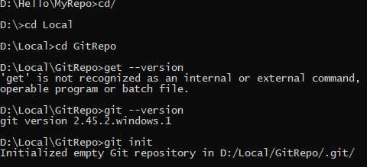

1. create one .txt file, five . c files and five .java files in the working area.

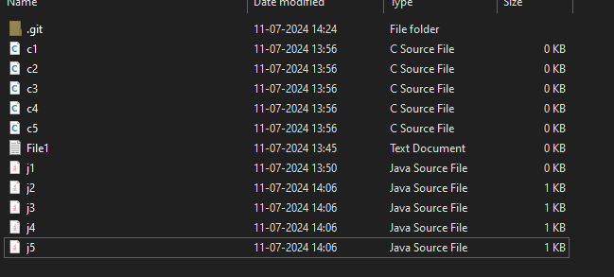

1. Verify the git status

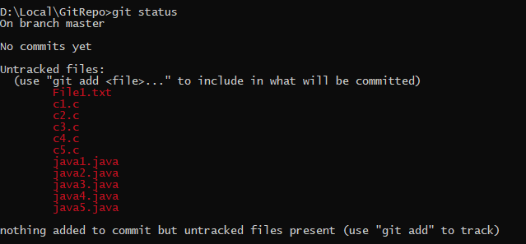

1. Add only the .txt into the staging area & 5) verify the git status

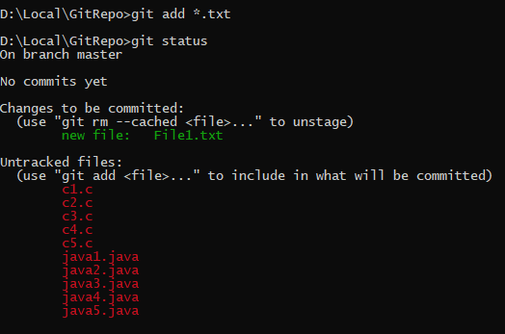

1. Make a commit with the name "TXT Commit"

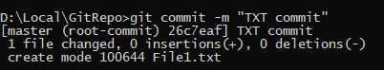

1. Add all .c files into the staging area & 8) verify the git status

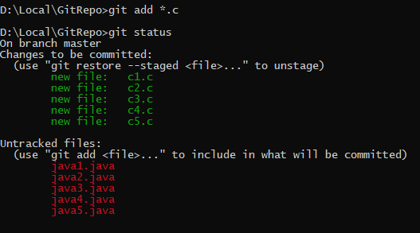

9)Make a commit with the name "C Commit"

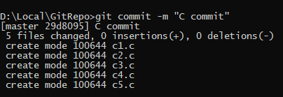

10)Add all .java files into the staging area & 11) verify the git status

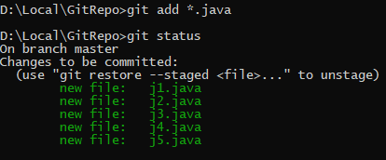

12) Make a commit with the name "Java Commit"

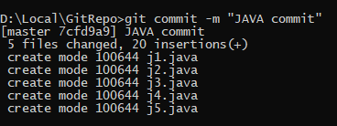

13) Delete all .java files from working area

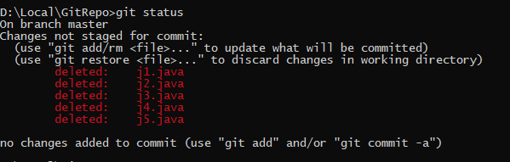

14) Now see the status

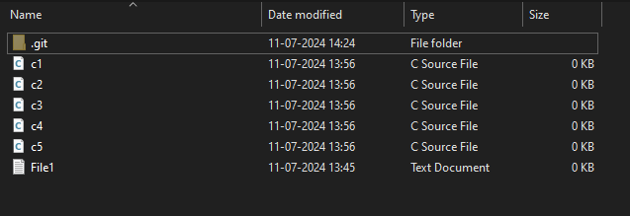

15) add the changes into the staging area & 16) Make a commit with the name "Delete Java Commit"

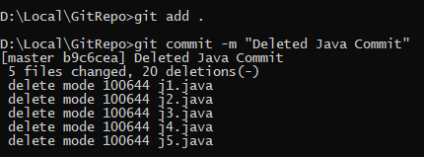

17) display all commit details

