

SPSS Project-5 Report

**Socio-Cultural, Political and Religious Impact of Urdu Satellite TV Channels on Indian Muslims**



April 20, 2020

Anirudh A (2018B4A70936H), Aswath Vinayak K (2018B4A70713H), Vijay krishna, (2017A7PS0111H)

Contents

Abstract & Summary 2

# Cronbach’s Alpha Tests ………………………………………………………………………………………………………..……………3

Basic Analysis of The Given Data 5

1. Discrete Data 5

Occupation 5

Educational Qualification 6

Mother Tongue 6

Gender, Marital Status and Number of Children 7

2. Continuous Data 8

Age 9

Income 9

Analysis of Section-A 11

1. $χ2$- Goodness Of Fit Test 11

Gender v/s Educational Qualification 11

Family Type v/s Number of Children 12

TV Sets v/s DTHs 13

2. Stem and Leaf Plots 14

Gender v/s Income 14

Age v/s Marital Status 17

Analysis of Section-B (Factor Analysis) 19

Section B 15-19 19

Section B 20 22

Analysis Of Section- C (Factor Analysis) 25

Section C 21.1-21.10 25

Section C 21.11-21.20 27

Section C 21.21-21.30 30

Section C 21.31-21.40 33

Analysis Of Section- D (Factor Analysis) 36

Section D 22.1-22.10 36

Section D 22.11-22.20 38

Section D 22.21-22.30 40

Section D 22.31-22.40 42

Summary and Conclusion ……………………………………………………………………………………………………………………………….44

References ………………………………………………………………………………………………………………………………………………..……45

Questionnaire …………………………………………………………………………………………………………………………………………………46

# 

# Abstract

A large data set of **primary data** has been given and it contains information got from a survey of 534 respondents. The data was collected in order to study various similarities and differences in **Socio-Cultural, Political and Religious Impact of Urdu Satellite TV Channels on Indian Muslims.** The data has been analysed and inferences have been made. Pie charts, bar graphs and histograms have been drawn and various measures of central tendency have been calculated. First, Cronbach’s alpha test has been performed to check the reliability.

The questionnaire contains four sections. For the first section (which involved topics like gender, income, educational qualification etc), two tests have been performed. For nominal data (E.g. gender), the **- test** has been performed while the **stem-and-leaf plots** have been drawn for continuous data (E.g. income, age). After analysing the descriptive tables, the **Kolmogorov-Smirnov test** and the **Shapiro-Wilk test** have been conducted to check for normality in case of continuous data.

Sections B, C, D contain yes/no responses and ratings on a scale of 1-5 or 1-10. For such data, a **factor analysis** has been performed which includes the **KMO and Bartlett’s tests**. The **co-relation matrix** which shows the percentage of correlation between two types of entries has been analysed next. Finally, **Scree plots** have been generated based on Eigen Values greater than 1.

The questionnaire has been attached at the end for references and serves as a legend/key to the report.

# Cronbach’s Alpha Tests

Cronbach’s alpha test in an estimate of the **internal consistency** and is a form of **reliability** test. If $α$ >0.3, we can conclude that the questionnaire is good enough and is internally consistent. The test statistic value of $α$ tells us the percentage of reliability. High reliability would be got if a **10-point Likert scale** is used.

## Cronbach’s Test for Section D

Section D includes Questions 22.1-22.40.

|  |  |  |  |
| --- | --- | --- | --- |
| **Case Processing Summary** | | | |
|  | | N | % |
| Cases | Valid | 534 | .1 |
| Excludeda | 1048041 | 99.9 |
| Total | 1048575 | 100.0 |
| a. Listwise deletion based on all variables in the procedure. | | | |
|  | | | |
| Conclusion: This table tells us that N=534, i.e., there are 534 respondents, it is a large sample and thus it we can do the required analysis. | | | |

|  |
| --- |
|  |



Conclusion: From the above table, Cronbach’s alpha value is 0.301>0.30. This shows that the questionnaire’s section D is reliable and internally consistent.

## Cronbach’s Test for Section C

Section D includes Questions 21.1-21.40.

|  |  |  |  |
| --- | --- | --- | --- |
| **Case Processing Summary** | | | |
|  | | N | % |
| Cases | Valid | 534 | .1 |
| Excludeda | 1048041 | 99.9 |
| Total | 1048575 | 100.0 |
| a. Listwise deletion based on all variables in the procedure. | | | |



Conclusion: 0.226<0.3. So, we conclude that section C is not internally consistent to a great extent. Since a 5-point Likert scale has been used, the reliability is on the lower side. The internal consistency would be higher if a 10-point Likert scale is used.

# Basic Analysis of The Given Data

The given data in section A was first classified into continuous data and discrete data.

First, a pie chart has been drawn for occupation, educational qualification and mother tongue. The aim of this analysis is to understand what percentage (and frequency) of the respondents fall under a given category. Conclusions have been written below each graph.

# Discrete Data

### Occupation

|  |  |  |  |  |  |
| --- | --- | --- | --- | --- | --- |
| **Occupation** | | | | | |
|  | | Frequency | Percent | Valid Percent | Cumulative Percent |
| Valid | 1 | 66 | .0 | 12.4 | 12.4 |
| 2 | 111 | .0 | 20.8 | 33.1 |
| 3 | 68 | .0 | 12.7 | 45.9 |
| 4 | 63 | .0 | 11.8 | 57.7 |
| 5 | 80 | .0 | 15.0 | 72.7 |
| 6 | 71 | .0 | 13.3 | 86.0 |
| 7 | 75 | .0 | 14.0 | 100.0 |
| Total | 534 | .1 | 100.0 |  |
| Missing | System | 1048041 | 99.9 |  |  |
| Total | | 1048575 | 100.0 |  |  |
|  | |  |  |  |  |

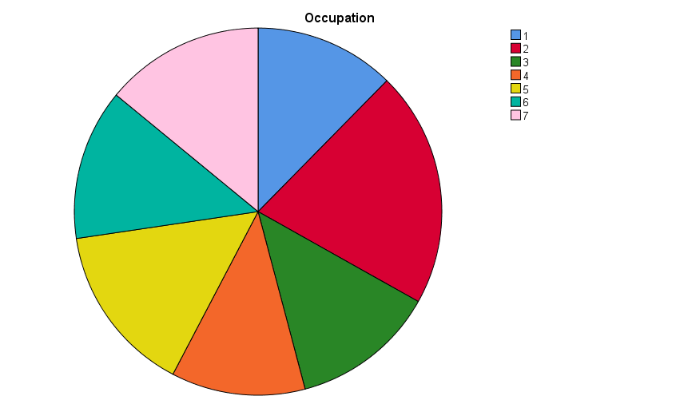

It can be seen that 10-20% of the population work in each sector.

### Educational Qualification

|  |  |  |  |  |  |
| --- | --- | --- | --- | --- | --- |
| **Educational Qualification** | | | | | |
|  | | Frequency | Percent | Valid Percent | Cumulative Percent |
| Valid | 1 | 84 | .0 | 15.7 | 15.7 |
| 2 | 121 | .0 | 22.7 | 38.4 |
| 3 | 183 | .0 | 34.3 | 72.7 |
| 4 | 114 | .0 | 21.3 | 94.0 |
| 5 | 32 | .0 | 6.0 | 100.0 |
| Total | 534 | .1 | 100.0 |  |
| Missing | System | 1048041 | 99.9 |  |  |
| Total | | 1048575 | 100.0 |  |  |
|  | |  |  |  |  |

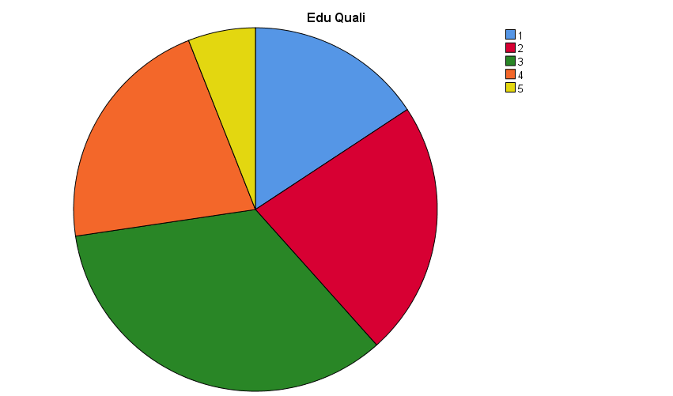

From this, we can infer that the greatest proportion falls under the 3rd qualification, i.e., 34% of the people are graduates.

### Mother Tongue

|  |  |  |  |  |  |
| --- | --- | --- | --- | --- | --- |
| **Mother Tongue** | | | | | |
|  | | Frequency | Percent | Valid Percent | Cumulative Percent |
| Valid | 1 | 434 | .0 | 81.3 | 81.3 |
| 2 | 66 | .0 | 12.4 | 93.6 |
| 3 | 9 | .0 | 1.7 | 95.3 |
| 4 | 12 | .0 | 2.2 | 97.6 |
| 5 | 5 | .0 | .9 | 98.5 |
| 6 | 4 | .0 | .7 | 99.3 |
| 7 | 4 | .0 | .7 | 100.0 |
| Total | 534 | .1 | 100.0 |  |
| Missing | System | 1048041 | 99.9 |  |  |
| Total | | 1048575 | 100.0 |  |  |

Conclusion: A huge part of the Muslims who have filled the form are Urdu speakers.

Similarly, bar graphs have been drawn for gender, marital status and number of children.

### Gender, Marital Status and Number of Children

|  |  |  |  |  |  |
| --- | --- | --- | --- | --- | --- |
| **Gender** | | | | | |
|  | | Frequency | Percent | Valid Percent | Cumulative Percent |
| Valid | 1 | 297 | .0 | 55.6 | 55.6 |
| 2 | 237 | .0 | 44.4 | 100.0 |
| Total | 534 | .1 | 100.0 |  |
| Missing | System | 1048041 | 99.9 |  |  |
| Total | | 1048575 | 100.0 |  |  |
| Conclusion: A few more males have responded to the survey than females.  **No. of Children** | | | | | |
|  | | Frequency | Percent | Valid Percent | Cumulative Percent |
| Valid | 1 | 133 | .0 | 24.9 | 24.9 |
| 2 | 131 | .0 | 24.5 | 49.4 |
| 3 | 62 | .0 | 11.6 | 61.0 |
| 4 | 208 | .0 | 39.0 | 100.0 |
| Total | 534 | .1 | 100.0 |  |
| Missing | System | 1048041 | 99.9 |  |  |
| Total | | 1048575 | 100.0 |  |  |
| **Marital Status** | | | | | |
|  | | Frequency | Percent | Valid Percent | Cumulative Percent |
| Valid | 1 | 193 | .0 | 36.1 | 36.1 |
| 2 | 318 | .0 | 59.6 | 95.7 |
| 3 | 23 | .0 | 4.3 | 100.0 |
| Total | 534 | .1 | 100.0 |  |
| Missing | System | 1048041 | 99.9 |  |  |
| Total | | 1048575 | 100.0 |  |  |

Conclusion: A large part of the respondents (almost 60%) have been found to be married and it is evident that it is highly likely to find families with four kids.

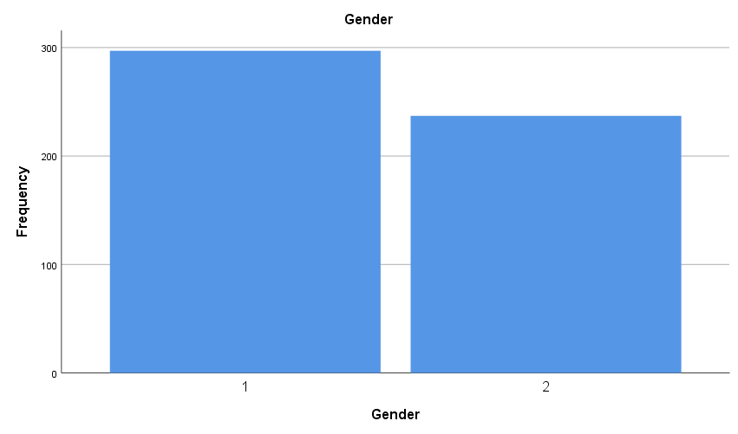 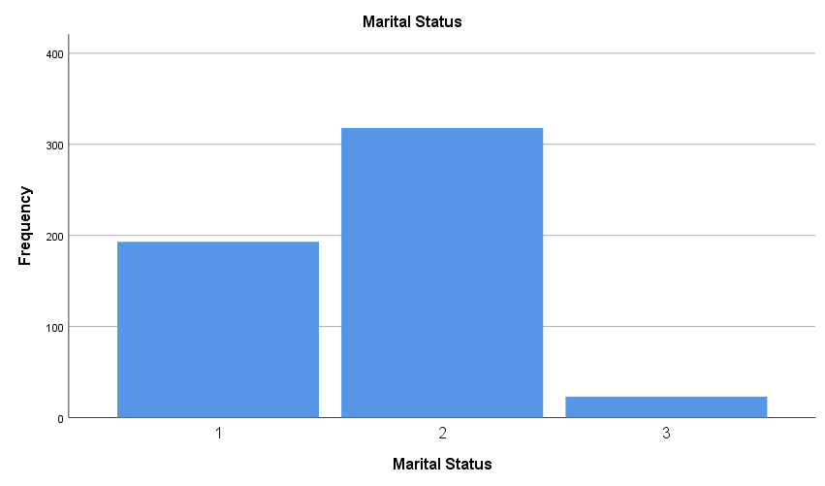 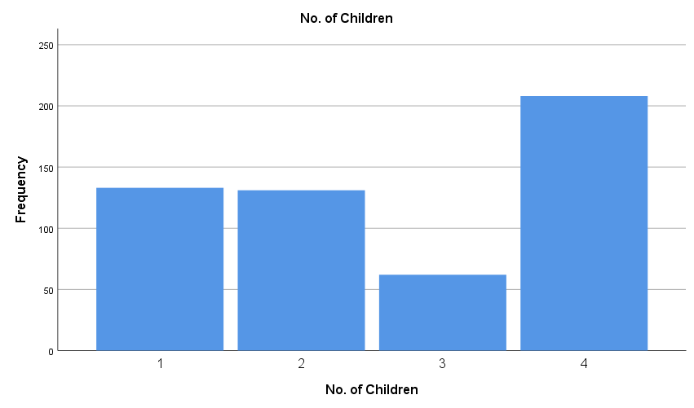

# 2. Continuous Data

Next, continuous data (age, income) has been analysed. It is a **“scaled” data**. As it is not wise to draw pie charts/bar graphs for such data, a histogram has been preferred. The histogram has also been compared with a **normal distribution and the skewness** has been checked. Mean, variance, range etc have been calculated.

|  |  |  |
| --- | --- | --- |
|  | | |
| Age in years | | |
| N | Valid | 534 |
| Missing | 1048041 |
| Mean | | 39.63 |
| Median | | 38.00 |
| Std. Deviation | | 16.558 |
| Variance | | 274.180 |
| Range | | 64 |
| Minimum | | 14 |
| Maximum | | 78 |
| Percentiles | 25 | 26.00 |
| 50 | 38.00 |
| 75 |  |

### Age

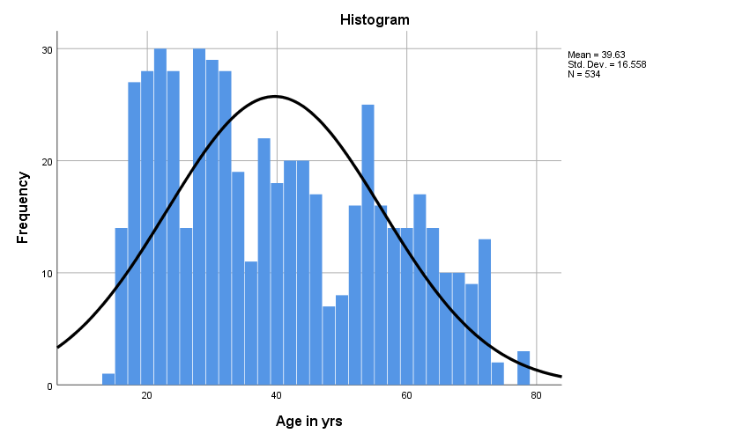

Conclusion: It can be seen from the following graphs that the mean and median age are about 39 years and most people lie within the age group of 30-40.

### Income

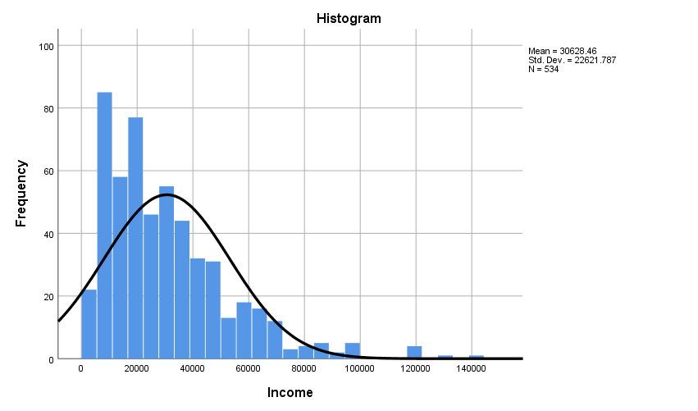

|  |  |  |
| --- | --- | --- |
|  | | |
| Income | | |
|  | | |
| N | Valid | 534 |
| Missing | 1048041 |
| Mean | | 30628.46 |
| Median | | 24850.00 |
| Std. Deviation | | 22621.787 |
| Variance | | 511745229.533 |
| Skewness | | 1.513 |
| Std. Error of Skewness | | .106 |
| Range | | 140500 |
| Minimum | | 3500 |
| Maximum | | 144000 |
| Percentiles | 25 | 14000.00 |
| 50 | 24850.00 |
| 75 | 42000.00 |

Conclusion: It is evident that the graph has a high skewness factor and that the mean (30628.46) is far away from the maximum (144000) than the minimum (3500), i.e., the graph is skewed to the left.

# Analysis of Section-A

## $χ^{2}$- Goodness of Fit Test

We know that the $χ^{2}$- test can be performed only if the given data is **nominal**. So, the $χ^{2}$- test has been done for a) Gender v/s Educational Qualification, (b) Family type v/s Number of children and, (c) TV Sets v/s DTHs.

**The null hypothesis for the $χ^{2}$- test is that the variables are independent.** The test tells us if the difference between observed and expected frequencies is large enough for the test to be significant.

The crosstabs table provides us with the observed and expected frequencies. The $χ^{2}$ tables tells us the percentage of cells that have a count less than 5. It also gives the $χ^{2}$, *p* values along with the degrees of freedom and level of significance. If the expected value is larger than 5, we use the **Pearson $χ^{2}$** value. Else, we use the **likelihood** value. The “Asymp. Sig (2-sided)” value denotes the p-value. So, if it is <0.05 (i.e., 95% LOS), we reject the null hypothesis and conclude that the two quantities are indeed dependent.

### Gender v/s Educational Qualification

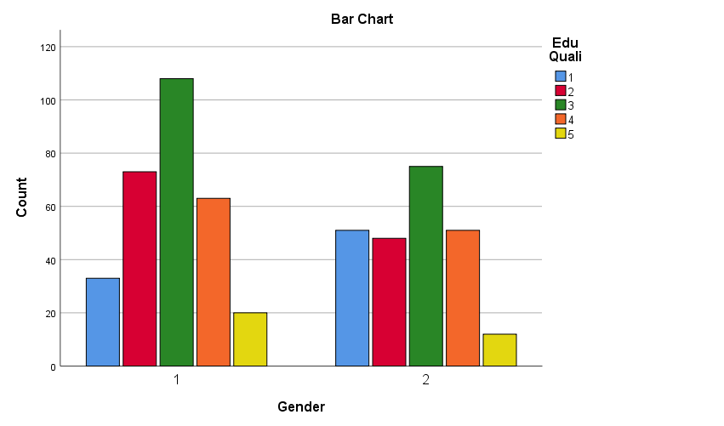

|  |  |  |  |  |  |  |  |  |
| --- | --- | --- | --- | --- | --- | --- | --- | --- |
| **Gender * v/s Educational Qualification Crosstabulation** | | | | | | | | |
|  | | | Educational Qualification | | | | | Total |
| 1 | 2 | 3 | 4 | 5 |
| Gender | 1 | Count | 33 | 73 | 108 | 63 | 20 | 297 |
| Expected Count | 46.7 | 67.3 | 101.8 | 63.4 | 17.8 | 297.0 |
| 2 | Count | 51 | 48 | 75 | 51 | 12 | 237 |
| Expected Count | 37.3 | 53.7 | 81.2 | 50.6 | 14.2 | 237.0 |
| Total | | Count | 84 | 121 | 183 | 114 | 32 | 534 |
| Expected Count | 84.0 | 121.0 | 183.0 | 114.0 | 32.0 | 534.0 |

Conclusion: Using the Pearson $χ^{2}$ value, 0.020<0.05. Thus, we reject the null hypothesis and conclude that gender and educational qualification are dependent.

### Family Type v/s Number of Children

|  |  |  |  |  |  |  |  |
| --- | --- | --- | --- | --- | --- | --- | --- |
| **Family Type v/s No. of Children Crosstabulation** | | | | | | | |
|  | | | No. of Children | | | | Total |
| 1 | 2 | 3 | 4 |
| Family Type | 1 | Count | 75 | 60 | 31 | 102 | 268 |
| Expected Count | 66.7 | 65.7 | 31.1 | 104.4 | 268.0 |
| 2 | Count | 58 | 71 | 31 | 105 | 265 |
| Expected Count | 66.0 | 65.0 | 30.8 | 103.2 | 265.0 |
| 4 | Count | 0 | 0 | 0 | 1 | 1 |
| Expected Count | .2 | .2 | .1 | .4 | 1.0 |
| Total | | Count | 133 | 131 | 62 | 208 | 534 |
| Expected Count | 133.0 | 131.0 | 62.0 | 208.0 | 534.0 |



Conclusion: Using the Pearson $χ^{2}$ value, 0.583>0.05. We do not have sufficient evidence to reject the null hypothesis and thus we conclude that family type and number of children are independent variables.

### TV Sets v/s DTHs

### 

Conclusion: Using the Pearson $χ^{2}$ value, 0.738>0.05. We do not have sufficient evidence to reject the null hypothesis and thus we conclude that TV Sets and DTHs are independent variables.

## Stem and Leaf Plots

As we cannot analyse continuous data using $χ^{2}$ test, we go for the stem-and-leaf plots. One continuous variable and one scaled variable has been chosen. **The dark line of the stem tells us the median while the leaf tells the variance.** The histograms are also drawn and the test for normality has also been done. The descriptive table gives information regarding mean, variance, range, skewness etc for each of the two variables.

Three Tests for Normality: -

1. **Kolmogorov Smirnov Test and Shapiro Wilk Test** – If the p-value >0.05, we conclude that normality holds.
2. **Normality Q-Q plot** – If the observed values lie along the “ideal” line, we can conclude that normality holds.
3. **Histogram** and skewness factor.

### Gender v/s Income



From the above table, it can be seen that the skewness coefficient is high. So, we can not expect normality to hold. It can also be seen from the histogram given below that the graph is skewed to the left.

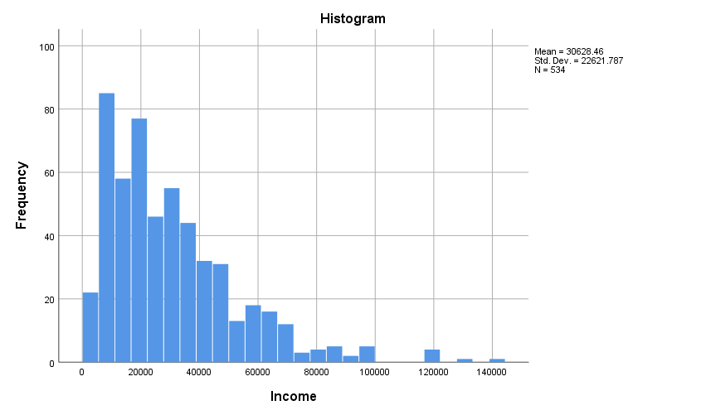

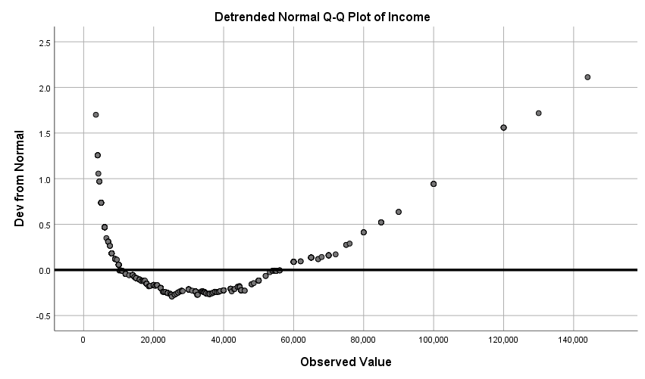 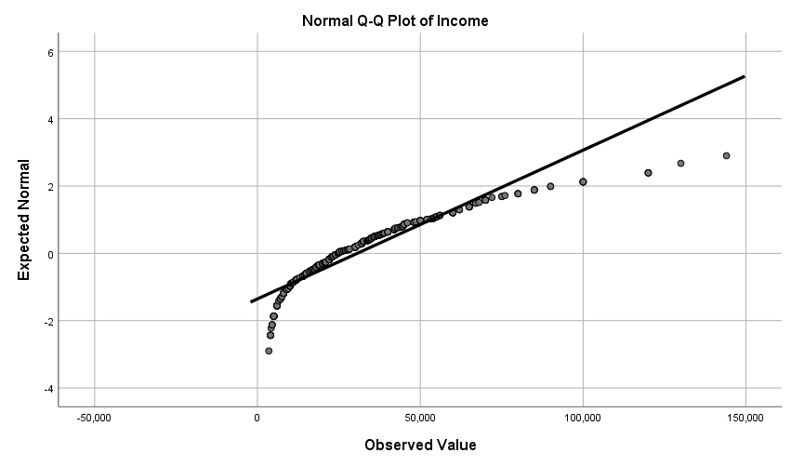

|  |  |  |  |  |  |  |
| --- | --- | --- | --- | --- | --- | --- |
| **Tests of Normality** | | | | | | |
|  | Kolmogorov-Smirnova | | | Shapiro-Wilk | | |
| Statistic | Df | Sig. | Statistic | df | Sig. |
| Gender | .370 | 534 | .000 | .632 | 534 | .000 |
| Income | .118 | 534 | .000 | .877 | 534 | .000 |
|  | | | | | | |
|  | | | | | | |

Conclusion: The Q-Q plots and the Kolmogorov Smirnov, Shapiro Wilk Test confirm the fact that the given data is not normally distributed.

### Age v/s Marital Status



The skewness factor is very high for ‘age’ and so, we can not expect it to be normally distributed.

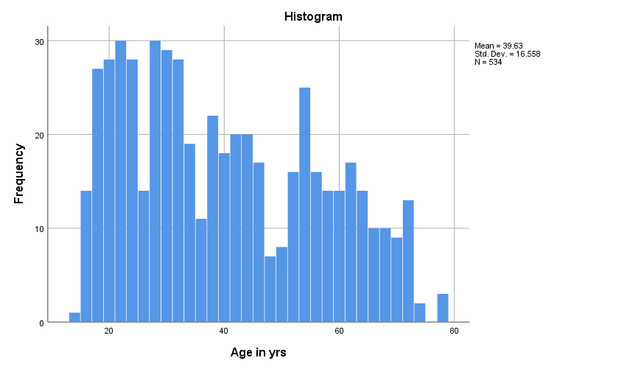

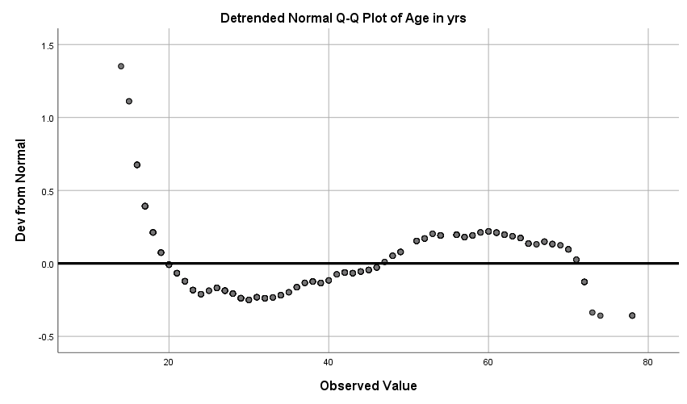 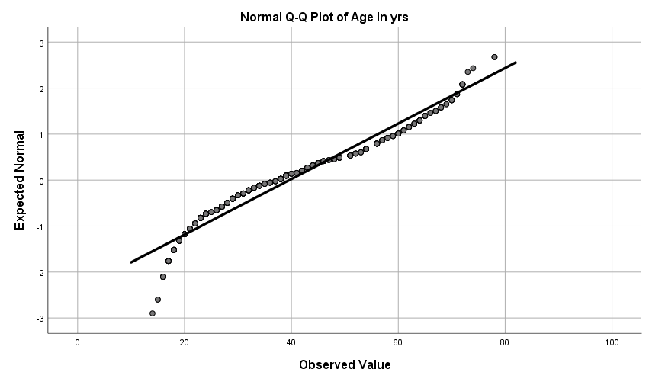

From the Q-Q plots, we can conclude that ‘age’ is not normally distributed but we need more evidence to conclude the same for ‘marital status’.

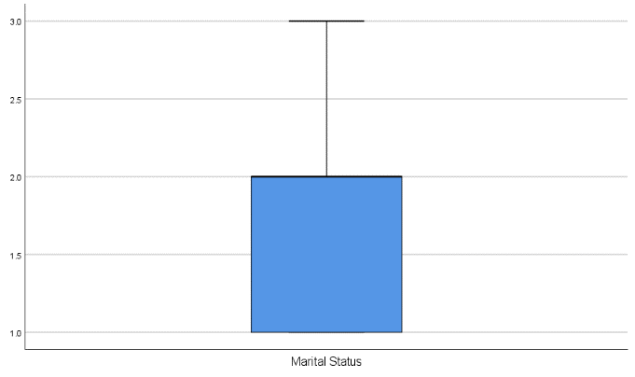 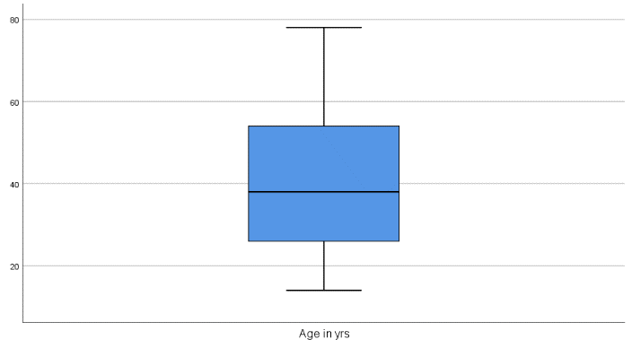



From the K-S test and Shapiro-Wilk test, we can conclude that the data is not normally distributed.

# Analysis of Section-B

Factor analysis is performed for **ordinal data**, i.e., when the data involves either yes/no type questions or when it involves some kind of ranking.

SPSS gives us the **correlation matrix**. It shows the percentage of correlation between 2 items and is 1 when an item is compared with itself. Perfect correlation between 2 different items is called a **“singularity”** and if such cases exist, we should remove one of the items before further analysis. The determinant value should be >0.00001. Otherwise, it means that the two quantities are highly unrelated.

A **scree plot** is drawn. The values with an **eigen value** constitute to maximum variance. This is also supported by the cumulative table. The pattern matrix is used to identify item which can be considered to be “similar”. The **KMO and Bartlett’s** **tests** have also been performed.

**NOTE:** **The same logic holds for Sections C, D as well and conclusions can be made similarly.**

## Section B 15-19

 

Conclusion: It can be seen that no two variables are highly correlated. Also, the communalities tell us the proportion of variance of each variable. The extraction values for 3 of the variables lies above 0.5 and is thus satisfactory.



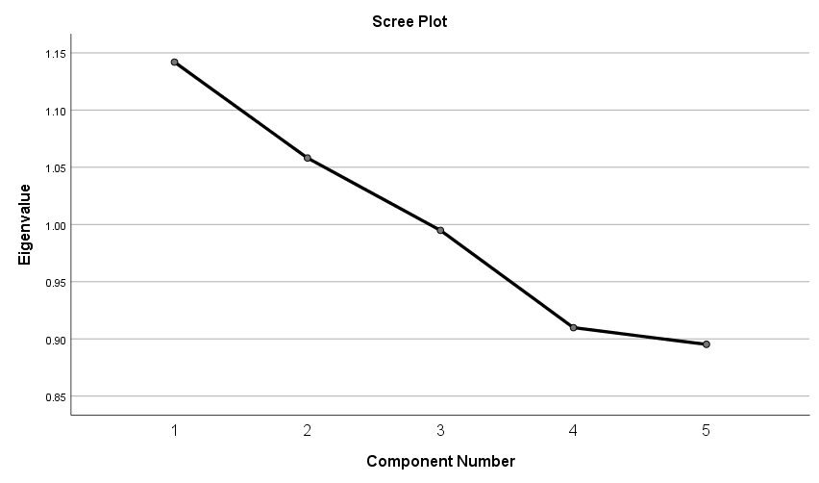

Conclusion: The cumulative table tells us that the first three variables constitute to most of the variance (82%). This can also be seen from the scree plot. 82% of variation comes due to the first three variables as they have an eigen value greater than 1.



Conclusion: From the table, we have 0.510>0.5 and so, the data can be taken to adequate but the sphericity value is 0.343>0.05. So, performing the factor analysis may not be very useful.



Conclusion: The first component can be considered to be highly corelated to @18 while the second is correlated to @17 and @19.

## 

## Section B 20



Conclusion: From the correlation matrix given below, it can be seen that no two variables are highly correlated. Also, the communalities tell us the proportion of variance of each variable. The extraction values for most variables lies above 0.5 and is thus satisfactory.



Conclusion: Adequacy value is >0.5 and Sphericity value is <0.05. Thus the data is adequate and fit for factor analysis.



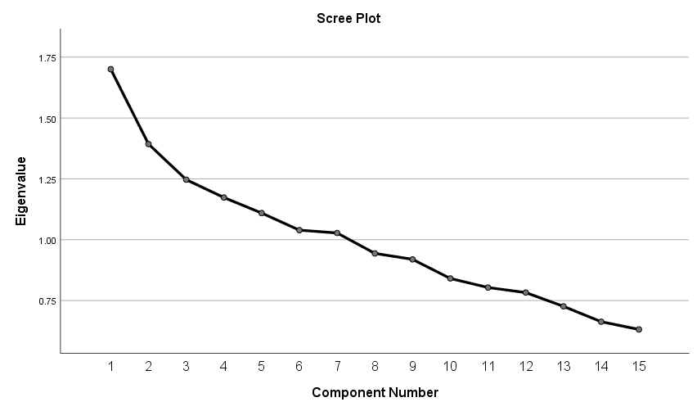 

Conclusion: The first 7 variables have an eigen value of more than 1 and thus constitute to most of the variance.



Conclusion: We find that components 1,3,5 have a negative correlation with 20.1. Similarly, we can compare the others.

# Analysis of Section- C

## Section C 21.1-21.10





Conclusion: 0.486<0.5 and 0.484< 0.05. Thus, it is not best suited for factor analysis.

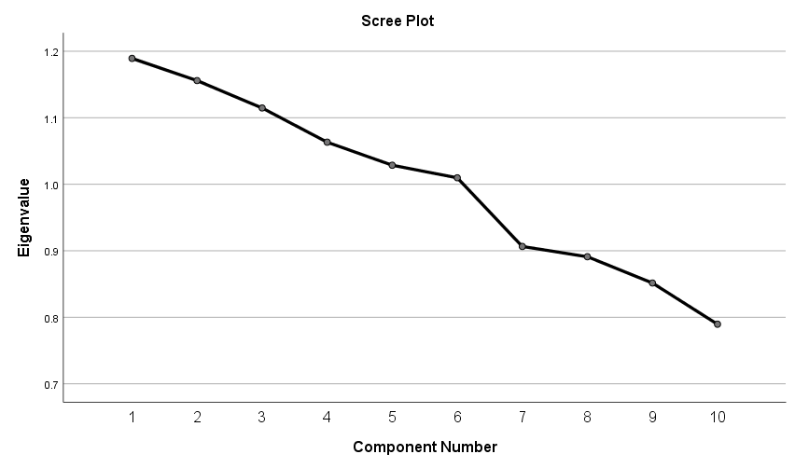 

Conclusion: 6 variables have an eigen value of more than 1 and these constitute to most of the variance (67%).

 

Conclusion: The communalities tell us the proportion of variance of each variable. The extraction values for all variables lies above 0.5 and is thus satisfactory. Also, we find that components 5,6 have a negative correlation with 21.1. Similarly, we can compare the others.

## Section C 21.11-21.20





Conclusion: The sphericity value is <0.05 and thus the data is adequate for factor analysis.

|  |  |  |  |  |  |  |
| --- | --- | --- | --- | --- | --- | --- |
| **Total Variance Explained** | | | | | | |
| Component | Initial Eigenvalues | | | Extraction Sums of Squared Loadings | | |
| Total | % of Variance | Cumulative % | Total | % of Variance | Cumulative % |
| 1 | 1.281 | 12.814 | 12.814 | 1.281 | 12.814 | 12.814 |
| 2 | 1.225 | 12.247 | 25.060 | 1.225 | 12.247 | 25.060 |
| 3 | 1.187 | 11.875 | 36.935 | 1.187 | 11.875 | 36.935 |
| 4 | 1.020 | 10.201 | 47.136 | 1.020 | 10.201 | 47.136 |
| 5 | 1.006 | 10.058 | 57.194 | 1.006 | 10.058 | 57.194 |
| 6 | .971 | 9.715 | 66.909 |  |  |  |
| 7 | .939 | 9.388 | 76.297 |  |  |  |
| 8 | .840 | 8.399 | 84.696 |  |  |  |
| 9 | .817 | 8.167 | 92.863 |  |  |  |
| 10 | .714 | 7.137 | 100.000 |  |  |  |
| Extraction Method: Principal Component Analysis. | | | | | | |
|  | | | | | | |

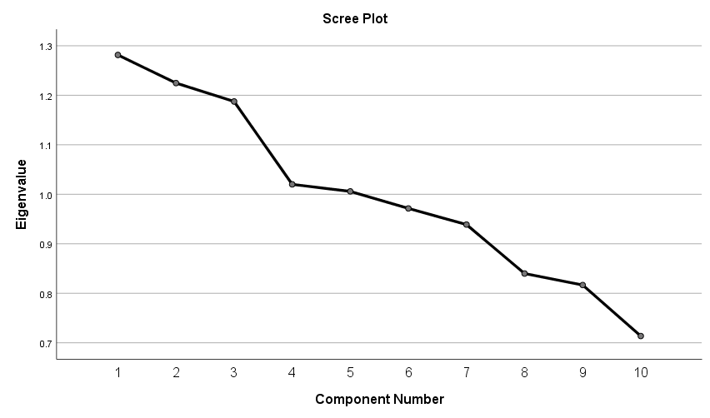

Conclusion: It can be seen that 4 components have an eigen value of more than 1 and they constitute to most of the variation.

 

The communalities tell us the proportion of variance of each variable. The extraction values for most variables lies above 0.5 and is thus satisfactory. Also, we find that components 2,4 have a negative correlation with 21.11. Similarly, we can compare the others.

## Section C 21.21-21.30

|  |  |  |  |  |  |  |  |  |  |  |  |  |
| --- | --- | --- | --- | --- | --- | --- | --- | --- | --- | --- | --- | --- |
| **Correlation Matrixa** | | | | | | | | | | | | |
|  | | 21-21 | 21-22 | 21-23 | 21-24 | 21-25 | 21-26 | 21-27 | 21-28 | 21-29 | 21-30 |
| Correlation | 21-21 | 1.000 | .045 | .033 | .021 | .074 | .013 | -.006 | .088 | .045 | .082 |
| 21-22 | .045 | 1.000 | -.060 | .004 | .026 | -.074 | .027 | -.054 | -.024 | .104 |
| 21-23 | .033 | -.060 | 1.000 | -.029 | .048 | -.048 | .053 | .088 | -.017 | -.028 |
| 21-24 | .021 | .004 | -.029 | 1.000 | .082 | .053 | .037 | .021 | .004 | .000 |
| 21-25 | .074 | .026 | .048 | .082 | 1.000 | .062 | .004 | -.006 | -.009 | -.005 |
| 21-26 | .013 | -.074 | -.048 | .053 | .062 | 1.000 | .000 | -.046 | .052 | .082 |
| 21-27 | -.006 | .027 | .053 | .037 | .004 | .000 | 1.000 | .014 | .047 | -.080 |
| 21-28 | .088 | -.054 | .088 | .021 | -.006 | -.046 | .014 | 1.000 | .046 | -.033 |
| 21-29 | .045 | -.024 | -.017 | .004 | -.009 | .052 | .047 | .046 | 1.000 | -.039 |
| 21-30 | .082 | .104 | -.028 | .000 | -.005 | .082 | -.080 | -.033 | -.039 | 1.000 |
| Sig. (1-tailed) | 21-21 |  | .147 | .220 | .312 | .043 | .381 | .442 | .021 | .151 | .029 |
| 21-22 | .147 |  | .084 | .459 | .277 | .044 | .263 | .107 | .288 | .008 |
| 21-23 | .220 | .084 |  | .252 | .132 | .134 | .112 | .021 | .350 | .259 |
| 21-24 | .312 | .459 | .252 |  | .030 | .110 | .194 | .310 | .461 | .499 |
| 21-25 | .043 | .277 | .132 | .030 |  | .076 | .461 | .449 | .419 | .456 |
| 21-26 | .381 | .044 | .134 | .110 | .076 |  | .497 | .145 | .116 | .029 |
| 21-27 | .442 | .263 | .112 | .194 | .461 | .497 |  | .373 | .141 | .032 |
| 21-28 | .021 | .107 | .021 | .310 | .449 | .145 | .373 |  | .146 | .223 |
| 21-29 | .151 | .288 | .350 | .461 | .419 | .116 | .141 | .146 |  | .184 |
| 21-30 | .029 | .008 | .259 | .499 | .456 | .029 | .032 | .223 | .184 |  |
| a. Determinant = .896 | | | | | | | | | | | | |



Conclusion: 0.491<0.5 and 0.088>0.05. So, factor analysis may not be adequate.

|  |  |  |  |  |  |  |
| --- | --- | --- | --- | --- | --- | --- |
| **Total Variance Explained** | | | | | | |
| Component | Initial Eigenvalues | | | Extraction Sums of Squared Loadings | | |
| Total | % of Variance | Cumulative % | Total | % of Variance | Cumulative % |
| 1 | 1.225 | 12.252 | 12.252 | 1.225 | 12.252 | 12.252 |
| 2 | 1.198 | 11.975 | 24.227 | 1.198 | 11.975 | 24.227 |
| 3 | 1.119 | 11.194 | 35.421 | 1.119 | 11.194 | 35.421 |
| 4 | 1.063 | 10.632 | 46.053 | 1.063 | 10.632 | 46.053 |
| 5 | 1.037 | 10.373 | 56.425 | 1.037 | 10.373 | 56.425 |
| 6 | .966 | 9.663 | 66.089 |  |  |  |
| 7 | .930 | 9.305 | 75.393 |  |  |  |
| 8 | .858 | 8.582 | 83.976 |  |  |  |
| 9 | .835 | 8.349 | 92.324 |  |  |  |
| 10 | .768 | 7.676 | 100.000 |  |  |  |
| Extraction Method: Principal Component Analysis. | | | | | | |

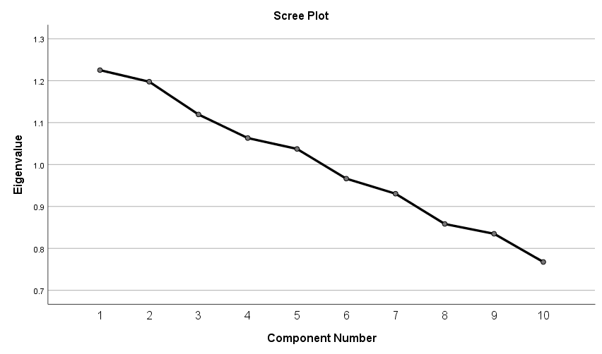

Conclusion: It can be seen that the first 5 components have an eigen value of >1 and they cause the most variance.

|  |  |  |
| --- | --- | --- |
| **Communalities** | | |
|  | Initial | Extraction |
| 21-21 | 1.000 | .565 |
| 21-22 | 1.000 | .715 |
| 21-23 | 1.000 | .500 |
| 21-24 | 1.000 | .418 |
| 21-25 | 1.000 | .553 |
| 21-26 | 1.000 | .615 |
| 21-27 | 1.000 | .564 |
| 21-28 | 1.000 | .492 |
| 21-29 | 1.000 | .680 |
| 21-30 | 1.000 | .540 |
| Extraction Method: Principal Component Analysis. | | |

|  |  |  |  |  |  |
| --- | --- | --- | --- | --- | --- |
| **Rotated Component Matrixa** | | | | | |
|  | Component | | | | |
| 1 | 2 | 3 | 4 | 5 |
| 21-21 | .479 | .429 | .171 | .229 | .264 |
| 21-22 | -.156 | .161 | .054 | .814 | -.005 |
| 21-23 | .611 | -.155 | .088 | -.097 | -.293 |
| 21-24 | -.085 | -.101 | .628 | .021 | .079 |
| 21-25 | .149 | .064 | .701 | .001 | -.190 |
| 21-26 | -.258 | .292 | .376 | -.478 | .305 |
| 21-27 | .027 | -.564 | .246 | .324 | .283 |
| 21-28 | .665 | -.003 | -.088 | -.065 | .194 |
| 21-29 | .066 | -.081 | -.068 | -.052 | .813 |
| 21-30 | -.069 | .713 | .021 | .165 | -.002 |
| Extraction Method: Principal Component Analysis.  Rotation Method: Varimax with Kaiser Normalization. | | | | | |
| a. Rotation converged in 12 iterations. | | | | | |

Conclusion: The communalities tell us the proportion of variance of each variable. The extraction values for most variables lies above 0.5 and is thus satisfactory. Also, we find that no component has a negative correlation with 21.21. Component 1 is highly related to 21.28. Similarly, we can compare the others.

## Section C 21.31-21.40

|  |  |  |  |  |  |  |  |  |  |  |  |  |
| --- | --- | --- | --- | --- | --- | --- | --- | --- | --- | --- | --- | --- |
| **Correlation Matrixa** | | | | | | | | | | | | |
|  | | 21-31 | 21-32 | 21-33 | 21-34 | 21-35 | 21-36 | 21-37 | 21-38 | 21-39 | 21-40 |
| Correlation | 21-31 | 1.000 | -.067 | -.083 | .002 | .063 | .071 | -.032 | .060 | .072 | .024 |
| 21-32 | -.067 | 1.000 | .071 | .016 | -.030 | -.092 | -.003 | -.017 | -.123 | .060 |
| 21-33 | -.083 | .071 | 1.000 | .032 | -.061 | .043 | .072 | .101 | -.060 | .046 |
| 21-34 | .002 | .016 | .032 | 1.000 | .085 | .044 | .091 | .068 | .012 | .023 |
| 21-35 | .063 | -.030 | -.061 | .085 | 1.000 | .069 | -.016 | .023 | .019 | .074 |
| 21-36 | .071 | -.092 | .043 | .044 | .069 | 1.000 | .088 | .006 | .028 | .103 |
| 21-37 | -.032 | -.003 | .072 | .091 | -.016 | .088 | 1.000 | .026 | .033 | .092 |
| 21-38 | .060 | -.017 | .101 | .068 | .023 | .006 | .026 | 1.000 | -.023 | .024 |
| 21-39 | .072 | -.123 | -.060 | .012 | .019 | .028 | .033 | -.023 | 1.000 | .009 |
| 21-40 | .024 | .060 | .046 | .023 | .074 | .103 | .092 | .024 | .009 | 1.000 |
| Sig. (1-tailed) | 21-31 |  | .062 | .028 | .479 | .073 | .051 | .231 | .083 | .048 | .286 |
| 21-32 | .062 |  | .051 | .357 | .246 | .017 | .477 | .352 | .002 | .084 |
| 21-33 | .028 | .051 |  | .231 | .081 | .160 | .048 | .010 | .084 | .143 |
| 21-34 | .479 | .357 | .231 |  | .025 | .157 | .018 | .059 | .391 | .294 |
| 21-35 | .073 | .246 | .081 | .025 |  | .056 | .358 | .299 | .333 | .043 |
| 21-36 | .051 | .017 | .160 | .157 | .056 |  | .021 | .441 | .261 | .009 |
| 21-37 | .231 | .477 | .048 | .018 | .358 | .021 |  | .271 | .226 | .016 |
| 21-38 | .083 | .352 | .010 | .059 | .299 | .441 | .271 |  | .300 | .292 |
| 21-39 | .048 | .002 | .084 | .391 | .333 | .261 | .226 | .300 |  | .417 |
| 21-40 | .286 | .084 | .143 | .294 | .043 | .009 | .016 | .292 | .417 |  |
| a. Determinant = .861 | | | | | | | | | | | | |



Conclusion: 0.536>0.5 and 0.001<0.05. So, the data is adequate and is suitable for a factor analysis.

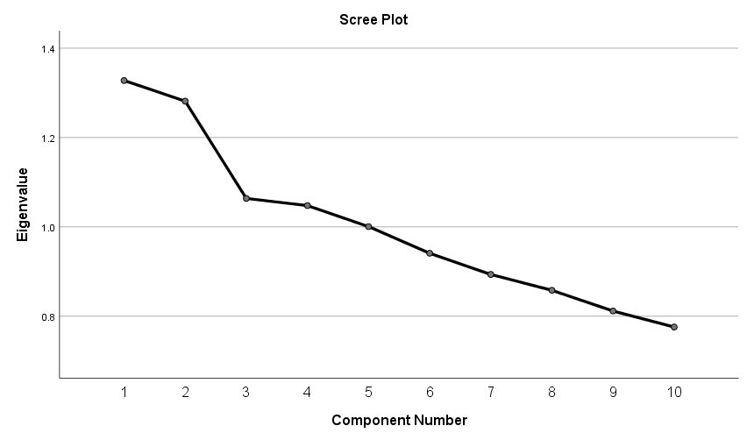

|  |
| --- |
|  |

|  |  |  |  |  |  |  |
| --- | --- | --- | --- | --- | --- | --- |
| **Total Variance Explained** | | | | | | |
| Component | Initial Eigenvalues | | | Extraction Sums of Squared Loadings | | |
| Total | % of Variance | Cumulative % | Total | % of Variance | Cumulative % |
| 1 | 1.328 | 13.276 | 13.276 | 1.328 | 13.276 | 13.276 |
| 2 | 1.281 | 12.814 | 26.090 | 1.281 | 12.814 | 26.090 |
| 3 | 1.064 | 10.636 | 36.725 | 1.064 | 10.636 | 36.725 |
| 4 | 1.048 | 10.476 | 47.201 | 1.048 | 10.476 | 47.201 |
| 5 | 1.001 | 10.005 | 57.206 | 1.001 | 10.005 | 57.206 |
| 6 | .941 | 9.409 | 66.615 |  |  |  |
| 7 | .893 | 8.934 | 75.549 |  |  |  |
| 8 | .858 | 8.580 | 84.128 |  |  |  |
| 9 | .812 | 8.115 | 92.243 |  |  |  |
| 10 | .776 | 7.757 | 100.000 |  |  |  |
| Extraction Method: Principal Component Analysis. | | | | | | |

It can be seen that 5 components constitute most of the variation (57%) and they have an eigen value of more than 1.

|  |  |  |  |  |  |  |  |  |
| --- | --- | --- | --- | --- | --- | --- | --- | --- |
| **Communalities** | | | | | | | | |
|  | | | Initial | | | Extraction | | |
| 21-31 | | | 1.000 | | | .522 | | |
| 21-32 | | | 1.000 | | | .539 | | |
| 21-33 | | | 1.000 | | | .544 | | |
| 21-34 | | | 1.000 | | | .736 | | |
| 21-35 | | | 1.000 | | | .591 | | |
| 21-36 | | | 1.000 | | | .479 | | |
| 21-37 | | | 1.000 | | | .544 | | |
| 21-38 | | | 1.000 | | | .729 | | |
| 21-39 | | | 1.000 | | | .441 | | |
| 21-40 | | | 1.000 | | | .597 | | |
| Extraction Method: Principal Component Analysis. | | | | | | | | |
| Rotated Component Matrixa | | | | | | | | |
|  | Component | | | | | | |
| 1 | 2 | | 3 | 4 | | 5 |
| 21-31 | .235 | .216 | | -.625 | .168 | | .040 |
| 21-32 | -.719 | .021 | | .118 | -.059 | | .064 |
| 21-33 | -.185 | .156 | | .351 | .573 | | -.184 |
| 21-34 | .055 | -.097 | | .270 | .165 | | .789 |
| 21-35 | -.086 | .221 | | -.351 | -.162 | | .620 |
| 21-36 | .252 | .639 | | -.004 | .081 | | -.016 |
| 21-37 | .207 | .332 | | .597 | .093 | | .159 |
| 21-38 | .010 | -.054 | | -.211 | .812 | | .150 |
| 21-39 | .640 | .037 | | .063 | -.148 | | .059 |
| 21-40 | -.242 | .730 | | .001 | -.053 | | .053 |
| Extraction Method: Principal Component Analysis.  Rotation Method: Varimax with Kaiser Normalization. | | | | | | | |
| a. Rotation converged in 13 iterations. | | | | | | | |

Conclusion: The communalities tell us the proportion of variance of each variable. The extraction values for most variables lies above 0.5 and is thus satisfactory. Also, we find that component 3 has a negative correlation with 21.31. Component 1 is highly related to 21.39. Similarly, we can compare the others.

# 

# Analysis of Section- D

**NOTE: The Analysis of Section D is exactly similar to that of Sections B, C.**

## Section D 22.1-22.10

|  |  |  |  |  |  |  |  |  |  |  |  |  |
| --- | --- | --- | --- | --- | --- | --- | --- | --- | --- | --- | --- | --- |
| **Correlation Matrixa** | | | | | | | | | | | | |
|  | | 22-1 | 22-2 | 22-3 | 22-4 | 22-5 | 22-6 | 22-7 | 22-8 | 22-9 | 22-10 |
| Correlation | 22-1 | 1.000 | -.021 | -.057 | .052 | .006 | .017 | .018 | -.043 | -.023 | -.001 |
| 22-2 | -.021 | 1.000 | .042 | -.041 | -.020 | -.024 | .077 | .034 | -.014 | .000 |
| 22-3 | -.057 | .042 | 1.000 | -.044 | .022 | -.012 | .069 | -.059 | .000 | .077 |
| 22-4 | .052 | -.041 | -.044 | 1.000 | .023 | -.085 | -.054 | -.061 | -.029 | .053 |
| 22-5 | .006 | -.020 | .022 | .023 | 1.000 | .002 | .142 | -.027 | -.017 | -.008 |
| 22-6 | .017 | -.024 | -.012 | -.085 | .002 | 1.000 | .036 | .046 | .058 | .008 |
| 22-7 | .018 | .077 | .069 | -.054 | .142 | .036 | 1.000 | -.080 | .056 | .019 |
| 22-8 | -.043 | .034 | -.059 | -.061 | -.027 | .046 | -.080 | 1.000 | .075 | .033 |
| 22-9 | -.023 | -.014 | .000 | -.029 | -.017 | .058 | .056 | .075 | 1.000 | .110 |
| 22-10 | -.001 | .000 | .077 | .053 | -.008 | .008 | .019 | .033 | .110 | 1.000 |
| Sig. (1-tailed) | 22-1 |  | .311 | .093 | .116 | .445 | .345 | .337 | .160 | .295 | .486 |
| 22-2 | .311 |  | .165 | .173 | .322 | .289 | .037 | .220 | .372 | .498 |
| 22-3 | .093 | .165 |  | .154 | .307 | .395 | .056 | .086 | .499 | .039 |
| 22-4 | .116 | .173 | .154 |  | .300 | .024 | .107 | .079 | .254 | .112 |
| 22-5 | .445 | .322 | .307 | .300 |  | .478 | .000 | .269 | .352 | .423 |
| 22-6 | .345 | .289 | .395 | .024 | .478 |  | .204 | .145 | .089 | .429 |
| 22-7 | .337 | .037 | .056 | .107 | .000 | .204 |  | .032 | .099 | .333 |
| 22-8 | .160 | .220 | .086 | .079 | .269 | .145 | .032 |  | .042 | .227 |
| 22-9 | .295 | .372 | .499 | .254 | .352 | .089 | .099 | .042 |  | .005 |
| 22-10 | .486 | .498 | .039 | .112 | .423 | .429 | .333 | .227 | .005 |  |
| a. Determinant = .892 | | | | | | | | | | | | |

|  |  |  |
| --- | --- | --- |
| **KMO and Bartlett's Test** | | |
|  | | |
| Kaiser-Meyer-Olkin Measure of Sampling Adequacy. | | .499 |
| Bartlett's Test of Sphericity | Approx. Chi-Square | 60.144 |
| df | 45 |
| Sig. | .065 |

|  |  |  |  |  |  |  |
| --- | --- | --- | --- | --- | --- | --- |
| **Total Variance Explained** | | | | | | |
| Component | Initial Eigenvalues | | | Extraction Sums of Squared Loadings | | |
| Total | % of Variance | Cumulative % | Total | % of Variance | Cumulative % |
| 1 | 1.238 | 12.378 | 12.378 | 1.238 | 12.378 | 12.378 |
| 2 | 1.206 | 12.059 | 24.437 | 1.206 | 12.059 | 24.437 |
| 3 | 1.109 | 11.093 | 35.531 | 1.109 | 11.093 | 35.531 |
| 4 | 1.087 | 10.868 | 46.399 | 1.087 | 10.868 | 46.399 |
| 5 | .997 | 9.970 | 56.369 |  |  |  |
| 6 | .983 | 9.835 | 66.203 |  |  |  |
| 7 | .908 | 9.075 | 75.279 |  |  |  |
| 8 | .878 | 8.777 | 84.056 |  |  |  |
| 9 | .821 | 8.211 | 92.267 |  |  |  |
| 10 | .773 | 7.733 | 100.000 |  |  |  |
| Extraction Method: Principal Component Analysis. | | | | | | |

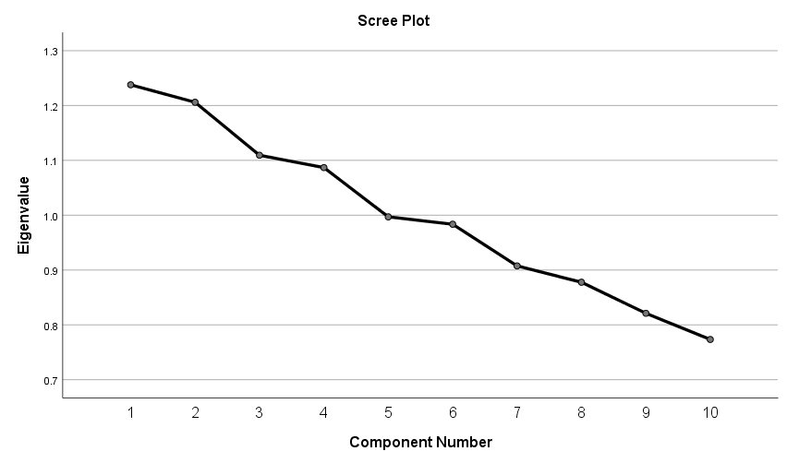

 

## Section D 22.11-22.20

|  |  |  |  |  |  |  |  |  |  |  |  |  |
| --- | --- | --- | --- | --- | --- | --- | --- | --- | --- | --- | --- | --- |
| **Correlation Matrixa** | | | | | | | | | | | | |
|  | | 22-11 | 22-12 | 22-13 | 22-14 | 22-15 | 22-16 | 22-17 | 22-18 | 22-19 | 22-20 |
| Correlation | 22-11 | 1.000 | .104 | .015 | .089 | .114 | .132 | -.046 | -.050 | -.064 | .064 |
| 22-12 | .104 | 1.000 | .137 | .085 | .040 | .022 | -.008 | .092 | -.046 | .074 |
| 22-13 | .015 | .137 | 1.000 | .036 | -.003 | .113 | .113 | .023 | -.111 | -.086 |
| 22-14 | .089 | .085 | .036 | 1.000 | -.003 | -.003 | .006 | -.016 | .037 | .004 |
| 22-15 | .114 | .040 | -.003 | -.003 | 1.000 | .124 | .025 | .000 | -.025 | -.049 |
| 22-16 | .132 | .022 | .113 | -.003 | .124 | 1.000 | .034 | -.009 | -.087 | .013 |
| 22-17 | -.046 | -.008 | .113 | .006 | .025 | .034 | 1.000 | .015 | .040 | .019 |
| 22-18 | -.050 | .092 | .023 | -.016 | .000 | -.009 | .015 | 1.000 | .125 | -.025 |
| 22-19 | -.064 | -.046 | -.111 | .037 | -.025 | -.087 | .040 | .125 | 1.000 | .002 |
| 22-20 | .064 | .074 | -.086 | .004 | -.049 | .013 | .019 | -.025 | .002 | 1.000 |
| Sig. (1-tailed) | 22-11 |  | .008 | .362 | .020 | .004 | .001 | .144 | .122 | .071 | .070 |
| 22-12 | .008 |  | .001 | .025 | .177 | .303 | .426 | .017 | .145 | .044 |
| 22-13 | .362 | .001 |  | .206 | .476 | .004 | .004 | .301 | .005 | .023 |
| 22-14 | .020 | .025 | .206 |  | .475 | .469 | .448 | .359 | .194 | .460 |
| 22-15 | .004 | .177 | .476 | .475 |  | .002 | .283 | .497 | .285 | .131 |
| 22-16 | .001 | .303 | .004 | .469 | .002 |  | .217 | .414 | .022 | .383 |
| 22-17 | .144 | .426 | .004 | .448 | .283 | .217 |  | .362 | .180 | .331 |
| 22-18 | .122 | .017 | .301 | .359 | .497 | .414 | .362 |  | .002 | .280 |
| 22-19 | .071 | .145 | .005 | .194 | .285 | .022 | .180 | .002 |  | .480 |
| 22-20 | .070 | .044 | .023 | .460 | .131 | .383 | .331 | .280 | .480 |  |
| a. Determinant = .819 | | | | | | | | | | | | |

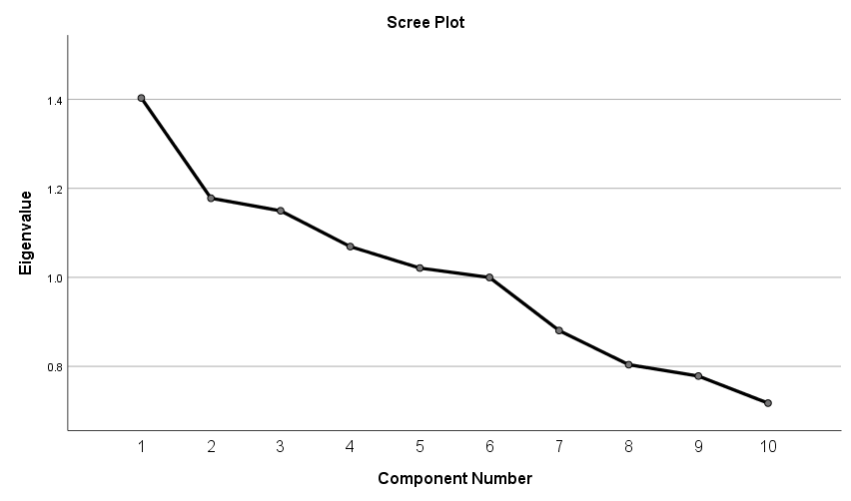

|  |  |  |  |  |  |  |
| --- | --- | --- | --- | --- | --- | --- |
| **Total Variance Explained** | | | | | | |
| Component | Initial Eigenvalues | | | Extraction Sums of Squared Loadings | | |
| Total | % of Variance | Cumulative % | Total | % of Variance | Cumulative % |
| 1 | 1.403 | 14.030 | 14.030 | 1.403 | 14.030 | 14.030 |
| 2 | 1.178 | 11.778 | 25.808 | 1.178 | 11.778 | 25.808 |
| 3 | 1.150 | 11.496 | 37.304 | 1.150 | 11.496 | 37.304 |
| 4 | 1.069 | 10.692 | 47.996 | 1.069 | 10.692 | 47.996 |
| 5 | 1.021 | 10.209 | 58.204 | 1.021 | 10.209 | 58.204 |
| 6 | 1.000 | 9.998 | 68.203 |  |  |  |
| 7 | .880 | 8.805 | 77.007 |  |  |  |
| 8 | .804 | 8.037 | 85.044 |  |  |  |
| 9 | .778 | 7.781 | 92.826 |  |  |  |
| 10 | .717 | 7.174 | 100.000 |  |  |  |
| Extraction Method: Principal Component Analysis. | | | | | | |



 

## Section D 22.21-22.30

|  |  |  |  |  |  |  |  |  |  |  |  |  |
| --- | --- | --- | --- | --- | --- | --- | --- | --- | --- | --- | --- | --- |
| **Correlation Matrixa** | | | | | | | | | | | | |
|  | | 22-21 | 22-22 | 22-23 | 22-24 | 22-25 | 22-26 | 22-27 | 22-28 | 22-29 | 22-30 |
| Correlation | 22-21 | 1.000 | .132 | .003 | .124 | -.047 | .090 | .014 | -.041 | .044 | .066 |
| 22-22 | .132 | 1.000 | .004 | -.119 | .040 | -.088 | .119 | -.029 | .070 | .036 |
| 22-23 | .003 | .004 | 1.000 | -.049 | -.033 | .055 | -.058 | .019 | .008 | .060 |
| 22-24 | .124 | -.119 | -.049 | 1.000 | .056 | .030 | -.066 | .091 | .037 | -.030 |
| 22-25 | -.047 | .040 | -.033 | .056 | 1.000 | .005 | -.020 | -.015 | .012 | .006 |
| 22-26 | .090 | -.088 | .055 | .030 | .005 | 1.000 | -.017 | .143 | .008 | .089 |
| 22-27 | .014 | .119 | -.058 | -.066 | -.020 | -.017 | 1.000 | .012 | -.006 | -.009 |
| 22-28 | -.041 | -.029 | .019 | .091 | -.015 | .143 | .012 | 1.000 | .038 | .074 |
| 22-29 | .044 | .070 | .008 | .037 | .012 | .008 | -.006 | .038 | 1.000 | -.030 |
| 22-30 | .066 | .036 | .060 | -.030 | .006 | .089 | -.009 | .074 | -.030 | 1.000 |
| Sig. (1-tailed) | 22-21 |  | .001 | .470 | .002 | .137 | .018 | .375 | .174 | .157 | .063 |
| 22-22 | .001 |  | .461 | .003 | .177 | .021 | .003 | .251 | .052 | .202 |
| 22-23 | .470 | .461 |  | .131 | .224 | .101 | .092 | .333 | .424 | .082 |
| 22-24 | .002 | .003 | .131 |  | .098 | .247 | .065 | .018 | .198 | .246 |
| 22-25 | .137 | .177 | .224 | .098 |  | .456 | .325 | .364 | .395 | .449 |
| 22-26 | .018 | .021 | .101 | .247 | .456 |  | .351 | .000 | .428 | .020 |
| 22-27 | .375 | .003 | .092 | .065 | .325 | .351 |  | .391 | .447 | .415 |
| 22-28 | .174 | .251 | .333 | .018 | .364 | .000 | .391 |  | .193 | .045 |
| 22-29 | .157 | .052 | .424 | .198 | .395 | .428 | .447 | .193 |  | .246 |
| 22-30 | .063 | .202 | .082 | .246 | .449 | .020 | .415 | .045 | .246 |  |
| a. Determinant = .840 | | | | | | | | | | | | |

|  |  |  |  |  |  |  |
| --- | --- | --- | --- | --- | --- | --- |
| **Total Variance Explained** | | | | | | |
| Component | Initial Eigenvalues | | | Extraction Sums of Squared Loadings | | |
| Total | % of Variance | Cumulative % | Total | % of Variance | Cumulative % |
| 1 | 1.301 | 13.010 | 13.010 | 1.301 | 13.010 | 13.010 |
| 2 | 1.223 | 12.225 | 25.235 | 1.223 | 12.225 | 25.235 |
| 3 | 1.140 | 11.398 | 36.634 | 1.140 | 11.398 | 36.634 |
| 4 | 1.047 | 10.466 | 47.099 | 1.047 | 10.466 | 47.099 |
| 5 | 1.022 | 10.218 | 57.317 | 1.022 | 10.218 | 57.317 |
| 6 | 1.008 | 10.079 | 67.397 | 1.008 | 10.079 | 67.397 |
| 7 | .895 | 8.955 | 76.351 |  |  |  |
| 8 | .878 | 8.782 | 85.134 |  |  |  |
| 9 | .822 | 8.218 | 93.351 |  |  |  |
| 10 | .665 | 6.649 | 100.000 |  |  |  |
| Extraction Method: Principal Component Analysis. | | | | | | |

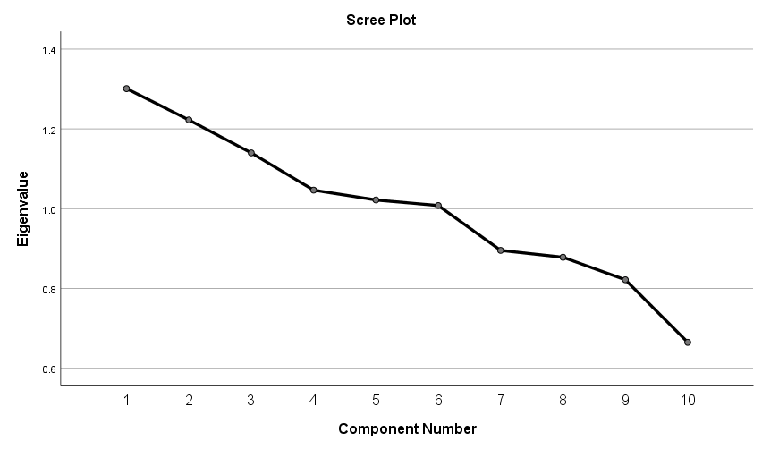



 

## Section D 22.31-22.40

|  |  |  |  |  |  |  |  |  |  |  |  |  |
| --- | --- | --- | --- | --- | --- | --- | --- | --- | --- | --- | --- | --- |
| **Correlation Matrixa** | | | | | | | | | | | | |
|  | | 22-31 | 22-32 | 22-33 | 22-34 | 22-35 | 22-36 | 22-37 | 22-38 | 22-39 | 22-40 |
| Correlation | 22-31 | 1.000 | .084 | .057 | .064 | -.029 | .112 | -.044 | .027 | .027 | -.047 |
| 22-32 | .084 | 1.000 | .052 | -.027 | -.081 | .062 | .027 | .017 | .063 | -.005 |
| 22-33 | .057 | .052 | 1.000 | -.101 | .003 | .000 | -.055 | .066 | .001 | .015 |
| 22-34 | .064 | -.027 | -.101 | 1.000 | .028 | .000 | -.042 | -.013 | .016 | -.110 |
| 22-35 | -.029 | -.081 | .003 | .028 | 1.000 | -.124 | .054 | .055 | .021 | .053 |
| 22-36 | .112 | .062 | .000 | .000 | -.124 | 1.000 | -.009 | -.050 | -.047 | .046 |
| 22-37 | -.044 | .027 | -.055 | -.042 | .054 | -.009 | 1.000 | -.020 | .032 | .049 |
| 22-38 | .027 | .017 | .066 | -.013 | .055 | -.050 | -.020 | 1.000 | .100 | .065 |
| 22-39 | .027 | .063 | .001 | .016 | .021 | -.047 | .032 | .100 | 1.000 | -.056 |
| 22-40 | -.047 | -.005 | .015 | -.110 | .053 | .046 | .049 | .065 | -.056 | 1.000 |
| Sig. (1-tailed) | 22-31 |  | .026 | .095 | .071 | .250 | .005 | .156 | .264 | .269 | .139 |
| 22-32 | .026 |  | .114 | .268 | .031 | .077 | .263 | .351 | .072 | .457 |
| 22-33 | .095 | .114 |  | .010 | .471 | .498 | .102 | .065 | .492 | .369 |
| 22-34 | .071 | .268 | .010 |  | .257 | .498 | .164 | .381 | .353 | .005 |
| 22-35 | .250 | .031 | .471 | .257 |  | .002 | .106 | .103 | .313 | .110 |
| 22-36 | .005 | .077 | .498 | .498 | .002 |  | .416 | .126 | .140 | .145 |
| 22-37 | .156 | .263 | .102 | .164 | .106 | .416 |  | .323 | .232 | .129 |
| 22-38 | .264 | .351 | .065 | .381 | .103 | .126 | .323 |  | .011 | .067 |
| 22-39 | .269 | .072 | .492 | .353 | .313 | .140 | .232 | .011 |  | .098 |
| 22-40 | .139 | .457 | .369 | .005 | .110 | .145 | .129 | .067 | .098 |  |
| a. Determinant = .873 | | | | | | | | | | | | |

|  |  |  |  |  |  |  |
| --- | --- | --- | --- | --- | --- | --- |
| **Total Variance Explained** | | | | | | |
| Component | Initial Eigenvalues | | | Extraction Sums of Squared Loadings | | |
| Total | % of Variance | Cumulative % | Total | % of Variance | Cumulative % |
| 1 | 1.275 | 12.750 | 12.750 | 1.275 | 12.750 | 12.750 |
| 2 | 1.206 | 12.057 | 24.807 | 1.206 | 12.057 | 24.807 |
| 3 | 1.174 | 11.738 | 36.544 | 1.174 | 11.738 | 36.544 |
| 4 | 1.068 | 10.675 | 47.220 | 1.068 | 10.675 | 47.220 |
| 5 | 1.011 | 10.106 | 57.326 | 1.011 | 10.106 | 57.326 |
| 6 | .946 | 9.457 | 66.783 |  |  |  |
| 7 | .877 | 8.768 | 75.551 |  |  |  |
| 8 | .841 | 8.409 | 83.960 |  |  |  |
| 9 | .820 | 8.202 | 92.161 |  |  |  |
| 10 | .784 | 7.839 | 100.000 |  |  |  |
| Extraction Method: Principal Component Analysis. | | | | | | |

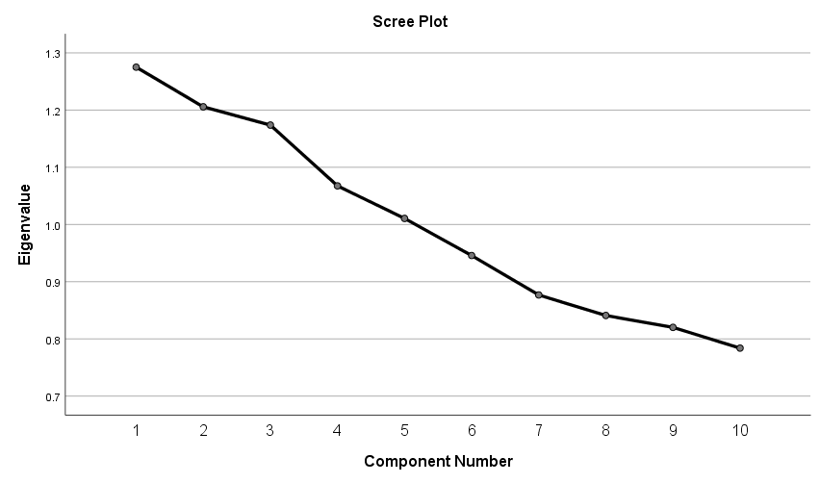

|  |  |  |  |
| --- | --- | --- | --- |
| KMO and Bartlett's Test | | | |
| Kaiser-Meyer-Olkin Measure of Sampling Adequacy. | | .513 |
| Bartlett's Test of Sphericity | Approx. Chi-Square | 72.058 |
| df | 45 |
| Sig. | .006 |
| . | | | |

# Summary and Conclusion

The given primary data has been analysed on SPSS and suitable inferences have been made. First, Cronbach’s alpha test has been performed to check the reliability and internal consistency of the questionnaire. Pie charts, bar graphs and histograms have been drawn and various measures of central tendency have been calculated.

The questionnaire contains four sections. For the first section (which involved topics like gender, income, educational qualification etc), two tests have been performed. For nominal data (E.g. gender), the - test has been performed while the stem-and-leaf plots have been drawn for continuous data (E.g. income, age). After analysing the descriptive tables, the Kolmogorov-Smirnov test and the Shapiro-Wilk test have been conducted to check for normality in case of continuous data. Normality has also been tested with the help of the Q-Q plot and histograms.

Sections B, C, D contain yes/no responses and ratings on a scale of 1-5 or 1-10.Such data is said to ordinal. For such data, a factor analysis has been performed which includes the KMO and Bartlett’s tests. The co-relation matrix which shows the percentage of correlation between two types of entries has been analysed next. Finally, Scree plots have been generated based on Eigen Values greater than 1.

# References

1. <https://www.ibm.com/account/reg/in-en/signup?formid=urx-19774>
2. <https://www.youtube.com/watch?v=2gHvHm2SE5s>
3. <https://youtu.be/g_3kaSnq-DY>
4. <https://www.youtube.com/watch?v=atWwZmIEZ9Q&t=276s>
5. <https://www.youtube.com/watch?v=pRA3Wapx7fY&t=755s>

# Questionnaire

**Section A: Profile of the Respondent**

**Table 1: Demographic Profile of the Respondent**

|  |  |  |  |  |  |  |  |  |
| --- | --- | --- | --- | --- | --- | --- | --- | --- |
| **S. No** | **SOCIO-ECONOMIC STATUS** | | | | | | | |
| 1 | **Name of the Respondent** |  | | | | | | |
| 2 | **Address** |  | | | | | | |
| 3 | **Name of the City** |  | | | | | | |
| 4 | **Gender** | 1. Male | | | | 1. Female | | |
|  | | | |  | | |
| 5. | **Age (Years)** |  | | | | | | |
| 6 | **Marital Status** | 1. Single | | 1. Married | | | 1. Other | |
|  | |  | | |  | |
| 7 | **Actual household monthly Income in ( Rupees)** |  | | | | | | |
| 8 | **Educational Qualification** | 1.Primary | 2. Secondary | 3. Graduation | 4. P.G & Above | 5. Madarsa Qualified | | |
|  |  |  |  |  | | |
| 9 | **Occupation/**  **Profession** | 1.Govt. Service | 2.Private Service | 3.Retired Professional | 4.Housewife | 5.Student | 6.Business | 7.Self Employed |
|  |  |  |  |  |  |  |
| 10. | **Mother Tongue** | 1.Urdu | 2.Hindi | 3.Telugu | 4.Marathi | 5.Bhojpuri | 6.Bangla | 7.Any Other |
|  |  |  |  |  |  |  |
| 11. | **Number of Children** | 1. 1-2 | | 1. 3-4 | | 1. More than 5 | | 4.None |
|  | |  | |  | |  |
| 12. | **Family Type** | 1. Single Family | | | | 1. Joint Family | | |
|  | | | |  | | |

**Table 2: Facilities available at the respondent’s residence**

|  |  |  |  |  |  |  |  |  |  |
| --- | --- | --- | --- | --- | --- | --- | --- | --- | --- |
| **S.No**. | **FACILITIES AVAILABLE** | | | | | | | | |
| 13. | **What type of TV Set do you have?** | 1. Colour CRT TV | 2. LCD TV | 3. )LED TV | 4. Plasma TV | 5. OLED TV | | 6. Black & White TV | |
|  |  |  |  |  | |  | |
| 14. | **What type of DTH connection do you have?** | 1.Airtel | 2.Dish TV | 3.Videocon  D2h | 4. Reliance | 5.Tata Sky | 6.DD Plus | 7. Sun Direct | 8..Any Other |
|  |  |  |  |  |  |  |  |

**SECTION B: The level of awareness of Indian Muslim viewer’s in respect of Urdu Satellite TV Channels**

15. For how long you have been watching Urdu Satellite TV channels?

1) 1-2 Years ( ) 2). 2-4 years ( )

3) 4-6 years ( ) 4) above 6 years ( )

16. How many hours daily do you watch Urdu Satellite TV Channels?

1) Less than I hr. ( ) 2) 1-2 hr. ( )

3) 2-3 hr. ( ) 4) More than 3 hr. ( )

17. What is your frequency of watching Urdu Satellite TV Channels in a day?

1) Always ( ) 2 Frequently ( )

3) Sometime ( ) 4). Very Often ( )

18. At what time do you like watching Urdu Satellite TV Channels in a day?

1). Morning ( ) 2) Afternoon ( )

3) Evening ( ) 4) Night ( )

19) Which Urdu Satellite TV Channel do you like the most? (Mark any one)

|  |  |  |
| --- | --- | --- |
| **S.No**. | **Name of the Channel** | **Preference** |
| 1. | ETV Urdu |  |
| 2. | DD Urdu |  |
| 3. | Zee Salaam |  |
| 4. | Aalami Samay |  |
| 5. | Munsif TV |  |

**20) Please indicate your attitude towards the following Genre of shows on Urdu Satellite TV channels (on a scale of 1 to 3)**

|  |  |  |  |  |
| --- | --- | --- | --- | --- |
| **S.No.** | **Genre of shows** | **Like**  **(3)** | **Neutral**  **(2)** | **Dislike**  **(1)** |
| 20.1 | News & Current Affairs shows |  |  |  |
| 20.2 | Talk shows , Documentaries |  |  |  |
| 20.3 | Health ,Fashion & Lifestyle shows |  |  |  |
| 20.4 | Women Issue based shows |  |  |  |
| 20.5 | Cookery shows |  |  |  |
| 20.6 | Reality shows |  |  |  |
| 20.7 | Socio-Cultural shows |  |  |  |
| 20.8 | Serials & Feature Films |  |  |  |
| 20.9 | Songs & Film based shows |  |  |  |
| 20.10 | Sufi Music/ Qawwali /Ghazal |  |  |  |
| 20.11 | Hamd-o-Naat |  |  |  |
| 20.12 | Religious Shows |  |  |  |
| 20.13 | Urdu language learning shows |  |  |  |
| 20.14 | Mushaira’s |  |  |  |
| 20.15 | Special shows on Ramzan,Hajj,Muharram,Urs, Milad Un Nabi etc. |  |  |  |

**Section C: Role of Urdu Satellite TV Channels in creating Social, Cultural, Political, and Religious Improvement and Change**

**Please indicate your attitude towards the following statements (on a scale of 1 to 5)**

|  |  |  |  |  |  |  |  |  |  |
| --- | --- | --- | --- | --- | --- | --- | --- | --- | --- |
| **S.No**. | **Statements /Questions on Social Indicators** | | **Strongly Agree ( 5)** | | **Agree**  **(4)** | | **Neutral**  **(3)** | **Disagree**  **(2)** | **Strongly Disagree (1)** |
| 21.1. | Urdu channels are successful in projecting social issues | |  | |  | |  |  |  |
| 21.2. | Shows are meaningful and close to the real life | |  | |  | |  |  |  |
| 21.3 | Shows are helpful in strengthening family relations | |  | |  | |  |  |  |
| 21.4 | Shows are helpful in reviving social values in youngsters | |  | |  | |  |  |  |
| 21.5. | Shows are helpful for education promotion | |  | |  | |  |  |  |
| 21.6. | Various health oriented shows motivate people to be health conscious | |  | |  | |  |  |  |
| 21.7. | Showcasing different schemes of Government that help in social awareness | |  | |  | |  |  |  |
| 21.8. | Provides awareness regarding safety , security and empowerment of women | |  | |  | |  |  |  |
| **S.NO**. | | **Statements /Questions on Social Indicators** | | **Strongly Agree ( 5)** | | **Agree**  **(4)** | **Neutral**  **(3)** | **Disagree**  **(2** | **Strongly Disagree (1)** |
| 21.9 | | Provide knowledge about Family planning , age of marriage for boy & girl and health related schemes | |  | |  |  |  |  |
| 21.10 | | Promotes communal harmony and spirit of tolerance | |  | |  |  |  |  |
|  | | **Statements /Questions on Cultural Indicators** | |  | |  |  |  |  |
| 21.11. | | Generates knowledge about different festivals, cultures ,values ,rituals and traditions | |  | |  |  |  |  |
| 21.12 | | Cookery shows on Urdu channels improve cooking techniques | |  | |  |  |  |  |
| 21.13 | | Educate and helps in learning about new recipes | |  | |  |  |  |  |
| 21.14 | | Provide information about balanced diet and make aware about healthy food habits | |  | |  |  |  |  |
| 21.15 | | Make acquainted with latest trends of fashion and new designs | |  | |  |  |  |  |
| 21.16 | | Help in the promotion of certain dresses because of religious considerations. | |  | |  |  |  |  |
| 21.17 | | Inspire you to dress up , make up and wear jewelry resembling to the anchors | |  | |  |  |  |  |
| 21.18 | | Educate about our culture and festivals | |  | |  |  |  |  |
| 21.19 | | Good source to learn Urdu language and get familiar with new Urdu words and their use | |  | |  |  |  |  |
| 21.20 | | Poetry through Mushaira’s helps in cementing communal harmony and spirit of co-existence | |  | |  |  |  |  |
|  | | **Statements /Questions on Political Indicators** | |  | |  |  |  |  |
| 21.21 | | Urdu channels are source of Political Socialization | |  | |  |  |  |  |
| 21.22 | | Promoting the minority rights | |  | |  |  |  |  |
| 21.23 | | Promoting democratic values in the society | |  | |  |  |  |  |
| 21.24 | | Are successful in becoming the voice of Indian Muslims | |  | |  |  |  |  |
| 21.25 | | Cover the issues which are neglected or not properly covered by main stream channels | |  | |  |  |  |  |
| 21.26 | | Show the International news related to Muslim community without any bias | |  | |  |  |  |  |
| 21.27 | | Are promoting Political awareness among Muslims | |  | |  |  |  |  |
| 21.28 | | Content of News /Talk shows is helpful in increasing awareness about Political Issues | |  | |  |  |  |  |
| **S.NO** | | **Statements /Questions on Political Indicators** | | **Strongly Agree ( 5)** | | **Agree**  **(4)** | **Neutral**  **(3)** | **Disagree**  **(2)** | **Strongly Disagree (1)** |
| 21.29 | | Are covering and promoting Minority rights in time ,accurately and without bias | |  | |  |  |  |  |
| 21.30 | | Information shared can be relied upon | |  | |  |  |  |  |
|  | | **Statements /Questions on Religious Indicators** | |  | |  |  |  |  |
| 21.31 | | Religion has a major role to play in our lives? | |  | |  |  |  |  |
| 21.32 | | Religious beliefs influence our dealings in life with others? | |  | |  |  |  |  |
| 21.33 | | Does viewing of Urdu channels help you to perceive religion differently? | |  | |  |  |  |  |
| 21.34 | | Religious shows on Urdu channels cater to religious awakening | |  | |  |  |  |  |
| 21.35 | | Are Refreshing, Meaningful and help in racticing religion | |  | |  |  |  |  |
| 21.36 | | Religious knowledge has developed after watching religious shows | |  | |  |  |  |  |
| 21.37 | | Live shows on religious issues give viewers a chance to participate and clarify their doubts | |  | |  |  |  |  |
| 21.38 | | Do religious shows depict the culture of religion more than the religion itself? | |  | |  |  |  |  |
| 21.39 | | Do the present religious programs on Urdu Channels help to clarify misconceptions in religion? | |  | |  |  |  |  |
| 21.40 | | Do religious shows in the Urdu channels help viewers to understand Islam in the present times? | |  | |  |  |  |  |

**Section D: Role of Urdu Satellite TV Channels in creating Social, Cultural, Political, and Religious Awareness**

**Please indicate your awareness towards the following statements (on a scale from 1 to 5)**

|  |  |  |  |  |  |  |
| --- | --- | --- | --- | --- | --- | --- |
| **S.No.** | **Social Awareness /Effectiveness Indicators** | **Always**  **(5)** | **Very Often**  **(4)** | **Neutral**  **(3)** | **Rarely**  **(2)** | **Never**  **(1)** |
| 22.1. | Do you insist family members, relatives or friends to be health conscious |  |  |  |  |  |
| 22.2 | Do you discuss the Public service messages and schemes with others |  |  |  |  |  |
| 22.3 | Contributed towards society to make it better |  |  |  |  |  |
| **S.NO** | **Social Awareness /Effectiveness Indicators** | **Always**  **(5)** | **Very Often**  **(4)** | **Neutral**  **(3)** | **Rarely**  **(2)** | **Never**  **(1)** |
| 22.4 | Did your opinion changed regarding social issues |  |  |  |  |  |
| 22.5 | Do you spend quality time together with your family members by watching shows |  |  |  |  |  |
| 22.6 | Do you take precautionary measures for keeping family members disease free and healthy |  |  |  |  |  |
| 22.7 | Like to study resemblances between television characters and yourself. |  |  |  |  |  |
| 22.8 | Like to precise Inter-Caste marriage in your life as you have seen on Urdu Channel |  |  |  |  |  |
| 22.9 | Give Importance to Family Planning and preventive care to children |  |  |  |  |  |
| 22.10 | Knowledge on age for marriage of Boy/Girl has increased |  |  |  |  |  |
|  | **Cultural Awareness /Effectiveness Indicators** |  |  |  |  |  |
| 22.11 | Imitating the dress of TV stars /anchors seen on Urdu channels |  |  |  |  |  |
| 22.12 | Get motivation regarding culturally rich dressing from the characters of Urdu Channels |  |  |  |  |  |
| 22.13 | It helps to do your household activities in a a better way |  |  |  |  |  |
| 22.14 | Did you purchase any apparel/Jewelry seen on Urdu channel |  |  |  |  |  |
| 22.15 | After watching cookery shows did you prepare new dishes |  |  |  |  |  |
| 22.16 | Did you changed your kitchen style as shown in Cookery shows |  |  |  |  |  |
| 22.17 | Various Urdu language learning based shows like Mushaira and Urdu Duniya provide learning experience to the viewer |  |  |  |  |  |
| 22.18 | Use certain words during conversation learned through Urdu channels |  |  |  |  |  |
| 22.19 | Try to celebrate festivals the way you see the celebrations on Urdu channels |  |  |  |  |  |
| 22.20 | Have you taken spirit of communal harmony and tolerance in your habits inspired by lives of Sufi saints of India that you learned through the telecast of their Urs |  |  |  |  |  |
| **S.NO** | **Political Awareness /effectiveness Indicators** | **Always**  **(5)** | **Very Often**  **(4)** | **Neutral**  **(3)** | **Rarely**  **(2)** | **Never**  **(1)** |
| 22.21 | Muslims related news are responsibly covered on Urdu channels? |  |  |  |  |  |
| 22.22 | Did the favor of the channel or any show towards a particular political party mould your mind towards that party |  |  |  |  |  |
| 22.23 | Representation of Muslims will increase in politics after getting awareness from Urdu Channels |  |  |  |  |  |
| 22.24 | political shows are acting as an agent of change in Muslims regarding different political issues |  |  |  |  |  |
| .22.25 | Empowerment of Muslims has been done due to informative advertisements , stories and Political issue- based shows on these Urdu TV channels |  |  |  |  |  |
| 22.26 | Do you feel that Urdu Channels are promoting Democratic norms properly |  |  |  |  |  |
| 22.27 | Urdu channels are playing an Important role in promoting the Women representation in Politics |  |  |  |  |  |
| 22.28 | Women empowerment has been done through different shows |  |  |  |  |  |
| 22.29 | Urdu Channels make you aware about Democracy and other Political Issues |  |  |  |  |  |
| 22.30 | International issues related to Muslim world are properly covered |  |  |  |  |  |
|  | **Religious Awareness/effectiveness Indicators** |  |  |  |  |  |
| 22.31 | Did you insist family member ,relatives and friends to practise religion |  |  |  |  |  |
| 22.32 | After the influence of religious shows on Urdu channels, whether belief towards religion and life has increased |  |  |  |  |  |
| 22.33 | Started practising namaz , after watching religious shows |  |  |  |  |  |
| 22.34 | Started observing roza , after watching religious shows |  |  |  |  |  |
| 22.35 | Started thinking that you should perform Hajj someday |  |  |  |  |  |
| 22.36 | Importance of religion got imbibed and overall learning about Islam has increased |  |  |  |  |  |
| 22.37 | **Religious Awareness/effectiveness Indicators** | **Always**  **(5)** | **Very Often**  **(4)** | **Neutral**  **(3)** | **Rarely**  **(2)** | **Never**  **(1)** |
| 22.37 | Have you ever discussed about the Importance of religion with your family members, relatives and friends? |  |  |  |  |  |
| 22.38 | Do the present religious programs on Urdu Channels help to clarify misconceptions in religion |  |  |  |  |  |
| 22.39 | Should Religious Live shows teach Islam directly? |  |  |  |  |  |
| 22.40 | Overall learning about Islam gets increase after watching religious shows on Urdu Channel |  |  |  |  |  |