Module-2

Session-1
Q1. Write a short paragraph in your own words defining what a 'program' is and give one real-life example from any app you use daily (like Instagram, Zomato, or Paytm).
Ans. A program is a set of instructions given to a computer or mobile phone to perform a specific task.
Programs help us use different apps and complete our daily work easily. For example, when we use Zomato.
a program allows us to search for restaurants, choose food, add items to the
cart, place the order, make payment, and track the delivery.

Q2. List three popular programming languages you have heard of, and for each, mention whether it is usually compiled, interpreted, or can be
both.<br><br><em><strong>Hint:</strong> Think of languages like Java, Python, and JavaScript.</em>
Ans. Java – Usually Compiled
Java is a popular programming language used to create mobile apps, software, and web applications. Java programs are usually compiled into bytecode before they are executed.
Python – Usually Interpreted
Python is a simple and popular programming language. It is used in websites, data science, artificial intelligence, and automation. Python is usually considered an interpreted language.
JavaScript – Can Be Both
JavaScript is mainly used to make websites interactive. It is also used in web applications and some mobile and desktop applications. Modern JavaScript engines can use both interpretation and compilation techniques.
Q3. Draw a flowchart (on paper or using any online tool) for the process of booking a movie ticket on Book My Show, starting from opening the app to receiving the booking confirmation.
Ans.

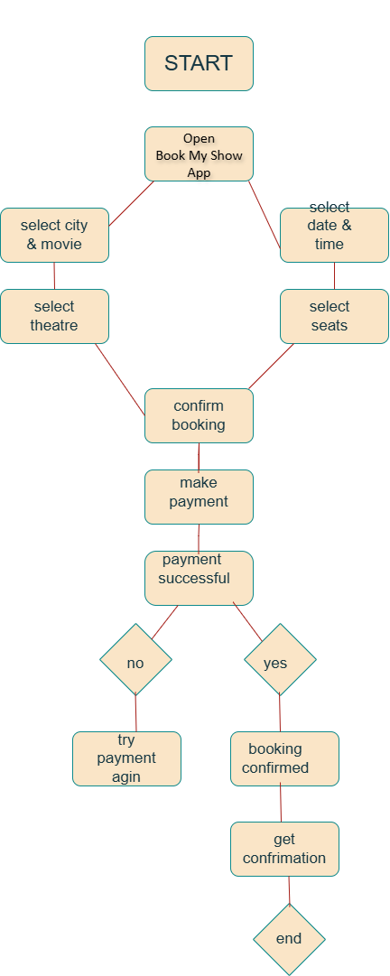

Q4. Write down the steps (as an algorithm, using simple numbered instructions) for ordering food on Swiggy — from opening the app to completing payment.
Ans. Start
Open the Swiggy app.
Select your location.
Search for a restaurant or food item.
Select the food you want.
Add the food to the cart.
Open the cart and check your order.
Enter or confirm the delivery address.
Select a payment method.
Make the payment.
Payment successful → Order Confirmed.
End.

Session-2

Q1. Install GCC on your computer and verify the installation by running gcc -version in your terminal or command prompt.
Ans. Install GCC on your computer. Open Command Prompt/Terminal and type:
gcc –version

Q2. Open VS Code or Dev C++ and create a new file named hello.c. Write a C program that prints 'Hello, Instagram World!' to the console.
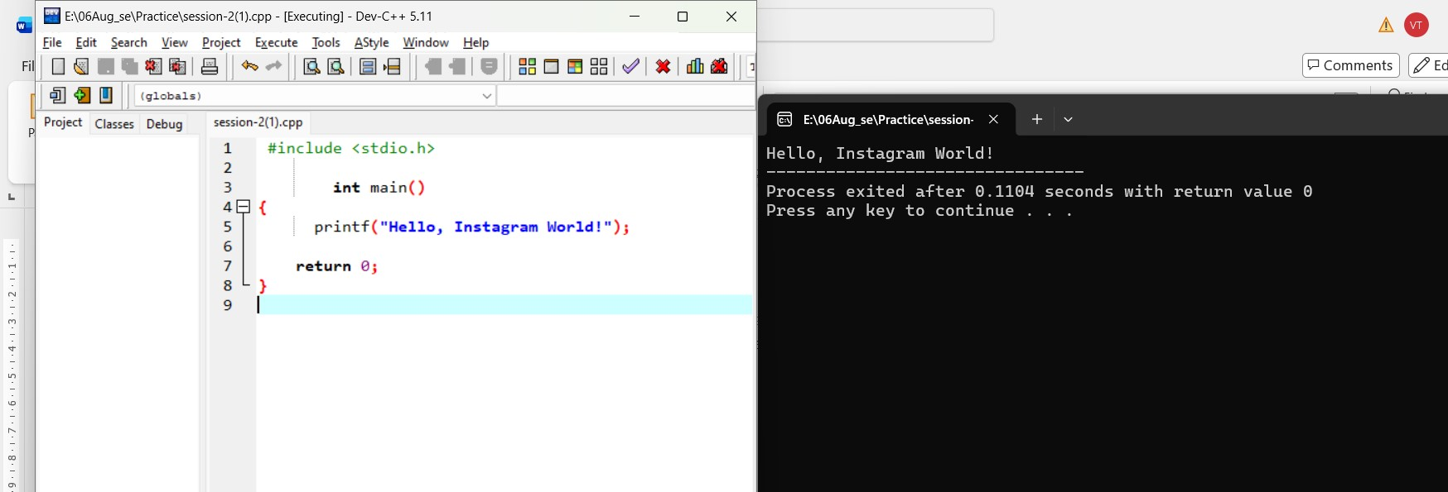

Hello, Instagram World!

Q3. Identify and label the header, main function, and return statement in your hello.c program using comments.
Ans

Header: #include <stdio.h>
Main Function: int main()
Return Statement: return 0;

Q4. Compile your hello.c file using the GCC command line (gcc hello.c -o hello) and run the output file to display the message in your
terminal.<br><br><em><strong>Hint:</strong> On Windows, the output file will be hello.exe; on Linux/Mac, it will be hello.</em> Ans.
Answer:
- Header: #include <stdio.h>
- Main Function: int main()
- Return Statement: return 0;

Session-3
Q1. Declare variables for a Flipkart product: product Name (as a string), price (float), and rating (double). Assign sample values and print each variable with its data type. Ans.

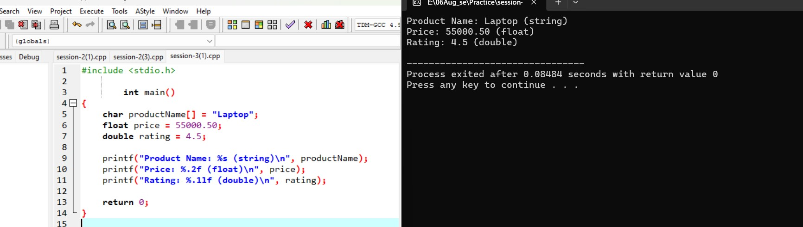
Product Name: Laptop (string)
Price: 55000.50 (float)
Rating: 4.5 (double)

Q2. Create a constant variable to store the GST rate (for example, 18%) and use it to calculate the final price of a Zomato order with a given base
price.<br><br><em><strong>Constraint:</strong> The GST rate must not be changeable after its initial assignment.</em>
Ans

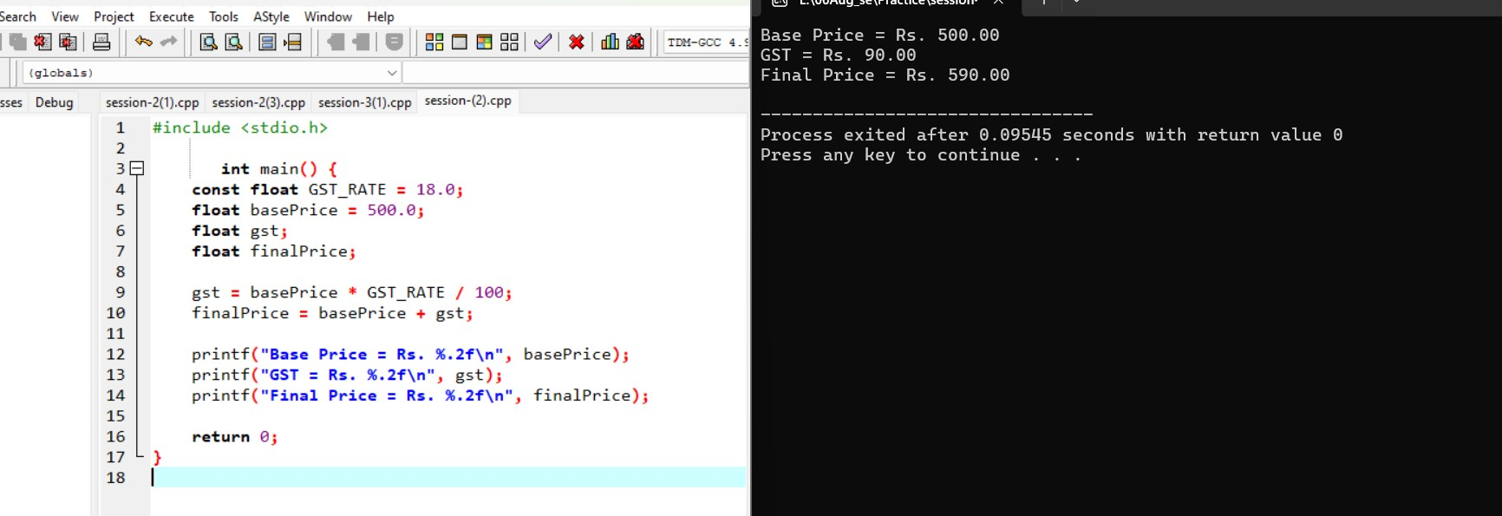

Base Price = ₹500
GST = ₹90
Final Price = ₹590

Q3. Write a program that stores your favorite Spotify playlist's name (string), total number of songs (int), and average song duration in minutes (float). Print all values in a single formatted sentence. Ans.
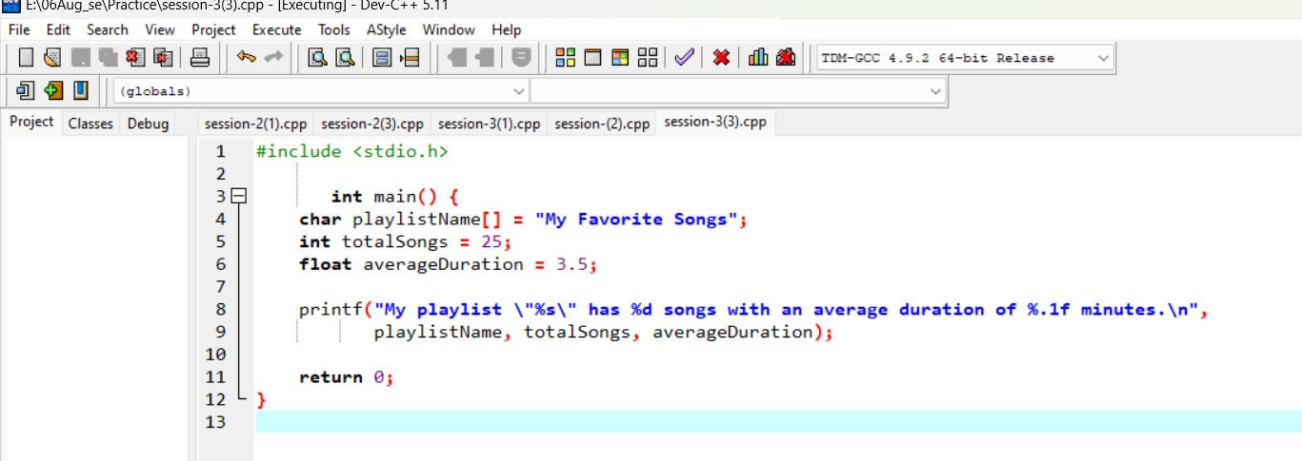

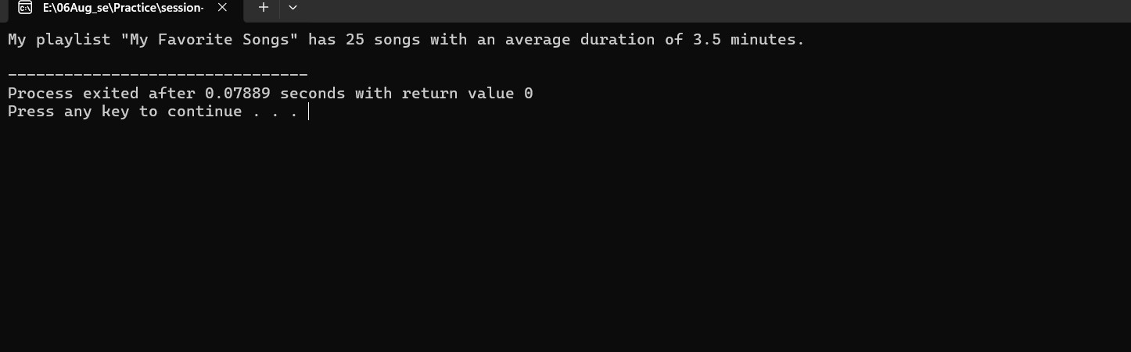
Playlist Name → My Favorite Songs
- Total Songs → 25
- Average Duration → 3.5 minutes

Q4. Identify and correct the invalid variable names from this list: 1stPlayer, player_age, $score, total-marks, userName.
<br><br><em><strong>Hint:</strong> Apply standard variable naming rules for your programming language.</em>
Ans. 1stPlayer → firstPlayer player_age → player_age $score → score total-marks → total_marks userName → userName Session-4

Q1. Create a simple JavaScript function called calculateTotal that takes two numbers: itemPrice and quantity, and returns the total bill amount using arithmetic operators. Ans.
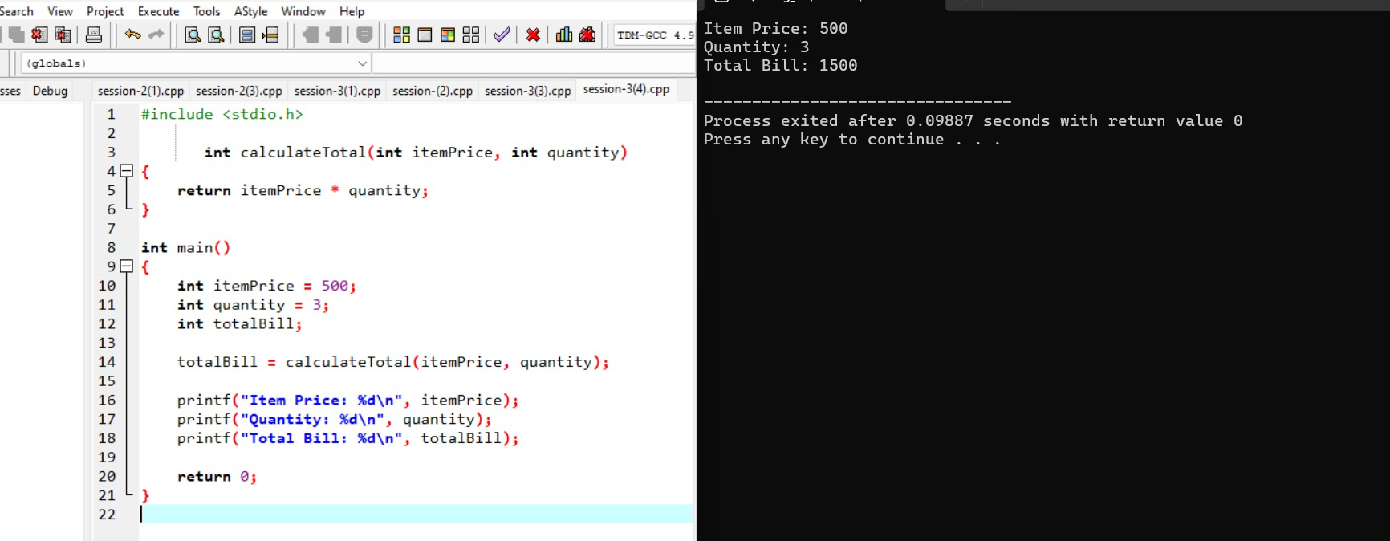
Item Price: 500
Quantity: 3
Total Bill: 1500

Q2. Build a Flipkart-style discount calculator: given product price, discount percentage, and a boolean is Member, use arithmetic and logical operators to calculate the final price (apply an extra 5% off if isMember is true). Ans.

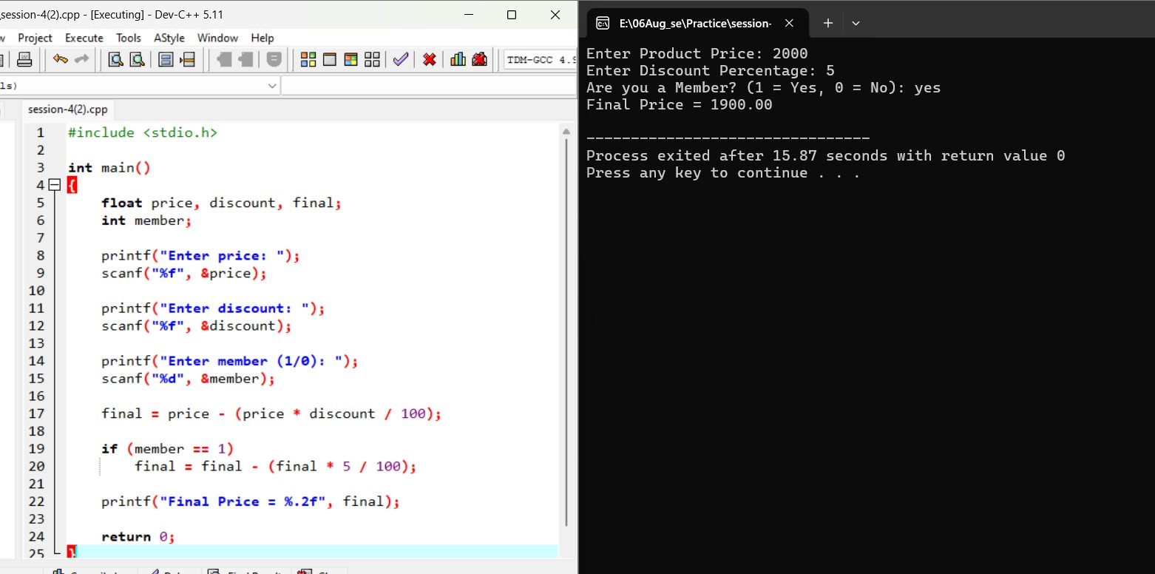
Enter Product Price: 2000
Enter Discount Percentage: 5
Are you a Member (1 = Yes, 0 = No): yes
Final Price = 1900.00

Q3. Write a function is EligibleFor Offer that takes a user's age and total order value, and returns true if the user is 18 or older AND the order value is above 500, otherwise false.<br><br><em><strong>Hint:</strong> Use relational and logical operators together.</em> Ans.

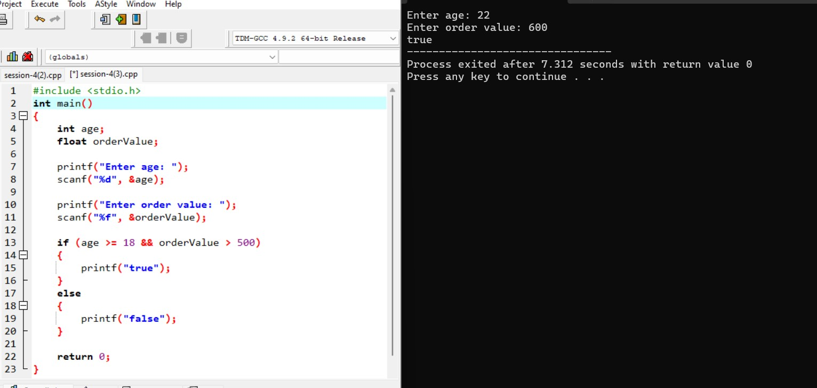
Enter age: 22
Enter order value: 600
True

Q4. Given three variables: likes, comments, and shares (all numbers), write code to check if a post is 'trending' on Instagram (at least 1000 likes OR more than 200 comments AND at least 50 shares). Print the result. Ans. #include <stdio.h>

int main()
{
int likes, comments, shares;

printf("Enter likes: ");
scanf("%d", &likes);

printf("Enter comments: ");
scanf("%d", &comments);

printf("Enter shares: ");
scanf("%d", &shares);

if (likes >= 1000 || (comments > 200 && shares >= 50))
{
printf("Trending");
}
else
{
printf("Not Trending");
}

return 0;
}
Enter likes: 1200
Enter comments: 150
Enter shares: 60
Trending

Q5. Write a code snippet that demonstrates the difference between preincrement (++count) and post-increment (count++) by logging the values before and after using both on a follower Count variable. Ans.

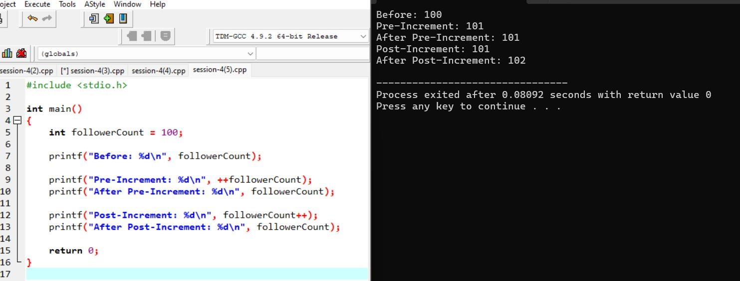
Before: 100
Pre-Increment: 101
After Pre-Increment: 101
Post-Increment: 101
After Post-Increment: 102

Session-5

Q1. Create a simple IPL Fan Bot that takes your favorite IPL team name as input and uses if-else-if statements to print a unique cheer message for each team (e.g., 'Go Mumbai Indians!', 'Chennai Super Kings for the win!'). If the team is not recognized, print 'Team not found!'
Ans
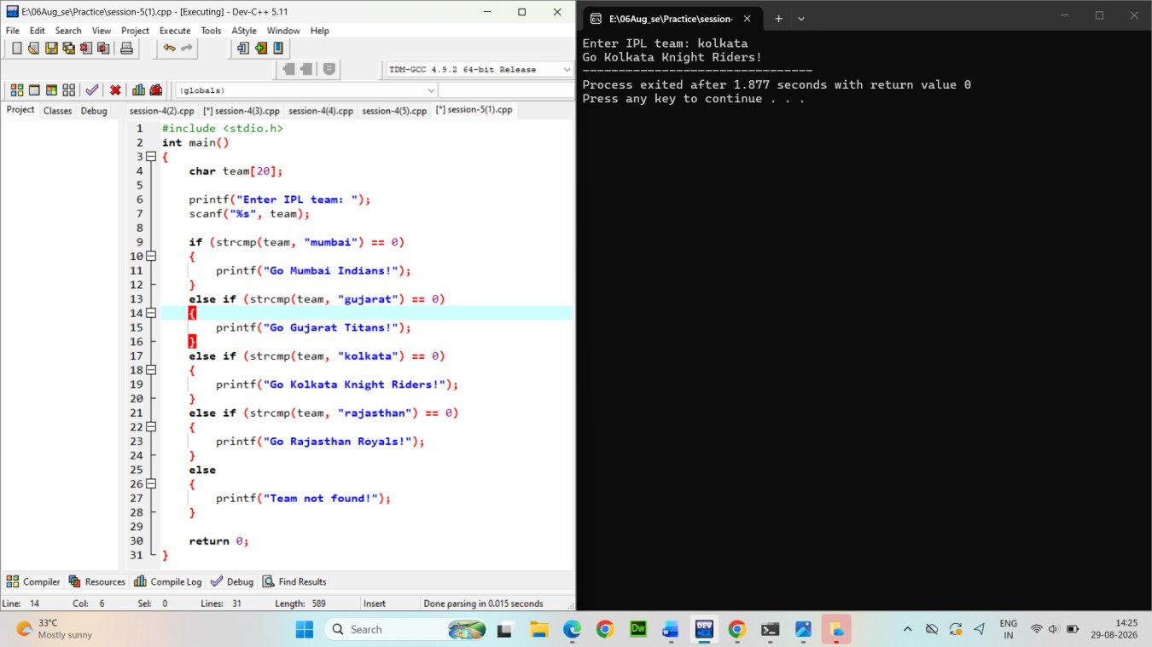
Output:
Enter IPL team: kolkata Go Mumbai Indians!

Build a Zomato-style food suggestion tool: take the user's preferred meal time ('breakfast', 'lunch', 'dinner', or 'snack') and use a switch-case statement to suggest a popular dish for that time. If the input doesn't match any meal, suggest 'Try some fruits!'. Ans.
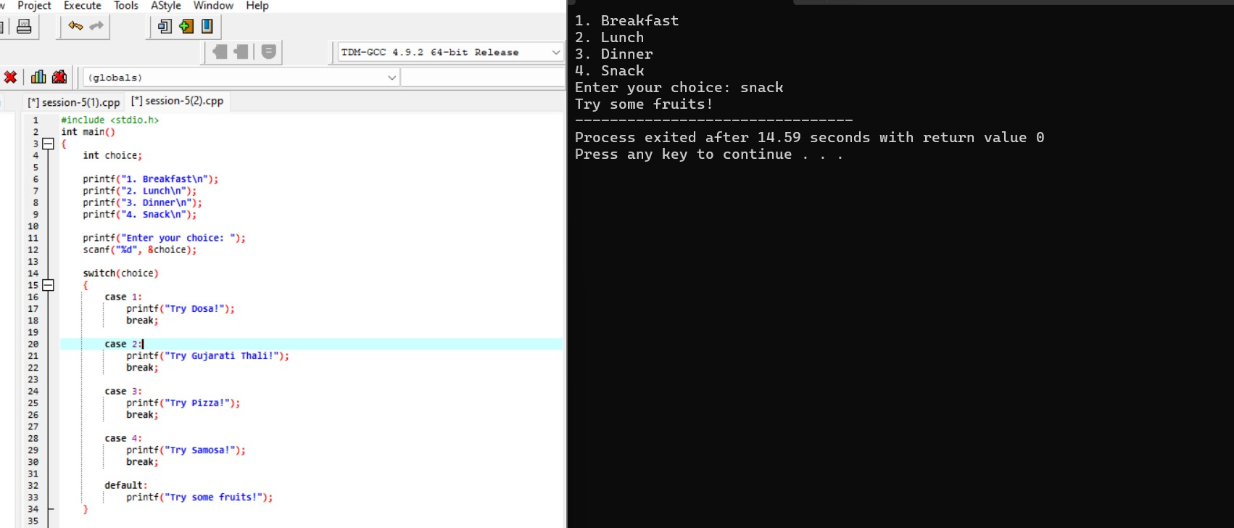
Output
- Breakfast
- Lunch
- Dinner
- Snack
Enter your choice: 2 Try Gujarati Thali!

Create a Flipkart discount calculator that asks the user for the total cart amount. Use nested if statements to check: if amount > 2000, apply 20% discount; else if amount > 1000, apply 10% discount; else, no discount. Print the final amount to pay.<br><br><em><strong>Hint:</strong> Use nested ifs to check each discount slab.</em> Ans.

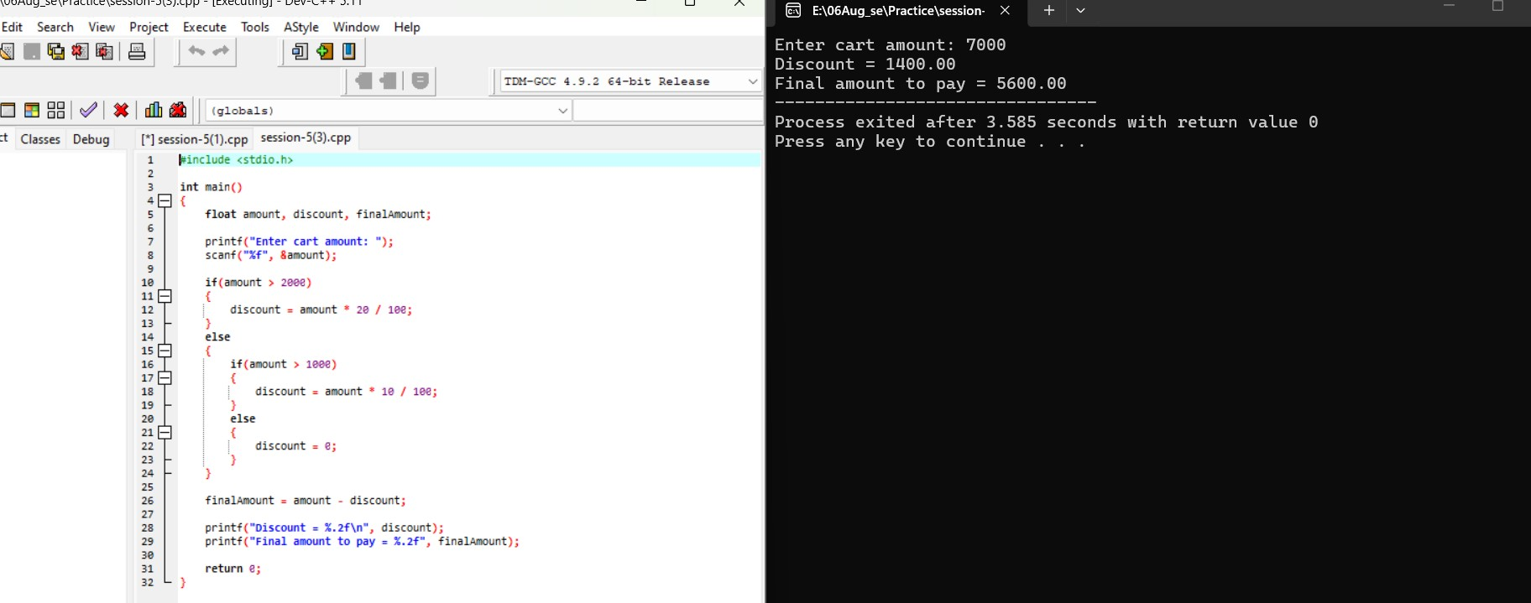
Output
Enter cart amount: 7000
Discount = 1400.00
Final amount to pay = 5600.00

Write a program that takes a user's age and checks eligibility for three things using if-else statements: if age >= 18, print 'Eligible for Driving License'; if age >= 21, also print 'Eligible for Credit Card'; if age >= 25, also print 'Eligible for Car Rental'. Print all applicable messages for the given age.
Ans

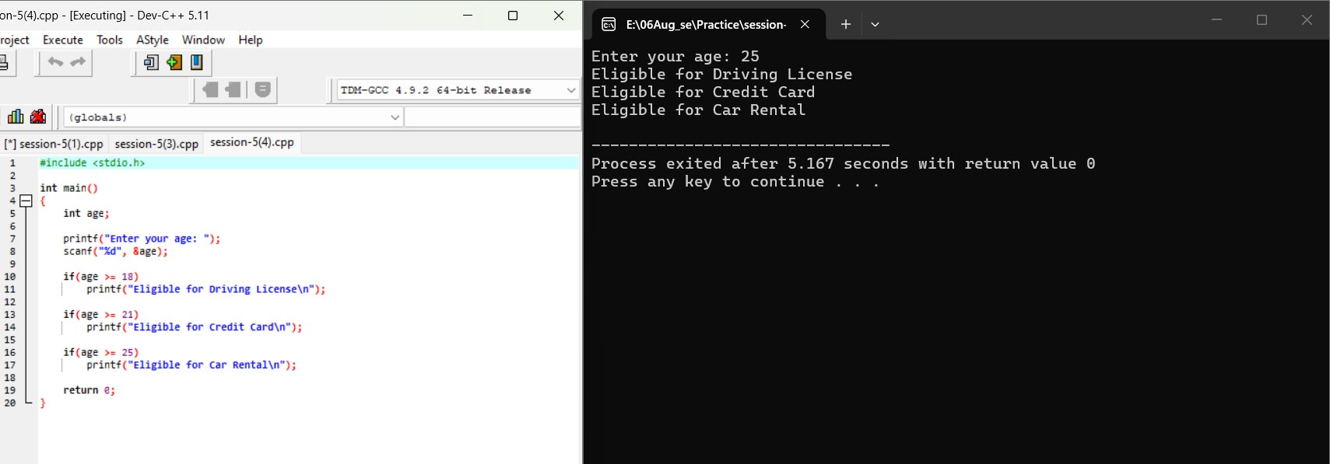
Output
Enter your age: 22
Eligible for Driving License
Eligible for Credit Card

s

Q5. Draw a simple memory diagram (on paper or using any drawing tool) showing how a pointer references the address of a variable, using the variables from your likes and ptrLikes example; label the variable, pointer, and address.
Ans.
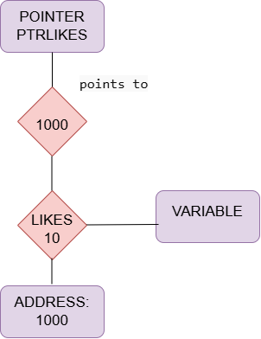
- likes → Variable
- ptrLikes → Pointer
- 1000 → Address

