Module-2
Session-1
Q1. Write a short paragraph in your own words defining what a 'program' is and give one real-life example from any app you use daily (like Instagram, Zomato, or Paytm).
Ans. A program is a set of instructions given to a computer or mobile phone to perform a specific task.
Programs help us use different apps and complete our daily work easily. For example, when we use Zomato.
a program allows us to search for restaurants, choose food, add items to the
cart, place the order, make payment, and track the delivery.

Q2. List three popular programming languages you have heard of, and for each, mention whether it is usually compiled, interpreted, or can be
both.<br><br><em><strong>Hint:</strong> Think of languages like Java, Python, and JavaScript.</em>
Ans. Java – Usually Compiled
Java is a popular programming language used to create mobile apps, software, and web applications. Java programs are usually compiled into bytecode before they are executed.
Python – Usually Interpreted
Python is a simple and popular programming language. It is used in websites, data science, artificial intelligence, and automation. Python is usually considered an interpreted language.
JavaScript – Can Be Both
JavaScript is mainly used to make websites interactive. It is also used in web applications and some mobile and desktop applications. Modern JavaScript engines can use both interpretation and compilation techniques.
Q3. Draw a flowchart (on paper or using any online tool) for the process of booking a movie ticket on Book My Show, starting from opening the app to receiving the booking confirmation.
Ans.

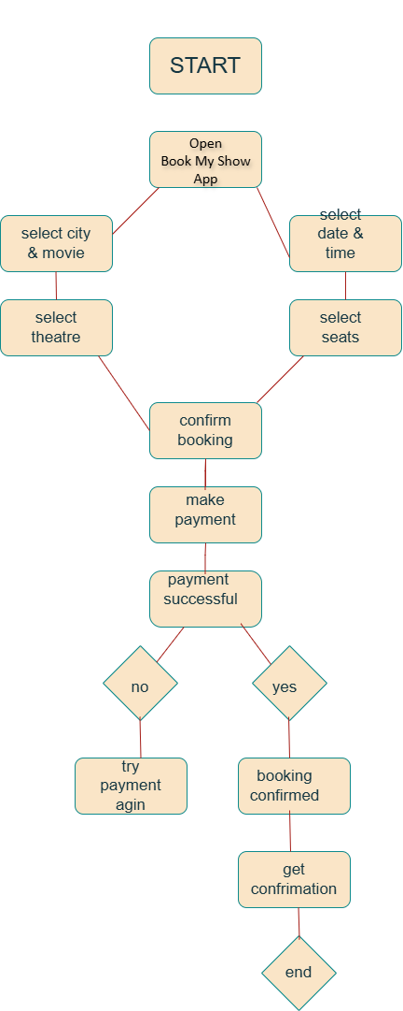

Q4. Write down the steps (as an algorithm, using simple numbered instructions) for ordering food on Swiggy — from opening the app to completing payment.
Ans. Start
Open the Swiggy app.
Select your location.
Search for a restaurant or food item.
Select the food you want.
Add the food to the cart.
Open the cart and check your order.
Enter or confirm the delivery address.
Select a payment method.
Make the payment.
Payment successful → Order Confirmed.
End.

Session-2

Q1. Install GCC on your computer and verify the installation by running gcc -version in your terminal or command prompt.
Ans. Install GCC on your computer. Open Command Prompt/Terminal and type:
gcc –version

Q2. Open VS Code or Dev C++ and create a new file named hello.c. Write a C program that prints 'Hello, Instagram World!' to the console.
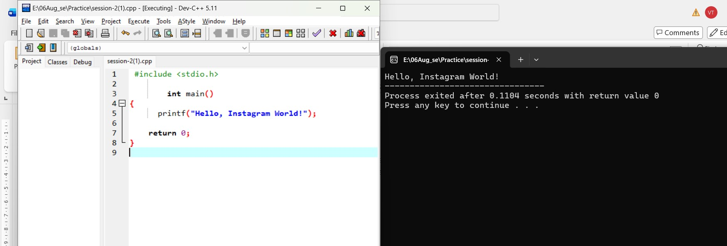

Hello, Instagram World!

Q3. Identify and label the header, main function, and return statement in your hello.c program using comments.
Ans

Header: #include <stdio.h>
Main Function: int main()
Return Statement: return 0;

Q4. Compile your hello.c file using the GCC command line (gcc hello.c -o hello) and run the output file to display the message in your
terminal.<br><br><em><strong>Hint:</strong> On Windows, the output file will be hello.exe; on Linux/Mac, it will be hello.</em> Ans.
Answer:
- Header: #include <stdio.h>
- Main Function: int main()
- Return Statement: return 0;

Session-3
Q1. Declare variables for a Flipkart product: product Name (as a string), price (float), and rating (double). Assign sample values and print each variable with its data type. Ans.

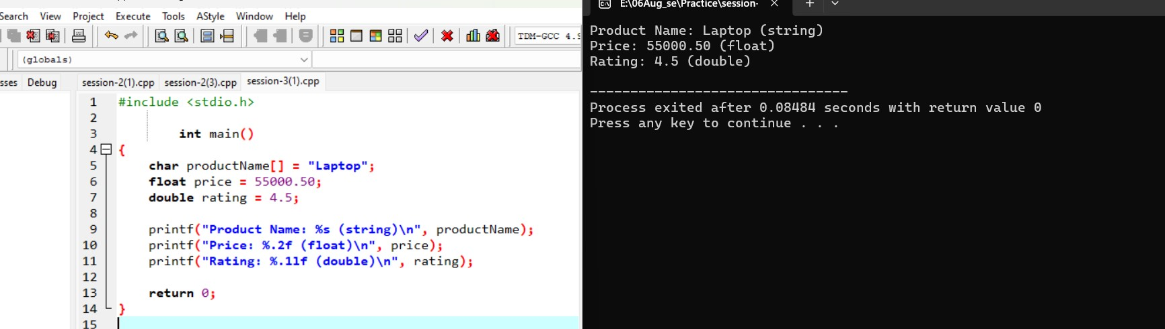
Product Name: Laptop (string)
Price: 55000.50 (float)
Rating: 4.5 (double)

Q2. Create a constant variable to store the GST rate (for example, 18%) and use it to calculate the final price of a Zomato order with a given base
price.<br><br><em><strong>Constraint:</strong> The GST rate must not be changeable after its initial assignment.</em>
Ans

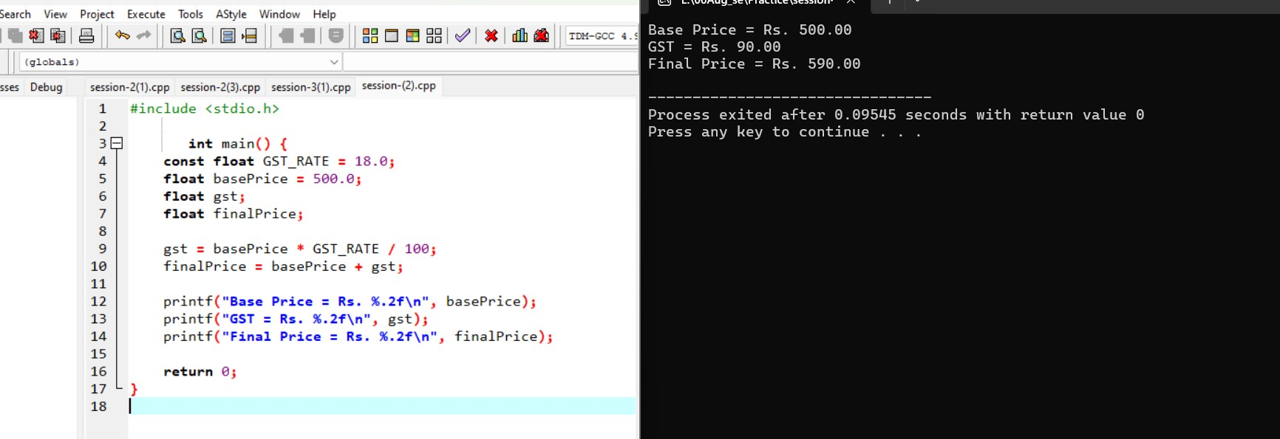

Base Price = ₹500
GST = ₹90
Final Price = ₹590

Q3. Write a program that stores your favorite Spotify playlist's name (string), total number of songs (int), and average song duration in minutes (float). Print all values in a single formatted sentence. Ans.
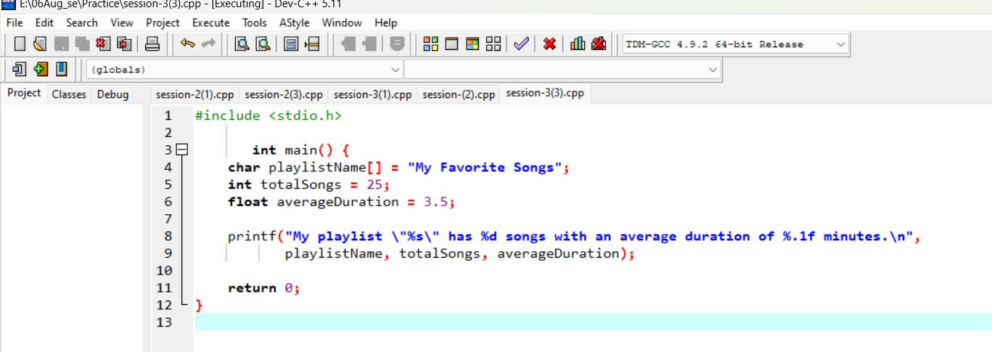

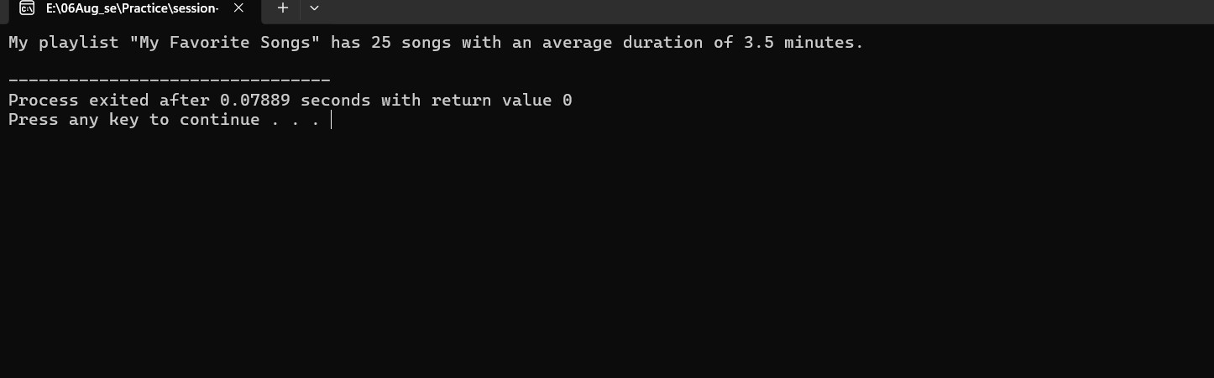
Playlist Name → My Favorite Songs
- Total Songs → 25
- Average Duration → 3.5 minutes

Q4. Identify and correct the invalid variable names from this list: 1stPlayer, player_age, $score, total-marks, userName.
<br><br><em><strong>Hint:</strong> Apply standard variable naming rules for your programming language.</em>
Ans. 1stPlayer → firstPlayer player_age → player_age $score → score total-marks → total_marks userName → userName Session-4

Q1. Create a simple JavaScript function called calculateTotal that takes two numbers: itemPrice and quantity, and returns the total bill amount using arithmetic operators. Ans.
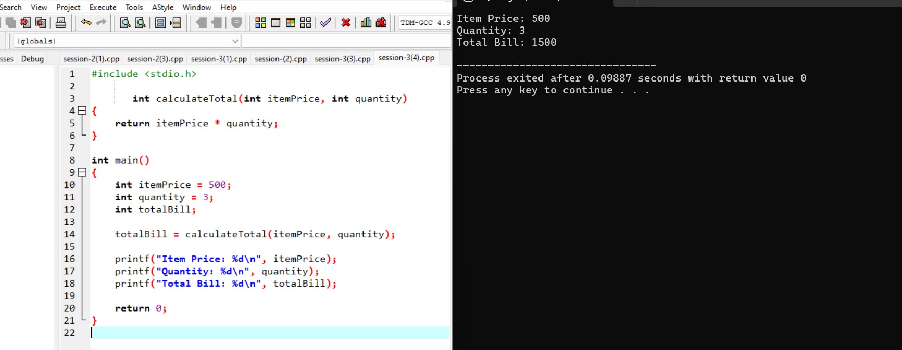
Item Price: 500
Quantity: 3
Total Bill: 1500

Q2. Build a Flipkart-style discount calculator: given product price, discount percentage, and a boolean is Member, use arithmetic and logical operators to calculate the final price (apply an extra 5% off if isMember is true). Ans.

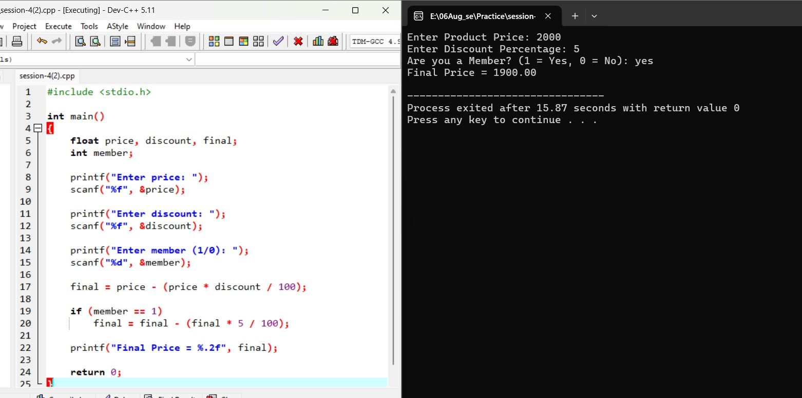
Enter Product Price: 2000
Enter Discount Percentage: 5
Are you a Member (1 = Yes, 0 = No): yes
Final Price = 1900.00

Q3. Write a function is EligibleFor Offer that takes a user's age and total order value, and returns true if the user is 18 or older AND the order value is above 500, otherwise false.<br><br><em><strong>Hint:</strong> Use relational and logical operators together.</em> Ans.

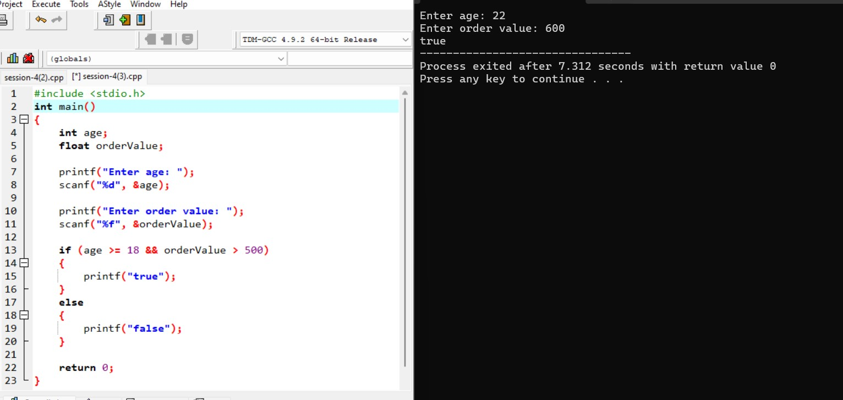
Enter age: 22
Enter order value: 600
True

Q4. Given three variables: likes, comments, and shares (all numbers), write code to check if a post is 'trending' on Instagram (at least 1000 likes OR more than 200 comments AND at least 50 shares). Print the result. Ans. #include <stdio.h>

int main()
{
int likes, comments, shares;

printf("Enter likes: ");
scanf("%d", &likes);

printf("Enter comments: ");
scanf("%d", &comments);

printf("Enter shares: ");
scanf("%d", &shares);

if (likes >= 1000 || (comments > 200 && shares >= 50))
{
printf("Trending");
}
else
{
printf("Not Trending");
}

return 0;
}
Enter likes: 1200
Enter comments: 150
Enter shares: 60
Trending

Q5. Write a code snippet that demonstrates the difference between preincrement (++count) and post-increment (count++) by logging the values before and after using both on a follower Count variable. Ans.

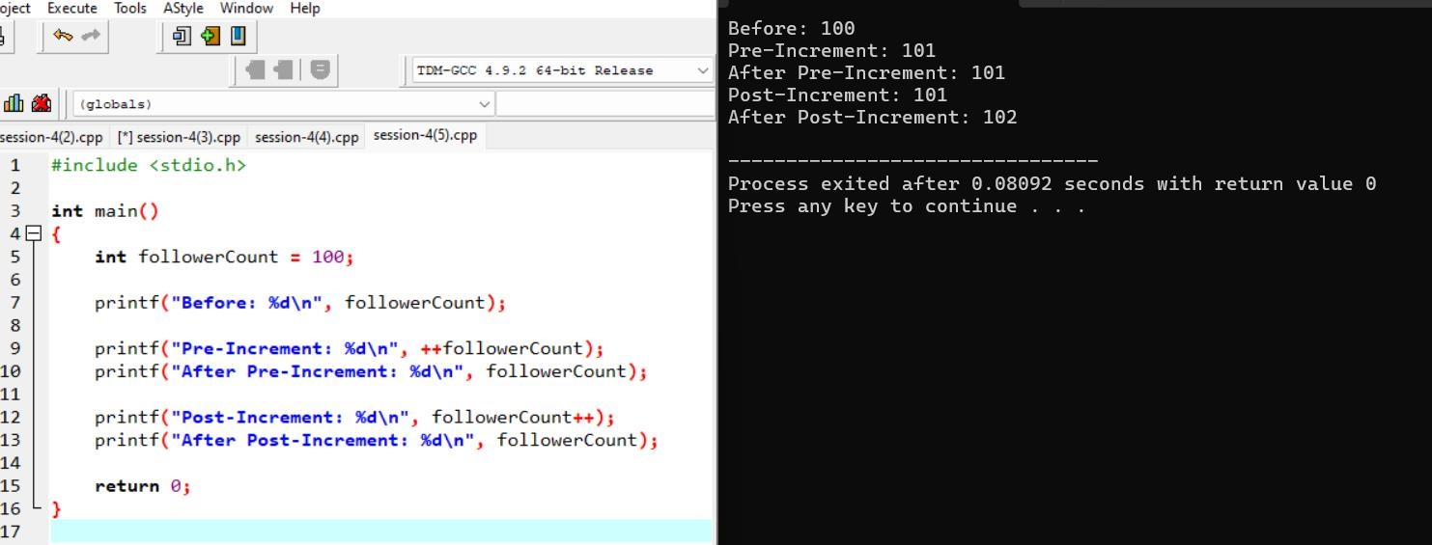
Before: 100
Pre-Increment: 101
After Pre-Increment: 101
Post-Increment: 101
After Post-Increment: 102

Session-5

Q1. Create a simple IPL Fan Bot that takes your favorite IPL team name as input and uses if-else-if statements to print a unique cheer message for each team (e.g., 'Go Mumbai Indians!', 'Chennai Super Kings for the win!'). If the team is not recognized, print 'Team not found!'
Ans
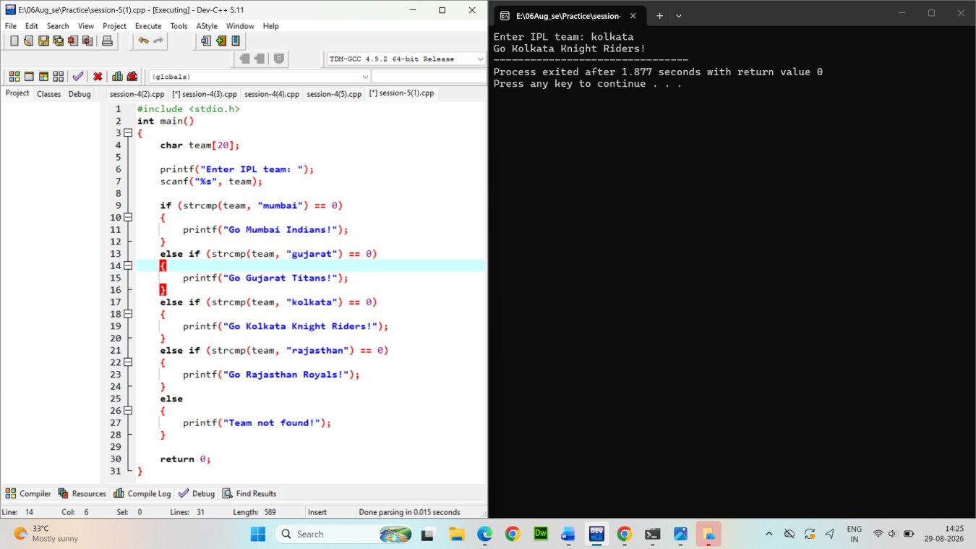
Output:
Enter IPL team: kolkata Go Mumbai Indians!

Build a Zomato-style food suggestion tool: take the user's preferred meal time ('breakfast', 'lunch', 'dinner', or 'snack') and use a switch-case statement to suggest a popular dish for that time. If the input doesn't match any meal, suggest 'Try some fruits!'. Ans.
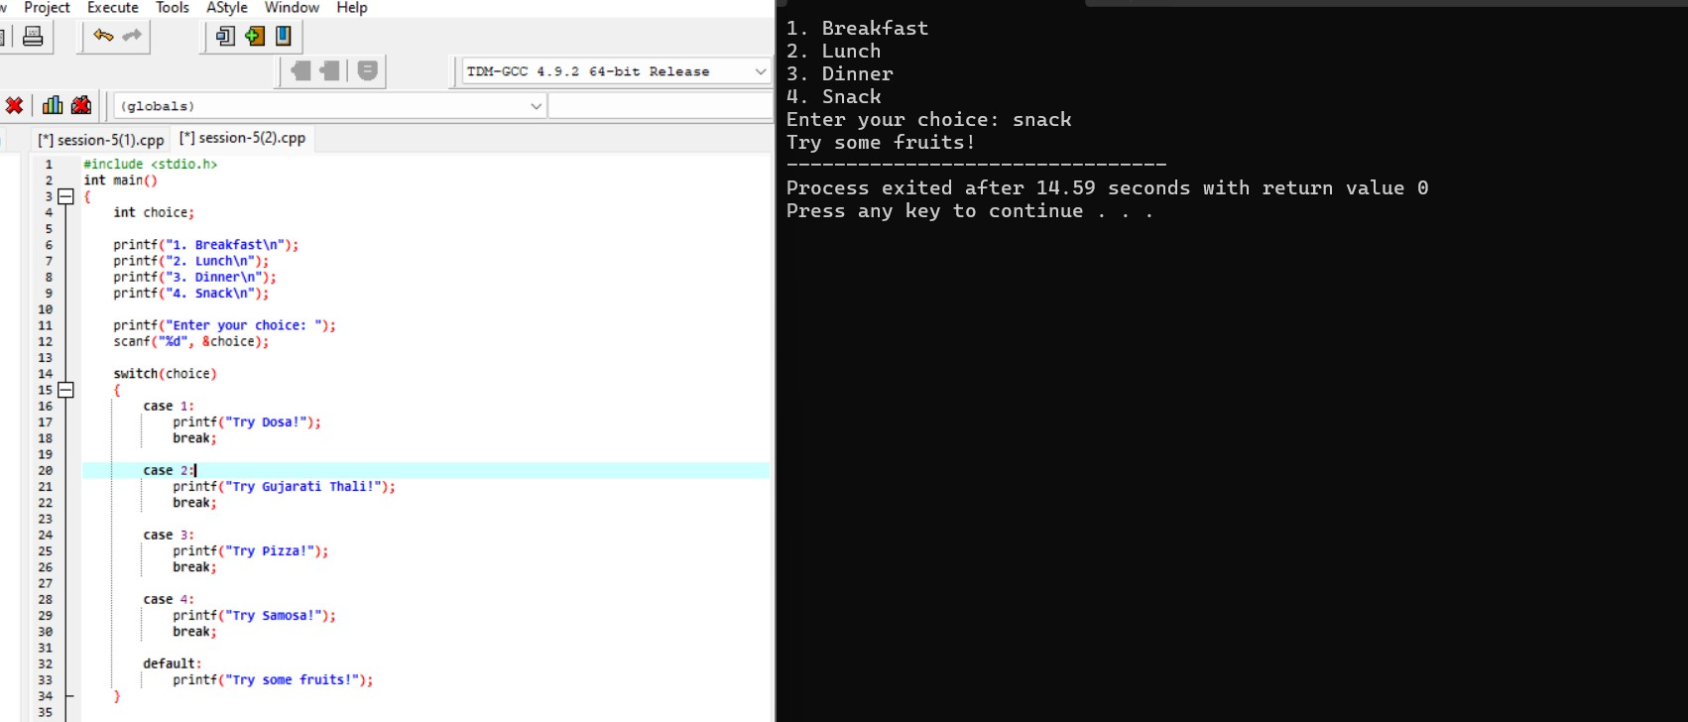
Output
- Breakfast
- Lunch
- Dinner
- Snack
Enter your choice: 2 Try Gujarati Thali!

Create a Flipkart discount calculator that asks the user for the total cart amount. Use nested if statements to check: if amount > 2000, apply 20% discount; else if amount > 1000, apply 10% discount; else, no discount. Print the final amount to pay.<br><br><em><strong>Hint:</strong> Use nested ifs to check each discount slab.</em> Ans.

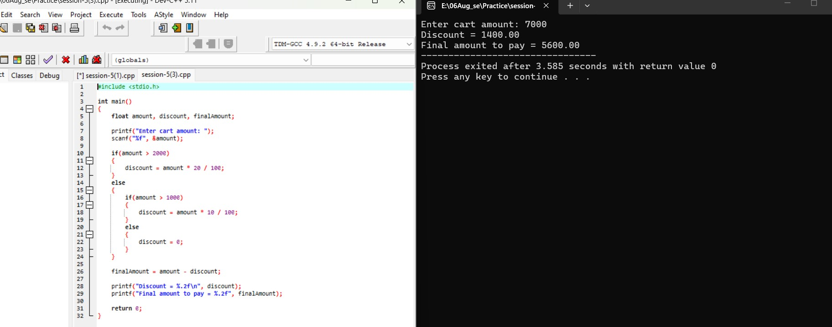
Output
Enter cart amount: 7000
Discount = 1400.00
Final amount to pay = 5600.00

Write a program that takes a user's age and checks eligibility for three things using if-else statements: if age >= 18, print 'Eligible for Driving License'; if age >= 21, also print 'Eligible for Credit Card'; if age >= 25, also print 'Eligible for Car Rental'. Print all applicable messages for the given age.
Ans

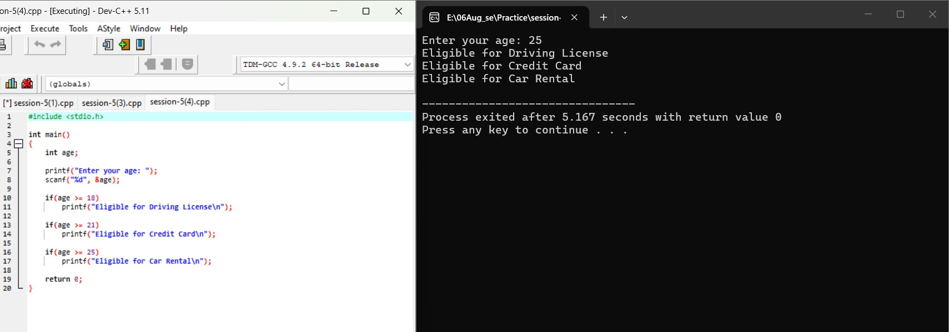
Output
Enter your age: 22
Eligible for Driving License
Eligible for Credit Card

Session-6

Q1. Write a program that prints the numbers from 10 down to 1 using a for loop, similar to a countdown timer.
Ans.

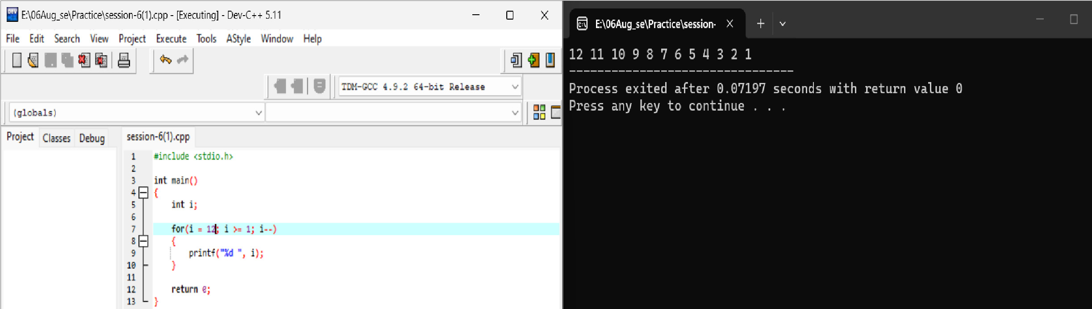
12 11 10 9 8 7 6 5 4 3 2 1

Q2. Create a menu-driven console app that lets the user: 1) View your favorite 3 IPL teams, 2) Add a new team, 3) Exit. Use a while loop to keep showing the menu until the user chooses Exit .<br><br><em><strong>Hint:</strong> Use input() (or Scanner in Java) to get the user's choice each time. </em>
Ans
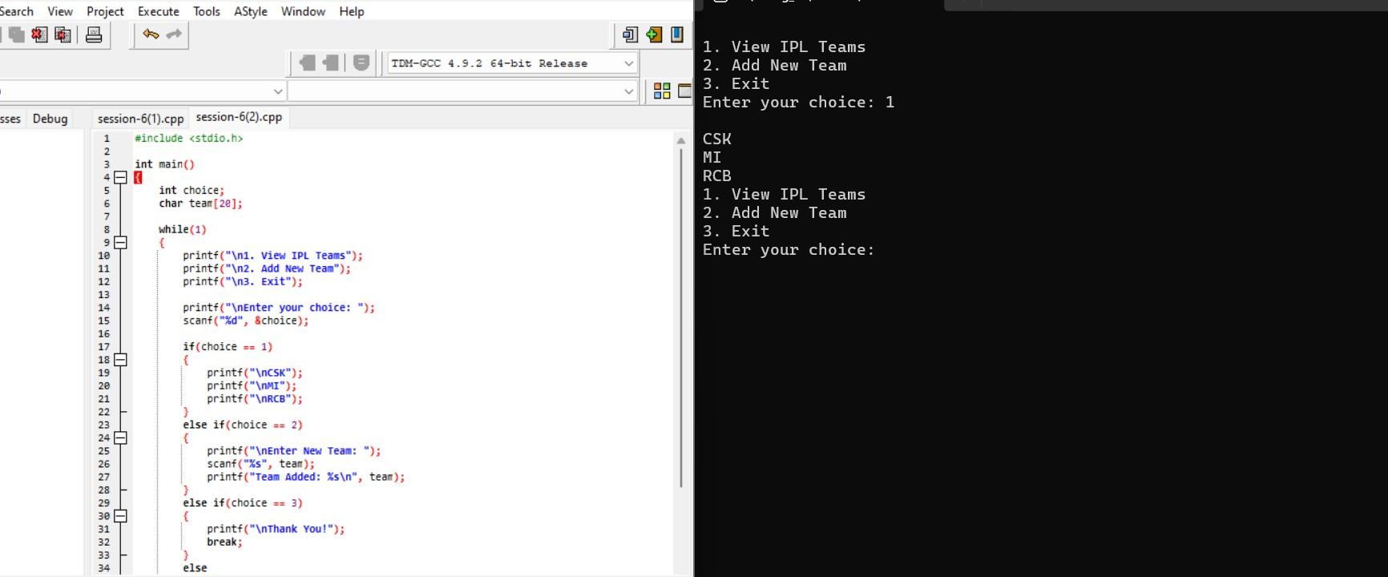

View ipl teams
Add new team
Exit
Enter your choice:1
Csk Mi
rcb

Q3. Build a 'Guess the Song' game like Spotify — the program randomly picks a song name from a list and asks the user to guess it. Use a do-while loop so the user can keep guessing until they get it
right.<br><br><em><strong>Constraint:</strong> Use at least 3 song names of your choice.</em> Ans.

Q4. Explain with your own example the difference between entry-controlled and exit-controlled loops by writing a short code snippet for each (for/while vs do-while) and describing what happens if the loop condition is false at the start.
Ans. Entry-controlled

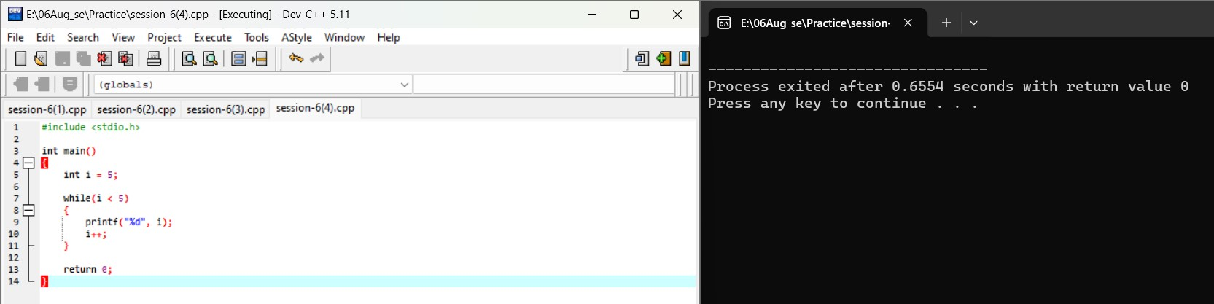
No Output
Exit -controlled

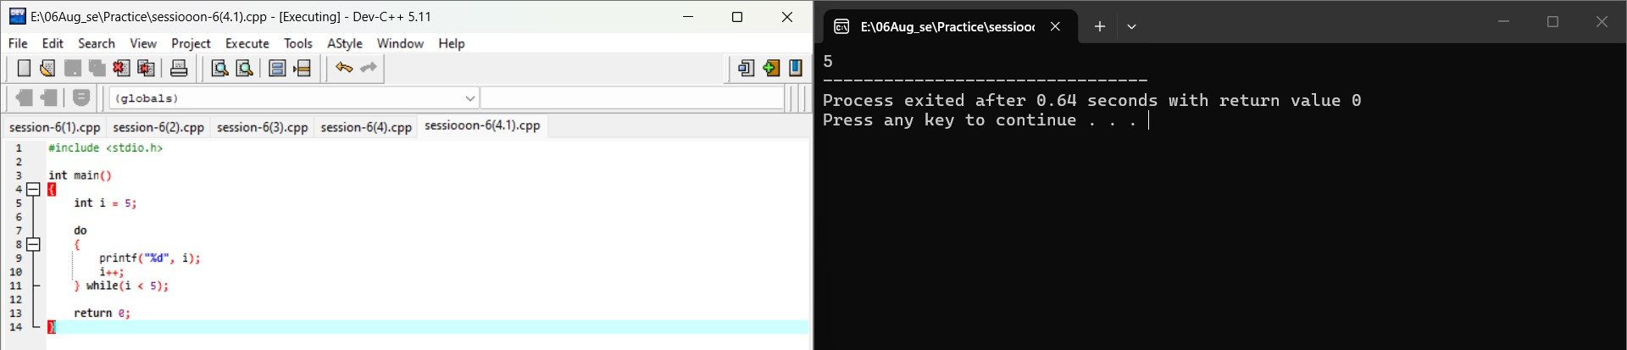

Session-7

Q1. Use nested for loops to print a grid of emojis representing a 5x5 Instagram post feed, where each cell shows a 📷 symbol. Ans.

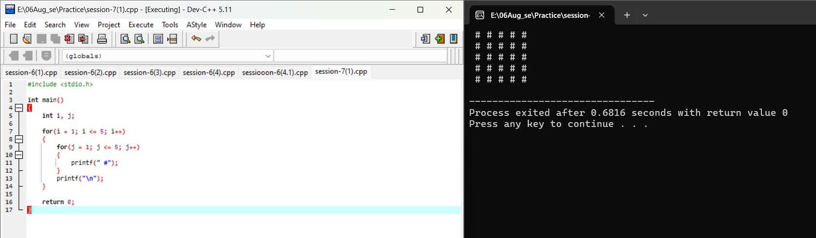

# # # # #
# # # # #
# # # # #
# # # # #
# # # # #

Q2. Build a right-angled triangle pattern using nested loops, where each row displays increasing numbers starting from 1, similar to how a leaderboard on a gaming app shows rank numbers.
Ans.

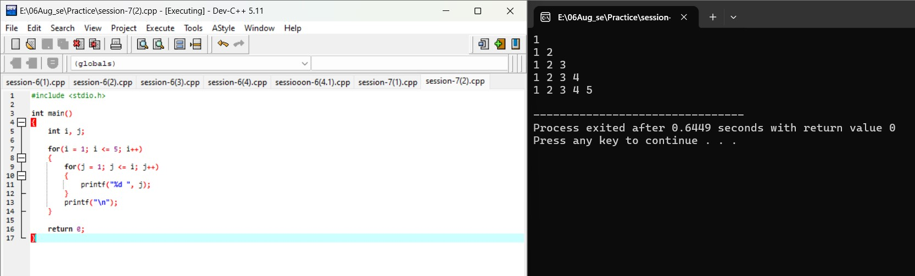

1
12
123
1234
12345

Q3. Create a pattern that prints a pyramid of stars (*) with 6 rows, centered like the loading animation you see on Book My Show when a page is loading. <br><br><em><strong>Hint:</strong> Use spaces to align the stars in the center for each row. </em>
Ans.

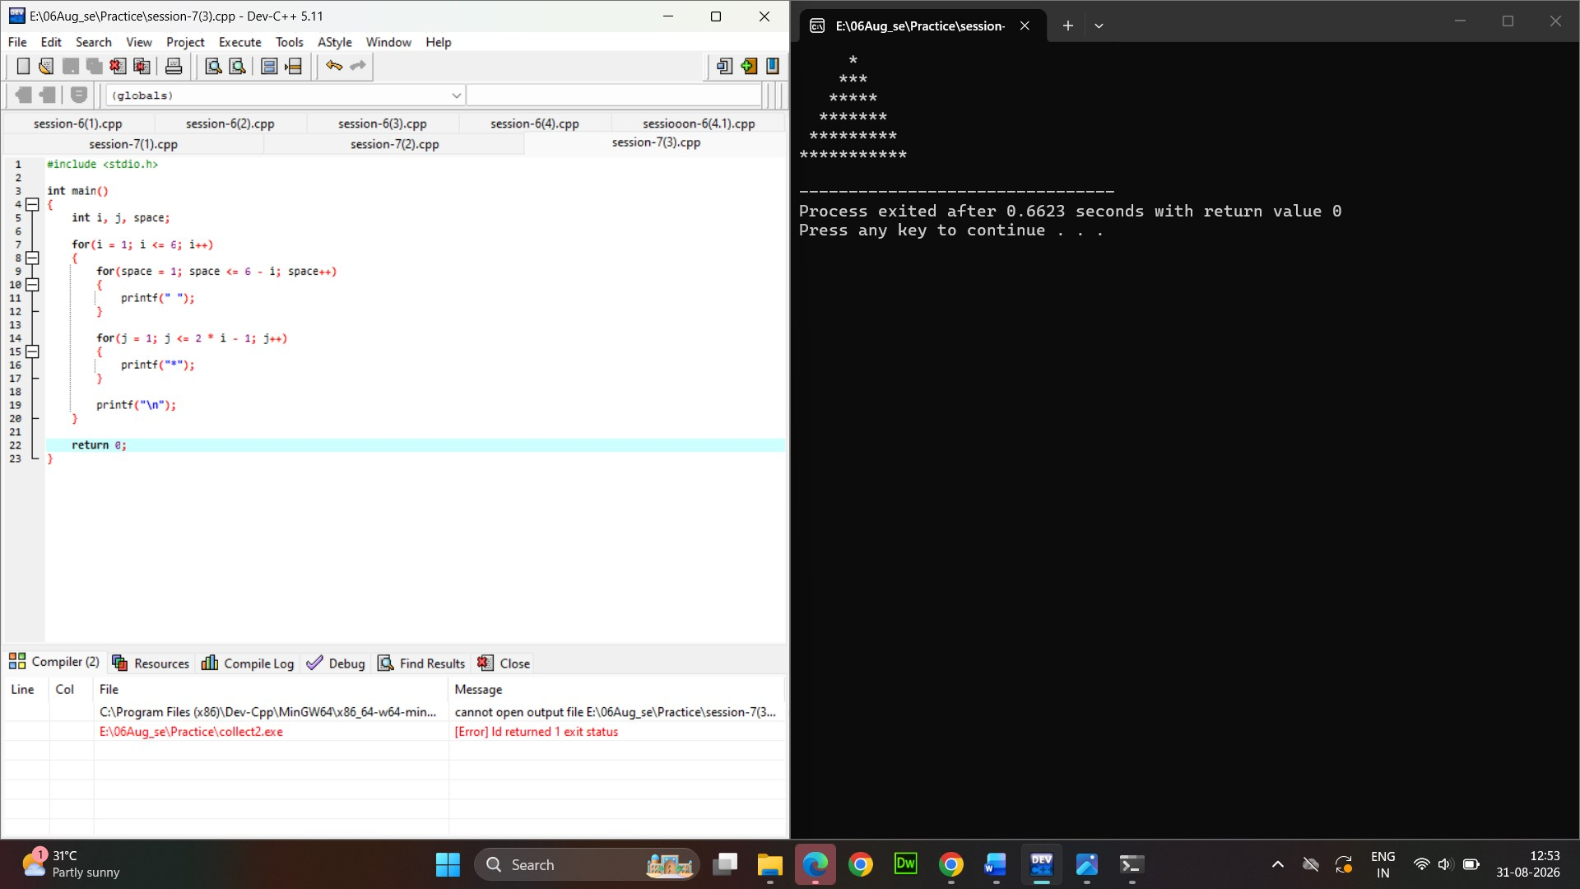

*
- * *
- * * * *
- * * * * * *
Q4. Write code using nested loops to print a pattern of alternating 0s and 1s in a grid, like the checkered background seen in some Spotify playlist covers (e.g., for a 4x4 grid, alternate 0 and 1 in each cell)
Ans.

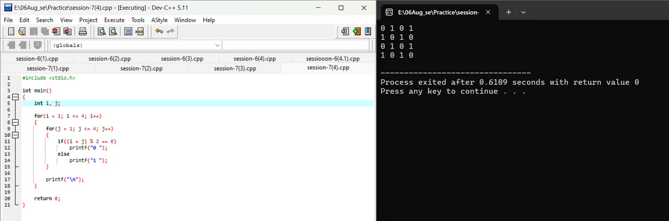

- 1 0 1
- 0 1 0
- 1 0 1
- 0 1 0

Q 5. Modify your pyramid pattern code to accept the number of rows as user input, so the user can set the height of the pyramid before printing. Ans.
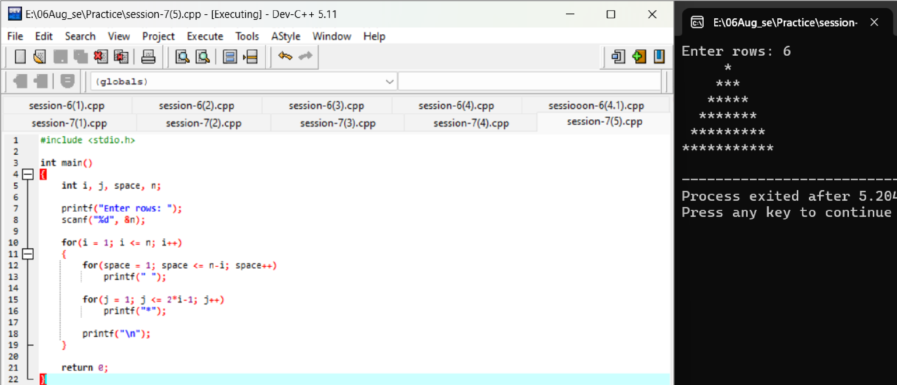

Enter row: 6
*
- * *
- * * * *
- * * * * *
- * * * * * * *

Session-8

Q 1. Declare a function called get UserInitials that takes a user's full name (like 'Virat Kohli') and returns their initials in uppercase (e.g., 'VK'). Call this function with your favorite cricketer's name and print the result. Ans.
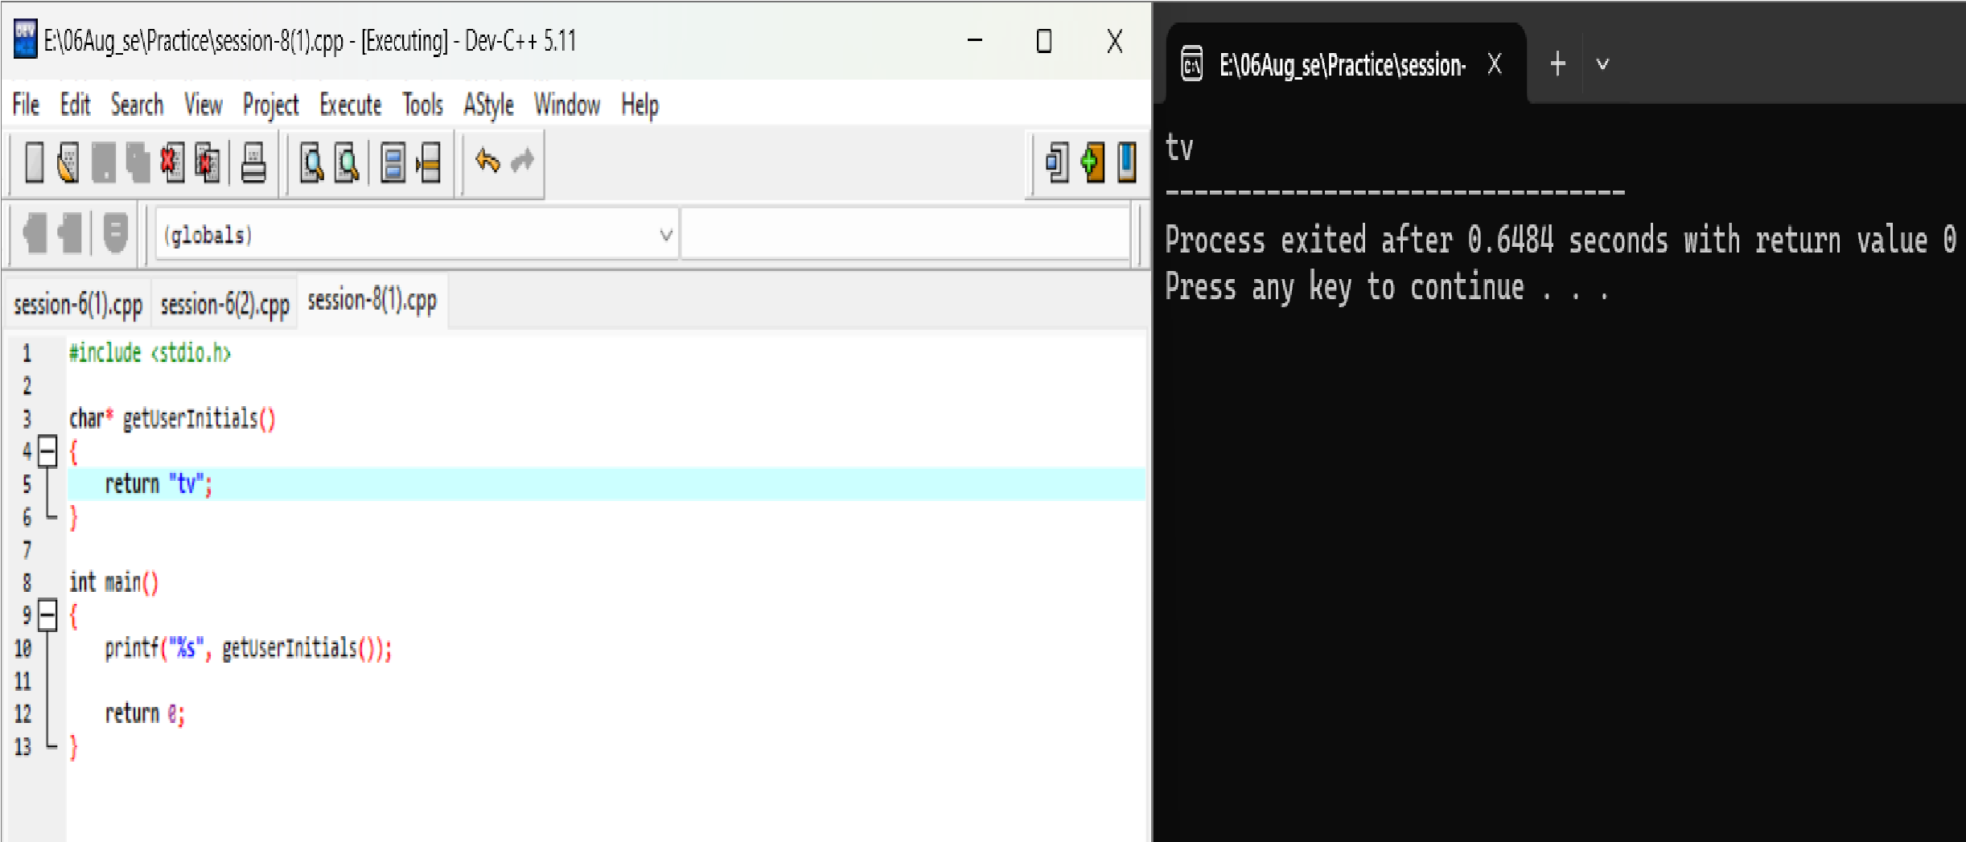

Q 2. Create a function add To Cart that takes a shopping cart array and a product name, adds the product to the cart, and prints the updated cart. Demonstrate how passing the cart array by reference allows changes to persist outside the function.<br><br><em><strong>Hint:</strong> In languages like JavaScript, arrays are passed by reference. In C/C++, use pointers for reference behavior.</em> Ans.

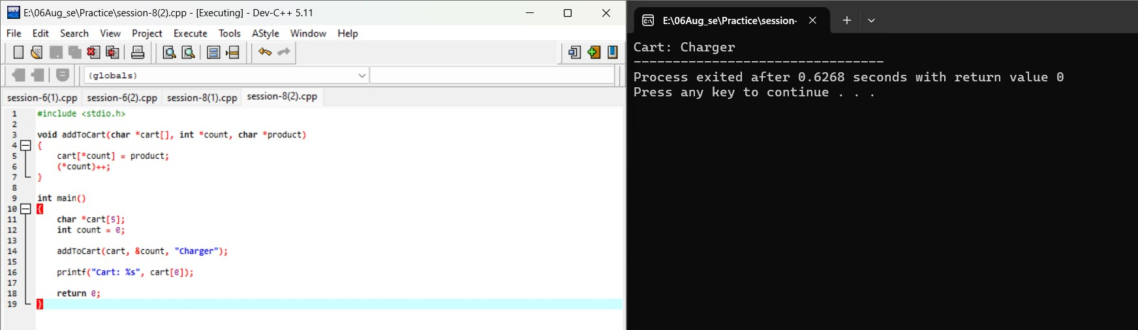

Q 3 Write two functions: increase Followers By Value and increase Followers By Reference. Each should take a followers count and add 1000 to it, but one should use pass-by-value and the other pass-by-reference. Show how the original followers count changes (or doesn't) after calling each function. Ans
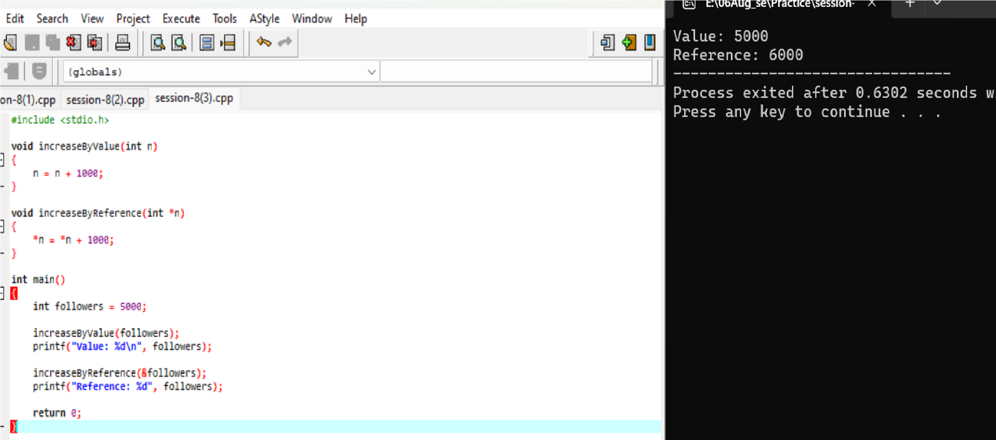

Q 4. Build a function format Price that takes a price in rupees and returns a string formatted like Flipkart's price tag (e.g., '₹1,599'). Use this function to display prices for three different products. Ans.
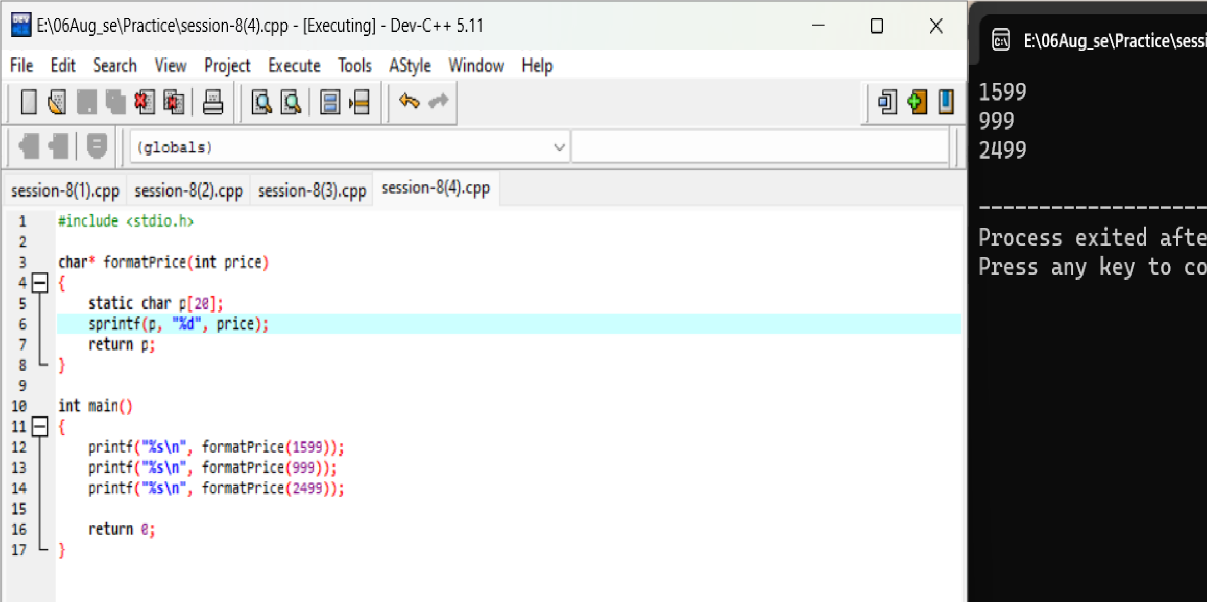

1599
999
2499

Q5. Refactor an existing function you wrote above to make it reusable for both product names and usernames (for example, a function that capitalizes the first letter of any string).<br><br><em><strong>Constraint:</strong> The refactored function should work for any string input, not just a specific use case. </em> Ans.
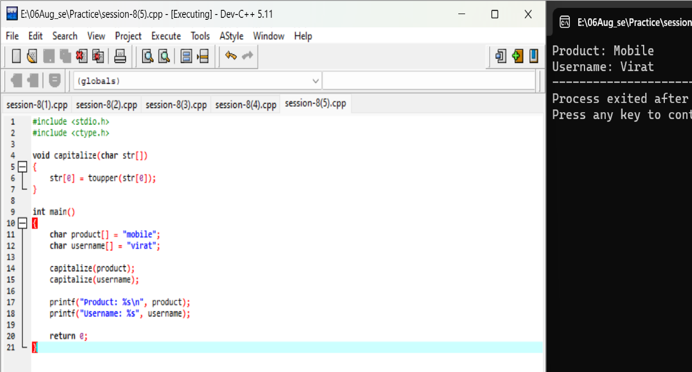

Product: mobile Username: virat Session-9
Q 1. Declare a 1D array called daily Steps with 7 elements to store your step count for each day of the week, assign sample values, and print each value using a loop.
Ans.
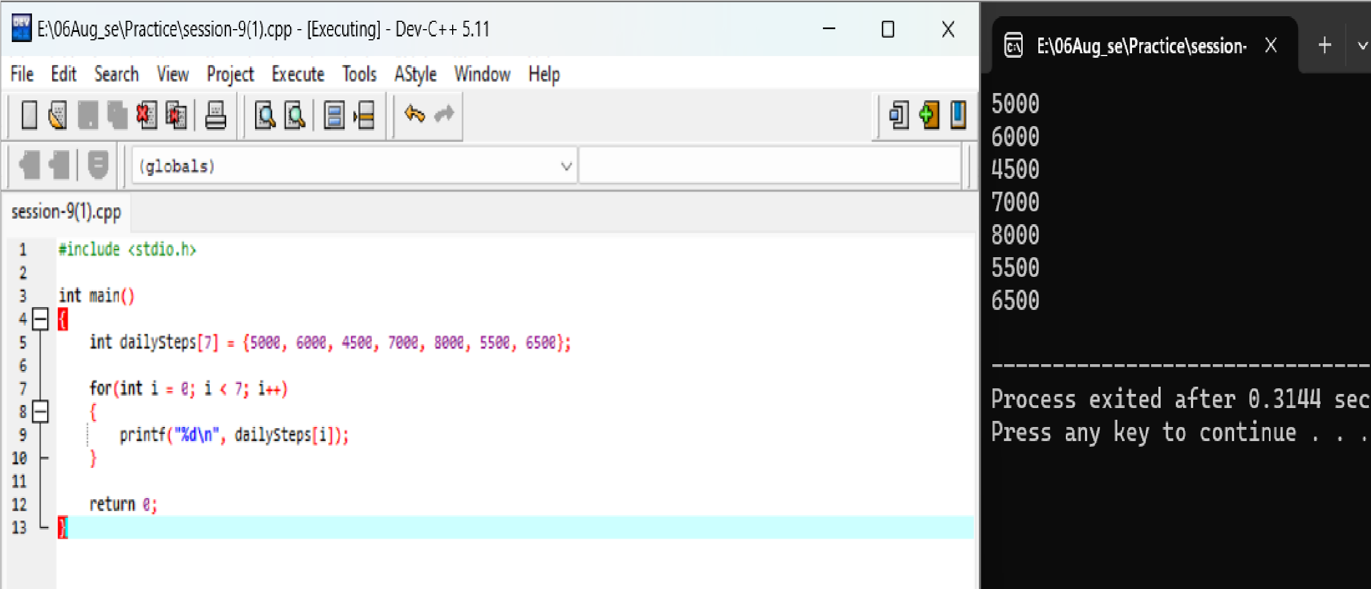
5000 6000 4500 7000 8000 5500 6500

Q.2 Create a 2D array called playlist Ratings to store ratings for 3 Spotify playlists over 5 days (rows = playlists, columns = days). Fill it with sample numbers and print the ratings for the second playlist.
Ans.
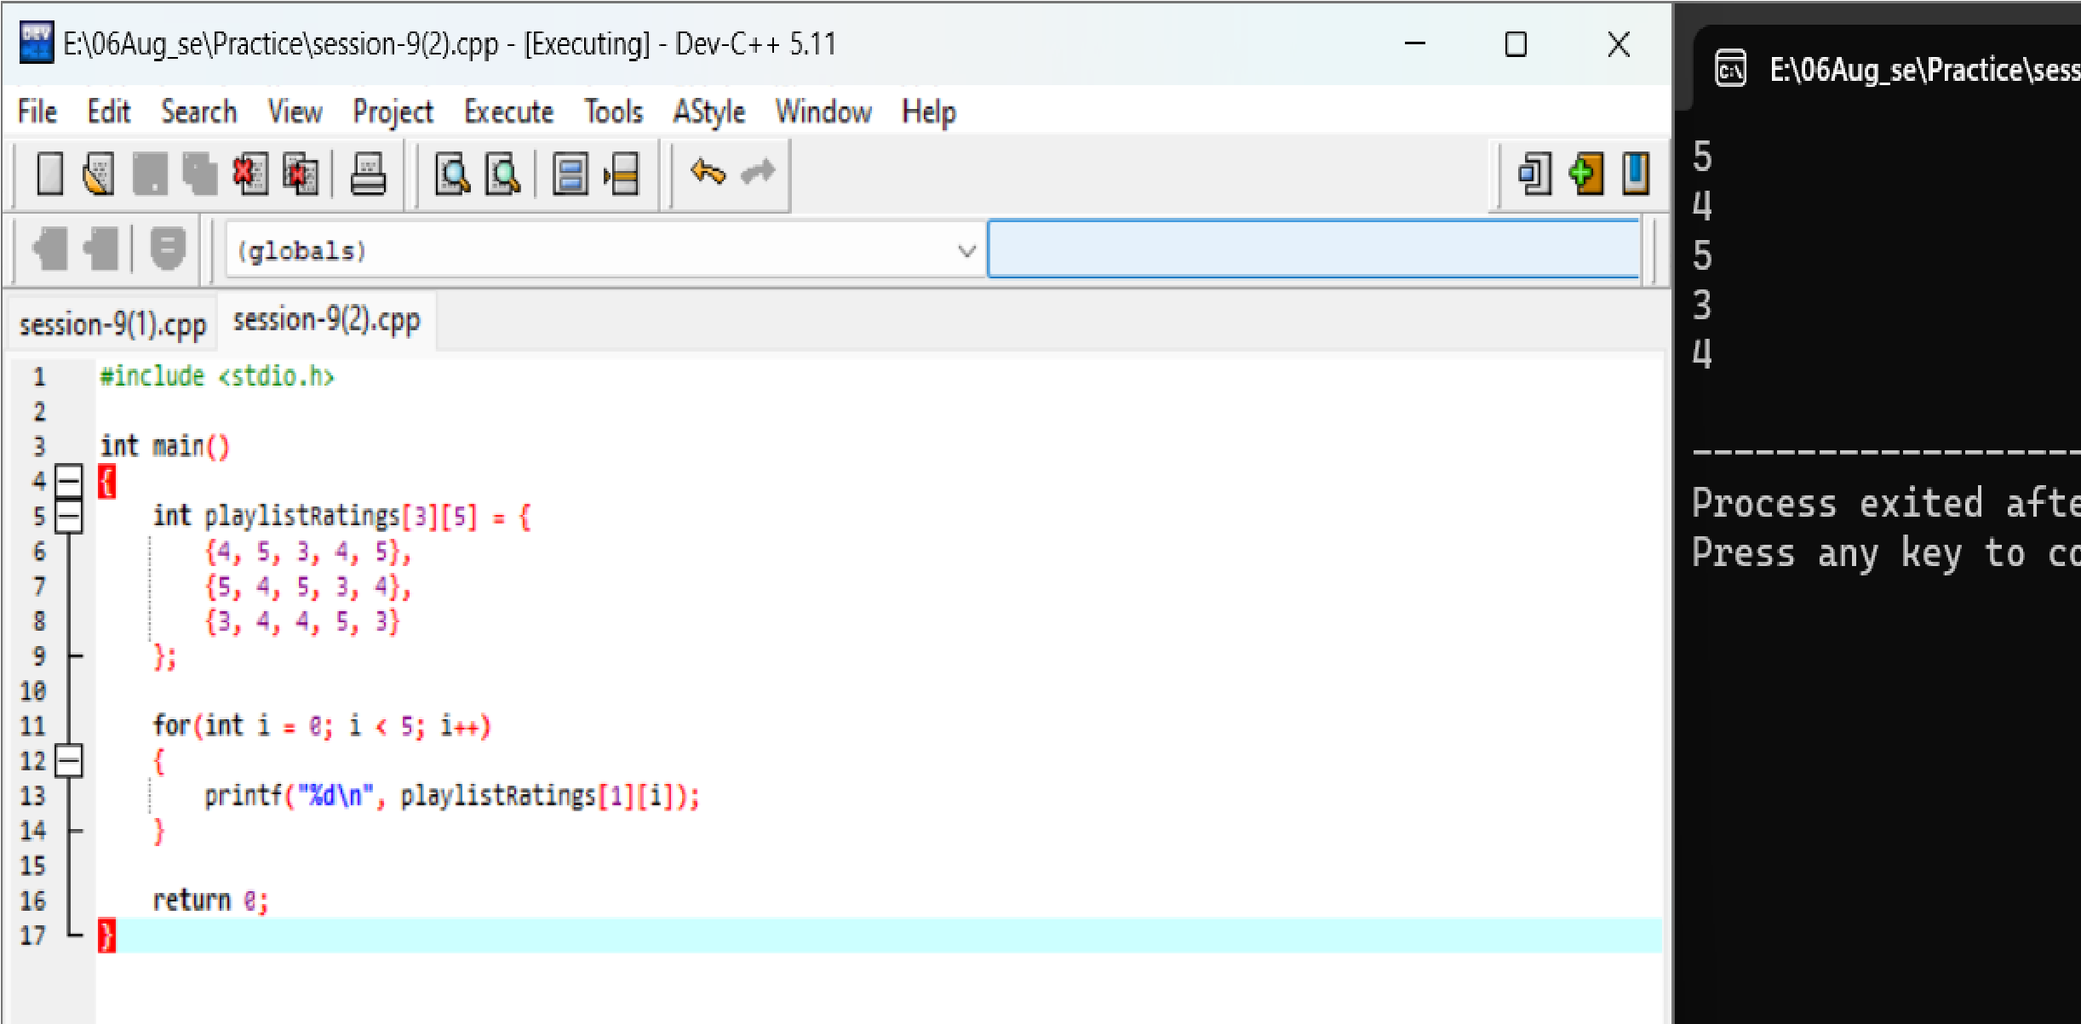
5 4 5 3
4

Q3. Build a function that takes a 1D array of 7 integers representing your daily
Zomato order amounts and calculates the average spend for the week .<br><br><em><strong>Hint:</strong> Use a loop to sum the values, then divide by the array length. </em>
Ans.
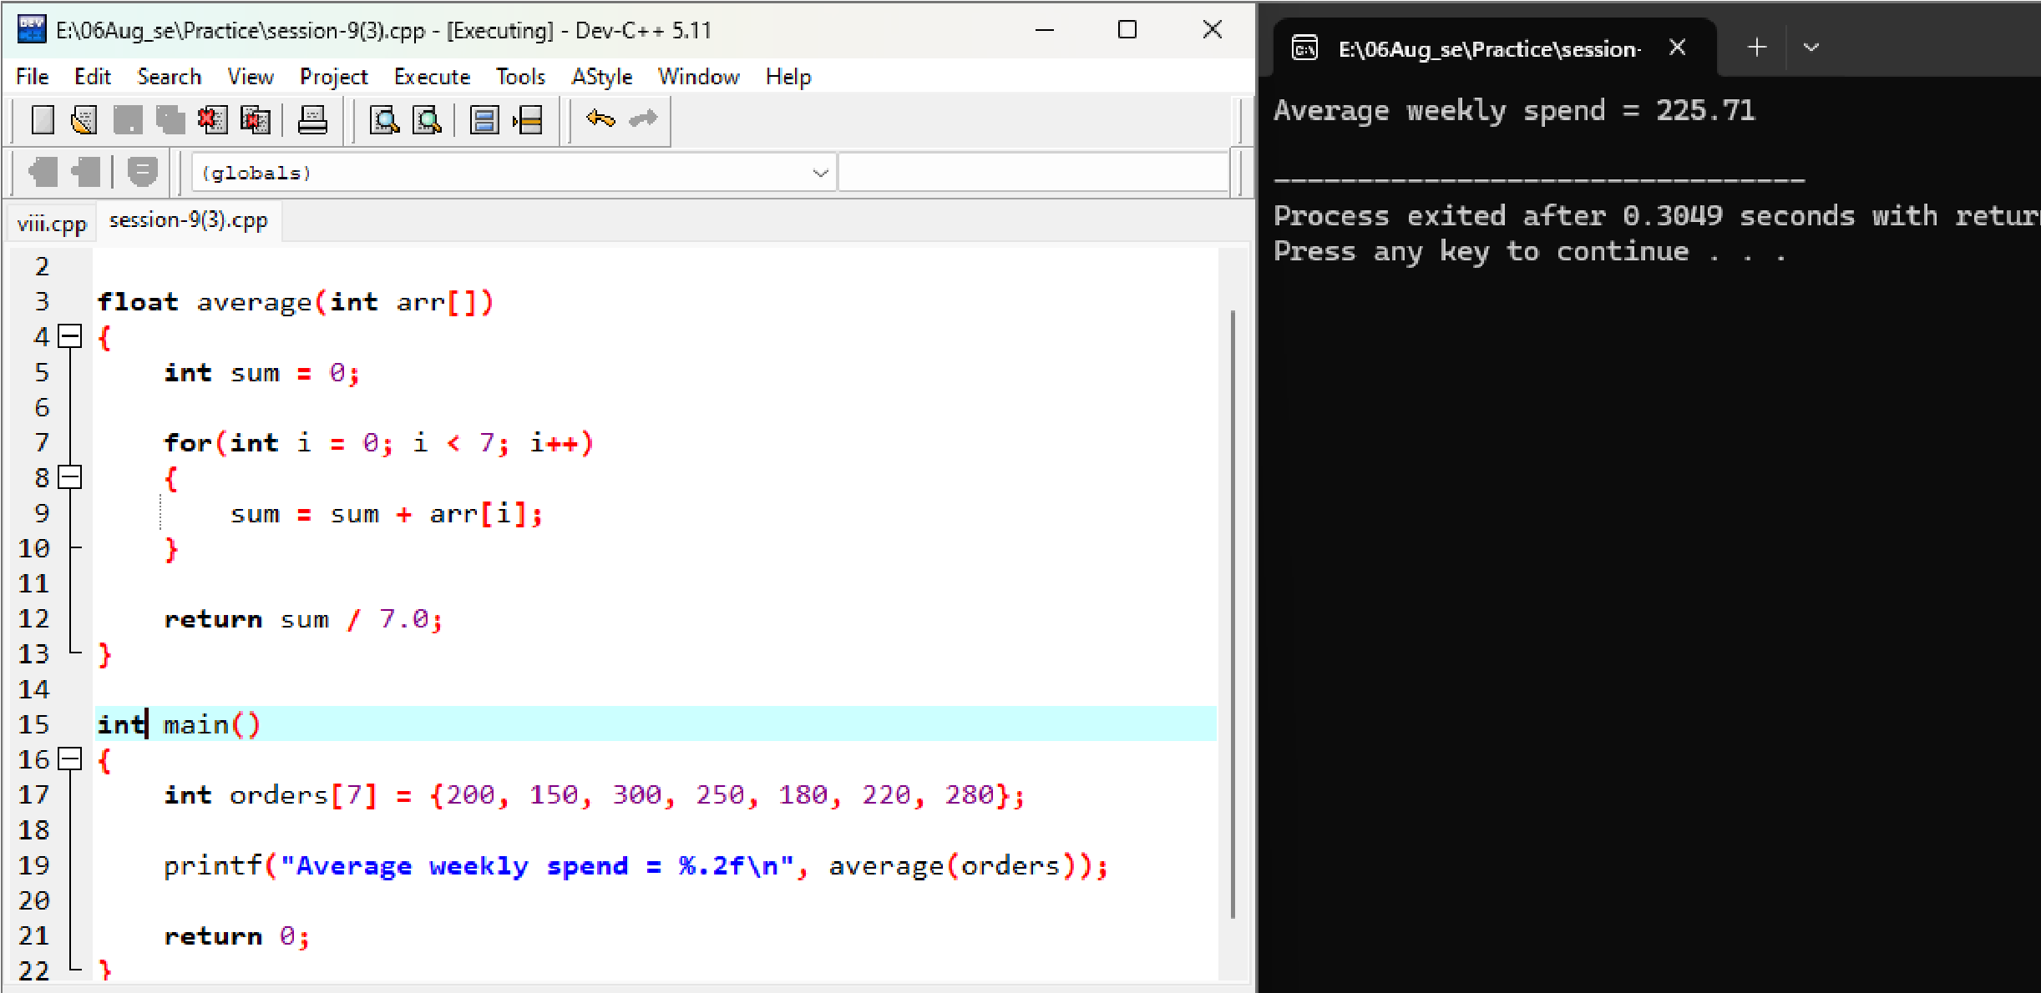

Average weckly spend =225.71

Q 4. Given a 2D array called cricket Scores where each row represents an IPL match and columns represent runs scored by each team, write code to print the highest score from each match.
Ans.
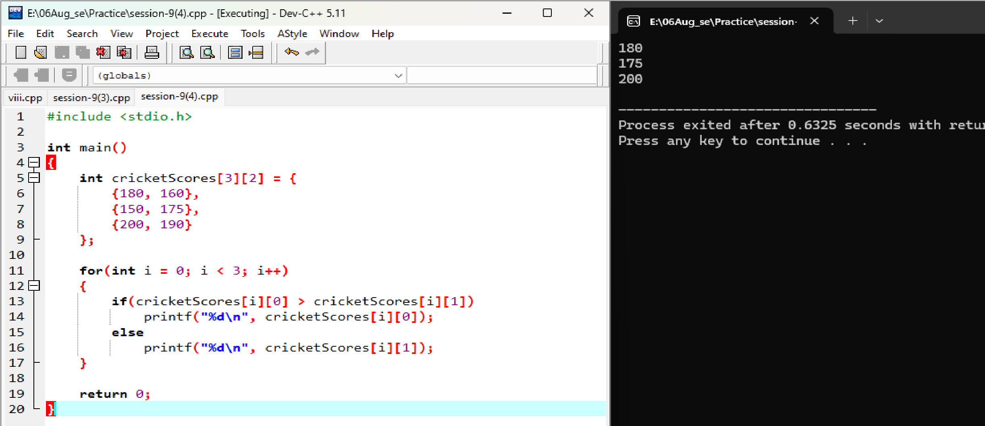

180 175
280

Session-10
Q 1. Declare a string variable called song Title and assign it the value 'Tum Hi Ho'. Print the length of the string using strlen ().
Ans.
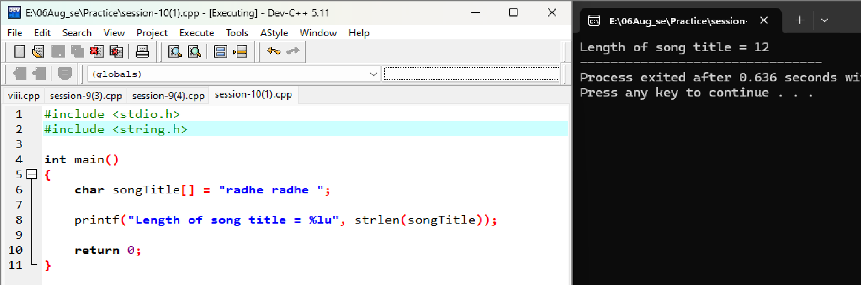
Length of song title=12

Q2. Ake input for two usernames (as strings) and compare them using strcmp (). Display whether they are the same or different.
Ans.
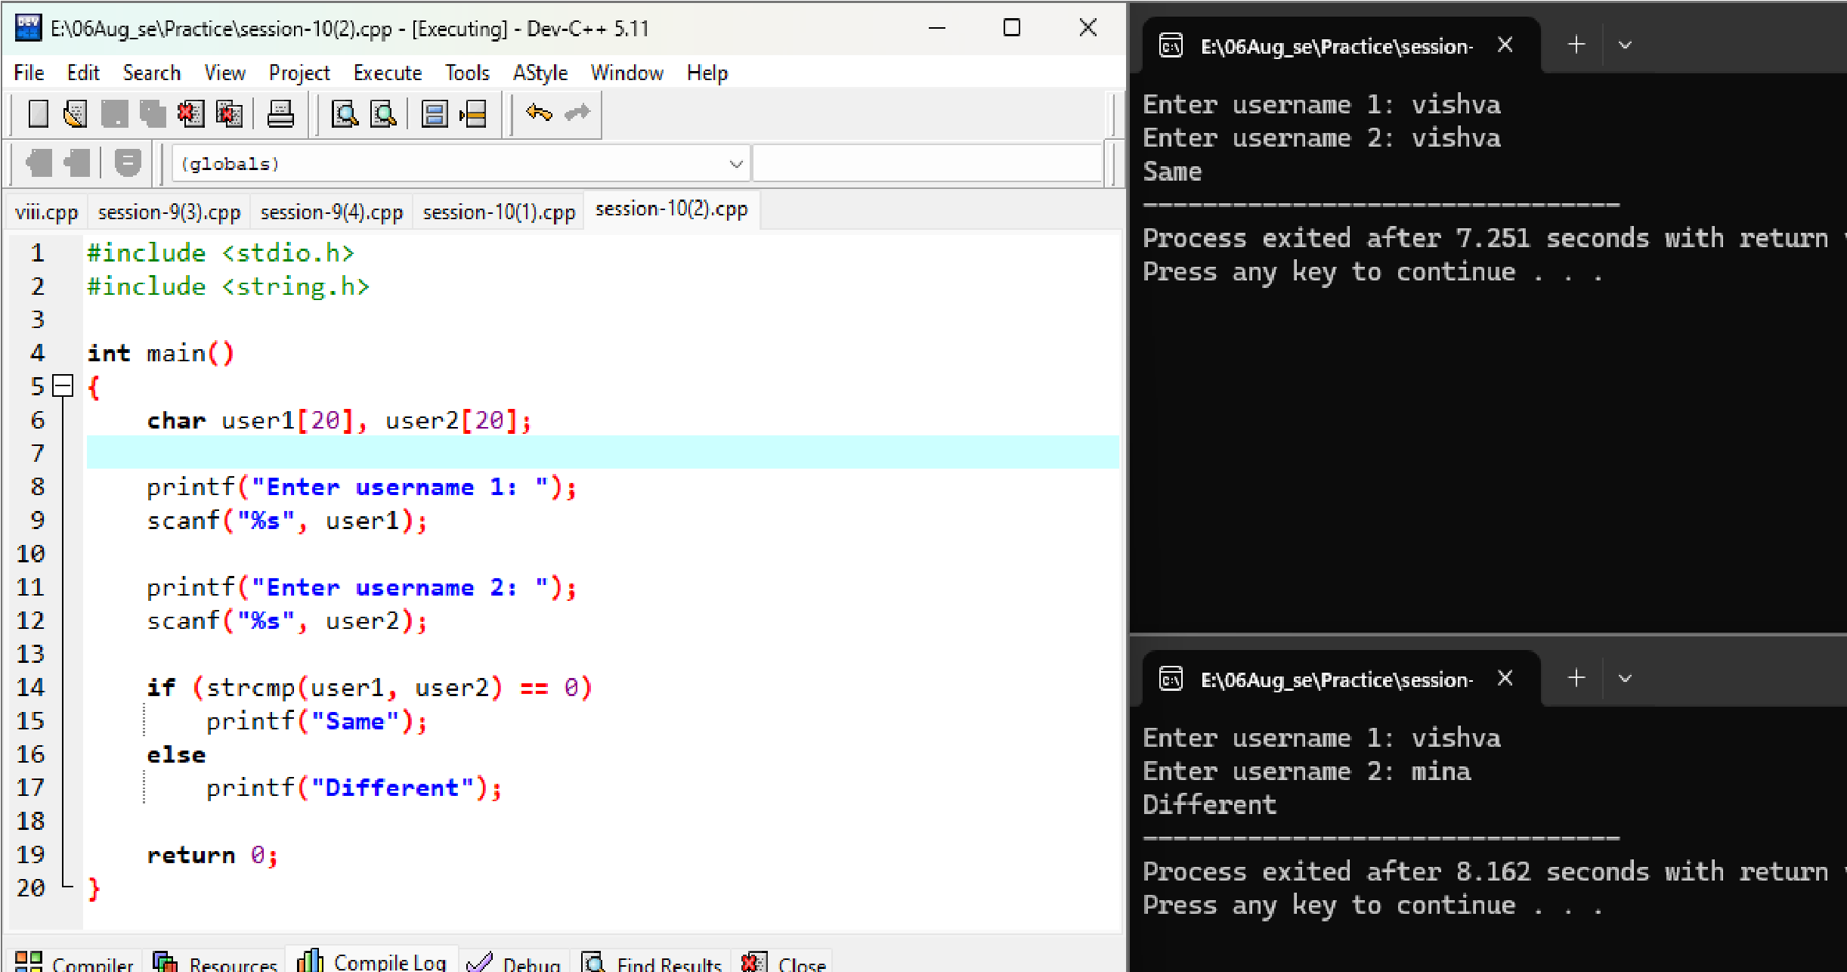

Enter username 1: Vishva
Enter username 1: mina
Different

Enter username 1: Vishva Enter username 1: Vishva same
- 3. Copy the string 'Flipkart' into another string variable called shopping App using strcpy (), then print the value of shopping App.
<br><br><em><strong>Hint:</strong> Make sure to declare enough space for the destination string. </em> Ans.
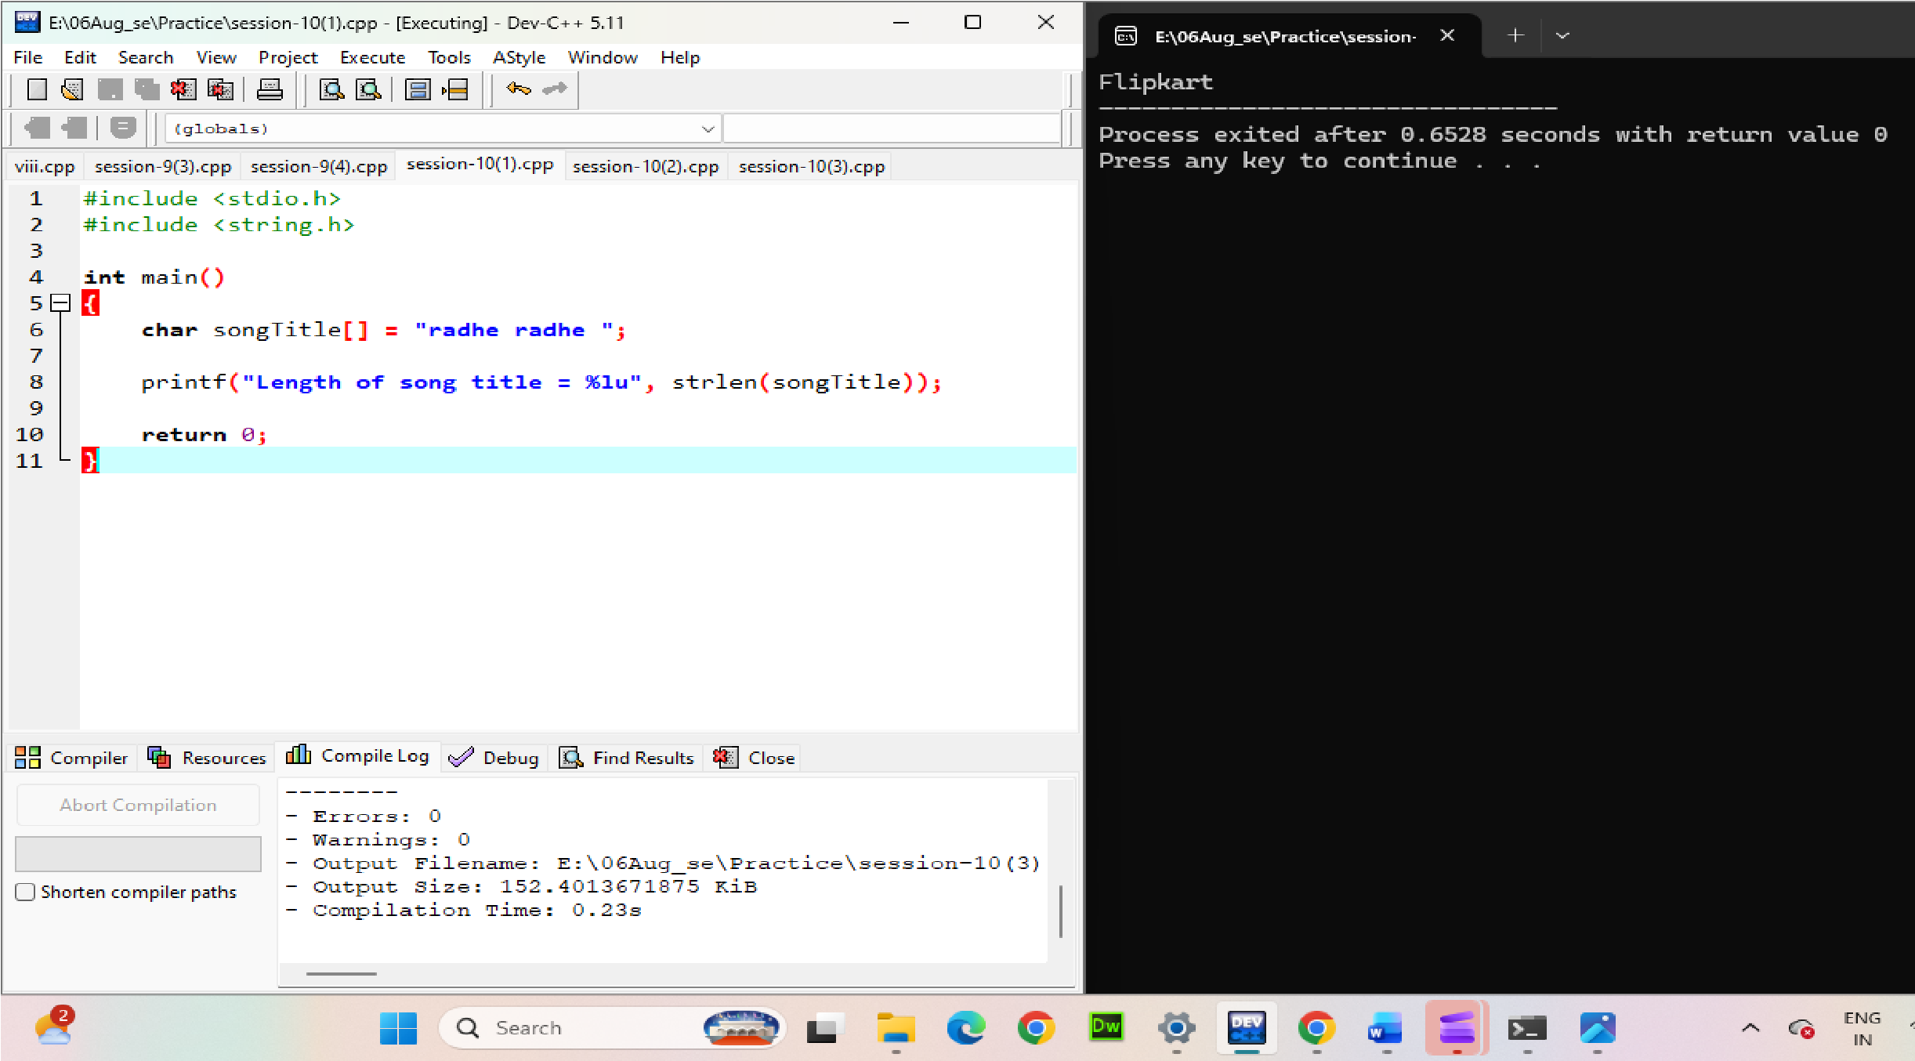

Filpkart

Q.4 Build a small script that takes the user's full name as input and creates a username by copying only the first 5 characters using strcpy (). Print the generated user name .<br><br><em><strong>Constraint:</strong> If the name is shorter than 5 characters, use the full name as the user name.</em> Ans.
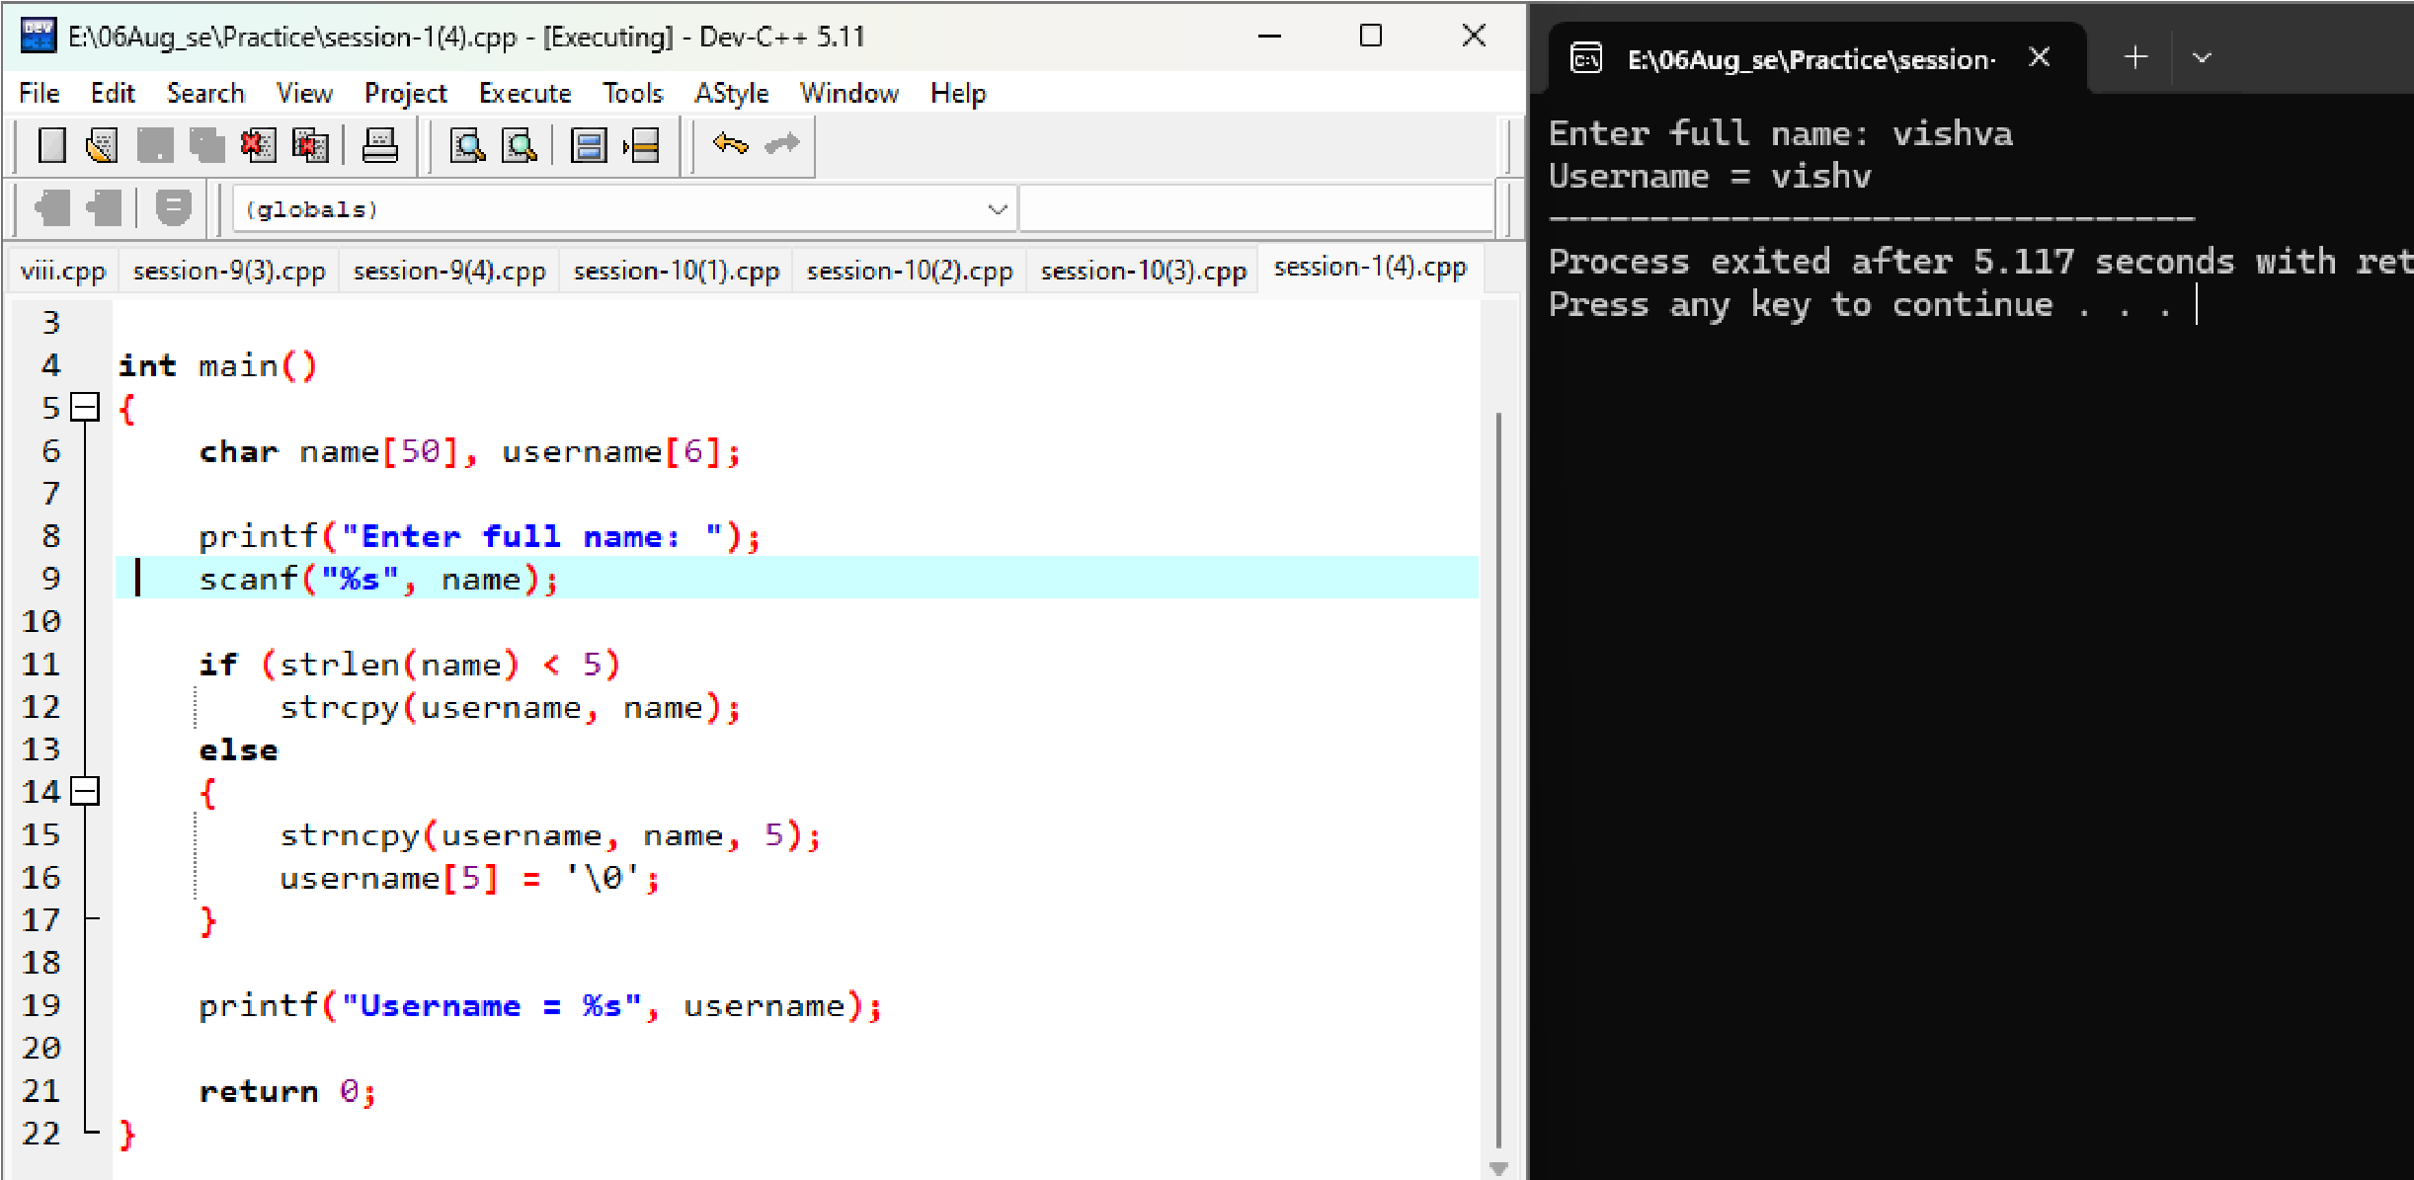

Enter full name = Vishva
Username=vishva

Session-11
Q 1. Declare an integer variable called likes and a pointer variable called ptrLikes; assign likes a value, point ptrLikes to likes, and print both the value and the address stored in ptrLikes.
Ans.
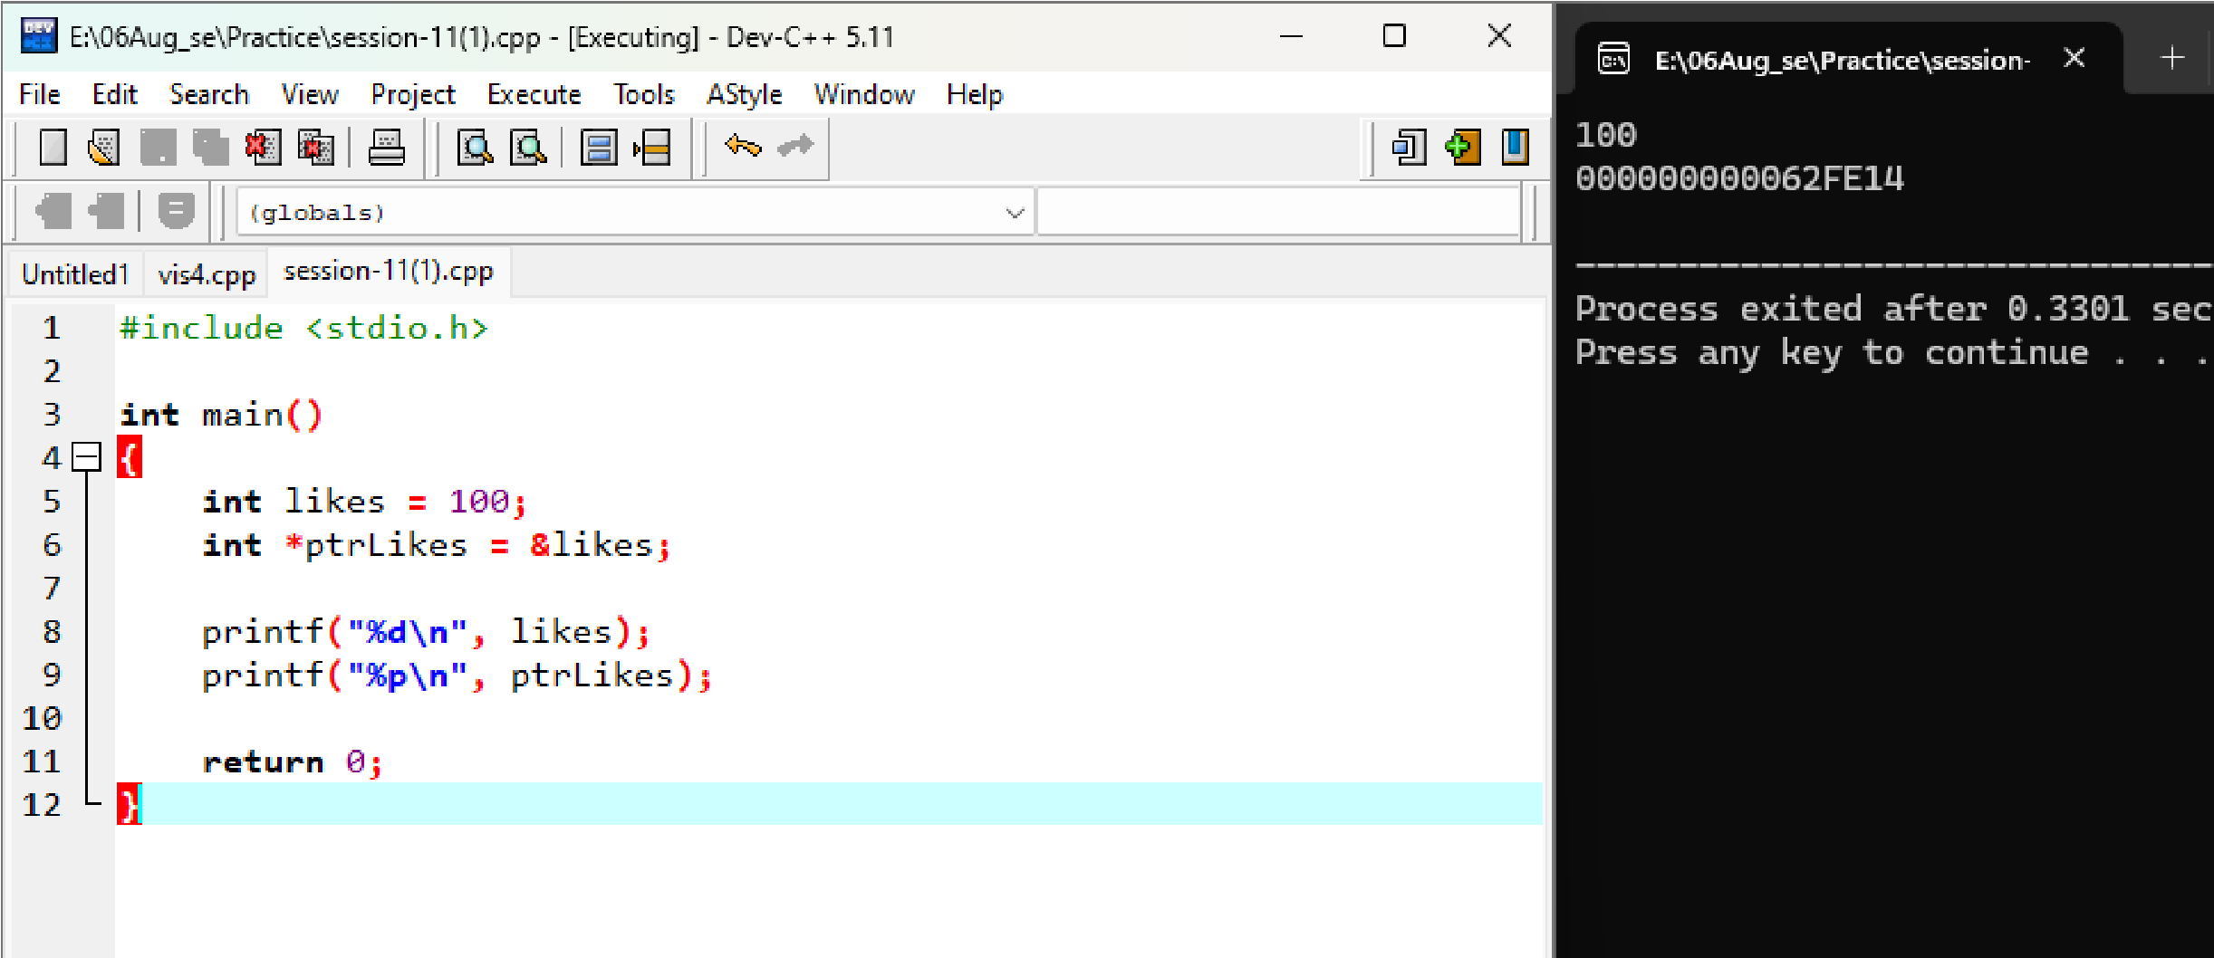

Write a function swap Playlist Counts(int *a, int *b) that swaps the number of songs in two Spotify playlists using pointers, then call the function in main and print the swapped values.
Ans.
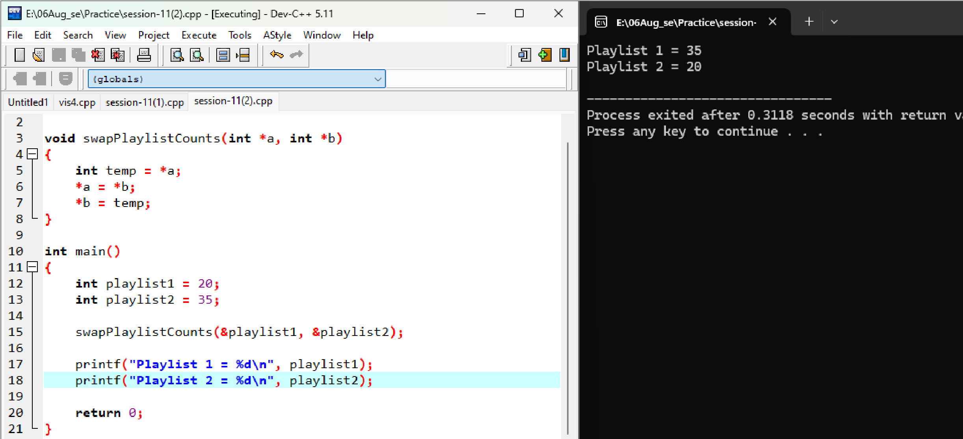
Playlist 1 = 35
Playlist 2= 20

Given an array of 5 order amounts (e.g., Zomato orders), use a pointer to iterate through the array and print each amount along with its memory address. <br><br><em><strong>Hint:</strong> Use pointer arithmetic to move to the next element. </em> Ans.
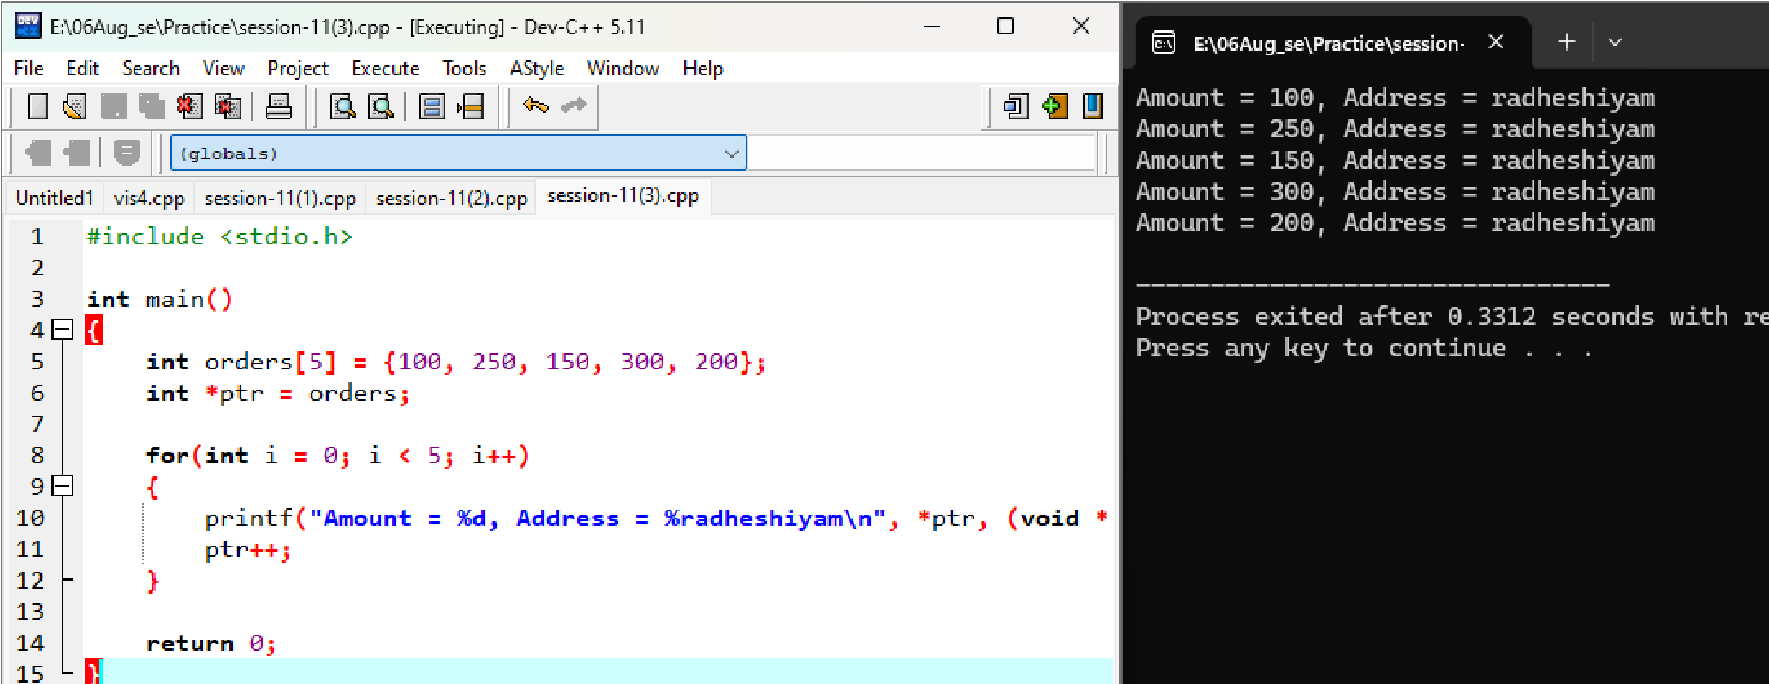

Create a function increment Followers (int *followers, int n) that increases each follower count in an array (representing Instagram followers for 5 friends) by 100 using pointer arithmetic, then print the updated counts.
Ans.
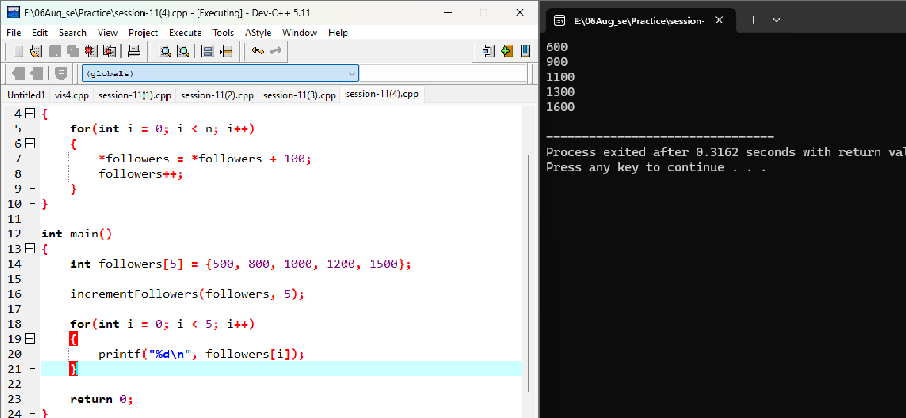

Q5. Draw a simple memory diagram (on paper or using any drawing tool) showing how a pointer references the address of a variable, using the variables from your likes and ptrLikes example; label the variable, pointer, and address.
Ans.
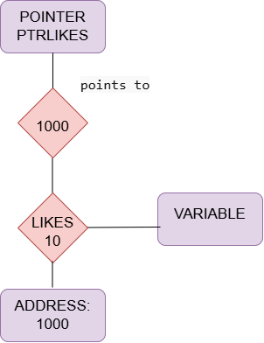
- likes → Variable
- ptrLikes → Pointer
- 1000 → Address

Session-12
Q1. Declare a structure named Playlist to store details of a song: title (string), artist (string), and duration in seconds (integer). Initialize one Playlist variable with your favorite song's details and print each field.
Ans.
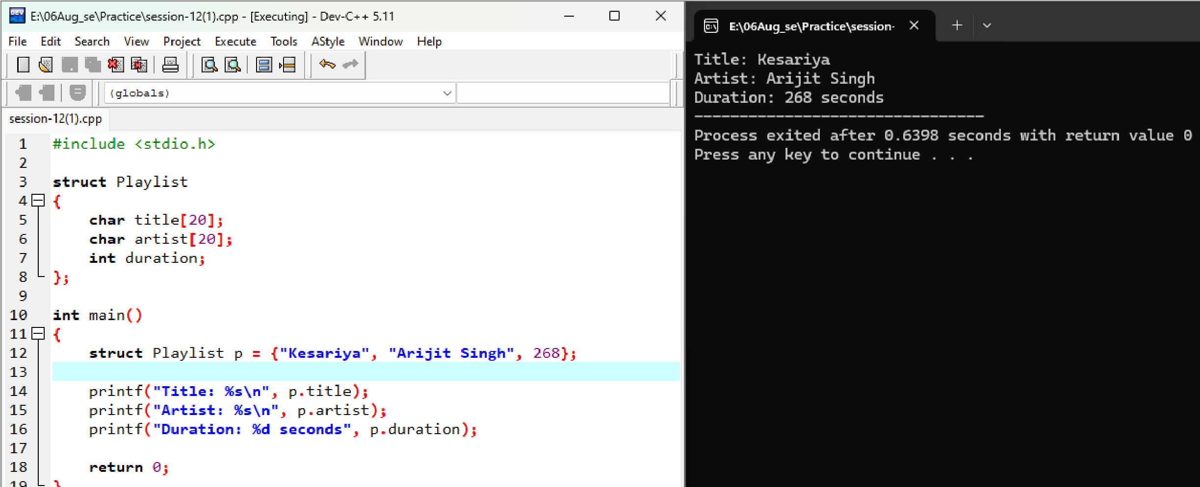
Title: kesariya
Artist: Arijit singh
Duration:268 seconds

Q2. Create a structure called FoodItem to store Zomato-style menu data: itemName (string), price (float), and rating (float). Initialize an array of 3 FoodItem variables with real menu items and display their details using a loop.
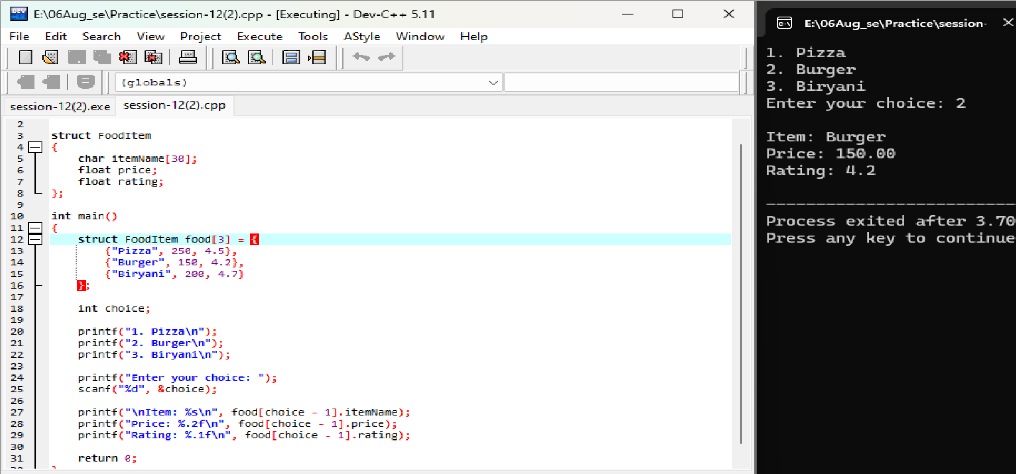
Ans.
PIZZA
BURGER
BIRYANI
ENTER YOUR CHOICE: 2
ITEM: BURGER
PRICE: 150.00
RATING:4.2

Q.3 Define a nested structure called MovieShow for a BookMyShow-style app: Movie (string), Screen (integer), and a nested structure Time with hours and minutes (integers). Create and initialize a MovieShow variable for any movie and print its details in the format 'Movie: X, Screen: Y, Time: HH:MM'. Ans
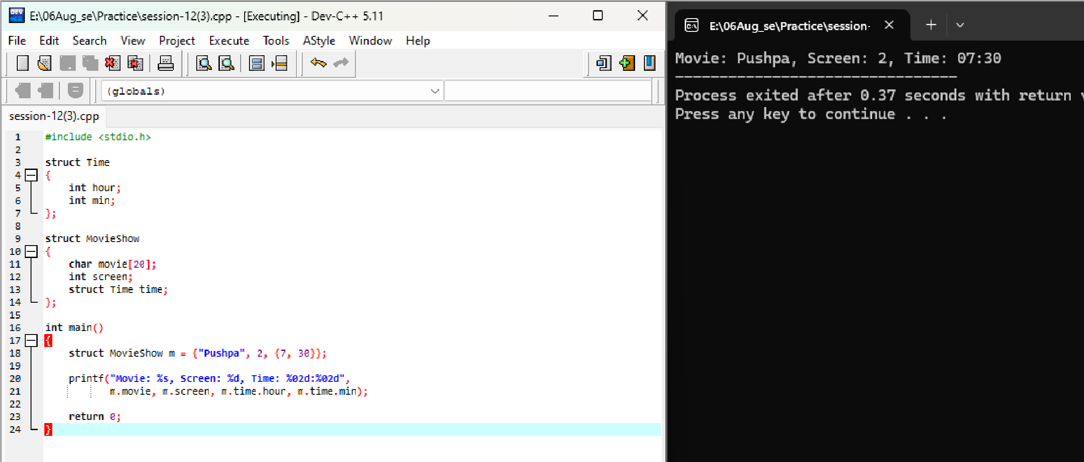

Movie: pushpa
Screen: 2
Time: 7:30

Q4. Build a structure called InstaProfile with fields: username (string), followers
(integer), and a nested structure Bio with fields: description (string) and age (integer). Initialize an InstaProfile variable with your own details and display all fields.
Ans.
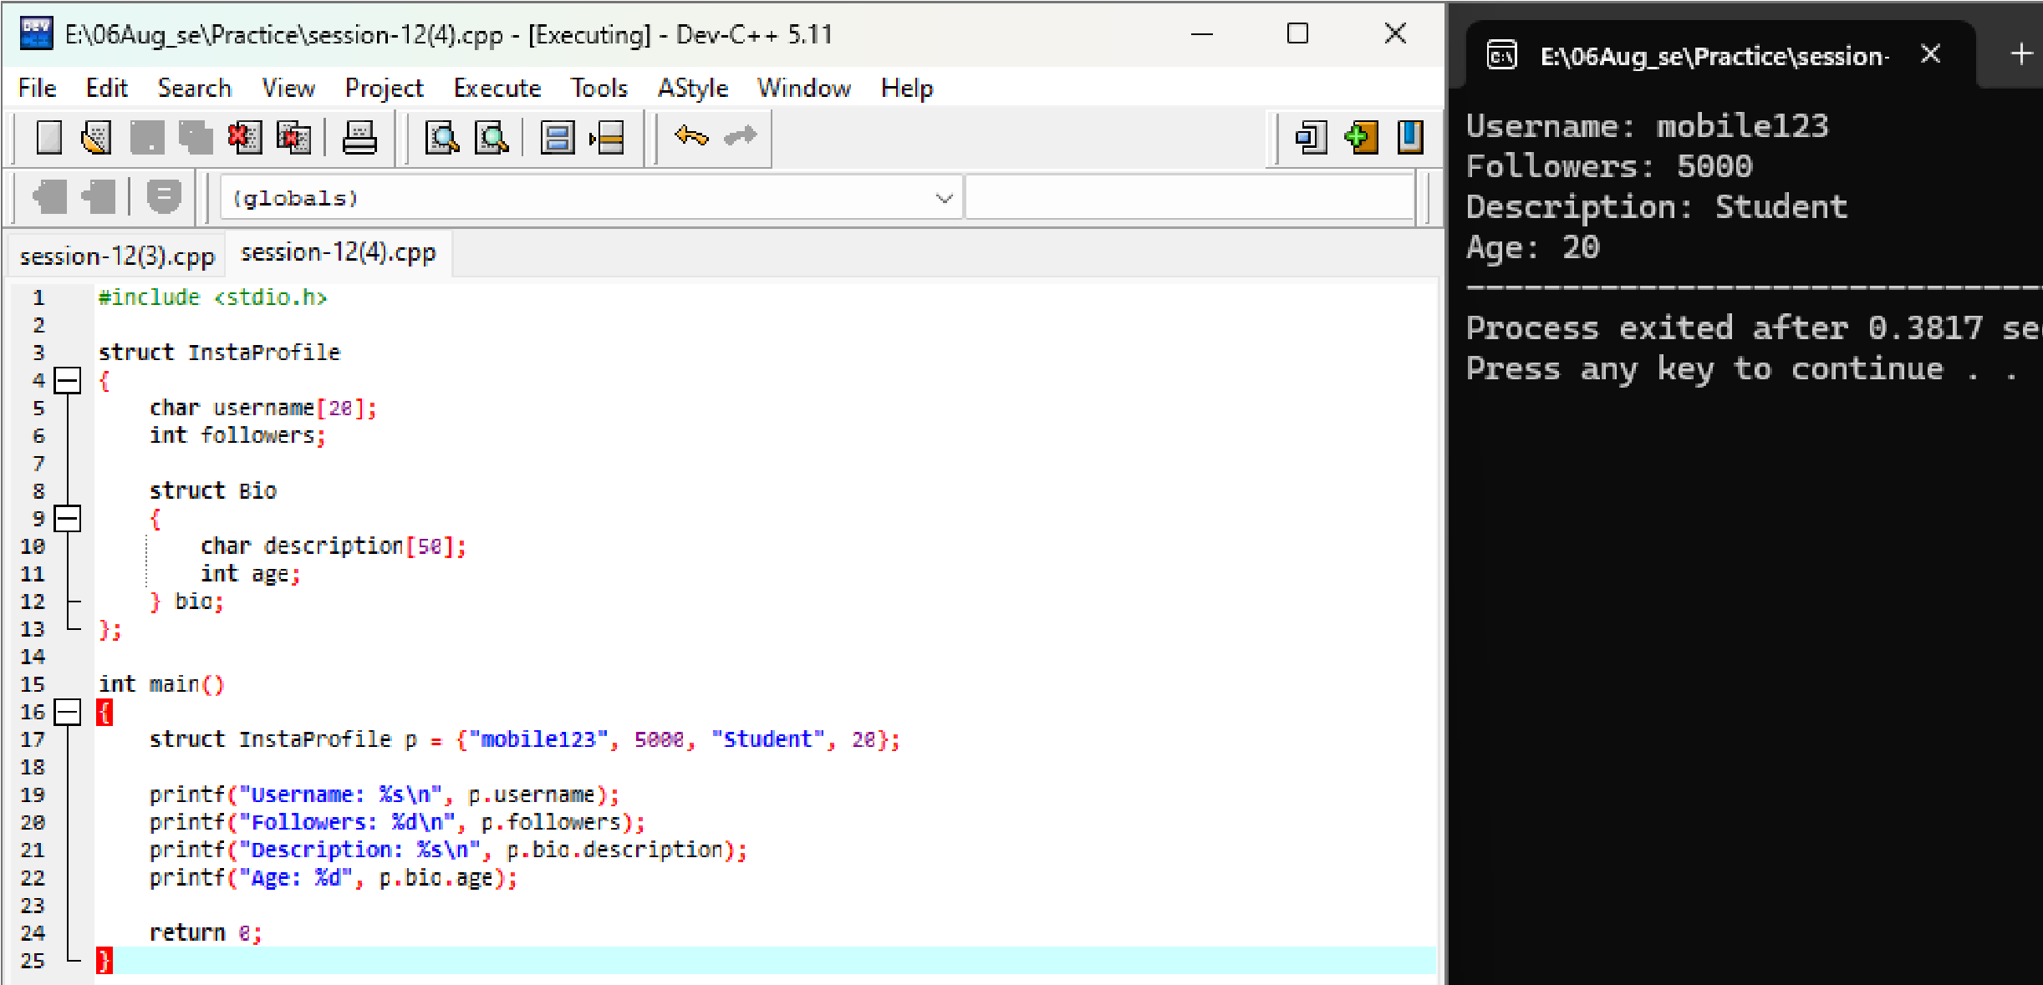

Username: mobile123
Followers: 5000
Description :student
Age : 20

Session-13
Q1. Create a file called playlist.txt and write the names of your top 3 favorite songs from Spotify into it using write mode (w).
Ans.
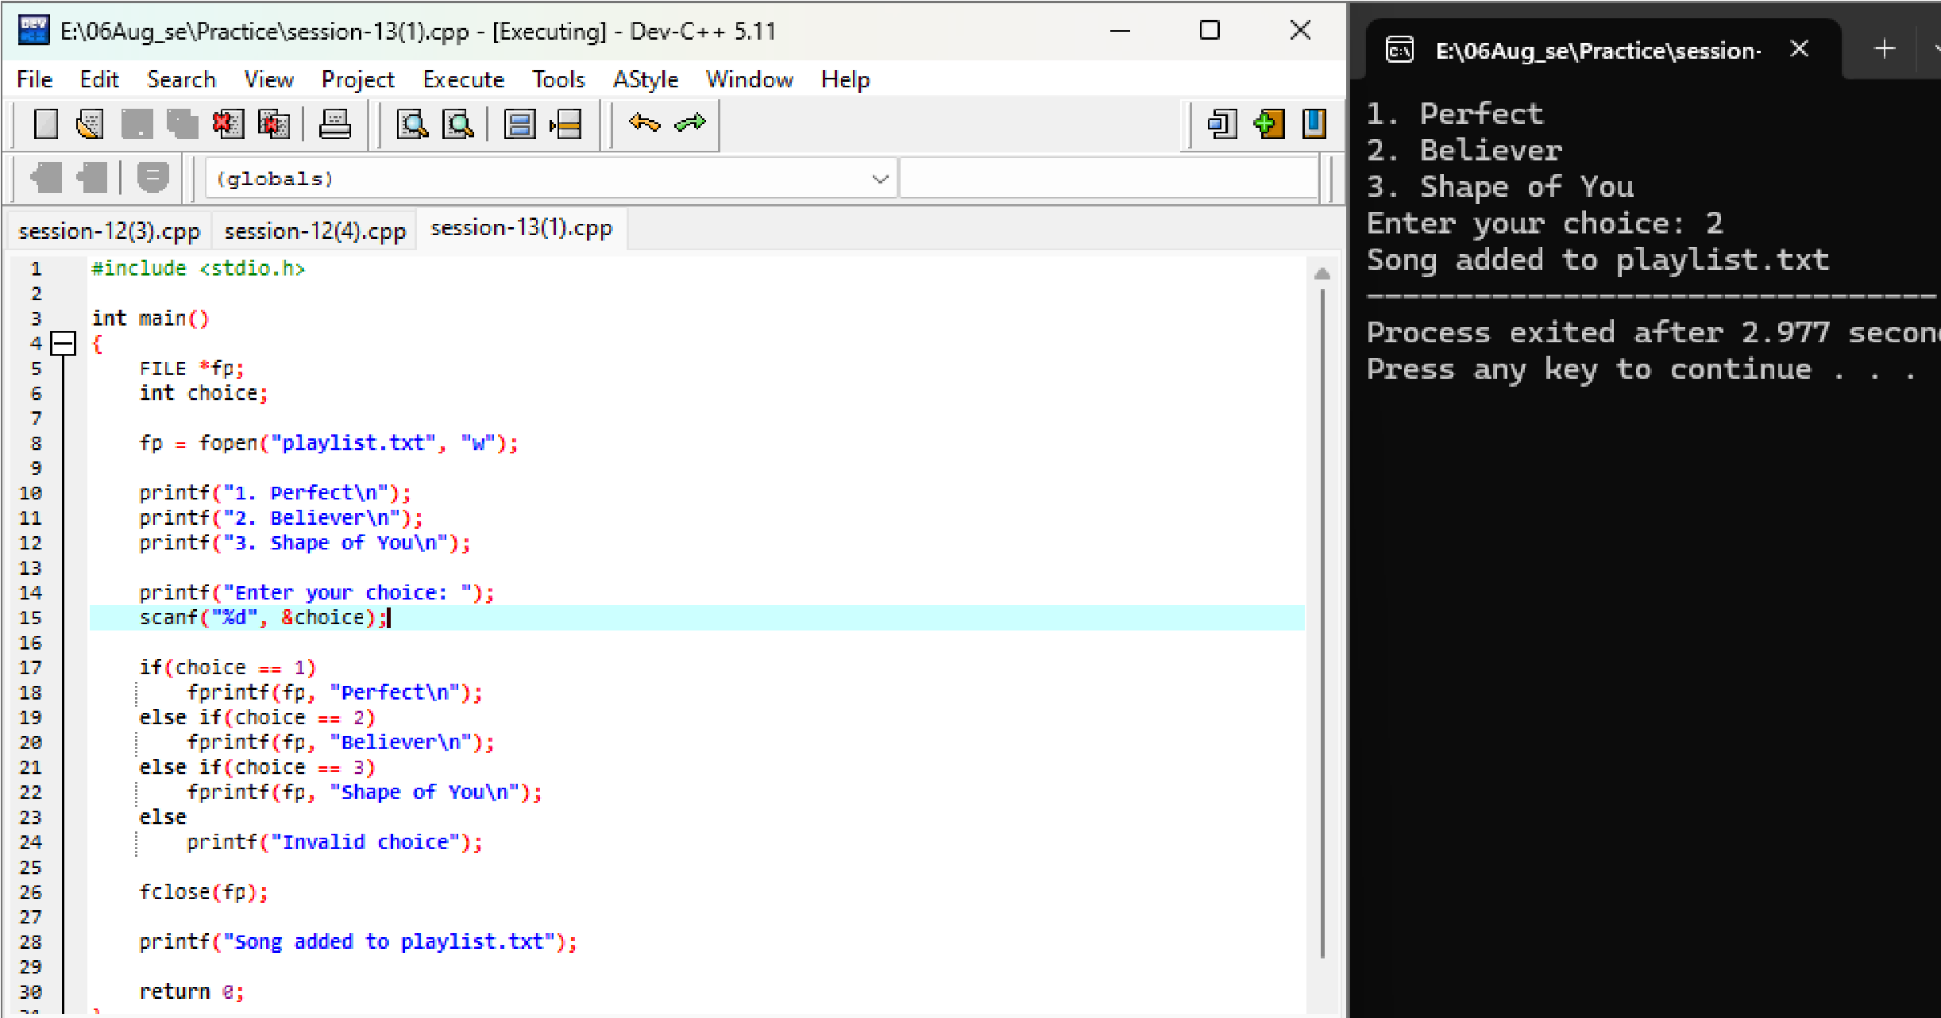
Perfect
Believer
Shape of you
Enter your choice: 2
Song added to playlist.txt

Q2. Open playlist.txt in read mode (r) and display each song name on a separate line in the console.
Ans
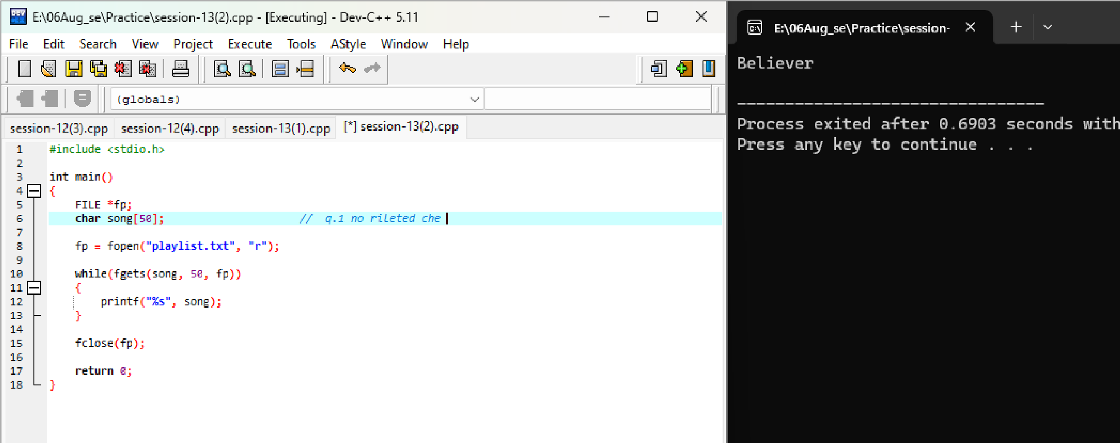

Believer // a ma qus 1 to canected

Q3. Add two more song names to playlist.txt without deleting the existing ones by opening the file in append mode (a).
Ans.

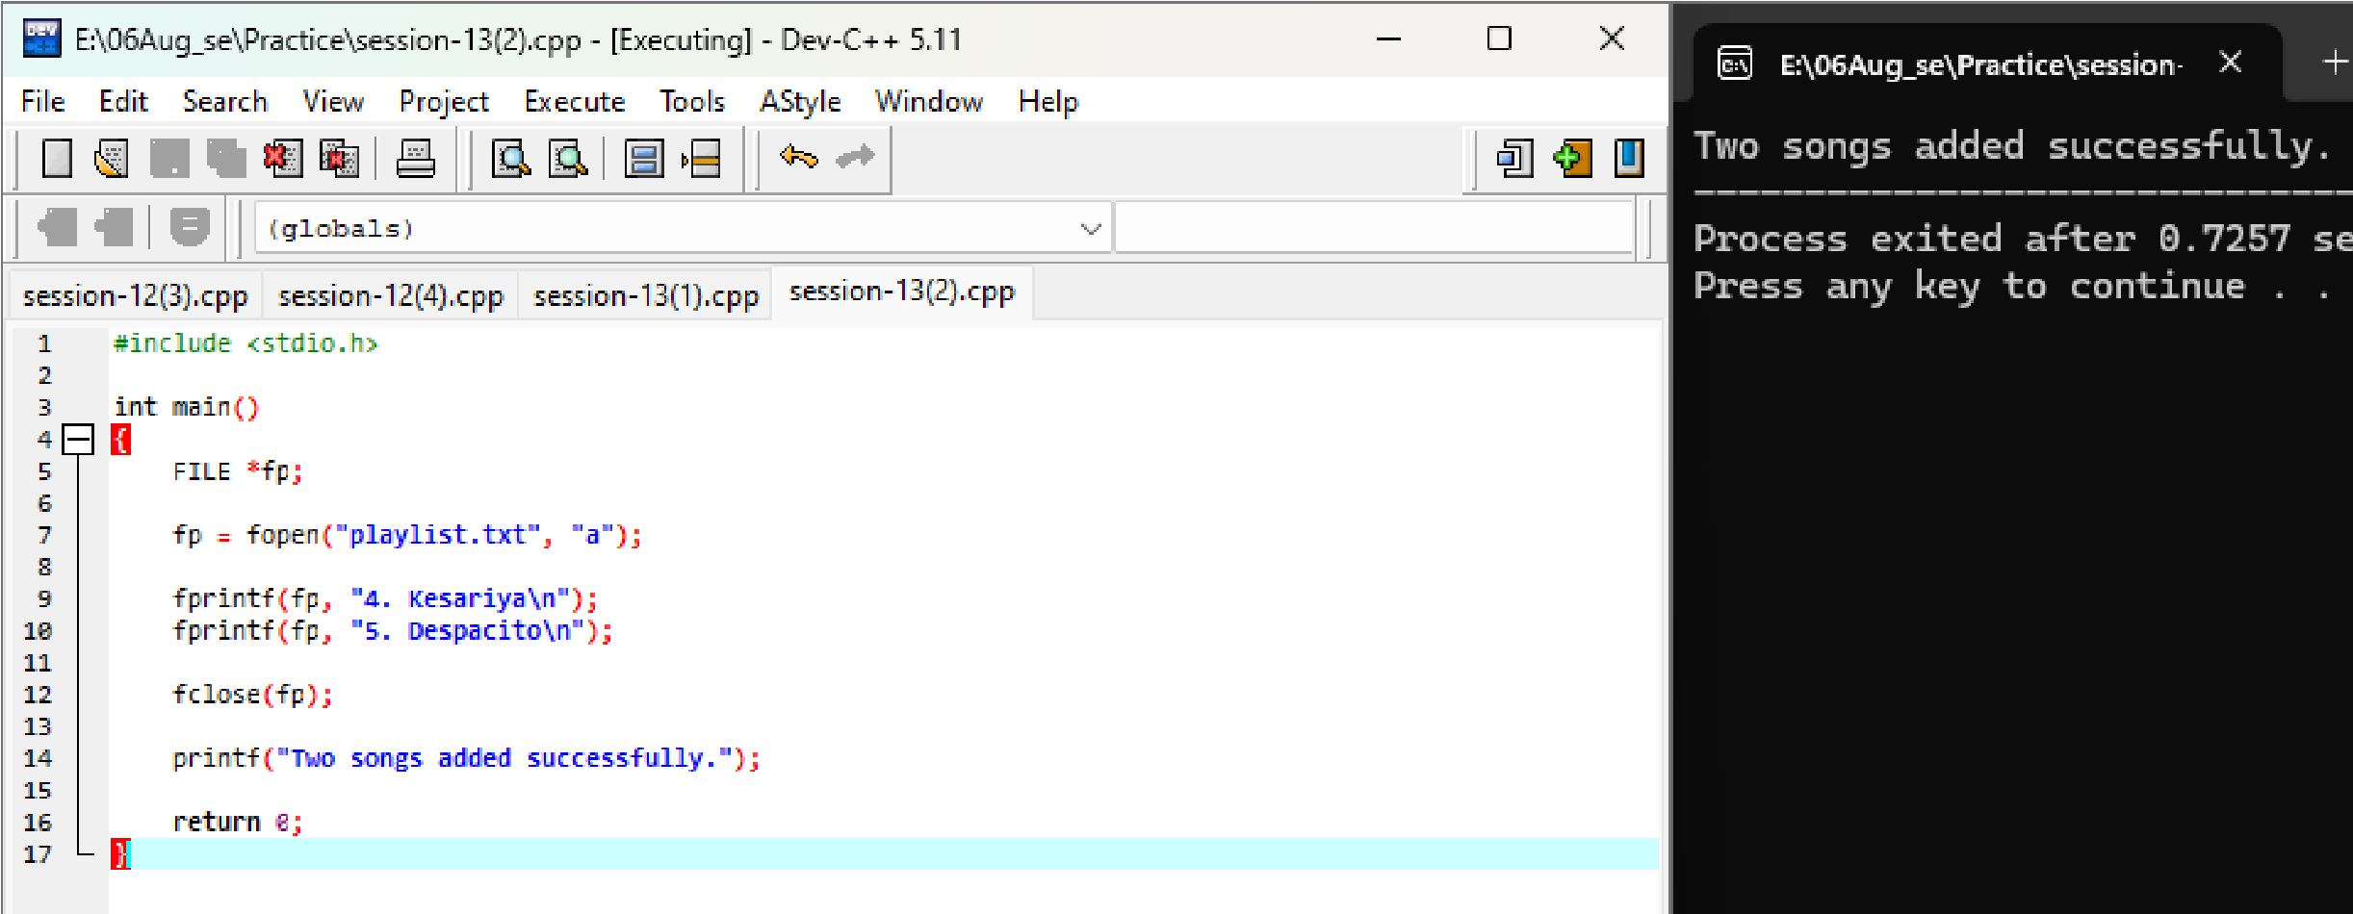
Two songs added successfully.

Q4 Write a program that reads all song names from playlist.txt and prints only those that contain the word 'love' (case-
insensitive).<br><br><em><strong>Hint:</strong> Use the 'in' keyword or equivalent string method for filtering.</em> Ans.
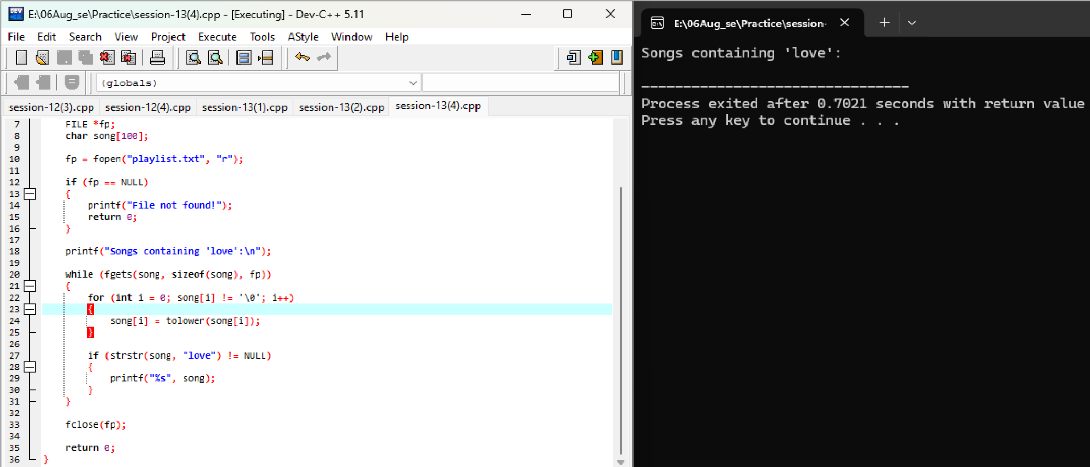
Songs containing ‘love’

Session-14
Q1. Given the following buggy code meant to calculate the total price of a
Zomato order, identify and fix the syntax and runtime errors:<br><br>let items
= ["Burger", "Pizza", "Fries"]; <br>let prices = [120, 250, 90];<br>let total =
0;<br>for (i = 0; i < items. length; i++) {<br> total =+ prices[i]<br>}
<br>console.log ("Total price is: " + total)
;<br><br><em><strong>Hint:</strong> Watch for assignment and loop variable issues .</em>
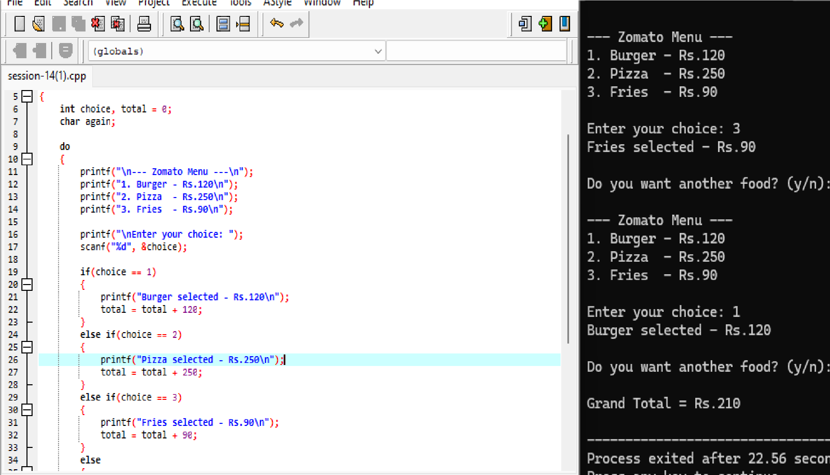
Ans

Rewrite the following code to improve its indentation and add comments explaining each step, so that a beginner can understand what it
does:<br><br>function isEven(num){if(num%2==0) {return true;} else{return false;}} Ans.
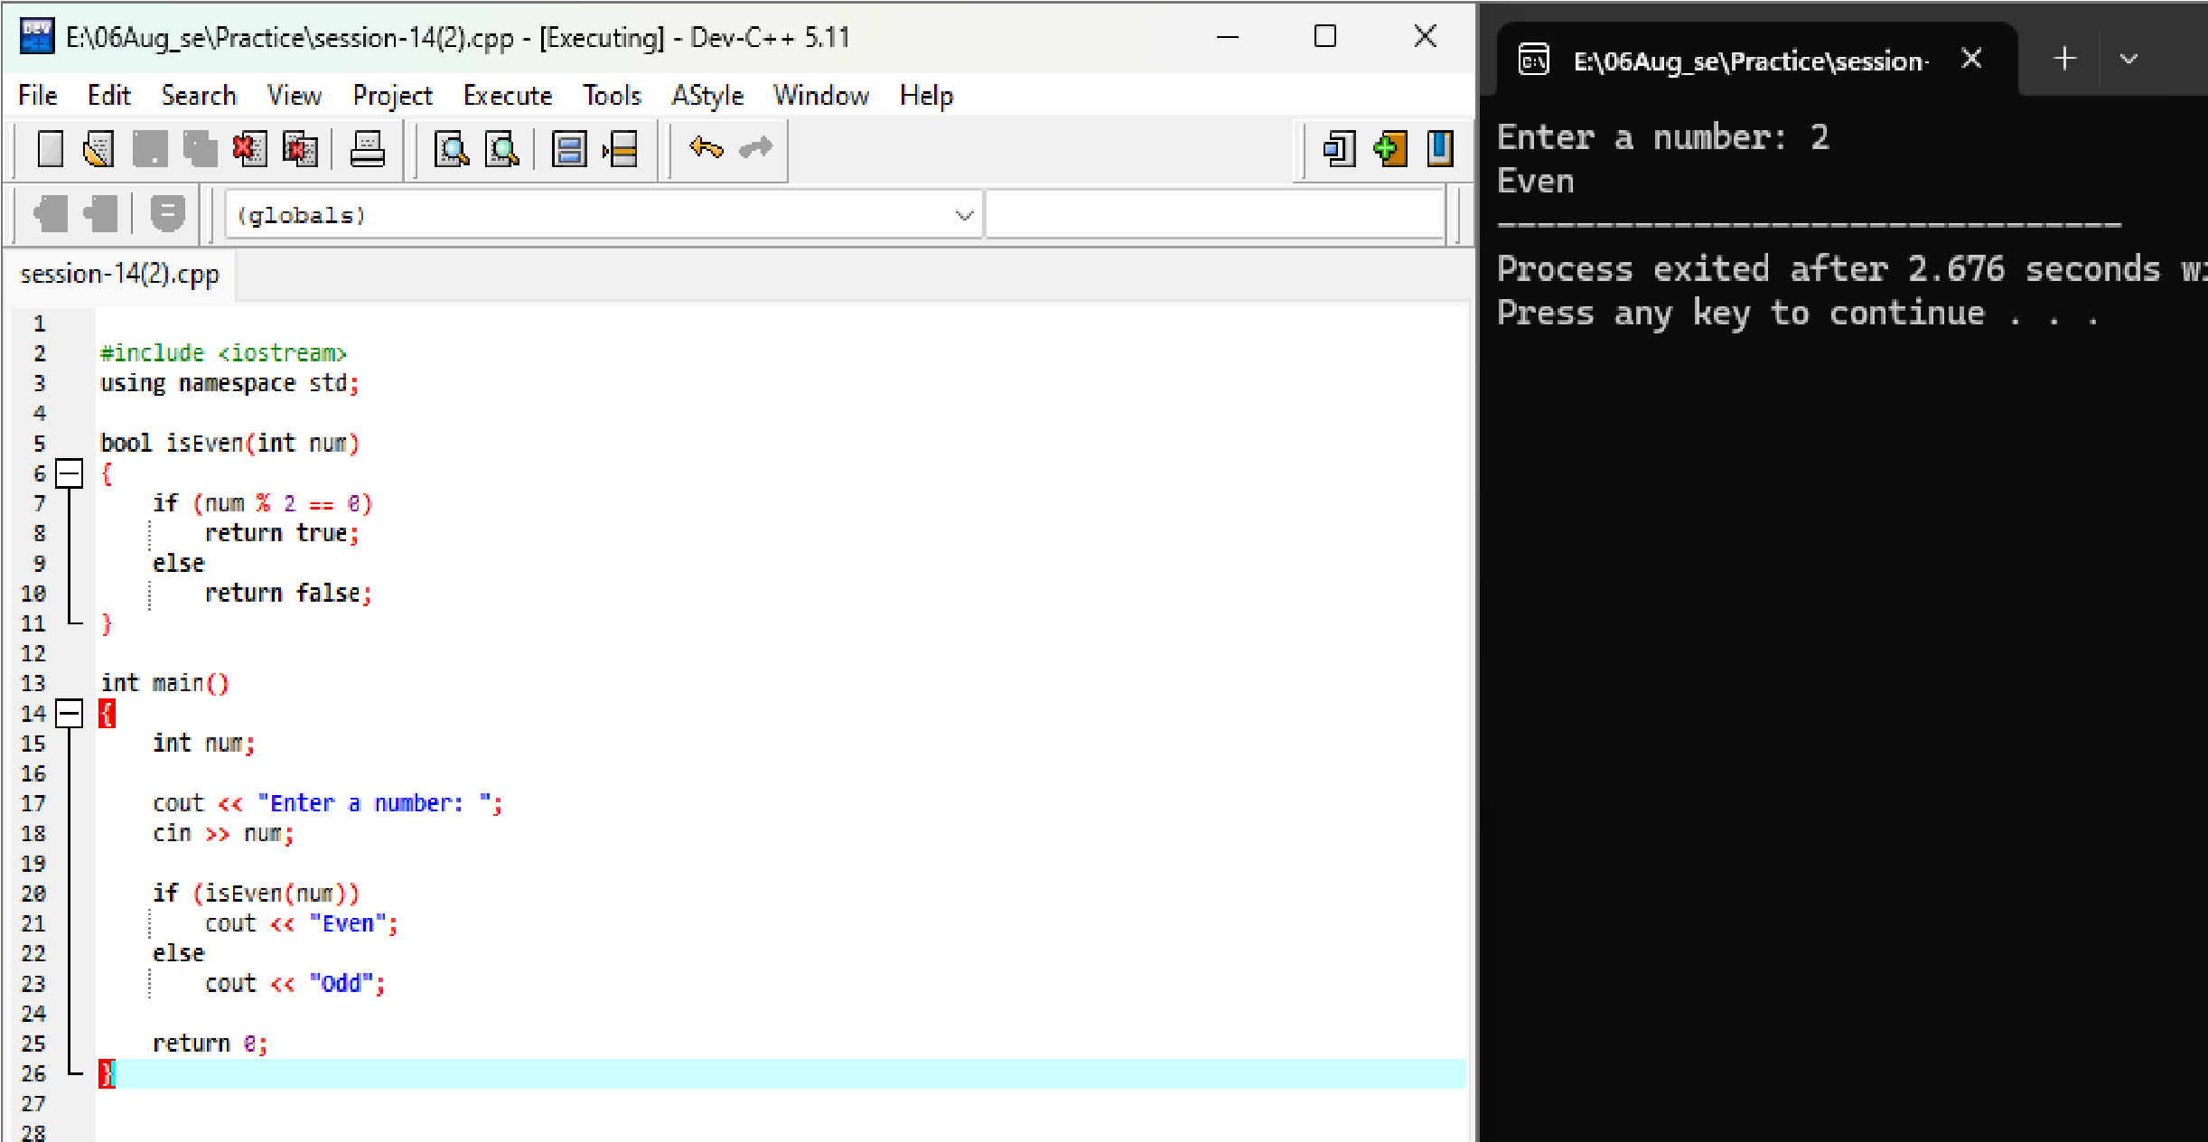

Enter a number : 2
Even

Write a function format Followers Count(count) that takes a number and returns a formatted string like Instagram: 1500 as '1.5K', 1200000 as '1.2M', and numbers below 1000 as-is. Add clear comments and use proper indentation.
Ans.
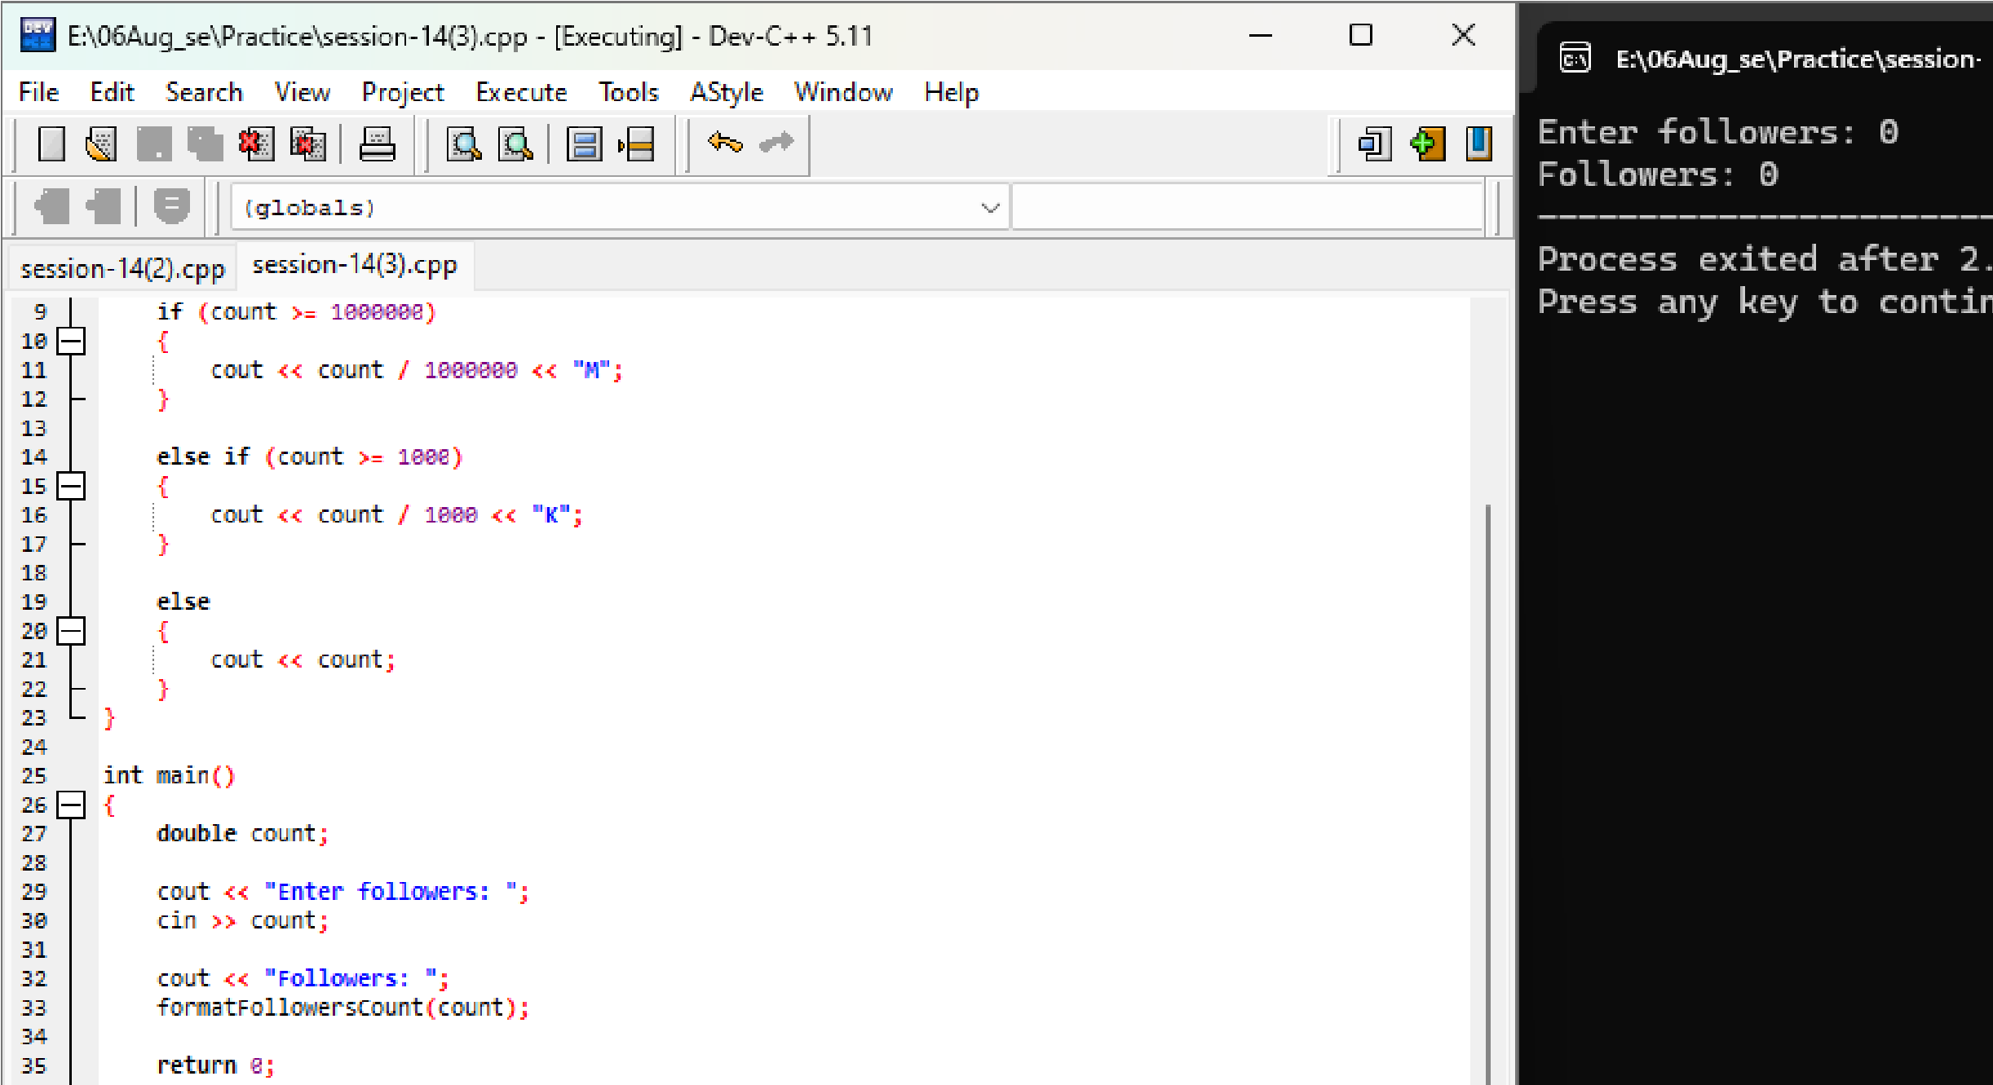

You are given a piece of JavaScript code that should print all even numbers from 1 to 10, but it doesn't work as expected:<br><br>for (let i = 1; i <= 10; i++) {<br> if (i % 2 = 0) {<br> console.log(i)<br> }<br>} <br><br>Find and fix the error, then rewrite the code with good indentation and at least one comment explaining the logic.
Ans.
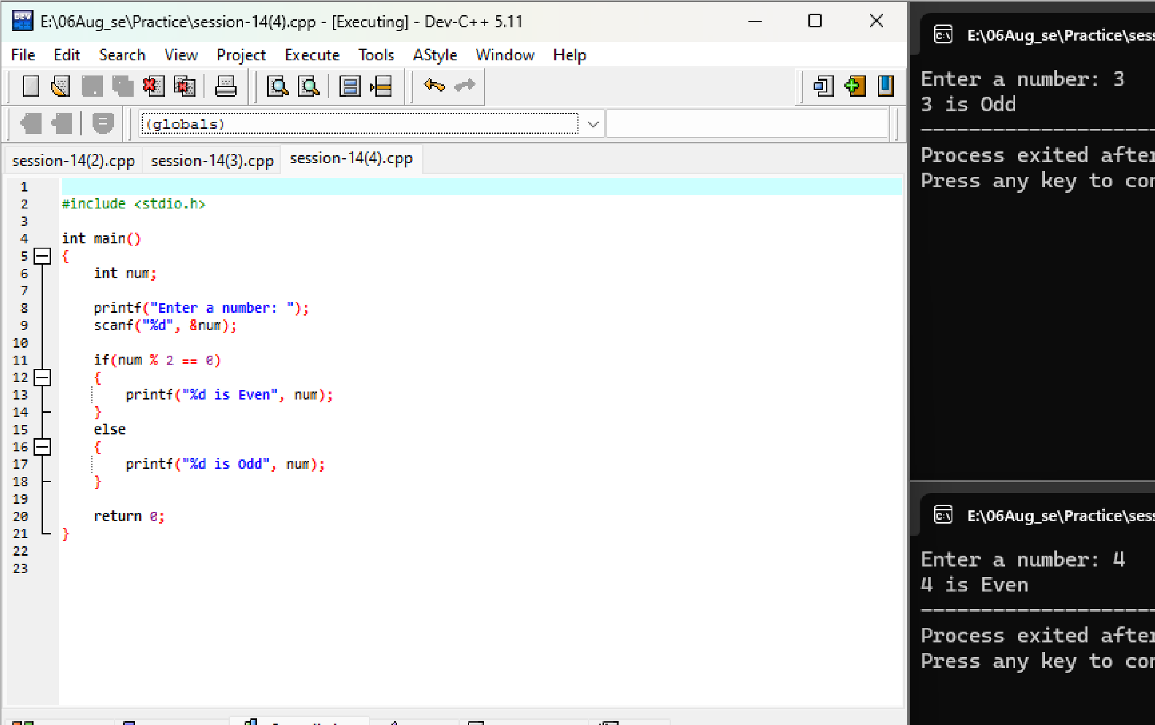

Enter a number : 3
- is old
Enter number : 4
- is even

