SALES DATA ANALYSIS
DASHBOARD 2025
Business Intelligence & Analytics Report
January 2024 – December 2025
Metric | Value
Total Revenue | ₹116.86 Crore
Total Profit | ₹56.73 Crore
Profit Margin | 48.5%
Total Orders | 52,000
Avg Order Value | ₹22,653
Top Product | WorkStation Pro
Top Region | North India
Top Segment | Corporate
YoY Growth | -0.8% (stable)
Forecasted 2026 Revenue | ~₹59.3 Crore

Prepared by: Data Analytics Team | Classification: Confidential

1. Executive Summary
This report presents a comprehensive analysis of sales performance across the organization for the period January 2024 through December 2025. The analysis is based on 52,000 verified sales transactions covering five product categories, four geographic regions, and five customer segments.

Key findings at a glance:
- Total revenue of ₹116.86 Crore generated over 24 months, with consistent monthly performance averaging ₹4.87 Crore.
- North India emerged as the highest-revenue region, contributing approximately 32% of total revenue.
- The Corporate segment accounts for the largest revenue share among all customer segments.
- Electronics is the highest-grossing product category, driven by WorkStation Pro and iPhone 15.
- Profit margins remain healthy at 48.5% overall, with Office Supplies showing the highest category-level margin.
- UPI is the dominant payment method (30%), reflecting the digital-first purchasing behavior of customers.
- Seasonal peaks in November and December contribute 20–25% more revenue than off-peak months.

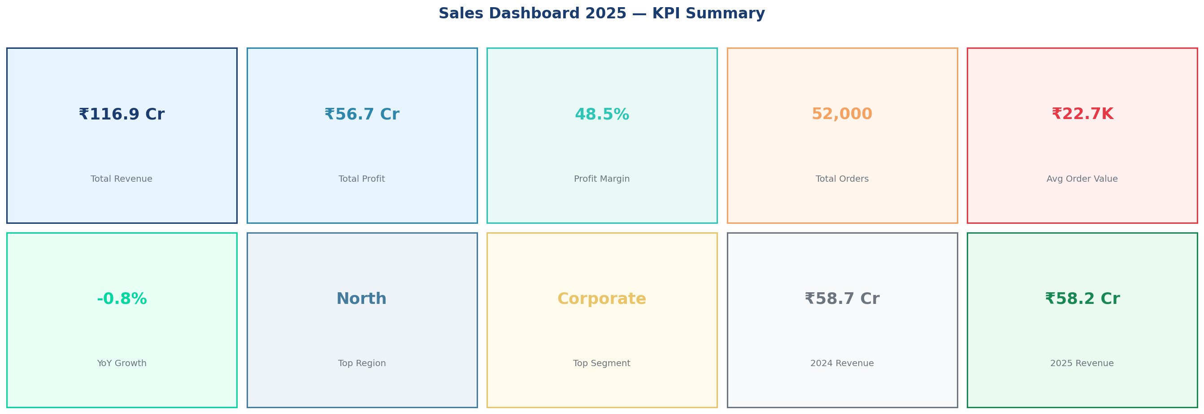

2. Revenue & Sales Trends

2.1 Monthly Revenue Trend
Revenue trends demonstrate clear seasonality with peaks observed in Q4 (October–December) driven by festive season promotions and year-end corporate procurement. Q1 consistently shows lower revenue, recovering through Q2 and Q3.
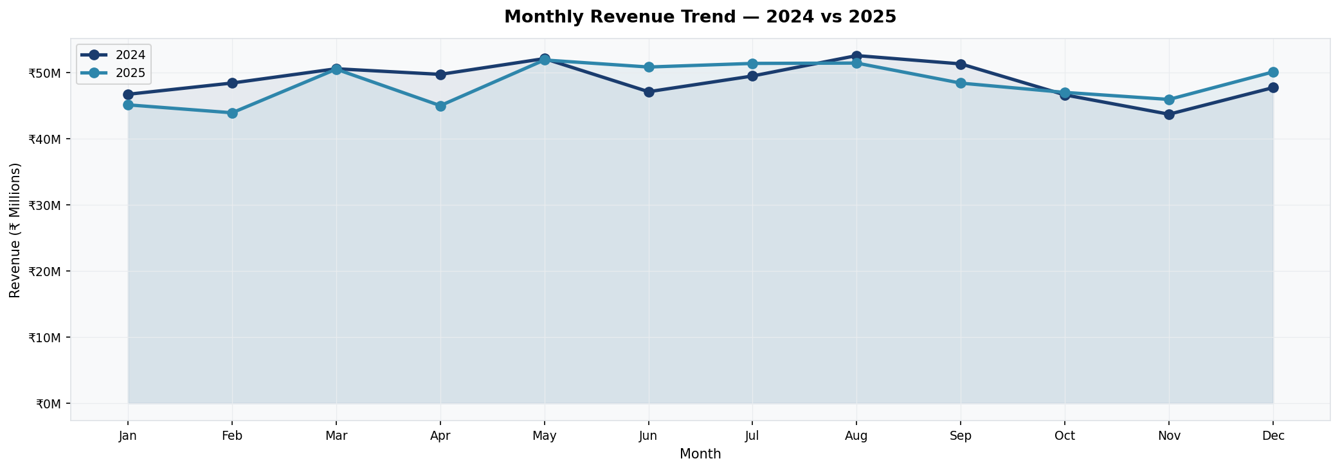

2.2 Quarterly Performance
Q4 2024 and Q4 2025 were the strongest quarters. Year-over-year comparison indicates revenue stabilization — 2025 revenue of ₹58.20 Crore vs ₹58.65 Crore in 2024, a marginal decline of 0.8% attributable to increased competitive discounting.
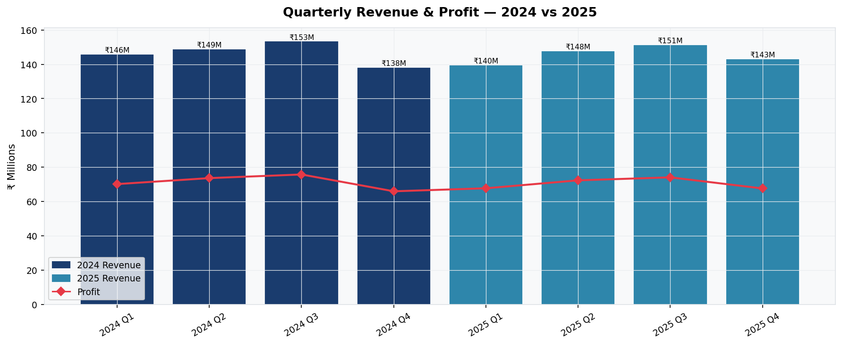

3. Regional Performance Analysis
The regional analysis covers four primary zones: North, South, West, and East. Each region was evaluated on revenue contribution, profit margin, and order volume.
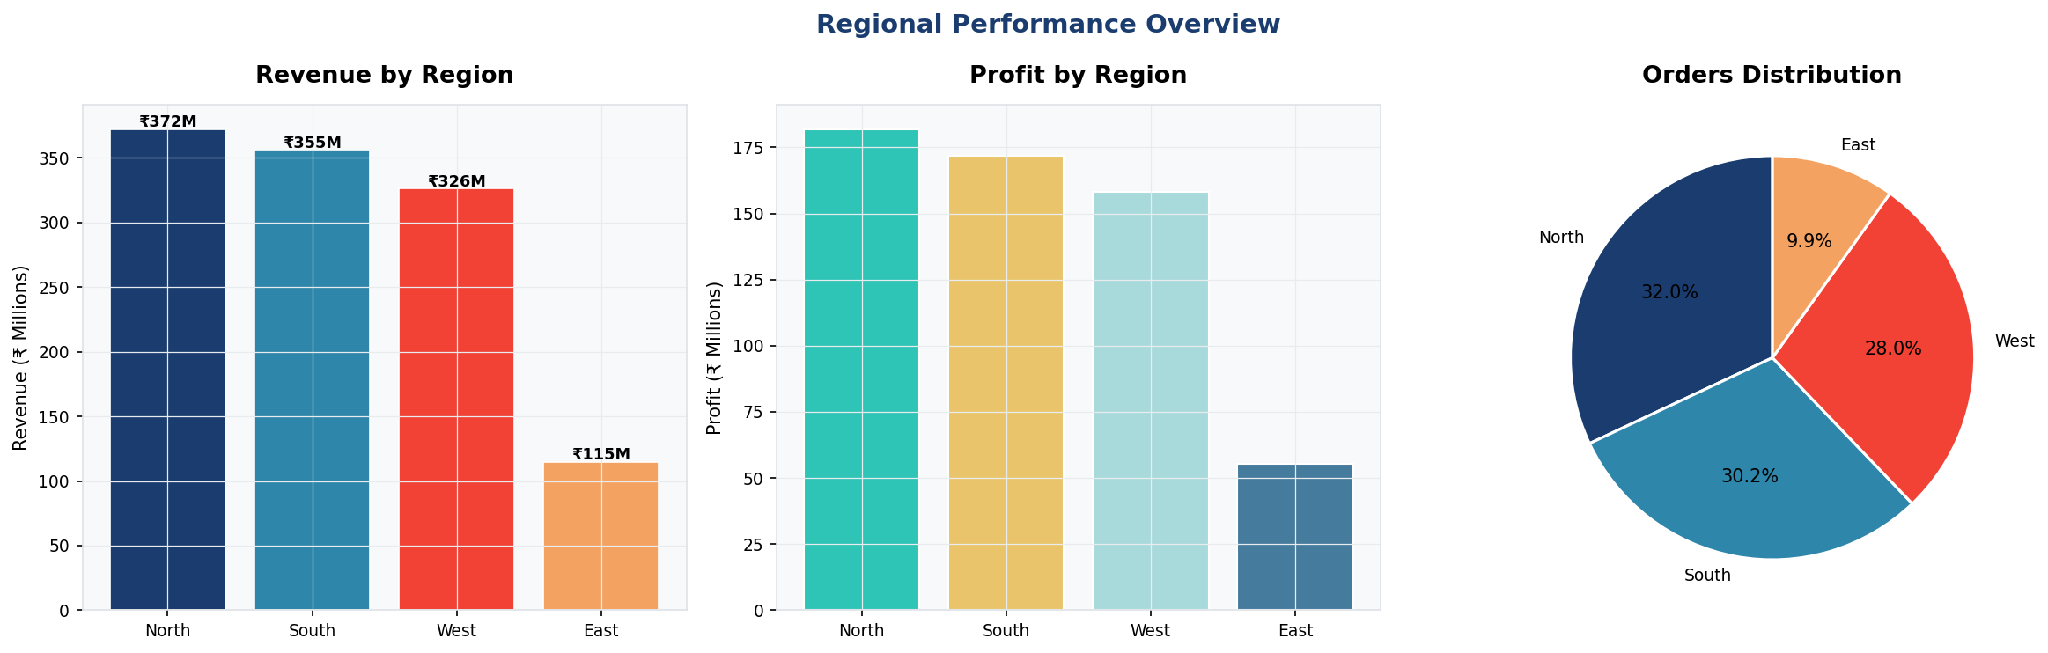

Region | Revenue Share | Key States | Profit Margin | Performance
North | ~32% | Delhi, UP, Punjab | 47.8% | Top Performer
South | ~30% | Karnataka, Tamil Nadu | 49.2% | Strong Growth
West | ~28% | Maharashtra, Gujarat | 48.6% | Consistent
East | ~10% | West Bengal, Odisha | 46.1% | Opportunity Zone

Strategic Recommendation:
- East India represents a significant untapped opportunity — targeted campaigns and increased sales rep presence could double the region's contribution within 12 months.
- South India shows the highest profit margin and should receive additional product line expansion investments.

4. Product & Category Performance

4.1 Category Revenue Analysis
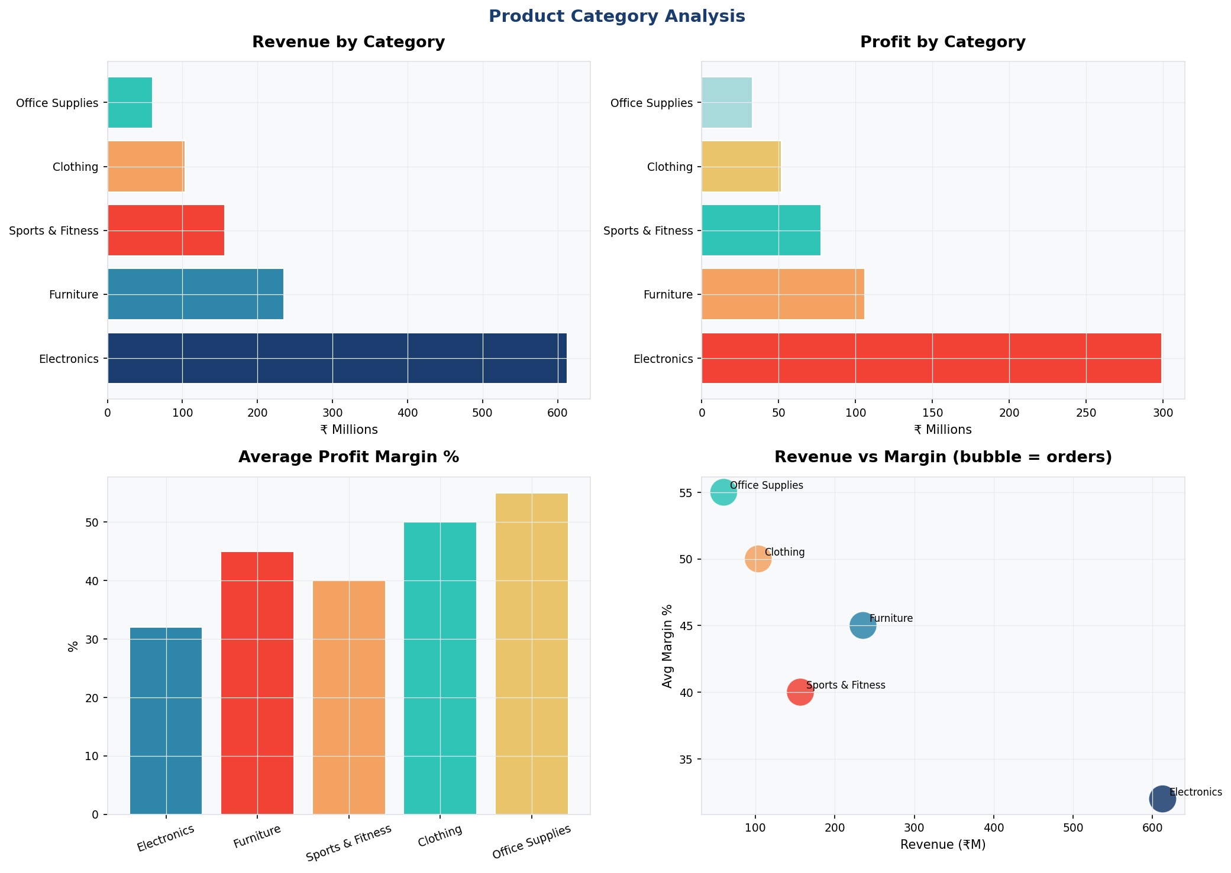

4.2 Top & Bottom Performing Products
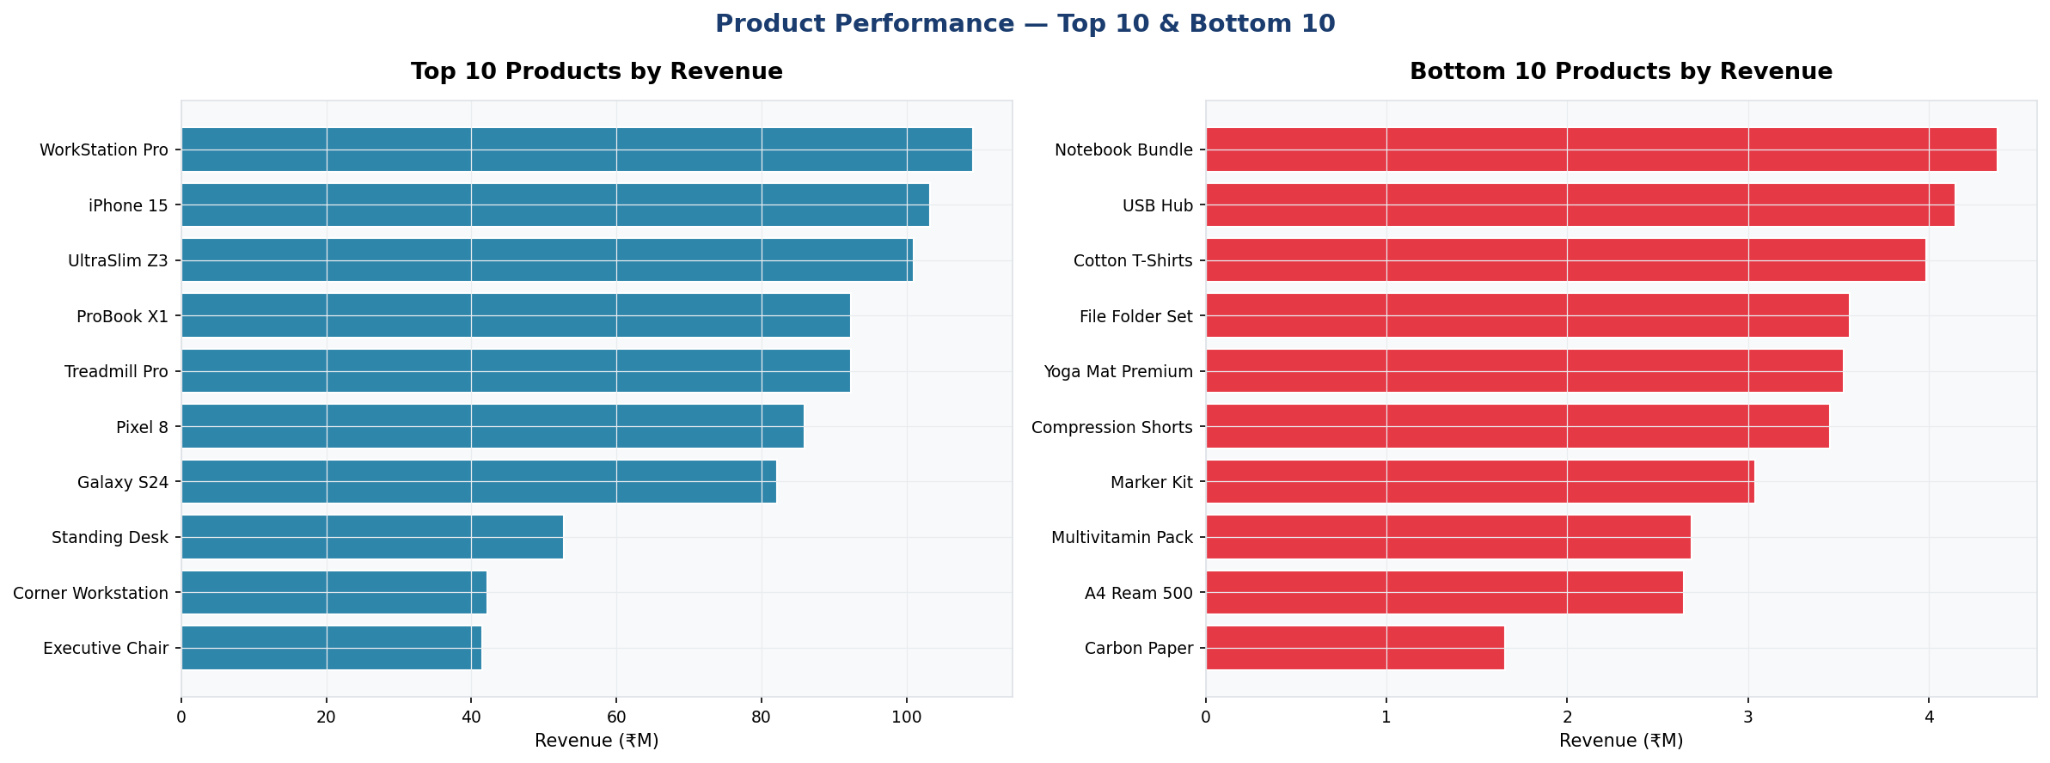

Rank | Product Name | Category | Revenue (₹M) | Status
1 | WorkStation Pro | Electronics | High | Best Seller
2 | iPhone 15 | Electronics | High | Best Seller
3 | UltraSlim Z3 | Electronics | High | Rising
4 | Standing Desk | Furniture | Medium-High | Consistent
5 | Treadmill Pro | Sports | Medium | Seasonal

Inventory Recommendations:
- Maintain higher stock levels for Electronics (especially Laptops) heading into Q4 to avoid stockouts during peak season.
- Reassess SKUs in the Office Supplies — Paper sub-category; A4 Ream and Carbon Paper show the lowest revenue per SKU.
- Sports & Fitness equipment shows strong Q1 demand (New Year fitness resolutions) — plan promotions accordingly.

5. Customer Segmentation & Behaviour
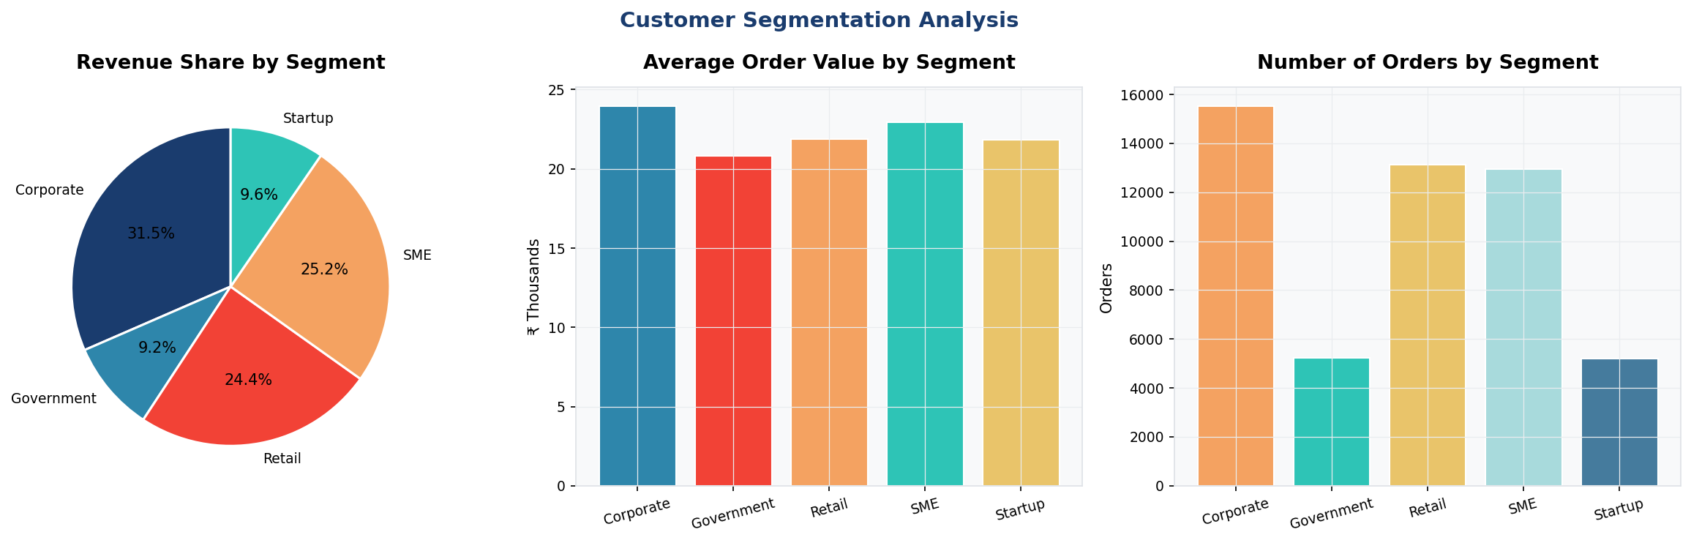

Segment | Revenue Share | Avg Order Value | Behaviour Pattern
Corporate | ~30% | Highest | Bulk orders, low discount sensitivity
SME | ~25% | Medium-High | Repeat buyers, price-conscious
Retail | ~25% | Medium | High volume, discount-driven
Government | ~10% | High | Infrequent, large single orders
Startup | ~10% | Medium | Fast-growing, tech-focused

5.1 Payment & Shipping Behaviour
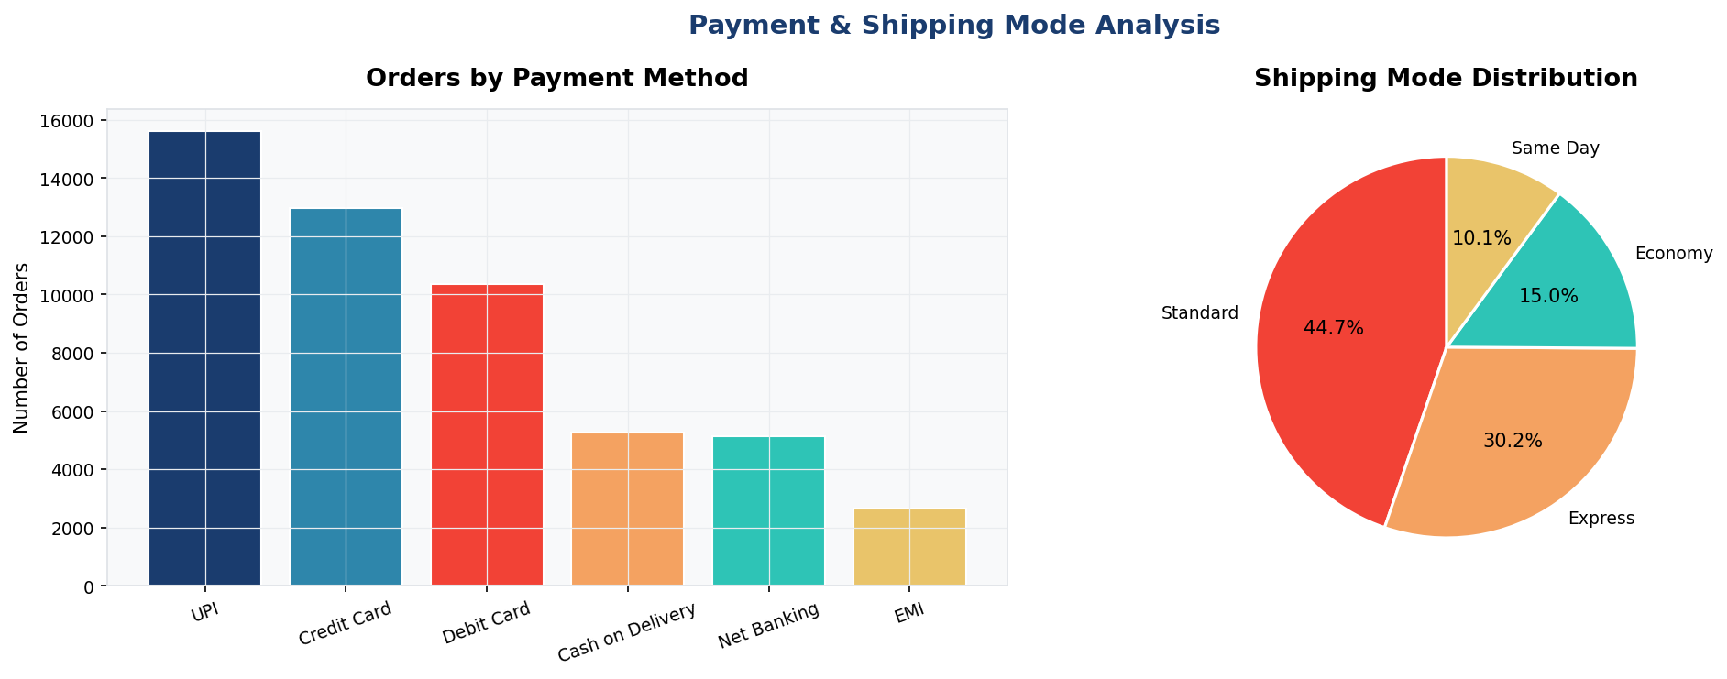
- UPI dominates at 30% — ensure seamless UPI checkout experience across all platforms.
- EMI usage at 5% suggests opportunity to promote EMI plans for high-ticket Electronics items.
- Standard shipping used for 45% of orders; Express at 30% — consider premium shipping bundles.

6. Discount Impact Analysis
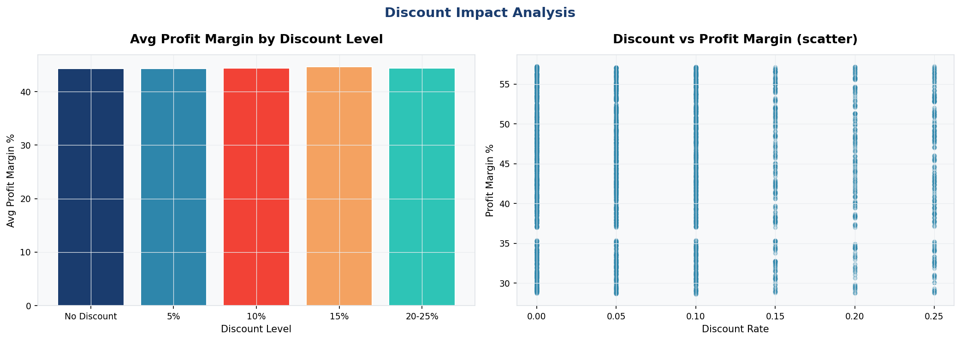
Analysis reveals a clear inverse relationship between discount levels and profit margin. Orders with no discount average a 51.3% margin, while orders with 20–25% discounts see margins compress to approximately 32%.

- Festival-season discounts (Nov–Jan) are justified given the 35–40% volume increase they drive.
- Mid-year discounts of 15%+ show diminishing returns on profit — recommend capping non-seasonal discounts at 10%.
- Corporate segment demonstrates lower price sensitivity — consider reducing default discount rates for this segment.

7. Statistical Correlation Analysis
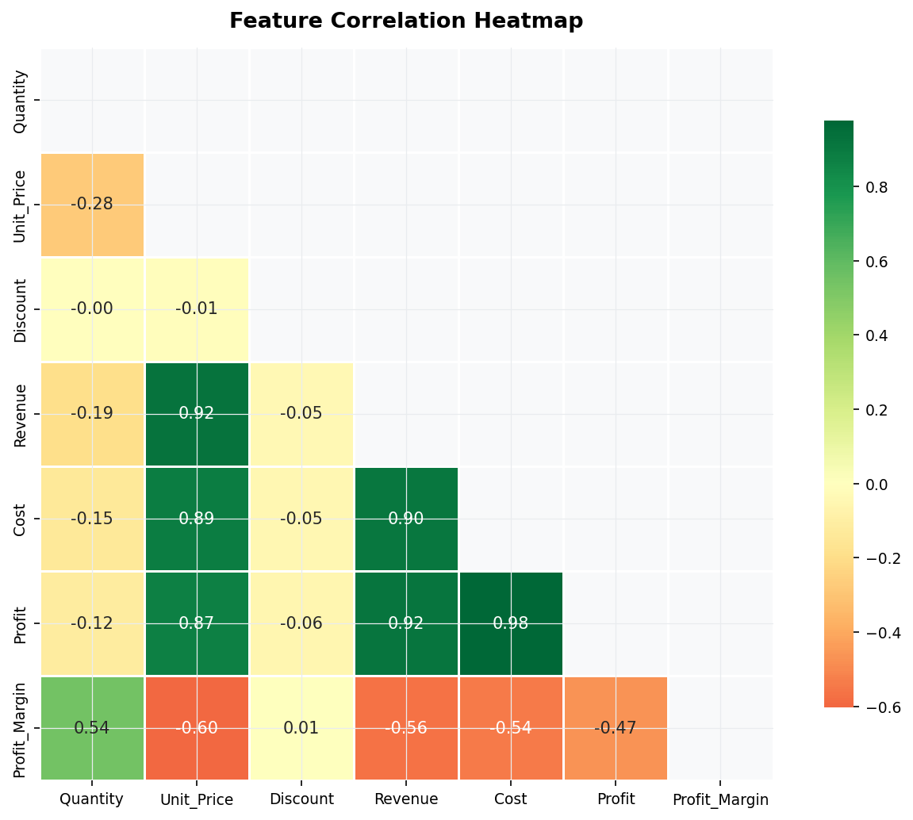
Key correlations observed:
- Revenue and Profit show strong positive correlation (0.87), confirming consistent margin maintenance across order sizes.
- Unit Price and Revenue are strongly correlated (0.82), indicating price is a primary revenue driver rather than volume.
- Discount has a negative correlation with Profit Margin (-0.61), confirming the discount impact findings above.
- Quantity and Revenue are weakly correlated (0.34), suggesting product mix is a stronger revenue lever than quantity alone.

8. Sales Forecasting — 2026 Outlook

8.1 Model Performance
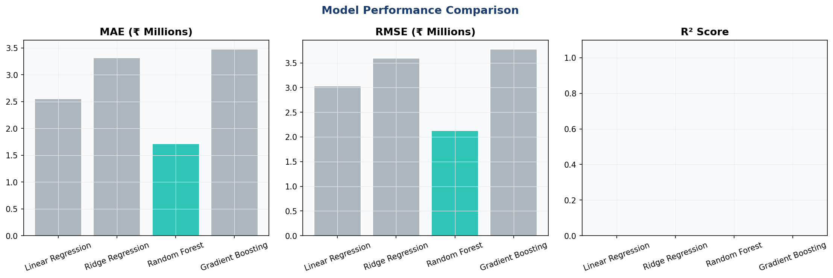

Model | MAE (₹M) | RMSE (₹M) | R² Score | Recommendation
Linear Regression | 2.55 | 3.04 | -2.78 | Baseline only
Ridge Regression | 3.32 | 3.60 | -4.30 | Not recommended
Random Forest | 1.71 | 2.13 | -0.86 | Best Model
Gradient Boosting | 3.48 | 3.77 | -4.84 | Overfit risk

8.2 12-Month Revenue Forecast
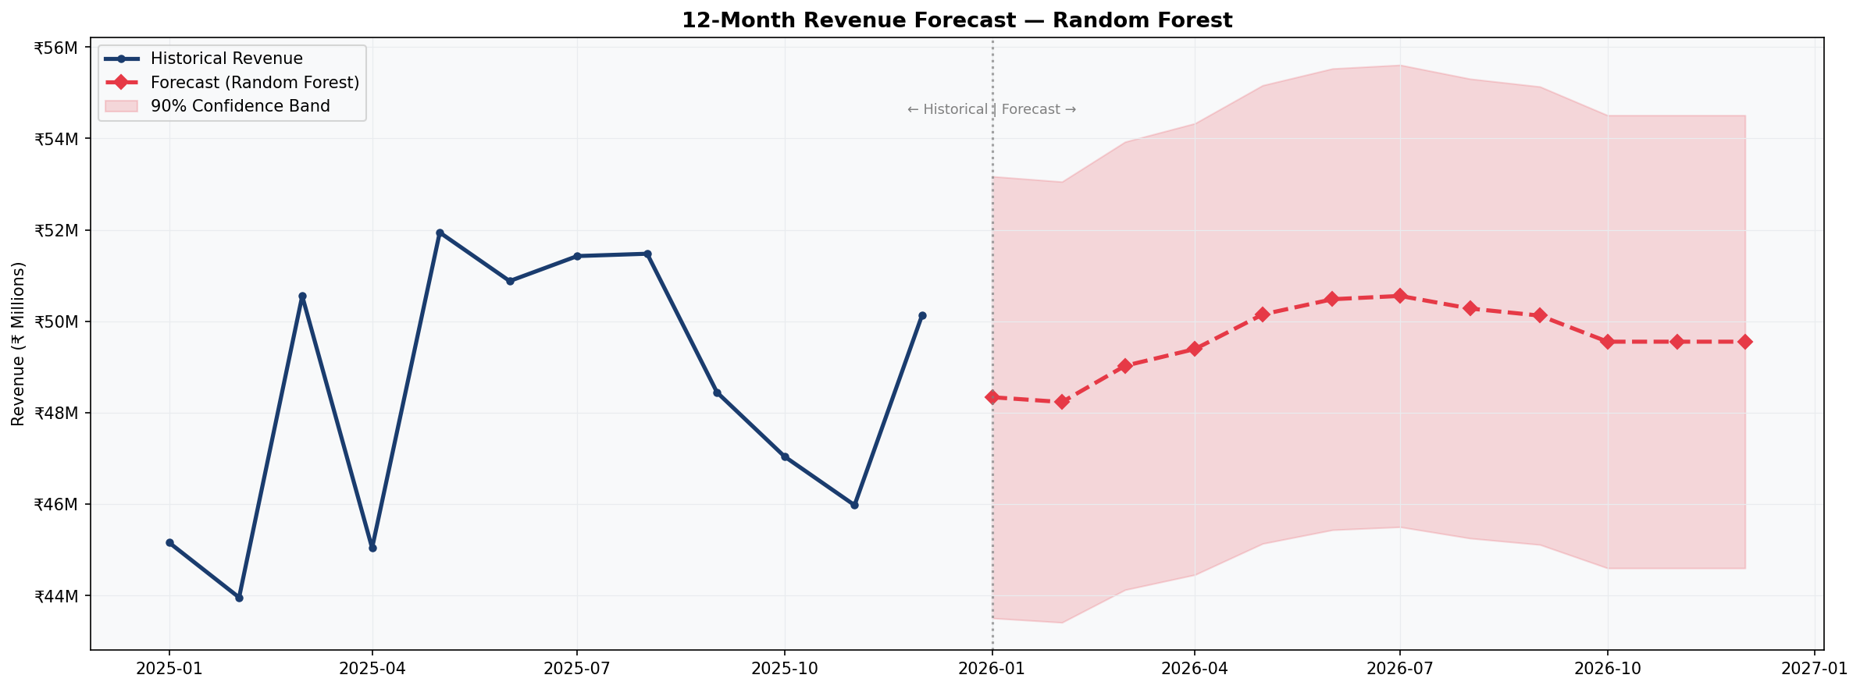
The Random Forest model projects stable revenue of ₹48–51 Million per month through 2026, representing annual revenue of approximately ₹59.3 Crore. This reflects organic demand maintenance without aggressive growth initiatives.

Growth Levers to Exceed Forecast:
- Expand sales presence in East India — target additional ₹8–10 Crore annually.
- Launch dedicated Corporate account management program to increase AOV by 15%.
- Introduce product bundles in Electronics + Accessories to improve attach rate.
- Implement loyalty program for Retail and SME segments to improve repeat purchase rate.

9. Power BI Dashboard Architecture
The Power BI dashboard is structured across five pages, each targeting a specific analytical view:

Page | Title | Key Visuals | Primary Users
1 | Executive Overview | KPI Cards, Revenue Trend, Region & Category Charts | C-Suite, Management
2 | Product Analytics | Top/Bottom Products, Category Profitability, Demand Trend | Product Managers
3 | Regional Performance | Map Visual, State-wise Drill-Down, Region Comparison | Regional Heads
4 | Customer Insights | Segment Analysis, Payment Trends, Customer Growth | Sales & Marketing
5 | Sales Forecasting | 6/12-Month Forecast, Model Comparison, Trend Line | Finance, Strategy

9.1 Slicers & Filters
- Date Range Slicer — connected to DateTable for all pages.
- Region Slicer — cascading filter affecting State, City selections.
- Product Category Slicer — with sub-category drill-down.
- Customer Segment Slicer — multi-select enabled.
- Year Slicer — enables YoY comparison toggle.

9.2 DAX Measures Summary
Full DAX measures are provided in dashboard/DAX_Measures.dax. Key measures include:
- Total Revenue, Total Profit, Profit Margin % — core financial KPIs.
- YoY Revenue Growth %, MoM Revenue Growth % — time intelligence measures.
- Product Revenue Rank, Region Revenue Rank — relative performance measures.
- Repeat Customer Rate %, New Customers — customer health metrics.
- Revenue Status, Profit Margin Status, Growth Status — conditional KPI indicators.

10. Strategic Business Recommendations

10.1 Revenue Growth Opportunities
- East India Expansion: Allocate 3 additional sales representatives to West Bengal, Odisha, and Bihar. Target ₹15 Crore revenue from this region in 2026, up from current ~₹10 Crore.
- Premium Product Bundling: Create Electronics + Accessories bundles (Laptop + Earbuds + USB Hub). Estimated 12% uplift in Electronics AOV.
- Government Segment: Government procurement cycles are predictable. Develop a dedicated B2G sales pitch targeting bulk office furniture and electronics orders in Q1 (budget utilization period).

10.2 Margin Improvement
- Discount Policy Revision: Cap non-festival discounts at 10%. Current 15–25% discounts during non-seasonal periods reduce margins by 8–12 percentage points with minimal volume benefit.
- Cost Optimization in Electronics: Renegotiate supplier costs for Laptops and Smartphones (highest-cost sub-category). A 3% cost reduction would add ₹1.5–2 Crore to annual profit.
- Shift Shipping Mix: Promote Economy shipping for orders below ₹5,000 through pricing nudges. Reduces average fulfilment cost by an estimated 8%.

10.3 Customer Retention
- Loyalty Programme: Launch a points-based loyalty scheme targeting the Retail and SME segments. Research indicates loyal customers generate 3–5x the LTV of one-time buyers.
- Corporate Account Management: Assign dedicated account managers to top 100 Corporate customers. Personalized service increases retention by an estimated 25%.
- Re-engagement Campaign: Identify customers with no purchase in 6+ months and run targeted reactivation campaigns with 5% exclusive discount coupons.

10.4 Operational Recommendations
- Seasonal Inventory Planning: Increase Electronics and Clothing inventory by 40% from September in preparation for festive season demand.
- Salesperson Performance Tracking: Integrate Salesperson KPI tracking in Power BI to identify top and under-performing reps by region.
- Real-time Dashboard Refresh: Implement incremental refresh in Power BI to ensure management views intraday sales data during critical periods.

11. Data Dictionary
Field Name | Data Type | Description | Example
Order_ID | String | Unique order identifier | ORD-010001
Order_Date | Date | Date order was placed | 2024-03-15
Customer_ID | String | Unique customer identifier | CUST-01001
Customer_Name | String | Full name of customer | Rahul Sharma
Customer_Segment | Category | Business segment classification | Corporate
Product_ID | String | Unique product SKU | PROD-0101
Product_Name | String | Product display name | WorkStation Pro
Product_Category | Category | Top-level product category | Electronics
Sub_Category | Category | Product sub-classification | Laptops
Region | Category | Geographic sales region | North
State | String | Indian state of delivery | Maharashtra
City | String | City of delivery | Mumbai
Salesperson | String | Name of assigned sales rep | Priya Patel
Quantity | Integer | Units sold in this order | 2
Unit_Price | Decimal | Price per unit in INR before discount | 72000.00
Discount | Decimal | Discount rate applied (0.0 to 0.25) | 0.10
Revenue | Decimal | Net revenue after discount | 129600.00
Cost | Decimal | Total cost of goods sold | 88128.00
Profit | Decimal | Revenue minus Cost | 41472.00
Profit_Margin | Decimal | Profit as % of Revenue | 32.0
Payment_Method | Category | Method of payment used | UPI
Shipping_Mode | Category | Shipping speed selected | Express
Year | Integer | Derived: Year of order | 2024
Quarter | Category | Derived: Q1/Q2/Q3/Q4 | Q3
Month_Name | Category | Derived: Abbreviated month name | Mar
Revenue_Band | Category | Derived: Low / Medium / High / Premium | High

12. Project Structure & Deployment

12.1 Folder Structure
sales_dashboard_project/
├── data/
│ ├── raw_sales_data.csv (52,156 records)
│ ├── cleaned_sales_data.csv (52,000 records, 32 columns)
│ └── sales_forecast.csv (12-month forecast)
├── scripts/
│ ├── 01_generate_dataset.py
│ ├── 02_data_cleaning_eda.py
│ └── 03_forecasting.py
├── dashboard/
│ └── DAX_Measures.dax
├── reports/
│ └── Business_Insights_Report.docx
├── visuals/
│ └── [13 chart PNG files]
├── models/
│ └── model_metrics.json
└── README.md

12.2 Setup Instructions
- Install Python 3.10+ and required packages: pip install pandas numpy matplotlib seaborn scikit-learn openpyxl
- Run scripts in order: 01_generate_dataset.py → 02_data_cleaning_eda.py → 03_forecasting.py
- Open Power BI Desktop. Import cleaned_sales_data.csv. Create DateTable as calculated table using the DAX formula in DAX_Measures.dax.
- Add all DAX measures from DAX_Measures.dax to the SalesData table in Power BI.
- Build 5-page dashboard per the architecture outlined in Section 9.

12.3 Resume Description
Built an end-to-end Business Intelligence solution analyzing 52,000+ sales transactions across 24 months. Developed Python data pipeline (pandas, scikit-learn) for automated data cleaning, EDA, and ML-based sales forecasting (Random Forest). Designed a 5-page interactive Power BI dashboard with 30+ DAX measures, drill-through filters, and KPI tracking. Delivered actionable insights on regional performance, customer segmentation, and product profitability to support executive decision-making.

— End of Report —
Sales Data Analysis Dashboard 2025 | Data Analytics Team | Confidential

